Task 1: Locating Sources
Identify and locate three different sources (a report, a journal article, and a website) related to the question
“What employability skills do university graduates need to succeed in the workplace?”
Show how you used keywords, search terms, and Boolean operators to find them, and explain how you know which type of source each one is and why it is appropriate for the research question.

Source Type & Why It Is Appropriate | URL/DOI | What search engine did you use? Google/Online Library/Library AI Assistant | Keywords/Boolean Operators Used
Article,  soft skills practically needed in the workplace and the perception of faculties at schools of business. | https://librarysearch.uwtsd.ac.uk/permalink/44WHELF_UWTSD/1bmis16/cdi_emerald_primary_10_1108_HESWBL-01-2018-0002 | UWTSD library | Employability and business graduates and success and workplace
Website,helps graduates build skills for workplace. | https://www.managers.org.uk/knowledge-and-insights/research/building-employability-skills/ | Google search | employability skills for graduates for workplace report

Task 2: Evaluating Information (CRAAP Test)
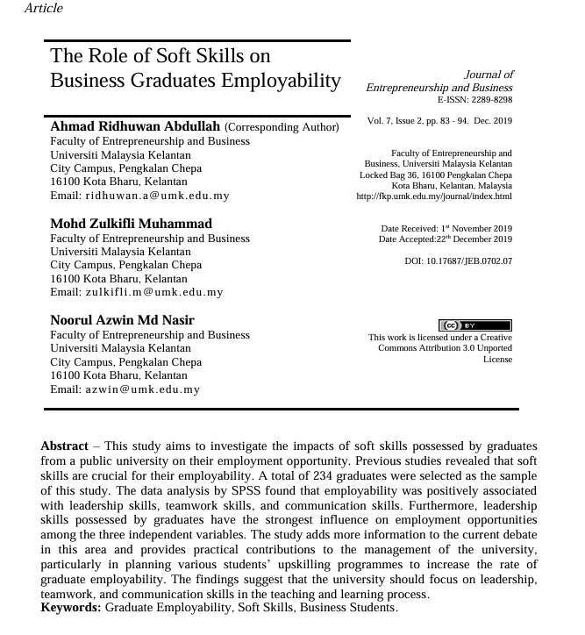
Your colleague has forwarded you a source from a peer reviewed journal, and they are not sure whether it is appropriate to use and has asked for your help. Your task is to evaluate the source by using the CRAAP Test to assess its appropriateness for the following question “What employability skills do business university graduates need to succeed in the workplace?”

CRAAP Test
Currency | Yes ,its published in 2019.
Relevance | Can help graduates to understand what skills are needed to have a better chance of employment success.
Authority | Journal of Entrepreneurship and Business E-ISSN:2289-8298
Accuracy
Purpose | 234 graduates selected in a study sample to understand how leadership and communication skills helps to find better job opportunity.
Task 3: Source Analysis
Your manager has provided you with a short extract from a source and has asked you to analyse the source by Identifying one strength, one weakness, and providing a brief explanation of the strength and weakness identified.
If you want to read the article online, please click the following link: https://www.universitiesuk.ac.uk/latest/news/strong-demand-graduates-employers

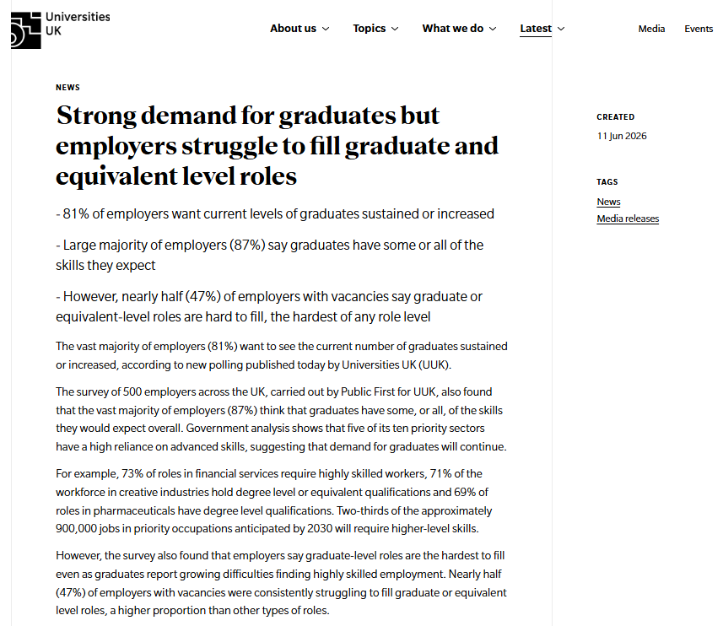
.

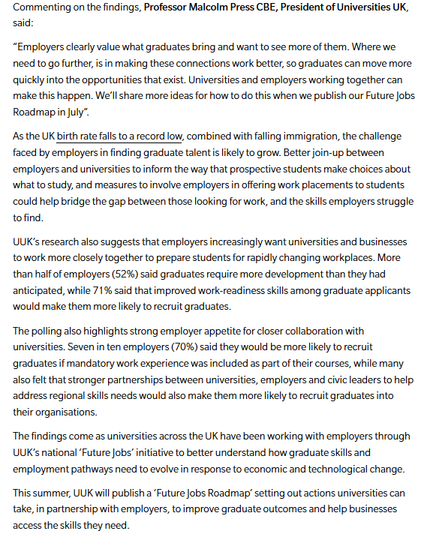

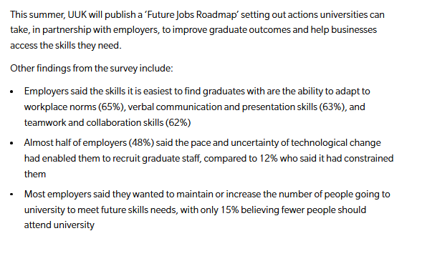

Strength of the Source:

Weakness of the Source:

