University of Wales Trinity Saint David



Walkabout, Swansea

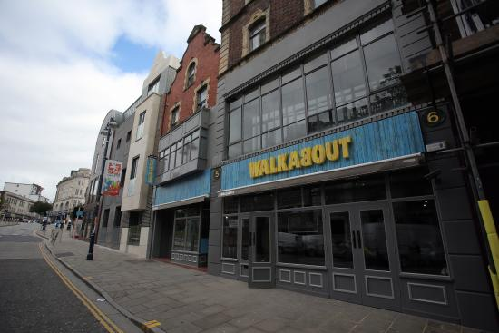

Project Initiation Document (PID)
Project Consultant: Norbert Kondor
Module: Consultancy Project
Level: 6
Lecturer: Michael Davies

Document Purpose
The purpose of the Project Initiation Document is to provide the venue’s management a good understanding of the project and ultimately to increase sales figures and the popularity of the venue during weekdays.

Project Deliverable Roles
The people listed below will receive a copy of the Project Initiation Document (PID) and the Final Project Document.

Consultancy Project
Organisation UWTSD | Name: Michael Davies
Reviewers
Organisation UWTSD | Name: Michael Davies
Acceptor/Approvers
Organisation Walkabout | Name: Marios Yiannou & Robert Nangalia

Executive Summary
The success of the project can greatly influence the ongoing success of the Walkabout Swansea venue. The implementation of new events and deals will be fundamental to the achievement of the desired outcomes whereas the most significant benefits are the increase in customer numbers during the weekdays.

Table of Contents
Document Purpose…………………………………………………...2
Project Deliverable Roles…………………………………………….2
Executive Summary…………………………………………………..2
- Project Justification…………………………………………...4
  - Aim……………………………………………………………..4
  - Background…………………………………………………....4
  - Objectives……………………………………………………..5
  - Rationale……………………………………………………....5
  - Benefits………………………………………………………..6
  - Possible Constraints and Assumptions…………………....6
- Project Approach…………………………………………......7
  - Potential Project Costs……………………………………….7
  - Project Risk Management…………………………………...8
  - Project Management Team Structure……………………...8
- Quality Management Strategy……………………………...10
- Communication Management Strategy…………………....10
- Project plan…………………………………………………...11
- Bibliography…………………………………………………...13

- Project Justification

  - Aim

The project aim is to critically review and identify potential new offers, deals and the introduction of new events to the venue to enable Walkabout Swansea to increase its turnover during the weekdays, mainly on Monday, Tuesday, Thursday and Friday.

The importance of adding to the existing offers and events is supported by the current positive impacts that it has on the business. For example, on Saturday between 7-10pm the customers can enjoy the ‘Happy Hour’ when all the drinks are discounted by 50%. Currently the consultant being a member of the bar staff; he experienced that this specific offer works really well for the business although when the ‘Happy Hour’ ends at 10pm, most of the customers tend to spend their time at another venue and if Walkabout could keep those individuals in the venue by having entertainment/events the business could potentially experience a significant gain. Furthermore, today nearly every brand and retailer uses discounts or other promotions to grow their businesses. Companies that understand the psychology behind special offers create a favorable brand image, deliver happiness to new and returning customers and boost long-term profitability and sales,

  - Background
Walkabout is part of the Stonegate Pub Company, which was formed in 2010 by a private equity firm called ‘TDR Capital’ after its purchase of 329 pubs from Mitchells & Butlers. Walkabout itself is an Australian themed sports bar equipped with a dance floor and three bars in total. In Swansea, Walkabout is located on Wind Street, which is the busiest street when it comes to nightlife, offering great opportunities for the venue. Since 2015 the General Manager of Walkabout Swansea is Marios Yiannou and since the beginning of 2018, Robert Nangalia is the Deputy Manager. Both of them have valuable experience in customer service and management that can be used to push the business forward. On the other hand, since Walkabout re-opened in 2015, there has been one consistent issue that surrounded the business: customers mostly visit the venue for the cheap beverages and leave when the offers end, generating further revenue for the competitors.

  - Objectives
In order to achieve the aim successfully, a number of objectives have been set up:
- The review and assessment of Walkabout’s current deals and events, recognizing its strength and weaknesses – (which offer is the most popular one currently? Why? Which event was the most successful in the past years? Was it the timing or the theme of the event?)
- Visit competitor venues as a ‘mystery shopper’ and experience their busy nights and identify key differences that would help Walkabout’s turnover rate
- Provide a detailed formal report with a set of recommendations which could potentially help the business to increase the profits and the customer numbers during the weekdays.

  - Rationale

Almost every organization exists to make a profit; this is how they can survive and expand – generating more profits. As it was mentioned above, Walkabout’s location is both a blessing and a great challenge; Wind Street and its surrounding area is packed with bars and clubs. Currently there are more than 18 pubs and clubs in the area and from a business point of view this means that your venue needs to be different from the other businesses in order to attract customers who have got an overwhelmingly large number of choices on where to go for a pint.

  - Benefits
The best outcome a customer-focused business can ask for is a happy customer. When customers enjoy themselves in a specific venue they tend to return and bring friends with them so that they can experience the same happiness the initial customer felt in the first place. With the completion of the final report several benefits that have been identified can help grow the business. Firstly, and most importantly, the increase of sales and number of customers in the venue during weekdays, significantly increasing its profits. Secondly, by providing more events and extra deals it is hoped that the customers will feel more valued and the number of great reviews can increase – further promoting the Walkabout.

  - Possible Constraints and Assumptions
When consulting for a pub-chain like Walkabout, the Head Office might be hesitant to invest the time and effort needed to implement the recommendations which consists of new deals and events being introduced to the business.
The consultant assumes, on the other hand, that the General Manager and the Deputy Manager is going to be willing to meet every week or every second week, and if its needed, they will provide the consultant with sales figures, or with other existing data that he might need for his research.

- Project Approach

The second purpose of this report is to create a work breakdown structure by detailing all the necessary steps and tasks that needs to be followed during the project’s duration.
Simplistically, the project’s outcome is expected to increase the revenue and the customer numbers during weekdays.

  - Potential Project Costs

Financially the project will require a minimal amount of funds as the consultant is offering his services just to add value to the business, free of charge. While organizing new events, all the necessary equipment is already accessible within the venue. The new deals and offers might be slightly different as at first it is a risk that the venue has to take to ‘trial’ these offers and see how the customers react to it. After the offers have gone through the ‘trial’ phase the management can compare the numbers and review the impact it has made on revenue. Additionally, it would be irresponsible from the consultant’s part to say that there would be no financial commitments to the execution of the project – but it is safe to say that the potential funds will be minimal.

  - Project Risk Management

Risk management is an important part of the project as the risks are inevitable when a business is executing new ideas. However, risks can be simply managed if they are planned for so as a result the following risks and solutions have been identified:

- Lack of reliable data due to the nature of a survey (people tend not to answer them seriously or unintentionally choosing the ‘wrong’ answer) – This will be taken into account, however the consultant aims to conduct a survey which will have 100+ responses in order to maximise the reliability of the survey.
- Lack of contribution to the project from the management due to other commitments may slow down the final report – The consultant will review the project regularly in order to make sure the objectives are met and the time to meet these objectives are realistic.

  - Project Management Team Structure

To maximise the probability of success for the project, time management and a clear assignment of roles is essential. During this project the consultant will act as the project manager and coordinator; however due to the nature of the project, some business resources will need to be accessible by the consultant provided by the management, but otherwise Marios or Robert will not need to be involved in every aspect of the project, however, constant communication will take place between them and the consultant and they are equally responsible for the decisions that are made during the project. Below the consultant has added a table which demonstrates the team structure for the Consultancy Project. Those who are ‘not involved directly with the project’ are still taken into consideration as all of the stakeholders opinions are valuable and should be listened at.

City and Council of Swansea
City And County of Swansea Council

Stonegate Pub Company
General Manager
The Consultant
Bar Staff
Other Staff members
Key
Those stakeholders who are directly involved with the project and the decision making process
Those stakeholders who are indirectly involved with the project and the decision making process
Those stakeholders who are not directly involved with the project
Deputy Manager

- Quality Management Strategy

In order to assure that the quality standards are satisfactory the consultant will keep his lecturer up to date with his work and direction at all times. Secondly, while conducting surveys/questionnaires the consultant will aim to have as many responses as possible (100+) as this type of secondary research can be unreliable if not gathered enough responses. Furthermore, while the consultant is looking into the business figures he will make sure to use the exact same numbers as he got from the management so that the data analysis and outcome can be as realistic as possible.

- Communication Management Strategy

The communication strategy is one of the most important aspects of the projects as the consultant relies on the information that he gets from the management in many cases. In order to make sure that the communication levels between the consultant and the business stakeholders are satisfactory, a communication plan is set up which will help the General Manager and the Deputy Manager to be engaged in the project. The consultant will keep a detailed record of the meeting times.
.

- Project Plan

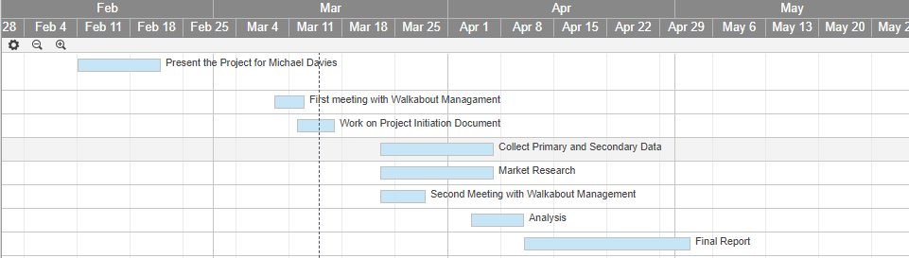
The first stage of the project was to present the consultants ideas to Michael Davies accompanied by a local business woman who gave us valuable feedback and guidance. Afterwards, due to unforeseen circumstances the consultant had to change the company he would consult for, so as a result he had a meeting with the Walkabout Management as he works there currently part time as a bar staff team member.

The second stage of the project was to create the Project Initiation Document for those involved (Michael Davies and Walkabout General Manager and Deputy Manager). At this stage the consultant was having a discussion with the Walkabout Management about their current issues in order for the consultant to have a good understanding of their current business situation. The third stage will focus mostly on data collection as the consultant plans to create a survey that would help understand the needs and expectations of the customers that visit the venues on Wind Street, Swansea. The consultant hopes that the Walkabout Management will help with the data collection in a sense that they would share the online survey created via social media and/or in a form of an e-mail.

Furthermore, the consultant plans on visiting competitor venues such as the Griffin, Bambu, Idols and The Bucket List in order to better understand what attracts specific age groups on different days, where and why. The fourth stage is the analysis when the consultant will gather all the data collected and based on that data he will make certain recommendations that will potentially increase the revenue and the visitor numbers. The last stage is the actual report creation when the consultant will present all of his findings and recommendations in a professionally done report format that will be accessible for the Walkabout Management and the University lecturer/reviewer only.

- Bibliography

Cocco, M., & Tuzzi, A. (2013). New data collection modes for surveys: a comparative analysis of the influence of survey mode on question-wording effects. Quality and Quantity, 47(6), 3135-3152
Hakes, C., & Pera International. (1991). Total quality management : The key to business improvement (A Pera International executive briefing). London: Chapman and Hall.
Walkaboutbars.co.uk. (2018). Walkabout. [online] Available at: https://www.walkaboutbars.co.uk/venues/swansea [Accessed 9 Mar. 2018].

