Digital Skills and Research Methods


(SMR Digital Limited, 2018)

Module Title: Digital Skills and Research Methods
Module No: BMSK4003
Student Name: Egle Miksyte
Student Number: 1814064
Tutor Name: Anupam Mazumdar

Table of Contents

- Introduction……….....................................................................p.3
  - Definition of a “Technology” ............................................p.3
  - Definition of a “Media Tool” .............................................p.3
- Effectiveness of the use of Media Tools at the workplace........p.4
- Social Media as a “Tool” ….......................................................p.6
  - Social Media as the Tool for Marketing…………………. p.8
  - Social Media as the Tool for Communication……………p.9
  - Social Media as the Tool for Information Gathering……. p.9
- Own Social Media………..........................................................p.9
- Conclusion..............................................................................p.10
References ............................................................................p.11

- Introduction

  - Definition of a “Technology”

A “Technology” is defined by Oxford Dictionary as “the methods for using scientific discoveries for practical purposes”. (Oxford University Press, n.d.) However, nobody would argue that the technology has in fact many various forms and it has certainly become the integral part of our lives and in fact it is difficult to imagine our lives now without modern electronic devices. (Maund, et al., 2017) Whilst for businesses, technologies have opened opportunities for growth and in fact some academics argue that it had started the fourth industrial revolution. (Wilkens, 2017)

For instance, Dropbox have not only improved the way the information is shared, but have in fact opened new opportunities for companies to optimise their operations and to reduce costs through the ability of bringing together employees distantly and in this way minimising labour costs. (Duraj, 2018) Whilst, IBM has introduced its own cloud system that allows users to work collaboratively on web development. (IBM, n.d.)

  - Definition of a “Media Tool”

In order to define the term a “Media Tool” it has to be first defined what “Media” is. According to Oxford Dictionary, the definition of “Media” is “the main means of mass communication (broadcasting, publishing, and the internet) regarded collectively.” (Press, 2019) Whilst the term a “Media Tool” is the method of interactive communication between the businesses and customers, internet users and between everyone in the world. (Non-Stop Media, n.d.)

Undoubtedly, when mentioning a “Media Tool” it is impossible not to mention the world’s most famous social media platform “Facebook”. Facebook is the globally known social media and social network website. (Facebook, Inc, 2018) According “Statista” the time we spend online per day has increased by 33.34% from 90 minutes per day to 135 minutes per day. (Lebo, 2017) Whilst the report by the Center for the Digital Future at USC Annenberg of the University of Southern California had found that the average American spends 24 hours per week online. (Lebo, 2017) The report had also found that the proportion of users accessing internet from mobile devises has risen from 23% in 2010 to 84% in 2017. (Lebo, 2017)
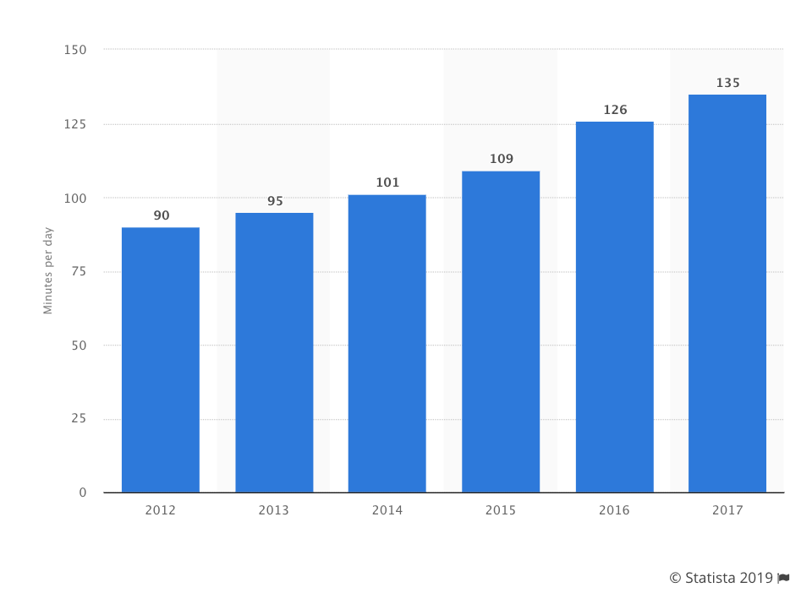
(Statista, 2019)

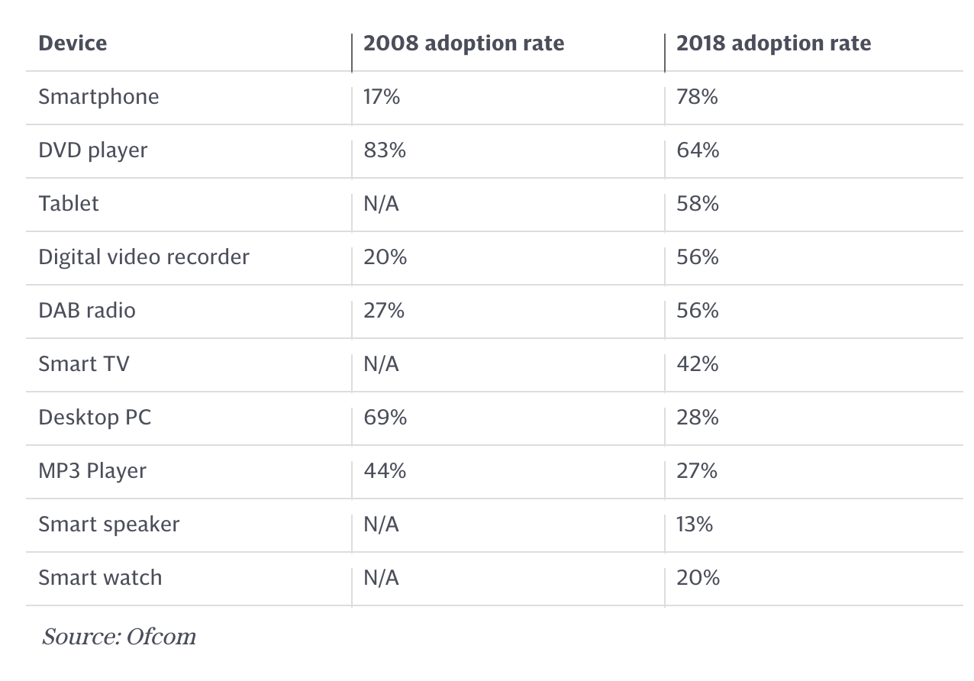
(Hymas, 2018)

The trend clearly illustrates that our behavior has changed and now we use digital technologies on the daily basis. This means that global businesses have to take these changes into consideration and to make the maximum use of it.

However, from the other perspective, the digital Skills and technologies are in some way bringing to the end of the corporate culture, because now it becomes the era of entrepreneurship, distributed leadership and the continual re-organisation of people and resources. (Michelman, 2017) These two boundaries will be explored further within this report.

- Effectiveness of the use of Media Tools at the workplace

Apart from platforms like Facebook, Instagram, Twitter and LinkedIn, another media tool which has had an important impact for is “Cloud Technology”. The cloud technology is the way of sharing and accessing data from computers and smartphones without being physically present at the office or any other location where that data was originally uploaded. (Oppitz & Tomsu, 2018) As Oppitz and Tomsu has described it “ the cloud is a metaphor for shifting services from one’s personal environment to a centralised organisation, sharing resources with other consumers and handing over ownership and responsibility to specialized providers”. (Oppitz & Tomsu, 2018) Dropbox and iCloud have helped businesses to cut their labour costs and to optimise their working practices. (Duraj, 2018)

For instance, Frimley Park Hospital which is part of the NHS Foundation Trust and serving nearly half a million of people, despite of the budget reduction has introduced the effective cloud storage system that allows staff to access patients’ records from tablets. This change had allowed to make the patients’ experience smoother and allowed to cut back office costs. (Baguley, 2013)

Another example is Betfair the online gaming company which after introducing the cloud system has enabled its customers to access information about the latest odds and allowing customers to make bets in-game. (Baguley, 2013) For companies like Betfair the cloud technologies are vital in order to keep their business competitive and running, because they allow instant access to information which in betting place the most important role.

In the early 2019, Google had informed the world that their new venture “Stadia” the games streaming service is due to launch in summer 2019. The service is fully based on cloud technology and will allow customers to play video games without having to download them to their own devices. (Chen & Wakabayashi, 2019)

From the perspective of the employees, the cloud technology can be useful in order to improve their co-working projects and in-fact to create the environment within which they can develop and grow as the professionals within their chosen fields. For instance, the cloud storage provides the following benefits for the employees:

- Usability – cloud storage allows to move files between the cloud storage and files’ local storage.

- Bandwidth – cloud storage allows users to send web links directly to recipients, instead of emailing those links to them.

- Accessibility – cloud storage allows users to access store files from anywhere as long as there is internet access for file sharing.

- Disaster Recovery – cloud storage allows users to back up their data via cloud service, which protects data from being lost.

- Cost Saving – cloud storage is extremely cost effective considering that you do not have to buy or to sell a physical product in order to allow access to it.

- Opportunity to work from home – cloud storage makes workplace flexible, meaning that employees can work remotely from the environment of their choice. According to Gallup poll, the number of workers working from home has increased from 9% in 1995 to 37% in 2015. (JONES, 2015) Whilst at least 70% of people globally have been found to work from home at least once a week according to IWG. (Browne, 2018)

- Opportunity to provide more effective customer service – cloud technology allows to access customers’ devices distantly and to offer solutions to technical problems, such as Apple which can access iPhones’ distantly and to solve issues quickly.

However, to every advantage there are numerous disadvantages of using cloud technology, to mention a few, these are:

- Accessibility – is an issue in case there is no internet connection which leads to inability to access the data.

- Security of Data – is one of the major issues surrounding cloud technology. The recent events like Sony hack and Cambridge Analytica scandal brings the issue of the security of the data stored. (Beall, 2018) Cloud technology means that the data is stored in one place and which makes it more vulnerable to hackers.

- Software – in order to manipulate the files across various devices, it will be important to ensure that the relevant software is installed on each of those devices so that it would be possible to access the required data.


(Digital Health Intelligence Limited, 2018)

The company where I used to work, specialises in surveying business and provides providing expertise services in the areas of road transport, cargo shipping and insurance. One of the specifics about the company’s business model was that the management used to track surveyors’ working hours by asking them to complete paper copies of the time schedule reports.

After joining the company, I have realised that such a system was not affective and was in-fact costly for the business. I have offered them to introduce cloud system provided by Amazon. The cloud technology allowed management to track the number of hours which every single surveyor had spent on the particular project and also what tasks they have undertaken for that project. This move had allowed company to decrease its labour costs by 28% in the first year.

- Social Media as a “Tool”

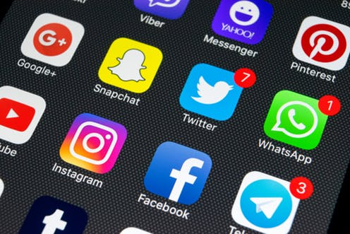
(Vidgen, 2019)

The term “Social Media” is defined as the “interactive computer-mediated technologies that facilitate the creation and sharing of information, ideas, career interests and other forms of expression via virtual communities and networks”. (Hermkens, et al., 2011)

The recent study by Oppitz and Tomsu, had found that the cloud service and infrastructure market is more than $150 billion smaller than the internet advertising market. (Oppitz & Tomsu, 2018) This different was partly influenced by the increase of social media websites from 970 million in 2010 to 2,62 billion in 2018, and which is also expected to increase to 3,02 billion in 2021. (Statista, 2019)
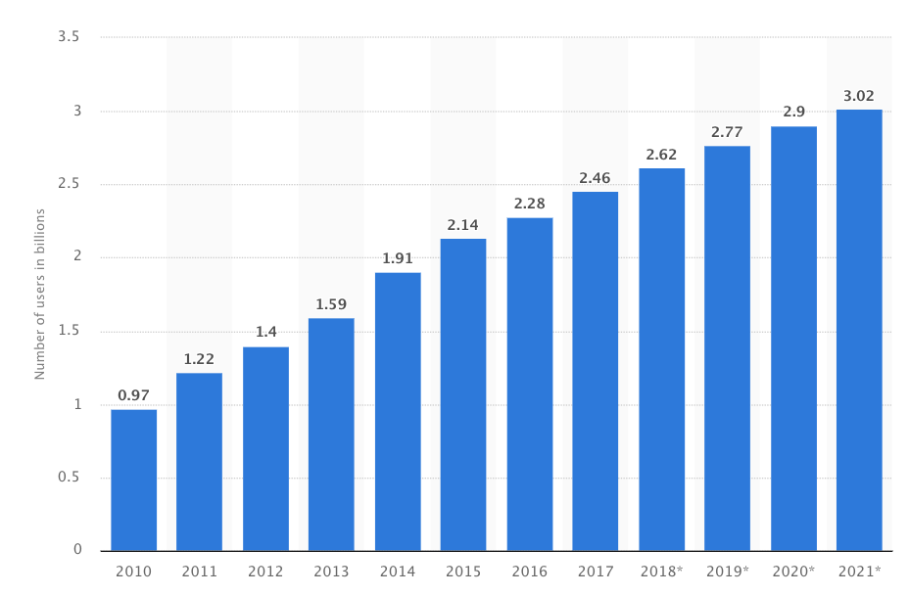
(Statista, 2019)

Whilst the study carried by TechCrunch, suggests that Facebook has 2,23 billion monthly users, whilst Instagram and WhatsApp have 1 billion and 1,5 billion retrospectively. (Constine, 2018) This means that Facebook is an important market for advertising products and services, as well as the tool for marketing, information gathering and communication within the workplace.

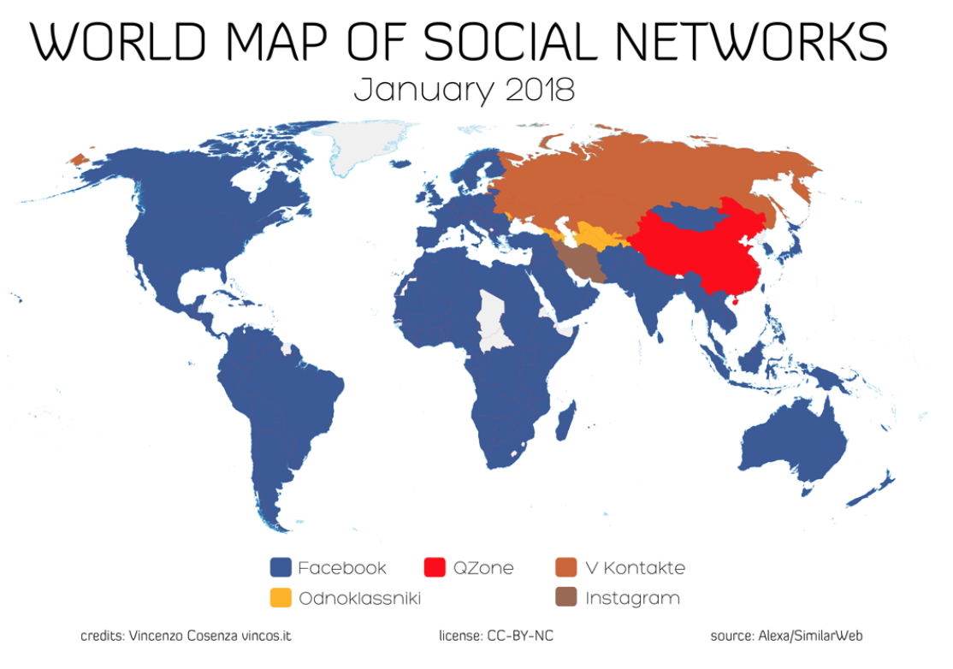
(KALLAS, 2018)

  - Social Media as the Tool for Marketing

The study carried out by Forbes (DeMers, 2014), had found out that the main benefits of social media marketing for businesses are:

- Increases Brand Recognition
- Higher Brand Authority
- Increases Inbound Traffic
- Decreased Marketing Costs
- Better Search Engine Rankings
- Richer Customer Experiences
- Improved Customer Insights

However, there are also some disadvantages of social media marketing, such as: (Business Blogs, 2018)

- Exposure to competitors
- Needs qualified personnel
- Slow returns on investments
- Tarnish brand name
- Time consuming

It can be clearly seen that there are more advantages than disadvantages of social media, because social media marketing can be used as a cost-effective tool to reach wide audience within the short period of time.


(Colwick Hall Hotel, 2019)

The marketing posts like the one above, provides Colwick Hall Hotel with opportunity to promote their services to all 7,149 of their followers for free which is a great tool for advertising.


(Colwick Hall Hotel, 2019)

  - Social Media as the Tool for Communication

Even though the exposure is high, the damage to business can also be severe. For instance, restaurants and hotels are very sensitive to reviews that are being left on their Facebook pages, for example customers can leave instant negative or positive feedback about the particular services of the restaurant or the hotel which may damage or vice versa improve business’s reputation. However, on the other hand the feedback even if it is a negative one, provides business with opportunities to review their working practices and maybe to change the product in order to satisfy customers’ needs.

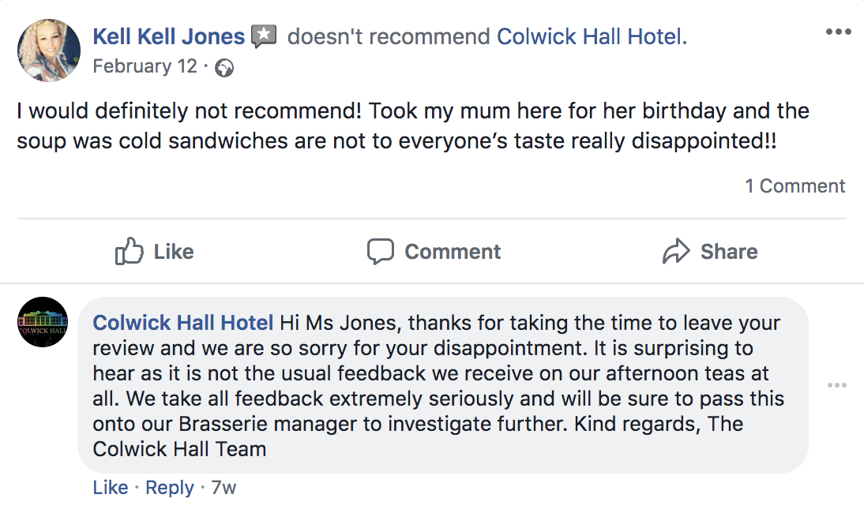
(Colwick Hall Hotel, 2019)

The benefit in social media as the tool for communication can also be found in corporate communication. For instance, the investigation into the working practice of one hospital carried out by Financial Times had found out that by using WhatsApp group chats allowed junior doctor trainees to access more experienced clinicians, who provided support and supervision to them. (Strachan, 2018)

  - Social Media as the Tool for Information Gathering

The scandal of Cambridge Analytica and Facebook had shown to the world that Facebook tracks everything what is being shared on their platform and may even share it with other companies, like Cambridge Analytica. (Wong, 2019) Therefore, social media can be used as a tool to gather information about what customers think about particular products and what they really need.

The SEO tools provide the opportunity to track the number of clicks customers had on a particular product and how many minutes they had spent on each page. Information like that allows businesses to better understand their target market and as the result to achieve higher profits.

- Own Social Media

I have created this Facebook Business page, because in my spare time I sell hand crafted bracelets for women. Before, I have only used to sell them on eBay, however, the disadvantage of that was, that I was not able to have the direct communication with my existing and perspective customers in the easy and the user-friendly way. Now, since I have the Facebook page, I will be able to receive enquiries and suggestions from the customers directly. I will also be able to advertise my products via hundreds of Facebook groups which is likely to increase my sales figures.

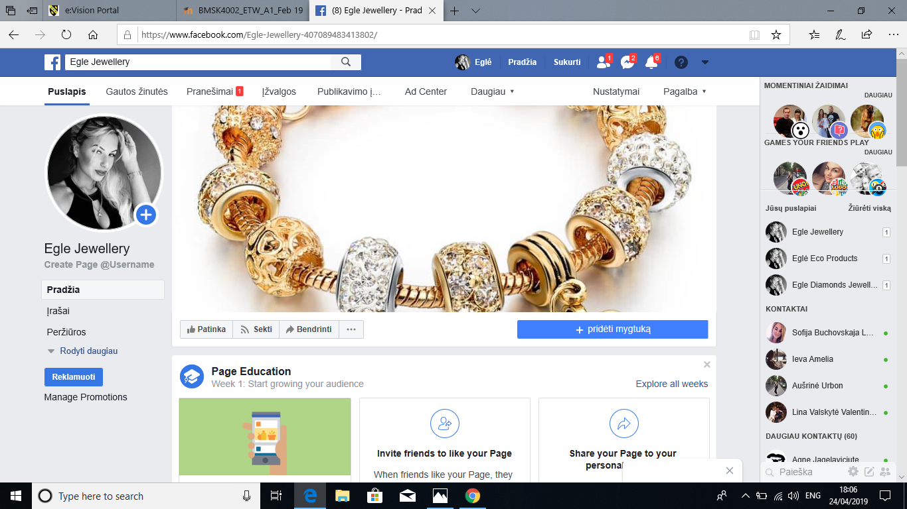

https://www.facebook.com/Egle-Jewellery-407089483413802/

The fact that I will be easily accessible for enquiries from my existing and perspective customers will benefit my brand image and will establish higher degree of trust for customers in my business venture.

- Conclusion

I believe that digital skills and research methods are important in all organisations, because they do not only improve and optimise the business processes, but more importantly improves the way how the employees communicate between each other and with customers. In the 21st Century, technologies have taken the integral part of our lives and continue to integrate further in our jobs.

References
Baguley, J., 2013. How cloud computing is changing the world ... without you knowing. [Online]
Available at: https://www.theguardian.com/media-network/media-network-blog/2013/sep/24/cloud-computing-changing-world-healthcare
[Accessed 03 04 2019].

Beall, G., 2018. 5 Ways Cloud Computing Is Changing the Business World. [Online]
Available at: https://www.business2community.com/cloud-computing/5-ways-cloud-computing-changing-business-world-02045310
[Accessed 03 04 2019].

Browne, R., 2018. 70% of people globally work remotely at least once a week, study says. [Online]
Available at: https://www.cnbc.com/2018/05/30/70-percent-of-people-globally-work-remotely-at-least-once-a-week-iwg-study.html
[Accessed 03 04 2019].

Business Blogs, 2018. Top 5 Advantages and Disadvantages of Social Media Marketing. [Online]
Available at: https://www.businessblogshub.com/2018/06/top-5-advantages-and-disadvantages-of-social-media-marketing/
[Accessed 03 04 2019].

Chen, B. X. & Wakabayashi, D., 2019. Google Introduces Streaming Video Game Service. [Online]
Available at: https://www.nytimes.com/2019/03/19/technology/google-stadia-video-game-streaming.html
[Accessed 02 04 2019].

Colwick Hall Hotel, 2019. Colwick Hall Hotel Reviews. [Online]
Available at: https://www.facebook.com/pg/colwickhallhotel/reviews/?ref=page_internal
[Accessed 08 04 2019].

Constine, J., 2018. 2.5 billion people use at least one of Facebook’s apps. [Online]
Available at: https://techcrunch.com/2018/07/25/facebook-2-5-billion-people/?guccounter=1
[Accessed 03 04 2019].

DeMers, J., 2014. The Top 10 Benefits Of Social Media Marketing. [Online]
Available at: https://www.forbes.com/sites/jaysondemers/2014/08/11/the-top-10-benefits-of-social-media-marketing/#3a74ef1d1f80
[Accessed 03 04 2019].

Digital Health Intelligence Limited, 2018. NHS green-lights cloud technology for storing patient data. [Online]
Available at: https://www.digitalhealth.net/2018/01/nhs-green-lights-cloud-technology/
Duraj, M., 2018. Is Dropbox Still A Great Cloud Solution Today?. [Online]
Available at: https://www.forbes.com/sites/maciejduraj/2018/11/25/is-dropbox-still-a-great-cloud-solution-today/#2c37c967421e
[Accessed 02 04 2019].

Facebook, Inc, 2018. Stats. [Online]
Available at: https://newsroom.fb.com/company-info/
[Accessed 03 04 2019].

Hermkens, K., McCarthy, I. P., Kietzmann, J. H. & Silvestre, B. S., 2011. Social media? Get serious! Understanding thefunctional building blocks of social media. Science Direct, Volume 54, pp. 241-251.

Hymas, C., 2018. A decade of smartphones: We now spend an entire day every week online. [Online]
Available at: https://www.telegraph.co.uk/news/2018/08/01/decade-smartphones-now-spend-entire-day-every-week-online/
[Accessed 02 04 2019].

IBM, n.d. IBM Cloud Services. [Online]
Available at: https://www.ibm.com/cloud/services
[Accessed 03 04 2019].

JONES, J. M., 2015. In U.S., Telecommuting for Work Climbs to 37%. [Online]
Available at: https://news.gallup.com/poll/184649/telecommuting-work-climbs.aspx
[Accessed 03 04 2019].

KALLAS, P., 2018. World Map of Social Networks 2018. [Online]
Available at: https://www.dreamgrow.com/world-map-of-social-networks/
[Accessed 03 04 2019].

Lebo, H., 2017. The 2017 Digital Future Report Center for the Digital Future at USC Annenberg. The Digital Future Report.

Maund, A., Schriek, M. & Tinkler, P. K., 2017. Certificate in Higher Education: Skills for the Workplace Student Yearbook. Thousand Oaks(California): SAGE Publications.

Michelman, P., 2017. The End of Corporate Culture as We Know It. MIT Sloan Management Review, Issue 2017 Summer Issue.

Non-Stop Media, I., n.d. New Media Tools. [Online]
Available at: http://non-stopmedia.org/new-media-tools/
[Accessed 03 04 2019].

Oppitz, M. & Tomsu, P., 2018. Inventing the Cloud Century. New York: Springer International Publishing.

Oppitz, M. & Tomsu, P., 2018. Inventing the Cloud Century. New York: Springer International Publishing.
Oxford University Press, n.d. Definition of technology in English. [Online]
Available at: https://en.oxforddictionaries.com/definition/technology
[Accessed 03 04 2019].

Press, O. U., 2019. Main definitions of media in English. [Online]
Available at: https://en.oxforddictionaries.com/definition/media
[Accessed 03 04 2019].

SMR Digital Limited, 2018. [Online]
[Accessed 08 04 2019].

Statista, 2019. Daily time spent on social networking by internet users worldwide from 2012 to 2017 (in minutes). [Online]
Available at: https://www.statista.com/statistics/433871/daily-social-media-usage-worldwide/
[Accessed 03 04 2019].

Statista, 2019. Number of social media users worldwide from 2010 to 2021 (in billions). [Online]
Available at: https://www.statista.com/statistics/278414/number-of-worldwide-social-network-users/
[Accessed 03 04 2019].

Statista, 2019. Number of social media users worldwide from 2010 to 2021 (in billions). [Online]
Available at: https://www.statista.com/statistics/278414/number-of-worldwide-social-network-users/
[Accessed 03 04 2019].

Strachan, M., 2018. 10 reasons you shouldn’t be using WhatsApp for work. [Online]
Available at: https://guild.co/blog/10-reasons-you-shouldnt-be-using-whatsapp-for-work/
[Accessed 03 04 2019].

Vidgen, B., 2019. Four ways social media platforms could stop the spread of hateful content in aftermath of terror attacks. [Online]
Available at: http://theconversation.com/four-ways-social-media-platforms-could-stop-the-spread-of-hateful-content-in-aftermath-of-terror-attacks-113785
[Accessed 03 04 2019].

Wilkens, U., 2017. Understanding organizational renewal from a multi-level perspective – Challenges and advancements. Journal of Competences, Strategy & Management, Volume 9, pp. 31-56.

Wong, J. C., 2019. The Cambridge Analytica scandal changed the world – but it didn't change Facebook. [Online]
Available at: https://www.theguardian.com/technology/2019/mar/17/the-cambridge-analytica-scandal-changed-the-world-but-it-didnt-change-facebook
[Accessed 03 04 2019].

