21/11/2025
University of Wales Trinity Saint David
lLONDON CAMPUS
Assignment 1
Learning in the Digital Era

Module Name: Learning in the Digital Era
Module Code: ACCA 4025

Student Name: Stephanie Tcha
Student ID: 2518542
Group No: 1

Lecturer’s Name: Koushik Modak
Submission Deadline: 21st November 2025

Table of Contents
Introduction 2
Main Body 2
Task 1: Written Summary and IEEE Referencing 2
Task 1 (a): Essential Skills for study and employment with IEEE referencing 2
Task 1 (b): Similarity Report Analysis 2
Task 2 2
Task 3 2
Task 4 2
Conclusion 2
References 2

Introduction

Main Body

Task 1: Written Summary and IEEE Referencing

Task 1 (a): Essential Skills for study and employment with IEEE referencing
I believe that every human was born with different skills which need to be polish as we grow to exploit it in study or work area, having say that to be successful in our endeavour it is crucial to develop the essential skills required in our field of study or employment.
The definition of skills is the ability to do something well. Skill can be divided into two categories, soft and hard skill.
Previous studies on employer skill requirements mainly focus on the difference between “soft” skills and “hard” skills in the labour market “Soft” skills refer to skills enable employees to fit in at a workplace, including skills related to individual personality, traits, flexibility, motivation, goals, and preferences. “Hard” skills, on the contrary, refers to skills enable employees to compete in tasks, including skills related to scientific knowledge and professional abilities [1].

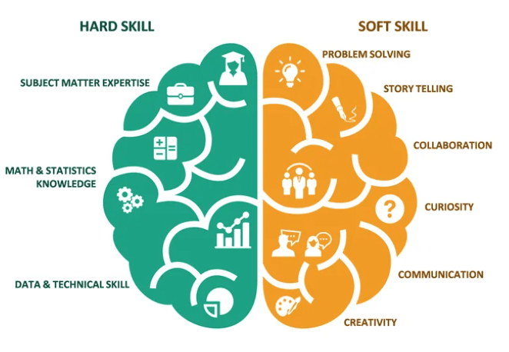

Figure 1: Hard and Soft Skills[2]
Below are some essential skills that need to be developed if not already acquire,
Teamwork: it develops your ability to socialise with others, appreciate cultural differences and establish your own identity with reference to your interaction with others in the group.
Reading and searching for information: Your ability to find, understand, and use information presented through words, symbols, and images. For example, we use this skill to locate information on forms and drawings, and to read items such as emails, reports, news articles, blog posts and instructions.
Communication: Your ability to receive, understand, consider, and share information and ideas through speaking, listening, and interacting with others. For example, we use this skill to listen to instructions, serve customers and discuss ideas.
Why this skill is important
Strong communication skills help you share information in a way that others can clearly understand. You also need strong communication skills to listen to, pay attention to, and understand others. In all jobs, communication skills are important for developing good working relationships with co-workers and clients, including those from different backgrounds and cultures. You also need these skills to work effectively in a team, understand a variety of viewpoints, and to gather and share information while problem solving – whether at work or in your daily life.

Writing: Your ability to share information using written words, symbols, and images. For example, we use this skill to fill out forms and applications, and write emails, reports and social media posts.

Why this skill is important
We write to communicate ideas and information to other people. In today’s world, we require writing skills that are suitable for different situations including digital platforms.
Knowing what to write, how much to write, and in which style to write is important. Writing skills ensure your writing is suitable for your purpose, the intended reader, and the context [3] [4].

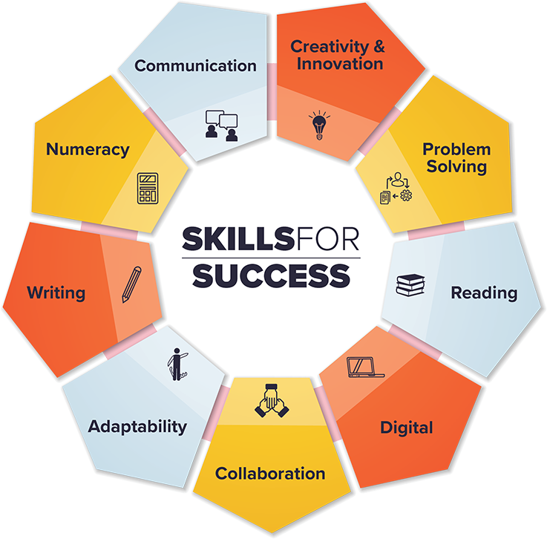

Figure 2: Essential Skills for Study and Employment [5]

Task 1 (b): Similarity Report Analysis

Task 2

Task 3

Task 4

Conclusion

References

References

[1] | “Applied energy,” 15 October 2021.
[2] | M. C. S, “Linked in,” 16 July 2024. [Online]. Available: https://www.linkedin.com/pulse/leadership-development-balancing-soft-skills-hard-mitch-chul-vnarf. [Accessed 03 November 2025].
[3] | S. Cottrell, The study skills handbook, London: Bloomsbury Publishing plc, 2024.
[4] | K. Gallagher, Essential study and employment skills, Oxford: Oxford university press, 2022.
[5] | “Canada.ca,” 18 August 2025. [Online]. Available: https://www.canada.ca/en/services/jobs/training/initiatives/skills-success/understanding-individuals.html. [Accessed 03 November 2025].

