Software Solutions for Business Assessment 1

Student name: Saidas Stankevicius
Student ID:2533410
Programme of study: CertHE Computing Skills for Workplace
Module Name: Software Solutions for Business
Module Code: ACCA406
Lecture’s Name: Amitave Bank, Anum Paracha, Kwame Assa Agyei
University: University of Wales Trinity Saint David

Table of Contents

Table of Contents
Introduction 3
Task 1: E-Commerce Website Builders / Solutions 3
Overview of E-commerce website builders 3
First E-commerce Solutions: Shopify 3
Second E-Commerce solution: Wix ecommerce 3
Comparison of the Two Solutions 3
Task 2: Mind-Map of Contemporary Software Applications 4
Task 3: Office Applications for creating, storing, presenting and Analysing Information/Data 5
Task 4: Communication and Collaboration Applications. 7
Conclusion 8
References 9

k

Introduction

This assignment explores different software solutions used in modern businesses. It focuses on e-commerce platforms, mind mapping tools, office applications, and communication and collaboration software. These tools are useful because they help businesses improve productivity, manage information, and support decision- making. The assignment also includes practical testing of selected features to show how they are used in real business situations. Overall. The aim is to understand how software supports day-to-day business operations.

Task 1: e-Commerce Website Builders / Solutions

Overview of E-commerce website builders
E-commerce website builders are tools that allow businesses to create and manage online stores without needing advanced technical skills. These platforms provide ready- made templates, payment systems, and tools to manage products and customers. They are widely used because they make selling products and services online easier and more efficient.
E-commerce website builders also provide additional tools such as marketing features, search engine optimisation, and customer support options. These features help businesses attract more customers and improve their online presence. As online shopping continues to grow these platforms have become essential for businesses of all sizes.

First E-commerce Solutions: Shopify
Shopify is a popular e-commerce platform that allows businesses to create online stores quickly and easily. It offers features such as customisable templates, secure payment options, and inventory management. Shopify is easy to use and suitable for small businesses and beginners. However, it requires a monthly subscription, and additional costs may apply for extra features. Another advantage of Shopify is its scalability, which means businesses can expand their online stores as they grow. It also offers a wide range of apps and integrations that allow business to customise their store further. However, some users may find the costs higher compared to other platforms, especially when adding premium features.

Second E-Commerce solution: Wix ecommerce
Wix ecommerce is another platform that allows users to build online stores using simple drag-and-drop system. It offers a range of design templates and tools for managing products and payments. Wix is user- friendly and ideal for small businesses or individuals. However, it may not offer as many advanced features as other platforms. Wix is particularly useful for beginners due to its simple interface and flexibility in design. It allows users to quickly create a visually appealing websites without coding knowledge. However, it may not be the best option for larger businesses that require more advanced e-commerce capabilities.

Comparison of the Two Solutions
Both Shopify and Wix ecommerce are useful tools for creating online stores, but they have different strengths. Shopify offers more advanced features and is better for growing businesses, while Wix is easier to use more suitable for beginners. The choice between them depends on the needs, budget, and size of the business.

Task 2: Mind-Map of Contemporary Software Applications

2.1 What is Mind Mapping?
Mind mapping is a visual technique used to organise ideas and information to help create a diagram that starts with central ideas and branches out into related topics. This method helps individuals and businesses structure their thoughts clearer. Mind maps are often used for planning, brainstorming, and problem-solving.

2.2 Benefits of Mind Mapping in Business
Mind mapping offers several benefits in business operations. It helps improve organisation by clearly showing relationships between different ideas, it also supports better decision-making by allowing users to see the bigger picture. In additions, mind mapping improves creativity and teamwork, as it allows multiple ideas to be shared and developed. Business use mind maps for planning project, managing tasks, and analysing information more effectively.

2.3 Mind Map of Contemporary Software Applications
The mind map above shows different types of software applications used in business operations. Each category represents a key area, such as communication, collaboration, and data management. These tools help businesses improve efficiency, manage tasks, and support teamwork. For example, communication tools allow teams to stay connected, while office applications help create and manage documents and data. Overall, the mind map demonstrates how different software applications are used together to support daily business activities.

Task 3: Office Applications for creating, storing, presenting and Analysing Information/Data
3.1 Microsoft word
Microsoft word is a widely used word processing application that allows users to create, edit, and format documents. It is commonly used in businesses for writing reports, letters, and official documents. Word included features such as spell check, templates, tables, and formatting tools. These features help users produce professional documents quickly and efficiently. One of the main benefits of Microsoft word is its ease of use and flexibility. However, it may not be suitable for handling large amounts of data or complex calculations.
3.2 Microsoft PowerPoint
Microsoft PowerPoint is a presentation software used to create slideshows for meetings, training, and business presentations. It allows users to combine text, images, charts, and animations to present information clearly. PowerPoint is useful for communicating ideas in a visual and engaging way. It also offers templates and design tools that make presentations more professional. However, too much information on slides can reduce effectiveness, and presentations may rely too heavily on visuals instead of detailed explanation.
3.3 Microsoft Excel
Microsoft Excel is a spreadsheet application used for organising, analysing, and storing data. It includes features such as formulas, charts, sorting, and filtering. Excel is widely used in businesses for financial calculations, data analysis, and reporting. One of its key benefits is its ability to handle large amounts of data and perform calculations quickly. However, it can be complex for beginners, and errors in formulas may lead to incorrect results.
3.4 Microsoft Access
Microsoft Access is a database management system used to store and manage large amounts of structured data. It allows users to create tables, forms, queries, and reports. Access is useful for business that need to organise and retrieve data efficiently. It helps improve data accuracy than other office applications and may require training to use effectively.
Practical Testing of Features
3.5.1 IF Function in Excel
The IF function in Microsoft excel is used to est a condition and return different results depending on heather the condition is true or false. In this example, the formula was used to show “pass” if the score was 50 or above and “fail” if it was below 50. This feature is useful in business for analysing data and making quick decisions.

Figure1: screenshot showing use of IF function in Excel

3.5.2 VLOOKUP Function in Excel
The VLOOKUP function I used to search for a value in a table and return related information from another column. In this example, the formula was used to find a name based on an ID number. This feature is useful in business because it helps users find information quickly and reduces manual searching.
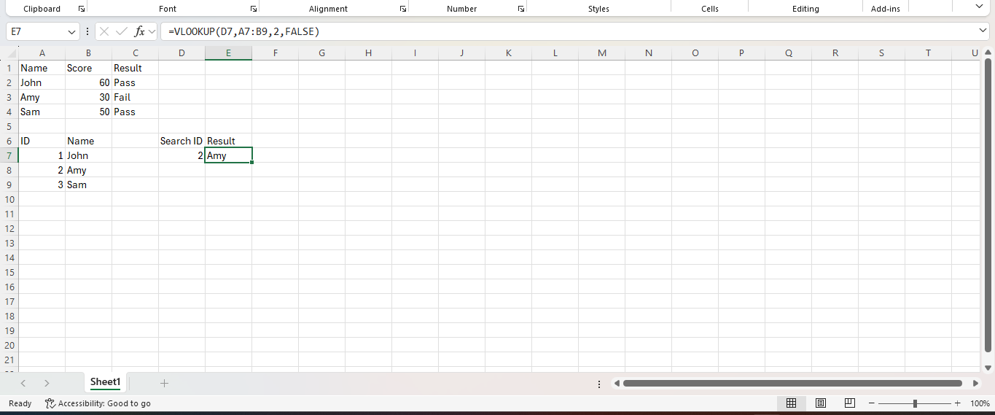
Figure 2: Screenshot showing use of VLOOKUP in Excel.

Task 4: Communication and Collaboration Applications.
4.1 Communication Application: Microsoft Teams
Microsoft Teams is a widely used communication platform in modern businesses. It allows users to send messages, make video calls, and share files in real time. One important feature of Microsoft teams is instant messaging, which helps team members communicate quickly and efficiently. Another useful feature is video conferencing, which allows meetings to take place even when employees are in different locations. Microsoft Teams is useful in business because it improves communication, supports remote working, and allows quick sharing of information.
Microsoft teams also support group chats, file sharing, and meeting scheduling, which makes it easier for organisations to manage daily communication. It is especially helpful for businesses with remote or hybrid workers because it keeps staff connected in one place. However, too many notifications and constant messages can sometimes be distracting for users.
4.2 Collaboration Application: Google Docs
Google Docs is a collaboration tool that allows multiple users to create, edit, and share documents online. It is mainly used in businesses and education which helps support real-time collaboration. One of its main features is that several uses can work on the same document at the same time. Another important feature is automatic saving, which reduces the risk of losing work. Google docs also allow comments and suggestions, making it much easier for team members to review and improve documents when needed together.
Google Docs improves teamwork by making collaboration faster and more flexible. It is useful for group work because users can access documents from different devices and locations. This makes it suitable for businesses with employees working in different places. However, it depends on internet access, and some advanced formatting features are more limited compared to Microsoft word.
4.3 Practical Test of Microsoft teams and Google Docs Features
4.3.1 Microsoft Teams Feature Test
For the practical test, a feature of Microsoft teams such as chat, video calling, or file sharing can be used to demonstrate communication in a business environment. This feature shows how teams support quick interaction and information sharing between users.
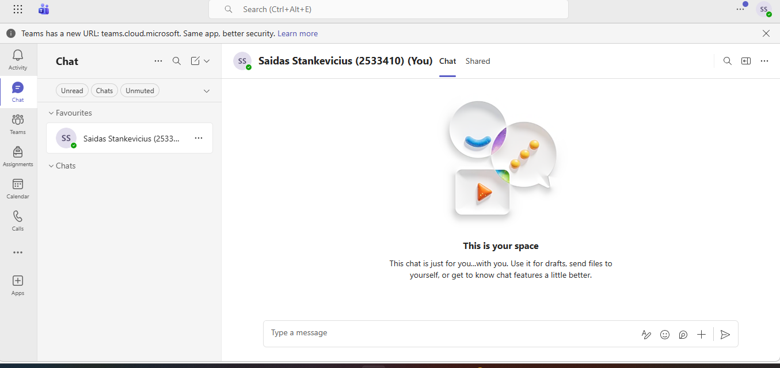
Figure 3: Screenshot showing the chat feature in Microsoft Teams used for communication and collaboration.

4.3.2 Google Docs Feature Test
For the practical test, a feature of google docs such as sharing, commenting, or real-time editing can be used to demonstrate collaboration. This feature shows how multiple users can work together on the same document efficiently.

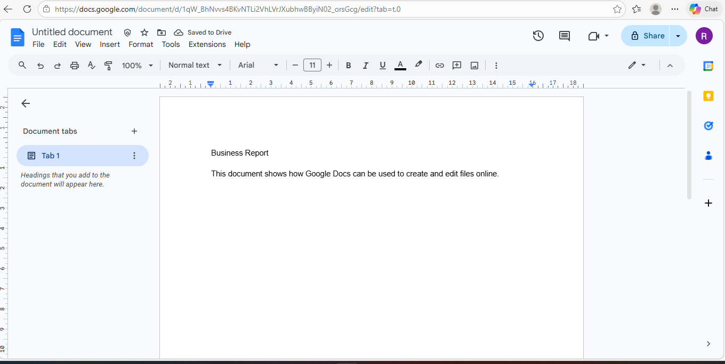
Figure 4: screenshot showing the use of Google Docs for creating and editing documents online.

Conclusion

In conclusion, this assignment has explored a range of software solutions used in modern business environments. E-commerce platforms such as Shopify and Wix enable businesses to create and manage online stores efficiently. Mind mapping tools help organise ideas and improve planning, while applications like Excel support data analysis and decision making through functions such as formulas and VLOOKUP. Communication tools such as Microsoft Teams and google docs allow collaboration and real-time interaction between team members. Overall, these software solutions play a key role in improving productivity, organisation, and communication within businesses. Understanding how to use these tools is essential for working effectively in today’s digital workplace.

References

Shopify (2024) what is Shopify? Available at: https://www.shopify.com (accessed:15 April 2026).

Wix (2024) Create a website with Wix. Available at: https://www.wix.com (accessed: 15 April 2026)

Microsoft (2024) Microsoft Teams. Available at: https://microsoft.com/en-gb/microsoft-teams (Accessed: 15 April 2026)

Google (2024) Google Docs. Available at: https://docs.google.com

Mind Meister (2024) Mind Mapping software https://www.mindmeister.com

Microsoft (2024) Microsoft excel. https://www.microsoft.com/en-gb/microsoft-365/excel

