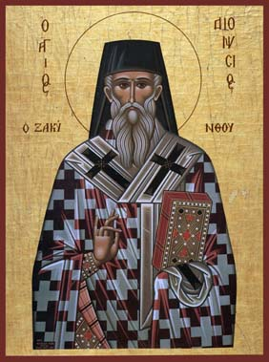
Dionysios, the patron Saint of Zakynthos, and the significance of Saints the community.

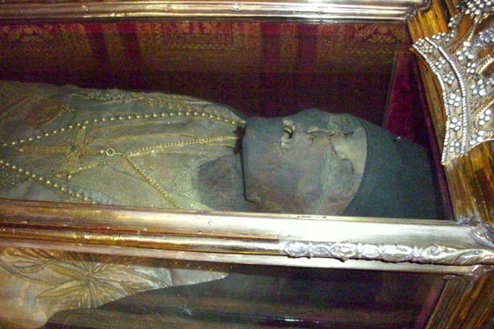
Dionysios is the patron Saint of Zakynthos, a Greek island in the Ionian Sea, following the Greek Orthodox faith. He was born in 1547 in Zakynthos, and spent his life dedicating himself the Church, eventually becoming an Archbishop in the Eastern/Greek Orthodox faith. He died at the age of 75 in 1622, and when his body was exhumed 3 years later, it was revealed uncorrupted.
Figure 2
Figure 1

In the Orthodox faith this is a sign of divine intervention, Gods way of showing this person lived a holy life. It is also said that the body emits an odour of frankincense, further influencing deepened roots of Christian interference due to it being one of the Three Wise Men’s gifts to the baby Jesus and it being an unnatural smell for a corpse. In Freeman, Charles. “The Incorruptible Flesh of the Martyrs.” Holy Bones, Holy Dust: How Relics Shaped the History of Medieval Europe, he describes the incorruptibility of a Saints body preceding the Last Judgement due to not suffering decomposition, to which ‘ordinary mortals suffered… which early Christian texts saw as one of the main evils from hell’. Due to the Saint being able to present themselves at the gates of heaven as they are shows that they are separate from sinners and will be welcomed among the fellow saints and angels.

Dionysios is known as the Saint of forgiveness due to forgiving the man who sought sanctity at the church who had committed murder, the victim being his beloved brother. There are conflicting reports over what happened next when Dionysios avoided to report the man to the authorities due to the story being an oral tradition with no written reports. Some say that Dionysios helped smuggle the man to Kefalonia (another island) whereas others say that the man later trained to become a priest within the church. It is almost an expectation for medieval saints to be assigned a patronage, usually associated with how they lived their lives and/or where they lived/died, such as the Virgin Mary having the widen patronage for all humanity due to birthing Jesus Christ, but also being associated with childbirth as she is ‘The Mother’.
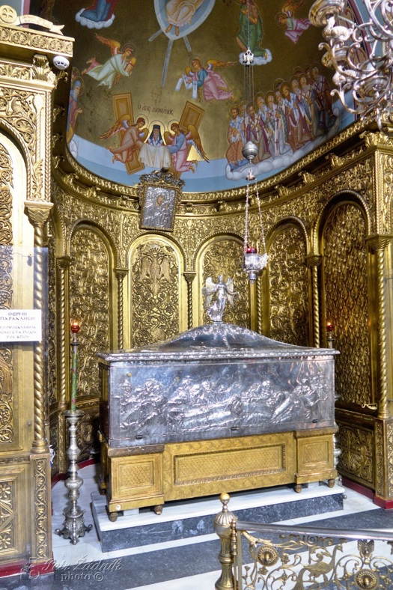
Dionyosios’s body is classed as a relic, relics according to orthodox faith are either the Saint themselves (be a full body or whatever remains such as a tooth), or the material culture that belonged or was used by them during their life (such as clothes or a comb) or items associated with their martyrdom (such as the killing arrows). The relic (his body) is kept in Agios Dionysios church, the largest Church in Zakynthos which is in the town centre and is displayed for all to see and worship. His grave furniture is a silver coffin case which can be opened/closed so the Saint is visible for worshippers to see. He is dressed in his ecclesiastical robes which have degraded over the past 400 years and the neck is adorned with crosses, the most common universal symbol for Christianity.

The coffin is placed in a designated separate but open corner of the church, the lower half of the wall is solid gold moulded in decoration of vines and flowers. Gold is a symbol of wealth and power, with the costs being expansional, this is not just to show the power and prestigiousness of the Saint, but of the Greek Orthodox Faith. Iconography is painted in the traditional Coptic art on the wall/celling of the dome surrounding/ encasing the coffin. Dionysios is in the centre, being carried up by angels to Jesus who looks down below to both Dionysios in the painting and his body in situ. Angels on each side of him fetch to give Dionysios the Holy Book and Saintly robes before he is greeted by Jesus, with fellow Saints huddled together in a congregation watching the spectacle.
Figure 3
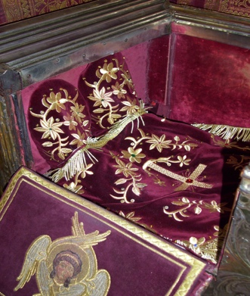
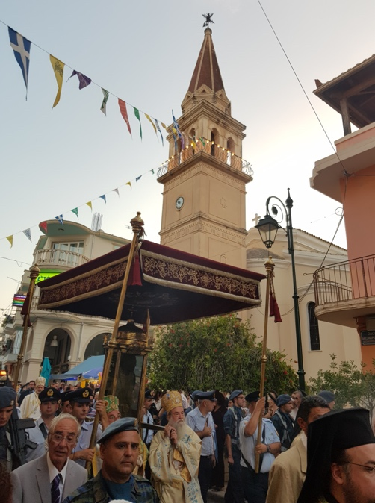
When visiting the relic, its liturgy practice bow and sign the cross with your finger across your chest before placing a kiss the Saints feet, which is exposed from an opening in his coffin, the flesh covered in purple velvet gold embroidered boots. Purple was the most expensive dye in the medieval world, and the gold threaded embroidery of flowers and a large cross in the centre further show the impact of the prestigiousness of the relic itself and of the Church’s position, with the cross/church as the point of convergence.

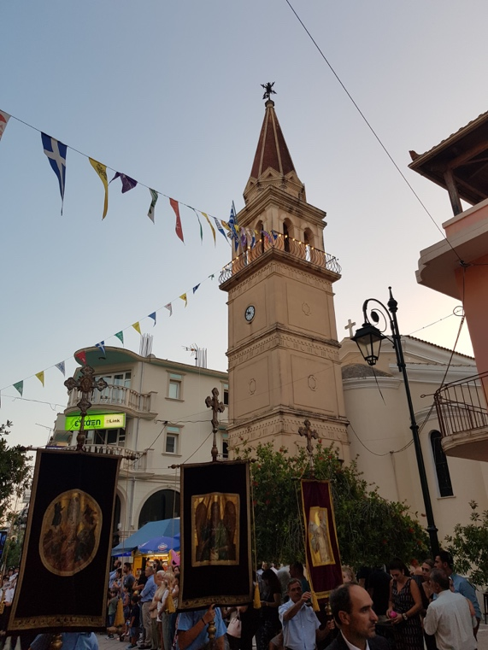
Robert Barlett in Why Can the Dead Do Such Great Things? : Saints and Worshippers from the Martyrs to the Reformation states that ‘dynastic or community identity can be expressed through the adoption of a particular saint’. This is common for Greek Islands, such as St. Grasimos the patron Saint of Kefalonia and St. Spyridon of Corfu. Saint Dionysios has two annual feast days, the 24th of August, the day of transfer where the relics returned to the island of Zakynthos and the 14th of December, his death day. For Saint Dionysios’s feast day (August) the whole island gathers to the town to celebrate, a parade is in procession from the micro community groups from the island such school children to gross, such as the military. This is not just a specific celebration related to the Saint/Agios Dionysios church but also a show of power of the Greek Orthodox Church and Greece as a country. The Faith and the Country can be seen as interlinked, such as the Church of England and the United Kingdom. The relic (body) follows this parade by high officials in the clergy, all can see the relic held upright in a see-through coffin case and is paraded through out the streets. Olive branches are thrown in his path, as a sign of respect and to bless his path. The evening ends with food stalls, music, dancing and fireworks, a celebration of Greek culture and shared faith within a community.
Figure 5
Figure 4

Saint Dionysios plays a huge role in the average Zakynthian household, with most of the native population being Orthodox, plaques of the Saint will be present in the personal icon alters, along with Jesus and the Virgin Mary. Icon alters are a common sight, almost an expectation in an Orthodox household, sometimes wreaths and lit candles will also adorn the space the homeowner has made to make prayers and protect the home/family members. These icons can be understood as apotropaic, with icons of Dionysios been given in certain situations, such as at the head of a crib for a newborn baby or someone ill in hospital. This is dependent however of the location of the orthodox family, a zakynthian household would not have the icon Saint of Corfu unless they have personally visited the island. Religion is further implemented in Greek orthodox life with members of the faith being named after Saints, and each year that person celebrates the ‘name day’ of that saint, which is seen more important than one’s birthday. Again, with annual celebrations, traditions and the history of Saints will not be forgotten.
Figure 6

In conclusion Saint Dionysios plays a huge role in Zakynthos’s identity, reenforcing Greek culture and traditions by following the Orthodox faith. Robert Barlett sums up the importance of Saints within a wider context as: ‘the church that houses the body, the city that houses the church, the country that houses the city, and, beyond all, the church is universal’. This shows how all aspects are interlinked, however that the Church is the catalyst for this chain, responsible for all, and the most supreme.

Image referencing:

Figure one: StDionysios, ‘Saint Dionysios of Zakynthos’, accessed on 17.10.2022. https://stdionysios.org/assets/images/icons/StDionysios.jpg
Figure 2: Archaeology Wiki, ‘The Sacred Slippers (emvades) of St. Dionysius of Zakynthos. Accessed on 17.10.2022 https://www.archaeology.wiki/blog/2014/04/07/the-sacred-slippers-emvades-of-st-dionysius-of-zakynthos/
Figure 3: Saraway, Accessed on 17.10.2022. https://media.safarway.com/content/f15f2c73-96fc-4c66-b9df-6d6cca7d706a_lg.jpg
Figure 4: Archaeology Wiki, ‘The Sacred Slippers (emvades) of St. Dionysius of Zakynthos. Accessed on 17.10.2022 https://www.archaeology.wiki/blog/2014/04/07/the-sacred-slippers-emvades-of-st-dionysius-of-zakynthos/
Figure 5 and 6: Taken myself.

Orthodox Wiki, Dionysius of Zakynthos, https://orthodoxwiki.org/Dionysius_of_Zakynthos Accessed on 14.10.2022
Greeka, ‘Zakynthos Agios Dionysios’ https://www.greeka.com/ionian/zakynthos/churches/agios-dionyssios/ Accessed on 14.10.2022
https://en.wikipedia.org/wiki/Incorruptibility#Eastern_Orthodox_Church Accessed on 14.10.2022
Orthodox Wiki, Dionysius of Zakynthos, https://orthodoxwiki.org/Dionysius_of_Zakynthos Accessed on 14.10.2022
FREEMAN, CHARLES. “The Incorruptible Flesh of the Martyrs.” Holy Bones, Holy Dust: How Relics Shaped the History of Medieval Europe Yale University Press, 2011, pp. 15–23. JSTOR, http://www.jstor.org/stable/j.ctt1nphg7.7. Accessed 16 Oct. 2022
Greek Reporter, Tasos Kokkinidis, ‘Greece’s Zakynthos Island Honors Patron Saint Dionysios’ Published 17.12.2021 https://greekreporter.com/2021/12/17/greeces-zakynthos-island-honors-patron-saint-dionysios-video/ Accessed on 14.10.2022
Londinoupolis, Demetrifs, ‘Saint Dionysios, the Saint of Forgiveness’ Published 31.03.2014 http://londinoupolis.blogspot.com/2014/03/saint-dionysios-saint-of-forgiveness.html Accessed on 17.10.2022
Emerald Villas & Suits, Celebrating the Saint of Healing and Forgiveness, published 17.12.2021 https://emerald-villas.gr/celebrating-the-saint-of-healing-and-forgiveness/ Accessed 17.10.2021
Greek Reporter, Tasos Kokkinidis, ‘Greece’s Zakynthos Island Honors Patron Saint Dionysios’ Published 17.12.2021 https://greekreporter.com/2021/12/17/greeces-zakynthos-island-honors-patron-saint-dionysios-video/ Accessed on 14.10.2022
Simply Catholic, Thomas Craughwell, The Blessed Virgin Mary: A saint for mothers, Accessed 16.10.2022. https://www.simplycatholic.com/the-blessed-virgin-mary-a-saint-for-mothers/
https://orthodoxwiki.org/Relics
Robert Barlett Why Can the Dead Do Such Great Things? : Saints and Worshippers from the Martyrs to the Reformation 2013, Princeton University Press, Princeton. Available from: ProQuest Ebook Central. [16 October 2022].
EuroHire, ‘Agios Dionysios -The Patron Saint of Zakynthos’ Published 10.08.2021, https://eurohire.net/agios-dionysios-the-patron-saint-of-zakynthos/#:~:text=Agios%20Dionysos%20is%20the%20patron,his%20remains%20to%20the%20island. Accessed 17.10.2022
Robert Barlett Why Can the Dead Do Such Great Things? : Saints and Worshippers from the Martyrs to the Reformation 2013, Princeton University Press, Princeton. Available from: ProQuest Ebook Central. [16 October 2022].

