
“Enhancing Operational Efficiency and Customer Experience at AKPerog Ltd.: A Proposal for an Integrated ERP-CRM Information System”

Managing Business Information

Module Code : LCLM5004

Lecturer Name : Amer Kareem

Student Name: Andrei Posmosanu

Student ID: 2335692

Table of Contents
1 Introduction 3
2 Evaluation of Existing Systems 4
2.1 Overview of Current Information Systems 4
2.2 Inventory Management Inefficiencies 4
2.3 Customer Relationship Management Challenges 5
2.4 Reporting and Decision-Making Issues 5
2.5 Compliance and Data Security Risks 6
3 Recommended Solution 6
3.1 Overview of the Proposed System 6
3.2 Justification for the Recommended System 6
3.3 Key Functional Components 7
3.4 Expected Operational Improvements 8
3.5 Ethical, Security and Compliance Considerations 8
3.6 Cost, Long- Term Value and Scalability 9
4 Implementation Plan 9
5 Conclusion 10
6 Reference 11

Introduction
AKPerog Ltd. is a fast growing consumer electronics retailer, which has 30 physical stores and operates an e-commerce platform, which has a growing and diverse customer base. The sales of the company have been increasing tremendously in the recent year, which indicates its good positioning in the market and demand. Nevertheless, alongside such a business triumph, AKPerog is experiencing accumulated operational inefficiencies due to old and disconnected information systems. The company now uses manual inventory tracking and offline data bases and this leads to stock variations between the physical stores and online orders. Such inefficiencies are often a cause of customer dissatisfaction, refunds, and missed sales. Moreover, the customer relationship management (CRM) practices of AKPerog are disrupted by fragmented and incomplete customer data in various systems that will not allow the marketing team to make targeted campaigns and ensure that customer service agents cannot effectively handle complaints. The decision-making procedures are also limited because financial reports and sales are not automatically formed with spreadsheets that may include old or false information and thus hinder the provision of business insight and the right forecasting. To make matters worse, there are also compliance and data security risks, the current systems of the company do not have enough access control and cannot address the requirements of the laws, including the General Data Protection Regulation (GDPR).

Evaluation of Existing Systems

Overview of Current Information Systems
The current portfolio of information systems that AKPerog Ltd. is working under is a set of fragmented and predominately manual information systems, which cannot support the operations of the fast-growing retail organization. The inventory management system of the company is chiefly manual and is operated using the spreadsheet and the periodical counts of the stock count which are done by the store staff. Although these techniques might have been adequate when the company had fewer outlets, they are not applicable to the current time in the management of real-time stock values of 30 retail stores and an online platform. Further, the information of customers is held in several and unrelated databases, there is no central CRM system to bring customer data together and analyse it.

Inventory Management Inefficiencies
One of the most important weaknesses of AKPerog is the manual system of inventory tracking. There is always a stock difference between online stores and real stores and this contributes to people buying products over the internet and finding them in the physical stores. This does not only destroy the trust of the customers but also makes the company incur expenses on the processing of refunds and revenue opportunities. Store managers waste too much time balancing stocks, and it is hard to determine which products are overstocked or understocked as it cannot be seen in real time. Laudon and Laudon (2022) indicate that manual systems may cause erroneous data and delays in operations, which may significantly affect the performance of the supply chain. In a retail business such as AKPerog, inventory management is critical in terms of customer satisfaction and maximization of working capital, but the existing system is not performing either of the two.

Customer Relationship Management Challenges
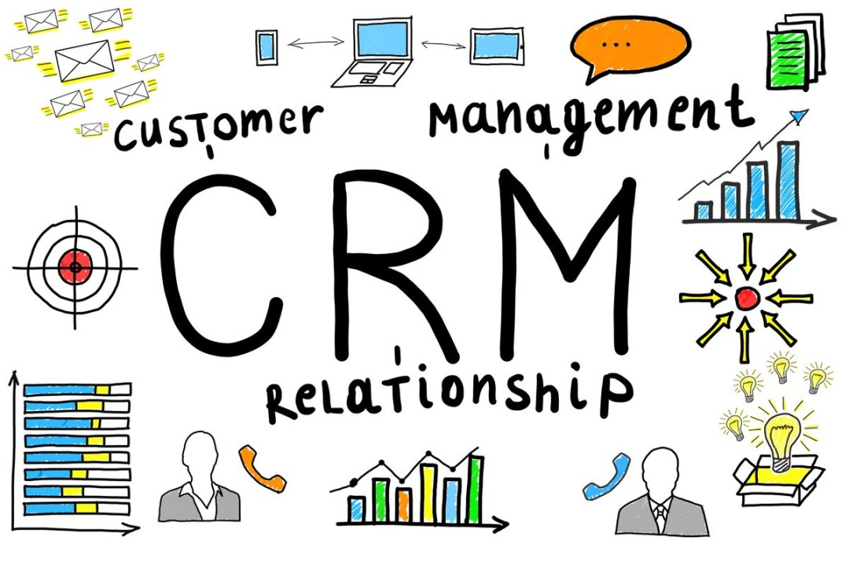
Figure 01: (Naeem, 2025)
Lack of an integrated CRM system has made AKPerog unable to capitalize on its increased customer base. E-commerce records, point-of-sale systems, and email lists have customer data scattered in different places, which does not allow the marketing team to design data-driven promotional strategies. According to Turban et al. (2021), the presence of the efficient CRM systems is critical to the development of the long-run relationships with the customers and personalized marketing. Without centralized data, customer service representatives would also have difficulty in monitoring complaints, previous purchases or preferences making customer support inconsistent and inefficient. Such a haphazard strategy compromises retention of customers as well as brand loyalty in a competitive retail industry.

Reporting and Decision-Making Issues
The second significant weakness is the use of spreadsheets to report and analyse. Clusters of data, which managers use manually to get information, not only costs them important time but also leaves human errors. The inability to use real-time analytics limits the management team to react to the changes in the market or detect the new sales trends. According to O’Brien and Marakas (2019), timely and correct information is essential in effective decision-making. At AKPerog, the report generation and a lack of automated dashboards make strategic planning and forecasting difficult to achieve, resulting in the loss of revenue opportunities and ineffective resource distribution.

Compliance and Data Security Risks
The old systems used by AKPerog also leave the company vulnerable to major data protection and cybersecurity threats. This has resulted from the absence of safe access controls, which raises the chances of unauthorized access to data or breach of data thus exposing the organization to the risk of non-compliance with the GDPR regulations. The European Commission (2022) states that companies must legally protect customer data with the use of the relevant technical and organizational means. The existing structure of AKPerog fails to comply with these requirements and it would lead to a negative reputation and financial fines.

Recommended Solution

Overview of the Proposed System
Enterprise resource planning (ERP) system with customer relationship management (CRM) and Business Intelligence (BI) should be suggested as the way of tackling the problem of operational inefficiencies in AKPerog Ltd. This single digital platform would substitute the existing disjointed applications, which will offer centralized data processing, live analytics and smooth departmental workflows. ERP systems like Microsoft Dynamics 365, SAP Business One or Oracle NetSuite are cloud-based applications that are especially appropriate to medium and developing retail companies such as AKPerog. Such systems combine major business processes such as inventory, sales, finance, procurement and customer management to a single digital environment, therefore, removing data silos and manual operations.

Justification for the Recommended System
The suggested ERP-CRM system is explained as founded on the strategic goals of AKPerog and its operational requirements. First, it deals with the inventory management issue of the company as it will offer both physical stores and e-commerce platform real-time stock availability. The automatic correspondence of the sales channels will eliminate the stock discrepancies leading to the cancellation of orders and the dissatisfaction of customers. Second, the system will ensure consolidation of customer data in one database by incorporation of CRM capabilities, which will enable targeted marketing campaigns, promotions and complaints to be handled effectively. Third, the Business Intelligence (BI) component of the ERP will provide the management with the opportunity to create precise and up-to-date sales and financial reports as opposed to the existing manual process with spreadsheets (Haddara, 2018).

Key Functional Components
a) ERP Module
The ERP component will unify the main business processes within the inventory, procurement, sales, and finance into a single platform. This integration is needed to make sure that all transactions including sales of a product or a purchase order update inventory and financial records in real time. Store managers and finance departments will access the correct stock, sales and cost reports instantly. Davenport (2018) states that ERP systems improve organizational performance as they offer a single source of truth when it comes to operational data, minimize redundancy and allow departments to coordinate with each other efficiently.
b) CRM Module
CRM module will be used as the main warehouse of all interactions with the customers, purchase records and service requests. This will help the marketing department to categorize the customers and promote them in a personalized way, depending on their tastes and purchasing patterns. The teams of customer service will be able to monitor complaints and offer quicker resolutions. Laudon and Laudon (2022) state that integrated CRM systems enable companies to improve their customer loyalty and retention through consistent customer experiences that are data-driven. In the case of AKPerog, the ability will change the way the company interacts with its customers both physically and digitally.
c) Business Intelligence (BI) and Analytics
The embedded BI tools that are part of the ERP system will consist of interactive dashboards and data visualization to assist the management in its decision-making. The tools will enable the executives to keep track of the sales trends, inventory turnover, and customer satisfaction levels in real-time. According to O’Brien and Marakas (2019), BI contributes to the agility of organizations by transforming inaccessible data into usable information. In the case of AKPerog, these analytics will enhance the accuracy of forecasting, nonperforming stores or products, and evidence-based strategic planning.
d) Integration with E-Commerce Platform
Through APIs, the new system will integrate well with the existing e-commerce platform of AKPerog, so the online and offline transactions will be synchronized. Whenever a customer orders an item via the internet, the system will update the inventory system automatically and send the message to the corresponding store (Nwosu and Ikediashi ,2021). On the same note, the online platform will immediately show consistency between the in-store sales and the online sales. The integration will serve an omnichannel retail approach where the customers will have the same shopping experience when they buy online or in the store.

Expected Operational Improvements
An integrated ERP-CRM-BI solution will result in significant enhancement of operations at AKPerog. Accuracy of inventories will be greatly enhanced because stock information will be updated automatically and on real-time. Customer satisfaction and reduced rates of refunds will be achieved by making the process of fulfilment of orders faster and more reliable. Automated reconciliation and reporting will simplify the financial management process and save time and minimize the accounting errors. Marketing department will have improved segmentation and campaign management and customer service will become more responsive and data-based. Above all, the management will be able to access real-time dashboards and analytics, which will allow making evidence-based decisions faster.

Ethical, Security and Compliance Considerations
The suggested ERP solution will enhance the data governance system of AKPerog by means of sophisticated access control, data encryption and audit trail. Role permissions will be used to make sure that the employees can only access the data that is pertinent to their duties and reduce the chances of unauthorized access and misuse of the data. Software vendors like Microsoft and oracle feature the GDPR-compliance feature, ensuring the safe storage and processing of customer information (European Commission, 2022).

Cost, Long- Term Value and Scalability
The suggested system will result in cost-saving in the long term since it will require the investment in licensing, customization and training at the beginning. ERP systems that run on clouds are based on subscription models and minimize the initial investment in capital (Almajali et al., 2016). The vendor does all the maintenance and upgrades and there is no need to have specialized IT infrastructure. Extra modules: AKPerog can easily add other modules (supply chain management or human resource planning) when the system is growing in size without significant system redesign.

Implementation Plan
The effective deployment of the recommended ERP-CRM-BI system at AKPerog Ltd. will involve a systematic and gradual implementation strategy that will not affect the operations to a great extent. It should start with needs assessment and selection of vendors where the system requirements are established clearly and the most appropriate solution, that is, Microsoft Dynamics 365 or SAP Business One is selected according to the functionality, scalability, and cost. The second step, system design and customization, will involve the adaptation of modules to the specific processes of AKPerog and the next step will be data migration, where all the existing records will be involved and transferred securely to the new systems. Functionality and user experience: This will be tested using a pilot implementation in a small number of the stores, and then rolled out fully across all sites and the e-commerce platform. Detailed change management and training programs on the staff will be necessary to have the users adopt and reduce resistance. Upon deployment, the company ought to put in place monitoring and evaluation stage where the main performance indicators to monitor include the accuracy of inventory, the speed of fulfiling orders and customer satisfaction. Risk mitigation should be ensured by addressing potential obstacles, like data migration errors, excessive costs and opposition of users, in the course of the active risk management and constant interaction. Full implementation and stabilization should take a realistic time of 6 12 months.

Conclusion
To conclude, AKPerog Ltd. has inefficiencies in its operations that are related to incomplete and outdated information systems that limit inventory accuracy, customer relationship management, decision-making and data security. The suggested ERP-CRM-BI system will provide a universal solution to these problems because it will unite the data and automate processes and allow real-time analytics. This change will make the operations more efficient, increase customer satisfaction, make sure that it complies with GDPR, and enable data-driven decisions. AKPerog can have a smooth transition to a digital maturity through a well-planned implementation program that involves staff training and change management. Finally, implementation of this contemporary form of information system will put the company in the position of sustainable growth, enhanced competitiveness and long-term success in the dynamic consumer electronics retailing business environment.

Reference
Almajali, D.A., Masa'deh, R.E. and Tarhini, A., 2016. Antecedents of ERP systems implementation success: a study on Jordanian healthcare sector. Journal of Enterprise Information Management, 29(4), pp.549-565.
Davenport, T.H. (2018) Process Innovation: Reengineering Work through Information Technology. Boston, MA: Harvard Business School Press.
European Commission (2022) General Data Protection Regulation (GDPR): Compliance Requirements for Businesses. Available at: https://commission.europa.eu .
Haddara, M., 2018. ERP systems selection in multinational enterprises: a practical guide. International Journal of Information Systems and Project Management, 6(1), pp.43-57.
Laudon, K.C. and Laudon, J.P. (2022) Management Information Systems: Managing the Digital Firm. 17th edn. Harlow: Pearson Education.
Naeem, (2025) ‘CRM challenges pharmaceutical industry: strategies for success’, LinkedIn. Available at: https://www.linkedin.com/pulse/crm-challenges-pharmaceutical-industry-strategies-success-naeem
Nwosu, A.C. and Ikediashi, D.I. (2021) ‘Evaluating the impact of ERP systems on organizational performance: A developing country perspective,’ Journal of Information Systems and Technology Management, 18(2), pp. 1–17.
O’Brien, J.A. and Marakas, G.M. (2019) Introduction to Information Systems. 17th edn. New York: McGraw-Hill Education.
Turban, E., Pollard, C. and Wood, G. (2021) Information Technology for Management: Driving Digital Transformation to Increase Local and Global Performance, Growth and Sustainability. 12th edn. Hoboken, NJ: John Wiley & Sons.

