UNIVERSITY OF WALES TRINITY SAINT DAVID

Programme: Business Management
Module: Data Handling & Business Intelligence (LCBB5000)
Lecturer: Joy Botu
Student name: Svetla Karadzhova
ID number:2006939

Table of Contents
Introduction 2
Part 1 – Pre-processing, Analysis and Visualization in Excel 2
Part 2 – Data Analysis 10
Advantages and disadvantages of SPSS and Excel 17
Conclusion 18
References 19

Data Handling Report

Introduction
This report is based on the data handling techniques based on Microsoft Excel functions and visualisation tools. The report is divided into part 1 and part 2 with each part aimed at achieving specific data handling techniques. In the first part of the report, the Crime dataset is used to determine the crime rate in terms of the number of offences per million population. The part further evaluates the use of excel for pre-processing of data, analysis and visualization of the data. These objectives are achieved in this part using “IF” and “PIVOT TABLES” to produce charts and graphs as appropriate. The study also includes Part 2, which provides the descriptive analysis of categorical variables and gender (0 = males, 1 = females). It also conducted k-means clustering analysis on video and puzzle variables.

Part 1 – Pre-processing, Analysis and Visualization in Excel
Under normal circumstances, the raw data is often coded with textual and numerical value, which may not make any sense at the first site (Nayak et al., 2016). They may also include missing data points or errors in the values entered for some data points. In this case, it is essential to always clean the data, analyse it and visualize making a better meaning for the data before further analysis aimed at finding the causal effects of certain variables within the dataset (Gibert, Sànchez–Marrè & Izquierdo, 2016). The data pre-processing techniques are used in Microsoft Excel to understand the data in terms of frequency distributions, percentages, means or standard deviation dependent on the way the data is pre-processed and the Excel functions used to aid such process.
For this part of the analysis, two pre-processing tools have been applied to help in cleaning and evaluating the data for a better understanding are “IF” function, Pivot Tables, Pivot Charts. The IF function was used to reorganize the dichotomous data that was coded using 0s and 1s to represent certain textual values (Gibert et al., 2016). These included three categorical (dichotomous) variables included in the crime data, namely, Region (0 = Northern Region, 1 = Southern Region), Gender (0 = Females, 1 = Males) and Youth Unemployment Rate (0 = Low Youth Unemployment, 1 = High Youth Unemployment). The textual values of these three dichotomous variables were assigned using the “IF” statements. For example, IF(C2=0,“Northern Region”, “Southern Region”) (Nayak et al., 2016). The same approve was used to assign the actual names of dichotomous variables and replace them with the dummy values of 0’s and 1’s.
The pre-processing of the data using “IF” statement as illustrated in the above section made it easier to analyse and understand the data using Pivot Tables and Pivot charts (Malley, Ramazzotti & Wu, 2016). In this context, the pivot charts were used to analyse the crime rate by region, the crime rate by male status and by youth unemployment status as presented in the following tables and graphs. The approach was taken to help in understanding overall crime rates based on their region, gender and youth unemployment rate (Nayak et al., 2016). The approach helps in categorizing the crime data in a more understandable way through tables and visualized graphs.
As presented in Table 1 below, the Crime has been analysed based on the frequency distribution. As provided, there were 779.9 crimes per 1 million population among males suffering high unemployment rate and 583.1 crimes per 1 million population among the females suffering high unemployment rate. This gives 1363 crimes per 1 million population among males and females suffering from high unemployment rate. On the other hand, there were 3052 crimes per 1 million population among males suffering from high unemployment rate and 417 crimes per 1 million population among the females suffering from high unemployment rate. This gives 3469 crimes per 1 million population among males and females suffering from high unemployment rate. There were a total of 3831.9 female crimes per 1 million population compared to a total of 1000.1 male crimes per 1 million population regardless of unemployment status as presented in Table 1 below.
Table 1: Pivot table for the sum of Crime Rate by youth unemployment and gender
Sum of CrimeRate | Column Labels
Row Labels | Females | Males | Grand Total
High Employment | 779.9 | 583.1 | 1363
Low Employment | 3052 | 417 | 3469
Grand Total | 3831.9 | 1000.1 | 4832

The numerical data explained in the above table is presented in the pivot chart in Figure 1 below. As presented in the chart, it is easier to visualise and determine which of gender and youth unemployment recorded the lowest and highest crime rates per 1 million population. As provided, there were few crimes per 1 million population among males than there are among females. Low Employment rate recorded higher crimes that high unemployment rate.

Figure 1: Pivot chart for the sum of Crime Rate by youth unemployment and gender

As presented in Table 2 below, the Crime has been analysed based on the frequency distribution by region and gender of the respondents. Thus, as provided there were 2221 crimes per 1 million population among females in the Northern Region and 1000.1 crimes per 1 million population among the males Northern Region. This gives 3221.1 crimes per 1 million population among males and females from Northern Region. On the other hand, there were 1610.9 crimes per 1 million population among females from Northern Region and zero crimes per 1 million population among males from Northern Region. This gives 1610.9 crimes per 1 million population among males and females from Northern Region. There were a total of 3831.9 female crimes per 1 million population compared to a total of 1000.1 male crimes per 1 million population regardless of unemployment status as presented in Table 1 below.
Table 2: Pivot table for the sum of Crime Rate by region and gender
Sum of CrimeRate | Column Labels
Row Labels | Females | Males | Grand Total
Northern Region | 2221 | 1000.1 | 3221.1
Southern Region | 1610.9 |  | 1610.9
Grand Total | 3831.9 | 1000.1 | 4832

The numerical data explained in the above table is presented in the pivot chart in Figure 2 below. The chart again makes it easier to understand the data through visualising and determining which of gender and region had recorded the lowest and highest crime rates per 1 million population. As provided, there were few crimes per 1 million population among males than there are among females. Northern region recorded high crime rates that Southern region.

Figure 2: Pivot chart for the sum of Crime Rate by youth unemployment and gender
Further pre-processing of data was conducted to assess the relationship between the state size and crime rate. The two datasets were all continuous variables and therefore they could be compared using graphs that work better with the categorical data. As results, simple regression and scatter plot was developed based on the lines of fit between crime rate variables and state size variable. The regression table was used to determine if there is a significant relationship between crime rate and state size while the scatter plot was development to assess the trend of relationship. As provided in Table 3, Correlations coefficient value of the model (R = 0.308) shows as average relationship between the two variables. The value of coefficient of determination (R-Square = 0.094) shows that only 9.4% of the total variation in the crime rate depends on the state size, which a low effect size. However, the F-statistics and p-value of the model we can see there is a statistically important effect of state size on crime rate (F(1.45) = 4,714, p = 0.035) at 0.05 significance level. Thus, the analysis shows that the state size significant influence the crime rate but the effect size is small (9.4%).

Table 3: Regression model for relationship between state size and crime rate
SUMMARY OUTPUT
Regression Statistics
Multiple R | 0.30794545
R Square | 0.0948304
Adjusted R Square | 0.07471552
Standard Error | 27.79292581
Observations | 47
ANOVA
 | df | SS | MS | F | Significance F
Regression | 1 | 3641.654 | 3641.654 | 4.71444 | 0.035222
Residual | 45 | 34760.1 | 772.4467
Total | 46 | 38401.76
 | Coefficients | Standard Error | t Stat | P-value | Lower 95% | Upper 95%
Intercept | 94.25081168 | 5.654119 | 16.66941 | 7.05E-21 | 82.86283 | 105.6388
State Size | 0.233708223 | 0.107636 | 2.171276 | 0.035222 | 0.016918 | 0.450499

The results of the simple regression model to assess the relationship between state size and crime rate as visualized in Figure 3 below. The chart shows that the fitted data has a positive trend such that the increase in the state size increases the crime rate and vice versa, which shows that there is a positive correlation. However, the reason why the relationship has a small effect size is that the data points are spread showing that the residual values are larger as the data points are far from the line of fit. It also shows the presence of outliers in the data set that reduces the accuracy of the relationship. Some data plots are far below or above the line of fit.

Figure 3: Scatter plot based on the line of fit for relationship between state size and crime rate
Another pre-processing of the data was conducted to assess the relationship between the youth unemployment and crime rate. The two datasets were also continuous variables and therefore they could be compared using normal graphs that work better with the categorical or dichotomous variables. Therefore, another simple regression and scatter plot was developed based on the lines of fit between crime rate and youth unemployment variable. The regression table was used to determine the significance relationship between crime rate and youth unemployment while the scatter plot based on the line of fit was developed to examine the trend of relationship between the two variables in Table 4. Value of correlations coefficient of the model (R = 0.051) shows as low durability of the relation between the two variables. The value of coefficient of determination (R-Square = 0.0.0025) shows that only 0.25% of the total variation in the crime rate depends on the state size are explained by the youth unemployment, which is a low effect size. The F-statistics and p-value of the model announce that there is no statistically important effect of youth unemployment on crime rate (F(1,45) = 0.115, p = 0.735) at 0.05 significance level. Thus, the analysis shows that the youth unemployment did not have significant influence on the crime rate.
Table 4: Table 5: Regression model for relationship between state size and crime rate

SUMMARY OUTPUT
Regression Statistics
Multiple R | 0.050613
R Square | 0.002562
Adjusted R Square | -0.0196
Standard Error | 29.1751
Observations | 47
ANOVA
 | df | SS | MS | F | Significance F
Regression | 1 | 98.37361 | 98.37361 | 0.115572 | 0.735469
Residual | 45 | 38303.38 | 851.1863
Total | 46 | 38401.76
 | Coefficients | Standard Error | t Stat | P-value | Lower 95% | Upper 95%
Intercept | 110.5523 | 23.17263 | 4.770813 | 1.97E-05 | 63.88021 | 157.2243
Youth Unemployment | -0.08111 | 0.238598 | -0.33996 | 0.735469 | -0.56167 | 0.399448

The results are visualized in the scatter plot presented in Figure 4 below. As can be seen, there is a slight negative relationship between youth unemployment and crime but the relationship is statistically insignificant. The trend line seems to be a horizontal line showing that there is no significant influence.

Figure 4: Scatter plot based on the line of fit for relationship between youth unemployment and crime rate

Part 2 – Data Analysis
The report using the descriptive statistics tools such as frequency distribution and percentages in SPSS software (George & Mallery, 2019). The results of the analysis were presented in Table 6 below. There was a total of 200 participants and out of that number, 95 participants (47.5%) liked vanilla ice cream, 47 participants (23.5%) liked Chocolate while the remaining 58 (29.0%) liked strawberry. The results of the analysis were also visualized using bar graph presented in Figure 5 below. The visualized results show that participants who liked vanilla are the largest number followed by those who liked strawberry and chocolate in the descending order. However, there is no mean or median for participants who liked chocolate flavour and those who liked strawberry flavour. The reason is that ice_cream is a categorical variable with values 1, 2 and 3 indicating vanilla, chocolate and strawberry flavours respectively. Although categorical data may take numerical values, those values are mathematically meaningless because they only represent groups within the variables, which in this case are the three flavours of ice cream (George & Mallery, 2019). Therefore, they do not have mean and median or any other central tendency parameter value because they are not numerical or continuous data.

Table 6: Descriptive statistics results of ice cream flavours liked by participants
Ice Cream
 |  | Frequency | Percent | Valid Percent | Cumulative Percent
Valid | Vanilla | 95 | 47.5 | 47.5 | 47.5
Valid | Chocolate | 47 | 23.5 | 23.5 | 71.0
Valid | Strawberry | 58 | 29.0 | 29.0 | 100.0
Valid | Total | 200 | 100.0 | 100.0

Figure 5: Bar chart results of ice cream flavours liked by participants

The data of the participants was also analyzed to determine the distribution of the respondents by their gender. The results of the descriptive statistics analysis was presented in the Table 7 and visualised in Figure 6 below (George & Mallery, 2018). As provided, there were 200 participants in total and out of this number, 91 males or 45.5% were males while the remaining 109 forming 54.5% were females. This shows that the female respondents were more than male respondents were in this sample frame. As visualized in the bar graph of Figure 6, it can be seen that females are more than males were.

Table 7: Descriptive statistics results of the participants’ distribution by gender
Respondent’s Gender
 |  | Frequency | Percent | Valid Percent | Cumulative Percent
Valid | Male | 91 | 45.5 | 45.5 | 45.5
Valid | Female | 109 | 54.5 | 54.5 | 100.0
Valid | Total | 200 | 100.0 | 100.0

Figure 6: Bar chart results of gender of the participants in the sample size
The k-mean clustering method is a data analysis technique used to cluster a given dataset into a number of distinct groups when the meanings of those groups are unclear in the beginning (Trenggonowati et al., 2019). It is referred to as unsupervised learning method because it is one of the techniques used in the SPSS modeller because they do not use the target field. Thus, instead of predicting outcomes, k-means tends to uncover the data patterns in the set of input fields by grouping the data points with similar values (Chandu, 2020). The grouping of the data in this context is done the records brought together within each groups have some aspects of similarity among themselves but the records or data in different groups are not similar.
According to Wang et al. (2017), the k-means model achieves this goal of grouping similar records by defining a set of centered cluster that are derived from the actual data. The centered cluster then assigns each data value to the cluster that is more familiar to it in terms of values based on the input field of the record. According to Chévez et al. (2017), this is done by the SPSS modeller to all the cases until they are all assigned to a given cluster. The checking, assigning and reassigning in done by the SPSS algorithms based on the maximum number of iterations until all of them are clustered. To run the k-means model in SPSS one or more fields are needed to set to the input or output (Celebi, Kingravi & Vela, 2013). The following screenshots shows the steps taken to analyze video and puzzle variables using k-means clustering.
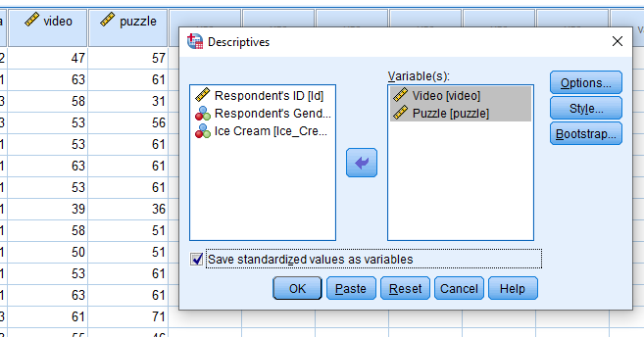
Figure 7: Standardization of the two variables (video and puzzle)

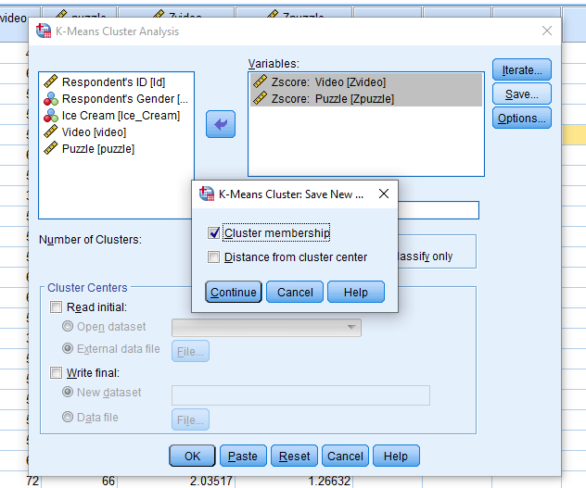
Figure 8: Performing k-means clustering using the standardized values of video and puzzle variables based on Z-scores
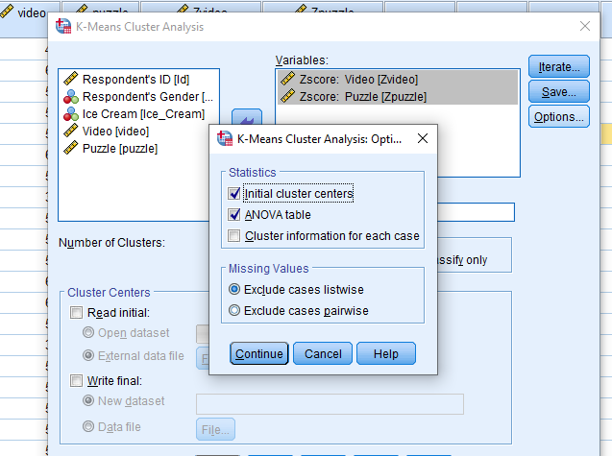
Figure 9: Including Anova table to determine the significance level of the clusters created.
The k-means results are reported using descriptive showing 200 samples with a minimum of 26 both variables and a maximum of 74 (M = 51.85, SD = 9.901) for video and 71 for puzzle (M = 52.40, SD = 10.736) as presented in Table 8 below.

Table 8: Descriptive statistics for video and puzzle variables
Descriptive Statistics
 | N | Minimum | Maximum | Mean | Std. Deviation
Video | 200 | 26 | 74 | 51.85 | 9.901
Puzzle | 200 | 26 | 71 | 52.40 | 10.736
Valid N (listwise) | 200

The results of the visualized k-means clusters are presented in Figure 10. It shows that that that the first cluster include records with negative valued data while the second cluster include positive valued data. The values are strikingly almost the same.

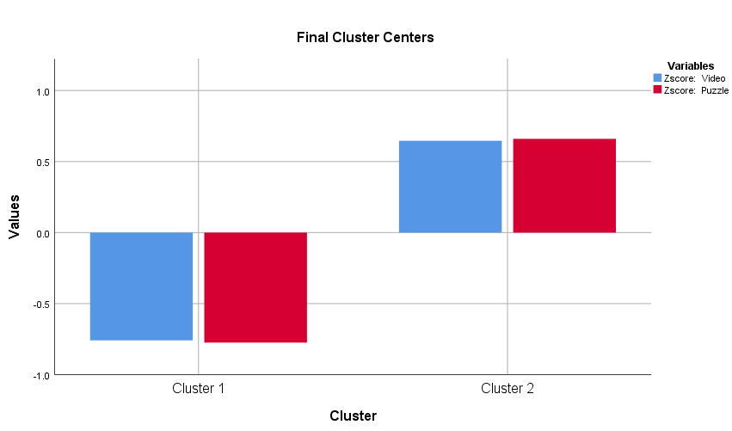

Figure 10: Visualized results of k-means clusters
The ANOVA results in Table 9 below shows that standardized values of video variable provided statistically significant clusters (F = 192.513, p<.01) at 15 significance level. Furthermore, it shows that standardized values of puzzle variable provided statistically significant clusters (F = 209.360, p<.01) at 15 significance level.

Table 9: ANOVA Table for K-eans clusters
A NOVA
 | Cluster |  | Error |  | F | Sig.
 | Mean Square | df | Mean Square | df | F | Sig.
Zscore: Video | 98.102 | 1 | .510 | 198 | 192.513 | .000
Zscore: Puzzle | 102.275 | 1 | .489 | 198 | 209.360 | .000

The most frequently used data mining technique is prediction models such as regression models to predict the response variables using the independent variables. On the other hand, clustering methods are often used in textual mining to group similar texts together to facilitate content classification (Gaikwad, Chaugule & Patil, 2014).

Advantages and disadvantages of SPSS and Excel
Excel | SPSS
Advantage:  - A simple to use tool for organization and processing of data  - Formulae and repetitive calculation  - It has multiple user access allowing for collaborative user access of the same document  - Simple and understandable graphical features | Advantage:  - Comprehensive statistical software  - Has many building statistical tests features  - Easy interpretation of results  - Easy and quick display of results in form of tables, figures and charts  - Data and results can be expanded
Disadvantage:  - It has limited functionality and data analysis tools.  - Complex and difficult to use syntax  - No suitable for larger data sets | Disadvantage:  - It is expensive to acquire  - Graphical features are not as simple as in MS Excel

Conclusion
Data handling is an essential part of understanding the data for further analysis and application. The one of the key aspect of data handling is PRE-processing using different tools such as definition of categorical variables, use of tables and charts to visualize the data. These allows for the understanding of the data behaviour. This allows for the understanding of the data to decide the best methods for analysis and visualization of the results for applicability in real life.

References
Celebi, M. E., Kingravi, H. A., & Vela, P. A. (2013). A comparative study of efficient initialization methods for the k-means clustering algorithm. Expert systems with applications, 40(1), 200-210.
Chandu, V. C. (2020). Identification of spatial variations in covid-19 epidemiological data using k-means clustering algorithm: a global perspective. MedRxiv.
Chévez, P., Barbero, D., Martini, I., & Discoli, C. (2017). Application of the k-means clustering method for the detection and analysis of areas of homogeneous residential electricity consumption at the Great La Plata region, Buenos Aires, Argentina. Sustainable cities and society, 32, 115-129.
Gaikwad, S. V., Chaugule, A., & Patil, P. (2014). Text mining methods and techniques. International Journal of Computer Applications, 85(17).
George, D., & Mallery, P. (2018). Descriptive statistics. In IBM SPSS Statistics 25 Step by Step (pp. 126-134). Routledge.
George, D., & Mallery, P. (2019). IBM SPSS statistics 26 step by step: A simple guide and reference. Routledge.
Gibert, K., Sànchez–Marrè, M., & Izquierdo, J. (2016). A survey on pre-processing techniques: Relevant issues in the context of environmental data mining. AI Communications, 29(6), 627-663.
Malley, B., Ramazzotti, D., & Wu, J. T. Y. (2016). Data pre-processing. Secondary analysis of electronic health records, 115-141.
Nayak, A. S., Kanive, A. P., Chandavekar, N., & Balasubramani, R. (2016). Survey on pre-processing techniques for text mining. International Journal of Engineering and Computer Science, 5(6), 16875-16879.
Trenggonowati, D. L., Ulfah, M., Ekawati, R., & Yusuf, V. A. (2019). Organization clustering airports using K-Means clustering algorithm. In IOP Conference Series: Materials Science and Engineering (Vol. 673, No. 1, p. 012081). IOP Publishing.
Wang, Q., Wang, Y., Niu, R., & Peng, L. (2017). Integration of information theory, K-means cluster analysis and the logistic regression model for landslide susceptibility mapping in the Three Gorges Area, China. Remote Sensing, 9(9), 938.

