  Component One:  What are the key skills required to work on the hotels front desk? 750 words (+/- 10%)  Contribution to Overall Module Assessment: 25% | Student No: | 2126985
 | Module Title: | Hotel Administration & Front Office
 | Module Code: | BMIH4004
You are the first thing guests see when they arrive at your hotel, and you are the last thing they see when they leave. As front desk staff, you are also responsible for maintaining guest satisfaction during your stay. If you want to learn more about receptionist jobs, you've come to the right place. This article explains the duties and responsibilities of a front desk employee, how to apply for a position, and his career path after working as a front desk employee. First and foremost, the receptionist is responsible for providing the necessary assistance to guests with a friendly smile. As the 'face' of the hotel, the front desk staff should provide excellent customer service even in difficult circumstances. Front desk staff not only respond to guest inquiries, but also handle check-in and check-out, charge credits to his cards, reconcile guest bills, and respond to emails and inquiries from guests and other departments of the hotel. I will also answer the phone. In addition, front desk staff can create and modify reservations, provide local recommendations, book restaurants and activities for guests, handle customer complaints, implement service restoration, and provide innovative solutions to potential problems. can provide. Additional responsibilities may include training new front desk staff, handling guest packages, responding to guest reviews, and collecting payments for retail merchandise.

Building guest relationships, providing personalized service, anticipating, and meeting guest needs, and providing prompt and courteous service are all responsibilities of the Guest Services Her Agent. In addition to properly closing guest accounts, you must report to the front office director and maintain the hotel's high standards for welcoming and registering guests. Must have good recall and follow-up skills, be able to multi-task, and be very detail oriented. Must be a good communicator, meticulously organized, team his player, positive attitude, good at problem solving and enthusiastic about new ideas.

communication: Essential for hotel front desk and guest service staff. When interacting with visitors or guests on the phone, it's important to speak clearly and maintain a positive attitude throughout the day.

Serenity: With front desk clerks juggling a variety of duties and having to deal with a large number of visitors on the go, a sane rep should resist the urge to panic under pressure. Staff should be able to multitask while remaining friendly to guests, even when the hotel is very busy.

Computer knowledge: Working in the front work area requires the use of a PC to keep records, process instalments, and complete a variety of tasks. You don't have to be a technician, but you should know how to use a computer. Must be familiar with hotel software or be able to learn new software quickly.

Friendliness: Hotel guests usually meet a receptionist as their first point of contact. For this reason, the front desk staff should be very welcoming. Each guest is greeted with a smile and a kind word by a knowledgeable guest relation her officer. Organization:
Front desk staff often juggle multiple tasks. You have to check out customers, answer phone calls, greet guests, and answer questions. Front desk clerks can handle all these tasks by staying organized.

Solving Problems: If you work at the front desk, you will be the first-person guests will call with problems. These issues might be insignificant, like asking for recommendations for restaurants. They might be significant, like a guest whose reserved room isn't wheelchair accessible as they requested. Even unanticipated emergencies could occur, such as a guest in need of medical attention. In spite of the difficult circumstances, you can provide guests with a positive experience and earn a positive review for your hotel if you are able to respond quickly and creatively to these obstacles.

Skills in sales: Although front desk staff aren't salespeople, they should be able to recommend hotel services and products. If their objectives and budgets would be better served, they may also encourage guests to purchase more expensive and luxurious rooms. As a result, individuals working in guest services must be comfortable promoting goods and services.

Teamwork: It's common for front desk staff to collaborate with others. In some cases, they need to work with different representatives at the front work area to deal with a troublesome issue. Sometimes, they have to talk to people in parking, housekeeping, and management departments of the hotel to make sure that guests are happy with their stay. Workers at the front desk need to be able to work with a wide range of people and get along with them.

Component Two: Contribution to Overall Module Assessment: 25%
In this scenario – It is your first day as a front desk associate and your manager has phoned in sick. Create an action plan and answer the following questions.

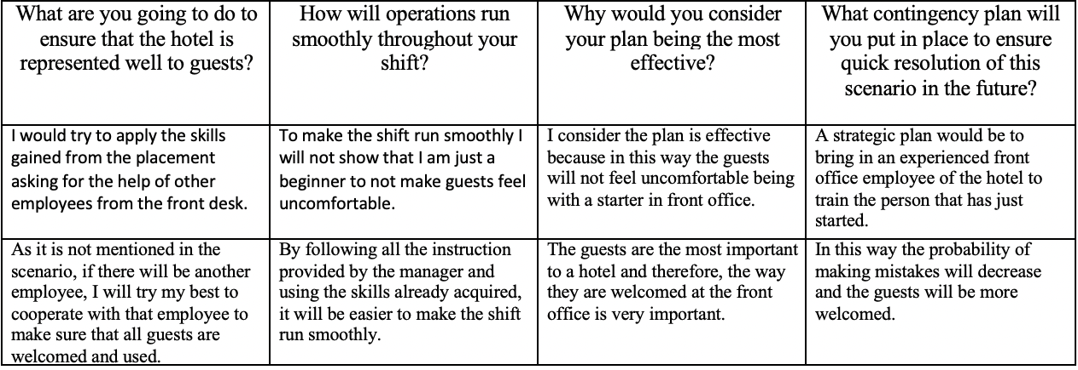

Component Three:
Contribution to Overall Module Assessment: 50% (1000 words +/- 10%)
Writing in essay format - Describe the key elements that are required when considering these four elements of hotel operations:

Element 1 – Property Management Systems (PMS)

Traditionally, a hotel property management system "PMS" is defined as software that enables a hotel or hotel group to manage front office functions such as reservations, guest check-in/check-out, room allocation, rate management and billing. I was. Hotel PMS also manages the delivery of a superior guest experience. The time and paper intensive process have been replaced with his PMS at the hotel.

His PMS technology for hotels has evolved beyond reception in recent years. Hotel property management systems, or PMS, are today's critical business operating systems, enabling hoteliers to deliver exceptional guest experiences. The buyer's travel process begins with choosing a destination and searching for lodging. Pre-stay shopping and booking interactions, on-site interactions with hotels and staff, in-room stays, and post-stay social media feedback all indicate a part of the guest experience. It is difficult for hoteliers to maintain a profitable hotel business while providing a personalized guest experience. Today's hotel PMS solutions enable hoteliers to effectively manage their business while delivering the desired guest experience. Hotel PMS offers many benefits to the hospitality industry.

Element 2 – Hotel reputation

The hospitality industry is the only industry similarly affected by the impact of reputation management. Around the world, people of all ages use online travel research before booking an accommodation. According to TripAdvisor, 93% of people value reviews when choosing a hotel. 53% of respondents said they would not book a hotel unless another guest contacted them.

As a result, customer decisions are increasingly dependent on user-generated content such as ratings and feedback. Therefore, it is invaluable to receive positive feedback from satisfied guests who share their experience at your hotel. On the other hand, negative feedback should be minimized to improve the quality of your hotel. must be used.

Therefore, it is becoming increasingly important for hoteliers to establish professional hotel reputation management that continuously monitors their online reputation. This is very important to the success of the hotel.

Sales are directly impacted by your online reputation in the highly competitive hospitality industry. Efficient management of a hotel's reputation therefore gives the hotel a competitive advantage in revenue management. On the other hand, a bad online reputation can lead to big losses. Don Sorensen, president of Big Blue Robot, is one of many marketers who say revenue management professionals don't understand this relationship.

Ignoring the negative comments that appear on the first page of search results is far more expensive than investing sufficient resources in effective hotel reputation management measures. A business owner often invests years to build a positive brand image for him. They are often surprised and surprised when they learn that their reputation has been damaged in a short period of time. Therefore, being proactive is the key to success. Don't try to clean up the mess after receiving negative feedback if it may be too late.

Element 3 - Communication

In today's world, communication skills are essential to personal and professional success. To succeed in the highly competitive hospitality industry, which requires excellent communication skills, you need excellent communication skills if you want others to understand quickly and clearly what you are trying to say. In contrast, lack of communication skills leads to misunderstandings, anger, irritability, and irritation. The most important quality of hospitality is the ability to communicate effectively with colleagues, guests, and employees. In this new age of electronic communication, the hospitality industry needs to emphasize and leverage verbal and non-verbal communication skills. Employee communication skills are important in hotels, even if they don't interact with guests. Many hotels train their employees on how to treat guests, even if it costs a lot of money. Effective communication skills cannot be taught or taken for granted, so employee training should be considered. Good communication skills show that you listen to your guests, solve their problems, value their feedback, and listen to their messages. All of this contributes to a positive guest experience.

Establish a program to improve staff communication skills so that complaints, questions, menus, bills, and other formalities can be easily handled. Take training once a month to improve your English communication skills and boost the morale of your hotel staff.

Element 4 - Staffing

According to Gallup (2020), employee engagement can improve overall productivity and efficiency. They found that companies with low employee engagement were 21% more productive than those with high employee engagement.

Indeed, employees are more likely to perform at work when they are trustworthy, exceed expectations, and are happy, which increases their productivity. They also tend to get better results. Companies invest in employee retention strategies to retain employees, improve their products and services, and implicitly build their brand and reputation. Enthusiastic employees always contribute to the company. They always take the initiative and impress the manager as well as the customer. The hospitality industry is in increasing demand for workers who share these values. We all know that people from all walks of life rely on the above industries to provide value for money services and unforgettable experiences.

References
John R. Walker. (2007). Introduction to Hospitality Management. 2nd Edition. Pearson Education, Inc. New Jersey 2.
Gary, Dessler (2006). A Framework for Human Resource Management. 4th edition. Pearson Prentice Hall. New Jersey. 3.
David, A. Decenzo and Stephen, P. Robbins (2007). Fundamentals of Human Resource Management. 9th Edition. Wiley. USA. 4.
Kerry, L. Sommerville (2007). Hospitality Employee Management and Supervision, concepts and practical applications. John Wiley & Sons. New Jersey. 5.
Michael Armstrong (2006): A Handbook of Human Resource Management Practice. 10th edition. Kogan Page Ltd, London and Philadelphia. 6.
Ivancevich.J. (2004): Human Resource Management, McGraw-Hill, New York. 7.
Dennis, Nickson (2007). Human Resource Management for The Hospitality and Tourism Industries. Elsevier. 8.
Charles Geer (2003) Strategic Human Resource Management. 2nd edition. Pearson Education, Inc. New Jersey. 9.
Michael Armstrong (2009). Armstrong’s Handbook of Human Resource Management Practice. 11th edition. Kogan Page Ltd, London and Philadelphia

