Network Operating Systems and Services (ACCA5023)
Research, build, and deploy, a Virtualised network
Sophie Meyrick-Vernon 2221762

Contents
Task 1 – Research 3
Hypervisors 3
Type 1 Hypervisor 4
Type 2 Hypervisor 4
Ip Addressing 4
Routing 5
Network Services 6
Task 2 – Technical Documentation 7
Hypervisor 7
Download and setup 7
IP AdDRESSING 8
Test and troubleshoot 9
Task 3 – Reflection 11

Task 1 – Research

Hypervisors
A hypervisor, or virtual machine monitor (VMM), is software that allows multiple virtual machines (VMs) to operate on a single physical system. Each VM runs its own operating system and applications. The hypervisor allocates and manages the physical CPU resources and memory to individual VMs as required, supporting the optimal use of physical IT infrastructure [1].
The two main types of Hypervisors are Type 1 (Bare Metal) and Type 2 (hosted) as seen in figure 1.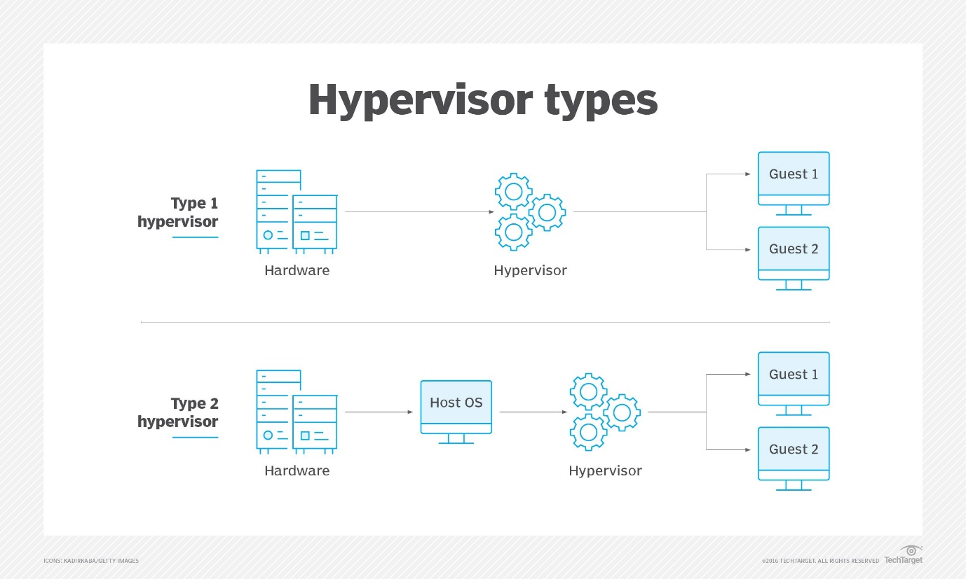
[figure 1] [1]

Type 1 Hypervisor
Type 1 hypervisors, known as Bare-Metal hypervisors are installed directly onto the host machines hardware, managing operating systems without relying on a primary operating system [1]. This direct interaction allows for efficient system resource allocation and enhanced performance. Hypervisors that run directly on the physical hardware, offer a high level of security as each VM operates independently, isolating workloads and minimizing the risk of attacks and vulnerabilities [2].
Hyper-V is one of the top 3 Tier-1 hypervisors, it allows you to create, deploy and manage Windows server virtual machines [3]. Each Hyper-V virtual machine functions as an if it were an independent physical computer, with its own operating system, memory, storage, network, and processor. This separation makes it possible to run applications with different kernel requirements on the same computer [3]. For example, you can run Windows 10 applications in one VM while simultaneously running a Debian-based database server in another. This flexibility is particularly useful for developers, and businesses managing diverse workloads on a single machine.
It is recommended that systems running a type 1 hypervisor such as Hyper- V have a 64-bit processor with second level address translation (SLAT) and at least 4gb of RAM, though it is recommended to have more memory when hosting multiple VMs [4].

Type 2 Hypervisor
Type 2 Hypervisors, also known as a Hosted hypervisor, are installed as an application software on top of an existing host operating system. Type 2 hypervisors rely on the host operating system to manage hardware resource allocation [5].
Type 2 hypervisors are small and efficient, as they do not require dedicated operating systems for each virtual machine. They are faster to deploy and easier to set up as they install like a regular application, this makes them more accessible for users [1]. Their efficient use of system resources enables a single computer to host more type 2 hypervisors compared to type 1, making them ideal for development, testing, and multi-OS environments [6].
One example of a type 2 hypervisor is Oracle VirtualBox, it can efficiently run most operating systems in a virtual environment [7]. It’s flexibility with being able to run different operating systems as virtual machines makes it a popular choice for developers testing software across different operating system environments.

Ip Addressing
Data transmission over the Internet follows a process regulated by networking protocols. When data is sent from one device to another, it is broken down into packets which are then made into bits. These packets travel through network devices, such as routers to reach their destination. Each packet has a header containing key information about the packet origin, destination device, and content. This means that on arrival, the packets can be reassembled to construct the data into its original form [8]. This process follows the Transmission Control Protocol/Internet Protocol (TCP/IP) model.
An IP address is a unique identifier assigned to a device on a network, enabling communication between computers, routers, and websites. It is essential for guiding data transmission across networks, ensuring information reaches its intended destination [9].
Each IP address is divided into two parts. The first part indicates the network identifier, and the last part is the host identifier. Hosts in the same network share an identical network identifier but have a unique host identifier. The division between these two parts is determined by the subnet mask, which specifies how many bits are allocated to the network and how many are reserved for individual hosts [10]. Subnetting is a larger network divided into smaller networks called a subnet. For example, in a company with 10 devices in each department, separating the devices by department into their own subnets protects the sensitive data as they are on their own network [11].
IP addresses come in two versions: IPv4 and IPv6. IPv4 is the first version of IP addressing and is the more widely used format. IPv4 can accommodate approximately 4 billion addresses as it uses a 32-bit address format. IPv6 was introduced to address the shortage of IPv4 addresses, due to the growth in internet connected devices, it uses a 128-bit address format which accommodates approximately 1x10³⁶ addresses [12].

Routing
Routing is fundamental for the transmission of packets of data. Routing selects the optimal paths for data packets transporting from the source to the destination device across networks [13].
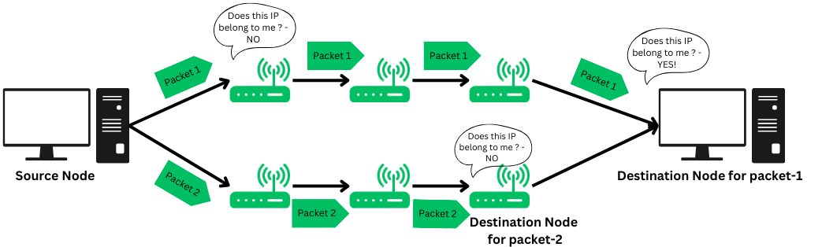
[figure 2] [14]
Routers are network devices that make decisions on packet forwarding between computer networks using routing protocols and routing tables. Routers direct traffic and ensure that data is directed to its destination IP address [14].
There are three types of routing static, dynamic and default. Static routing is done by the network administrator, by manually entering the routing information after assessing all the routes. This method of routing is most suitable for small scale networks, as the network administrator needs to have accurate knowledge of the topology to ensure the safe transportation of data. Dynamic routing has minimal human intervention, it uses the shortest path algorithm to transmit packets over a network. This type of routing is essential for larger complex networks; however, it gives the network admin less control, consumes more bandwidth and is expensive. An example of a dynamic routing protocol is OSPF (Open Shortest Path First), it uses Dijkstra’s algorithm to find the shortest path based on cost [15]. Default routing is a technique when a router forwards packets to a default route when there is no defined path for its destination [14]. This is commonly used in home networks where the network exit traffic is sent to the ISP.

Network Services
Virtual Private Networks (VPNs)
VPNs are used to mask IP addresses, redirecting it through a remote server run by the VPN host. By doing this, the users’ data is protected with encryption making it useless to cyber criminals. This ensures that data is protected, for example remote workers accessing confidential files from home, using a VPN is the safest way for data to be securely received [16]. VPNs are useful when using public Wi-Fi, shielding users from threats such as man in the middle attacks.
Dynamic Host Configuration Protocol (DHCP)
DHCP is the automation of assigning IP addresses, subnet masks, gateways and DNS servers to devices within a network. DHCP ensures that all devices are assigned an IP address as this is essential for communications within the network and to the internet. This is essential for large enterprises as individually assigning IP addresses would be far too time consuming [17].
Active Directory Domain Services
Active Directory Domain Services is a Microsoft directory service that manages and organizes network resources. This is a useful tool for administrators to find information within a device as resources are stored in an organised structure [18].
Certificate Authorities (CA)
A Certificate Authority (CA) is a trusted entity responsible for issuing digital certificates, which verify the authenticity of web servers. These certificates use public key cryptography to establish a secure connection between users and web servers, ensuring data integrity and confidentiality [19]. Users connecting to a website with a certificate can then feel confident that they are using a genuine website.

Task 2 – Technical Documentation

Hypervisor
The hypervisor used was a Type 2 hypervisor, primarily chosen based on available resources. Oracle VirtualBox is free and open source. VirtualBox gives the ability to run multiple OS on a single computer, this is perfect for configuring networks across four devices running Linux and Windows. VirtualBox supports for snapshots so that you can revert to a previous state, reducing risks. Additionally, it allows for exportation and importation of virtual machines (VMs) making it easy to migrate VMs if a different computer is used to run it.

Download and setup
Windows Server installation

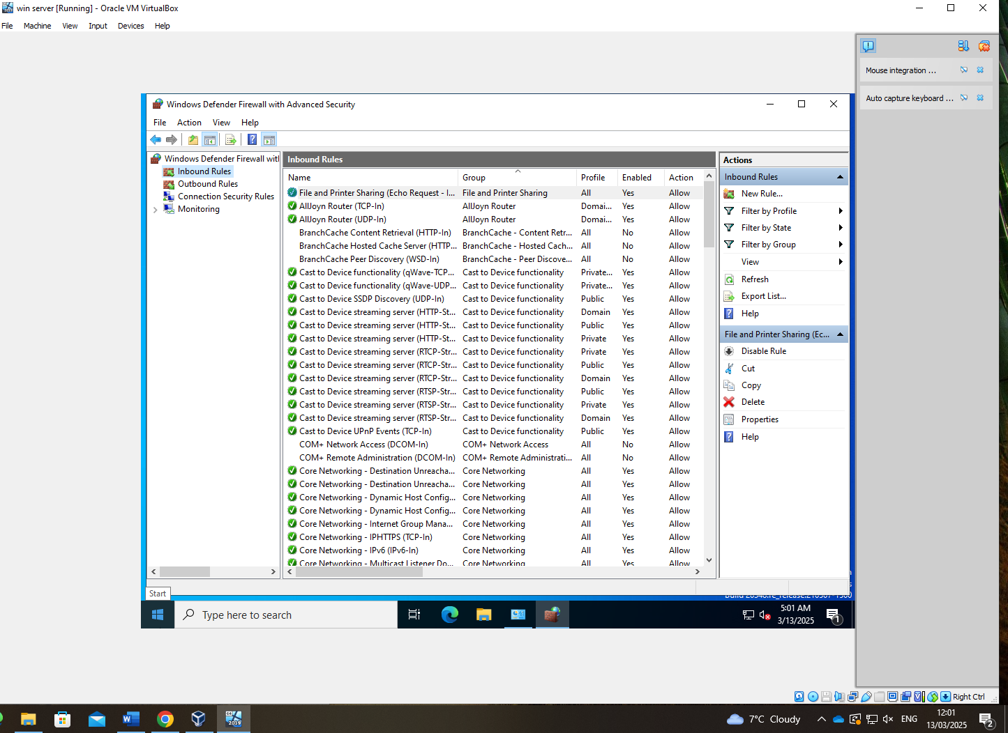
Firewall restrictions initially blocked communication. Added a rule as seen in the inbound rules to allow necessary traffic.

IP AdDRESSING
Windows Server: IP: 10.0.2.4
Subnet Mask: 255.255.255.0
Default Gateway: 10.0.0.1
Windows Client: IP: 10.0.2.5
Subnet Mask: 255.255.255.0
Default Gateway: 10.0.0.1

Debian Server: IP: 10.1.1.1
Debian Client: IP: 10.1.1.2

Test and troubleshoot
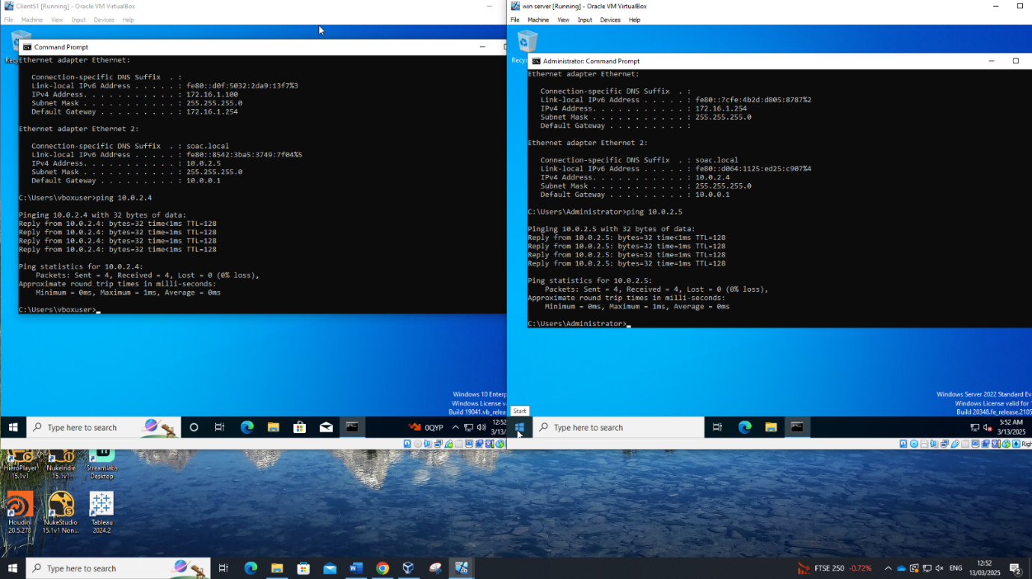
Windows Server and client pinging each other.
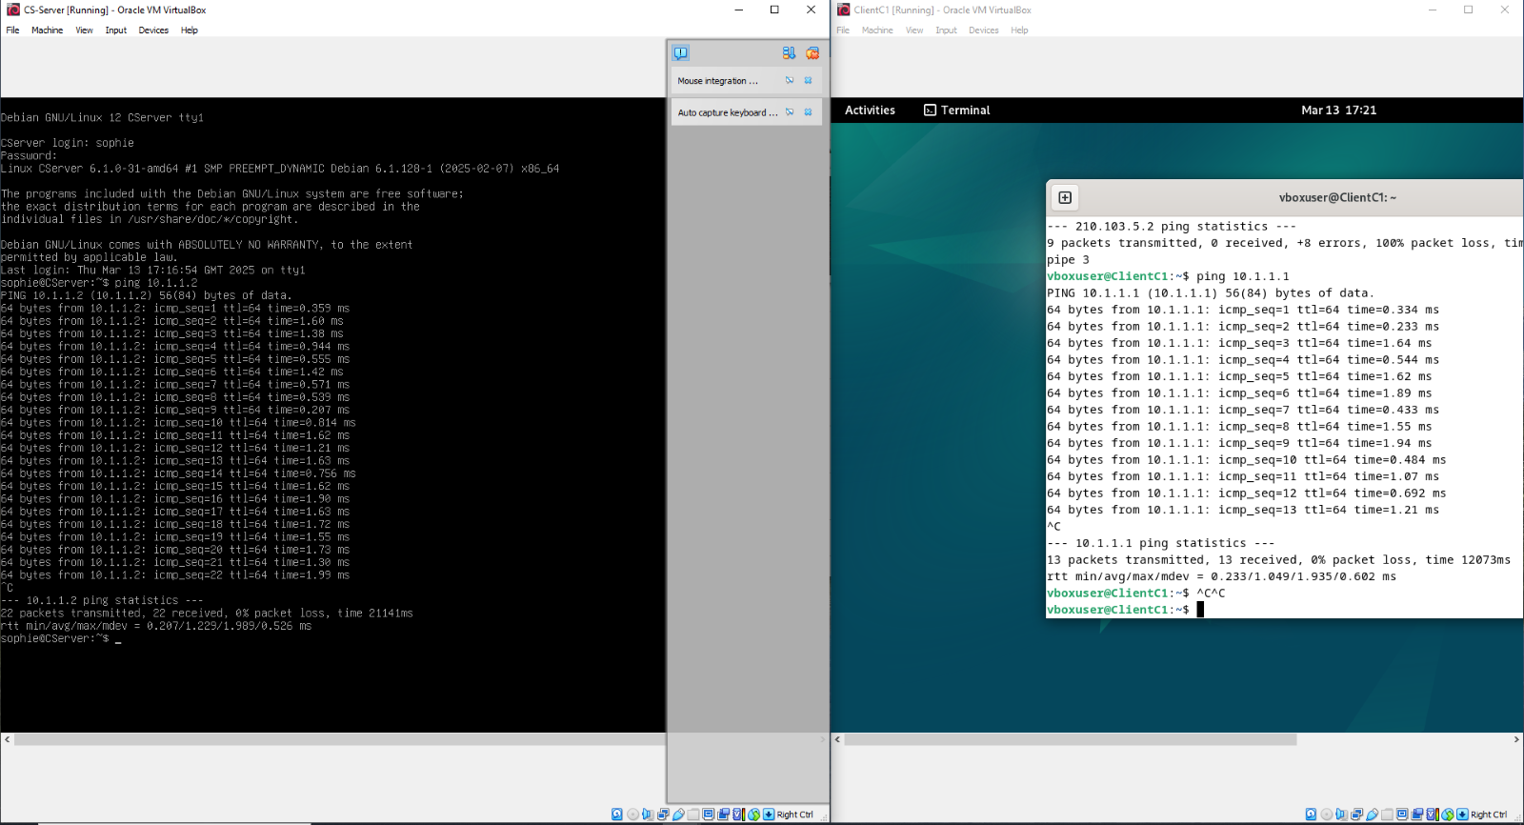
Debian Client and Server pinging each other.
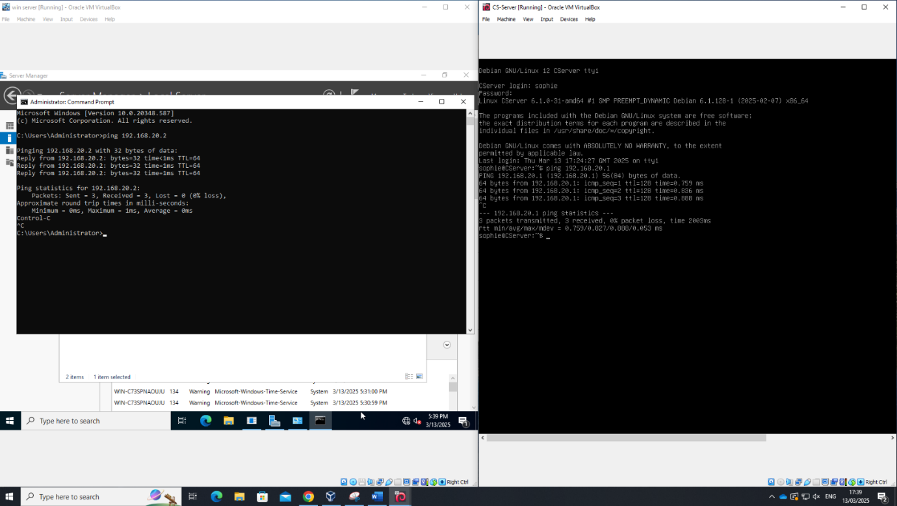
Windows Server and Debian server pinging each other.

Task 3 – Reflection
During network deployment, several challenges emerged, the main ones being IP address conflicts, and firewall restrictions. The IP conflict issue was diagnosed using ipconfig and ping commands, leading to the assignment of unique IP addresses replacing the ones in the topology diagram from Task 2. Firewall restrictions initially blocked communication, requiring rule modifications to allow necessary traffic. The most significant challenge was the corruption of the save file, leading to a complete network rebuild, from this set back snapshots and backups in multiple storage locations were made to mitigate future damages.

References

[1] | S. J. Bigelow, “What's the difference between Type 1 vs. Type 2 hypervisor?,” TechTarget, 7 March 2024. [Online]. Available: https://www.techtarget.com/searchitoperations/tip/Whats-the-difference-between-Type-1-vs-Type-2-hypervisor. [Accessed 11 February 2025].
[2] | A. S. Walia, “Bare Metal Hypervisors: Benefits and Use Cases,” DigitalOcean, 24 January 2025. [Online]. Available: https://www.digitalocean.com/community/conceptual-articles/what-is-bare-metal-hypervisor. [Accessed 11 February 2025].
[3] | Unknown, “What Is Hyper-V and How Does It Work?,” Site24x7, [Online]. Available: https://www.site24x7.com/learn/what-is-hyper-v.html#:~:text=Hyper%2DV%20is%20a%20hypervisor,Server%20and%20Windows%20Virtual%20PC. [Accessed 11 February 2025].
[4] | Unknown, “System requirements for Hyper-V on Windows and Windows Server,” Microsoft Learn, 16 January 2025. [Online]. Available: https://learn.microsoft.com/en-us/windows-server/virtualization/hyper-v/system-requirements-for-hyper-v-on-windows?pivots=windows. [Accessed 17 February 2025].
[5] | I. S. Stephanie Susnjara, “What are hypervisors?,” IBM, 30 October 2024. [Online]. Available: https://www.ibm.com/think/topics/hypervisors. [Accessed 17 February 2025].
[6] | J. MacPherson, “What Is a Hypervisor? – Types, Benefits & How Does It Work?,” Park Place Technologies, 14 February 2022. [Online]. Available: https://www.parkplacetechnologies.com/blog/what-is-hypervisor-types-benefits/. [Accessed 17 February 2025].
[7] | E. Mendelson, “Oracle VirtualBox,” PC Mag, 6 January 2025. [Online]. Available: https://uk.pcmag.com/system-performance/18779/oracle-vm-virtualbox-for-mac. [Accessed 17 February 2025].
[8] | “What is the Internet?,” Cloudflare, [Online]. Available: https://www.cloudflare.com/en-gb/learning/network-layer/how-does-the-internet-work/. [Accessed 19 February 2025].
[9] | “Structure and Types of IP Address,” Geeks for Geeks, 12 November 2024. [Online]. Available: https://www.geeksforgeeks.org/structure-and-types-of-ip-address/. [Accessed 24 February 2025].
[10] | “What is a subnet? | How subnetting works,” Cloudflare, [Online]. Available: https://www.cloudflare.com/en-gb/learning/network-layer/what-is-a-subnet/. [Accessed 26 February 2025].
[11] | “Introduction To Subnetting,” Geeks for Geeks, 7 February 2025. [Online]. Available: https://www.geeksforgeeks.org/introduction-to-subnetting/. [Accessed 28 February 2025].
[12] | “What’s the difference between IPv4 and IPv6?,” AWS, [Online]. Available: https://aws.amazon.com/compare/the-difference-between-ipv4-and-ipv6/. [Accessed 24 February 2025].
[13] | “What is Routing? | IP Routing,” Azion, [Online]. Available: https://www.azion.com/en/learning/network-layer/what-is-routing/#:~:text=Routing%20is%20the%20process%20of,%2C%20available%20bandwidth%2C%20and%20congestion.. [Accessed 28 February 2025].
[14] | “What is Routing?,” Geeks for Geeks, 16 August 2024. [Online]. Available: https://www.geeksforgeeks.org/what-is-routing/. [Accessed 2 March 2025].
[15] | H. P. C. W. J. K. E. R. Thaddeus Abiy, “Dijkstra's Shortest Path Algorithm,” Brilliant, [Online]. Available: https://brilliant.org/wiki/dijkstras-short-path-finder/. [Accessed 11 March 2025].
[16] | “What is VPN? How It Works, Types of VPN,” Kaspersky, [Online]. Available: https://www.kaspersky.com/resource-center/definitions/what-is-a-vpn. [Accessed 11 March 2025].
[17] | D. H. C. P. (. Meaning. [Online]. Available: https://www.fortinet.com/resources/cyberglossary/dynamic-host-configuration-protocol-dhcp#:~:text=Protocol%20(DHCP)%20Meaning-,What%20is%20DHCP%3F,enables%20access%20to%20a%20network.. [Accessed March 11 2025].
[18] | A. D. D. S. overview, Microsoft, 11 March 2025. [Online]. Available: https://learn.microsoft.com/en-us/windows-server/identity/ad-ds/get-started/virtual-dc/active-directory-domain-services-overview. [Accessed 12 March 2025].
[19] | P. L. Rahul Awati, “What is a certificate authority (CA)?,” Tech Target, March 2025. [Online]. Available: https://www.techtarget.com/searchsecurity/definition/certificate-authority. [Accessed 12 March 2025].

