

Postgraduate/Distance Learning
Assignment coversheet & feedback form

THIS SHEET MUST BE THE FIRST PAGE OF THE ASSIGNMENT YOU ARE SUBMITTING (DO NOT SEND AS A SEPARATE FILE)

For completion by the student:
Student Name: SHANNON LOUISE WAKELING

Student University Email: 2115400@student.uwtsd.ac.uk
Module code: HPCA7015  Module title: FOUNDATIONS IN CULTURAL  ASTRONOMY AND ASTROLOGY | Student ID number:  2115400 |  |  | Educational support needs:  No
Assignment title: 2000 word essay on a topic in the subject area; -
‘Essay Based on a Sky Journal’.

Assignment due date: 2nd December 2021
This assignment is for the 1st 2nd 3rd 4th 5th 6th module of the degree
I confirm that this is my original work and that I have adhered to the University policy on plagiarism.
Signed ……SHANNON LOUISE WAKELING………………

Email submission:if you are submitting this form via email, please tick this box □
(as a substitute for your signature) to confirm that you agree to the above declaration.
Assignment Mark
1st Marker’s Provisional mark
2nd Marker’s/Moderator’s provisional mark
External Examiner’s mark (if relevant)
Final Mark

NB. All marks are provisional until confirmed by the Final Examination Board.

For completion by Marker 1 :
Comments:

Marker’s signature: |  |  | Date:
For completion by Marker 2/Moderator:

Comments:

Marker’s Signature: |  | Date:
External Examiner’s comments (if relevant)

External Examiner’s Signature: |  | Date:
Essay Based on a Sky Journal

This essay is based on my own Sky Journal. The observations in this Journal will be analyzed within the context of the following quote from Vincent van Gogh:

‘Be clearly aware of the stars and infinity on high. Then life seems almost enchanted after all.’

The aim of this essay is to show how the sky provides meaning and purpose to humans by enchanting their lives. Through examining my own Sky Journal and the above quote from van Gogh, as well as the series of letters he wrote to his loved ones, we see the embodiment of two separate meanings of the word ‘enchanted’. The letter this quote was taken from was originally written in French. The original word van Gogh used was ‘enchantée’ which can mean both delightful and magical. One meaning of the word ‘enchantée’ referring to a feeling or experience, the other referring to a philosophical concept or a sense of ‘other-worldliness’. The feelings that the sky provoked in myself, and van Gogh were ones of calm and comfort, which in turn provided a source of meditation and self-awareness. Observing the sky allowed myself and van Gogh to feel connected to something bigger than ourselves and to question the meaning of life. The second definition of the word ‘enchanted’ which points to the creation of another world, will be explored in the context of art, showing how observing the sky can lead to creative expression. This essay will explore these two definitions of the word ‘enchanted’ and show how they are of equal importance in the sky’s ability to provide us with a sense of meaning.

Dutch born artist Vincent Van Gogh (1853 -1890) is an ‘enviable figure in the world of Arts’. Van Gogh’s vantage point for observing the sky was one free from the light pollution which is experienced in today’s society. He was a Christian and used religious symbolism as a lens through which to interpret the sky. He felt emotionally connected to the cosmos, and the sky became a symbol of eternity for him. The quote from Van Gogh which this essay centers around was taken from a letter which he wrote to his younger brother Theodore.

The original intention of my Sky Journal was to note observations of the phases of the moon, however, due to the presence of clouds, buildings and light pollution, it was in the end, less about the moon and more about the sky in general. ‘No moon again tonight, clouds soft and foggy, present but somehow barely discernable’. The Sky Journal contains observations of the Sky between the hours 21:00 and 23:00 from 1/11/2021 – 18/11/2021 in Haarlem, The Netherlands. The moon was only visible on the last two days of observations. Its magnificence ‘took my breath away’, despite the clouds, the sky’s provocation of emotions in me will be subsequently explored as source of meaning in my life throughout the essay:

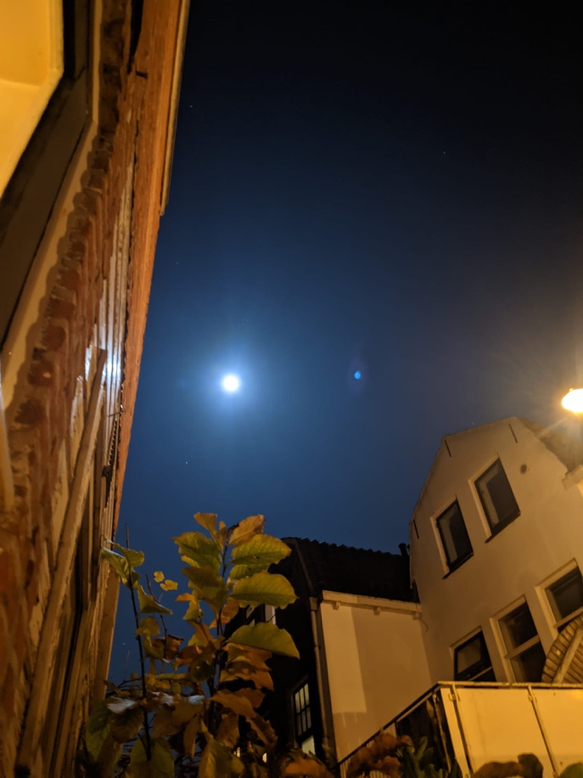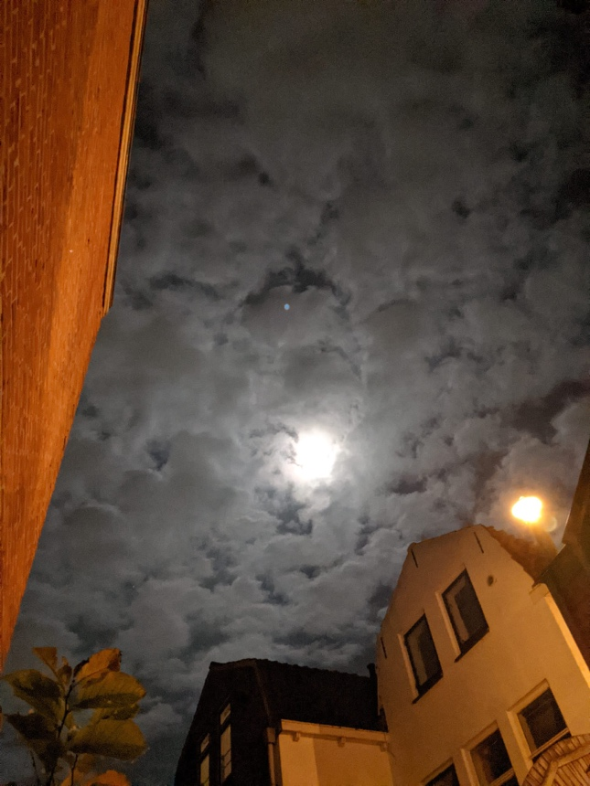
Figure 1. Shannon L. Wakeling, Photo of the Moon, Figure 2. Shannon L. Wakeling, Photo of the Moon on a Cloudy
[Digital Photograph], Sky Journal, Haarlem Netherlands, night, [Digital Photograph], Sky Journal, Haarlem Netherlands,
17/11/2021. 18/11/2021.

Academics Frank Martela and Michael Steger described two types of meaning in one’s life. The first being one of psychological importance pertaining to an individual’s experiences. The second of philosophical importance concerned with answering existential and metaphysical questions. In exploring the first dictionary definition of the word ‘enchanted’ as a feeling, it is shown how the provocation of emotions and feelings provides a psychological sense of meaning in one’s life. Through examining the letters from van
Gogh to his brother, it is exemplified that the sky at night was somewhere he looked to for a feeling of comfort:

You should be able to live on a piece of bread while doing a full day’s work and have enough strength left over to smoke and have a drink, because you need it under those conditions. And yet to be clearly aware of the stars and infinity on high. Then life seems almost enchanted after all.

In this quote he shows how the sky was a point of meditation for him after a day of work. He implies that the grandeur of the sky gave his life meaning and made the hard work worthwhile. A similar experience of calm, comfort and meditation was observed in my own Sky Journal:

I have only just realized that every night when I look at the sky between 21:00 and 21:30 the bell at the church in town rings constantly for that 30 mins, I never even noticed it or mentioned it in my journal thus far. Totally present for my observations, tonight I had so much on my mind, I looked forward to going outside and observing the sky, was a nice break from my own thoughts.

Keeping a Sky Journal for me, was a meditation in presence and self-awareness. Psychology Professors Paul J. Silvia and Maureen E. O’Brien suggest that greater self-awareness can lead to a fuller, more ‘flourishing’ and purposeful life.

The second meaning of the word ‘enchanted’ refers to ‘magical’ concepts outside of this world. Through his use of the word ‘infinite’, van Gogh refers to the sky as being beyond the scope of human perception. In a previous letter to his sister, he references the sky as Godlike, ‘With the great starry firmament, something…that one could only call God and eternity, put back in place above this world.’ In this way, van Gogh alludes to the concept that the sky connects the observer to a source greater than themselves. I made similar observations in my Sky Journal noting how the sky made me feel ‘connected to something bigger’. In my Sky Journal this external source called me to philosophize about society and life:

Maybe this is what (Dr. Clive) Ruggles meant when he talked about the absence of the night sky, perhaps humans amidst our light pollution have lost perspective of the grandeur of the universe and the concept that we are a part of something much bigger than ourselves…we have put so much between ourselves and the sky.

Throughout van Gogh’s collection of letters, he also had philosophical thoughts prompted by the sky. His attempt to grasp the meaning of life through the concept of death shows this:

The sight of the stars always makes me dream in as simple a way as the black spots on the map, representing towns and villages, make me dream. Why, I say to myself, should the spots of light in the firmament be less accessible to us than the black spots on the map of France. Just as we take the train to go to Tarascon…we take death to go to a star…while alive, we cannot go to a star, any more than once dead we’d be able to take the train.

This ‘otherworldly’ enchantment from the sky is shown in both my own, and van Gogh’s life through connecting us to a world outside of our own and allowing us to question the world in which we currently live. An example of Martela and Stegers’ philosophical meaning being created in our lives.

Scholar Patrick Curry explored this second definition of the word ‘enchanted’ involving a creation of a secondary world and linked this concept of enchantment with art. This is exemplified in my own sky observations, as I was immediately drawn to mention colour. The opening phrase of my Sky Journal:

Teal upon the horizon getting darker into a midnight blue, as the light makes its way up, if I was to paint that portion, I would use Phthalo blue, until directly overhead it’s almost black

Both Figures 3 and 4 below, exhibit how observing the sky inspired van Gogh and myself to draw/paint our observations. Whilst there is no comparison between my own artistic abilities and those of van Gogh, one of the ways the sky enchanted our lives was through inspiring artistic expression. As Academic Philosopher John Hosper’s expresses ‘What art gives us . . . is something which is not knowledge but perhaps more valuable than knowledge-the enrichment of experience itself”. Reiterating the point that the creation of art is true source of psychological, experiential meaning in one’s life.

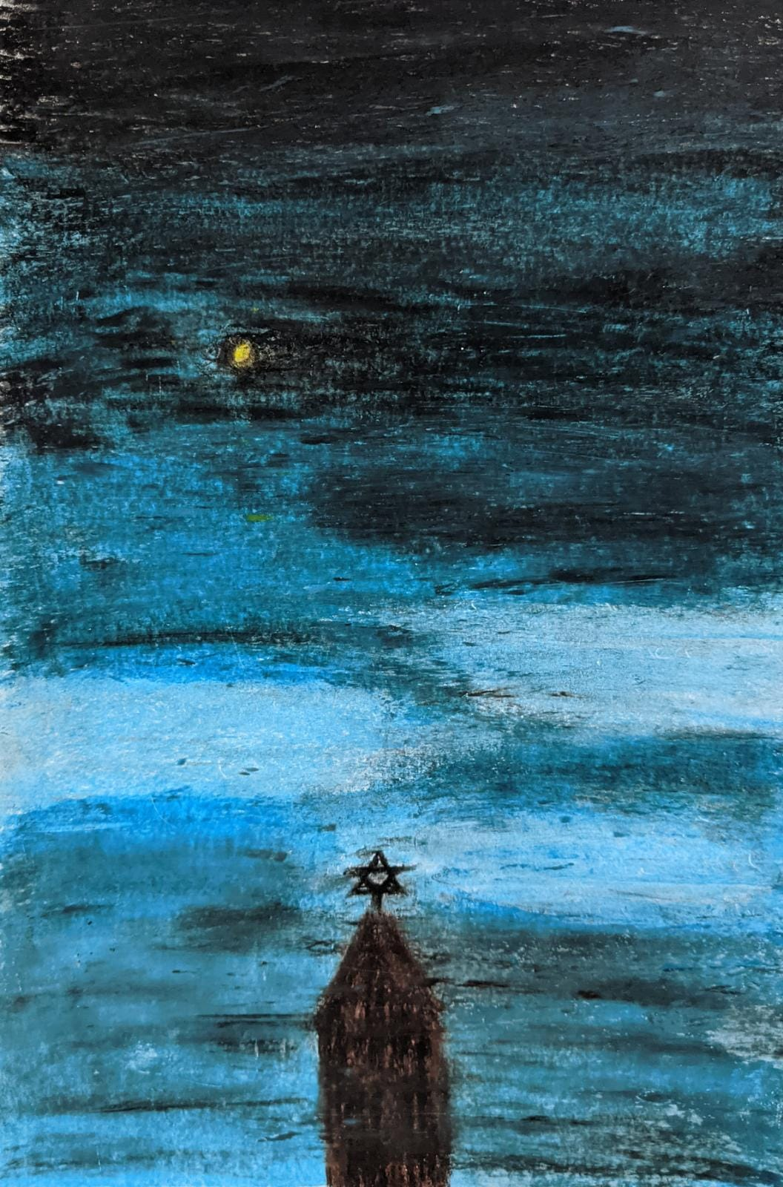
Figure 3. Shannon L. Wakeling, ‘Sketch of the Night Sky’, [Oil pastel on paper], Sky Journal, Haarlem Netherlands, 14/11/2021

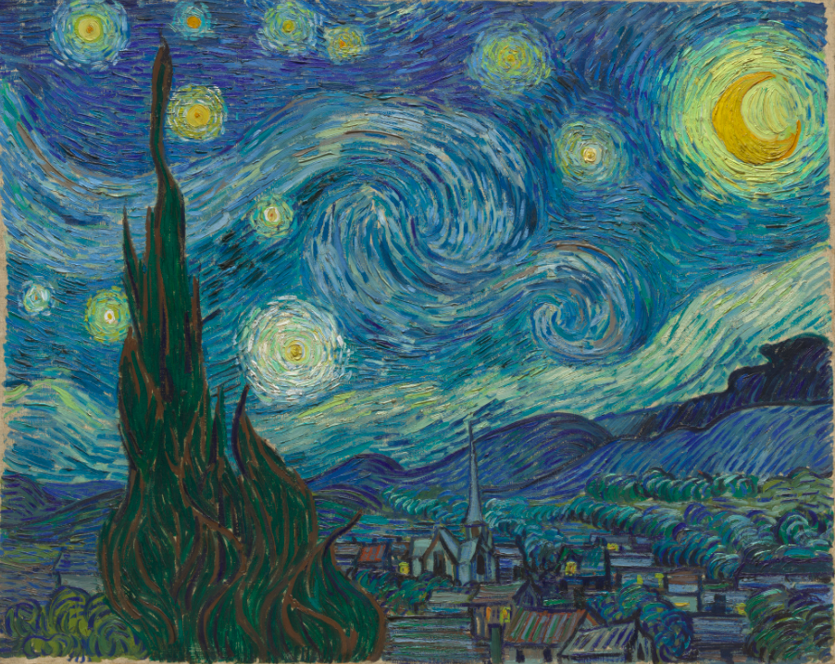
Figure 4. Vincent van Gogh (1853-1890), The Starry Night, June 1889, [Oil on Canvas],73.7 x 92.1 cm, The Museum of Modern Art (MoMA) New York City, Image: MoMa, New York City, Credit: Acquired through the Lillie P. Bliss Bequest (by exchange). Conservation was made possible by the Bank of America Art Conservation Project.
Regardless of which meaning of ‘enchanted’ van Gogh had intended, it is clear, the sky encompasses both embodiments of the word in our lives. It has been shown how the sky provoked feelings of comfort and calm, providing a meditative experience resulting in a greater sense of self awareness. A form of psychological meaning in one’s life. Observing the sky enchanted myself and van Gogh’s life through becoming a beacon for a world outside of our own, a connection to something grander than ourselves, prompting us both to ponder the meanings of life. An example of the creation of philosophical meaning in one’s life. Evidence was provided in this essay of a link between enchantment in our lives which the sky inspired and artistic expression. Both van Gogh and I were prompted to create artworks after observing the sky. Feeling; meditation; self-awareness; connection to a source great than ourselves; inquisition into the meaning of life; artistic creation; all became sources of meaning and purpose in our lives after observing the sky. My Sky Journal started out with the intention of observing the moon phases and ended up in a general observation of the clouds and the sky. This led my Sky Journal to become less of a monologue and more of dialogue with the sky. It was through this conversation that I was prompted to explore my own existence, and through this psychological and philosophical exploration it has become clear that, a relationship with the sky is a meaningful connection worth having.

Bibliography

Wakeling, Shannon L., Sky journal, Haarlem Netherlands, (November 1 – 18 2021)

“638 (642, 506): To Theo van Gogh. Arles, Monday, 9 or Tuesday, 10 July 1888. - Vincent van Gogh Letters.” [n.d.]. Vangoghletters.Org <http://www.vangoghletters.org/vg/letters/let638/letter.html> [accessed 2 December 2021]

“670 (674, W8): To Willemien van Gogh. Arles, on or about Sunday, 26 August 1888. - Vincent van Gogh Letters.”[n.d.]. vangoghletters.Org
<http://www.vangoghletters.org/vg/letters/let670/letter.html> [accessed 1 December 2021]

Conner, Tamlin S., Colin G. DeYoung, and Paul J. Silvia. “Everyday Creative Activity as a Path to Flourishing,” The Journal of Positive Psychology. (Taylor and Francis (Online): 2018) Volume 13 (2).

Curry, Patrick. “Magic vs. Enchantment,” Journal of Contemporary Religion, (Taylor and Francis (Online): 1999), Vol.14 (3).

“Enchanté.” [n.d.]. Cambridge.Org <https://dictionary.cambridge.org/dictionary/french-english/enchante?q=enchant%C3%A9> [accessed 25 November 2021]

Fanger, Claire, ‘The Life and Death of Magic in the Canonical History of Philosophy: Brian P. Copenhaver: Magic in Western Culture: From Antiquity to the Enlightenment. (Cambridge: Cambridge University Press, 2015) , Metascience.

van Gogh, Vincent. 1997. The Letters of Vincent van Gogh, ed. by Ronald de Leeuw, trans. by Arnold J. Pomerans (London, England: Penguin Classics)

Kerr, Walter. “Meaning and Truth in the Arts by John Hospers,” The Thomist, (The Catholic University of America Press: 1947) Volume 10. Issue 3.

Martela, Frank, and Michael F. Steger. “The Three Meanings of Meaning in Life: Distinguishing Coherence, Purpose, and Significance,” The Journal of Positive Psychology, (Taylor and Francis (Online): 2016), Vol. 11, No. 5.

Mota, Pedro ‘Creativity and Mental Illness: Vincent van Gogh as the Archetypal Figure’, The Journal of Psychohistory, (New York: Association for Psychohistory, Inc: 2021)

Silvia, Paul J., and Maureen E. O’Brien. “Self-Awareness and Constructive Functioning: Revisiting ‘the Human Dilemma,’” Journal of Social and Clinical Psychology, (Guilford Press Periodicals: 2004), Volume 23 (4)

Trachtman, Paul. 2009. “Van Gogh’s Night Visions,” Smithsonian Magazine
<https://www.smithsonianmag.com/arts-culture/van-goghs-night-visions-131900002/> [accessed 25 November 2021]

“Vincent van Gogh. The Starry Night. Saint Rémy, June 1889.” [n.d.]. Moma.Org <https://www.moma.org/collection/works/79802> [accessed 1 December 2021]

Walker, John A. “Van Gogh and the Colours of the Night by Sjraar van Heugten & Others,” The Art Book, (Oxford, UK: Blackwell Publishing, 2009), Vol.16 (4).

Shannon L. Wakeling, Sky journal, Haarlem Netherlands, (November 1 – 18 2021) pp. 1-15
Vincent van Gogh and Ronald de Leeuw, The Letters of Vincent van Gogh (London: Penguin Books, 1997) p. 392
“Enchanté.” [n.d.]. Cambridge.Org <https://dictionary.cambridge.org/dictionary/french-english/enchante?q=enchant%C3%A9> [accessed 25 November 2021]
“Enchanté.” [n.d.]. Cambridge.Org
Claire Fanger, ‘The Life and Death of Magic in the Canonical History of Philosophy: Brian P. Copenhaver: Magic in Western Culture: From Antiquity to the Enlightenment. (Cambridge: Cambridge University Press, 2015), Metascience, p. 446
Patrick Curry, ‘Magic Vs. Enchantment’, Journal of Contemporary Religion, 1999, p. 403
Curry, ‘Magic Vs. Enchantment’, p. 403
Curry, ‘Magic Vs. Enchantment’, p. 403
Pedro Mota, ‘Creativity and Mental Illness: Vincent van Gogh as the Archetypal Figure’, The Journal of Psychohistory, (New York: Association for Psychohistory, Inc: 2021), p. 140
Walker, “Van Gogh and the Colours of the Night by Sjraar van Heugten & Others,” p. 28
Walker, “Van Gogh and the Colours of the Night”p. 28
Walker “Van Gogh and the Colours of the Night” p. 28
Walker, “Van Gogh and the Colours of the Night” p. 28
van Gogh and de Leeuw, The Letters of Vincent van Gogh, p. 392
Wakeling, Sky journal, pp. 1
Wakeling, Sky journal, p. 1
Wakeling, Sky journal, p. 14
Frank Martela, and Michael F. Steger. “The Three Meanings of Meaning in Life: Distinguishing Coherence, Purpose, and Significance,” The Journal of Positive Psychology (Taylor and Francis (Online): 2016), Vol. 11, No. 5. p. 5.
Martela and Steger. “The Three Meanings of Meaning in Life” p.5
Martela and Steger. “The Three Meanings of Meaning in Life” p. 5
Martela and Steger. “The Three Meanings of Meaning in Life” p. 5
Paul Trachtman, “Van Gogh’s Night Visions,” Smithsonian Magazine 2009 <https://www.smithsonianmag.com/arts-culture/van-goghs-night-visions-131900002/> [accessed 25 November 2021]
van Gogh, and de Leeuw, The Letters of Vincent van Gogh, p. 392
Trachtman, “Van Gogh’s Night Visions,” Smithsonian Magazine 2009
Wakeling, Sky journal, p. 1
Wakeling, Sky journal, p.8
Tamlin Conner, Colin G. DeYoung, and Paul J. Silvia. “Everyday Creative Activity as a Path to Flourishing,” The Journal of Positive Psychology. (Taylor and Francis (Online): 2018) Volume 13 (2). p. 181
Paul J Silvia, and Maureen E O’Brien, ‘Self-Awareness and Constructive Functioning: Revisiting the Human Dilemma’, Journal of Social and Clinical Psychology, (Guilford Press Periodicals: 2004), Volume 23 (4), p. 480
“Enchanté.” [n.d.]. Cambridge.Org
van Gogh and de Leeuw, The Letters of Vincent van Gogh, p. 392
“670 (674, W8): To Willemien van Gogh. Arles, on or about Sunday, 26 August 1888. - Vincent van Gogh Letters.”[n.d.]. Vangoghletters.Org <http://www.vangoghletters.org/vg/letters/let670/letter.html> [accessed 1 December 2021]
Wakeling, Sky journal, p. 2
Wakeling, Sky journal, p. 11
“638 (642, 506): To Theo van Gogh. Arles, Monday, 9 or Tuesday, 10 July 1888. - Vincent van Gogh Letters.” [n.d.]. Vangoghletters.Org <http://www.vangoghletters.org/vg/letters/let638/letter.html> [accessed 25 November 2021]
Martela and Steger. “The Three Meanings of Meaning in Life:” p.5
Curry,‘Magic Vs. Enchantment’, p. 403
Curry, ‘Magic Vs. Enchantment’p. 403
Wakeling, Sky journal, p. 1
John Hospers as cited in, Walter Kerr, ‘Meaning and Truth in the Arts by John Hospers (review)’, The Thomist, (The Catholic University of America Press:1947), Volume 10 (3) p. 367

