Slide 1: Cover page
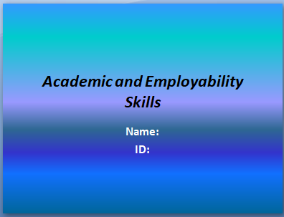
Slide 2: Introduction
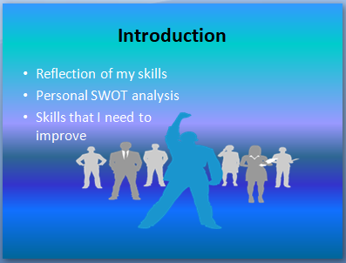
The following assessment is the reflection of my skills that would be accounted for by the employers while I apply for any job roles in a reputed company. In accordance with this, the following assessment will discuss the skills that are accounted for by the employer and based on it a personal SWOT analysis will be discussed. Further, the assessment will also discuss the skills that need to be improved in accordance with time management tools. Lastly, the assessment will discuss the skills that I need to improve and new ones that need to be adopted by me for self-enhancement and development.

Slide 3: What skills the employers are looking for in sales manager
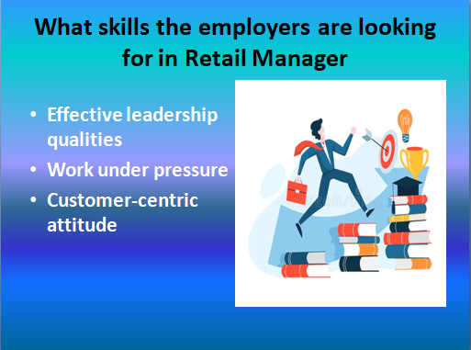
In consideration of the roles and responsibilities of a retail manager, it can be noted that I must have effective leadership qualities along with an ability to motivate others. During the peak season, the work pressure will be huge (Kuraesin and Eldine, 2018). In such a situation the retail manager must plan and priorities the workloads and accordingly delegate. All the strategies of the retail manager must be customer-centric and must have the capability to grasp new concepts. Apart from this, a good retail manager must have the ability to multi-task and work under tremendous pressure without losing temper. Further, it is also necessary for them to have shrewd business sense along with a well-developed commercial awareness (Prospects, 2021). Lastly, a retail manager must have an effective teamwork spirit for generating fresh and innovative ideas for the company.
Slide 4: MY SWOT Analysis in light of industry expectations
Strengths | Weakness
- Pursued my studies in business studies  - Know about marketing  - Work under pressure | - Lack infield experience  - Lack knowledge regarding the business operation in the retail sector  - Face difficulty in communication
Opportunity | Threat
- The growing demand of retail sectors | - The increasing number of people seeking jobs in retail sectors
In context to the above SWOT analysis, it can be noted that I have fulfilled the qualification requirement that would be needed when I apply as a retail manager in any reputed company. Further, I also have all the knowledge related to marketing and can work efficiently under pressure. However, I lack infield experience and the business operation that goes in retail management. Further, I also face difficulties in communicating with others. The analysis above also relates that the increasing demands of the retail industry can be a better opportunity for me in the role of retail manager but the increasing number of applicants can be a threat to my career (Ari, Nurhayati and Yudhawati, 2020).
Slide 5: Using time management tools to improve the skills that I have
Do now | Do later
- Pursue higher studies in business management | - Learn different marketing strategies
Crucial | Not crucial
- Gain in-field experience | - Acquiring skills to work under pressure
I will have to give my major priority to pursuing higher studies in business management and gain more experience through internship programs. Once I achieve this, I can focus on gaining different marketing strategies and eventually will be able to acquire new skills to work under pressure.
Slide 6: My PDP for improving my existing skills
Objective | Actions | Resources | Deadline
Pursue masters degrees in business studies | - Enrol for a masters degree in a reputed university | - Internet resource  - Reviews | 8-9 months
Enhance my knowledge in marketing | - Refer to different management books and reading resources  - Study the strategies of different leaders | - Internet  - Books  - Articles | 3-4monts
Acquire different skills for working under pressure | - Refer to the strategies of different leaders  - Apply the learning skills in practice files | - Different activities to enhance my efficiency  - Different reading material | 4-5 months
In accordance with the above PDP plan, it can be noted that I hold a degree in business studies but I will have to advance my degree to be the most eligible for the post of retail manager. I have some basic skills in marketing but it is not enough to handle difficult situations in the retail sector (Kusumaningsih, 2020). I will have to refine it by acquiring infield practical knowledge. I have the ability to work under pressure but to be a successful retail manager I will have to advance this skill.
Slide 7: Using time management tools to gain the skills that I do not have
Do now | Do later
- Develop my communication skills | - Enhance my teamwork spirit
Crucial | Not crucial
- Gain in-field practical knowledge | - Boost my vocabulary
I face difficulties in interacting with new people. Further, I also do not have any experience in how operations are conducted in retail sectors. I will have to work on my teamwork spirit and eventually boost my vocabulary to enhance fluent communication skills.
Slide 8: My PDP for gaining the skills that I lack
Objective | Actions | Resources | Deadline
Improve my communication skills | - Boost my vocabulary  - Indulge more in group interaction | - Differing reading materials  - Talk events  - Social gathering | 3-4 months
Enhance my infield experience | - Enrol myself on internship programs  - Enhance my knowledge | - Internet connection  - Internship programs  - Access to differing reading resources | 4-5 months
Enhance knowledge in retail management | - Refer to different skills and strategies of leaders from different retail sectors | - Books related  - Internet sources  - Strategies and tools useful in retail sectors | 6-7 months
In context to the overall analysis, it can be noted that I will have to give my major emphasis on my communications skills as being a retail manager I will have to deal with customers as well as with other co-workers (Vyt and Cliquet, 2017). Developing an infield experience can be a huge help for me in accelerating as a retail manager in future.

Slide 9: Conclusion
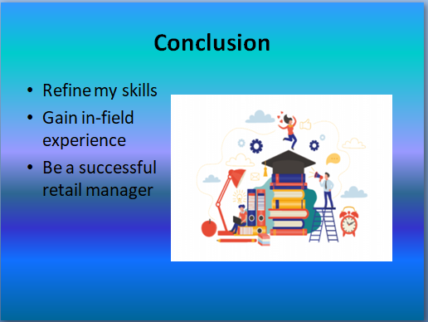
In accordance with the above analysis, it can be noted that despite me having some of the skills I will have to refine them to be a successful retail manager. Further, I also realised that along with theoretical knowledge it is also necessary for me to build my practical experience through internship programs.

Slide 10: References
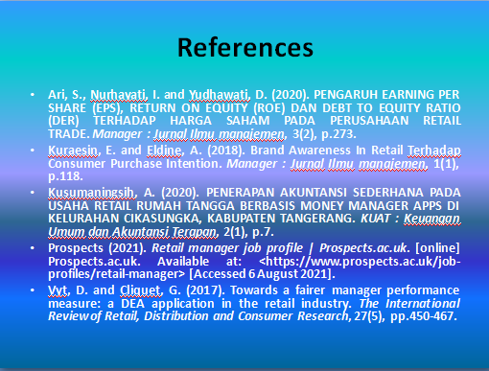
Slide 11: Thank You


