Digital Surveying and Highway Design Module code – ACBA4017
Building survey
Jocasta Napier
Student Number - 2316860

Table of Contents
Introduction 2
Survey Objectives and Scope 2
Selection of Digital Tools and Technology 3
Thermal Camera 3
Drone 5
RTK – GPS with GNSS 6
Survey Planning 7
Site Survey 7
Challenges and Solutions 8
Weather 8
Hot Weather 8
Wind 9
Rain 9
Conclusion and Recommendations 9
References 10
Bibliography 10

Figure 1- example of thermal imagining, Syntegra Group (2021) 4
Figure 2 - Drone set up, J.Napier 6

Introduction
It is important for a building survey to be carried out on different types of property such as new builds, office building and existing homes etc. These surveys are conducted to understand the condition of the building and if any works need to be carried out. These surveys are also taken out on plots of land to establish, the condition of land and if it suitable for building on.

The use of digital technology is becoming a more frequently used method in building surveying due to the amount of information obtained, as well as a more efficient, use of time to collect the data and accuracy.

This assignment will investigate the different tools which can be used to conduct a survey, along with the importance of conducting this task, the benefits of using this method, what challenges can occur and how to work around them.

Survey Objectives and Scope

A building survey is carried out to collect data before any works can begin on the building. The survey will show the condition of the property, outline any issues which are outstanding in need of immediate repair and ones which may occur in the future. This information will then be assessed and allow the correct forecasting of costs, design, planning, materials, and time which is needed to carry out proposed project.

Before carrying out a survey a scope needs to decided, the scope will indicate which areas need to be reviewed by the surveyor and how much detail needs to be collected in the building survey. The majority of house surveys follow (Royal institution of Chartered Surveying (RICS) standards which is split over three levels, the lower level provides a basic level of information regarding a building and then this proceed to get more in depth as it gets to level three as more test will be carried out to check the quality of the property, as shown on RICS.org (2024)

Selection of Digital Tools and Technology

There has been a significant improvement when it comes to surveying a building or land due to the use of digital technology.

This is due to surveying previously being carried out by human judgement using machinal hand tools, which could lead to human error due to the large area or the amount of detail that needed to be collected could lead to something being missed or inputted incorrectly.

The improvement of surveying has come from digital technology, which has not only minimised the number of errors which could occur. It also reduces the amount of time it takes to carry out a survey, there is also a massive increase in the amount of data collected. It is also possible to connect the data from different pieces of equipment and link them together to get an even more in depth and precise detailing on the survey.
Go Report (2024).

Some tools used to carry out these surveys are drones, RTK – GPS with GNSS and thermal cameras. These tools are described in more details below –

Thermal Camera

A Thermal camera can be used on any property type, usually best to use in cooler weather or night. The camera is used to capture the heat content of a building, along with showing if there is any heat maybe escaping from the building.

To carry out this survey a person will walk around the outside of the surrounding area of the building, making sure the entire building is captured. This information is then pulled from the thermal camera and reviewed. The photo will then be compared to a temperature chart to see if there is any heat being lost in different areas of the building.

An area most likely to show a higher heat loss within a building in the roof as heat rises there is more chance of it escaping through the roof, which will the show a higher loss in temperature of the data collected. Other areas which may show a higher heat loss, is around a window if the window seal has not been filled correctly, this will be identifiable on the thermal camera with a higher reading in that area. This data will then be passed on to review to see if there are any improvements which need to be made. As shown the image below

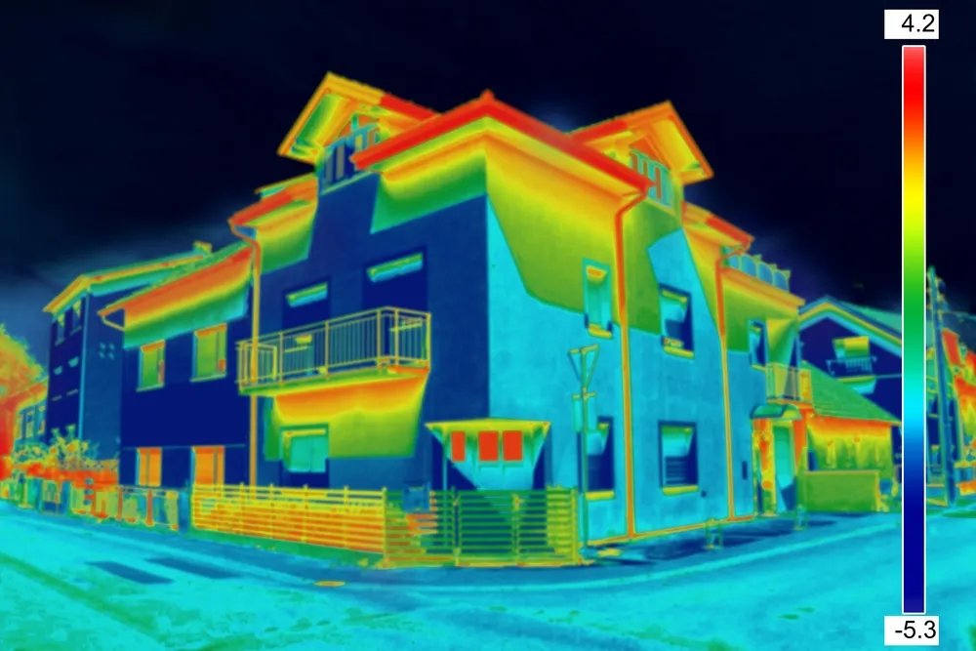
Low heat loss in Blue
High heat loss in RED
Figure 1- example of thermal imagining, Syntegra Group (2021)

It is important when carrying out a survey to try and avoid any of your own reflection in the windows as it will cause an incorrect reading in that area, this can also happen if there are trees in the reflection.

Drone

Drones are becoming a very popular method for surveying land and building as it is a quick method to obtain data of a large area, in a minimal amount of time. Depending on the amount spent on the drone the better the quality the camera will be, which will then allow for a better quality of imaging.

When it comes to operating a drone, it is important that the person operating the drone has a license to fly it and has also be trained to do so. Before starting any survey, the surveyor will need to make sure the area they are surveying is also in a allow to fly zone or have a permit for that area.

Once the correct checks have been made the surveyor will then need to set up the drone, depending on the drone it will have a landing disc, which is placed n an open area. The tablet that comes with the drone will need to be set up, the coordinates of the area being surveyed will need to be uploaded. The drone will then create its own flight plan, once it does this take flight and take multiple photos of the area, along with a video. The time of this will vary depending on how large an area is being surveyed, once finished the drone will return to the landing pad. The data collected is then uploaded and each photo is linked together to make an overall bird’s eye view of the area surveyed. This then allows a clear view of the building and the surrounding area.
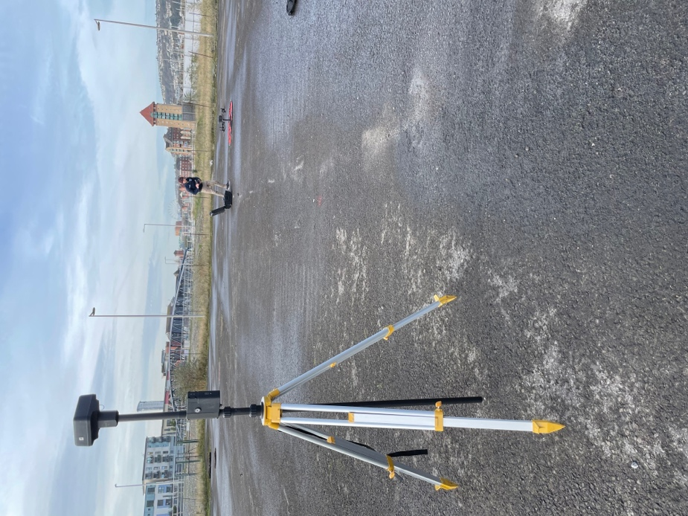
GPS base station
Drone on the landing disk.
Figure 2 - Drone set up, J.Napier

RTK – GPS with GNSS
Real Time Kinematic (RTK) is a piece of surveying tool which uses satellites which allows for real time position with high proposition up to 2cm +/-. The satellite used is a global national satellite system (GNSS).

The surveyor on site will then use either a base station or a rover which is positioned around different key areas of the building such as the corners and in between an area of grass and patio. Once all key areas have been measured and labelled the information is downloaded and can be linked with the drone footage, this will give the surveyors a clear guide to the areas they have on the surrounding area.

Using these methods of surveying is one of the more time-consuming methods especially if the rover is being used to survey will need to go to each individual points, which will depend on the size of the building to how much time it will take.

Survey Planning

Site Survey

Site survey is usually carried out by one individual, who will walk over the site to view the condition of the building, to see if there are any issues on the ground surrounding the building.

This will then go into more details of what type of materials have been used in the building and around it to check the quality and see if any repairs need to be made. Along with this survey it will consist of checking the windows, where the exits are and what they come out on to. As well as the internal survey which will look at the condition of the walls and flooring. RICS (2014)

When developing a plan to conduct a survey on a building the following steps would be carried out –
- Once the building being surveyed has been chosen it is important the surveyor contacts the owner of the building to gain permission to be on the land and survey the building, find out when they would like the survey to be carried out and what level of survey is needed.

- The next step would be selecting which equipment will be taken to the building survey which will be –
- Drone – to get a bird’s eye view of the building and surrounding area, as well as seeing the condition of the roof.
- RTK – GPS with GNSS – This would be used to mark out the perimeter of the building, as well as any land including within the property, also any landmarks on the property.
- Thermal Camera – to make sure the building is insulated correctly and efficiently.

- When the tools are picked, it is important to check the weather forecast, to make sure the drone will be safe to fly. As well as make sure all equipment is charged fully before the survey and have a spare battery.

- Create a scope for the survey to be carried out, so the surveyor knows how much data is needed to be collected.

- Once everything has been planned out the surveyor will attend the site and carry out the intended surveys.

- When completed all data will be downloaded and analysed and created into a report.

Challenges and Solutions

When looking to survey any piece of land or building, there is a potential for challenges to occur such as

Weather

Surveys can be very weather dependent due to the different condition it can either put a stop to the survey taking place or they can help show any faults within a building which may not been seen in certain weather types. Below will go over different weather types and the impacts they may have on a survey; it will also advise how the equipment is affected and what can happen to solve this.

Hot Weather

When it comes to a warm sunny day, it is ideal for flying drones as it will allow a safe flight along with a clear photos, but if you were looking to check the heat loss of a building it would be more beneficial to do this on a cooler day or a cold evening, as there would not be as great of a temperature loss on a hot day between the inside and outside of a building as there would be little difference in temperature meaning any problem areas would be less noticeable or missed altogether.

Wind

Most surveys can be carried out during windy weather, as most surveys are not affected by this. The main surveying tool effected would be a drone, due to it being potentially dangerous to use in high winds. As it could cause the drone to fly off its flight path to worse case it could fall out of the sky, which could cause damage to the drone or it could crash into the building being surveyed or any others in the area, as well as any pedestrians walking close by.

Rain

It is more beneficial for a property to survey it when it is raining as it gives the opportunity to notice any leaks or potential damages to the property, such as damp patches, it can also show any surface run off from the ground or around the building, such as any pooling or poor drainage on the building.

Conclusion and Recommendations

Overall this assignment has shown the importance of each step which is needed to take place, when carrying out a survey. It is important to check and see if the weather is suitable, as it is a vital element to a building being surveyed, as well as making sure the surveyor has the correct access to the area. If a surveyor does not carry out these reviews, it could present more costs and time to the project as they would not be able to make sufficient reports and therefore the survey would need to be repeated to get this information correct for a new report.

References

RICS (2024) RICS HOME SURVEYS, Available at: https://www.rics.org/profession-standards/rics-standards-and-guidance/sector-standards/building-surveying-standards/home-surveys (Accessed: 14/12/2024)

GO REPORT (2024) Five reasons why digitisation is the future of surveying, Available at: https://goreport.com/five-reasons-why-digitisation-is-the-future-of-surveying/ (Accessed: 12/12/2024)

Syntegra Group (2021) Thermal Imaging Survey, Available at: https://syntegragroup.com/m-and-e2/services/building-control-compliance-testing/thermal-imaging-survey/ (Accessed: 10/12/2024)

RICS (2014) ‘Measured Surveys of Land, Building and Utilities. 3rd Edn. London: RICS. Available at: https://www.rics.org/content/dam/ricsglobal/documents/standards/measured_surveys_of_land_buildings_and_utilities_3rd_edition_rics.pdf (Accessed: 11/12/2024)

Bibliography

RICS (2021) Description of the RICS Home Survey Level 1, Available at: https://www.rics.org/content/dam/ricsglobal/documents/standards/description_of_the_rics_home_survey_level_1.pdf (Accessed: 14/12/2024)

RICS (2021) Description of the RICS Home Survey Level 2, Available at: https://www.rics.org/content/dam/ricsglobal/documents/standards/description_of_the_rics_home_survey_level_2.pdf (Accessed: 14/12/2024)

RICS (2021) Description of the RICS Home Survey Level 2 with valuation, Available at: https://www.rics.org/content/dam/ricsglobal/documents/standards/description_of_the_rics_home_survey_level_2_with_valuation002.pdf (Accessed: 14/12/2024)

RICS (2024) Description of the RICS Home Survey Level 3, Available at: https://www.rics.org/content/dam/ricsglobal/documents/standards/Description-of-the-RICS-Home-Survey-Level-3.pdf (Accessed: 14/12/2024)

