

L7:Aritificial Intelligence
(ACCA7026)

Comparison of handwritten digit recognition results based on three algorithms
Name: Zhen Zhang(2106316)

MSc Data and Artificial Intelligence

Wales Institute for Science and Art (WISA)
University of Wales Trinity Saint David

January 13th, 2022

1.Introduction
Artificial intelligence recognition technology has been widely used in various fields in this fast-paced development society, but also makes the computer toward the direction of intelligent development. On the one hand, machine learning enthusiasts at home and abroad love artificial intelligence models represented by machine learning and neural network. On the other hand, the open source of machine learning systems promotes the development of artificial intelligence. Handwritten digit recognition is an important branch of optical character recognition (OCR) technology, which studies automatic handwritten digit recognition by computer and other electronic equipment. This paper uses machine learning naive Bayes, K-nearest neighbor and support vector machine to recognize handwritten numbers, and tests their accuracy respectively. This paper is divided into five parts, the structure is as follows: The first part is the research of the relevant literature of handwritten number recognition system, the second part is the overview of the three algorithms and the algorithm process, the third part is the comparative analysis of experimental results, and the fourth part is the summary of the whole paper.
2.Related work
Optical character recognition (OCR) has been a hot research field for more than 60 years since 1950s. Among them, template matching algorithm is the earliest recognition algorithm, and then developed to support vector machine algorithm, currently widely used algorithm is based on neural network.
Research on optical character recognition technology began in 1920s. Tausheck used 10 blocks of templates corresponding to 10 Arabic digits to identify numbers through template matching method. He blocked the digital template from the light transmittance area and got the identification number at the minimum. In the 1950s, optical character recognition (OCR) was actually implemented using computers. Crimsalde et al. [4] input a fixed template into the computer, and use the flying spot scanner to recognize characters through matching method, and obtain character recognition results from the computer storage results. In the early 1970s, Parks et al. proposed a feature extraction method, in which the first area is the topological structure features of characters. At the same time, the method of multi-level structure link is used to identify characters. In the early 1990s, Vapnik et al published the proposed support vector machine (SVM)^{[3]}, which led to character recognition research. The traditional handwritten number recognition process is complicated. First, independent feature extraction algorithm is used to extract local features such as HOG ^{[4}]and SIFT^{[6]}, and then classifier such as support vector machine is trained to classify local features, so that handwritten numbers can be recognized.
With the development of machine learning, machine learning methods have also been widely used in the field of computer vision. LeCun proposed the first convolutional neural network (CNN) with complete structure letnet-5 ^{[6]}on the basis of forward feedback neural network, and achieved success in handwriting recognition. When Hinton[2] designed the deep network model to realize the recognition of handwritten numbers, each layer of network used too bad unsupervised learning to initialize parameters, which could effectively avoid local convergence. Experiments proved that the algorithm had better recognition effect than SVM. Bengio[3] conducted a large number of experiments on handwritten digital data sets in 62 different environments, which verified that the deep network model could extract the essence of handwritten digits. Lee et al. [4] proposed the convolutional deep confidence network, introduced convolution operation to the restricted Boltzmann machine, and constantly optimized the underlying features into the essential features of the high-level. This method can effectively extract the digital features of the natural environment. Darmatasia et al. ^{[8]} proposed the combination of SVM and CNN for handwritten digit recognition, CNN as feature extraction, SVM as classifier, and L1 loss function and L2 regularization. This algorithm has better recognition effect than CNN alone. Mohebid et al. ^{[5]} combined the improved self-mapping algorithm with the convolutional neural network, and the improved algorithm had better recognition effect on MNIST handwritten data sets.
3.Description of algorithm
3.1Naive Bayes
Naive bayes classification is a kind of algorithm, the algorithm basic principle, the algorithm can be made of bayesian algorithm was simplified and on some conditions, because after the simplified conditions, for a given target is simplified to the conditions of the attributes of each target value is independent of each other, so the algorithm is referred to as "simple" bayesian. For the decision result, the weight of each attribute variable on the decision result is not different. In practical application scenarios, naive Bayes algorithm simplifies greatly compared with Bayesian algorithm, especially in terms of the items to be classified, but the same simplification reduces the classification effect of Bayesian algorithm to a certain extent. The result of the solution is judged according to the size of the probability value of each category under this condition, which belongs to the category with the largest probability value. The formal definition of naive Bayes classification is as follows:
- Let $m=\{x1,x2,x3⋯,xn\}$an item to be classified, and each x be a characteristic attribute of m
- There's a collection of categories $C=\{n1,n2,⋯nm\}$
- To calculate$P(ni|m),P(n2|m),⋯,P(nm|m)$
- If $P(n_{k}|m)=max\{P(n1|m),P(n_{2}),⋯,P(n_{m}|m)\}$,则m$ϵn_{k}$
Naive Bayes model is based on Bayes' theorem, so as a probability classification algorithm, it has a solid mathematical foundation, and relatively stable classification ability, so it has a strong interpretability; Due to the assumption of the independence of attribute conditions, naive Bayes model has a simple structure, so compared with other classification algorithms, its operation speed has been greatly improved in the process of modeling, so it has a great advantage in processing large sample data. In general, it is simple and efficient.
In addition, naive Bayes also has certain defects: in the case of small data samples, some actual situations may not appear in the training samples, which will lead to the loss of some information in the algorithm modeling, thus leading to large deviations in the calculated classification results. Properties of conditional independence assumption can make the calculation more simple, but in real life, things more or less have a certain correlation between, if a strong correlation between attribute, then using naive bayesian algorithm of classification results will have certain error, and the actual effect of making its classification;
3.2Support Vector Machine
Support vector machine (SVM) is a supervised learning method, that is, the classification of training points is known, and the corresponding relationship between training points and the classification is obtained, so as to separate the training set according to the classification, or predict the corresponding category of new training points. It is a method of learning, classification and prediction (sometimes called regression) mainly for small sample data, which can solve the over-learning problem that neural network cannot solve. Support vector machine is a linear classifier defined in feature space with maximum classification interval [4]. Its goal is to find the optimal classification surface that can achieve the above requirements. In the case of linearly separable, if there are m samples in a given sample set, that is:
$$T=\{(x_{1},y_{1}),(x_{2},y_{2}),⋯(x_{m},y_{m}),y_{i}ϵ\{-1,+1\}\}$$
Where xi represents the$ith$ sample in the feature space and Yi represents its classification result. The core of support vector machine is to find an optimal classification surface $w *x+b=0$ in the feature space of sample set T. The classification surface should maximize the classification interval, that is, the maximum distance between the samples closest to the surface (i.e. support vector) and the surface. In essence, the process of solving the optimal classification surface is to solve a quadratic convex programming problem, that is, to find the w and B that meet the condition $yi(w*x+b)≥1$, and to maximize the classification interval. In the case of linear inseparability, a slack term ξ is introduced, that is, the problem satisfying $yi(w*x+b)+ξ≥1$ condition can continue to use the optimal classification surface for approximate linear partition, so that the generalized optimal classification surface can be obtained. Under the nonlinear condition, SVM algorithm can transform the fractional linear problem into linear problem in high space condition by obtaining the optimal classification surface. An important concept "kernel function" in SVM simplifies the above transformation and solving process. Kernel function can transform sample space into higher dimensional space, and this transformation process will not increase the complexity of the calculation process. Support Vector machine
is finally perfect because of kernel function.
The basic idea of maximizing the partition plane interval makes support vector machine avoid the dependence on data scale and data distribution, so it has a good effect on machine learning problems with small samples. SVM transforms the low-dimensional feature dimension space into the high-dimensional dimension space. Although it seems that the calculation is more complicated, it transforms the nonlinear problem of the classification task into a linear problem. The kernel function determined by only a few support vectors not only solves the problem of dimension disaster, but also decouples the sample dimension from the complexity of the algorithm. In theory, the result of SVM optimization method is the global optimal solution. In addition, SVM is excellent in robustness, learning ability and generalization ability. ^{[6]}
3.3K-nearest neighbor algorithm
The basic idea of K-Nearest Neighbor Algorithm is to measure the distance between sample points and different feature points to determine the category of sample points. The working principle of k-Nearest Neighbor Algorithm is to assume that there is a sample data, which is often called training data in machine learning, and each data in the data set has its own corresponding label attributes. That is, the set has a mapping of data to the sample set. When we input A data without labels, the K proximity algorithm requires us to compare the data with every data feature in the sample set one by one, and then extract the first A sample labels corresponding to the features most similar to the data. Finally, the classification of the label with the most frequent occurrence in A data is counted, and this category is used as the label classification of the new data. Generally, A is an integer not greater than 20, and its selection needs to be determined according to the size of the training data set.
KNN mature theory, simple ideas, both can be used to make classification and can do return, can be used in nonlinear classification, because of the limited KNN method mainly by the surrounding adjacent samples, not by discriminant class field method to determine the type of subordinate, so for class field for classification of cross or overlap more sample set, KNN method than other method is more suitable for; At the same time, the algorithm is suitable for automatic classification of the class domain with large sample size, while those with small sample size are prone to misclassification by using this algorithm^{.[8]}
The corresponding KNN algorithm has a large amount of computation, especially when the number of features is very large. When the sample is imbalanced, the prediction accuracy of rare category is low; KD tree, ball tree and other models need a lot of memory; Lazy learning methods, which basically don't learn, make predictions slower than algorithms like logistic regression. Compared with the decision tree model, KNN model has some disadvantages, such as poor interpretability

4.Algorithm Flow
4.1Naive Bayes algorithm flow
In deep learning, many classification methods are derived based on Bayes method, among which naive Bayes algorithm is the most commonly used. It's particularly widely used, using probabilistic classification.
In the naive Bayes algorithm, the training set is represented as feature vector A and decision variable C. In this algorithm, it is assumed that each feature is independent and has an independent effect on the decision variables. According to this hypothesis, if each attribute in the set of all attribute vectors represented by sample A is independent of each other, it can be:[7]
$$P(A|C_{i})=\prod_{k=1}^{n}{P(a_{i}|C_{i})}$$
So a posterior probability$P(C_{i}|A)$ Represents the probability that feature A belongs to Ci, which is known by Bayes' criterion and can be calculated by the following formula:
$$P(C_{i}|A)=\frac{{P(C}_{i})}{P(A)}\prod_{j=1}^{m}{P(a_{k}|C_{i})}$$

4.2Support Vector Machine algorithm flow
(1) Construct Lagrange function:
$$minL_{p}=\frac{\left|\overset{→}{W}\right|}{2}=\sum_{i=1}^{N}{λ_{i}y_{i}\overset{→}{X_{i}}}$$
The parameter $λ$becomes the Lagrange multiplier
(2) Let the partial derivatives of Lp with respect to W and b be equal to zero, then:
$$\frac{∂L_{p}}{∂\vec{W}}=0⟹\vec{W}=\sum_{i=1}^{N}{λ_{i}y_{i}\vec{X_{i}}}$$
$$\frac{∂L_{p}}{∂b}=0⟹\sum_{i=1}^{N}{λ_{i}y_{i}=0}$$

(3) Feasible solutions w, b and λ I are obtained by using the following formula
4.3K-nearest neighbor algorithm flow
(1) First calculate the distance between the sample data and the features of the current data, and select the vector distance measurement rule. In the above image pre-processing, handwritten numbers have been transformed into vectors, and the author uses Euclidean distance as the distance measurement rule. The smaller the Euclidean distance is, the greater the similarity is. In two-dimensional space, assuming that the coordinate of point A is (x1, y1) and the coordinate of point B is (x2, y2), the calculation formula of Euclidean distance dAB at two points AB is:[8]
$$d_{AB}=\sqrt[2]{{(x_{1}-x_{2})}^{2}+{(y_{1}-y_{2})}^{2}}$$
In n-dimensional space, assuming that vector A is $(x_{11},x_{12},⋯x_{1n})$and vector B is $(x_{21},x_{22},⋯x_{2n})$ the Euclidean distance of vector AB can be calculated by
$$d_{AB}=\sqrt[2]{\sum_{i=1}^{n}{{(x_{1i}-x_{2i})}^{2}}}$$
(2) The selection of K value. 10 kinds of numerals can be accommodated into the neighboring K class, so K=10 should be selected, which enable to improving accuracy .
(3) The choice of decision-making scheme. The classification value that appeared most frequently in K data was taken as the final predictive value. The handwritten digits to be recognized are identified as 2 if the most similar samples in MINIST data sets are found through Euclidean distance calculation.
(4) Then, all the calculated distances are sorted in ascending order. The first I sample points with the smallest distance are selected, and the frequency of the category in the first ft sample points is counted, and the corresponding classification of the sample points with the highest frequency is taken as the classification of the current data.

5.Comparison and analysis of experimental results
5.1 Partition the data set
MNIST is a classic data set in the field of machine learning . Each sample of this data set is a 28×28 pixel grayscale handwritten digital image. It is mainly divided into two parts. One was a training set of 60,000 handwritten digital images, the other a test set of 10,000. Dividing the data set can effectively avoid the problem of over-fitting in the training process.
5.2 the Image preprocessing
Image preprocessing is mainly to remove the useless information in the image and retain the key information. In this way, it is convenient to identify and improve the reliability of image feature extraction.The pre-processing of MNIST images mainly includes normalization and binarization. Normalization is mainly to the image clipping and scaling, unified image specifications. Binarization is to grayscale the image data, map the gray value to the range of 0-1, and value the gray value after mapping 0 or 1, the image is represented by a binary matrix.
5.3Result
5.3.1Results of Naive Bayes experiment
The calculation results and accuracy of handwritten numbers based on naive Bayes are shown in Figure 1 and Figure 2 below.
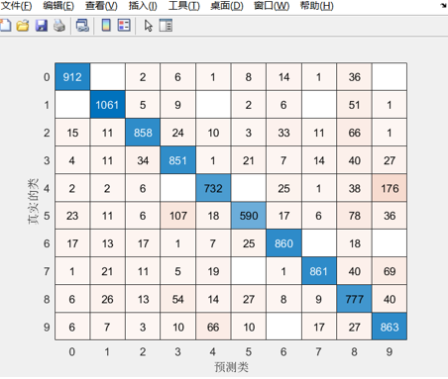
Figure1. Calculation results
Figgure2. Naive Bayes accuracy
5.3.2 Results of Support Vector Machine experiment
The calculation results and accuracy of handwritten numbers based on n Support Vector Machine are shown in Figure 1 and Figure 2 below.

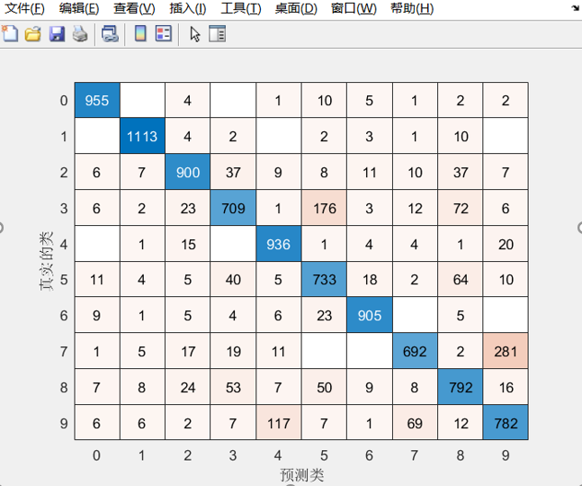
Figure3. Calculation results
Figure4. Support Vector Machine accuracy
5.3.3 Results of K-nearest neighbor
The calculation results and accuracy of handwritten numbers based on n Support K-nearest neighbor are shown in Figure 5 and Figure 6 below.

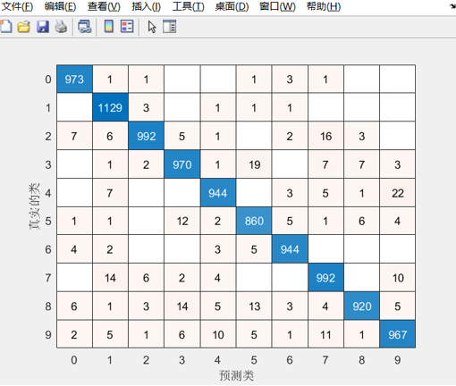
Figure4. Calculation results

Figure5. K-nearest neighbor accuracy
6. Conclusion
This paper tests the handwritten digit training set based on the above three algorithms, and the following conclusions can be drawn from the experimental test results:
As for Naive Bayes algorithm, its logic is very simple and the algorithm is relatively stable. Among the three algorithms, the calculation time of this data set is the shortest. However, if the attribute independence of the data set is poor, the classification accuracy will be reduced.
As for Support Vector Machine algorithm, it uses quadratic programming to solve the support vector, and solving quadratic programming will involve the calculation of n-order matrix (n is the number of samples), so when n is very large, the calculation is large. For this data set, it is found that matlab uses 45 2-classifications to solve the 10-classification problem. Among the three algorithms, it takes the longest time to calculate this data set and the program runs slowly, but its accuracy (85.17%) is higher than that of naive Bayes algorithm.
As for K-nearest neighbor algorithm, the mature theory, thought simple, for the training data set of time complexity is lower than support vector machine (SVM) algorithm, compared with naive bayes algorithm, presumption that there is no data, high accuracy, is not sensitive to abnormal points, but relative to the simple Naïve Bayes for this data set its large amount of calculation, the three algorithms for this data set its computation time is located in the middle, The calculation time is long, and the accuracy of this dataset is the highest (96.91%)
This article focuses on the three algorithms in-depth study, can be found that with increasing the amount of data, the accuracy of is also in constant rise, but the corresponding computing time will increase, naive bayes algorithm for this dataset computing time the shortest, but corresponding calculation precision rate is low, precisely the highest rate of K neighboring algorithm, computation time is better than support vector machine (SVM) algorithm, It is slightly higher than the naive Bayes algorithm. From two perspectives of accuracy rate and calculation time, the K-nearest neighbor algorithm of the three algorithms has the best recognition effect for this data set.

REFERENCES:
- Arica, Nafiz, Yarman-Vural, et al. Optical Character Recognition for Cursive Handwriting.[J]. IEEE Transactions on Pattern Analysis & Machine Intelligence, 2002.
- HAO, Meng-lin, TIAN, et al. The study of feature extraction of handwritten digits based on Euler algorithm[C]// 2014 International Conference on Advances in Materials Science and Information Technologies in Industry(AMSITI 2014). 0.
- Vapnik V N . The Nature of Statistical Learning Theory[J]. Springer, 1995.
- Dalal N , Triggs B . Histograms of Oriented Gradients for Human Detection[C]// IEEE Computer Society Conference on Computer Vision & Pattern Recognition. IEEE, 2005.
- Lowe D G . Object recognition from local scale-invariant features[J]. Proc.int.conf.on Computer Vision Iccv, 1999.
- Lecun Y , Bengio Y , Hinton G . Deep learning[J]. Nature, 2015, 521(7553):436.
- Liu C L , Nakashima K , Sako H , et al. Handwritten digit recognition: benchmarking of state-of-the-art techniques[J]. Pattern Recognition, 2003, 36(10):2271-2285.
- Ahlawat S , Choudhary A . Hybrid CNN-SVM Classifier for Handwritten Digit Recognition[J]. Procedia Computer Science, 2020, 167:2554-2560.
- Tuba E , Bacanin N . An algorithm for handwritten digit recognition using projection histograms and SVM classifier[C]// 2015 23rd Telecommunications Forum Telfor (TELFOR). IEEE, 2015.
- Xu J W , Xu J , Yue L . Handwritten Bangla Digit Recognition Using Hierarchical Bayesian Network[C]// International Conference on Intelligent System & Knowledge Engineering. IEEE Xplore, 2008.
- Ghadekar P , Ingole S , Sonone D . Handwritten Digit and Letter Recognition Using Hybrid DWT-DCT with KNN and SVM Classifier[C]// 2018 Fourth International Conference on Computing Communication Control and Automation (ICCUBEA). 2018.
Appendix：
SVM：
clear
clc
close all

load("train_x.mat")
load("train_y.mat")
%train_x = train_x(1:200,:);
%train_y = train_y(1:200,:); %these codes are for test run

% Onehot to number
train_label = vec2ind(train_y')-1;

class = {'0','1','2','3','4','5','6','7','8','9'};

Md1= fitcecoc(train_x,train_label,"Learners","svm");
load("test_x.mat")
load("test_y.mat")
test_label = vec2ind(test_y')-1;

predict = predict(Md1,test_x);
temp = predict-test_label';
num = 0;
for i = 1:length(test_label)
if(temp(i)==0)
num=num+1;
end
end
accuracy = num/length(test_label)
confusionchart(test_label',predict)
NB：
clear
clc
close all

load("train_x.mat")
load("train_y.mat")
%train_x = train_x(1:200,:);
%train_y = train_y(1:200,:); %these codes are for test run

% Onehot to number
train_label = vec2ind(train_y')-1;

class = {'0','1','2','3','4','5','6','7','8','9'};

Md1 = fitcnb(train_x,train_label,'DistributionNames','mn')
load("test_x.mat")
load("test_y.mat")
test_label = vec2ind(test_y')-1;

predict = predict(Md1,test_x);
temp = predict-test_label';
num = 0;
for i = 1:length(test_label)
if(temp(i)==0)
num=num+1;
end
end
accuracy = num/length(test_label)
confusionchart(test_label',predict)
KNN：
clear
clc
close all

load("train_x.mat")
load("train_y.mat")
%train_x = train_x(1:200,:);
%train_y = train_y(1:200,:); %these codes are for test run

% Onehot to number
train_label = vec2ind(train_y')-1;

class = {'0','1','2','3','4','5','6','7','8','9'};

Md1= fitcknn(train_x,train_label,"NumNeighbors",1,"ClassNames",class);
load("test_x.mat")
load("test_y.mat")
test_label = vec2ind(test_y')-1;

predict = predict(Md1,test_x);
predict = str2num(cell2mat(predict));
temp = predict-test_label';
num = 0;
for i = 1:length(test_label)
if(temp(i)==0)
num=num+1;
end
end
accuracy = num/length(test_label)
confusionchart(test_label',predict)

