Changemakers: creativity and value creation (BMBM5020)
E-PORTFOLIO

MUKUL BAKKOLLA
2220398
UNIVERISTY OF WALES TRINITY SAINT DAVID
14-DECEMBER-2024
Table of Contents
1. Formulating Research Question 2
Identifying the issue or problem 2
Value of the research 2
Research approach 3
2. Primary & secondary research techniques 4
Primary method- 4
3. Present your Ideas 4
Reflection 4
4. Data analysis 5
Conference poster 6
5. References 8
6. Interview Questionnaire 10
Marketing's Role in Sainikpuri’s Business Success 10
6.1 Concu answers 10
6.2Bayleaf Bistro answers 11
6.3 Coffee cup answers 12

Formulating Research Question

“How does marketing influence the success of a business in highly competitive location?”

Identifying the issue or problem
Businesses operating in highly competitive locations often struggle to differentiate themselves and achieve sustainable growth. Even if they have good products or services, they might not be able to get enough of the market if their marketing strategies don't work or aren't carried out well. Important because it has a direct effect on a business ability to stay in business, keep customers, and make money. The chosen topic was based on an underlying problem with our restaurant. which is situated in a highly competitive neighbourhood consisting of over 20 restaurants, all in a radius of 2 km. These include newcomers to the field, competing against corporate giants and establishments that have been dominating the area for over a decades. As one of the newcomers to the area, our unique selling point was the rooftop dining area with live music every weekend and a newly curated menu by a famous chef, which included some of the popular dishes that were not found commonly. Although we have become a prominent brand in our locality, we had great difficulty gaining new customers and reaching more people. One of the most important aspects of growth is the acquisition of new customers, and marketing plays an essential part in this process said Voicu (2024). This is when we began focusing on digital marketing. Restaurants need marketing to attract customers, establish brand loyalty, and enhance exposure. Effective marketing may set your restaurant apart and build brand recognition. Says Jeremy (2024) Making interesting content, running online ads, and working with influencers can help the restaurant's online profile a lot and bring in more customers. Says Chowbus (2024); in this report we will find out how important marketing is in our locality and how much impact it has on the business. Is it the only strategy that aids in attracting new customers? What is the level of importance it has to be given? and we will try to understand how marketing impacts a business in a highly competitive area.

Value of the research
The outcomes of this research can deliver practical strategies for small-to-medium enterprises (SMEs) aiding them in refining their marketing approaches to enhance performance. Additionally, it has the potential to better academic understanding by analysing the relationship between marketing initiatives and business success within highly competitive industry. This Research will help our restaurant plan the next marketing mix efficiently, and effectively and help us understand if we should focus on any other aspects towards gaining new customers.

Research approach
We will be using an abductive research approach to understand the following topics: We will gather the information qualitatively by conducting interviews. We will be interviewing three restaurant marketing or management teams: 1) Bayleaf Bistro, a newcomer to the market; 2) Coffee Cup, an established player in the street; and 3) Concu, a branded cafe with a branch in our locality.

Primary & secondary research techniques

Primary method-
I will be using interviews as my primary research technique where I will be interviewing 3 restaurants in the same locality with completely different backgrounds of each. Why interviews because With interviews, we can get more detailed information from a small group of people about: Personality, Behaviour, Likes, Dislikes, Feelings, Attitudes, Opinions, and Knowledge.
Interviews are the best way to do qualitative research because they help you explain, better understand, and look into the thoughts, actions, feelings, phenomena, etc. of the people you are researching.
Most interview questions are open-ended so that the person being interviewed can give a lot of information. Says Virginia Tech (2023)

Present your Ideas

elevarors pitch 1.mov

Link to the elevators pitch.

( feedback- Hi Mukul I have seen your video really good information about Sainikpuri, really shocked with the intense competition you have in that small neighbourhood, It was clear of the information you got out of your productive interviews and made lot of sense loved the way you put it out in the video, you did stumble but overall good job. But the analysis part I was kind of expecting more of your views to it or suggestions you will have for the restaurants in the neighbourhood to follow, Try to cover these topics next time and thank you for giving me the opportunity to give you feedback. Yours faithfully, Sejal Ahuja. )

Reflection

Thanks for taking the time to watch and comment on my elevators pitch about a restaurant in Sainikpuri. Thank you very much for appreciating the study, interviews, and information I gave you. It is interesting that you noticed how competitive things are in such a small neighbourhood. The restaurants in Sainikpuri are one of a kind because of the competition in the neighbourhood and serve a wide range of cuisines However, I agree with your idea that I should have shared more of my personal insights and give useful restaurant suggestions in my opinion. You make a good point. I know that while I did a good job of sharing objective results from the interviews, my own voice and analytical point of view could have given the conversation more meaning.
In future videos, I'll try to find a good mix between telling analytics and giving strategic advice. For example, restaurants in Sainikpuri could focus on phone/Email marketing and build better relationships with their regular customers. They could also try new ways to work together, such as pop-ups or community events, to set themselves apart. I could also look at new dining trends and offer ways that local businesses could change to stay competitive. Your feedback also shows how important it is to make sure that material matches what viewers expect. After thinking about this, I'm going to try to organise my videos in a more strategic way, with parts for personal reflection and clear takeaways for viewers. This will make sure that the narrative is better and more interesting. Once again, thank you for your helpful comments. I'm excited to work on these things in my next project.

Data analysis

Concu, Bayleaf Bistro, and Coffee Cup adopt different marketing strategies.
Through high-quality products, social media aesthetics, and word-of-mouth, Conçu succeeds in organic growth. Instagram is their main marketing platform because of their quality desserts and aesthetics. Conçu maximises marketing effectiveness with less cost by prioritising quality and customer-shared content.
However, Bayleaf Bistro markets events and communities. Rooftop dining, live music, and influencer collaborations create a vibrant view. Their use of Google Business to boost local presence and focus on unique events like open mics set them apart in a congested field. A somewhat bigger marketing budget lets them run different campaigns and promotions.
The oldest of the three, Coffee Cup, emphasises reliability. They use Instagram and Facebook to show comfortable ambience and delicious food to keep customers. Free samples to promote new cuisines show their customer-centric approach, despite their low marketing cost.
All three choose quality over price, showing that consistent quality and client experiences are crucial to long-term success in Sainikpuri competitive market.
According to the research by(Ahmad, Abdul Rahman and Abdul Kadir, 2024) customer trust and relations is very important to get a competitive edge.
According to Occhiogrosso (2023) Considering social media in local marketing. Restaurants may reach local customers on Facebook, Instagram, and Twitter with geo-targeted ads, hashtags, and community content. These platforms provide direct customer connection, exclusive offers, local events, and feedback and reviews.
According to the research by (Nasir, 2015) In a hard and competitive economy, enterprises must identify methods to enhance the effectiveness of marketing efforts and maximise returns on marketing investments. Marketing techniques that allow organisations to perform well and overcome the challenges of difficult periods can be identified as follows The focus on Customer Retention, Consumer Insights, Explore Alternatives to Price Reduction, Maintain Marketing and Advertising Campaigns. Which is seen in the case of the three restaurants we have interviewed that they do follow the following tools, To overcome obstacles and achieve organisational success in a competitive business environment.

Conference poster

(link for a clear conference poster)
.

Untitled (2).pdf

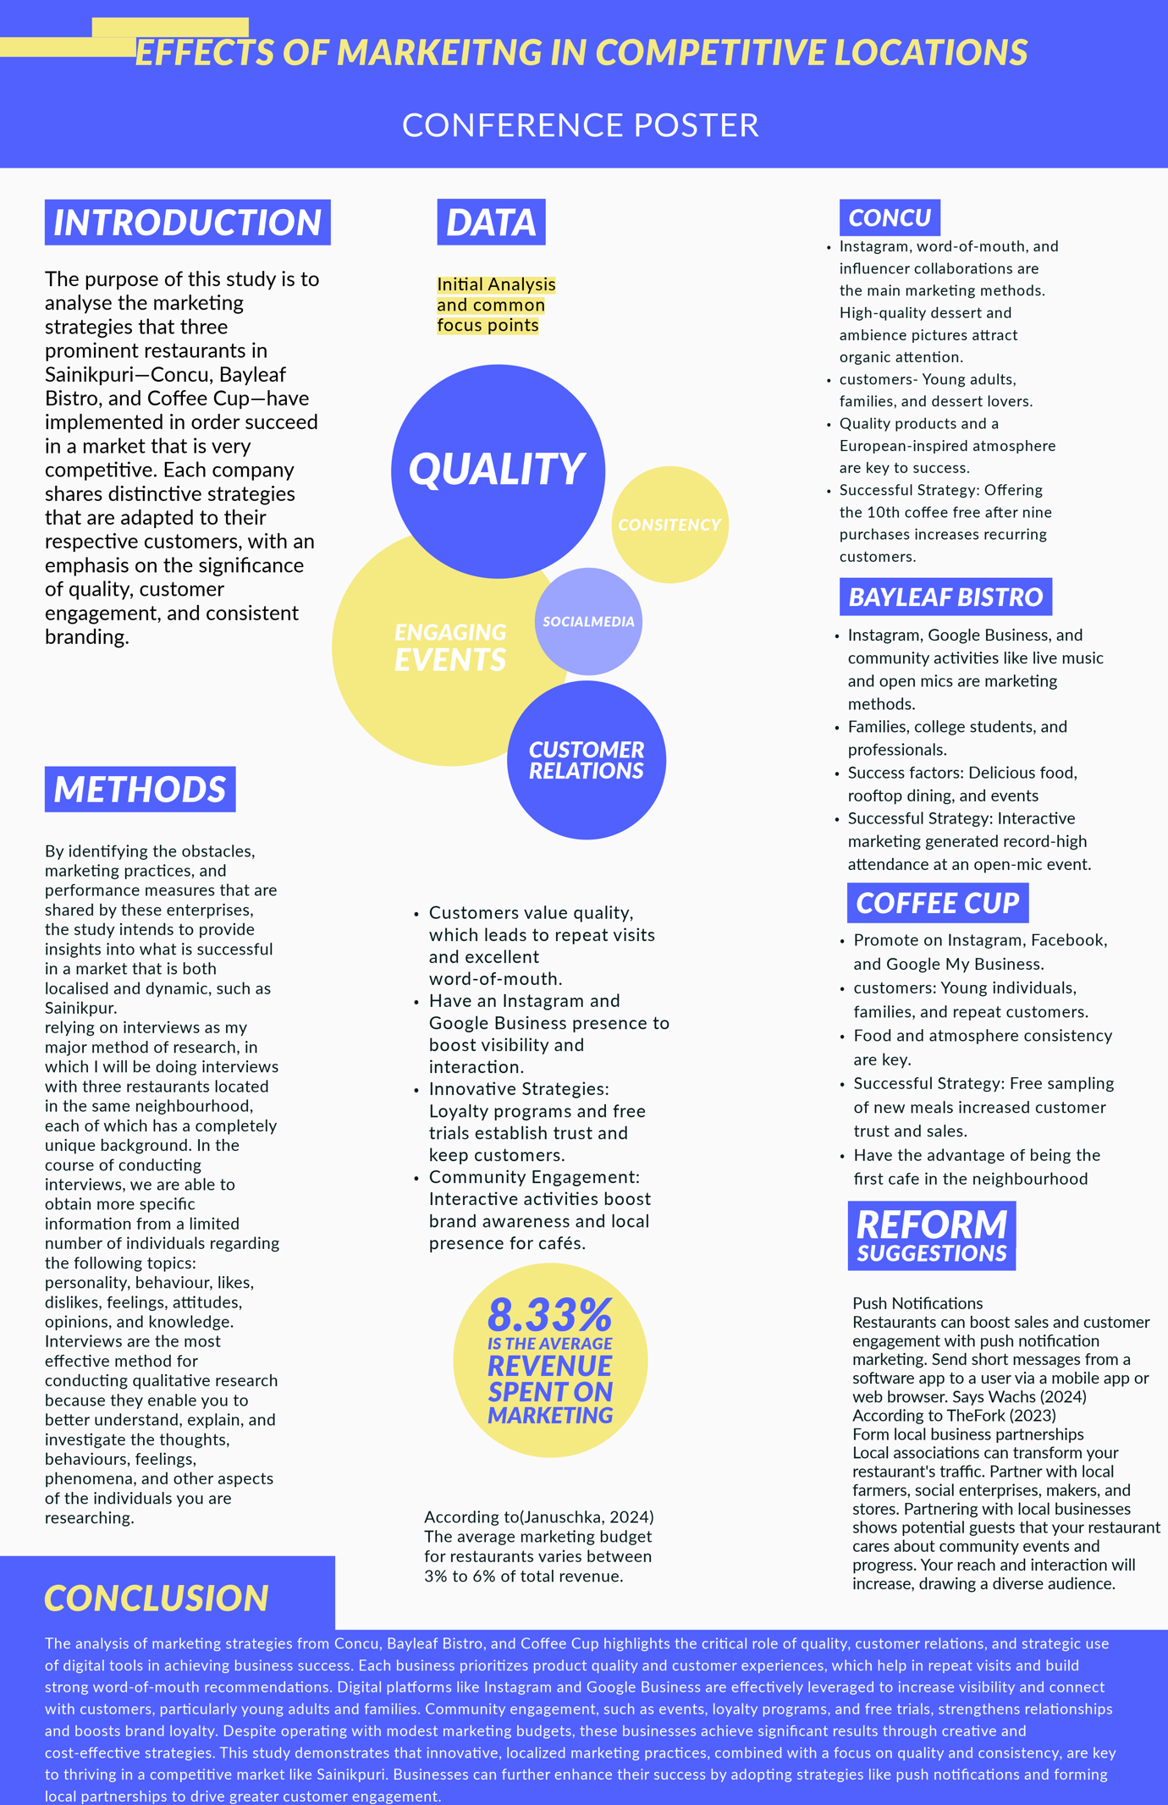

References
Ahmad, Z., Abdul Rahman, M. and Abdul Kadir, K. (2024). Sustainability Marketing as Restaurants’ Business Strategy in the New Norm. International Journal of Academic Research in Business and Social Sciences, [online] 14(1). doi:https://doi.org/10.6007/ijarbss/v14-i1/20636. [Accessed 13 Dec. 2024].
Chowbus (2024). Digital Marketing for Restaurants: 15 Best Practices. [online] Chowbus POS. Available at: https://pos.chowbus.com/blog/article/digital-marketing-for-restaurants [Accessed 13 Dec. 2024].
Januschka, L. (2024). Average Marketing Budget For A Restaurant: Breakdown & Tips. [online] Restaurant Growth. Available at: https://www.restaurantgrowth.com/blog/average-marketing-budget-for-restaurant/ [Accessed 13 Dec. 2024].
Jeremy (2024). The Importance of Marketing for Restaurants: Unveiling the Recipe for Success. [online] Available at: https://restaurantresults.co/the-importance-of-marketing-for-restaurants/ [Accessed 13 Dec. 2024].
Nasir, S. (2015). Marketing Strategies in Competitive Markets and Challenging Times. Advances in Marketing, Customer Relationship Management, and E-Services, [online] pp.1–24. doi:https://doi.org/10.4018/978-1-4666-8231-3.ch001.
Occhiogrosso, G. (2023). Restaurants Are Shifting Their Attention Back To Local Marketing. [online] Forbes. Available at: https://www.forbes.com/sites/garyocchiogrosso/2023/08/09/why-restaurants-are-shifting-their-attention-back-to-local-marketing/ [Accessed 12 Dec. 2024].
TheFork (2023). How to attract more customers? 12 marketing tips! | TheFork Manager. [online] Theforkmanager.com. Available at: https://www.theforkmanager.com/en-gb/blog/how-attract-more-customers [Accessed 13 Dec. 2024].
Virginia Tech (2023). Research Guides: Research Methods Guide: Interview Research. [online] Vt.edu. Available at: https://guides.lib.vt.edu/researchmethods/interviews [Accessed 12 Dec. 2024].
Voicu, L.-A. (2024). 10 Restaurant Customer Acquisition Strategies That Will Boost Growth. [online] GloriaFood Blog. Available at: https://www.gloriafood.com/restaurant-customer-acquisition [Accessed 13 Dec. 2024].
Wachs, D. (2024). 11 Restaurant Marketing Strategies That Work in 2022. [online] Restaurant Management & Growth Blog. Available at: https://www.7shifts.com/blog/restaurant-marketing-strategies-and-tips/ [Accessed 13 Dec. 2024].

Interview Questionnaire

Marketing's Role in Sainikpuri’s Business Success
- What marketing methods do you use to attract customers in a competitive market?
- How do you know if your marketing is helping your business?
- Do you use digital marketing like social media or websites?
- who your main customers are?
- How much of your earnings do you spend on marketing?
- What challenges have you faced in making your business stand out?
- Do you believe pricing or quality impacts your marketing effectiveness?
- Can you share an example of a marketing idea that worked really well for your business?
- What feedback do you get from customers about your marketing, and do you make changes based on it?

6.1 Concu answers

- What marketing methods do you use to attract customers in a competitive market?
At Conçu, we rely heavily on word-of-mouth, social media platforms like Instagram, and collaborations with local influencers. We also focus on the visual aesthetics of our desserts and cafe ambience, which naturally draws the attention of our customers and they tend to share the photos online.
- How do you know if your marketing is helping your business?
We take note of customer feedback in which we have a section on how did you hear about us, social media engagement, and the number of new customers visiting the cafe. The increase in footfall after a campaign or social media post also helps us measure success.
- Do you use online marketing like social media or websites?
Yes, Instagram is our main platform. We post high-quality images of our desserts and showcase seasonal or festive offerings. We also use our website to share the menu and special offers or baking classes which we offer.
- Who your main customers are?
Most of our customers are young adults, families, and sweet tooths.
- How much of your earnings do you spend on marketing?
A small percentage, around 5-10%, is allocated for marketing. Most of our growth has come organically through quality products and customer experiences which are shared by them through social media.
- What challenges have you faced in making your business stand out?
The cafe scene in Sainikpuri is growing rapidly, so staying unique is a challenge. We focus on our handcrafted desserts, European-inspired ambiance, and consistent quality to stand apart.
- Do you believe pricing or quality impacts your marketing effectiveness more?
Quality yes. While pricing is important we have the reputation of being the priciest café in Sainkpuri, our customers are willing to pay the premium price for our quality and taste. High-quality desserts bring repeat customers and create a buzz around our brand.
- Can you share an example of a marketing idea that worked really well for your business?
We have a coffee scheme, where you buy 9 coffees in store the 10th coffee is on us this draws a lot a customers to come in regularly for coffee. Which has been very successful.
- What feedback do you get from customers about your marketing, and do you make changes based on it?
Customers often tell us they found us through Instagram or from a friend’s recommendation. They love seeing more behind-the-scenes content, so we’ve started sharing videos of how our desserts are made.

6.2Bayleaf Bistro answers
- What marketing methods do you use to attract customers in a competitive market?
At Bayleaf Bistro, we focus on social media marketing, especially Instagram and food influencers to showcase our rooftop seating and our special menu. We use google business tools to enhance our restaurant in google search, We also engage with the local community through events and collaborations. Word-of-mouth has been powerful for us as well and our food sets us apart from everyone.
- How do you know if your marketing is helping your business?
We monitor customer footfall, online reviews, and engagement on our social media platforms. When customers mention they found us online or through a friend’s recommendation or have seen an influencer reel, we take note of the information to keep track of the progress. which is when we know our efforts are paying off.
- Do you use online marketing like social media or websites?
Yes, Instagram is our primary tool. We post pictures of our food, drinks, and cafe events. We also use Google Business to reach our local audience and share updates or special offers.
- who your main customers are?
Our main customers are families, college students who come in after their college to catch up with their friends in the evenings, and working professionals who have a safe and calm place to work with good food options. We observe their preferences through orders, feedback, and conversations, which helps us refine our offerings.
- How much of your earnings do you spend on marketing?
We allocate around 10% of our revenue for marketing. Most of it goes into social media ads, professional food photography, and running special promotions.
- What challenges have you faced in making your business stand out?
The Sainikpuri area has many great dining options, so standing out is tough. Our focus has been on maintaining high-quality food and rooftop dining with live music at the weekends. Building relationships with our customers has been key to retaining them.
- Do you believe pricing or quality impacts your marketing effectiveness more?
Quality, without a doubt. While competitive pricing helps, it’s the taste, freshness, and presentation of our food that keeps customers coming back. Happy customers are our best marketers. However, to attract more customers we offer special meal deals in the afternoons which are very affordable compared to our competitors.
- Can you share an example of a marketing idea that worked really well for your business?
We recently held an open mic event where anybody could come up to the stage and sing, which had drawn a lot of upcoming artists to the restaurant, resulting in a big event in the area, which got us a record-high amount of footfall in a day.
- What feedback do you get from customers about your marketing, and do you make changes based on it?
Customers appreciate our engaging social media posts, But asked for more live music nights and special offers. So in our capacity we have increased the number if events we conduct in a week. and started the new concept of special offers throughout our social media posts.

Coffee cup answers

- What marketing methods do you use to attract customers in a competitive market?
At coffee cup , we focus on Instagram and Facebook to showcase our food and cozy seating areas. We also run special promotions like weekday discounts
- How do you know if your marketing is helping your business?
We pay attention to customer feedback, track footfall during promotional events, and observe engagement on our social media posts.
- Do you use online marketing like social media or websites?
We use Google My Business to ensure we’re easy to find and well-reviewed. We also use Instagram and facebook to keep our customers updated on our new offers or food additions.
- who your main customers are?
Most of our customers are young adults, families, and food enthusiasts who appreciate a mix of good food and great ambiance.
- How much of your earnings do you spend on marketing?
We allocate about 5% of our revenue to marketing. This includes social media ads, collaborations with influencers, and creating attractive content for our platforms.
- What challenges have you faced in making your business stand out?
Sainikpuri is a trending neighbourhood in Hyderabad. We are the oldest cafe in the area starting from day-to-day operations with no customers to having two branches now. Our consistency in food and ambience is what sets us apart.
- Do you believe pricing or quality impacts your marketing effectiveness more? Why?
Quality, without a doubt. While we ensure our prices are competitive, it’s the quality of our food and service that keeps customers talking about us and bringing their friends along.
- Can you share an example of a marketing idea that worked really well for your business?
when we started a new cuisine customer did not believe we would get it right so we gave out free samples to try and it got customers to come back again just for that dish
- What feedback do you get from customers about your marketing, and do you make changes based on it?
Customers are happy with the engagement we have.

