Module : BMSS5007
Developing your Professional Profile

Modiwl : BMSS5007C
Datblygu eich Proffil Proffesiynol



Asesiad / Assessment :
E-portfolio prep for CPD / Work

Gan / By: Lucy Richards

Arweinydd Modiwl / Module lead : Heddwen Davies

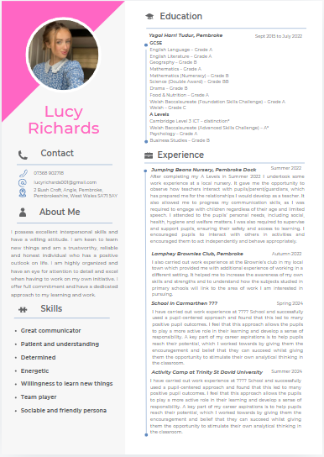
Llythyr
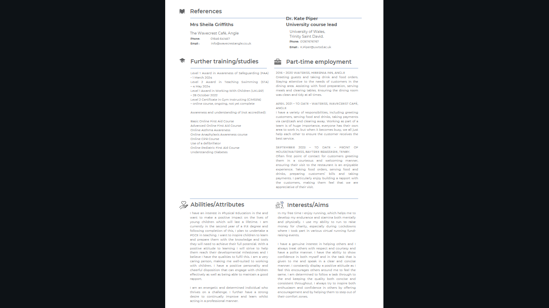

Lucy Richards
2 Bush Croft
Angle
Pembroke
Pembrokeshire
SA71 5AY

13th October 2024
Haverfordwest Primary School
Haverfordwest
Pembrokeshire
SA61 2NX

Dear Sir/Madam,

As a newly-qualified teacher with experience of working in a primary school setting I would very much like to be considered for the role of PE Teacher for girls at Haverfordwest Primary School – please find my CV attached. I feel I would be well-suited to the role as I have a strong passion for inspiring and educating young minds and feel that the nature of my work so far in education has prepared me ready for this position.

My interest in Physical Education stimulated me to take on a PE teaching role at Trinity of St David University’s Summer Camp. My role was to devise and lead activities over a 4-week period to stimulate and encourage pupils and to teach them how exercise can be rewarding and fun! I taught an age range between 5-15yrs of mixed abilities which required me to create and adapt activities which were suitable for all. As part of this, I had to liaise with my peers and also senior staff meaning that I have also developed skills in communication and leadership. I faced some challenges along the way, such as dealing with anxious and introvert pupils and overcame them by offering encouragement and praise when needed. The impact overall was very positive, and this was measured by the feedback received from both the pupils and parents by the end of the camp.
I have a Bachelor of Education degree in PE and have experience teaching across the primary school age range with a strong understanding of the UK curriculum. I am committed to creating an engaging and stimulating learning environment for my pupils, and I have a proven track record of motivating and encouraging pupils to make good progress.
In addition, I have carried out work experience at the model School, in Carmarthenshire and successfully used a pupil-centred approach and found that this led to many positive pupil outcomes. I feel that this approach allows the pupils to play a more active role in their learning and develop a sense of responsibility. A key part of my career aspirations is to help pupils reach their potential, which I work towards by giving them the encouragement and belief that they can succeed whilst giving them the opportunity to stimulate their own analytical thinking in the classroom.
I have also completed the STA Level 2 Award in Teaching Swimming. This allows me to teach the essential swimming skills, water safety and all four keystrokes. I can plan, deliver, assess and evaluate lessons for both adult and child participants, helping them to develop, both as swimmers and individuals in the aquatic environment.
I am particularly excited about the opportunity to join Haverfordwest Primary school because of its reputation for providing a high-quality education and its commitment to creating a positive and inclusive learning environment. I align with the school’s values, and I am confident that my skills and experience make me a perfect fit for the position.
As shown by my experience, I am enthusiastic about education and always strive to do the best for my pupils. I am able to take on responsibility for learning and have experience of successfully managing a class. I also have the enthusiasm and determination to ensure that I make a success of this role.

I am available for an interview at your convenience and would welcome the opportunity to discuss how I can contribute to the success of your school. Thank you for considering my application and I look forward to hearing from you.
Yours faithfully

Lucy Richards
Lucyrichards001@gmail.com
07368 902718

Focus Statement

My career ambition is to become a Physical education teacher, either in a primary or secondary school setting. I am motivated to equip others with the tools are resources to pursue the life they want to live, and for them to be happy and healthy individuals. From my own experience, Physical educators play such a crucial role in the development of healthy habits in youngsters and pave the way for a lifelong love for movement, sport and exercise. My love for sport and movement and my passion for healthy living, are all reasons I believe this would be the perfect job for me.

SWOT analysis

My strengths in reliability and work ethic I think put me in good stead to make a good teacher. As a teacher, it is vital that parents and pupils can rely on you and trust that your thinking in the best interests of the pupils. My strengths in communication and a good understanding of individuals and their specific needs is also something that will be of benefit. As a teacher, you need to be able to gauge certain individuals, and find what’s best for them, and also try to understand certain behavior patterns and why they are occurring,

My weaknesses in IT and digital skills may be problematic in a teaching position, because as the world is becoming more digitalized, IT is going to become more and more part of the school and curriculum. However, I am confident in basic IT and things like digital registration and creating PowerPoints and work online would all be achievable. Also with the PE curriculum mostly being practical based, I don’t think this will be too much of an issue in this profession. But to improve, I am going to attend some workshops held by my university, on IT and software skills.

A major opportunity of mine that could be utilized in a PE teaching setting would be my experience in athletics and swim teaching. These are two areas of sport I am passionate about in my personal life, and therefore believe I could help influence children to become excited by these. Also, my ability to teach swimming is critical, especially in a primary setting, as many children have very basic, or no swimming ability. Swimming is a crucial skill to develop and prevent life loss in unforeseen situations.

One of my threats would be my inability to project my voice. Also having good control of my class and the confidence to maintain their attention. I feel I could overcome this by undertaking a course in public speaking, but also just having more experience in the classroom, to allow me to figure out the best way for me to gain class control.

Training Needs Analysis

Main skill requirements of job | Relative importance (0-10) | Self-rating (0-10) | Training needs
Enthusiastic and motivating towards children, especially to take up new sports | 10/10 | 7/10 | Learn more in depth about other sports, so that I feel more confident delivering them. Obtain level 1 qualifications in Rugby, Football etc:
Punctual and excellent time management | 10/10 | 6/10 | Will work on my punctuality skills as I am often late. I am going to start using to-do lists and prioritize my tasks in order of importance.
Effective planning skills | 10/10 | 7/10 | Planning skills are of paramount importance in a teaching role as it is essential you have your lessons planned and ready for your classes. To work on this, I will practice planning lessons for my upcoming work experience placements in schools.
Great communication skills | 10/10 | 9/10 | I believe I already have strong communication skills having worked in customer facing jobs for many years. However, I will continue to practice these skills and make them more relevant to a job teaching, through work experience in schools whereby I will need to communicate effectively with students.

SMART targets

Specific: My goal is to become a successful PE teacher who will inspire the next generation and make a positive difference in students’ lives. My aim is to create a positive learning environment where students feel motivated to explore and understand the subject of PE. I want to improve students' physical activity and prepare them for future challenges.
Measurable: I will be able to measure how well I am going to progress my knowledge as I will complete some Level 1 courses in different sports. At the end I will have gained additional knowledge and will see how much more confident I’ll feel about teaching it.
Attainable: My goal is relevant to my career ambition as I have already successfully learned the basics of teaching and would like to strengthen my abilities further. I believe my goal to become a PE teacher is achievable because I am already studying a PE degree and have plans to undertake a PGCE qualification afterwards.
Relevant: I will set a goal to improve the number of hours spent volunteering in a School as this will give me the necessary experience to become a successful PE teacher.
Time-Based: I will attend a 1-year football coaching course as this is a sport I am unfamiliar with. This will make me more employable and I will have completed it by the time I have finished my PE degree and PGCE.

Concluding comments

To summarize, in order to achieve my ultimate goal of becoming a PE teacher, it is apparent to me that that there are many weaknesses I need to address before embarking on this career. Completing CPD courses, increasing my hours of teaching experience, and working on my confidence and time management will ultimately help me to achieve this. Although I do have certain areas which require improvement, I do believe my current qualities put me in a good position and will be valuable to my teaching career.

Word count – 1576

Appendices

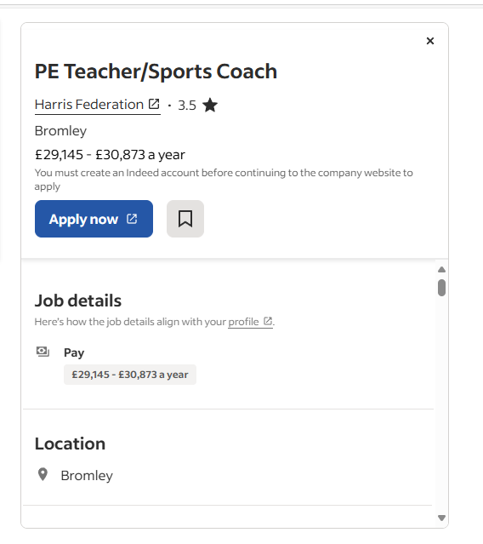
Job advertisement

SWOT analysis

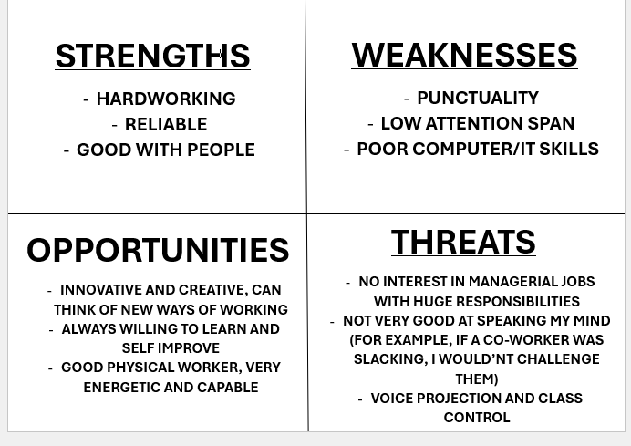

Reference list

Hughes, R (2023). ‘How to set SMART goals to advance your career’. One Education. (Accessed on 31/10/2024). How to Set SMART Goals to advance your Career – One Education

Schnitzius, M., Kirch, A., Spengler, S., Blaschke, S. and Mess, F., 2021. What makes a physical education teacher? Personal characteristics for physical education development. British Journal of Educational Psychology, 91(4), pp.1249-1274.

