Job Advertise
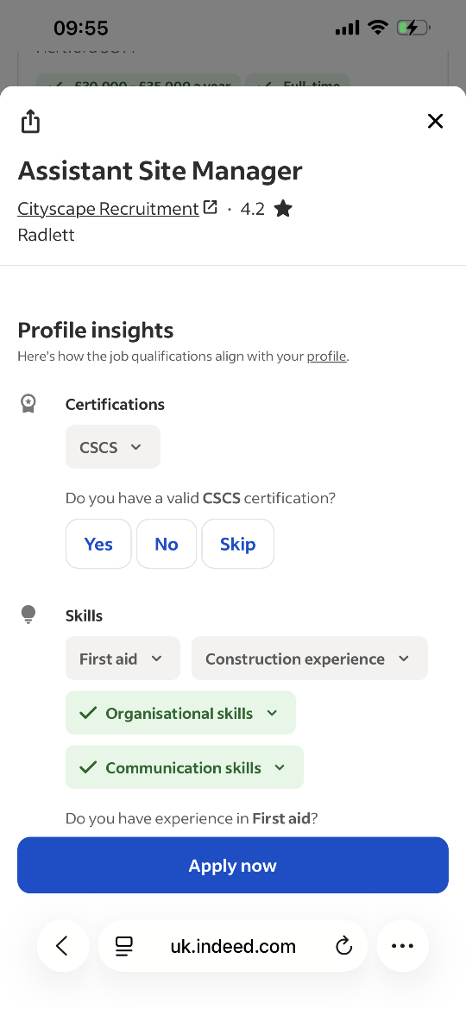
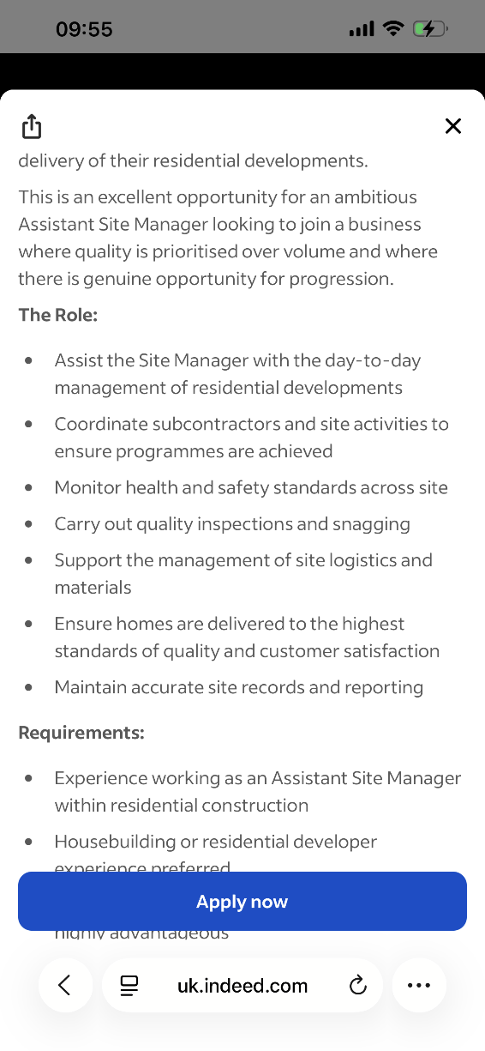
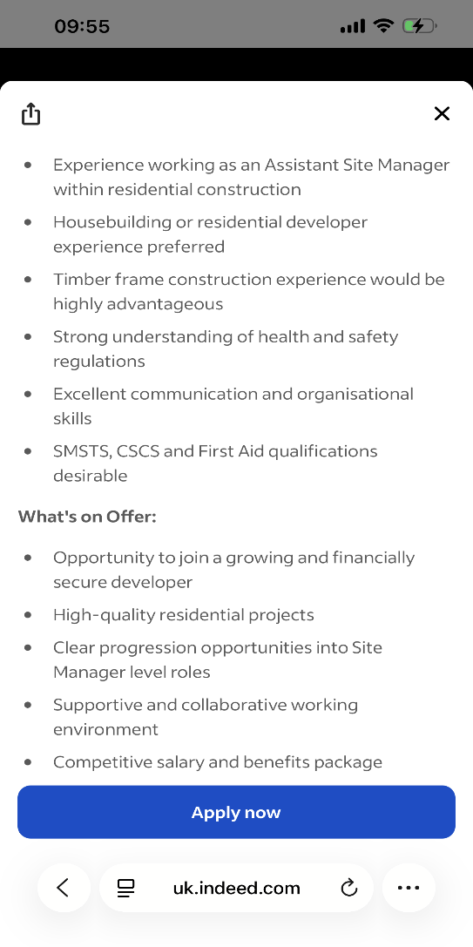

YAROSLAV ZHENCHUK
2514092@student.uwtsd.ac.uk

Personal Profile
Experienced construction professional with over 15 years of experience in the building industry, including maintenance supervision, multi-trade work and façade construction. Skilled in coordinating subcontractors, caring out site inspections, quality checks and ensuring health and safety standards are maintained. Currently developing business and management skills through studies at the University of Wales Trinity Saint David. Looking to progress in Cityscape Recruitment from a trade background into an Assistant Site Manager role, bringing strong practical knowledge, reliability and a hands-on approach to site management.

Key Skills
- Site supervision and daily site coordination
- Subcontractor coordination
- Health & Safety compliance
- Site inspections and quality checks
- Snagging and defect management
- Reading and understanding drawings
- Maintenance and refurbishment projects
- Construction problem solving
- CSCS Green Card holder
- Asbestos Awareness certified

Professional Experience
06/2025-Present
BTS Interiors Ltd
Maintenance Supervisor
London
- Supervise maintenance work across council projects.
- Coordinate subcontractors and ensure works are completed safely and to required standards.
- Carry out site inspections, quality checks and snagging activities.
- Support planning of daily tasks and resolve site issues efficiently.
04/2022 – 06/2025
Tenfold Close Ltd
Multi Trader
London
- Completed multi-trade repairs and refurbishment works for insurance projects.
- Worked from drawings and specifications to deliver quality workmanship.
- Identify defects, completed snagging and ensured customer requirements were met.
- Maintained high standards of health and safety on site.
08/2005-03/2022
Globus Construction Ltd
Façade Construction Worker
Lviv, Ukraine
- Worked on façade installation and external building works.
- Developed strong knowledge of construction processes and site operations.
- Worked alongside different trades and subcontractors to meet project deadlines.
- Followed site safety procedures and quality requirements.

Education
University of Wales Trinity Saint David
Certificate of Higher Education
Business Skills for the Workplace
10/2026 to Present
Languages
- Ukrainian- Native
- English – B1
- Polish-B2
- Russian-C1
References available on request

Yaroslav Zhenchuk
Chelmsford
18th July 2026
CityScape Recruitment
43 High St, Rickmansworth WD3 1ET

Dear Hiring Manager,
I am writing to express my interest in the Assistant Site Manager position. I have over 15 years of experience working in the construction industry, with a strong background in maintenance supervision, multi-trade works and façade construction.
Throughout my career, I have developed practical knowledge of the site operations, including coordinating subcontractors, carrying out site inspections, completing quality checks, managing snagging and maintaining health and safety standards. My current role as a Maintenance Supervisor involves supervising works on council housing projects, ensuring tasks are completed safely, efficiently and to a high standard.
After many years working in trade roles, I am now looking to progress into site management. I believe my hands-on construction experience gives me a strong understanding of the challenges faced on the site and allows me to communicate effectively with trades, subcontractors and management teams.
I am currently studying Business Skills for the Workplace at the University of Wales Trinity Saint David, which is helping me further develop my management and organisational skills. I also hold a CSCS Green Card and Asbestos Awareness certification.
I am a reliable, hardworking and motivated construction professional who is ready to take the next step into an Assistant Site Manager role and contribute positively to your team.
Thank you for considering my application. I would welcome the opportunity to discuss how my experience and skills could benefit your company.

Yours faithfully,
Yaroslav Zhenchuk

