Introduction
This poster examines the key concepts of health, well-being, and lifestyle in early childhood, highlighting how lifestyle influences a child’s health and development. It also explores the practitioner’s role in supporting these areas, insights from relevant theorists, and the resources available to promote and sustain children’s health and well-being.
According to UNICEF (2022) and Save the children 2018), Article 24 of the UNCRC states that all children have the right to the best possible healthcare and to physical and emotional well-being. This includes access to nutritious food, medical care and a safe environment for a healthy start in life.
Health
The World Health Organization (2025) defines health holistically, covering physical, mental and social well-being beyond just absence of illness. It stresses everyone’s right to health without discrimination based on gender, race, culture or status. Early infancy is crucial, with investments in nutrition, care, education and strong parent-child bonds benefiting individuals and society. Caring, safe and culturally respectful environments are essential for healthy development and lifestyles.
Moreover, The World Health Organization (1986) defines health as meeting obligations and goals while adapting to one's environment, emphasizing physical and social aspects, which is crucial for supporting children with health issues in early learning settings.
Additionally, Marmot (2010) explains health as a social construct influenced by age, occupation, living conditions, and birth. Both mental and physical health matter and social factors are crucial for improving outcomes.
Positive early experiences and quality programmes support healthy development, while socioeconomic status and healthcare access impact holistic well-being.
According to (WHO, 1986; Tickell, 2011), early childhood health and self-care are essential foundations for lifelong well-being, supporting physical growth, emotional and cognitive development, and social and learning skills Through active play and education, children learn the importance of exercise, healthy eating, safety, and hygiene, which helps reduce obesity and chronic disease risk while promoting healthier lifestyles and academic success.
The Parliamentary and Health Service Ombudsman (2015) explains that government and disability advocates are adopting the social model of disability, focusing on accessibility and inclusion. This changes the view of disability from a personal issue to a societal one, emphasizing the social environment over individual limitations.
Furthermore, Musgrave (2017) highlights that health is a complex concept without a single definition and stresses the importance of understanding health determinants such as environment, socioeconomic status, education, and relationships especially in early childhood. Practitioners can support children’s development by recognizing and addressing these factors to create inclusive environments.
Berlinski & Schady (2015) argue that one of the major obstacles to early childhood health is economic status, which frequently prevents children from low-income families from having access to basic resources like good healthcare, nutritious foods and educational opportunities. According to the Children's Commissioner for Wales (2024), approximately 30% of children in Wales are living in poverty, with around 26% of these children residing in households where at least one adult is employed.
Likewise, Mwangi et al. (2021) identify barriers to healthcare for children with neurological impairments, including financial costs like transport and long distances limiting visits. Limited resources and low caregiver health literacy reduce awareness of services. Cultural beliefs, such as attributing impairments to curses, and stigma discourage care-seeking. Domestic duties and confidentiality concern also restrict access. Addressing these barriers is vital to improve care quality and availability.
Moreover, Hesketh, Lakshman, and van Sluijs (2017) stress the need for improved nutrition and physical activity education to combat rising childhood obesity. Parental understanding is crucial, but barriers such as limited time, finances and unhealthy family environments hinder children’s activity and diet. Public Health Wales (2024) reports 11.4% of 4-5-year-olds were obese and 13.4% overweight in 2022-2023.
However, Jackson and Third (2023) noted early childhood facilities have several challenges, including insufficient finance, inadequate training and a lack of essential resources such specialised equipment. These challenges make it more difficult to provide comprehensive and equitable care since financial assistance is sometimes insufficient to meet the various needs of children.
Wellbeing
Berlinski & Schady (2015) define early childhood well-being as physical health, emotional stability, social skills, and cognitive development, emphasizing nurturing relationships, secure environments, and supportive educational experiences for resilience and long-term positive outcomes. Well-being is viewed as a state of overall health, emotional balance and personal fulfilment.
Moreover, Statham and Chase (2010) define well-being as the overall quality of life, characterized as a dynamic state that improves through achieving social and personal goals. It includes both subjective elements, such as happiness and satisfaction and objective factors like financial stability and education.
Furthermore, Hong, Ra and Jang (2014) claims well-being as a general sense of life satisfaction that includes emotional, psychological and social aspects. It involves the ability to handle stress, build healthy relationships, and experience satisfaction, joy and purpose. Well-being ultimately means feeling happy, valued and connected to a community in daily life.
Additionally, Early childhood is crucial for emotional and psychological stability, according to Chan and Hazan (2022), who also maintain the importance for strong bonds and supportive surroundings. In addition, they note at how negative childhood experiences can cause long-lasting mental health problems.
Bracknell Forest Council (2024) defines social well-being in early childhood as developing social skills, forming healthy relationships, following social norms, and building confidence and resilience in new situations. Emotional well-being involves children's ability to understand, manage, and express emotions, and to show self-control when needed.
Manning-Morton (2014) stresses that well-being in early childhood is essential for encouraging risk-taking, managing emotions and forming strong relationships. It also fosters kindness and empathy and builds confidence, allowing children to express their feelings and thoughts more freely.
Yates et al. (2008, cited in Darling-Churchill & Lippman, 2016) state that early social and emotional development involves safe interactions, healthy emotional expression and exploring cultural and social environments. However, Darling-Churchill and Lippman (2016) note challenges in assessing well-being due to developmental differences and unclear definitions. They stress focusing on positive development and accurately assessing children from diverse cultural and language backgrounds to avoid misinterpretation.
One challenge that may arise is providing quality care at home and in nurseries, as negative conditions can harm children's emotional, mental, and physical development. Additionally, parental support and knowledge are vital, as stress, limited understanding, or lack of resources can affect parenting, potentially impacting a child’s well-being, resilience, and confidence in the long term (Berlinski & Schady, 2015).
Furthermore, Mainstone-Cotton (2017) claims a child's entire well-being is greatly impacted by poverty and studies show that this economic disadvantage can have a negative impact on a child's mental health.
Additionally, Bradshaw (2016; National Institute for Health and Care Excellence (NICE), 2021) identify barriers to children's well-being as including individual challenges like learning needs, mental health issues, and social difficulties; family factors such as neglect, abuse, and lack of emotional support; social barriers that hinder peer integration; and institutional barriers where sufficient support is lacking.
Hong, Ra and Jang (2014) link positive emotions like pleasure and love to happiness. Children often feel joy through hobbies, relationships, encouragement and achieving goals. However, many struggle to express what happiness means to them, so educators must understand children’s happiness to create loving, supportive environments.
Davies (2024) states that health and well-being are vital to education, enabling children to explore life challenges. Emphasizing physical, mental, social, and emotional health fosters a holistic understanding that helps children manage life effectively.
Chan and Hazan (2022) introduce the Health Hexagon (Figure 1), a holistic model that promotes well-being by focusing on meaning, purpose, and social relationships. It outlines six key elements for mental health: adequate sleep, healthy eating, regular exercise, time in nature, supportive relationships, and a strong sense of purpose. The model aids both individual and community well-being, especially during crises like the COVID-19 pandemic.

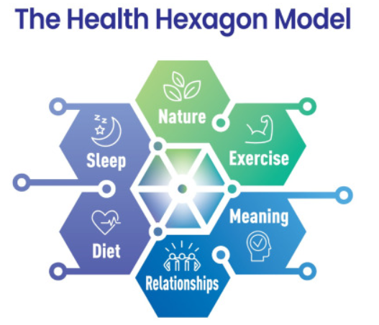
Figure 1: The Health Hexagon Model (Chan and Hazan, 2022)

Lifestyle
Brivio et al. (2023) highlight that the term "lifestyle" lacks a singular definition, as it is a multifaceted concept shaped by various psychological and sociological influences.
According to Van Acker (2016) and Brivio et al. (2023), lifestyle refers to the actions and decisions that are influenced by attitudes, values, motives and viewpoints and that represent one's social standing. It includes activity patterns as well as the driving forces behind behaviour. Furthermore, values and cultural ideas impact that lifestyle by defining what is seen acceptable in social circumstances, which in turn promotes or restricts actions.
However, Cambridge Dictionary (2019) states it as one concept. The term "lifestyle" refers to the way an individual lives, encompassing their behaviours, dietary choices, hobbies and how they allocate their time. Each person's lifestyle is unique, shaped by a variety of factors including cultural influences, social circles, friendships and personal preferences.
Thomas and Lewis (2016) assert that a child's lifestyle can be significantly shaped by their exposure to peers who exhibit positive habits. These relationships foster an environment that encourages constructive thinking and behaviour, ultimately promoting a healthier lifestyle for the child.
Estyn (2013) highlights the vital role of physical education in supporting children's development, health, and overall well-being. Promoting well-being involves healthy living practices such as nutritious eating, drinking, and building meaningful relationships. Together, these elements contribute to holistic development, showing the connection between physical health and social interactions.
Lioret et al. (2020) maintains barriers to a child's healthy lifestyle often stem from the influence of parents or caregivers, including excessive screen time and poor dietary choices. Additionally, lower levels of maternal education are associated with unhealthy lifestyle patterns in children. These factors can contribute to the development of future unhealthy habits, ultimately affecting the child's overall health and well-being.
Furthermore, Lekše, Prosen, and Prosen (2023) explain that parental challenges—such as limited time for physical activity, financial constraints, and lack of awareness or motivation to provide nutritious food—can hinder young children from leading healthy lifestyles. Environmental factors also play a role, with unsafe communities, inadequate physical activity facilities, and limited access to healthy food further restricting children's ability to adopt healthy behaviours.
Adopting healthy lifestyles is essential for both individual and community well-being, as it significantly influences physical, mental and social health. Conversely, unhealthy lifestyle choices can result in various health issues, including mental health disorders and diminished overall well-being (Vaquero-Abellan, Marquez and Martínez, 2022).
The Foresight Mental Capital and Wellbeing Project (2008) states that a healthy lifestyle with regular exercise, balanced diet, and enough sleep reduces illness and obesity risks, boosts mental well-being, and strengthens bones and muscles. Physical activity improves mood, a nutritious diet supports cognition, and social connections enhance emotional resilience and mental health.
Theorists
Bronfenbrenner's ecological systems theory as shown in Figure 2, emphasizes the interconnectedness of a child's environment, including macrosystems, mesosystems and microsystems such as home and early childhood settings. This framework helps practitioners address children’s needs by highlighting the shared responsibility of families, professionals and society in promoting children's health and well-being (Musgrave 2017).
Bronnfrenbrenners Theory Photo
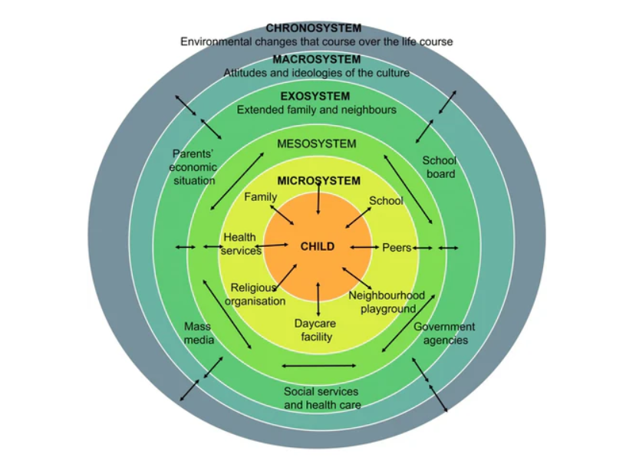

Figure 2: Bronnfrenbrenners Theory Photo
(Flavin, 2023)
Pichère and Cadiat (2015) argue that Maslow’s hierarchy of needs as shown in Figure 3, influences well-being, with basic physiological needs being essential for personal growth. Unmet lower-level needs can harm health, well-being and lifestyle.

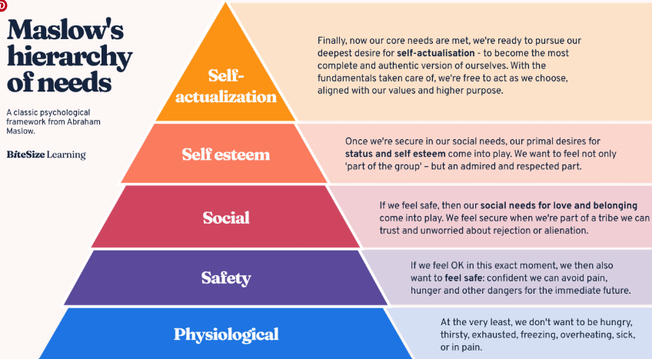

Figure 3: Maslow’s hierarchy of needs
(Bitesize Learning, 2024)
Practitioners’ role
Musgrave (2017) maintains practitioners are crucial in promoting health outcomes in diverse settings by creating inclusive environments for children from diverse backgrounds. They implement health promotion initiatives, engage parents and collaborate with professionals to address health challenges. They must consider socioeconomic factors and cultural beliefs.
The Department for Education (2023) highlights that children thrive in nurturing environments supporting emotional, social well-being, and overall development. Practitioners build relationships, promote co-regulation, and collaborate with families. Similarly, Mainstone-Cotton (2017) also stresses the importance of partnerships with families and agencies to encourage risk-taking and problem-solving, boosting confidence, well-being, and development.
Transitioning from childcare to home can be difficult for children and requires patience. Building trust between practitioners, parents and children supports confidence and resilience. Collaborating with professionals like school nurses and educational psychologists is essential for promoting well-being and addressing diverse needs through a holistic approach in early years settings (Wilson 2016).
Norfolk (2025) presents techniques like the TIPP method, opposite action, and the STOP strategy to improve self-regulation, health, and relaxation, providing practitioners with effective tools to manage stress and promote well-being in settings.
Support
The 2025 poverty report highlights challenges impacting young people’s health and well-being, including higher living costs for disabled individuals compared to non-disabled ones and 54% of low-income families lacking access to nutritious food. Low wages and limited support worsen poverty. Policies focus on job aid, affordable housing, debt help and health support (Joseph Rowntree Foundation, 2025).
Health promotion, defined by the WHO (1986), the procedure focuses on physical, mental, and social well-being, empowering individuals and communities to manage their health. It emphasizes understanding health, setting personal goals, adapting to environments, and using available resources.
The Welsh Government (2022b) launched the Healthy Child Programme, promoting early intervention, nutrition, mental health, parenting support, and physical activity for families with children under seven, providing essential health assessments and interventions (Gov, 2025). Additionally, Public Health Wales (2024) runs a program in primary schools to assess the health needs of 4- and 5-year-olds, gathering data to develop targeted services to tackle childhood obesity and improve well-being strategies.
Furthermore, Welsh Government (2022) has launched a free breakfast club to provide equal access to nutritious breakfasts to low-income families, aiming to address obesity among young children. The initiative aims to improve children's overall well-being, concentration and health. All children have equal access thereby reducing discrimination.
Welsh Government (2019) states efforts are underway to introduce initiatives like Active Wales to promote equal access to sports by investing in new facilities and providing free swimming lessons, enhancing participation in physical activity for all.
The Dahlgren and Whitehead Model (Figure 4) offers a framework for understanding health determinants behavioural, social, economic, and environmental. It promotes a holistic, equity-focused approach, encourages cross-sector collaboration, addresses root causes rather than just individual behaviours, and supports research on social and economic health factors (Dahlgren and Whitehead, 2021).
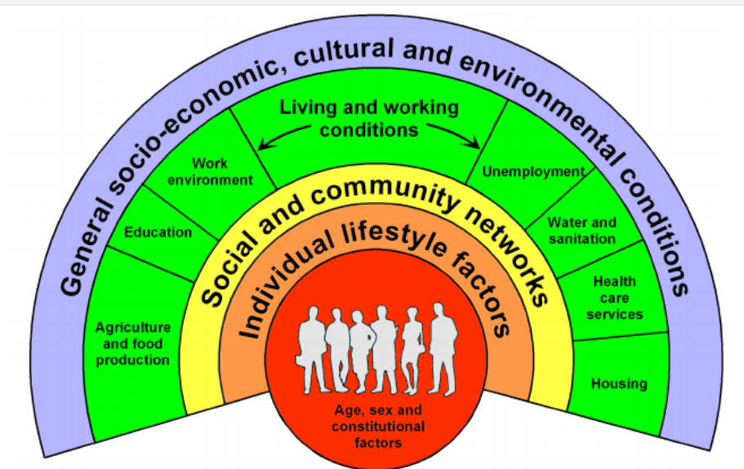
Figure 4: Dahlgren and Whitehead Model
(researchgate, 2011)
Llywodraeth Cymru (2022) explains that Wales’ new curriculum promotes resilience, empathy, mental and physical health to develop healthy, independent individuals who make positive lifestyle choices and engage actively in society. The Reggio Emilia Early Learning Centre (2024) aligns with this approach, emphasizing well-being, safe environments, and viewing the environment as the “third educator” to foster child-led learning, creativity, and a sense of belonging. Similarly, the Welsh Government (2022) highlights that the non-maintained curriculum also follows a child-centred approach like Reggio Emilia.
Conclusion
In conclusion, a child’s health and well-being are influenced by various factors that affect their overall quality of life. Emphasizing holistic health, including mental, social and physical aspects is crucial despite challenges. Theories support this approach and practitioners play a key role in promoting children’s well-being. Governments and educational institutions have introduced initiatives to encourage healthy lifestyles, addressing issues like obesity and poverty.

