Module: Marketing Management (LCMB7001)
Name: Nkechi Jefia
ID: 1714551
Lecturer: Tushara Balendran
Date: 28/07/2022

Assessment 1

TABLE OF CONTENTS
Company’s Background 3
Communication 4
Description of Communication Model 4
Integrated Marketing Communication 6
Nike’s new Promotional Strategy 6
Branding 7
Brand Equity 8
Keller’s Brand Equity Model. 8
Stages of the Customer Journey (Nike) (Caveney, 2021) 10
Customer Touchpoints (Nike) 11
12
Total Engagement Model, Nike 13
Recommendations 14
References 15

Introduction
This business report will explore the marketing strategies and methods used within my chosen organisation The Nike company. Marketing is a powerful tool that utilises various streams. This will be demonstrated by exploring integrated marketing communication (IMC), new promotional strategies, customer journey and touchpoints related to the organisation. Furthermore, recommendations of future market strategies for the Nike company to ensure future success for the marketing element of the Nike company. Nike is a global leader in the sportswear sector. It is a flagship brand responsible for developing several technologies that are now prevalent in the market. Phil Knight and Bill Bowerman created the company. Nike's headquarters are located near Beaverton, Oregon, in the Portland metropolitan area. The company is well-known for its footwear, clothing, and equipment. Nike was started in 1964 as Blue Ribbon Sports, and in 1971 the corporation was renamed Nike after the victory of the Greek goddess Nike.

Company’s Background
Nike’s mission is to bring innovation inspiration (NIKE, 2022)
As discussed earlier, Nike’s story was started with the Nike, previously known as Blue Ribbon Sports (BRS), which was created in January 1964 by University of Oregon track athlete Philip Knight and his coach Bill Bowerman (Companies History, 2013). Phil Knight ran for the track of school and field team, by putting the Phil Knight in contact with his coach, Bill Bowerman. Phil Knight became the first student to try his coach (Bowerman) shoes. After seeing Phil Knight as an unimportant to test his running shoes. Then, Phil Knight got the offer from Bowerman to take one of his and fix them up with the custom design. Eventually, the shoes were good enough even though his teammate took them and ended up using the shoes to win gold in the 1960s Olympics. Then Knight acquired the opportunity to execute his realistic theory by testing a trip to Japan right after his complete graduation in 1962 (Knight and Ridder, 2019). Phil Knight cracked an agreement with a Japanese organisation to export Japan’s best shoes known as Tiger shoes into the U.S. However, the Bowerman had a strong believed long that the shoes of Germany would be the best for the market and were not much special to be improved on, Bowerman supported Knight’s new start-up and entered as an equal partner in the business deal. Nike is headquartered in Beaverton, Oregon, and NIKE, Inc. encompasses the Nike, Converse, and Jordan brands. Nike's mission statement is "To bring inspiration and innovation to every athlete in the world, if you have a body, you are an athlete” (NIKE, 2022). Maintaining this mission statement inspires Nike to do everything in its power to help people reach their full potential.

Communication
Communication can be defined as the transfer of information as well as the sharing of meaning. Communication is the process of exchanging knowledge and mutual understanding from one person to another (Luneburg, 2010). Communication entails a sender and a receiver. This includes people's emotions, cultural situations, communication mediums, and even their physical locations. It has been reported that effective communication skills are highly valued by firms all over the world (Lunenburg, 2010). Various communication models showcase the transmission of information, one of them is the Shannon and Weaver Model.

Description of Communication Model

According to Tawafak et al., (2019), the receiver, sender, and message are all linked during the communication process. In the communication process, the communicator initiates the transmission of the message, which concludes with the feedback receiver, and this process of communication is depicted with the help of lines of pictures, which is known as the communication model. In layman's words, the graphical communication process is seen as a communication paradigm.
The communication model is made up of three parts: the receiver, the sender, and the message (Party, 2022). This model, however, ignores several aspects of the communication process. As a result, a model of comprehensive communication is shown above, which incorporates all parts of the communication process. The model structures the communication process of distinct sections rationally and progressively. Finally, it may be claimed that a communication model is a structured virtual representation of the communication process.
The communication model emerged to understand the communication process. Whereas, this helps to understand the most important aspects of communication.
- The communication method is simple to grasp. As a result, the model can aid in the logical and simple understanding of the communication process.
- The communication model informs the flow of information from one person to another in the organisation.
- The communication model can help orient the different features of the communication process to its readers.
- The communication process is a highly complicated topic. This paradigm makes it simple to present the problem of complexity.

The Shannon and weaver model shows the communication process between source and destination. The source creates a message which can be discrete or continuous (Chandler, 1994). In the beginning, the model was just developed to improve complicated communication but later on, it was applied broadly in the field of communication.

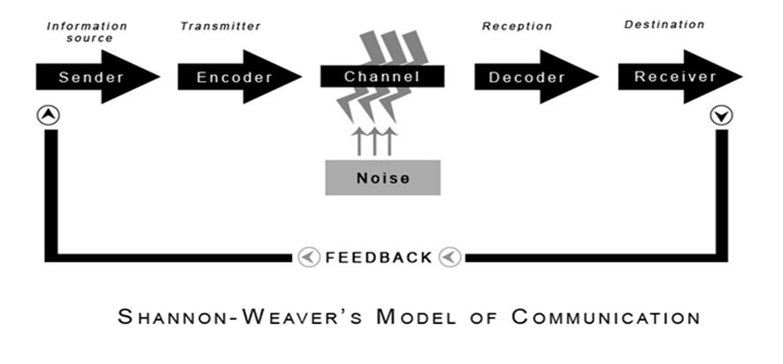
Figure 1 Shannon and Weaver Model of Communication
Source: (Communication Theory, 2014)
Sender – The intended message is chosen by the information source from a set of available messages, which can be a combination of written or spoken words, images, or sounds.
Encoder – The encoder, also known as the transmitter, transforms the message into a signal. A message is a thing that is sent and received, and it is the focus of all communication.
Channel – A channel is the path that a message follows between the transmitter and the receiver.
Noise – Noise is defined as any unwanted additions to a transmitted signal that causes distortion or transmission inaccuracy.
Decoder – Decoding is just the exact opposite of encoding. As part of the communication model, a device is needed that can decode a message into a proper format that can easily be understood by the receiver(Chandler D, 1994).
Receiver –A receiver, often referred to as a decoder, is a reverse transmitter that turns the signal back into the message (Chandler D, 1994)

Integrated Marketing Communication

Integrated marketing communications (IMC) is a process that involves the management and organisation of all 'agents' in the analysis, planning, implementation, and control of all marketing communications contacts, media, messages, and promotional tools (Pickton and Broderick, 2013, p.26)This integrated marketing communication is a field of multi-disciplinary that unifies the traditional and the new media practices. This is aimed at a specific target audience to maximise the enhancement and coherence of marketing communications efforts in achieving predetermined product and corporate marketing communications objectives. (Pickton and Broderick, 2013, p.26).Social media, advertising, marketing, and consumer analytics are independent teams inside an integrated marketing communication or organisation that fosters the merging of disciplines to create a more comprehensive strategy.

Nike’s new Promotional Strategy
Nike's new promotional tactics are divided into two categories: online marketing; new promotional techniques to promote brand awareness including social media marketing and digital marketing, as well as offline promotional marketing, such as advertising and sales promotion.

Online Strategy | Offline Promotional strategy
- Facebook (Utilising Facebook ads)  - Instagram (Nike can reach millions of people through influencers such as athletes and Gym enthusiasts)  - Youtube (creating a youtube channel based on Nike and also sponsoring Youtube creators with Nike gear)  - Tiktok (utilising content creators and ads on this platform)  - Company website | - Advertisement (for example, billboards)  - Print (for example, magazines and newspapers)  - Broadcasting (for example, TV and radio)  - Sales promotions

Using social media as a marketing technique is an excellent way of increasing brand awareness; networks such as Facebook, Instagram, Twitter, and others will help increase NIKE's visibility to consumers (Reference). This Passive technique is based on using social media's public arena as a potential source of customer voices. The marketing purpose is to provide marketers with knowledge about market needs, customer experiences, competitive movements, and trends (Reference). Social media is used as a communication tool in the Active strategy. This is to accomplish three goals: direct sales, customer acquisition, and customer retention (Reference). For example, using well known social media influencers on Instagram with good analytics, such as a big engagement to market the Nike brand.
Furthermore, having a good business website will function as a finishing point for the online customer, meeting expectations of potential products they see on social media. It is vital to highlight that social media marketing is not a stand-alone process because most strategic goals necessitate the presence of a decent corporate website that is effective, trustworthy, organizationally integrated, and customer-focused (Reference). As a result, social media plays a critical role in Nike's integrated marketing communication strategy for increasing brand recognition. In addition to its reach, it is a great source of customer insight and data. Because it is beneficial, social media should be used in advertising efforts.
Nike is also largely reliant on traditional forms of marketing, such as advertising to promote their products, particularly those involving famous people such as celebrities and sports. Furthermore, Nike mostly employs sales promotion techniques such as discount codes to gain buyers for their goods. Nike's television commercials are always adrenaline-pumping. Knowing that Nike's strength is drawn solely from sports. As a result, Nike should increase the intensity of their advertisements so that people can relate to them in every way.

Branding
Branding is the process of distinguishing one company's products or services from those of another. Brands have a big influence on our society. Brands also play a variety of responsibilities inside the brand portfolio. Brands can provide coverage, protection, image extension, and a range of other functions for a corporation (425th page). A brand is a name given to a specific product, service, or line of items. It exists to set one product or service apart from the competition. A brand is the manifestation of client goodwill earned throughout a service or product's life cycle. A brand is defined as a name, symbol, logo, design, picture, or any combination of these, that is used to identify a product or service. Nike, for example, is a well-known brand that thrives on its simple tick logo and notorious phrase Just Do It, which has helped the brand stand out from the crowd.

Brand Equity
Brand Equity is considered to be a marketing term that explained the brand’s value. The increased value supplied to products and services is referred to as brand equity. Brand equity and value are represented in how people think, feel, and act about the brand, as well as the company's prices, market share, and profitability. Brands play a significant impact in increasing a company's financial value (Kotler and Lane, 2016, pp.446–454). Brand equity must be measured to be effectively managed (Kotler and Lane, 2016, pp.446–454)

Keller’s Brand Equity Model.
The model of Keller’s brand equity is considered to be a model of customer-based brand equity, which is best known as a pyramid.
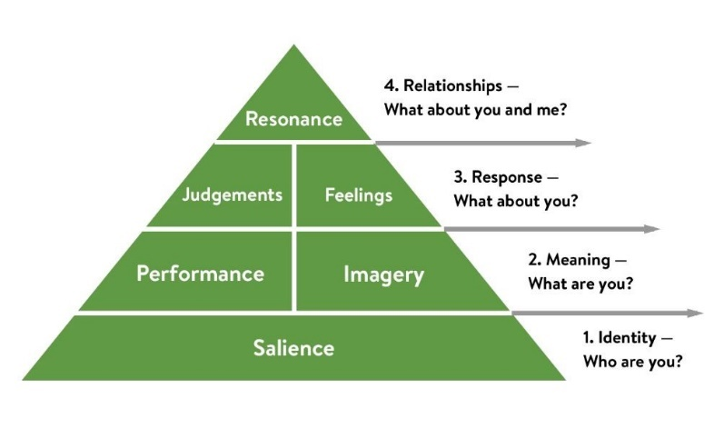
Figure 2Keller’s Pyramid.
Sources: (Tasci, 2020)
Keller's Brand Equity Model is a pyramid that is also known as the Customer-Based Brand Equity (CBBE) Model (Hawker, 2019). The approach simply asserts that to have a successful brand, one must develop optimal brand interactions or experiences. Each interaction with your brand should leave current and prospective customers with pleasant ideas, emotions, and convictions (Hawker, 2019). If companies like Nike can deliver such value, then brand equity has been established. (Tasci, 2020).
Keller's pyramid is divided into four levels. Identity, Meaning, Response, and Relationships are the levels of Nike brand equity on the pyramid (Hawker, 2019).
Identity – "Who are you?" is the inquiry. The perception of Nike by its customers is referred to as brand awareness. What do customers believe about their brand, and is that opinion accurate?

Meaning – this is how well Nike product satisfies the needs of your customers, for example, style and design, product reliability, durability, and serviceability) and imagery. This is noted as the brand's social currency.

Response – This is judgements and feelings, how does the Nike brand make you feel. For example, if people see someone decking out in the Apparel of Nike, they might assume he is an athlete or sports fan. Why do people like to connect with a brand? How does a customer perceive it?

Relationships – This is brand resonance, which is how a customer identifies themselves with the Nike brand. This is the strong, lasting relationship your brand hopes to build with every customer you gain along your business journey.

Advantages and Disadvantages of Keller’s Brand Equity Model

Advantages | Disadvantage
- Sustainable Customer Loyalty: This is the most important benefit of Nike’s brand equity. Every company wishes to have a loyal consumer base. This can be attributed to several factors. Devoted clients, for example, spread positive and wonderful word-of-mouth about Nike branded worth and equity. If you have a high brand presence and awareness, consumers will prefer you more (Hawker, 2019).  - Customer Retention: Customer retention has a lower cost because it is an ongoing action that helps to keep the Nike brand alive. It is one of the top priorities when developing mass marketing campaigns (Hawker, 2019). | - Brand resonance: Due to Nik’s brand equity, the actual competition is more prevalent. It is more difficult than it appears to make a brand resonate with customers. Companies will face more losses than ever before if they fail to resonate their brand with their target consumers (Hawker, 2019).  - Outsourcing to cut costs: Outsourcing a team without carefully managing your brand image and equity is a mistake. Most brands do that when starting, thinking to cut costs. By doing so, they only lose to their competitors in the long run (Hawker, 2019).

Stages of the Customer Journey (Nike)(Caveney, 2021)
Awareness
\
Consideration |  | Decision
- This is where Nikky encounters the Nike brand but is not looking to purchase anything as of yet. This stage is all about understanding the problem that the customer has and looking for a solution for it. For example, Nikky is an athlete looking for a good pair of running shoes but, has a specific problem with her feet, she is wide footed.  . | - This stage is about Nikky knowing what the solution to the problem will be, but she does not know how to solve it or where to go to solve it. | - This stage is where brand associates sit down to discuss Nikky’s options and even give her a sale promotion. She is convinced by Nike’s branding and decided to purchase running shoes from them.

Customer Touchpoints (Nike)

Customer touchpoints are any interaction (including non-physical interactions) that may change your customer's perception of your product, brand, business, or service (Goodey, 2021).
Pre-purchase: Pre-purchase touchpoints are frequently regarded as delivering unknown effects with the Nike company. They are described as all points of interaction a potential client makes with a business before interacting with the firm itself. Even though their particular effects on consumers cannot always be converted into statistics, they remain an important aspect of the customer journey. For example, it can take the form of social media posts, word of mouth or content sponsorships (Goodey, 2021).
Purchase: The purchase touchpoints are all of the interactions the customer has with the Nike company while acquiring the offered service. The primary touchpoint of this most likely took the form of physically going into the business to make a purchase. However, there is much more to consider now in terms of buying touchpoints, for instance, websites, events and retailers (Goodey, 2021).
Post Purchase: The post-purchase touchpoint involves when the customer has made their purchase at the Nike brand company. For example, social media, email and newsletters (Goodey, 2021)9.

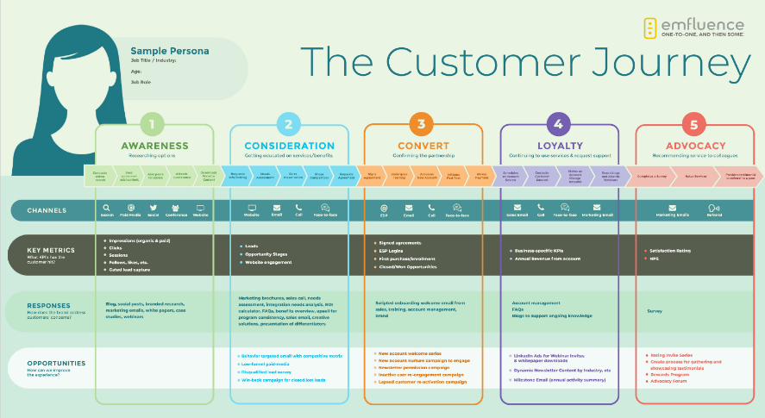

Figure 3 The Customer journey
Source: (Gao, Melero and Sese, 2019)

Strength and Weakness of the Customer Journey Map
Strengths | Weakness
- The Nike company is to deliver solutions that matter to customers since this method will assist them in understanding the customers' problems to be handled or pain points in advance. This is especially critical for new businesses. (Caveney, 2021)  - Understanding the demands of the customers upfront enables Nike to provide solutions that matter to their clients, allowing them to be and remain relevant in the market.  - Nike can identify gaps in the way their customers interact with them. The smallest businesses struggle to offer customers multiple channels of entry or touchpoints. | - Nike Customers may be neglected in the process as a result of a failure to recognise specific consumer needs or a lack of in-depth understanding of customers  - Customer journey mapping necessitates a strong customer-centric strategy on the part of the Nike company. Most businesses lack this and use a route map which results in a poor experience owing to a lack of comprehension(Caveney, 2021).

Total Engagement Model, Nike
Total Engagement ensures that the four critical components of customer value proposition, brand advertising, culture, and customer experience are all aligned. To generate engaged customers, a company should take the following steps: Create a one-of-a-kind value proposition based on extensive customer understanding and competitor positioning (Brodie, Hollebeek and Conduit, 2017, p.4). Following that, the value proposition should be delivered to clients regularly through brand advertising. This promise is best achieved by engaged employees who support and understand the strategy, as well as their roles in its success. As a result of this cultural foundation, a planned customer experience falls short of the brand's advertising promise (Brodie, Hollebeek and Conduit, 2017, p.4). For example, Nike engages and motivates its customers in a personalized that can evolve their loyalty. Nike is consistently employing to evolve the customers’ loyalty and take the marketers a way that can apply to their own companies. The best part is, that consumers can easily purchase through the app, the recommendation of the relevant products is easy to buy them gives, Nike had the chance to exceed the heat of recency, the spending of customers and frequency.

Recommendations
Nike has used a variety of strategies to achieve its current global position; however, more could be done to achieve more desired growth. Among the recommendations are: Having a constant understanding of their customers' attitudes toward their products and services, as well as their branding. When launching products and services to customers, Nike should consider different ethnicities, racial backgrounds, ages, and geographical locations. They can also allow customers to resolve issues over the phone rather than relying solely on email and social media; this can broaden the range of customers willing to invest in the Nike brand, but it may be costly for the company. Nike should broaden their marketing efforts to include not only influencers on platforms like Instagram, but also the 'everyday user,' who has access to potential brand consumers.
Nike should create a quarterly marketing strategy to maintain its brand equity image in the eyes of its customers. This can be accomplished by engaging with marketing managers and associated social media platforms, as well as investigating the analytics of how their brand is performing across all platforms. This allows them to see which areas of their marketing are more positively responsive and focus their efforts there. Furthermore, Nike could create additional discount offers that attract existing customers and new customers through word of mouth. Nike should cover all aspects of marketing, not just learn from competitors. They should also look at marketing strategies used by other industries to help them stay in business and become more dominant in the industry and in people's minds.
Conclusion
In conclusion, Nike is one of the top evolving brands in the sports industry in every way, but their competitors and other small businesses are also improving in areas such as marketing. Nike has pioneered new methods of marketing its brands and has evolved year after year. This report examined marketing concepts to dissect Nike's branding and how it is presented to consumers. Nike has used integrated marketing communication efforts as well as online and offline marketing, which has influenced the global growth of the Nike brand. As a result, Nike should devise a comprehensive strategy to erect a barrier.

References

Brodie, R.J., Hollebeek, L.D. and Conduit, J. (2017). Customer engagement: contemporary issues and challenges. London; New York: Routledge, p.4.
Caveney, L. (2021). Guide to Customer Journey Stages and How to Track Them. [online] Ruler Analytics. Available at: https://www.ruleranalytics.com/blog/content-marketing/customer-journey-stages-guide/#:~:text=It [Accessed 15 Apr. 2022].
Chandler, D. (1994). Transmission Model of Communication. [online] visual-memory.co.uk. Available at: http://visual-memory.co.uk/daniel/Documents/short/trans.html#N.
Communication Theory (2014). Shannon and Weaver Model of Communication. [online] Communication Theory. Available at: https://www.communicationtheory.org/shannon-and-weaver-model-of-communication/.
Companies History (2013). Nike. [online] Companies History - The biggest companies in the world. Available at: https://www.companieshistory.com/nike/.
Gao, L., Melero, I. and Sese, F., 2019. Multichannel integration along the customer journey: a systematic review and research agenda. The Service Industries Journal, 40(15-16), pp.1087-1118.
Goodey, B. (2021). Customer touchpoints: Definition & Analytics Guide. [online] www.sentisum.com. Available at: https://www.sentisum.com/library/customer-touchpoints.
Hawker, K. (2019). Keller’s Brand Equity Model — What It Is & How to Use It. [online] Medium. Available at: https://medium.com/@keatonhawker/kellers-brand-equity-model-what-it-is-how-to-use-it-84e42d562299.
Knight, P. and Ridder, R., 2019. Shoe dog. [Amsterdam]: Dwarsligger®.
Kotler, P. and Lane, K. (2016). A framework for marketing management. 6th ed. Boston: Pearson, pp.446–454.
Lunenburg, F.C. (2010). Communication: The Process, Barriers, and Improving Effectiveness. Schooling, 1.
NIKE (2022). About Nike. [online] Nike News. Available at: https://about.nike.com/.
Party, J., 2022. PractisingTransdisciplinarity and Trans-Domain Approach in Education: Theory and Communication in Values and Knowledge Education (VaKE) (Invited Paper). Proceedings of the 13th International Multi-Conference on Complexity, Informatics and Cybernetics: IMCIC 2022, [online] Available at: <https://www.iiis.org/CDs2022/CD2022Spring/papers/ZA898JG.pdf> [Accessed 21 March 2022].
Pickton, D. and Broderick, A. (2013). Integrated marketing communications. Harlow U.A: Prentice-Hall, p.26.
Tasci, A., 2020. A critical review and reconstruction of perceptual brand equity. International Journal of Contemporary Hospitality Management, 33(1), pp.166-198.
Tawafak, R., Romli, A., Arshah, R. and Malik, S., 2019. Framework design of university communication model (UCOM) to enhance continuous intentions in teaching and e-learning process. Education and Information Technologies, 25(2), pp.817-843.

