CIPD Postgraduate Diploma in HRM
HRM in Context (BMHR7004)
Name: David Rees
CIPD Membership Number: 44081837
Date: 09/12/2017
Word Count
Word Count Limit | 2,000 (+ 10% = 2,200)
Word Count  (*Based on the removal of:  - Abstract/Executive Summary  - Title  - Contents page  - References  - Reference list  - Bibliography  - Footnotes  - Appendices  - Words used in tables, graphs and other forms of data presentation  - Equations | 1,925

I declare that this assignment is my own work and that any information obtained from books and other sources have been appropriately referenced.

Signed: David Rees Date: 09/12/2017

Contents
Executive Summary 2
Introduction 3
Methodology 3
Findings 5
Conclusions 13
Recommendations 14
Bibliography 17
Appendix 1: Perthyn PESTLE 26
Appendix 2: Perthyn SWOT 40
Appendix 3: Distinctions within the VUCA framework 47
Appendix 4: Perthyn’s Strategic Process and Governance 48
Appendix 5: Models of the HRM function 49
Appendix 6: Strategy approaches 50
Appendix 7: Carval functions 51

Executive Summary
This report considers the external environment that Perthyn is currently operating within, whilst analysing the organisation’s internal strengths and weaknesses to maximise opportunities and limit threats. This report recommends that Perthyn focus on employee engagement to meet the short and long-term requirements of the organisation.

Perthyn are a person-centred organisation and the theme of employee engagement is one of great prevalence in all political, economic, sociological, technological, legal and environment considerations. Employee engagement can improve individual health and wellbeing, reduced sickness absence and turnover, higher levels of productivity, performance, innovation, customer service, commitment and job satisfaction (Truss et al, 2012, p.227). Many organisations have improved their employee engagement through initiatives, and at the heart of these initiatives are the employees themselves, with organisations ensuring that goal alignment occurs at every level of the organisation and is well-communicated (Harvard Business Review, p.2).

This report concludes and recommends that Perthyn develop an employee engagement strategy through employee workshops, improving the employer brand, ensuring employees have access to existing technology and encouraging flexible working policies for all.

Introduction
This report will analyse the significant environmental factors currently impacting on Perthyn, and will make recommendations for HR strategy to inform Perthyn’s Strategic Plan in the short term.
Perthyn, a medium size organisation with 800 employees, provides care and support to 200 individuals in England and in Wales. Perthyn are a third sector charity and have built strong relationships with 8 local authority areas and UNISION (Perthyn, 2017).

Methodology
The report is informed by current, relevant and reliable secondary sources of information and data, including ACAS, CIPD, peer-reviewed journals, case studies and textbooks. Conclusions and recommendations will be made from findings based on models and theories, relevant legislation, best practice and organisational examples.
An organisation will achieve congruence when its environment, resources and values are mutually reinforcing (Kew and Stredwick, 2012, p.32). The main areas requiring strategic environmental analyses are socio-cultural, technological, economic, environmental, political, legal and ethical contexts (Farnham, 2015, p.139). There are several tools which can be used to analyse business environments, and this report is informed by a PESTLE analysis (Appendix 1) and SWOT analysis, within which a PRIMO-F approach is applied (Appendix 2).
A PESTLE analysis is an appropriate framework and activity to use in a range of business planning situations, which can encompass strategic business planning, workforce planning, marketing planning, product development, organisational change and HR strategy, reports and projects (CIPD, 2017i).
A SWOT analysis considers internal and internal factors which can impact on an organisation, namely strengths, weaknesses, opportunities and threats. It's a model for matching an organisation's goals, programmes and capacities to the social environment in which it operates (CIPD, 2015a). It provides a useful way of screening strategic options, where options maximising ‘strengths’ or opportunities’ are preferable to those that are not (Farnham, 2015, p.148), whilst PRIMO-F is a simplified way of showing strengths and weaknesses in the relevant areas (RapidBi, 2011).
PESTLE and SWOT Comparison
Although similar, there are some differences between a PESTLE analysis and SWOT analysis
Advantage / Disadvantage | PESTLE | SWOT
Simple framework | ✓ | ✓
Facilitates understanding of wider business environment | ✓
Analyses strengths and weaknesses of an organisation |  | ✓
Encourages external and strategic thinking | ✓ | ✓
Supports the anticipation of future business threats | ✓ | ✓
Enables organisations to explore opportunities | ✓ | ✓
A flexible analysis tool |  | ✓
Process must be completed on a regular basis | ✓ | ✓
Users can over-simplify the amount of data used | ✓ | ✓
Resource heavy; the best reviews require different perspectives and input | ✓ | ✓
Access to quality internal data sources can be time consuming and politically difficult |  | ✓
Access to quality, external data sources can be time consuming and costly | ✓ | ✓
Difficult to fully anticipate developments that may affect an organisation in the future | ✓ | ✓
Capturing too much data may cause difficulties in itself | ✓ | ✓
Data used in the analysis may be based on assumptions | ✓ | ✓
Lacks detailed structure, so key elements may get missed. |  | ✓
(Adapted from CIPD, 2015a and CIPD, 2017i)
Used effectively with a PESTLE analysis, the PRIMO-F can provide a structure to completing a SWOT analysis. Together they form a very powerful diagnostic suite (RapidBI, 2011). The optimum PESTLE approach is through collaboration as multiple perspectives will deliver a better outcome (CIPD, 2017i), therefore this report may be limited in its breadth of analysis.
Other approaches include Porter’s 1980 Five Forces Framework (Dobb’s, 2014, p.32), Choo’s 2001 two-dimensional model of environmental scanning (Kew and Stredwick, 2016, p.12), Johnson et al’s 2011 scanning approach (Kew and Stredwick, 2016, p.13) and Armstrong’s six step guide to HR strategy formation (Armstrong, 2016, p.75). However, the combined detailed PESTLE and SWOT analysis is sufficient to meet the requirement this report.

Findings
As indicated (Appendix 1 and 2), there are several factors which will have a high impact on Perthyn within the short term. Due to the limited scope of this report, it will analyse the most critical and actionable factor which can improve organisational performance based on environmental trends. Therefore, the focus of this report is employee experience, which is interconnected with technological progress, demographics, agility and talent acquisition. As an organisation which focuses on people, family, community and society (Perthyn, 2014, p.3), it is critical that Perthyn’s biggest cost and asset, its staff, are productive, engaged and content.
Agility is a key focus of the modern, competitive company. New technologies, changing customer demands, demographic shifts and globalisation have changed the world of work significantly (Cannon, 2017). Indeed, pundits and leaders alike have asserted that we now live in a VUCA world (Bennett, 2014), with the uncertainty surround Brexit (CIPD, 2017b) evidencing this. Bennet (2014) indicates that addressing agility “is key to coping with volatility” (Appendix 3), and this can be achieved through resources being aggressively directed toward building slack and creating the potential for future flexibility. Perthyn’s biggest resource is its people, and therefore creating an excellent employee experience can meet Perthyn’s strategic aim to “attract, retain and train high calibre staff” (Appendix 4).
How this can be achieved will be influenced heavily by current trends. These include:
- 79% of organisations consider employee experience an important trend (Deloitte, 2017b, p.6)
- Only 4.3% of the UK are currently unemployed (ONS, 2017)
- By 2030, the care sector may need between 350,000 and 700,000 new jobs. (Griffiths et al, 2017, p.3)
- Adult social care is a growing sector that, in 2016, had around 20,300 organisations, 40,400 care providing locations and a workforce of around 1.58 million jobs. (Griffiths et al, 2017, p.4)
- One million more older people need to be in work by 2022 (CIPDg, 2017)
- In the next ten years, 75% of the workplace will be millennials (Kruse, 2017)
- Almost three quarters of UK businesses surveyed say that they will employ more people (net) in future and most think that technology will have a significant or very significant impact on their businesses (Deloitte, 2015, p.2)
- New CIPD research shows 4% of UK working adults aged between 18 and 70 are working in the ‘gig economy’ (Willmott, 2017), however there have been a larger number of workers wanting to work more hours in recent years (Taylor, 2017, p. 20)
- Flexibility does work for many people; an agile labour market is good for protecting employment (Taylor, M., 2017, p. 26)
- By the end of this financial year, £6 billion will have been cut from councils’ adult social care budgets since 2010 – with need for services growing all that time (Dennis and Stevenson, 2017)
- Less than half of us feel our job is just a way of making money (Taylor, 2017, p11)
Care providers will shortly consist of a five-generation workforce, in a growing industry which is expected to do more with less, whilst managing the impact of legalisation such as NMW increases and the Apprentiship Levy. Employees are now demanding more flexibility as evidenced with the gig economy, which is becoming a critical hygiene factor as employees of all ages demand flexibility for a variety of reasons, such as caring, lifestyle choices, other employment and education, and therefore employers need to be more open to flexible flexibility (Makoff, 2017b). Employees now look at everything that happens at work as an integrated experience that impacts daily life in and outside the workplace, including physical, emotional, professional and financial well-being (Deloitte, 2017b, p.54). As a result, new organisational rules need to be developed:
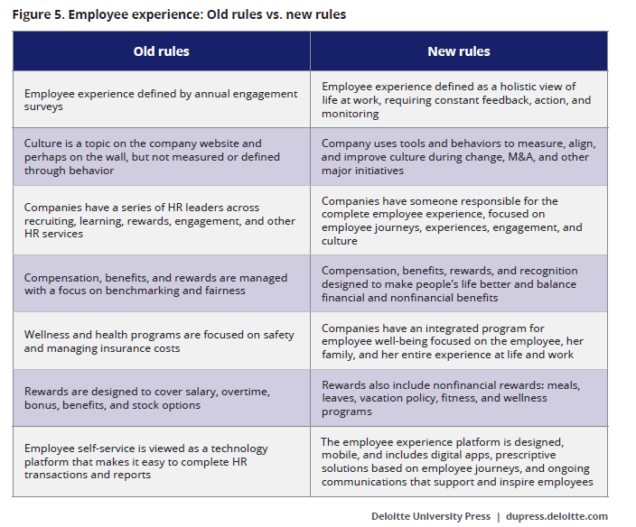
(Deloitte, 2017b, p.60)

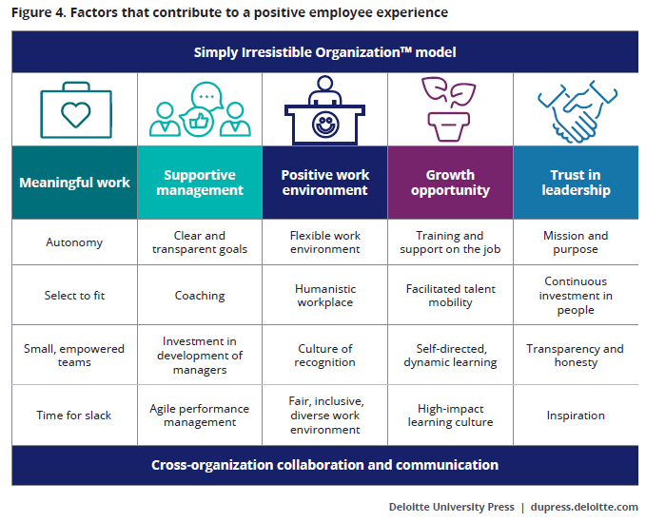

Deloitte (2017b, p.55)
By strengthening the employee experience, this can increase innovation, productivity, and bottom-line performance while reducing costs related to hiring and retention in highly competitive talent markets (Harvard Business Review, 2013, p.1) ensuring that the organisation can positively respond to the volatile external environment. Two models exist which indicate how Perthyn could approach this strategy.
Higgs’ model (Taylor, 2010, p.439)
High Rewards  Low Culture  Employer of Cash | High Rewards  High Culture  Employer of Choice
Employer of Churn  Low Rewards  Low Culture | Employer of Values  Low Rewards  High Culture

Taylor’s model (Taylor, 2010, p.440)
Tight market/career opportunities  Developers | Tight market/few career opportunities  High Payers
Selectors  Loose market/career opportunities | Involvers  Loose market/few career opportunities
As HR strategies should vary based on contextual factors, firms should aim to develop a relatively consistent style (Boxall and Purcell, 2011, p.70), Perthyn’s short and long strategy therefore should be aligned to their values and mission. Unless funding dramatically changes, there will always be low rewards in the care sector, therefore Perthyn must maximise their culture to maintain a position as an employer of value and developers within this continually tight labour market.
Employer branding is a useful tool to help organisations differentiate what they have to offer in the labour market, and recruit, retain and engage the people they need to succeed (CIPD, 2010).
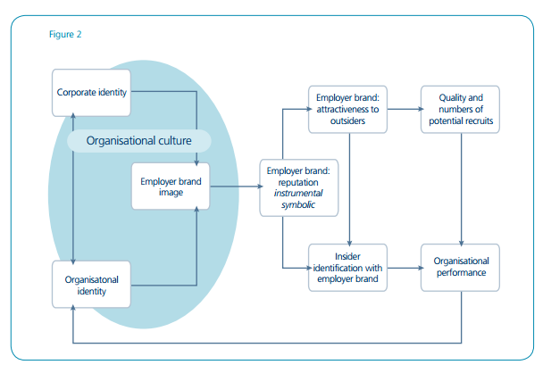
(CIPD)
Developing a positive organisational culture will inform the employer brand and reputation, which can be used to attract and retain staff. Perthyn’s human resource department can support this strategy development. HRM has been defined as Boxall and Purcell (2011, p.1) as “all those activities associated with the management of work and people in organisations.”
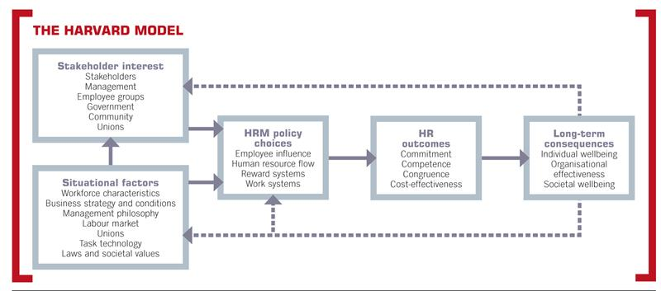
How an organisation should structure its HR function depends on its organisational strategy, wider organisational structure and the requirements of its customers and the organisation it is supporting (CIPD, 2015a). There are several HR models and approaches (Appendix 5), but the Harvard model (below) has been one of the most influential (Armstrong, 2016, p.8)

(Boseilie, 2015)
This is the approach Perthyn currently adopts, with people utilised as a potential asset rather than merely a variable cost (Armstrong, 2016, p. 9). There are also several approaches to effective HR strategies and improved performances (Appendix 6), however the Harvard model is the most appropriate for Perthyn as it meets the visions and values of the organisation especially within the following HR policies:
Implicit HR Policy | Element | Perthyn Strategy
Selection process | Emphasis attitudes as well as skills | Interview questions involve strength based questions as well as competency based questions. Service users involved at all levels.
Appraisal | Open, participative, two way feedback | Supervisions are quarterly and involve two-way participation with actionable outcomes for both parties
Learning and development | Central to model, lateral and upward career advancement. | Training and development department supports employees with the skills and qualifications required for current and future roles.
Participation and employee involvement | Two way communication, problem solving groups | Team meetings, communication books and regular supervisions support open dialogue.
Adapted from Farnham (2015, p.174)
Due to the split of the HR teams, the Ulrich three-legged stool model (Haden, 2017) is also applied by Perthyn, with HR administrators managing transactional services, HR Advisors specialising in recruitment and Senior HR Advisors, an HR manager and an HR Director who work closely with business leaders on strategy. However, only 35% of organizations worldwide employ an HR service delivery model, which is an attribute of high-performing HR functions (Mercer, 2017). This puts Perthyn at competitive advantage, although it must also invest in technology (Mercer, 2017):
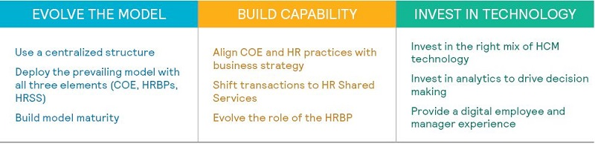
Whilst there are limited resources available to develop technology, Perthyn already has a HR system which offers reporting and analytics, employee self-service and recruitment ATS (Appendix 7). The former is used to produce limited reports whilst the latter two are not utilised at all. To meet the needs of future employees, service users and to be an agile organisation, Perthyn must develop existing technologies and train new and current staff.
Organisations in different sectors have successfully developed their employee experience, as indicated below:
Organisation and Industry | Change / Action | Outcome
Citi Group  (Global financial services) | Incorporated a range of work settings and technology to support more active and connected work styles (Cannon, 2017) | Success factors were based on management readiness, technology, change management and providing for staff needs. (Cannon, 2017)
Mace  (Consultancy and Construction Company) | Measured employee engagement through annual staff surveys  Participated in benchmarking survey (Truss et al, 2012, p.234) | Discovered that:  - High engagement levels existed, however, employees who worked to high pressure deadlines suffered work-life balance.  - Results indicated scope which employees shared ideas and knowledge  - Managers could benefit from management development  - CSR approach could be enhanced  - Appraisal process could be improved.  An engagement model was developed as a result of the findings to meet the above needs (Truss et al, 2012, p.234)
Guy’s and St Thomas’ NHS Foundation Trust (Health Care) | Developed a learning agreement with the staff side (trade unions) to ensure  that the learning needs of individuals in entry support jobs are identified and addressed  Utilising technology to facilitate knowledge-sharing internally and  externally  Increased community work (CIPD, 2014, p.23-31 | Learning representatives appointed to engage with staff to find out about their learning needs and to facilitate communication, helping both staff aspirations and the organisations.  Using app-based solutions to encourage staff to know a little bit about a lot of things as well as their specialism, uploading an idea and getting help. Rewarded through trust miles.  Upskilled staff and a shift their mindset around where and when they work. Also introduced a graduate nurse rotation programme. (CIPD, 2014, p.23-31)
Matt Black Systems  (Manufacturing) | Recognised that low productivity trends  were at least in part associated with the organisational culture, and therefore opted for a people-centric direction for change, focusing on addressing disengagement and disempowerment in the workforce. (CIPD, 2014, pp.32-33). | Focused on nurturing employee motivation to deliver targets, designing the organisation to support three prime motivational elements established by Dan Pink’s research: autonomy, mastery and purpose.  Productivity increase and mindset shift achieved through the removal of overtime (replaced with equivalent compensation on top of their previous salary), and bonus for on time delivery. Employees were increasingly in control of the value they were adding and consequently their income (CIPD, 2014, pp.32-33).
Birmingham City Council  (Local Authority) | Needed to undergo a radical transformation to keep the workforce motivated and engaged to increase efficiency and save costs. (Truss et al, 2012, p.231-232) | Introduced BEST (Belief, Excellent, Success Trust) workshops with all employees (junior to senior) to consider how they could contribute personally and within a team to make improvements. Workshops involve self-evaluation and collaboration. Over 6,000 ideas emerged (to date) and other events and initiatives reinforce the values. (Truss et al, 2012, p.231-232)

Conclusions
Perthyn have the infrastructure, values and vision to facilitate an excellent employee experience, however it is not being evidenced internally or externally, or supported by technology/data which is currently available. In fact, some external data is negative (Indeed, Google and Glassdoor reviews) and is impacting on the employer brand.

Whilst the organisation adopts a best practice approach to HRM and on the surface, appears to be meeting employees needs, some practices may be good for the company but not the workforce and best practice models are typically silent on these tensions (Farnham, 2015, p.179).

Senior managers are far more likely to be optimistic than middle management in their perceptions of engagement levels, whilst human resources are also less likely to claim highly engaged employees (Harvard Business Review, 2013, p.8). In addition, employees are more likely to trust senior managers when they feel they are listened to and when their views are taken into account when decisions are made (CIPD, 2013, p.2). At Perthyn, there is currently no way to accurately measure employee engagement and therefore there may be a ‘blind spot’ between employees, managers and the senior executive team.

As evidence in the findings, many organisations started employee engagement initiatives through employee consultation. Once employee engagement is understood, an effective strategy can be developed alongside all stakeholders, taking the following into impactful employee engagement drivers into consideration:
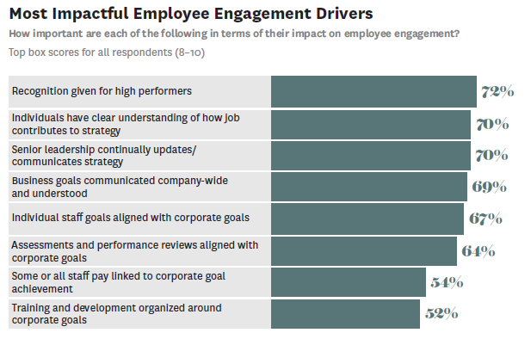
(Harvard Business Review, 2013, p.7)
Sustainable organisation performance is achieved in the face of both internal and external challenges over time, rather than simply achieving high performance levels over the short-term or during good economic periods (CIPD, 2016). Therefore, driving performance through leadership, engagement and organisation development (CIPD, 2016) can result in sustainable success.

Recommendations
This report recommends that Perthyn:
- Measures employee engagement using data from candidate interviews, stay interviews, ongoing performance conversations and exit interviews to build a complete, real-time understanding of employee issues (Deloitte, 2017, p.59)
- Ensures HR and senior managers are aligned with staff teams through effectively utilising the business partnership approach and increasing employee voice.
- Maximises social media and online platforms to promote and manage the employer brand.
- Implements Carval Self Service to reduce HR transactional tasks and increase employee responsibility.
- Ensure all HR strategies are inclusive of the five-generation workforce and workforce trends, maximising their potential through flexible working which meets employee’s individual needs.
The below action plan can support the above recommendations:
Action | Outcome | Account-able | Success measure | Target Date | Cost
Organise workshops with all employees to consider how they could contribute personally and within a team to make improvements.  Within which, create and issue self-evaluation surveys which are based on meaningful work, supportive management, positive work environment, growth opportunity and trust in leadership (Deloitte, 2017, p.55) | Recommendations  1 and 2 | Senior HR Advisors, HR Manager | Attendance and feedback from 100% of employees | July 2018 | Staff time
Analyse and measure the results of the above workshops, creating actionable items that inform the strategic plan | Recommendations  1 and 2 | All HR team:  *HR admin – data input  *HR Advisor and Snr HR Advisor: Regional analysis  *HR Manager and Director: Company analysis and creation of an action plan | Timely completion of input and action items | Oct 2018 | Staff time, any initiative idea costs
Recruit a marketing manager to focus on employee brand, or upskill and second an existing employee | Recommendation 3 | HR Manager | Marketing manager in place by February 2017 | Feb 2017 | Advertising, salary, recruitment time
Liaise with Carval to discuss self-service options such as office access or an app.  Train employees in self-service. | Recommendation 4 | IT dept.  Training dept. | Carval self service implemented | May 2018 | Costings to be provided by Carval.
Review HR policies and strategy to ensure they consider correct workforce trends and are flexible in their approach | Recommendation 5 | Senior HR Advisors, Operational managers | Policies are reviewed in a timely manner, changes communicated | April 2018 | Staff time

