

Graduate Diploma Professional Police Practice

LEVEL 6 - 40 Credits

Workbook title: Competency Based Workbook 6 (PCDA) - BMPP 6006D

12 Elements 10,000 words

(SOUTH WALES POLICE, GWENT POLICE AND UWTSD)

Learner name: John Hughes
Learner’s University Registration Number:
1910664

FACULTY OF BUSINESS AND MANAGEMENT
PUBLIC SERVICE PROGRAMME

Module title: Policing in the Workplace 3 (PCDA) - BMPP6006D

Workbook Guidance

Please read these notes carefully. They provide essential information. The documents you will use in developing your workbook are on the following pages.

What is the workbook for?

The purpose of this workbook is to enable learners to demonstrate and provide evidence of how they meet the learning outcomes set by the College of Policing, for the BSc programme. Essentially, you are being asked to outline your experiential learning based upon your theoretical understanding in a range of operational situations.

This workbook differs from those that you have already completed in that Task 3 -it has an options section giving you the opportunity to answer on an 'advanced learning' area.

Complete the question relevant to the area that has been agreed with the force to study in year 3.

You are expected to answer only 1 of the 5 options below:

- Response Policing.
- Policing Communities.
- Road Policing.
- Information and Intelligence.
- Conducting Investigations.

You may wish to use the same incidents as you’ve outlined in the Occupational Competence Portfolio. Wherever possible we are looking for you to reflect on your personal experience. However, if for any reason there are areas that you feel that you can only answer from a 'hypothetical' perspective, then make this clear within your answer.

How should the workbook be presented?

Blank electronic copies can be found on Moodle of this workbook. You must submit this document electronically therefore it is important that you save your work regularly and upload the final typed version through Turnitin on Moodle.

Word count policy can be found in chapter 7 of the Academic Quality under section 7.7 (this applies to presenting work above and under the specified word count).
(https://www.uwtsd.ac.uk/media/uwtsd-website/content-assets/documents/academic-office/aqh-chapters/chapters---en/Chapter_07_Assessment_Taught_Programmes_Pages_72-79-UPDATED-05-11-2019.pdf)

Reflective practice is a core aspect for your workbooks and although there is a variety of useful resources on Moodle, there is one particular book, that is specifically based on reflective practice in policing, here is a link to one chapter from Selina Copley’s Reflective Practice for Policing Students:
https://moodle.uwtsd.ac.uk/pluginfile.php/298870/mod_resource/content/1/Reflective%20Practice%20for%20Policing%20Students%20-%20Selina%20Copley%20Chapter5.pdf

How is the workbook assessed?

Advice and support about the completion of this workbook will be provided by university staff as part of your initial training day. Your tutor constable and in-force training staff will not be involved in assessing or marking your workbook after it has been submitted.

Dates of workbook submission will be made available during the initial training day and posted on Moodle.

Once submitted your workbook will be assessed and marked independently.

Confidentiality

It is important that no individual can be identified either directly or indirectly from the information in the workbook. However, you must:

- adhere to guidance in the Candidate Handbook about confidentiality;
- not identify individuals including witnesses, victims or offenders by name;
- not write information that enables any individual to be identified indirectly through the description you provide. This includes references to names, colleagues, places (including hospitals, schools, town, villages, streets) specific incidents which were high profile and could be identified due to past publicity, other professionals or any other personal information including medical or other conditions;
- take personal responsibility for adhering to confidentiality rules.
- not include any dates of any incidents or anything that specifically identifies an actual incident.

Please be aware that any content that is deemed to be inappropriate, disrespectful, or abusive will not be tolerated. Following review of any content of this nature the information will be shared with the employer of the student responsible.

Should any health and wellbeing concerns be raised because of disclosures made by the student within this workbook, the employer of the student will be informed.

NOTE

Your workbook will be submitted electronically via Turnitin on Moodle. Guidance on this is in the Candidate Handbook.

Remember that the workbook is YOUR responsibility you must not rely on the assessor or anyone else to pick up any confidentiality breaches, as this is your work and you must accept full responsibility for confidentiality. Meeting all the confidentiality requirements is very important.

Dyslexia and other special circumstances

If you have any condition that you feel may affect your ability to deal with any part of the programme, please see the Candidate Handbook for further guidance. The University has a Student Services Unit that may be able to help but it is the learner’s individual responsibility to contact them.

Competency Based Workbook 6 - Learner Workbook

Guidance:

- Your workbook must contain tasks 1 - 4 below (in the order given);
- You should use the pro-forma to insert your text within each section;
- Note that this module has 4 compulsory tasks with Task three being a choice of 'advanced learning area’ relevant to the area that has been agreed with the force to study in year 3.. Choose only 1 of the 5 options; as only one of these options will be considered for marking.
- You should upload your completed document as a saved pdf file of this workbook; if this is not possible then a Word Doc file is acceptable. Do not send a scanned file from a photocopier, an apple.dot file, or a Microsoft publisher file as Turnitin will not be able to assess them, despite you being able to upload them.

Contents

 | Area of Professional Practice | Word count
TASK 1 | Learning Plan / Personal Development Plan | 2000 equivalent
TASK 2 | Occupational Competency Portfolio (OCP) | 2000 equivalent
TASK 3 OPTIONS SECTION | CHOOSE ONLY 1 OF THESE 'ADVANCED LEARNING AREA’ OPTIONS. IT SHOULD BE ONE THAT HAS BEEN AGREED WITH THE FORCE TO STUDY IN YEAR 3. | All options are  6000 words
Option 1  Option 2  Option 3  Option 4  Option 5 | Response Policing  Policing Communities  Road Policing  Information and Intelligence  Conducting Investigations
TASK 4 | Bibliography

Task 1
Personal Study programme / Individual Learning Plan

One of the learning outcomes identified in the accompanying module descriptor (BMPP 6006D) asks that you formulate and implement a personal study programme to further enhance the development of your professional police practice. A template has been added for an ‘Individual Learning Plan’ that you can use for this task.

This task builds upon the last personal study programme/Individual learning plan completed in a previous workbook. Again this learning plan allows you to assess what level you believe you are in key knowledge, skills and experience against where you believe you (and the force) consider you should be – now and in the coming 6 to 12 months. Some elements within it will be the same or similar to those identified before, however the ratings and your development needs would have changed.

2000 words equivalent. Please note that this is not the actual number of words used in completing the table, the count reflects the thought and research behind it.

ANSWER - please complete the template on the next page:

Knowledge, Skills and Experience Assessment

 | REQUIRED |  |  | RATING |  |  | DEVELOPMENT NEED
KNOWLEDGE  Further knowledge of in depth traffic laws and relevant paperwork. | Low  1-4 | Med  5-7 | High  8-10  X | Low  1-4 | Med  5-7  X | High  8-10 | To try to be more proactive whilst on shift. I often use my discretion as I do not have time to ticket people for minor offences such as having headlamps out. I also need to improve on my knowledge and understanding of how to complete small traffic files for court for these minor offences. I need to learn what goes into them, how long they take to complete and the outcome of them. For example how many points someone may get or if they are eligible for a driving course.  I do have some knowledge and am constantly trying to improve, however having the time on shift to do so holds me back.
SKILLS  Contemporaneous interviews | Low  1-4 | Med  5-7  X | High  8-10 | Low  1-4  X | Med  5-7 | High  8-10 | My knowledge and understanding of how and when to complete a contemporaneous interview is lacking.  My expectations of how it should go, how it needs to go are low and I have little confidence in completing one.  I have had little opportunity to complete many contemporaneous interviews for minor offences such as shop lifting due to the area I police. We often have to arrest for the incidents we attend. However I do wish to explore how and when these types of interviews are relevant and necessary and then the process after. For example, completing a GAP file for court after interviewing there and then for a shoplift, compared to a minor assault, I am unsure if I would be able to do this and will explore these options.
EXPERIENCE  Interviewing regarding more complex investigations or investigations with multiple offences. | Low  1-4 | Med  5-7 | High  8-10  X | Low  1-4 | Med  5-7  X | High  8-10 | I have interviewed multiple suspects for many offences, however I find it nerve-racking when I have to interview a suspect for multiple offences, when I am not the officer in case of these offences. If I arrest for an assault, and then realise that this person is also wanted for other offences and have to interview for them, I find it daunting that I have to read through other officers paperwork and interview based solely on this information and the evidence.  I am confident gathering my own evidence and interviewing, however doing it on other officers behalf is not something I am confident in.

TASK 2
Recognition and confirmation of progress on the Occupational Competency Portfolio (OCP).

By signing the section below, you are acknowledging your continuing progress on O.C.P.
This is recognised by the university as work that is fully supporting this module BMPP 6006D; Policing in the Workplace 3 and in signing it will be equivalent to 2000 words towards the 10000 words total.

Confirmation of the progress on the Occupational Competency Portfolio (OCP).

I confirm that I am progressing with the Occupational Competency Portfolio (OCP) in accordance with the regulations.

Signed: John Hughes

Date: 18/06/2022

TASK 3

This is a reminder that this TASK 3 section is an opportunity for you to answer a question on an 'advanced learning' area - RELEVANT TO THE AREA THAT HAS BEEN AGREED WITH THE FORCE TO STUDY IN YEAR 3.

You are expected to answer only 1 of these 5 options:

Response Policing.
Policing Communities.
Road Policing.
Information and Intelligence.
Conducting Investigations.

You may wish to use the same incidents as you’ve outlined in the Occupational Competence Portfolio.

Wherever possible we are looking for you to reflect on your personal experience. However, if for any reason there are areas of your essay that you feel that you can only answer from a 'hypothetical' perspective, then make this clear within your answer.

In your answer to this task, you may also wish to consider how this links into your final year 3 project.

Were there any practical solutions that you were able to derive from an incident, an investigation, or a case that you attended in year 2/3?

Did this play any part in your choice of the topic area you have agreed and intend to study in your final year 3 project?

There will undoubtedly be areas of common research and learning opportunities that you can utilise for this task and for your final year 3 project.

Whatever option you study for your task 3 it is will be beneficial for you to use a recognised reflective model.

Within your answer you should consider ‘what went well’, ‘what not so well’ and ‘what you would do differently next time’; consider both your performance and the performance of others around you.

TASK 3 Option 1

Relevant areas of the National Policing Curriculum:

Response Policing

You should choose a policing incident from year 2/3 that was of a complex nature, in which you played a significant role in providing a response.

Critically analyse the social/political/strategic drivers that impact upon the response to this incident.

You could consider the strategic priorities of your Force; for example, victim led crime, harassment, racially motivated crime, or domestic violence.

Consider how strategies are evolved for those involved in response policing can remain effective in an increasingly challenging environment.

6000 words (+/- 10%: include your actual word count at the end of each section)

ANSWER:

TASK 3 Option 2

Relevant areas of the National Policing Curriculum:

Policing Communities

You should choose a policing problem relating to policing communities from year 2/3 that was of a complex nature, in which you played a significant role in providing a response.

Critically analyse the key emerging issues and potential challenges faced to ‘problem solve’ a solution.

Consider how this could then help to reduce community tension and promote community cohesion.

Consider the competing priorities, any cost/financial constraints and availability of resources. Also consider community expectations against the capability of your force to respond

6000 words (+/- 10%: include your actual word count at the end of each section)

ANSWER:

TASK 3 Option 3

Relevant areas of the National Policing Curriculum:

Road Policing

You should choose a serious collision that you have been involved from year 2/3 that was of a complex nature, in which you played a significant role in providing a response.

Critically reflect upon the management of a serious collision in which you played a significant role in. What were the causes and what strategies, and initiatives could be implemented to reduce the likelihood of it reoccurring?

6000 words (+/- 10%: include your actual word count at the end of each section)

ANSWER:

TASK 3 Option 4

Relevant areas of the National Policing Curriculum:

Information and Intelligence

You should choose an investigation that you have been involved in during year 2/3 that was of a complex nature, in which you played a significant role.

Critically evaluate and reflect upon how information and intelligence was used to progress a given policing operation.

Consider the role of the National Intelligence Model and reflect on how information and intelligence was critical to the outcome of the situation and analyse how the role of NIM as a business process is used to shape a wider force policing objective.

Examples of policing operations could be relating to cannabis factory, organised crime groups, or handling of stolen goods.

6000 words (+/- 10%: include your actual word count at the end of each section)

ANSWER:

TASK3 Option 5

Relevant areas of the National Policing Curriculum:

Conducting Investigations

You should choose an investigation that you have been involved in during year 2/3 that was of a complex nature, in which you played a significant role.

Critically evaluate the role of the victim, or the witness in the investigation and the strategies employed to manage their journey through the criminal justice system. Consider the role of specialists in relation to complex live (or cold) cases.

Critically reflect on how you have ensured the wellbeing and resilience of the investigative team and self during the investigation.

Consider the professional support involved for victims and witnesses and how you maximise the evidential opportunities they present.

6000 words (+/- 10%: include your actual word count at the end of each section)

ANSWER:

TASK 3 Option 3

Relevant areas of the National Policing Curriculum:

Road Policing

You should choose a serious collision that you have been involved from year 2/3 that was of a complex nature, in which you played a significant role in providing a response.

Critically reflect upon the management of a serious collision in which you played a significant role in. What were the causes and what strategies, and initiatives could be implemented to reduce the likelihood of it reoccurring?

6000 words (+/- 10%: include your actual word count at the end of each section)

ANSWER:

Within this essay I will be using the Borton (1970) reflective tool to reflect upon my leadership style.

I was on my last night shift of the set, nearing the end of my shift at around 05:30am, when an emergency call came out informing us that there had been a road traffic collision on the A426 just outside of Barry.
My colleague and I were the only officers available and I drove us to the incident.

This is when I started to ask myself what I would need to do at the scene, what my role might be and what I might be faced with at the scene as the control room had stated that the collision was between a Heavy Goods Vehicle (HGV) and a motorcycle.
I was the officer with more experience and felt a some pressure knowing that it was likely my colleague would rely on me for support and information.

I made sure to put my knowledge and experience to use by ensuring that before I left the station, I had my body worn camera to activate and collect any visual evidence that might be relevant to the investigation.
I also took an defibrillator from the station with me in case any casualty needed to be resuscitated.
After making sure that I had all of the equipment I needed for the incident, I made sure to mentally prepare myself for the aftermath of the initial call of a HGV vehicle versus a motorcycle.
I was preparing myself for the worst possible outcome, that being a deceased casualty or even more than one. I was also taking into account that other agencies such as the fire and ambulance service may be involved and how I could help them and assist them, but also that I had a responsibility to ensure that the best evidence was kept for any investigation that may need to take place.

I remember thinking about the location given to me of the incident and thinking that the road was a busy rural road which could pose a hazard to myself and my colleague and any other agencies or members of the public.
I instinctively asked the control room if roads policing officers had been made aware and would be attending as they have the experience and knowledge regarding such serious collisions.

When I initially arrived at the scene it was obvious what had happened and I could see that the offending vehicle had been overtaking an HGV and collided with an oncoming motorcyclist.
Although in my mind the driver of the car driver was clearly at fault, I still had to treat that driver with respect and care for their wellbeing. I ensured that I kept the driver calm and warm as it was a cold morning. My role at this stage was to secure and preserve evidence and also to care for the driver as she was obviously in shock and may have had unidentified injuries.
When I first approached her, she was smoking and so I asked her to stop as I was aware that it was likely she would need to be breathalysed at some point.
Upon reflection, I should have stayed with her at all times, however the scene needed to be managed, there were multiple people on the scene who may have been witnesses and the scene needed to be preserved. Due to this, I had to leave her a couple of times, however I did make sure to leave her with members of the public so that she was cared for at all times.
Upon reflection of this, I realise that evidence could have been lost or tampered with.
For example, if the offending driver was on their phone or had been distracted, then they may have been able to erase this evidence from their phone or other devices. They could even have made off from the scene. I understand that if I had stayed with the driver then these would have been less likely to happen, however with just myself and my colleague on scene this was difficult to achieve.
I do reflect on this and realise that this was a complex scene with multiple possible witnesses, three involved vehicles with one casualty at that time seriously injured. All of these factors, including this being my first major road traffic collision, played a part in how I dealt with this incident.
When the fire service arrived, I handed the casualty onto them as a paramedic was not available, this was due to them all caring for the injured rider. I utilised fire officers to assist me as I was aware of their more advanced first aid training and equipment than myself.
I then escorted the driver to an ambulance and it was around this time that Roads Policing Units (RPU) attended the scene and looked after the driver.

Whilst the RPU officers initially started to arrive, I made sure that I was passing them relevant information about the scene, possible witnesses, and the condition of the casualty.
I was also relaying information to my sergeant, including where they needed to create a road closure to preserve the scene.
Upon reflection on this, I can remember that my sergeant placed their vehicle in the wrong location meaning that multiple vehicles were let onto the road and had to be turned around. I thought that I was being as clear as I could, however I feel as though my sergeant misunderstood me. I think in part that this was because in my mind, it was obvious where the road closure needed to be, however I may not have been clear in my explanation due to trying to manage the scene and a casualty. If I had asked the control room to guide my sergeant to the correct location then it is likely they would have been able to correctly place the road closure.
This taught me that delegating certain tasks to other officers or staff could be beneficial, especially during high stress situations whereby I may be preoccupied with a task. This was a valuable lesson for me.

The aftermath of the incident:
Immediately after the incident my colleague and I felt that we had performed well under pressure and had done all that we could at the scene, being professional and carrying out our roles well, especially as we were the only officers on scene for the majority of the incident. We took control of the scene together and worked well as team members and then handed the scene on to our roads policing colleagues and other emergency service colleagues.

I did not reflect upon my feelings for some time after the incident, however when I drove down that same road responding to an emergency call, I drove passed the site of the incident and realised that the incident had affected me.
When looking deeper into this, I realise that this is an upsetting and an emotional incident to attend.
The circumstances of the incident from my perspective, whereby both parties were going to work and it was likely a normal day for them.
The male rider of the motorcycle was only 21 years old, he was simply on his way to work and going about his journey as normal keeping to his side of the carriageway, in my view riding sensibly and within the law.
The female driver also going to work, but being stuck behind an HGV (Heavy Goods Vehicle), which she had likely been behind for some time. I feel as though she had become impatient and carelessly tried to overtake the HGV at the least opportune moment.
I have driven this road multiple times and know that it is an extremely difficult and challenging place to overtake, due to the long sweeping left hand curve which can obscure the view of oncoming vehicles.
It is at this point she has pulled into the oncoming lane and has accelerated to overtake the HGV but due to the left hand curve, has not noticed the oncoming motorcycle until it was too late.
She has then collided with the motorcycle head on which has sent the rider over the bonnet and over the vehicle, he has then landed around 15 – 20 metres behind the car. I was told later by paramedics that he likely died on impact with the road.
I can reflect upon this incident knowing that there was nothing I could have done to prevent this from happening or to change the outcome, however I often think about this incident when driving past that same spot and think about both people involved and their families.
His life had been taken away, simply from someone wanting to overtake a HGV seemingly in a rush, and has misjudged their actions on a blind bend and killed somebody. His family will mourn the death of their son, who was young and not at fault.
The effect on the driver’s life is also substantial. Having to live with the fact that her direct action resulted in someone losing their life must take a huge toll on their day-to-day life.

My personal and professional attitude changed due to this incident.
I have found myself much more aware of vulnerable road users and poor drivers. Around a week after the incident, I was patrolling the road leading up to the collision site. I noticed a vehicle overtaking another car on a hatched marking with white diagonal stripes, meaning that you should not enter that area unless it is necessary to do so, which in my opinion it was not. This vehicle then sped up to exceed the speed limit and caried on this way for a mile or so before I pulled it over. I may not have necessarily done this before, however as it was so soon after the incident, I felt in necessary to speak to the driver about their actions and why they were improper and could have been dangerous.
To my surprise, a woman aged around 50 exited the vehicle with her elderly mother and father in the vehicle, which possibly due to some unconscious bias I did not expect. I personally would have thought that someone who had more driving experience would have known better, however they were local and this may have had an impact on why they disregarded the highway code.
I explained why the hazard lines were there, to protect road users who may be turning or about to turn, and that her actions could have caused a collision.
At first she seemed to disagree with me, however after I explained that I had recently attended a fatal RTC in close proximity to where she had been and the brief circumstances, which were not dissimilar, she apologised for her poor driving and I let her on her way with a warning.

I now wish to utilise the opportunities within training to support my goal of working towards becoming an RPU officer. By doing this I feel I can make the roads safer by passing my knowledge on to drivers of all ages, but especially the more at risk drivers such as young drivers of both genders. The Department for Transport (2021) show statistics in which there were around 30,000 male casualties in the 17 – 29 age category in 2021, with the age category of 30 – 49 being slightly higher. These statistics shows that younger male drivers are more likely than all other age and gender categories to be injured on the UK’s roads.
With this in mind, female casualties for the same age ranges in 2021 were around half, 15,000, which is approximately the same as the 50 – 69 age range for males. By comparing this data, young female drivers are also quite likely to be involved in a collision, meaning I make sure to engage with both categories of the driving population to try to address any poor driving and instil better habits.

A positive tool to counter poor driving and anti-social driving is the Section 59 warning (Police Reform Act, 2002).
This can allow an officer to use their discretion regarding a persons driving, of which their general attitude can have an effect on the outcome.
My policing style allows for mistakes to be made, and if I feel as though the driver is remorseful for their actions and understands the consequences if they carry on driving in such a manner, then I will be less inclined to issue them with a Section 59 warning.
However, if I determine their attitude towards driving, combined with how they were driving to be so poor then I will issue a Section 59 warning.
I feel as though this warning serves as a reminder to that person for the next 12 months that they must abide by the rules of the road and drive in a normalised and considerate manner. Otherwise, the police have the lawful power to seize that vehicle if it, or the driver, is seen to be driving in a careless and inconsiderate way, causing alarm or distress, having not learnt from their previous mistake.
Although the vehicle is only seized for a short period of time, I feel as though initiatives like this serve a major role in reducing poor driving and instilling better driving habits.

This leads on to the “Becoming a better driver” (Mares, P et al, 2015, p30) and although this handbook is directed at professional emergency drivers, many of the processes, attitudes and general information is relevant to every driver on the road.
A part of driving that I feel should be explored more is evaluating your own driving, your own skill set and learning from experience and mistakes.
This comes after I was involved in a serious collision around 6 years ago. Since then, I have adjusted my driving style and ensure to follow at a safe distance as I cannot predict what the driver ahead of me will do.
Each individual person has their own style of driving and their characteristics from their life can be brought into this (Mares, P et al, 2015, p38).
This is an interesting insight into why some drivers may be poor drivers due to, for example, their aggressive driving, such as tailgating or overtaking slower moving vehicles, or their tentative driving such as moving off slowly or being over cautious at junctions.
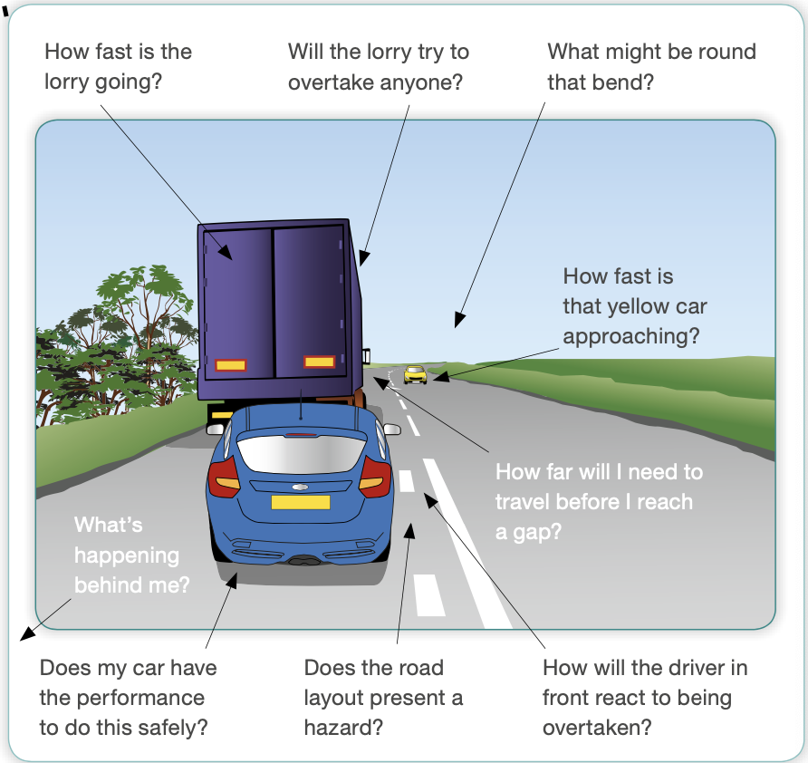
Another example is that one in six young drivers are likely to be involved in a collision between the ages of 17 and 24, which could be put down to their inexperience of life and driving experience (Mares, P et al, 2015, p35).
Figure 1 Anticipating hazards when overtaking a HGV
By dissecting figure one from Roadcraft (Mares, P et al, 2015, P223), it breaks down each thought process of which a driver wishing to overtake any vehicle in front of them should go through.
Each of these steps is a logical approach to ensure that the safest manoeuvre is completed and that hazards are anticipated.
Each part of the overtaking procedure is explained thoroughly in Roadcraft (Mares, P et al, 2015, Chapter 11) and the stages, when following a large vehicle, are to manoeuvre your vehicle to see along both sides of the large vehicle to be able to get a better view past it, when it is safe to do so pull out to the right with a clear path ahead. From this position the driver then makes the decision after assessing the road ahead and the perceived gap which the driver’s vehicle will be able to safely manoeuvre into. If the manoeuvre is not deemed safe, then the driver simply pulls back into the left behind the large vehicle again.
At every stage the driver should re-assess.
In this case, it is likely that the driver failed to take many of these processes into consideration and I feel would be a contributing factor to the collision.
By overtaking on a blind bend, it drastically reduced the visibility of the driver being able to perceive any hazard approaching, especially whilst overtaking a large vehicle of which they would not have been able to see past.

Another factor which I recognised could have contributed to the collision is the alertness and tiredness of the driver, especially between 23:00 and 06:00 as this the greatest risk of tiredness related collisions. The incident happened between the hours of 23:00 and 06:00, of which Mares, P et al (2015) state that this is the most likely time for a driver to be affected by tiredness due to being less alert. This affects the drivers anticipation to react to hazards, especially when (added to the fact) that the driver was taking a familiar route along a rural road.

Another impact factor that I personally feel as though was quite likely to have been involved, was that the driver was familiar with the roads and used them regularly to commute back and forth to work. Mares, P et al (2015, p45) state that acquiring a habit when driving a familiar route can affect your perception to hazards along that route, meaning that two thirds of crashes occur on a road the driver is familiar with.

As stated by Mares, P et al (2015, p201) there are multiple hazards that drivers need to account for when overtaking:
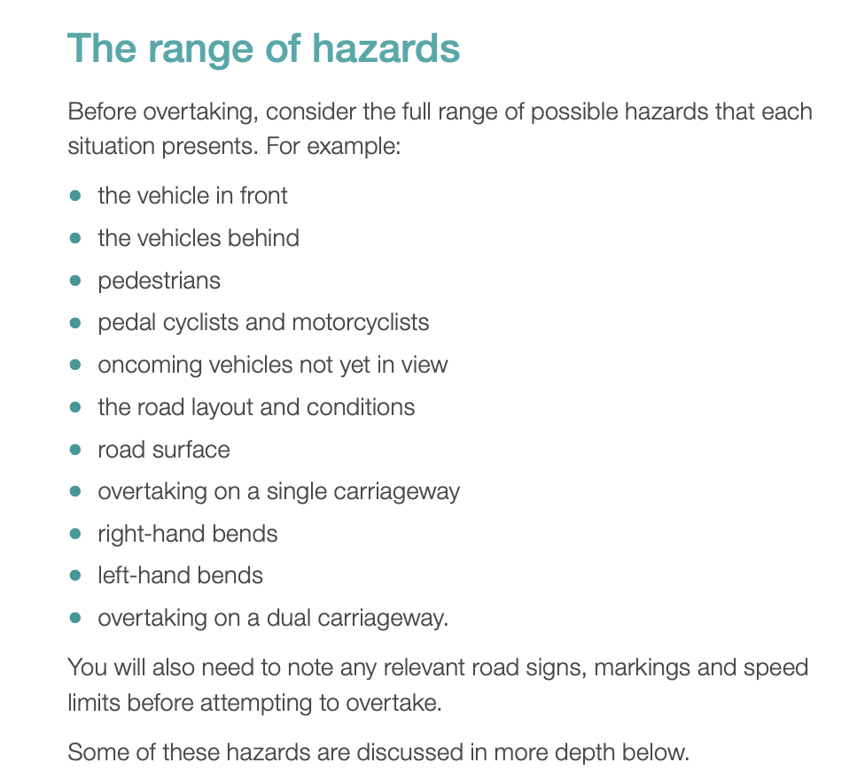
Figure 2 - Range of Hazards (Mares, P et al, 2015, p201)

I completed my blue light course in March 2021, my instructor advised me that overtaking is one of the most dangerous manoeuvres that can be undertaken, due to your vehicle crossing the centre of the road and then being in oncoming vehicles path.
This is supported by the statistic where 1 in 20 occupants are killed in accidents when overtaking, often due to head on collisions (Mares, P et al, 2015, p186).
This incident occurred on an “A road” where the speed limit is 60mph, which relates to the fact stated that the risk of death when colliding at 60mph is 90%, so the outcome was almost inevitable in regard to the incident I attended. Especially taking into consideration that motorcyclists are one of the most vulnerable road users (Highway code, 2022).
This is due to the fact that they are more difficult to see due to their size and their manoeuvrability through traffic, approaching traffic from angles other vehicles would not be able to, therefore being less visible.
When combining this with the notion that motorcycle riders have significantly less protection against impacts and collisions, with there being no frame around the rider, as there is around a driver of a car and other vehicles. (Freidman, 2017)

Whenever I drive, professionally and at my own leisure, I reflect upon my teachings from my blue light course to ensure that I am aware of other road users, especially vulnerable road users, poor or nervous drivers and any other hazard or danger.
I make it my responsibility to be aware of how I am driving to the conditions of the road and to take in other drivers’ actions around me.
I use the system of car control (Mares, P et al, 2015, p26), which incorporates information, position, speed, gear and acceleration.
This means that I am always taking in information, using that information to conduct safe manoeuvres utilising my positioning, speed, gear and acceleration and giving other road users signals to benefit them. By using this system, I conduct myself in an appropriate manner on the roads.

Mares, P et al (2015) also references anticipating hazards that could occur by making the driver aware of observation links. These can range from a row of parked cars and anticipating a door opening or a pedestrian walking from between them onto the road, from noting chevrons, warning signs and the type of lines in the road.
To relate this to the incident I attended, the whole length of the road has long broken white lines in the centre. These are hazard warning lines, (Highway code, 2022) and are used to warn road users of a multitude of hazards and to make sure that the road is clear ahead before crossing this line.
On this specific section of road I would perceive the hazard to be the long sweeping bend to the left, of which the white lines follow. When utilising the correct overtaking position, the driver would likely be able to see the lines running off to the left and this should inform the driver of the hazard.

A report published by the Department of Transport (2021) found that in most collisions where a rider was killed or seriously injured, the driver or rider of the other vehicle had failed to look properly.

Strategies and initiatives to reduce casualties.

Drivers:
The Department for Transport (2011) recognised the need to educate drivers at various stages to achieve the correct attitudes and experience needed to be safe and responsible drivers. Starting from when a new driver is learning and then passes their driving test. The Pass Plus scheme was set up by the Driving Standards Agency in 1995 (Goodson,M, 2022), and was designed to improve new drivers experience of driving by ensuring that they completed six modules which cover some more challenging aspects of driving, such as motorway driving, driving in poor weather conditions and driving at night.
By utilising this scheme, young drivers can improve their skills and knowledge, making them a safer driver and some insurance companies will issue a discount due to a young driver having this accreditation (Gov.uk, N.D.).

I feel that by tackling young drivers bad habits or poor knowledge and skill set at the source by utilising schemes such as Pass Plus, this should instil good driving behaviour and set them up to continue driving well.
However, over time other bad habits can be picked up and I do feel that more should be done by the government to implement knowledge checks and assessments for drivers throughout their driving lifetime.

An initiative within the police that can be utilised is a specific form which relates mainly to medical reasons, whereby an officer may suspect the driver of being impaired in their driving in some way by a medical related problem. This could also be considered because of the poor reactions of a driver within their manoeuvring of the vehicle.
A D751 is a police form and allows a police officer to advise the Driver and Vehicle Licence Agency (DVLA) of their concerns regarding the driver.
This form can be issued regarding any driver and does not depend on their age or gender, it focuses solely on the officers observations and suspicions relating to a possible medical condition which affects their safe control of the vehicle.

I personally feel that the Government put too much responsibility on the driver to recognise their own poor driving and to report their own medical conditions. It is an offence not to notify the DVLA of a medical condition which is likely to affect your driving.
Although not all medical conditions are associated with elderly people, there are online resources available on the ageuk website (2020) which provides information on what may affect an older persons ability to drive safely and what they or family members can do to get support for this.
This could also be useful information for people with medical issues.

In Merseyside, an interesting and affordable initiative was set up in 2016 called Drive Safely For Longer, this scheme gives drivers over 60 the opportunity to have their driving skills assessed by a trained driving instructor. This can help older drivers to renew their skills and knowledge, check that they are fit and legal to drive and the driving instructor will give them feedback.
Although not a test, it could provide an invaluable tool for that driver to asses if they are capable of continuing to drive safely, or if it might be best to retire from driving Merseyside Road Safety Partnership (2022).

Road safety initiatives:

Safety cameras are used across the UK to help reduce the speed of vehicle in specific areas, such as schools or other areas where collisions due to speed are a risk (Safer roads Humber, N.D.).
These can be mobile sites or fixed camera locations, the camera is set to activate at a specific speed and the driver will receive a notice of intended prosecution. They may have to pay a fine, have points added to their licence or be able to take a speed or safety awareness course.
Sussex Safer Roads Partnership (2022) state that they use safety cameras alongside high visibility mobile cameras to deter this behaviour due to the number of serious collisions in their area.
Sussex Safer Roads Partnership (2022) also states that the reason for these more serious collisions is often speed, this being because when a vehicle is travelling faster, the driver has less time to react.
By implementing measures such as safety cameras, they hope to reduce casualties and collisions within their area.
I feel as though mobile speed enforcement locations along the road which the incident occurred at would be a visible presence and I feel this would have a significant impact on the drivers attitude who take this route, especially local drivers who would be aware that a mobile speed camera van may be sat around the corner.
I feel this would make the road safer and would be a high visibility deterrent, as used by Sussex Safer Roads.

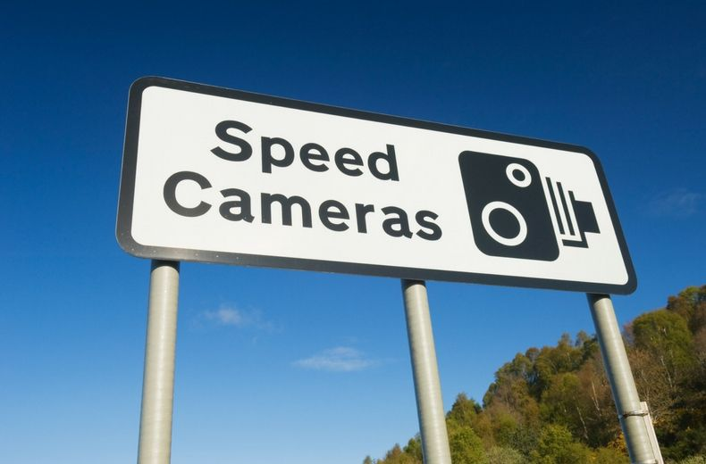
Figure 3, Speed camera sign (RAC,2022)

By utilising signage such as in figure 3, I feel as though this would also deter unfamiliar users of that road from exceeding the speed limit as they might not know the locations where they set up and would be likely to travel slower and be more cautious of their driving style in the area.

Signage:

An interesting use of technology in America can be seen in an installation of LED illuminated chevrons which highlight the curves in the road in order to be more visible to drivers, therefore helping to ensure that the driver is directed safely around the bend (Woof, 2012).
Woof (2012) also notes that in London road safety is being taken seriously and over one million pounds has been dedicated to making the Camden high street area safer by introducing traffic calming schemes. These schemes modifications include widening footpaths, removing excess signage, and reducing the speed vehicles can travel.

I am personally aware that there are minimal safety features of this road, other than steel barriers alongside the carriageway to prevent vehicles that leave the carriageway from ending up in a field.
I feel that as an attempt to prevent this from happening again at the same location, there are many measures that could be utilised.

Another factor to take into consideration is that this road forms part of a route to Cardiff International Airport. It is highly likely that drivers attending the Airport may be unfamiliar with the route and the roads, which according to Mares, P et al (2015, p12) driving on an unfamiliar route is a potential risk to the journey.
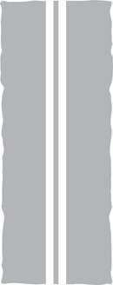
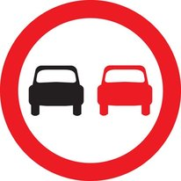
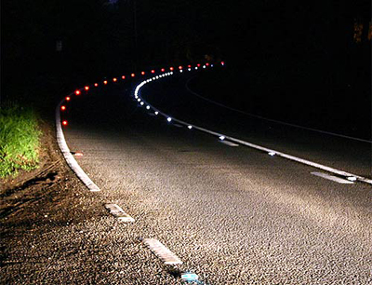
Figure 4, Solid white lines (Highway code, 2022).
Figure 5, No overtaking sign (Highway code, 2022).
Figure 6 Cats eyes reflecting (Made up Britain, 2017)
1. An installation of double solid white lines along the whole stretch of the road, indicating to drivers that they must not overtake at this point would ensure that drivers are aware that they must not overtake at this point as it would be illegal to do so. Installing new reflective cats-eyes studs between the lines would also improve the visibility of the hazard and the bend, especially during low visibility such as darkness or poor weather conditions.

No overtaking signage could be introduced alongside the double white lines throughout the route, adding to the visibility of the fact that no overtaking is allowed.
With this signage in place, drivers would know not to overtake and therefore I feel this would significantly reduce the chances of another head on collision on this route.

2. Other signage
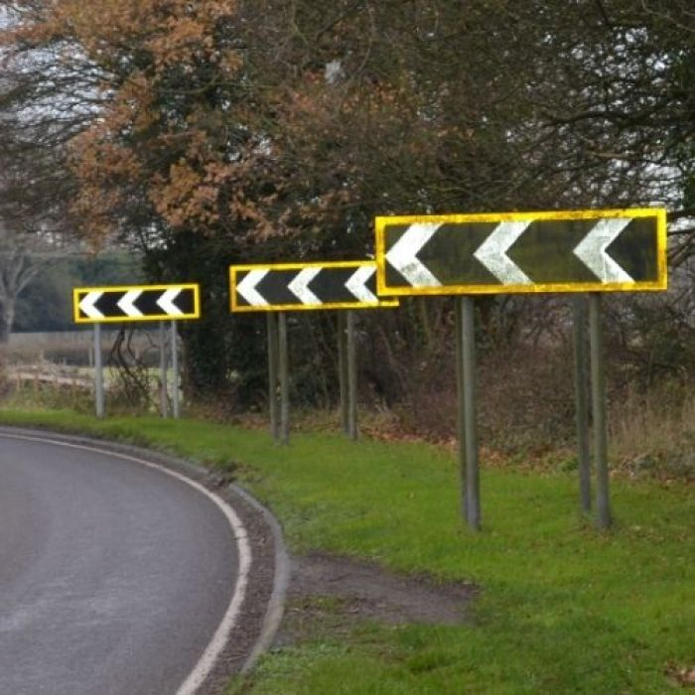

The installation of further signs such as chevrons, as pictured in figure seven, would dramatically increase the presence of the bend due to a number of factors, the main one being the size of the signage. The signs are reflective and are highly visible in reduced light or darkness. The installation of chevrons after a long stretch of road is advantageous as this will make the driver aware that a bend is approaching, (Traffic choices, 2015).
Figure 7 Chevron showing sharp deviation of route (Jardine motors group, 2016)
Figure 8 Left hand bend warning sign (Highway code, 2022)
I personally feel that when chevrons are set out as in figure seven, there is a continued perception of distance which is exaggerated by the signage, making it easier to be able to follow the curvature of the road.
The installation of left-hand bend warning signs on the approach to the bend will also make the bend more visible to drivers, warning them that there is a bend ahead, combined with the chevrons and double white lines should drastically reduce the number of drivers who would attempt an overtake on this route.

A study by Clarke, et al (2010) focusing on fatal road collisions in the UK noted that 44% of fatal accidents occurred on a bend with the majority of those involved being younger drivers. The study also found that speed was a factor in 74% of the accidents and contributed to the driver losing control of their vehicle due to this.

Conclusion:
In order to improve the safety of this part of the road, South Wales police, the local authorities and also Cardiff International Airport could consider a joint venture to make the road more user friendly by imposing some of the above safety features.
Cardiff Airport specifically could have a dedicated information page regarding the roads with an interactive map or route guiding visitors to the Airport.
Currently the “To and From” page (Cardiff International Airport Ltd, N.D.) has limited directions regarding the area and does not mention that some of the access routes are from rural roads. There could be some further, more in depth information regarding the speed limits and that there are multiple roundabouts on this route which could be confusing to drivers, therefore meaning that their full attention may not be on the road.

South Wales police could introduce specific layby sites so that mobile safety camera vans would be able to set up in the area and deter drivers from considering speeding or undertaking unsafe manoeuvres.
The College of Policing (2022) state that safety cameras reduce drivers likelihood of speeding due to the general deterrence and the threat of being caught speeding and the consequences of this, and the directed deterrence to drivers who have already been prosecuted and would not wish to be prosecuted again.
The College of Policing (2022) also stated that evidence supports safety cameras being an effective tool in reducing road collisions and reducing drivers speed.
Fixed speed cameras can be covert or overt, I personally feel that an overt fixed camera would suit this road best as the hours of operation would be 24/7 and this would impact all drivers who used the road.

The local council could implement any one of the initiatives mentioned in this essay, such as double white lines and introducing additional signage, all of which I feel would have a significant impact upon road safety in that area.

Another measure would be to reduce the speed limit, however I personally feel that reducing the speed limit would have a counterintuitive effect especially on local drivers, as they might become annoyed and agitated at the slow pace of traffic on this long stretch of road and may undertake dangerous manoeuvres to make progress in their journey.
To combat issues with slow moving vehicles such as farm traffic or HGV’s, additional layby’s with the specific purpose for these slow moving vehicles could be installed to ease traffic congestion. An article published by Somerset Live (Brinsford,J, 2017) quotes the Highway Code “Rule 169…motorists should not hold up a queue of traffic, especially if they are driving a large or slow-moving vehicle”. By adding laybys for these slow moving vehicle vehicles, it would aide drivers in being able to implement this rule more freely and efficiently.
However, if no overtaking signs and solid white lines were installed, it would mean that a lower speed limit could be enforced by the design of the road.

I would suggest that if all of or some of the suggestions raised above were implemented, then this would make the road safer for all road users and would dramatically decrease the likelihood of another fatal collision occurring on this stretch of road.

Word count – 5406

Bibliography

AgeUk (2020) Worried about someone’s driving?
Available at https://www.ageuk.org.uk/information-advice/travel-hobbies/driving/worried-about-someones-driving/
(Accessed on 11th June 2022).
Borton, T. (1970). Reach, touch, and teach: student concerns and process education. McGraw-Hill.

Cardiff International Airport Ltd (N.D.) To and From
Available at: https://www.cardiff-airport.com/by-road/
(Assessed on 10th June 2022)
Clarke, D.D., Ward, P., Bartle, C. and Truman, W. (2010). ‘Killer crashes: fatal road traffic accidents in the UK’. Accident Analysis & Prevention, 42(2), pp.764-770.
Available at: https://www.sciencedirect.com/science/article/pii/S0001457509003091#
(Accessed: 11th June 2022)
College of Policing (2022) Speed Cameras
Available at: https://www.college.police.uk/research/crime-reduction-toolkit/speed-cameras
(Accessed 10th June 2022)

Brinsford, J This is the law for slow-moving vehicles and when tractors, lorries, caravans and cyclists should pull over
Available at https://www.somersetlive.co.uk/news/somerset-news/law-slow-moving-vehicles-tractors-196711?fbclid=IwAR3zkmMQqFB4N3u6WZn4b7YGq_YlBsX9WxD0KO5MPglKIqMkq_t2tpZJuS4
(Accessed on 20th June 2022)
The Department of Transport (2021). Reported road casualties Great Britain, provisional results:2021
Available at Reported road casualties Great Britain, provisional results: 2021 - GOV.UK (www.gov.uk).
(Accessed on 1st June 2022).
Friedman, J.S. (2017). Why Motorcyclists are the most vulnerable drivers on the road.
Available at Why Motorcyclists are the Most Vulnerable Drivers on the Road (smflegal.com).
(Accessed on 1st June 2022).

Goodson, M. (2022). The Pass Plus Scheme: how much it costs, car insurance discounts and is it worth it?
Available at The Pass Plus Scheme: how much it costs, car insurance discounts and is it worth it? | Carbuyer.
(Accessed on 10th June 2022).

GOV.UK (ND). Medical conditions, disabilities and driving
Available at Medical conditions, disabilities and driving: Telling DVLA about a medical condition or disability - GOV.UK (www.gov.uk).
(Accessed on 10th June 2022).

GOV.UK. (ND). Pass Plus
Available at Pass Plus: Car insurance discounts - GOV.UK (www.gov.uk).
(Accessed on 10th June 2022).
The Highway Code (2022). Road signs giving orders. (Figure 5)
Available at Road signs giving orders - THE HIGHWAY CODE (highwaycodeuk.co.uk).
(Accessed on 17th June 2022).

The Highway Code (2022). Road users requiring extra care.
Available at Road users requiring extra care - Overview (204) - THE HIGHWAY CODE (highwaycodeuk.co.uk).
(Accessed on 17th June 2022).

The Highway Code (2022). Road markings. (Figure 4)
Available at Road markings - THE HIGHWAY CODE (highwaycodeuk.co.uk).
(Accessed on 17th June 2022).
Highway code (2022) Warning signs on the road (Figure 8)
Available at: https://www.highwaycodeuk.co.uk/warning-signs-on-the-road.html
(Accessed: 15th June 2022)
Jardine motors group (2016) Painted Chevrons: What do they mean? (Figure 7)
Available at: https://news.jardinemotors.co.uk/how-to/painted-chevrons-what-do-they-mean
(Accessed: 14th June 2022)
Made up Britain (2017) Cat Eyes (Figure 6)
Available at: https://madeupinbritain.uk/Cat_Eyes
(Accessed: 12th June 2022)
Mares P,. Coyne P,. MacDonald B,. (2015) Roadcraft. 4th Edition The Stationary Office
Merseyside Road Safety Partnership (2022) Drive smarter, choose an engage instructor.
Available at Road Safety Initiatives - Merseyside Road Safety Partnership.
(Accessed on 10th June 2022).

Police Reform Act (2002).
Available at Police Reform Act 2002 (legislation.gov.uk).
(Accessed on 1st June 2022).

RAC. (2022). Speed Cameras – how they work. (Figure 3)
Available at https://www.rac.co.uk/drive/advice/cameras/speed-cameras/.
(Accessed on 18th June 2022).

Safer Roads, Humber (ND). Safety Camera Sites.
Available at Safety Camera Sites (saferroadshumber.com).
(Accessed on 18th June 2022).

Sussex Safer Roads Partnership (2022). About us
Available at Sussex Safer Roads Partnership | Who We Are & What We Do.
(Accessed on 18th June 2022).

Traffic Choices (2015). Chevrons.
Available at Road signs giving orders - THE HIGHWAY CODE (highwaycodeuk.co.uk).
(Accessed on 18th June 2022).

Woof, M. (2012). Effective signage and road markings boost road safety.
Available at https://www.rac.co.uk/drive/advice/cameras/speed-cameras/.
(Accessed on 18th June 2022).

TASK4 Bibliography
The bibliography should only include sources referenced within the workbook using the Harvard referencing system. Information about referencing in written assignments and how to avoid plagiarism can be found on Moodle. It is important that you are aware of the importance of ensuring that the work submitted is your original work.

