Introduction to Research
Literature Review

Title:
Is there enough support surrounding Burnout, Compassion Fatigue and Vicarious traumatisation and Secondary traumatic stress within field of nursing?

Name: Ashley Jones

Student Number: 2109767

Module lead:
Jodie Croxall & Kalee Thomas

Module code: BMHP5005

ABSTRACT

The conceptualisation of secondary traumatic stress (STS) has been described as multifaceted; thus, researchers have stated there is a lack of conceptual clarity surrounding STS. The use of different terminology at times to refer to the same concept contributes to this confusion. Closely related concepts of secondary traumatic stress such as compassion fatigue, burnout, well-being, and vicarious traumatisation, needs to be differentiated and will be differentiated throughout this programme of work. This review of the literature attempts to bring together a variety of current findings on burnout, secondary trauma, vicarious trauma, and compassion fatigue in articles published between 2012 and 2022. First, the researcher looked for key terminology (i.e., vicarious trauma, secondary trauma, burnout, compassion fatigue) within the article to see what topics they covered. Second the researcher reviewed the articles to see what the articles have in common through thematic Analysis (Bryon Clarke et al, 2018). Lastly, the researcher summarised what the articles offered in terms of assistance when dealing with trauma through lower and higher order themes.

SECTION 1: INTRODUCTION AND RATIONALE

Posttraumatic stress disorder (PTSD) was first listed in the Diagnostic and Statistical Manual of Mental Disorders-III in 1980 (American Psychiatric Association, 1980). Research proposed by Summerfield (2001), suggests that Veterans of the Vietnam War were the first persons diagnosed with this PTSD. Over the past three decades, the psychological effects of direct exposure to extreme traumatic stressors have been well documented. Despite this, Figley (1988) expressed that secondary exposure can have the same detrimental effects of from an extreme traumatic stressor as those who experienced the primary exposure.
It is fair to say that secondary traumatic stress is an occupational hazard for persons who provide direct patient care to traumatised victims. In the field of nursing, burnout, vicarious trauma, secondary trauma and compassion fatigue are all terms often used to describe exhaustion from treating and seeing patients. Nurses play a key role in supporting patient health and recover from trauma, such of which puts the nurse in a vulnerable position by experiencing indirect trauma, such as vicarious trauma, secondary traumatic stress, and compassion fatigue. Thus in with Figley’s (1988) research, suggesting there is a “cost of caring” for health care providers dealing with traumatised patients. Sabo, (2006) further implies that caring for a patient can lead to personal hatred and self-doubt when the patient faces unpredictable outcomes. Despite this, nurses must be empathetic and form trusting relationships to thriving within their role (David, 2002). However, newly qualified nurses are at greater risk of experiencing such forms of indirect trauma as they are often unprepared and provided with the tools to cope with the new experiences and such demands. Although there have been studies on reducing in-directed trauma within nursing, there is a lack of research on the experiences of newly qualified nurses within the field. Particularly, the resources and education to support the newly qualified nurses to cope and manage the exposure to trauma.
Conceptualisation Clarification
The conceptualisation of secondary traumatic stress (STS) has been described as multifaceted; thus, researchers have stated there is a lack of conceptual clarity surrounding STS. The use of different terminology at times to refer to the same concept contributes to this confusion. Closely related concepts of secondary traumatic stress such as compassion fatigue, burnout, well-being, and vicarious traumatisation, needs to be differentiated and will be differentiated throughout this programme of work.
How Secondary Traumatic Stress will be defined within this research?
In simple terms, Figley (1995) described Secondary traumatic stress as an individual may become traumatised only by learning of a tragic event that has happened to someone else. It has been further defined as a natural reacting emotions and behaviours from gaining knowledge of a traumatising event experienced by a significant other (Aston, 2012).
Aim of the Narrative Review

A reoccurring theme within secondary traumatic stress literature over the past decade is the need for improved conceptualisation. Past research has integrated STS as a multifaceted construct with compassion fatigue, burnout, well-being and vicarious traumatisation. Such of which have created ambiguity surrounding the term secondary traumatic stress. In line with the research proposed by (Caswell, 2018), the majority of the key factors ‘integrated’ with STS deserve the right for their own categorisation. However, research from (Caswell, 2018) proposes that they are closely linked to STS.

The purpose of this narrative review is to provide an overview of the research surrounding burnout, well-being and vicarious traumatisation in field of nursing, particularly surrounding the support and education for newly qualified nurses. Furthermore, to attempt to bring understanding and differentiation of Compassion fatigue, burnout, well-being and vicarious traumatisation within nursing. Lastly, to provide theoretically informed recommendations to support newly qualified nursing dealing and managing STS.
In simple terms:
Aim: An narrative review of the education to support and coping with burnout, well-being and vicarious traumatisation within field of nursing.
- To discover the tools provided to the newly qualified nurses to identify burnout, compassion fatigue, vicarious trauma and secondary trauma.
- To explore the skills and identify the measures in place to monitor burnout, compassion fatigue, vicarious trauma and secondary trauma.
- To identify the warning signs and ways to prevent and treat burnout, compassion fatigue, vicarious trauma and secondary trauma within nurses
- To provide recommendations for planning, implementing, and evaluating the nurses experiences and needed support in these areas.

SECTION 2: METHODOLOGY & METHODS

The literature search was performed through December 2022, using google scholar, PubMed and ProQuest Such literature search allows the research to be theoretically informed through credible research surrounding the aims of this research (Patton, 2020). To provide an ‘efficient’ narrative review, the literature search was restricted to articles published in the last 10 years (2012-22).
A total of 1013 articles were retrieved, (522 from PubMed, 469 from Google scholar and 22 ProQuest) out of which 44 articles were identified as eligible during pre-screening. The researcher pre-screened articles by removing articles based on the titles first, followed by the abstracts second. The research pre-screened articles but removed articles that were not from journals and did not collect data or were not literature reviews. After the removal of duplicate articles based on reading title and abstract review, 21 articles remained to analyse. Finally, the researcher looked for key words in the abstracts of the 21 articles and kept any article that gave suggestions or areas of inclusion to the research topic or assistance for a classroom setting. The researcher identified 8 articles that the met final criteria. These articles enhanced our understanding of trauma and support within nursing. For details on the 8 articles refer to (Appendix Table 1).

SECTION 3: Results
This review of the literature attempts to bring together a variety of current findings on burnout, secondary trauma, vicarious trauma, and compassion fatigue in articles published between 2012 and 2022. First, the researcher looked for key terminology (i.e., vicarious trauma, secondary trauma, burnout, compassion fatigue) within the article to see what topics they covered. Second the researcher reviewed the articles to see what the articles have in common through thematic Analysis (Bryon Clarke et al, 2018). Lastly, the researcher summarised what the articles offered in terms of assistance when dealing with trauma through lower and higher order themes.
A critical evaluation and common themes
It is fair to say that the studies recognise that professional burnout is a phenomenon that can occur in most any ‘social work setting’. It has been conceptualised that vicarious trauma, secondary traumatic stress, and compassion fatigue are unique to direct practice with crisis and trauma population. Although, all studies stated that there is no clear ‘definition’ to both secondary traumatic stress, compassion fatigue and vicarious trauma, which makes
Objectives:
it a phenomenon that is difficult to measure, educate and monitor. In contrast throughout the studies, it was popular that trauma history within the person plays a pivotal around the high order themes (Vicarious trauma, secondary trauma stress, compassion fatigue and burnout). In light of this a lack of organisational structure and inadequate supervision and support, were themes throughout the studies that were popular towards occupational burnout. Furthermore, coping strategies and ‘preventive strategies’ further related around the relationship with emotional distress in relation to communication skills, ethical rounds, and mindfulness, all of which are proposed to have a pivotal role in personal development.
The articles that were reviewed have a lot of similar themes. Every narrative mentioned disturbances in life in some form. There are different levels of PTSD, self-reported vicarious trauma, and belief disruption, according to the studies. Contrarily, belief disruption was based on the practitioners' personal trauma and did not indicate vicarious trauma. Such personal factors or some would say ecological systems (Nancy, 2009), refer to how likely the individual is to develop vicarious trauma, burnout secondary trauma and compassion fatigue. For example, someone who is exposed to personal history of violence, and disruption of cognitive abilities are have increased chance of secondary trauma or burnout.

Identify areas of controversy and/or methodological weaknesses within the literature
In line with the rationale of this literature review, tools touched on to occupational burnout, compassion fatigue, vicarious and secondary traumas as well as provide skills to measure the concepts within the workplace. The researcher analysed the information and found the following themes that explain burnout, vicarious trauma and secondary traumatic stress.
A popular way to measure burnout from the findings were Maslach Burnout Inventory (MBI) (Maslach and Jackson, 1981) and the Professional Quality of Life scale (ProQOL) which is been recommended through theorists to use on a regular basis to assess both organizational and individual risk of burnout and trauma-related conditions in “high-risk” environments. Maslach burnout inventory includes 22 items divided into three subscales: emotional exhaustion, depersonalisation, and personal accomplishment. In contrast burnout is viewed as a continuous variable, Research proposes that although we have tried to measure trauma, it is a 'constant variable' that depends on the individual experience of trauma, aligned with their Ecological systems (Newell and MacNeil, 2010). Such of which highlights that there is no one way to measure burnout, compassion fatigue, and vicarious trauma. Furthermore, Van Mol et al, (2015) research identified a broad range of intervention strategies, including various intensivist work schedules, training programmes on coping with emotional discomfort, increasing communication skills, and relaxing techniques, emerged from the current literature search. Although, it can be said that these are a broad range of interventions which need to be systematically considered (Yang et al, 2012). Research further suggests that a person who is exposed to personal history of violence, and disruption of cognitive abilities are have increased chance of secondary trauma or burnout. However, there is little research around methods in how the employer identifies the following within nurses, particularly within longitudinal research. Shorey’s (2022) research, further elaborates on the following through four high order, the four main themes were (1) "instantaneous response to the trauma," (2) "finding hope in the midst of chaos," (3) "dealing with the aftermath," and (4) "resolution to move on." It was further proposed that communication and teamwork within the health care profession identified numerous challenges contributed through management, hierarchy and lack of organisational structure.

Discussion
Despite the large body of research, burnout, compassion fatigue, secondary traumatic stress, wellbeing and vicarious trauma remains an unclear construct. However, it is evident from the research that ‘burnout’ can occur more likely, within everyday life, than secondary traumatic stress, vicarious trauma and compassion fatigue. In contrast from the finding the studies within this research area are few than 100 people. Furthermore, there is a lack of longitudinal research within this sector surrounding ‘preventive’ strategies and coping methods within the field of nursing. In light of this, there no specific information following racial demographics and a lack of specific personality traits that may increase the chances of secondary trauma. Some of the research finding within the articles were contradictory, as some stated high work pressure was correlated with burnout in one study yet in a few others it was unrelated. An increasing concern, was how research papers attempted to measure trauma and within the same paper, stated the ‘following cannot be measured as it a variable construct’. In three of the following studies, the response rate was less than 50 percent. Henceforth, it simply cannot be conclude burnout is due to the lack of proper supervision and organisational structure.
In addition, a large scale of the research identified that experience to trauma, increases the percentage of experiencing secondary trauma stress and burnout once more. However, the search studies proposed no method in screening and checking the individual previous history. Such of which plays a pivotal role in implementing self-care, it is important to include information about good supervision, dealing with your own trauma and how it related to burnout. Implementing how to give proper supervision will help members of staff and hierarchy and prepare them to be in that supervisory role. Despite this, the literature articulating ‘preventative strategies’, there was little evidence of proactive methods that can be used for the health carer providers. Thus, lacking direction in terms how and where resources could be used today. Finally, based finding that lack of organizational structure in the work environment it would be important to know if a creative and interactive work environment is helpful in reducing the competing demands of employment and academics, potentially resulting in reduced risk of burnout. Finally, given the absence of organisational structure in the workplace, it is crucial to understand if a creative and interactive work environment may assist employees balance the demands of their jobs and their academic obligations, thereby lowering their risk of burnout.

Section 4 – Recommendations and conclusion

Recommendation 1:
Getting to know the person (Social baggage) by having an induction meeting as there is an increased chance of STS / compassion fatigue / burnout when the individual has previously gone through high levels of trauma in their history. Therefore, these members of staff are more vulnerable and should have coping strategies put into place and closely monitored (Jaeckle, et al, 2022).

Recommendation 2:
Education through continues professional development (CPDs) throughout the year to all staff, with multilevel interventions to address STS/ Compassion fatigue / Burnout (Aycock and Boyle, 2009), Gaining knowledge will allow individuals to develop a range of coping strategies to support them throughout their occupation (Awe, et al, 2010).

Recommendation 3:
Maben and Bridges (2022) suggest that having regular appointments to support mental health and wellbeing should be prioritised like surgeries and dentists. Thus, regular compulsory appointments will be highly supportive for members of staff. Providing this support will help to prevent the negative outcomes.

Recommendation 4:
Burnout is known to be a “gateway to compassion fatigue”, Studies have shown that there is a lack of longitudinal research on gathering this evidence.

Conclusion
As an overview of the research, personal factors need to be considered, along with the ecological systems of oneself.
Furthermore, communication played a pivotal role within the research papers through both hierarchy and the nurses. In light of this research conceptualised that burnout is caused by poor time-management, organisation and a lack of support and resources from management. Lastly, in order to apply this theory into practice through interventions, it needs to be systematic and through a longitudinal study to promote further research (Delaney, 2018).
Despite this research of conceptualisation there is still a lack of conceptual clarity surrounding secondary traumatic stress as everyone is independent on their own experiences and some coping strategies might work for oneself may not work for another.

REFERENCING

Cummings, C., Singer, J., Hisaka, R. and Benuto, L.T., 2021. Compassion satisfaction to combat work-related burnout, vicarious trauma, and secondary traumatic stress. Journal of interpersonal violence, 36(9-10), pp.NP5304-NP5319.
Delaney, M.C., 2018. Caring for the caregivers: Evaluation of the effect of an eight-week pilot mindful self-compassion (MSC) training program on nurses’ compassion fatigue and resilience. PloS one, 13(11), p.e0207261.
Figley, C.R., 1988. Toward a field of traumatic stress. Journal of Traumatic Stress, 1(1), pp.3-16.
Newell, J.M. and MacNeil, G.A., 2010. Professional burnout, vicarious trauma, secondary traumatic stress, and compassion fatigue. Best practices in mental health, 6(2), pp.57-68.
Shorey, S. and Wong, P.Z.E., 2021. Vicarious Trauma Experienced by Health Care Providers Involved in Traumatic Childbirths: A Meta-Synthesis. Trauma, Violence, & Abuse, p.15248380211013135.
Van Mol, M.M., Kompanje, E.J., Benoit, D.D., Bakker, J. and Nijkamp, M.D., 2015. The prevalence of compassion fatigue and burnout among healthcare professionals in intensive care units: a systematic review. PloS one, 10(8), p.e0136955.
Yang, Y.H. and Kim, J.K., 2012. A literature review of compassion fatigue in nursing. Korean Journal of Adult Nursing, 24(1), pp.38-51.

Appendix

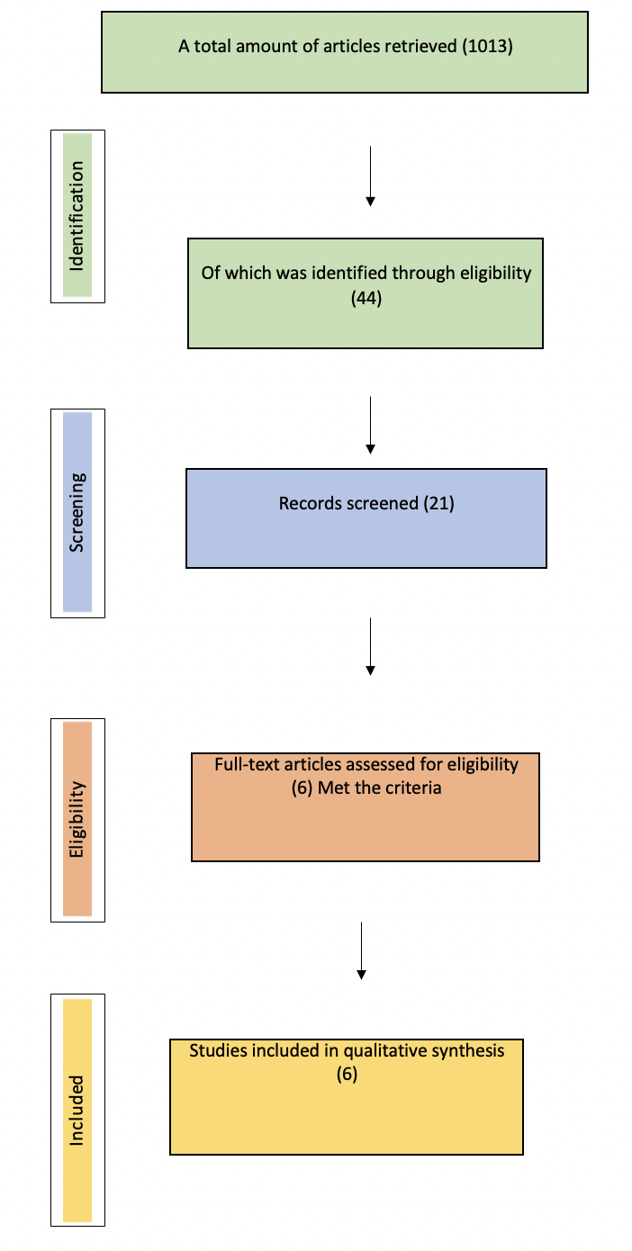

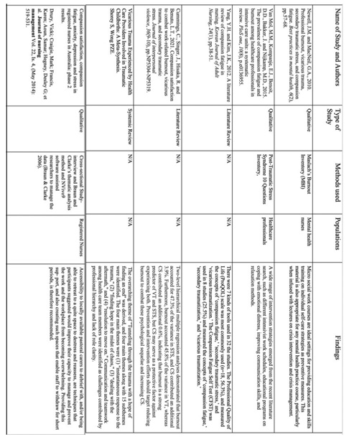

APPENDICES

- Literature Search Strategy

- Critical Appriasal Tool

