Individual Reflective Report (Entrepreneurial Learning)
Programme: Certificate in Higher Education Skills for the Workplace
Module: Managing Enterprise in the 21st Century
Module code: BMSW 4006
Assignment Title: Business plan
Lecturer’s Name: Dr Oluwaseun (Olu) Adegbite

Student Names | Student ID Numbers
Florina Madalina Gugoi | 2111163
Ion-Sotir Gugoi | 2113008
Salah Mheidean | 2109425
Venetia Francis | 2108963
Addis Gebresilasie | 2112297

Executive Summary
Gem Star is launching its business selling citrine bracelets made of emerald. It has created an effective business model and it provides a great extent of services to its customers. The company also analyses its strengths, weaknesses, opportunities, and threats through the SWOT analysis method. The citrine bracelets are fashionable and easy to carry everywhere on daily basis. Gem Star has made a precise market survey before launching their new product which is citrine bracelets (emerald). For this purpose, there is an implementation of PESTLE analysis in their business strategy. There is an evaluation of the external factors that have a great impact on the business. There is also an analysis of their target market and target customers. The conclusion summarises the business plan of Gem Star in a nutshell. The jewellery brand Gemstar is a leading brand which is developing its marketing strategy as they are launching its new product. The management team of the company has adopted various marketing strategies to promote their newly launched jewellery item.

Table of Contents
Executive Summary 2
Introduction 4
Business overview 4
Products and services 4
Market audit 5
Competitors: 5
Pestle Analysis 5
Swot Analysis 6
Target Market 7
Marketing Plan 7
Management Team 8
Financial plan 8
A financial plan type-Balance sheet of the company: 8
Forecast profit and loss account 10
Conclusion 11
References 12

Introduction
A business plan is a systematic approach to achieving the targets of the company and upgrading the company's growth (Ferreras-Garcia, Hernández-Lara and Serradell-López, 2019). Gem Star has launched its stores in The UK to produce citrine bracelets made of emerald. It has set up an innovative design and structure plan to flourish and enhance its business in the UK.

Business overview
Gem Star is launching its stores with the goal of bringing the trend of emerald citrine bracelets to the market. The company plans to launch in December 2022 intending to make the business a success. The company has a General Partnership structure and plans to open its first store in London Mall. They offer a variety of stylish citrine bracelets starting at a minimal price. Gem Star has made their products pocket-friendly with people's financial aspects in mind. The business attracts both genders, both of whom enjoy wearing these citrine bracelets. The slogan states "Bring sparkle to everyday life," which means that wearing them makes people's everyday attire look more special. The company has developed a unique process to improve its business. The company plans to give customers discounts on citrine bracelets made of emerald. This will attract customers to buy the products. Gem Star needs to stay aware of its competitors so that it can continue to stand out among its customers. The company has planned out the investments that will be made in the citrine bracelets market before launching them.

Products and services
Gem Star plans to produce citrine bracelets from precious emeralds in various shapes and sizes. The jewellery ranges from light to heavy, and the products are designed for different occasions. The products are designed to be sold on digital platforms, with prices that are globally competitive. The company has detailed information about the manufacturing process. (Musiyarira et al., 2019). The company provides warranty cards to customers assuring them of the quality of citrine bracelets. The emeralds used in this product are guaranteed to be genuine. The company will exchange any faulty citrine bracelets with new ones and will also take steps to improve their products as needed. The company has provided detailed information about its emerald citrine bracelets collection so that their customers are aware of the product. Gem Star would benefit from improved customer relationships and a higher brand value. Customers who purchase citrine bracelets online are not necessarily fraudulent, and Gem Star takes full responsibility for the bracelets it is selling in the market.

Market audit

Competitors:
Comparing the relative qualities and flaws of possible challengers is a vital part of outlining a successful competitive technique. We provide a variety of jewellery that will be popular with customers and give businesses a competitive edge. Our jewellery is affordable, which will make it more attractive to guests. Low costs and income can be adversely affected by location. The location of our company suits our budget, offers a large parking lot and is convenient for customers, visitors, and suppliers.

Pestle Analysis
The Gem Star is a rising organisation that is starting to gain traction in the UK market. They are working with different types of Gem Star bracelets. They are planning to launch a citrine bracelet (emerald) on the market. The stone is said to provide better health and knowledge, so a proper evaluation should be done to see if the new product is selling well in the market. PESTLE analysis is a great way to get a snapshot of external factors that may be affecting a business.
Political: The brand will initially operate its business in the UK market. The proper functioning of the UK government rules and regulations should be maintained. Gem Star needs licenses from the government in order to operate in the sector it has its business in. (Trisakhon, Onputtha and Peamchai, 2018). It is important that proper documentation and availability of the licenses for operating the business is maintained so that any future expansion into other countries is done with awareness of the different business rules in place in different places.
Economic: Gem Star is looking to make a name for themselves in the UK market by providing authentic Gem Star services. The high value of these stones means that the brand has to keep production costs low in order to maintain an effective pricing structure. (Xu and Yu, 2019). This will benefit a large number of people and the business will grow healthily in the market.

Social: The business sector is very social because it is entirely dedicated to helping society. The brand has to be conscious of its social responsibilities and provide its services in a way that meets those responsibilities (Trisakhon, Onputtha and Peamchai, 2018). There should be no violence or unethical behaviour in social media marketing because this can be harmful to the business.
Technological: The brand should use advanced technologies to conduct market research and produce products. These technologies can be used to help brand and promote products. People from all walks of life are increasingly reliant on digital platforms, regardless of their financial situation. Digital platforms can be very helpful for advertising your product, as they allow you to use modern technology to make your products more visible to customers (Xu and Yu, 2019).
Legal: The brand has to navigate a risky and legal landscape when operating in a sector where ethical and social issues are common. To avoid fraud, the brand must maintain proper licenses and legal papers, and be aware of false imitation of their products. (Phittayanon and Rungreunganun, 2019).
Environmental: The brand has been able to maintain a high level of efficiency while still keeping its natural feel. The importance of maintaining a natural balance between Gem Stars is crucial for them. They are effective investors who keep the environment sustainable, which helps gain the trust of the public.

Swot Analysis
- Strengths: The company creates high-quality products that customers trust. The company focuses on interacting directly with its customers. The variation in products and cost can help to keep customers loyal to a company. The company maintains transparency with its customers and offers home delivery options (Serdiuk, Votchenko and Bogdashev, 2019).
- Weaknesses: The company is about to be launched soon, so its brand recognition is very low. Many people prefer to purchase expensive jewellery such as emeralds from well-established brands. The company's citrine bracelets may not be attracting customers.
- Opportunities: The company has the opportunity to grow its business in many different areas. To maintain and grow its brand recognition, a company must provide good customer service. Digital platforms should be used to advertise the citrine bracelets to make customers aware of the products, and then select the right investors and listen to customer opinions to improve the business (Goel and Sahai, 2020).
- Threats: The competitors may be introducing the same emerald bracelets made of citrine, which makes the company's competition tough. The financial crisis would lead to the downfall of the business. Selling the emerald citrine bracelets online would likely result in a decline in sales as many people don't feel comfortable buying products online.

Target Market
Every business has to decide what its target market is and who its target customers are. This will help the business make the most profit possible. Target marketing is one of the most fundamental marketing strategies used by brands to determine how much demand there is for their products and to see if people are interested in buying them. This helps the brand to control the productivity of its products and reduces the chances of losing business. The Gem Star brand also carefully evaluated its market before launching its product. The most targeted people from the age group of 30-60, as people from this age group have shown the greatest affection for the citrine (emerald) bracelet. (Grant et al., 2018).After these people, the brand has targeted people in the age group of 19 to 30. This age group enjoys wearing jewellery, and they are generally fond of it.

Marketing Plan
The marketing of The Gem Star must be carried out systematically in order to be successful. Jewellery is about making up stories, and a successful jewellery marketing strategy means searching for and spreading the story of each jewellery piece through various social media platforms, appropriate advertising, unique content and more.Jewelry is loved by women across the globe, so marketing will be done in a way that women can connect with the brand, just as it can promote luxury jewellery from any female star. (Priskila et al., 2020). The brand has reasonable knowledge of jewellery market statistics as well as basic consumer personal information, staff will try to connect with consumers and have a solid understanding of age, preferences and also what exactly they are , the consumer is looking to have in a piece of jewellery. The brand will have a retail store, website, social media, and virtual stores to connect with consumers in person. The brand will use different social media platforms like Facebook to promote their events and programs, on Instagram the brand will have a lot of followers that will eventually increase the number of customers, on YouTube they will be able to do live broadcasts of their events .Priority is given to the online marketing and sale of jewellery through the company's website as it also helps to track the customer's purchase history.

Management Team
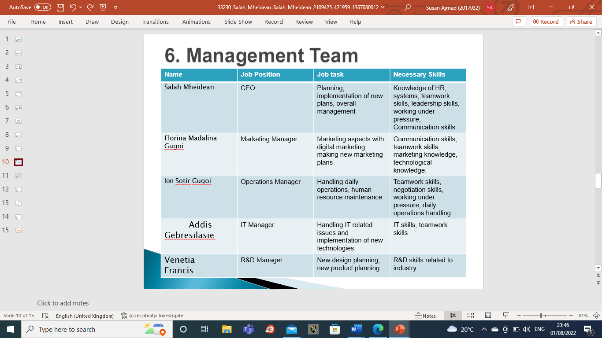

Financial plan
Financial planning is the process of developing a company's long-term financial goals and developing a strategy. The affordability of a business is important in achieving its goals and objectives. A financial plan is a plan that helps you make sure you have enough money to do what you need it to do, like buy long-term assets, pay your bills, and save for the future. In short, financial planning helps a business to use its money and other assets appropriately (The Balance, 2022).

A financial plan type-Balance sheet of the company:
We require an opening balance for a start-up before we can purchase supplies, cover rent, and pay for services like utilities. A grant of 50,000 pounds, a bank loan of 30,000 pounds, and investments of 100,000 pounds from my business partner and I total the opening balance of our company, which is £330,000. We plan to spend £150,000 on materials, which will include jewellery from other nations and office supplies. At the end of the first month, we anticipate having 330,000 pounds in incoming revenue and 189,760 pounds in total expenses. 140,240 pounds less will be coming in than going out.
There will be 332,620 pounds of outgoing and 3,260,000 pounds of total arriving at the end of the year, leaving closed balance of 2,927,380 pounds .
Des 2022 | Jan  2023 | Feb 2023 | Mar 2023 | Apr 2023 | May 2023 | Jun 2023 | Jul 2023 | Aug 2023 | Sep 2023 | Oct 2023 | Nov 2023
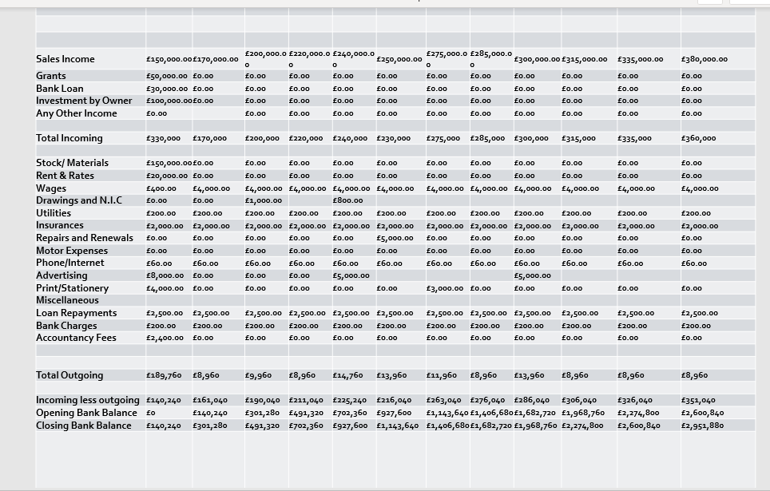
Start-up expenses | £33.000
Overall income | £32.60.000
Overall expenses | £308.120
Gross income | £16.200
Net income | £3.000

A balance sheet is one type of a financial plan that presents the assets and liabilities of a company. The financing of the assets either through debt or through equity are referred in a balance sheet. A balance sheet is constructed on the basis of following fundamental equations-
Assets= Equity+ Liabilities
Total assets= Current+ non-current assets
Total liabilities= Current+ non-current liabilities
Total equity of shareholders= Share capital+ Retained earnings (Corporate Finance Institute, 2022).

Forecast profit and loss account
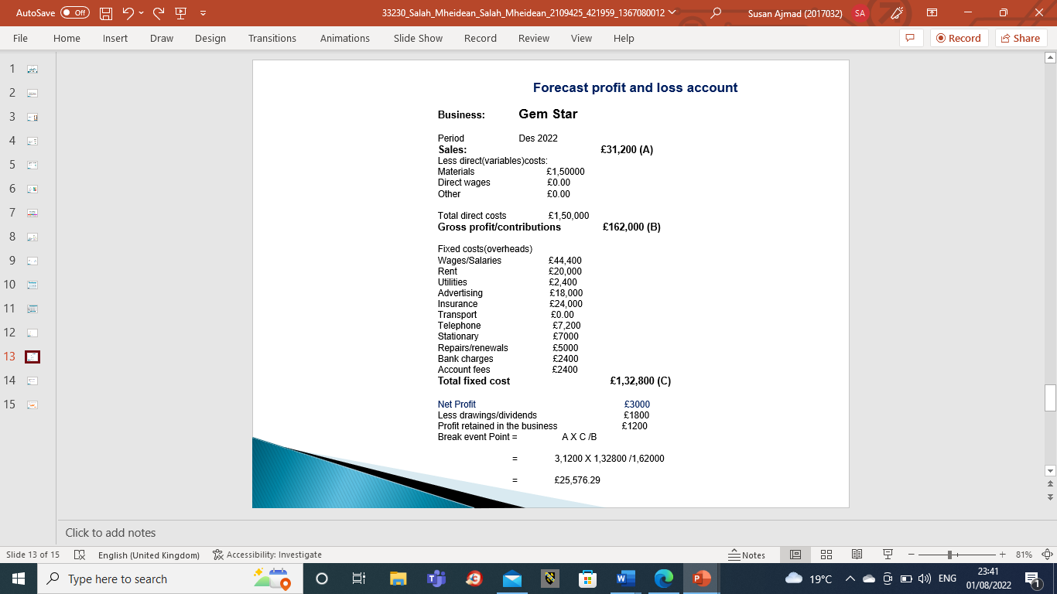

Conclusion
In conclusion, it can be said that the brand Gem Star has made an almost proper business plan that can be beneficial for them to make potential growth in their business. The brand is initially starting with the UK market but has the vision to deal in the global market as well. The market plan they have adopted, and the proper modification of this market plan will help them to achieve their dream market. The only thing they have to keep in mind is to maintain the proper business ethics and non-violation of the customers' trust.

References
Corporate Finance Institute, (2022). Balance Sheet. [online] Available at: <https://corporatefinanceinstitute.com/resources/knowledge/accounting/balance-sheet/> [Accessed 19 July 2022].
Ferreras-Garcia, R., Hernández-Lara, A.B. and Serradell-López, E., (2019). Entrepreneurial competences in a higher education business plan course. Education+ Training, 61(7/8), pp.850-869. Available at: https://www.emerald.com/insight/content/doi/10.1108/ET-04-2018-0090/full/html

Gerasimenko, V.V. and Golovanova, E., (2021). Evaluation of consumer behaviour on the Internet under the conditions of pandemic shock based on search activity in the luxury segment. Population and Economics, 5, p.16. Available at: https://populationandeconomics.pensoft.net/article/63315/download/pdf/

Goel, R. and Sahai, S., (2020). Big Data and Artificial Intelligence: Revolutionizing the Indian Retail Industry with Respect to Virtual Jewelry Stores. In Transforming Management Using Artificial Intelligence Techniques (pp. 1-9). CRC Press.
Available at: https://www.taylorfrancis.com/chapters/edit/10.1201/9781003032410-1/big-data-artificial-intelligence-richa-goel-seema-sahai

Grant, G.D. et al. ( 2018). Accurate delineation of cell cycle phase transitions in living cells with PIP-FUCCI. Cell Cycle, 17(21-22), pp.2496-2516. Available at: https://www.tandfonline.com/doi/pdf/10.1080/15384101.2018.1547001

Musiyarira, H.K., et al. (2019). Formulating strategic interventions for the coloured Gem Star industry in Namibia by utilising the logical framework approach. The Extractive Industries and Society, 6(4), pp.1017-1029. Available at: https://www.sciencedirect.com/science/article/abs/pii/S2214790X18303174

Phittayanon, C. and Rungreunganun, V., (2019). Analyzing Factors Influencing Industrial Competitiveness of Thai Silver Jewelry Industry Using Analytic Hierarchy Process. International Journal of Mechanical Engineering and Technology, 10(3). Available at: https://www.academia.edu/download/58925834/IJMET_10_04_040.pdf
Priskila, S. and Darma, G.S., (2020). Employee Perception of Brand Value in the Jewelry Industry. Journal of Economics, Business, & Accountancy Ventura, 23(2), pp.267-278. Available at: https://pdfs.semanticscholar.org/8533/6da2404139fef6f7459a8596434401177849.pdf

Serdiuk, A.V., Votchenko, E.S. and Bogdashev, I.V., (2019). The market value of brands on an international scale: considering the example of jewelry industry. Sciences of Europe, (39-3 (39)), pp.8-12. Available at: https://cyberleninka.ru/article/n/the-market-value-of-brands-on-an-international-scale-considering-the-example-of-jewelry-industry

The Balance, (2022). How Will a Financial Plan Help Me?. [online] Available at: <https://www.thebalance.com/how-will-a-financial-plan-help-me-2385556> [Accessed 19 July 2022].
Trisakhon, C., Onputtha, S. and Peamchai, P., (2018), July. The effect of external business environment on business performance of small and medium food processing enterprises in Bangkok and metropolitan area. In Proceedings of The 14th International conference in Applied Computer Technology and Information System (NCOBA-2018) (Vol. 23). Available at: https://www.researchgate.net/profile/Suraporn-Onputtha-3/publication/329923693_The_Effect_of_External_Business_Environment_on_Business_Performance_of_Small_and_Medium_Food_Processing_Enterprises_in_Bangkok_and_Metropolitan_Area/links/5c23d81ca6fdccfc706b1255/The-Effect-of-External-Business-Environment-on-Business-Performance-of-Small-and-Medium-Food-Processing-Enterprises-in-Bangkok-and-Metropolitan-Area.pdf

Xu, H. and Yu, X., (2019). PRESSED GIBBSITE AND CALCITE AS A RHODOCHROSITE IMITATION. Gems & Gemology, 55(3). Available at: https://www.gia.edu/doc/FA19-Rhodochrosite-Imitation.pdf

