
Management, Innovation and Sustainability
Approaches to Innovation And Organizational Change


Executive Summary
April 28, 2025
University of Wales Trinity Saint David

The purpose of this report is to analyse the effectiveness of a departmental change at Valero Refinery by Altrad Services. Eight employees were transferred from the integrity and projects departments to the mechanical bolting department. This change was driven by pressure from the client due to the department falling over a thousand hours behind on routine maintenance of PSVs. This change was poorly executed as there was limited communication, very little planning, and barely any support offered to the staff being transferred.

Lewin's force field is applied to the change to outline the driving forces and resisting forces. This also shows if the change was necessary to implement. Using Kotters 8 8-step model, the change is reviewed for its effectiveness, which highlights numerous failings by management in dealing with the transfer of staff. These include the failure to create a sense of urgency through communication, the absence of a strategic vision, the failure to engage with the workforce while being transferred or afterward, and to support them through the change. This led to resistance to the change among the workforce being transferred and low morale.

Lewin's 3-step model is also applied and used to suggest changes that could have been made that would have helped ease the transfer. It demonstrates how early communication, training, and recognition would have reduced resistance posed by the workforce. The motivation model applied suggests that the use of transformational leadership and open communication would have improved employee engagement and morale.

In conclusion, this report finds that while the change was necessary, it was mishandled and rushed. A more structured approach and use of a change management model would have reduced resistance and improved morale. It also finds that while change management models are still relevant, they must be flexible to keep up with the modern-day work environment.

Table of Contents
Executive Summary 0
Introduction 3
Main Findings 4
Overview of the Change 4
Assessment of Management's Effectiveness 5
How The Change Could Have Been More Effective 7
Motivation Model 8
Conclusion 9
Bibliography 10
Bibliography 10

Introduction

Altrad Services is one of the leading providers of support services in the industrial sector. They cover everything from mechanical engineering to scaffolding access and thermal insulation. “Part of the Altrad group with almost 52,000 people distributed throughout more than fifty countries worldwide, with 120 subsidiaries operating in Europe, North and South America, Canada, the Middle East, Africa, and Asia Pacific” (Altrad,2025).

The change of department being focused on occurred at the Valero oil refinery. Eight employees were moved from the projects/integrity department to the mechanical bolting department. This was because the department was over a thousand hours behind on scheduled work. Two of the employees transferred had no experience in the work undertaken in this department and were unqualified in changing out PSVs (pressure safety valves); the move was outside of their trade and training.

Clear leadership and management can aid changes in the workplace, as effective leaders can gain the trust of employees, and the employees are then less likely to resist change because they trust their leader (Yazdanifard,2015). Management communicating the change as soon as possible or while in the planning stages will help employees take an interest and prepare for the change (Dragomiroiu,2014). Research indicates that it is far easier to convince people to accept change if a vision of ease can be crafted. Successful implementation of change often resembles a hybrid form combining low-level participation and management direction (Fernandez,2013).

Main Findings

Change in terms of an organizational or managerial environment can mean that an organisation is going in a different direction, that other practices are being introduced, or a shakeup of the workforce; these are a few possible scenarios. “This is referred to as change management and is defined as the science-informed practice of managing planned organizational change” (Have,2022).

Resistance to change is commonplace and generally perceived as a bad thing or a threat. This feeling can easily be spread through the workforce. This can be down to several issues, one of the most common is fear of change and the uncertainty that comes with it. There is also the change to the norm and the way things were; this can be perceived as a threat (Warrick, 2023).

Overview of the Change

It was brought to light by the client that the mechanical bolting department was over a thousand hours behind on scheduled maintenance work servicing PSVs. As a result of this, the client requested Altrad to boost numbers in the department and supply more people to try to make up the deficit. It was decided by management that eight people could be transferred from the integrity and projects departments, as projects were coming to an end and integrity was reducing its numbers. Of the eight people transferred, three were not mechanical fitters/bolters and had very limited bolting knowledge and experience. The transfer was planned out weeks ahead of its implementation, but it was not communicated to the staff affected until a few days before.

This change was necessary as not only was it requested by the client, but it was critical for the safe running of the refinery. However, it was a poorly thought-out and poorly planned attempt to make up the hours that they had fallen behind. This is because it wasn’t created by a lack of workforce in the department. It was caused by the client's own permitting and work system, which resulted in multiple scheduled jobs being unable to be carried out. A third of the workforce used to bolster the department weren’t mechanical bolters as a result were inefficient at the role due to a lack of knowledge and in some cases a lack of interest. Although Altrad was forced into making this change, it seems that it was a reactive and poorly thought-through response by the client.

Assessment of Management's Effectiveness

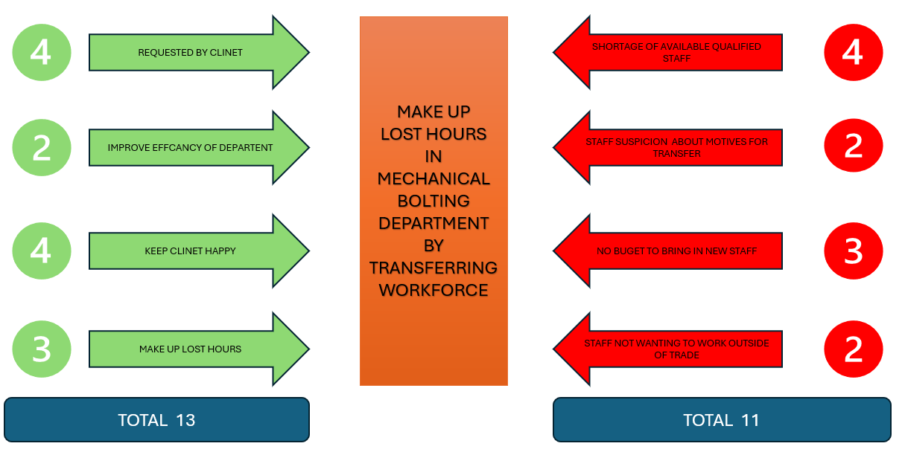
Figure 2 Lewins Forcefield (Reyes, 2024)

As outlined in Figure 2, the main driving force behind implementing the change was pressure from the client and the need to keep the client happy; both of these scored four. The force of change outweighs the force of resistance by a total of two. This means that the change was necessary. The main resisting forces to this were the lack of qualified personnel available to fill the needed roles, which scored four, and the lack of budget to hire new personnel, which scored three. Therefore, existing personnel had to be used although it was not their field of expertise; they created another force of resistance as they were unwilling to transfer to this department. However, it was only a force of two, which scored low.

To assess how this change was managed, Kotter’s model will be used. This is one of the most widely recognised models for change management; it uses an eight-stage process. It works by instilling a sense of urgency and understanding of the need to change, then builds on this, driving the change along. It also empowers the workforce to facilitate the change and celebrate short-term wins, then fix the change in place. This model places a strong emphasis on leadership and viewing change as top lead process this model focuses on organisational culture. Some problems with this model are that it isn’t detailed enough and is very linear, which means it wouldn’t be suited to every type of change. It is also overly planned and rigid in its structure, which is not reflective of real life, where you must constantly adapt. This model also assumes the readiness for change within the company (Pollack, 2015).

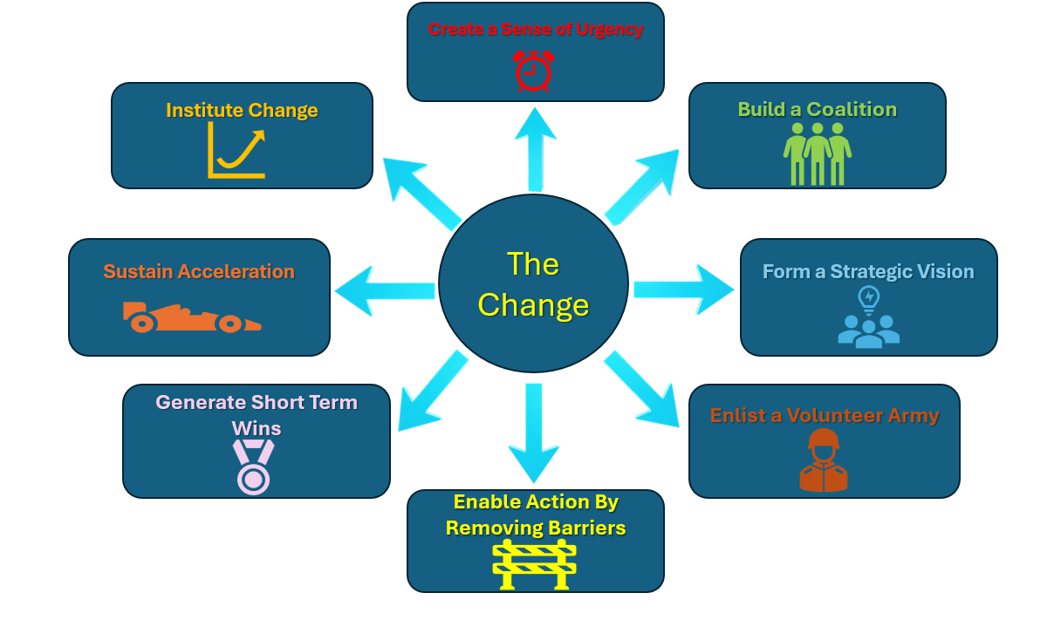
Figure 1 Kotter’s change model (kotterinc, (2025))

Applying Kotter’s model, at the first step management have failed, as there was no sense of urgency conveyed to the workforce. This would not have been hard, as there was a sense of urgency due to the client urgently wanting to make up the lost hours, so they did not fall outside of safety protocols, but this was not conveyed to the workforce. Kotter (2008) notes, “the failure to create a sense of urgency to be the single biggest error made when trying to change organisations”

The second step is to build a coalition to guide the change. This could not have possibly happened, as there was very little notice given to the workforce of the coming change. They were only informed a few days beforehand, and there was no attempt from the mechanical bolting department, projects, or integrity departments to help guide the workforce. The role of a program sponsor is vital to the success of implementing an organisational change (Helm, 2005).

Step three, a strategic vision plays a key role in beneficial change, it directs, aligns, and inspires actions in large numbers of people (Kotter, 2012). This step was missed; there was no vision created or laid out to the workforce, they were just told that the change was happening and when. The management used a very autocratic style of management, which is not in keeping with Kotter’s model. “Authoritarian decree often works poorly even in simple situations” (Kotter, 2012). As a result, step four was not met either as without the vision put in place it is going to be impossible to get people onboard to champion the change and sell it to the rest of the work force.

Step five was half achieved as most of the workforce were already trained in this discipline, as it was in keeping with their line of work. Unfortunately, these were not the workforce who created the most resistance to the change; it was the platers and pipefitters who were resistant, as it was outside of their line of work and trade. This would have been the perfect opportunity to try to smooth out the change by offering them training in bolting. This would have helped them overcome any doubts or worries they might have had about why they were transferred outside of their trade and would have given them a sense of belonging in the new department (Bashir, 2015)

Step five, generate short-term wins, was missed as there was no information fed back to any of the workforce about the progress on reducing the hours the department were behind. This would have been the perfect opportunity to show that the change was needed and the correct move, as well as reassuring the three staff who were transferred outside of their trade that they were a help to the department and not moved for other reasons. As trust in the reasons for their transfer was very low, they were doubting the motives. “Short-term wins help to demonstrate the viability of change and to build momentum” (Pollack, 2015).

Step seven, sustain acceleration, did not happen as it is hard to build on wins when no wins are conveyed to the workforce. Strangely, step eight, institute change, seemed to be a success as over time, all the workforce that were transferred assimilated into the department and settled into their roles. This being the case, morale was very low among most of the staff who had been transferred.

How The Change Could Have Been More Effective

To look at how the change could have been managed more effectively, the Lewin 3-step model will be applied. Its broadness helps to lend it to this situation. It alludes to the principle that change, especially the mental change of employees, is a journey as opposed to a straightforward step-by-step process and can involve a few stages of misconception or mistrust before reaching the other side (Pawar, 2017).

The first step is to unfreeze; this means to disrupt and break the pattern of the status quo. Only then can new behaviours and change start to be implemented and learnt. It also considers that the employees must feel safe and secure in the change before it takes place. Otherwise, no change will occur. The second part to change considers that planned change is difficult to achieve. The last step is to refreeze this, which looks to stabilize the group back into a new equilibrium to make sure new behaviours are set and safe from regression (Burnes, 2004).

To start unfreezing the norm, using Lewin’s change theory, informing the workforce being transferred as soon as possible, and any questions that they had being heard and addressed would have helped them feel secure, aiding the unfreezing (Kritsonis, (2005)). Instead, the lack of information creates uncertainty amongst individuals as the effects and motives of the change can’t be predicted (van den Heuvel, 2015). They should have also been informed of the reasons for the transfers to the mechanical bolting department, which would have also helped them understand the need for the transfer and tempered some of the resistance to the move (Kraft, 2016).

Once the transfer had taken place, employees should have been offered training tailored to the new department, such as bolting, PSVs, and permit training. This would have been most advantageous to the three that were outside of their trade, but would also have helped the mechanical bolters that were transferred. This would have helped them understand the new role and become more efficient. It also would have made them feel valued in this role, to show that they were being invested in (Ocen, 2017). “According to social exchange theory, providing employees with continuous training opportunities can be viewed as a signal to employees, indicating that the organization cares about them and appreciates their contributions” (Mansour, 2022).

To refreeze the change in place management could have released to all the employees in the bolting department the figures on the amount the deficit of hours had been reduced. This would have acted as a reinforcement to the employees that the change was working and that they were making a difference. This would have helped them feel part of the department. According to Jalagat (2016) “Realization and successful implementation of change in the organization enable a smoother experience of the positive consequences of change for both the employees and the organization”.

Motivation Model
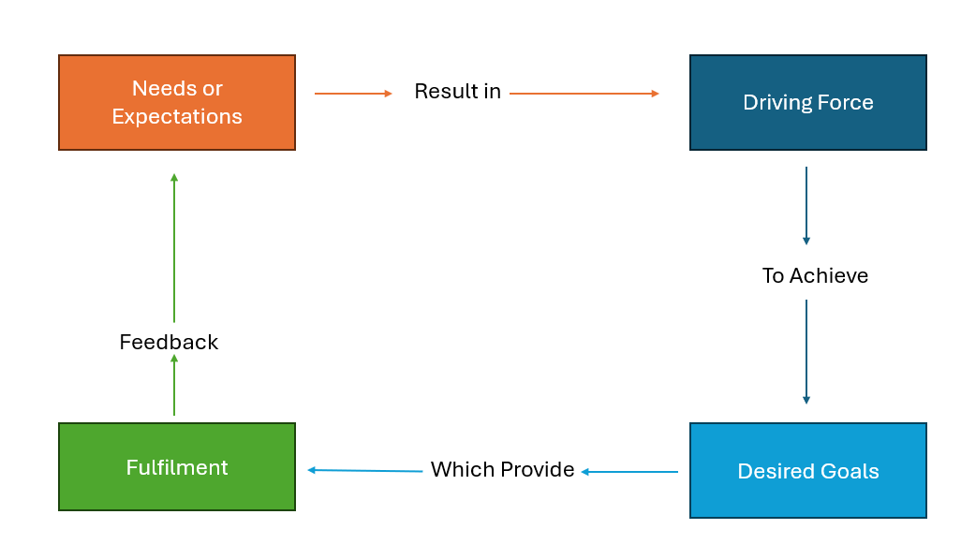
Figure 3 Simplified Motivation Model (Mullins, (2010))
One of the most effective ways to guide employees through change is by using transformational leadership. This is where a usually charismatic leader inspires and motivates employees using a shared vision, which fosters personal and organizational growth (Oreg, 2011) In the above scenario, the management used an autocratic style across the board, offering little to no explanation for the change and did not consult or support the employees, which led to low motivation in the employees. Using the above model, the management could have met with the workforce and explained the reasoning behind the change and found out the employees’ expectations and worries; from this, they could have acted on them. “Communication was the most significant factor affecting staff motivation. When described as ‘good’, it was open, honest, appropriate and timely” (Shannon, 2017). Offering training in the department and presenting this as an opportunity to advance their skills, depending on each employee's driving goals. With regular meetings to check in on the employees to see how they are doing in the new department and seeing if anything else can be put in place would not only have raised motivation but also productivity (Osabiya, 2015).

Conclusion

In conclusion, the change of transferring staff to the mechanical bolting department by Altrad was poorly planned and executed. The very autocratic management style used did not lend well to the situation and led to no communication with the workforce, which led to low motivation and uncertainty. It does not seem that any management model was used, and it was almost taken for granted by management that the employees would just get on with it. The employees would have significantly benefited from a meeting with the management explaining the reasons for the change due to the external pressures which would have helped lower resistance to the change posed by the workforce (Kraft, 2016). This should have been done as soon as possible and any concerns that the employees had should have been addressed by management.

Following this training should have been offered to staff in the department, which would have helped the transferred staff feel valued and secure in their new positions, with the added advantage of making sure they were efficient and able to carry out the role (Ocen, 2017). Updates on the progress of the department would have been of great advantage and would have shown that the transfer was the correct move, also that it was working to reduce the lost hours to put the department back on schedule. Results of following a change management model and carrying out these actions would have significantly raised morale and motivation in the workforce, making the transition far smoother (Jalagat, 2016). This backs that the change management models are still effective in the modern workplace but in some instances need slightly modifying as change isn’t always straight forward.

Bibliography

Bibliography
Altrad, (2025). Altrad uk. [Online]
Available at: https://uk.altradservices.com/
[Accessed 23 march 2025].
Bashir, N., (2015). The relationship between training and organizational commitment among academicians in Malaysia. Journal OF Managment Development, 34(10), pp. 1227 - 1245.
Burnes, B., (2004). Kurt Lewin and the Planned Approach to Change:A Re-appraisal. journal of Management Studies, 41(6), p. 985.
Dragomiroiu, E., (2014). Role of Managers in Management of Change. Procedia Economics and Finance, Volume 16, pp. 293-298.
Fernandez, S., (2013). Manging sucsesful organizational change in the public sector. In: J. R. D. Robert F. Durant, ed. Debating Public Administration Management Challenges, Choices, and Opportunities. 1st ed. New York: Routledge, pp. 7 - 27.
Have, D., (2022). Evidence-based change management. Organizational Dynamics, 51(3), p. 100899.
Helm, J., (2005). Effective project sponsorship an evaluation of the role of the executive sponsor in complex infrastructure projects by senior project managers. Project Management Journal, 36(3), pp. 51--61.
Jalagat, R., (2016). The impact of change and change management in achieving corporate goals and objectives: Organizational perspective. International Journal of Science and Research, 5(11), pp. 1233 - 1239.
kotterinc, (2025). kotterinc. [Online]
Available at: https://www.kotterinc.com/methodology/8-steps/
[Accessed 15 4 2025].
Kotter, J. P., (2008). A Sense of Urgancy. Boston: Harvad Buisness Press.
Kotter, J. P., (2012). Developing A Vision And Strategy. In: Leading change. Boston: Harvard business press, pp. 69 - 87.
Kotter, J. P., (2012). The Change Problem and its Solution. In: Leading Change. Boston: Harvard business press, pp. 3 - 19.
Kraft, A., (2016). Giving and Making Sense About Change: The Back and Forth Between Leaders and Employees. Journal of Business and Psychology, Volume 33, pp. 71 - 87.
Kritsonis, A., (2005). Comparison of change theories. International journal of scholarly academic intellectual diversity, Volume 8, pp. 1 - 7.
Lunenburg, F. C., (2010). Approaches to managing organizational change. International journal of scholarly academic intellectual diversity, Volume 12, pp. 1 - 10.
Mansour, A., (2022). Perceived benefits of training, individual readiness for change, and affective organizational commitment among employees of national jordanian banks.. Cogent Business & Management,, Volume 9, pp. 1 - 27.
Mullins, L., (2010). work moteration and job satisfaction. In: Management and organisational behaviour. Harlow: Financial Times Prentice Hall, pp. 252 - 253.
Ocen, E., (2017). The role of training in building employee commitment: the mediating effect of job satisfaction. European journal of training and development, 41(9), pp. 742 - 757.
Oreg, S., (2011). LEADERSHIP AND EMPLOYEES’REACTIONS TO CHANGE: THE ROLE OF LEADERS’PERSONAL ATTRIBUTES AND TRANSFORMATIONAL LEADERSHIP STYLE. Personnel psychology, 63(3), pp. 627 - 659.
Osabiya, B. J., (2015). The effect of employees motivation on organizational performance. Journal of public administration and policy research, 7(4), pp. 62 - 75.
Pawar, A., (2017). Study on adaptability of change management: review of Kurt Lewins and Kotter model of change. Research Revolution International Journal of Social Science and Management, 5(4), pp. 79 - 83.
Pollack, J., (2015). Using Kotter’s Eight Stage Process to Manage an Organisational Change Program: Presentation and Practice. Systemic Practice and Action Research, Volume 28, pp. 51-66.
Reyes, J., (2024). safetyculture. [Online]
Available at: https://safetyculture.com/topics/force-field-analysis/
[Accessed 20 april 2025].
Sarayreh, B., (2013). Comparative study: The Kurt Lewin of change management. International Journal of Computer and Information Technology, 3(4), pp. 626 - 629.
Shannon, E. A., (2017). Motivating the workforce: beyond the ‘two-factor’ model. Australian Health Review, Volume 43, pp. 98 - 102.
van den Heuvel, S., (2015). Does a Well-Informed Employee Have a More Positive Attitude Toward Change? The Mediating Role of Psychological Contract Fulfillment, Trust, and Perceived Need for Change.. The Journal of Applied Behavioral Science,, 51(3), pp. 401 - 422.
Warrick, D., (2023). Revisiting resistance to change and how to manage it: What has been learned and what organizations need to do. Business Horizons, 66(4), pp. 0007-6813.
Yazdanifard, M. J. H. &. D. R., (2015). How Effective Leadership can Facilitate Change in Organizations through Improvement and Innovation. Global Journals Inc. (USA), 15(9), pp. 1 - 6.

