BMIH5007
Financial Management for the Hotel Industry
Student name : Bianca Negreanu
Student id :2244613
Module leader : Tristan Hawkins

I confirm that I have not used any AI tools in the research and creation of this
assignment. I confirm that I have not presented any AI generated materials as my own
work. I confirm I have copies of my drafts, notes, and other resources I used, which I may be asked to provide in evidence.

Table of Contents
Assignment 1 4
1. Introduction 4
2. Comparison of Total Revenue 4
3. Comparison of Market Position 5
4. Comparison of Growth Potential 7
5. Comparison of Financial commitment to CSR 9
6. Recommendations 11
7. Conclusion 11
Assignment 2 12
1. Introduction 12
2. Evaluation of the trends in the financial performance of the past three years of The City Hotel 12
2.1 Revenue and Expenses Trends of the City Hotel 12
2.2 Profitability Trends of the City Hotel 13
2.3 Patterns of Liquidity 15
2.4 Trends of Solvency 16
3. Determination of the key reasons for the decline in profit to focus on real-world events and the current economy 16
3.1 Economic Challenges 17
3.2 Changing Consumer Behavior 18
3.3 Labor Costs and Staff Shortages 18
3.4 Increased Competition 18
4. Turnaround strategy to revitalise the financial health and develop a brand reputation of the Hotel 19
4.1 Delivering Personalised Services 19
4.2 Promoting Digital Presence and Innovation 19
4.3 Controlling Operational Costs 19
5. Conclusion 20
References 21
Assignment 1 21
Assignment 2 22

Assignment 1

1. Introduction
Financial management includes organising, planning, directing and monitoring an organisation's monetary activities to attain its goals and ensure supportable development. This report grants an in-depth examination of Shangri-La Hotels and Premier Inn Hotels, two important players in the hospitality trade, concentrating on their financial administration strategies. It inspects key areas including market positioning, total income, financial commitment and growing potential for corporate social responsibility (CSR). By comparing these organisations, the report aims to classify critical issues affecting their financial presentation and sustainability. The visions expanded will lead to tailored references for each hotel group, aimed at improving their competitive benefit and endorsing long-term development in an active market setting.

2. Comparison of Total Revenue
Shangri-La Hotels functions in the luxury section, producing revenue chiefly over food and beverage services, room sales and subsidiary services such as event hosting, and spa treatments. In 2022, Shangri-La described total income of about $1.45 billion, reflecting a recapture from the pandemic as travel claims flowed, chiefly in Asia-Pacific marketplaces (Shangri-La, 2022). The average daily rate (ADR) for Shangri-La belongings can range from $200 to $500, reliant on location and season (statista, 2023). However, the brand faced encounters during the pandemic, with an important income deterioration of around 45% in 2020 compared to 2019. Salvage trends arose in 2021 and 2022 (Shangri-la, 2022), strong-minded by deliberate growths in emerging markets and improved marketing efforts directing high-net-worth persons.
In difference, Premier Inn proposes in the budget section, focusing on affordability and worth. In 2022, Premier Inn's sale grasped approximately £1.5 billion ($1.8 billion), viewing resilience even during monetary fluctuations (whitbread, 2022). Premier Inn conveyed a strong retrieval post-pandemic, with occupancy rates being about 85% in 2022 (whitbread, 2022). The company’s attention to the domestic UK market and planned partnerships with travel agencies and airlines boosted its discernibility and customer base. Additionally, Premier Inn has dedicated to expanding its footprint, directing for new hotel openings, which strengthens its modest position.
Though Shangri-La’s income is inclined by luxury travel tendencies, Premier Inn’s presentation remains steady due to its budget-based model. Throughout the pandemic, Shangri-La confronted a income decline of about 45%, while Premier Inn achieved to maintain a steady development route, with a year-over-year upsurge of 15% in 2022 (business times, 2021).
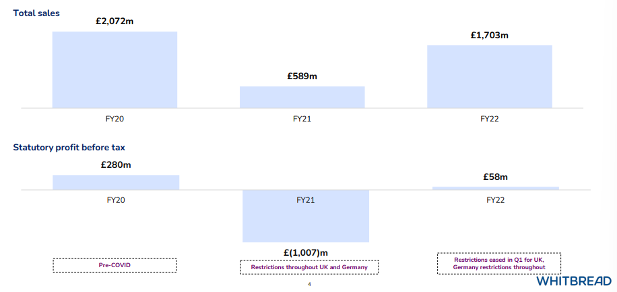
Figure 1: Returning to profitability after Covid (Premier Inn)
(Source: whitbread, 2022)
Both organisations experience important costs, but these vary. Shangri-La’s luxury positioning demands higher working costs due to finest recruitment and conservation of upscale facilities. Equally, Premier Inn assistances from economies of scale, upholding a minor operational cost construction, which agrees it to keep room rates modest while ensuring quality.
In instant, Shangri-La Hotels and Premier Inn Hotels display distinct income sources and trends reflective of their market parts. Shangri-La's luxury focuses energies higher potential income, with fluctuations due to economic conditions, while Premier Inn’s economic strategy ensures stable development and pliability during economic recessions.

3. Comparison of Market Position
Shangri-La Hotels and Premier Inn inhabit separate positions in the hospitality market, reflecting their dissimilar target demographics and commercial plans.
Shangri-La Hotels is located in the luxury section, catering mainly to wealthy travellers and business customers. The brand emphasises tailored service, high-end facilities, and exclusive experiences. Shangri-La has a important presence in Asia-Pacific marketplaces, where it likes robust brand faithfulness and praise among high-net-worth people. According to industry reports, Shangri-La grasps about 3% of the worldwide luxury hotel market part (Statista, 2023). Its brand insight is carefully knotted to luxury, with customers watching it as a best choice for extravagant stays. Marketing efforts frequently high point wellness programs, gourmet dining, sole cultural knowledges which further improve its plea to discriminating customers.
In contrast, Premier Inn works in the budget section, concentrating on reasonability and value for money. Targeting business travellers, families and budget-conscious customers, Premier Inn has recognised itself as a dependable option for those looking for ease without extreme costs. The brand dues to hold about 5% of the UK hotel market portion (Whitbread PLC, 2023), making it one of the main budget hotel chains in the nation. Its brand insight is associated with constancy and dependability, with many customers escalating the frank, no-frills method to accommodation.
Consumer demographics for Shangri-La are tilted towards advanced income brackets, with an important portion of its custom being global business travellers and wealthy leisure tourists. The brand frequently entices guests who arrange luxury experiences, eager to pay a premium for excellent service and facilities. In difference, Premier Inn demands to a wider demographic, including families on holiday, business specialists looking for cost-effective lodging, and budget travellers. This varied customer base is involved to the chain’s modest pricing and suitable locations.
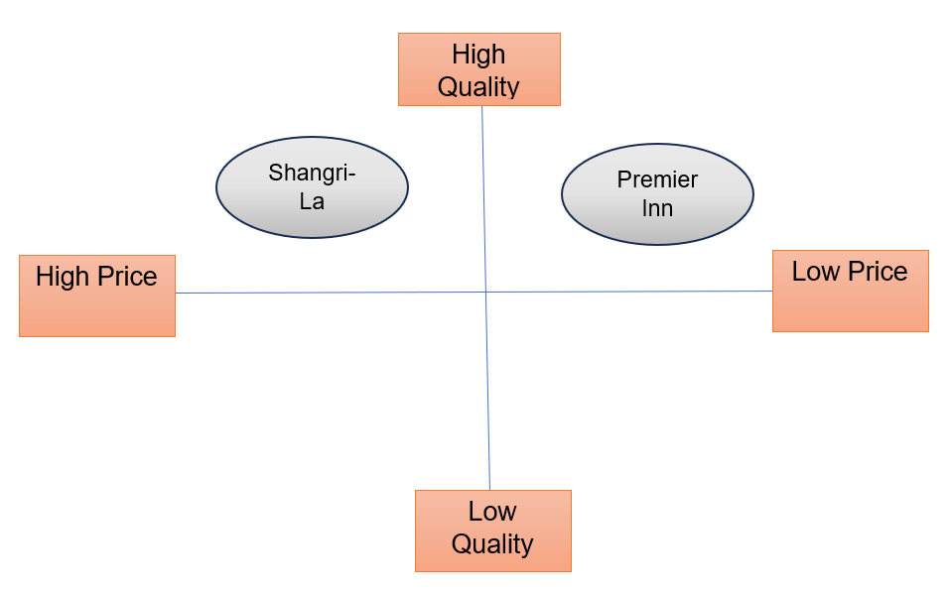
Figure 2: Positioning map
(Self-created)
The market positioning of both hotel groups also replicates their own expansion plans. Shangri-La focuses on high-end growths in main cities and resort termini, often leveraging collaborations with limited attractions to improve guest knowledges. Temporarily, Premier Inn's growth strategy is entrenched in growing its footprint in the UK and directing areas with high request for budget spaces, such as business districts and near airports. In summary, Shangri-La and Premier Inn attend dissimilar market segments, with separate brand insights and client demographics. While Shangri-La emphasises extravagance and exclusiveness, Premier Inn focuses on worth and accessibility, each figure out a robust position in the competitive hospitality scenery.

4. Comparison of Growth Potential
The Shangri-La and the Premier Inn hotels are both prominent players in the hospitality industry. However, both operate in separate markets. The Shangri-La Group has been successful in establishing its presence in various cities in the Asian market (Shangri-La Group, 2020). The website provides information regarding the host of services that are provided to the guests at the Shangri-La Hotels. The management has leveraged the attractiveness of multiple destinations in Asia and harnessed technical insights to develop hotels that are suitable for particular locations. Apart from accommodation, the services of the Shangri-La Group include wellness retreats, family-centred experiences, extravagant restaurants and bars and managed clubs (Shangri-La Group, 2020). Despite the extensive list of services, the prospect of profitability of the Shangri-La hotels is restricted to its operations in selective Asian countries. Furthermore, the price range of the aforementioned services aligns with the dimensions of the premium pricing strategy.
In terms of the growth potential of the Shangri-La hotel, the demand for hospitality businesses in Asian countries plays a major role in influencing the sales volume of contemporary businesses in the hospitality industry. The image below offers a comprehensive insight into the average international tourist arrivals in different regions of the world. The data extracted from Statista (2022), implies that the number of international tourist arrivals in Asian countries is behind the volume of tourists visiting European countries for tourism purposes. However, a uniform trajectory of positive changes can be noted in the tourist arrivals from 2005 to 2019. This observation reflects positively on the tourism and hospitality industry of the Asian countries as uniform growth in the number of tourist arrivals is likely to amplify the demand for accommodation and other similar services that are included within the catalogue of the Shangri-La Hotels.
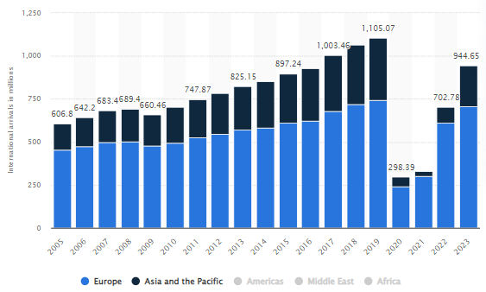
Figure 3: Tourist Arrivals by Region
(Source: Statista, 2022)
On the other hand, the website of the Premier Inn indicates that the properties within its catalogue offer diverse services (Premier Inn, 2024). The operational locations are situated across multiple notable cities and towns in the UK and the rooms and additional services cater to the demands of both luxury-seeking and budget-sensitive consumers (Premier Inn, 2024). From the image above, it can be seen that countries in the European region experience higher tourist influx as compared to Asian countries (Statista, 2022). Additionally, the graph below informs that the rate of luxury rooms experienced a steep rise in prices as the demand for luxury services improved over the years. This observation is validated by the law of supply and demand, which implies that prices of products or services fluctuate on the basis of supply and demand (Luther, 2022). Hence, it can be stated that the growth potential for both organisations is positive, which is supported by the growing demand for luxury-focused customer groups.
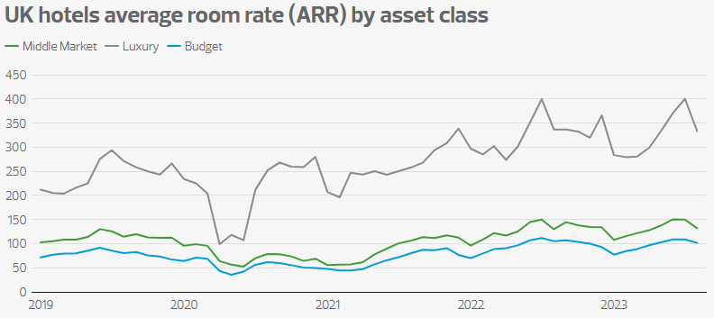
Figure 4: Average Room Rates by Class
(Source: rsmuk, 2023)

5. Comparison of Financial commitment to CSR
The Shangri-La Hotels and the Premier Inn Hotels are both prominent players in their regional hospitality industry. The Premier Inn has an extensive presence in the UK, with its hotels located in various parts of the UK (Premier Inn, 2024). On the other hand, the operations of the Shangri-La Hotels are carried out within selective Asian countries with strong economic potential for supporting the process of the luxurious offerings of the Shangri-La hotels. Both organisations are major organisations, whose activities affect the lives of several stakeholder groups across their operational market. The study conducted by Żak (2015), examines the Triple Bottom Line (TBL) theory and defines the theory as a foundational concept of CSR.
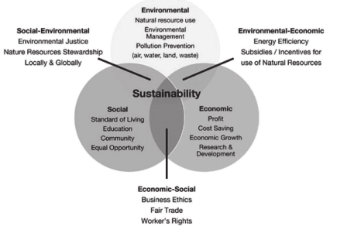
Figure 5: Responsibilities of the TBL Theory
(Source: Żak, 2015)
The study further informs that businesses strive to implement effective CSR policies as CSR responsibilities influence brand image and consumer perception associated with purchasing services of particular brands. The sustainability initiatives of the Shangri-La hotels are influenced by five values which include doing good, never giving up attitude, facilitating one's own success, competing to win and immense focus on customer engagement (Shangri-La, 2024). These values are reflected in the CSR operations of Shangri-La, which has invested significant capital resources to strengthen its CSR commitments. As of 2023, the financial commitments of the Shangri-La Group amount to $3.9 billion (Shangri-La, 2024). The purpose of these investments encompasses initiatives like reduction in energy consumption, employee welfare, community engagement projects and waste management.
Conversely, the ESG report of the Premier Inn indicates that the organisation has invested £504 million on its 'Green Bond' (Whitbread, 2024). The investments made on the green bond of the Premier Inn include reducing emissions and energy consumption, climate change implications, transitioning to a net zero plan and enhancing community engagement (Whitbread, 2024). The initiatives taken by the management of the Premier Inn are aimed at enhancing the CSR commitments of the organisation and subsequently influence consumer perception towards staying with Premier Inn. Rationalising two sets of information, it can be said that both organisations have made significant investments towards CSR initiatives, which has aided in enhancing consumer perception of both brands.

6. Recommendations
The website of Shangri-La Hotels provides a descriptive insight into the operations carried out by the organisation in pursuit of financial profitability and community engagement. However, it also implies that the operations are restricted to selective Asian countries (Shangri-La, 2024). It was noted from the graph that tourist arrivals in European countries outperform the tourist arrival volume in Asian countries (Statista, 2022). Therefore, the chances of financial prosperity of the Shangri-La Hotels can be addressed by facilitating expansion into European markets. This will formulate additional revenue streams, and align with the consumer preferences of luxurious lifestyles in notable European countries.
Additionally, the operations of Premier Inn seek to capitalise on the demand for budgetary accommodation seekers and customers who prefer luxurious lifestyles. However, it was noted that the current business environment is more inclined towards luxurious lifestyles (rsmuk, 2023). Therefore, the management of the Premier Inn can amplify its financial profits by reducing investments in budgetary accommodation and services and prioritising the expansion of its luxury segment which will enable the organisation to capitalise on the demand for high-end accommodation.

7. Conclusion
In conclusion, Premier Inn Hotels and Shangri-La Hotels demonstrate separate market positioning plans within the hospitality business. Shangri-La marks prosperous travellers with an emphasis on luxury and modified experiences, holding a distinguished share in the worldwide luxury marketplace. Equally, Premier Inn provides budget-conscious customers, emphasising affordability and dependability, making it a front-runner in the UK budget section. Both brands efficiently influence their sole strengths to meet the demands of their individual demographics. By considering these changes, each organisation can further improve its modest advantage and endure to thrive in a developing market scenery.

Assignment 2

1. Introduction
This case study explores The City Hotel, an urban formation featuring a bar, restaurant and event amenities, which has handled significant tasks in current years, counting occupancy rates, deteriorating revenue and customer gratification. Worried about the hotel’s future feasibility, the owner pursues expert valuation to control if a turnaround plan can reestablish its monetary health and standing. The objectives of this study comprise assessing the hotel’s monetary performance tendencies over the past three years, classifying key issues contributing to its success decline, and suggesting a complete strategy to revive the business or attain the most feasible monetary outcome for the owner.

2. Evaluation of the trends in the financial performance

2.1 Revenue and Expenses Trends of the City Hotel
Trend analysis is a significant part of financial management. It involves assessing the financial records of previous financial years and producing appropriate reports that provide accurate forecasts in financial management (Haralayya, 2021). Throughout 2021-2023, The City Hotel has experienced major volatility in its revenue and expenditure. These fluctuations are the prime reasons behind the financial instability of the City Hotel. Analysing the financial records of the organisation, it was established that the inflow of funds from hotel operations has been inconsistent, while expenses, which include both direct and indirect operational costs, have experienced major increments. This financial instability has affected the organisations' pursuit of financial prosperity, which has been primarily driven by changes in consumer demand, unforeseen economic circumstances, extensive competition, and rising operational costs. The decline in revenue has been catalysed by reduced occupancy rates of hotel rooms and lower customer satisfaction, which are responsible for affecting the hotel's financial stability.
Analysing trends in revenue and expenses is crucial for making informed financial decisions (Olayinka, 2022). It allows business firms to identify opportunities to reduce costs and better manage resources to enhance financial stability. The image displayed below shows a declining trend in both revenue and expenses, but rising costs in areas like depreciation, amortisation, and provisions have further reduced operational profits. Moreover, the shift in consumer alignment toward other hotels has negatively impacted the City Hotel’s occupancy rates and overall revenue generation.
The factor of low occupancy rates has led to a significant decline in turnover and profitability, and customer dissatisfaction with service quality has damaged the hotel's brand value. These financial challenges have facilitated a steep declining financial performance despite deriving positive changes in the cost levels. To mitigate these challenges of accumulating expenses, the City Hotel must focus on attaining efficiency in service quality, building customer-focused experiences, and taking initiatives that aid in segregating itself from the rest of the competition. These initiatives will help the management in lowering the operational expenses, and simultaneously improve its financial position. Enhancing these aspects of the hotel service is key to reversing the negative financial trends and stabilising the hotel's fiscal health.
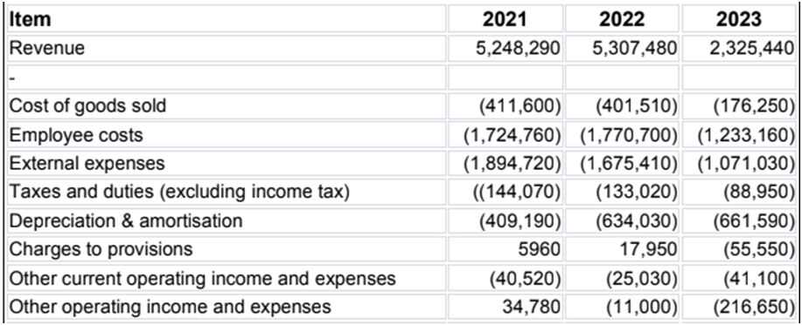
Figure 6: Revenue and Expenses of the City Hotel

2.2 Profitability Trends of the City Hotel
Analysing the profitability trend is a common practice in modern businesses as it provides a dedicated financial forecast that serves as a benchmark of performance for respective businesses (Palepu et al., 2020). In this section, the profit margins of the City Hotel were assessed to generate an overview of the financial stability within the operations of the organisation. The graph displayed below reflects the profitability ratio of the City Hotel for different operational years. The profitability trends denote variations in terms of the profit levels across financial years, which subsequently enables businesses to evaluate the revenue generated from operations. The City Hotel has experienced a steep decline in revenue, largely due to ineffective pricing strategies, which have driven customers to choose alternative accommodations (El-Said, 2020). Continuing on this trajectory may result in financial loss for the organisation. Thus, in order to remain competitive within its operational market, the management of the City Hotel must focus on reducing costs and implementing a competitive pricing strategy that seeks to undercut the prices of competitors. This initiative will attract more customers while improving occupancy rates and boosting profitability.
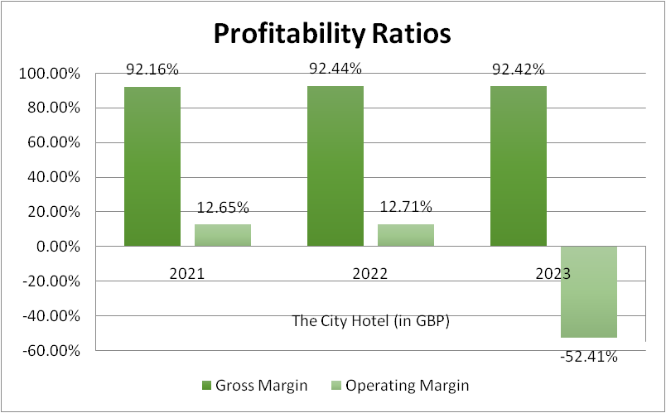
Figure 2: Profitability Ratio of the City Hotel
The data portrayed on the graph reveals the decline in profitability for The City Hotel between 2021 and 2023, as indicated by the negative trend in its operating margin. However, the gross profit of the City Hotel remains relatively stable, but rising costs and low customer engagement have caused the operating margin to turn negative. On the other hand, the availability of additional accommodation options has changed consumer preferences, which has led to intense competition within the hospitality industry.
Therefore, the City Hotel needs to manage concurrent consumer demand, gather feedback, and enhance its quality of service in order to regain market share and improve profitability. By enhancing service delivery and aligning pricing strategies with market requirements, the concerned staff of the City Hotel can improve its financial performance and cultivate long-term financial prosperity and sustenance.

2.3 Patterns of Liquidity
The liquidity data of the City Hotel has exhibited a steady decline, which has led to a negative impact on its cash flow. In this case, the hotel experienced a decline in liquidity due to low revenue and profit, which reduced cash flow and obstructed the ability to meet emergency financial requirements. Thus, maintaining optimal capital resources is pivotal for improving liquidity and overall financial performance.
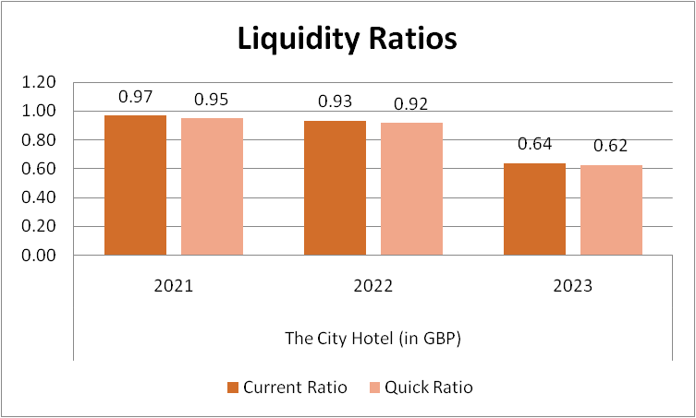
Figure 3: Liquidity Ratio of the City Hotel
The liquidity ratios indicate a declining trend from 2021 to 2023, primarily because the hotel lacks sufficient current assets to cover its short-term liabilities. To enhance the liquidity of the City Hotel, the management needs to manage cash flow more efficiently and optimise the use of its short-term assets.

2.4 Trends of Solvency
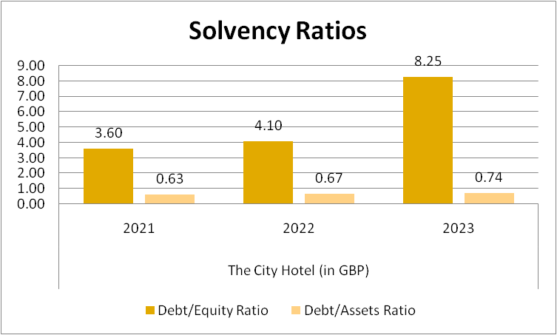
Figure 4: Solvency Ratio of the City Hotel
Solvency refers to an organisation's ability to meet its long-term debt obligations without compromising its financial stability (Enyi, 2022). The graph above displays the solvency ratio of the City Hotel, and it exhibits a positive change in debt usage, while low reliance on equity and assets over the past three years has negatively impacted The City Hotel's solvency. To optimise the solvency, the hotel needs to reduce its debt levels and optimise the utility of the organisational assets and equity in its capital structure. By obtaining long-term investments, the hotel can lower its financial risk. Furthermore, structuring operations to prioritise customer engagement will also drive the hotel's brand value, attracting more equity capital and improving its state of solvency.

3. Determination of the key reasons for the decline in profit to focus on real-world events and the current economy
The deterioration in profitability for The City Hotel can be credited to numerous interconnected features deeply knotted to present financial conditions and changes in customer behaviour.

3.1 Economic Challenges
The continuing cost of living crisis has meaningfully obstructed consumer expenditure. With inflation rates flying around 10%, throwaway income has been reduced, forcing customers to prioritise vital expenditures over optional spending (statista, 2024). This heaviness is chiefly relevant in the hospitality sector, where facilities like hotel stays are repeatedly seen as non-essential. Therefore, The City Hotel has experienced a noticeable deterioration in occupancy rates, as probable guests are progressively cautious to assign their limited capital to hotel rooms. This decrease in bookings and dining practices has strictly affected the hotel’s income streams.
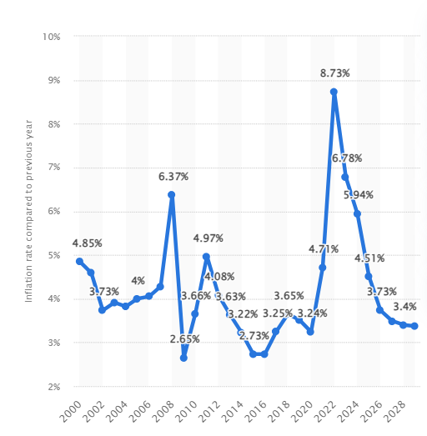
Figure 5: Global inflation rate
(Source: Statista, 2024)

3.2 Changing Consumer Behaviour
COVID-19 pandemic has directed to permanent alterations in customer preferences. Today’s explorers prioritise safety, health and elasticity when selecting accommodations. Improved hygiene procedures, contactless facilities, and flexible reservation options have become vital factors in customer decision-making. Moreover, the increase of leisure travel, which associates business journeys with leisure events, has shifted prospects for hotel contributions. Guests now pursue unique involvements that improve their stay, such as wellness facilities or local cultural events. If The City Hotel has not modified its services to meet these developing preferences, it hazards distancing potential clients. Undesirable reviews rising from unmet hopes can further harm the hotel’s standing and occupancy rates.

3.3 Labor Costs and Staff Shortages
The hospitality sector is presently facing increasing labour charges and important staff shortages. In the UK alone, the hotel industry is short around 400,000 workers, leading to pay inflation and enlarged working costs (ft, 2022). For The City Hotel, these increasing labour expenditures confuse efforts to uphold high-quality facility and operational competence. The incapability to entice and recall skilled staff can lead to a deterioration in service quality, further lessening customer satisfaction and faithfulness. As labour costs upsurge, the hotel may struggle to persist competitively valued, making it less attractive to possible guests.

3.4 Increased Competition
The modest landscape for hotels has strengthened, with recognised brands and other accommodations, such as Airbnb, competing for market share. The short-term rental market saw a development of 23% in 2022, illustrating budget-conscious explorers looking for unique knowledges at lesser prices (vantagemarketresearch, 2023). Outmoded hotels that quickly adapt to market variations, by improving hygiene procedures, contributing flexible booking choices or making gorgeous packages, are better placed to seize market share. If The City Hotel flops to efficiently strive with these offerings, it hazards trailing both occupancy and income.
In summary, The City Hotel's weakening in profitability outcomes from a mixture of economic challenges, shifting consumer behaviour, increasing labour costs, and enlarged competition. To converse with this trend, the hotel must grow a complete turnaround plan that lectures these challenges, improves its service contributions, and relocates itself in the market. By familiarising to the developing landscape, The City Hotel can work to restoring its monetary health and refining customer satisfaction.

4. Turnaround strategy to revitalise the financial health and develop a brand reputation of the Hotel
To revitalise The City Hotel's economic health and increase its brand standing, three planned areas should be prioritised: promoting a robust digital presence, delivering personalised services and monitoring operational costs.

4.1 Delivering Personalised Services
Improving customer experience through personalised services is vital. The City Hotel can apply tailored contributions, such as customised welcome posts based on guest partialities and special events. Utilising customer information to antedate needs, like dining choices or room preferences can make memorable stays (Pelet et al., 2021). Training workers to involve genuinely with guests will make them feel appreciated, leading to helpful reviews and augmented loyalty.

4.2 Promoting Digital Presence and Innovation
A robust online occurrence is dynamic for enticing guests and creating brand value. The City Hotel should capitalise in a user-friendly website that shows its unique contributions and local charms. Appealing with possible guests on social media can influence perceptibility and foster community influences (Lee and Hsieh, 2022). Ground-breaking technologies, such as mobile booking apps and contactless check-in, improve suitability and security, enticing health-conscious tourists.

4.3 Controlling Operational Costs
To enhance profitability, The City Hotel must emphasise on monitoring operational costs. A complete review of costs can classify areas for decreases, such as supply chain efficiencies and energy use. Applying inventory administration systems can rationalise operations and diminish waste (Vaka, 2024). Cross-training employee deliver suppleness during peak and off-peak periods, optimising labour prices.
By concentrating on these plans, personalised guest involvements, a strong online presence, and cost switch, The City Hotel can efficiently revitalise its monetary health and find a strong brand standing.

5. Conclusion
In summary, The City Hotel faces important challenges that impend its monetary health and brand standing. To discourse these subjects, a complete turnaround plan is vital. By prioritising modified services, the hotel can improve the guest knowledge and nurture customer faithfulness. Emerging a durable digital occurrence will not only entice new guests but also endorse the hotel’s sole offerings and local charms, leveraging social media for assignation. Moreover, the implementation advanced technologies, like contactless services, will increase suitability and safety. Monitoring operative costs over efficient observes, such as staff cross-training and inventory management will maximise profitability. By executing these planned initiatives, The City Hotel can revive its processes, reinforce its competitive situation, and ensure lasting sustainability in the hospitality marketplace.

References

Assignment 1
businesstimes(2021)Shangri-La Asia reverses into losses as Covid-19 hit hotel operations[online]Available at:https://www.businesstimes.com.sg/companies-markets/shangri-la-asia-reverses-into-losses-as-covid-19-hit-hotel-operations/[Accessed on: October 15, 2024]
Luther, D., 2022. Law of Supply and Demand Defined. [online] Oracle NetSuite. Available at: https://www.netsuite.com/portal/resource/articles/erp/law-of-supply-demand.shtml [Accessed 15 Oct. 2024].
Premier Inn 2024. Why We’re Premier. [online] www.premierinn.com. Available at: https://www.premierinn.com/gb/en/why.html [Accessed 15 Oct. 2024].
rsmuk 2023. Luxury hotel sector leads the way with record room rates during summer season | RSM UK. [online] www.rsmuk.com. Available at: https://www.rsmuk.com/insights/hotels-tracker/luxury-hotel-sector-leads-the-way-with-record-room-rates-during-summer-season [Accessed 15 Oct. 2024].
Shangri-La Group 2020. Our Presence. [online] Shangri-la.com. Available at: https://www.shangri-la.com/group/ [Accessed 15 Oct. 2024].
Shangri-la(2022)2022 FINAL RESULTS ANNOUNCEMENT[online]Available at:https://sitecore-cd.shangri-la.com/-/media/Project/Shangri-La-Group/Investor/Files/Public-Disclosures/Latest-Top-Publications/e_final-results_20230324.pdf[Accessed on: October 15, 2024]
Shangri-La, 2024. Sustainability Report 2023. [online] sitecore-cd.shangri-la.com. Available at: https://sitecore-cd.shangri-la.com/-/media/Project/Shangri-La-Group/Investor/Files/Thailand-Public-Disclosures/Sustainability-Reports/2023/SLBK-SD-Report-2566EN.pdf [Accessed 15 Oct. 2024].
Statista 2022. International tourist arrivals by region. [online] Statista. Available at: https://www.statista.com/statistics/186743/international-tourist-arrivals-worldwide-by-region-since-2010/ [Accessed 15 Oct. 2024].
statista(2023)Average daily rate (ADR) of rooms in luxury hotels in India from financial year 2016 to 2020, with estimates until financial year 2023[online]Available at:https://www.statista.com/statistics/1239383/india-average-daily-rate-of-luxury-hotels/[Accessed on: October 15, 2024]
statista(2023)Hotel industry worldwide - statistics & facts[online]Available at:https://www.statista.com/topics/1102/hotels/#topicOverview[Accessed on: October 15, 2024]
Whitbread 2023. Environmental, Social and Governance Report 2022/23. [online] Available at: https://cdn.whitbread.co.uk/media/2023/07/Whitbread_ESG_Report_2022.pdf [Accessed 15 Oct. 2024].
Whitbread(2022)FY22 Preliminary Results 28 April 2022[online]Available at:https://cdn.whitbread.co.uk/media/2022/04/Full-Year-FY22-Presentation-FINAL.pdf[Accessed on: October 15, 2024]
whitbread(2023)The Economic Impact of Premier Inn Hotels[online]Available at:https://cdn.whitbread.co.uk/media/2023/08/The-Economic-Impact-of-Premier-Inn-hotels_2022-study_final.pdf[Accessed on: October 15, 2024]
Żak, A., 2015. Triple bottom line concept in theory and practice. Social Responsibility of Organizations Directions of Changes, 387(1), pp.251-264.

Assignment 2
El-Said, O.A., 2020. Impact of online reviews on hotel booking intention: The moderating role of brand image, star category, and price. Tourism Management Perspectives, 33, p.100604.
Enyi, E., 2022. Corporate Financial Stability: An Immutable Link between Going Concern and Earning Capacity of Firms. Current Aspects in Business, Economics and Finance, p.88.
ft(2022)UK hospitality industry loses nearly 200,000 overseas workers[online]Available at:https://www.ft.com/content/027ea2e9-d6c3-4a18-a735-87f92ace95a4[Accessed on: October 15, 2024]
Haralayya, B., 2021. Study on trend analysis at John Deere. Iconic Research And Engineering Journals, 5(1), pp.171-181.
Lee, C.T. and Hsieh, S.H., 2022. Can social media-based brand communities build brand relationships? Examining the effect of community engagement on brand love. Behaviour & Information Technology, 41(6), pp.1270-1285.
Olayinka, A.A., 2022. Financial statement analysis as a tool for investment decisions and assessment of companies’ performance. International Journal of Financial, Accounting, and Management, 4(1), pp.49-66.
Palepu, K.G., Healy, P.M., Wright, S., Bradbury, M. and Coulton, J., 2020. Business analysis and valuation: Using financial statements. Cengage AU.
Pelet, J.É., Lick, E. and Taieb, B., 2021. The internet of things in upscale hotels: its impact on guests’ sensory experiences and behavior. International Journal of Contemporary Hospitality Management, 33(11), pp.4035-4056.
statista(2024)Global inflation rate from 2000 to 2022, with forecasts until 2028[online]Available at:https://www.statista.com/statistics/256598/global-inflation-rate-compared-to-previous-year/#:~:text=Despite%20the%20economic%20impact%20of%20the%20coronavirus%20pandemic%2C,prices%2C%20before%20the%20Russia-Ukraine%20war%20exacerbated%20this%20further[Accessed on: October 15, 2024]
Vaka, D.K., 2024. Integrating Inventory Management and Distribution: A Holistic Supply Chain Strategy. the International Journal of Managing Value and Supply Chains, 15(2), pp.13-23.
vantagemarketresearch(2023)Short-term Rental Market- Global Industry Assessment & Forecast[online]Available at:ttps://www.vantagemarketresearch.com/industry-report/shortterm-rental-market-2178[Accessed on: October 15, 2024]

