BMPD5016
Organisational Performance and Culture in Practice.
Clare Mugford

1. Advantages and disadvantages of organisational structures (AC 1.1)
Hywel Dda University Health Board, use a tall Hierarchical structure with many layers of management. The Health Board is a compliance focussed organisation and as such, are required to put safety first with many policies designed to protect, and control safety measures.
The advantages of working to this formal structure are employees and managers have clearly defined specialist roles and responsibilities that relate to achieving functional goals, which in turn move the organisation towards achieving the strategic goal. (Taylor and Woodhams, 2022a) A hierarchical structure also provides greater accountability as it is clear to establish who a decision or issue would sit with. There are, however, disadvantages to using this hierarchical structure, as mentioned by Taylor and Woodhams (2022b), it can be much harder for good ideas and innovation at the bottom of the hierarchy, to be heard and considered by the executives at the top. Therefore, strategic changes and innovations that are required will take longer to be communicated, understood, and enacted.
As stated by Armstrong and Taylor (2020b) there is also the risk that too many levels of management and supervision inhibit communication and teamwork and create extra work and unnecessary jobs. This can also impact on the culture from team to team as often within hierarchy, a command-and-control approach is evident, which can also lead to employees feeling their ideas are not heard and they then become detached and disengaged.
A matrix structure as used by Google, is much more complex than hierarchical, as employees may report to their functional manager as well as a project manager. However, matrix structure allows employees to work towards project objectives collaborating with other departments, whilst also continuing their functional roles, ensuring maximum efficiency for the business. A matrix structure as pictured below – Image 1, is most common for technology companies such as Google. This is because (typically) no individual person in a software company has the full skill set to build and maintain high-quality software and then take it to market. (Layfield, 2023)

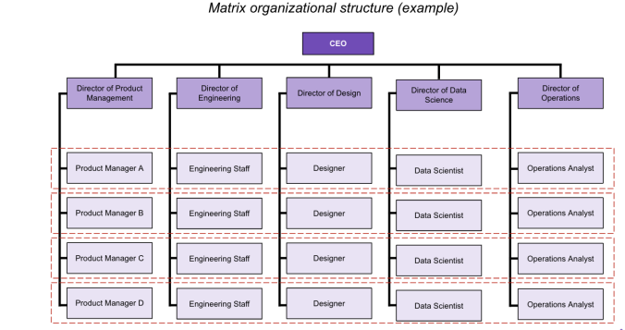Image 1

Taylor and Woodhams (2022c) describes how matrix lead organisations can be positive and very motivating environments, allowing employees to develop new skills and collaborate with other departments. On the other hand, the disadvantages of being structured in this way according to (Asana, 2023) are that response times can be slower, priorities can be unclear, and management can provide conflicting guidance around priorities creating potential power struggles.

2. Connections between organisational strategy and services (AC 1.2)
As part of the Healthier Mid & West Wales strategy report (A Healthier Mid and West Wales Our Future Generations Living Well, no date a), Hywel Dda have identified and acknowledged that each community within their area has different healthcare requirements. To ensure services are delivered safely and targeted sufficiently, according to the health board plans within (A Healthier Mid and West Wales Our Future Generations Living Well, no date b) they plan to re-group the existing 3 counties into 7 integrated localities, not to separate communities but to provide a mechanism for local leadership and delivery of services, allowing each area more influence on resources within their area. This could, however, increase costs associated to allocation of staff to cover each locality, reducing the funds available for direct patient care.
Hywel Dda state that focussing on each locality’s requirements, ensures services are targeted to the correct areas, allowing the health board to achieve their vision of working in the communities to provide more joined-up support and care as close to home as possible. (Hywel Dda University Health Board, no date)
Health needs vary by area with Hywel Dda University Health Board having fewer people aged 25-44 and more people aged 55-79 than other places in Wales. (A Healthier Mid and West Wales Our Future Generations Living Well, no date b) Hywel Dda identified this requirement through analysis of data, and made a key focus to be same day and urgent care access for the local and temporary population, with particular reference to meeting the needs of the older age community (A Healthier Mid and West Wales Our Future Generations Living Well, no date b) Identifying the needs of their services users means they can plan their strategy effectively and provide the care and services required.
Community engagement forums have been held to allow local communities to voice their opinions and views on various other aspects of the Healthier Mid & West Wales strategy, including topics such as services provided and the location of the new planned new hospital. Community engagement forums as described by NICE (2016) are a great way to maximise the involvement of the local communities through needs assessments, development planning and delivery and evaluation, all with the aim to improve their health and wellbeing and reduce health inequalities. However, many forums have been held online since the Covid19 pandemic, and a recent survey conducted by Age UK, as detailed by Cooper (2022), showed over 2million over 75’s as still digitally excluded, this accessibility issue denies a voice for a key targeted and majority age group within the health board area.
3. External factors impacting organisations (AC 1.3)
Various external factors can impact organisations, factors such as Political, Economic, Social, Technological, Legal and Environmental.
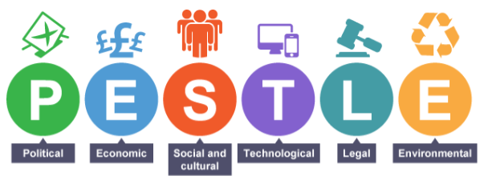(BBC, 2021)
Environmental factors affecting Hywel Dda University Health Board (UHB), include waste disposal and sourcing sustainable resources, resulting in an objective to move away from a throw away culture. Ellen Macarthur at National Geographic states how the circular economy provides long term benefits to the environment, ‘all products, and especially plastics, metals, and textiles, should be designed with the intention that their raw materials will be recovered and recycled. It makes sound business sense’ (MacArthur, 2018) By adopting the circular economy approach, the organisation will see numerous long-term benefits including improved sustainability, reputation, and financial savings which is a constant objective within the health sector.
Social influences are also impacting the health board. Pembrokeshire is a popular relocation hotspot for retirement due to the rural, slower pace of life and beautiful landscapes. According to reports from Office for National Statistics (2023) Between the last two censuses, the number of people aged 65 to 74 years rose by just under 3,100 (an increase of 21.3%). The increased ageing population means people are living longer which is great news for people, however, it also means additional pressure on already stretched health services such as geriatrics and A&E.
The organisation needs to ensure services continue to run consistently and ensuring patient safety is not compromised, however, figures from Referral to Treatment - Maximum Waiting Times (2020) show that as at end of June 2020, the maximum wait times for a first outpatients’ appointment in Geriatric Medicine was 54 weeks. The main waiting time targets set by NHS Wales are: 95% of people start treatment within 26 weeks of their referral being received (Hywel Dda University Health Board, no date), this highlighting wait time targets are not being achieved. On the other hand, these figures were published from a time when the pandemic was peaking, further analysis of recent figures would be required to determine if services are still being impacted.
Economical factors include costs of resources and supplies going up putting pressure on the organisation to identify savings elsewhere. The cost-of-living crisis is also impacting negatively on people’s mental health, this includes both staff and the wider population. Both will have a negative impact on the health board’s ability to continue with their service efficiently.
According to Finch (2022), in the latest poll (June 2022) conducted by the Health Foundation, nearly half (48%) of the poorest 40% of families in the UK contain at least one person with poor health. As mentioned by Finch (2022b), this could be due to rising costs of both food and energy leaving people malnourished in cold homes leading to respiratory issues and worse.

4. Technology and the impact it has on work (AC 1.4)
The use of technology within the NHS has increased significantly over time, seeing many positive benefits such as reduced costs and a lower carbon footprint due to sending text and email appointment reminders as opposed to posting letters. Also, targeting clinical interventions more efficiently due to better quality, more extensive patient data and the speed at which it can be accessed, is another huge benefit from advancing data recording technologies within the NHS.
However, according to Bright et al., (2023) the concerns raised are regarding the security of the data and the accuracy over the health information provided online. Results from their Digital Technology and Health II Survey conducted in 2021/2022 show only 20% agreed that they had a better patient experience when using internet-based options to access health care. When asked about disadvantages, 52% agreed that they worried about the privacy and security of data while using the internet (28% disagreed that this was a worry). Ensuring security of data stored within NHS online platforms, is essential to protecting the service users and their personal information. CIPD also recommends employers establish guidelines regarding technology and AI, stating Guidelines should be based on ethical and responsible principles to ensure human-centred, transparent, and accountable use of AI, but also manage the risks, including data privacy and security. CIPD (2023a)
Whilst the impact of increased technology within an organisation can be hugely beneficial, as stated by CIPD, providing workers with more flexible ways of working, this can also come with lower levels of job security and higher stress due to the blurring of work and home life. (Houghton and Baczor, 2020a) 30% of those surveyed in 2020 in a YouGov UK panel, stated that their use of portable devices makes it difficult to switch off (Houghton and Baczor, 2020b). The increased flexibility of being able to work from home from portable devices, can lead to employees working for longer and without regular breaks. An increase in virtual meetings for both team collaboration and patient appointments, whilst beneficial saving travelling time and reducing the carbon footprint; It can be hard to pick up on body language and expressions in virtual meetings, which can hamper creativity. (Houghton and Baczor, 2020c)
Being unable to switch off from work is not supportive of employee wellbeing and can lead to burnout. It may also increase poor motivation levels, decreased job satisfaction, and a reduced quality of work, therefore getting the balance right when using technology is essential to obtaining good quality work. Rather than simply ‘leading with the latest technology’, people professionals and business leaders should partner to design new strategies that achieve optimal balance between people and technology that meets the needs of the organisation and its workforce (Houghton and Baczor, 2020d)

5. Edgar Schein’s model (AC 2.1)

Edgar Schein’s model of Organizational Culture contains three levels to understand and shape an organisations culture, as shown below:
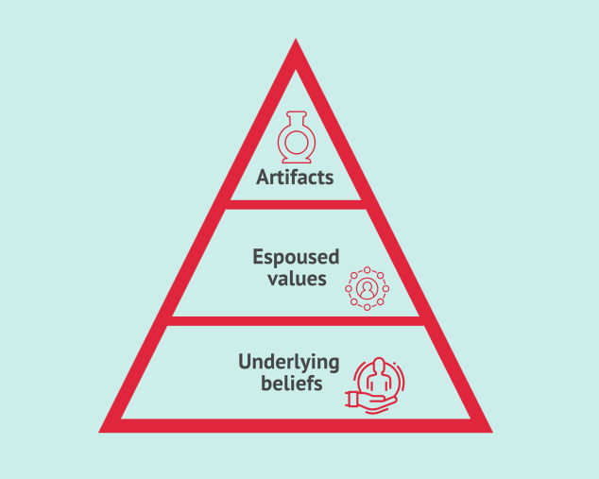
(Cuofano, 2021)
Level | Description | Examples
Artifacts | These are the visible elements of culture that provide a surface insight into the culture. | Dress code, Office layout, symbols and logos.
Espoused Values | This is the goals, values, and mission statements. They can be changed in order to influence culture. | Organisational values, contracts and agreements.
Underlying Assumptions/ Beliefs | These are not easily measured or changed; they are the subconscious assumptions about the work and achievements of an organisation. | Experiences shared within the organisation.  Deep rooted beliefs and thoughts.

The first step, Artifacts, leaders can look at and consciously influence culture by initially considering the working environment, dress code and how employees talk to each other.
As described by Cuofano (2021b) if employees exhibit values that contradict the organisational values, the next step would be to look into the underlying assumptions.
The final step is considering the underlying assumptions. To enable change, assumptions must be considered for example behavioural traits and the overall climate of the organisation - how employees interact with one another.
The advantages of using this framework, as mentioned by Denis (2022) are that the model provides a mechanism to encourage deeper thought into culture by using the various levels, however the disadvantages are that everyone’s view on culture and how it is created is different.

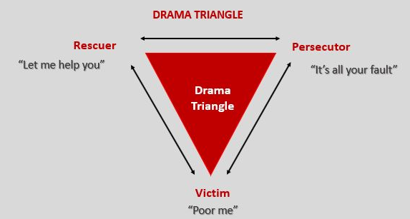
(Leadership tribe, 2020)

The drama triangle as shown above is a model of dysfunctional social interactions and illustrates a power game that involves three roles: Victim, Rescuer, and Persecutor (Leadership tribe, 2020)
Victims assume themselves powerless and feel trapped, blaming persecutors and always seek a rescuer to solve the problem for them.
Persecutors, as described by Kelly (2023a), display power over others, often when feeling insecure and regularly use aggression to deflect attention away from their own problems.
The rescuer will always step in to save the day and resolve the problem, often at the expense of their own wellbeing. They may unintentionally enhance the victim’s sense of helplessness and the persecutors want for control.
In an organisation, the drama triangle can manifest in power struggles and conflicts. Colleagues may find themselves in the victim role, blaming external factors for challenges at work. (Kelly, 2023b)
With encouragement to empower individuals to take ownership of their responsibilities, you can create a more collaborative and constructive environment.

6. People practices and their impact on organisational culture and behaviours. (AC 2.2)

Culture in the workplace is multidimensional and can be impacted by the structure, leadership and people practice approaches within an organisation. Within Hywel Dda UHB, various people practices are used to encourage and promote a positive and inclusive, high-performance culture.
Policies have been developed to support employees such as an equality, diversity and inclusion policy and the flexible working policy, which has enabled workers to manage both their professional and personal responsibilities more easily. The CIPD (2022) explains how the increased flexibility of hybrid working reduces stress levels, reduces commuting costs and results in better staff morale. Flexible workers have a higher level of job satisfaction, commitment and are more likely to increase discretionary effort compared to those who do not work flexibly. (McCartney, 2023) However, working remotely has its disadvantages, it does reduce opportunities for reflection and informal mentoring. (Wiltshire, 2022) so having adopted a hybrid approach where possible, Hywel Dda UHB workers can feel supported whilst achieving flexibility.
Positive behaviours within teams can have a huge impact on the productivity levels and culture shifts within the workforce. As stated by Cumbria Training Services (no date) Behaviour Breeds Behaviour, so creating a positive and inclusive workplace is essential.
Inclusivity is not an option in people practice, it’s a necessity, and people professionals should lead the way in creating a diverse and inclusive environment where all individuals can thrive and feel their opinion matters, and building a culture of belonging and support. (Waite et al., 2021b) Hywel Dda UHB actively promotes inclusivity and diversity, with teams coordinating events and information regularly.
Hywel Dda UBH fully supports the continued learning and development (L&D) of their staff, ensuring further training opportunities are available for all. Through funding dedicated training schemes and external qualifications for staff, the health board is displaying they are invested in, and value their people, which is a core behaviour within the CIPD (2023) professions map.
For L&D, the classroom is also an opportunity to listen and explore how employees are feeling and anchor people back to the organization’s purpose and values (Wiltshire, 2022) When successful, stories told within the organisation can bring a sense of pride and advocacy.

7. Managing change models (AC 2.3)

There are 3 simple steps to Lewins’ 3 step change management model as shown below.

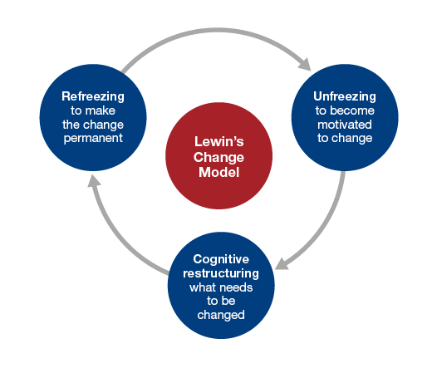(Leadership Centre, no date)

The first stage ‘Unfreezing’ involves preparing the workforce for the upcoming change, educating them, and ensuring when the change is explained, highlighting the positives in order to obtain employee engagement. This stage is often the most challenging stage.
During the ‘changing/restructuring’ stage, communicating clearly, and highlighting the benefits will be essential, as it encourages your team members to remain motivated towards the change. McPheat (2023) states celebrating milestones and small victories also helps during this stage.
The ‘refreeze’ stage involves establishing new ways of working and ensuring the desired outcomes are rewarded. This is an essential stage according to Roberts and Tracey (2023) to ensure the change remains the ‘new normal’ and so individuals don’t revert back to old processes. If this happens, revisiting previous steps to identify and address issues preventing the organisation obtaining complete backing from all employees must be completed.
The advantages of using Lewin’s model include its simplicity and streamlined strategy allowing it to be easily followed by all. However, according to McPheat (2023), it could be too simple stating critics argue that the three stages of change aren’t sufficient for adequate change management, leaving too much open for interpretation and misunderstanding.

Kotter’s 8-step change model (as shown in the image below), is another simple step by step model, focussing on preparing for the change instead of the actual change process.

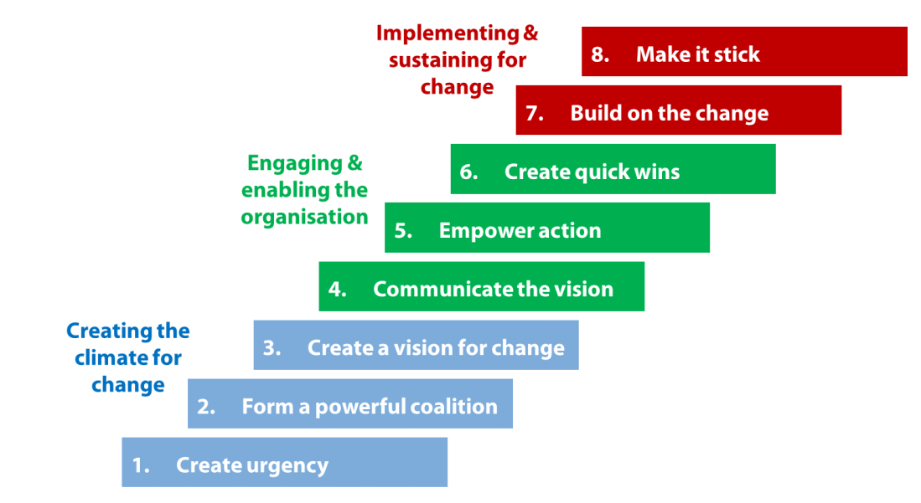 (Veyrat, 2017)

The first 3 stages as mentioned by Roberts and Tracey (2023b), cover increasing urgency, building a guiding team, and getting the right vision, which is grouped as ‘getting the right climate for change’ and maps to Lewin’s unfreeze stage.
Once a clear vision and strategy is set and understood, the engaging and enabling the organisation stage begins, which requires clear communication to gain buy in, empowering action, and creating quick, short-term wins. The 3 steps will identify any issues or concerns from employees, leading to creation of processes and structures to manage these. Then once implementation the proposed change begins, rewarding the contributions of those that have met the targets set and achieved early victories whilst sharing success stories, will further support employees and obtain buy-in.
The final 2 stages referred to as ‘Don’t let up’ and ‘make it stick’, cover implementing change and, very importantly, sustaining change. (Roberts and Tracey, 2023b) Ensuring the change becomes an integral part of the organisations culture and is visible in all aspects, is essential to it becoming the new norm according to Juneja (2019) and missing even a single step might result in serious problems.

8. How change is experienced (AC 2.4)

How any change is experienced including those within the workplace, can vary from person to person and from day to day. Elisabeth Kubler Ross designed a model ‘Kubler-Ross Change Curve’ in 1969, that describes the emotional stages and reactions when dealing with change and transition.
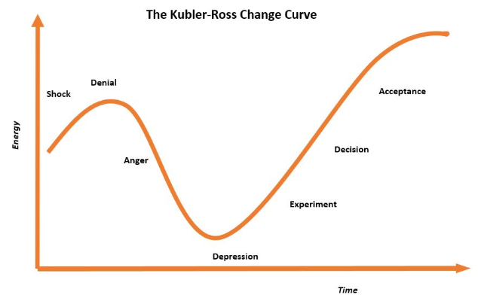(Tahir, 2019)
As described by Tahir (2019), the first responses of the curve are the initial shock and denial to the news or change. This stage demands careful and considered communication and support from the change leader/employer to reduce the risk of panic amongst employees. This initial shock, while frequently short lived, can result in a temporary slowdown and loss of productivity. Performance tends to dip sharply, individuals who are normally clear and decisive seek more guidance and reassurance. (University of Exeter, 2023)
After the initial shock comes the next stages of anger and depression. Performance will be at its lowest, employee morale will be lacking, with anxiety levels at their highest. Tahir (2019b) suggests this is an expected, natural response but how it is handled is essential to how people transition into acceptance of the proposed change. Suggesting positive actions, rewards and training workshops can often reassure and support the employees.
Experimenting with ideas of how to move forward comes next. According to the University of Exeter (2023), it is at this stage individuals accept that change is inevitable, and begin to work with the changes rather than against them.
During acceptance and integration, energy levels and productivity show signs of recovering however, The University of Exeter (2023) explains how it is not uncommon for employees to return to an earlier stage if the level of support drops or if employee concerns are not addressed.
This change model is universal so everyone can relate to it in some way. Predictions can be made, allowing employers to plan accordingly and can highlight to employees that their emotional responses are normal and expected. Furnishing individuals with the knowledge that others understand and experience similar emotions is the best way to return, with as little pain as possible, to optimal performance. (University of Exeter, 2023)
However, the risk of using this model is that it doesn’t account for individual responses and assumes everyone will experience the same responses, and within a similar timeframe when in reality as described by Tahir (2019b), people may move back and forth between stages and others may linger in one stage for an extended period.

9. The importance of wellbeing at work and factors that can impact wellbeing (AC 2.5)
Promoting employee wellbeing within an organisation, and consistently integrating this throughout its leadership and culture is essential to achieving a positive and flourishing working environment. Employees that feel valued and engaged are far more likely to produce good work, higher performance and are less likely to be absent from work. Investing in employee wellbeing can lead to increased resilience, better employee engagement, reduced sickness absence and higher performance and productivity. (Suff, 2023)
In turn, reduced sickness absence, lower staff turnover rates and increased productivity from employees are all financially beneficial to an organisation.
As well as having a duty of care to ensure their workers are healthy both mentally and physically, employers will also benefit from promoting employee wellbeing by attracting good workers to the organisation making the recruitment process easier and by retaining their existing good staff.
Internal factors that can impact on wellbeing at work, as identified by Armstrong and Taylor (2020,a) can include:
- Working environment - are there suitable amenities/ rest spaces for breaks and are working conditions safe for employees?
- Job design – are the job descriptions fit for purpose, do they require review?
- Relationships between both colleagues and with management – are policies in place to ensure fair working and encourage anti-bullying. Is training available for management on how to manage stress at work and developing leadership skills required to manage change.
- Financial wellbeing – are the pay scales fair?
If the above factors are unsuitable or inappropriate, an organisation is at risk of losing good workers and wasting time and money replacing those workers. The risks don’t stop at just financial; employers could face legal action if the correct policies and procedures aren’t followed.
External factors affecting employee wellbeing include the pressure on organisations from the government, regulatory authorities, and the media to behave responsibly in the way they treat their people. (Armstrong and Taylor, 2020, p.571)
Other external factors which employers must consider in order to achieve good wellbeing at work for their employees are providing the opportunity for good work-life balance and flexible ways to support those with caring responsibilities such as parents and carers.
To support work-life balance, organisations can have clear policies that comply with all legal obligations but also that drives a positive culture showing that the employer recognises how important work-life balance is to its employees. Culture underpins innovation and success. In sending out a positive message that the organisation cares about the people it employs, it also presents to potential employees and external stakeholders that it is an employer of choice. (Waite et al., 2021a p.145)

10. Links between the employee lifecycle and people practice roles (AC 3.1).
The employee lifecycle, as shown below, can be separated into 7 different stages, each adding benefits to the employees’ overall employment experience.

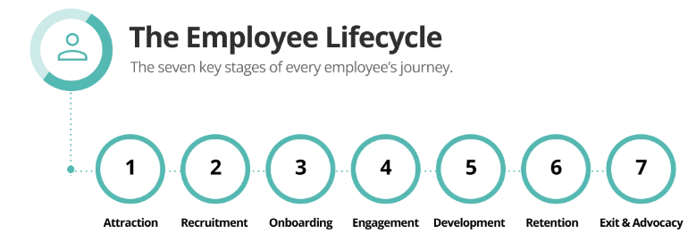(Fields, 2023)
Stages 1 and 2 focus on the optimisation of job listings, to attract good quality applications from candidates who are not only qualified, but also a good fit for your company culture (Fields, 2023). It is also at these stages that an organisation can ensure and enforce a fair and diverse recruitment process. Recruitment campaigns and resourcing teams work collaboratively to produce appealing job adverts and accurate jobs descriptions and the effective tracking of applications, responding in a timely manner. Failure to provide a positive experience at this stage can impact negatively on your organisations’ reputation, resulting in fewer applications or increased turn-over rates, however, as mentioned by Newell (2019), if you create an employee experience, the employee life cycle in your organization will be extended.
According to Fields (2023), these first stages are key as these are when applicants are first exposed to your brand and will decide whether or not you appeal as a potential employer. First impressions count so it is essential that the jobs adverts created by the recruitment teams, highlight the benefits of working within the organisation and promote and display the behaviours expected. This could include any financial benefits and rewards schemes that are available, and learning and development opportunities. Having a positive culture that prioritizes employee development and innovation is sure to win your brand a great reputation. (Symonds, 2021)
Development and Retention stages interlink with each other and impact on one another hugely. Investing in employee training and development not only gives your business access to additional skills in the long term, but also helps to optimise your employee life cycle. (Fields, 2023b)
Learning and development teams within organisations can provide further training programmes and present upskilling opportunities to existing employees, supporting their individual career aspirations ensuring the employee feels valued, in turn, becoming less likely to seek employment elsewhere. Giving your employees something to work towards and aspire to also supports engagement and retention. (Fields, 2023c)
People professionals within the recruitment function monitor staff turnover rates and reasons in a bid to identify trends for leaving. Some employees will naturally leave due to ill health, moving away or returning to study for example, however, according to Taylor and Woodhams (2022d, p.100), 90% of employee leavers fall into the category of avoidable dissatisfaction reasons. By completing exit interviews/discussions, it allows an organisation to identify issues and develop effective strategies in order to resolve these.

11. How people practice supports organisational strategies (AC 3.2).
Various strategies were set by Hywel Dda UHB, in order to overcome some of the extreme pressures following the Covid19 pandemic.
Detailed within the Hywel Dda University Health Board – Annual Report 2022/23, various objectives were put in place to improve these measures, such as increasing the number of nurses and midwifes they have in post (Hywel Dda University Health Board, 2023a). The health board identified that vacancy gaps and staff retention levels impacted on their capacity to both see and treat patients.
According to the data within Hywel Dda University Health Board – Annual Report 2022/23, 2955 nursing and midwifery staff were in post in March 2023, this far exceeding their ambition target of 2870, see image below:
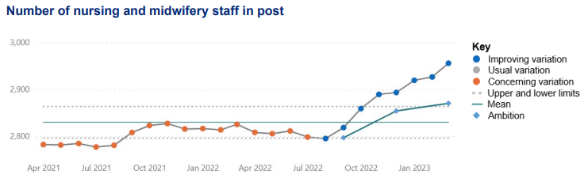
(Hywel Dda University Health Board, 2023a)
Staff retention groups within the People, Organisational Development and Culture Committee have implemented employee engagement surveys and have rolled out wellbeing focus groups and webinars to encourage employee engagement and retention. Having engaged employees, as discussed by Young (2023), leads to more motivated, healthy, and loyal staff, leading to better performance and productivity. Collaborative work with the learning and development team has also identified further training and qualifications to offer to the clinical staff to encourage them to progress within the health board rather than looking at other health boards in order to achieve their career aspirations. As discussed by MOL Learn (2022) one study has found that 94% of employees would stay with an employer that offers training opportunities, so it is essential the health board provides opportunities for continuing professional development.
The recruitment function also supported this strategy by running various targeted recruitment campaigns and by establishing an International Nursing recruitment project. These successful recruitment drives filled many vacancy gaps and more than achieved the Health Boards recruitment goal.
However, whilst achieving that strategy, it did not have a direct impact on the number of patients seen, another of the health boards key objectives.
When looking at the below metrics included in the November 2023 report (Hywel Dda University Health Board, 2023b), it shows that a large number of people are still experiencing lengthy wait times in A&E, across all four health board sites.

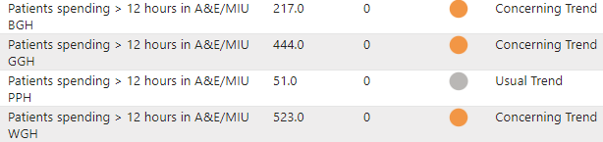
Whilst exceeding the numbers of nursing staff in post, it hasn’t necessarily achieved the desired impact on patient services and their ability to see and treat patients within a timely manner.
That being said, staff retention levels have improved as shown below, detailed within the health boards performance update as at November 2023. (Hywel Dda University Health Board, 2023b). 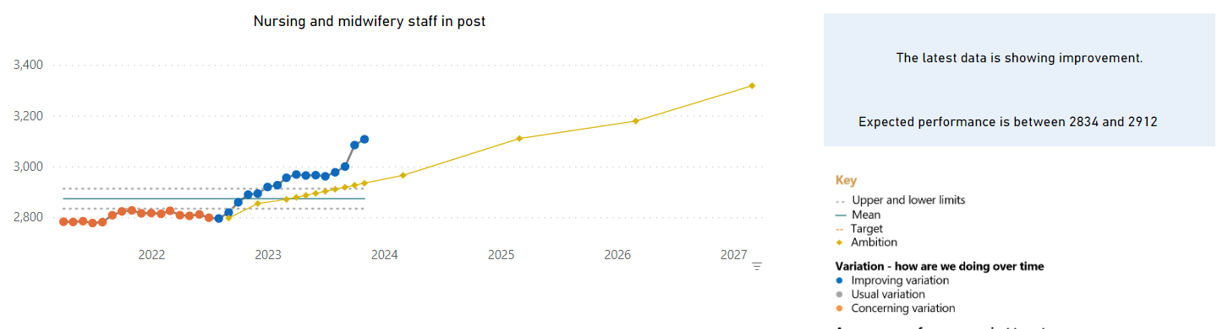
This is, however, financially beneficial for the health board as it reduces the costs that would be incurred to train new staff.

12. Processes for consulting and engaging with internal customers of the people function (AC 3.3).
Various processes can be used within an organisation to effectively engage and consult with internal customers of the people function in order to understand their needs.
Collaborative meetings within the Workforce and Organisational Development department allow sharing of ideas and knowledge, whilst presenting an opportunity to gain feedback on what is working well within each function and what isn’t working so well. The benefits of collaborative meetings as mentioned by Richards (2023) are they allow all attendees have an equal opportunity to contribute and are encouraged to share their thoughts and opinions to work together to achieve a common goal. The feedback gained is crucial to identifying better ways of working and ensuring we have the best opportunities to produce good work for all employees within the people function. Large collaborative meetings won’t, however, provide a comfortable platform for more introvert members of staff.
Appraisals or performance conversations/reviews are common consultation methods that can be used to establish and monitor needs of internal customers within the people function. However, as spoken about by Gifford (2022a), There’s been much debate over the last decade about whether ‘traditional’ approaches to appraisal are fit for purpose as they aren’t frequent enough, they focus on past performance as opposed to current and the process as a whole is excessively bureaucratic, time consuming and demotivating.
360 degree or multisource feedback, however, involves employees receiving ratings and feedback from a number of stakeholders, including colleagues and any reports they manage, as well as their own manager (Gifford, 2022b) this giving employees the bigger picture from their feedback and a more objective basis for administrative decisions.
Offering learning and development training within the Workforce and Operational Development sector, can highlight areas where further knowledge and training may be required. Monitoring the participant attendance can highlight if work has changed slightly within a team, and identify needs for further training. Also, as explained by Stopgap (2021) by completing a training needs analysis you can identify if on a departmental level, there may be new workstreams that require different skills or point towards the need to restructure teams.

Reference list
A Healthier Mid and West Wales Our Future Generations Living Well. (n.d.). [online] Hywel Dda University Health Board. Available at: https://hduhb.nhs.wales/about-us/healthier-mid-and-west-wales/healthier-mid-and-west-wales-folder/documents/a-healthier-mid-and-west-wales-strategy/ [Accessed 13 Jan. 2024].
A Healthier Mid and West Wales Our Future Generations Living Well. (n.d.). [online] Hywel Dda University Heath Board, p.24. Available at: https://hduhb.nhs.wales/about-us/healthier-mid-and-west-wales/healthier-mid-and-west-wales-folder/documents/a-healthier-mid-and-west-wales-strategy/ [Accessed 14 Jan. 2024].
Armstrong, M. and Taylor, S. (2020a). Armstrong’s Handbook of Human Resource Management Practice. 15th ed. London: KoganPage, p.571.
Armstrong, M. and Taylor, S. (2020b). Armstrong’s Handbook of Human Resource Management Practice. 15th ed. London: KoganPage, p.209.
Asana (2023). What Is a Matrix Organization and How Does It work? [online] Asana. Available at: https://asana.com/resources/matrix-organization [Accessed 15 Dec. 2023].
BBC (2021). PESTLE analysis - Critical thinking and problem solving - WBQ National: Foundation KS4 Revision. [online] BBC Bitesize. Available at: https://www.bbc.co.uk/bitesize/guides/zcjhfcw/revision/2 [Accessed 7 Dec. 2023].
Bright, D., Hodgson, K., Preece, E. and Davies, A. (2023). Use of the Internet and Digital Technology to Manage Health in Wales: past, current, and Future Preferences. [online] Public Health Wales, p.11. Available at: https://phw.nhs.wales/news/proportion-of-people-using-the-internet-frequently-to-manage-their-health-has-almost-doubled/use-of-the-internet-and-digital-technology-to-manage-health-in-wales-past-current-and-future-preferences/ [Accessed 4 Jan. 2024].
CIPD (2022). CIPD | Explore Our Related Content. [online] CIPD. Available at: https://www.cipd.org/uk/knowledge/guides/planning-hybrid-working/ [Accessed 15 Dec. 2023].
CIPD (2023a). CIPD | Automation, AI and Technology. [online] CIPD. Available at: https://www.cipd.org/uk/views-and-insights/cipd-viewpoint/automation-ai-technology/ [Accessed 4 Jan. 2024].
CIPD (2023b). The Profession Map. [online] CIPD. Available at: https://www.cipd.org/globalassets/media/comms/the-people-profession/profession-map-pdfs/profession-map-full-standards-november-2023.pdf [Accessed 15 Dec. 2023].
Cumbria Training Services. (n.d.). ‘Behaviour Breeds Behaviour’ – Cumbria Training Services. [online] Available at: https://cumbriatrainingservices.co.uk/2018/08/30/behaviour-breeds-behaviour/ [Accessed 8 Dec. 2023].
Cuofano, G. (2021a). What Is Schein’s Model of Organizational Culture? The Schein’s Model of Organizational Culture in a Nutshell. [online] FourWeekMBA. Available at: https://fourweekmba.com/scheins-model-of-organizational/ [Accessed 12 Jan. 2024].
Cuofano, G. (2021b). What Is Schein’s Model of Organizational Culture? The Schein’s Model of Organizational Culture in a Nutshell. [online] FourWeekMBA. Available at: https://fourweekmba.com/scheins-model-of-organizational/ [Accessed 12 Jan. 2024].
Denis, G. (2022). Edgar Schein’s Organizational Culture Model. [online] Expert Program Management. Available at: https://expertprogrammanagement.com/2022/09/edgar-schein-culture-model/ [Accessed 12 Jan. 2024].
Fields, J. (2023a). What Is the Employee Life Cycle? Optimising the 7 Stages. [online] www.peoplehr.com. Available at: https://www.peoplehr.com/en-gb/resources/blog/what-is-the-employee-lifecycle/ [Accessed 4 Jan. 2024].
Fields, J. (2023b). What Is the Employee Life Cycle? Optimising the 7 Stages. [online] www.peoplehr.com. Available at: https://www.peoplehr.com/en-gb/resources/blog/what-is-the-employee-lifecycle/ [Accessed 4 Jan. 2024].
Fields, J. (2023c). What Is the Employee Life Cycle? Optimising the 7 Stages. [online] www.peoplehr.com. Available at: https://www.peoplehr.com/en-gb/resources/blog/what-is-the-employee-lifecycle/ [Accessed 4 Jan. 2024].
Finch, D. (2022). The cost-of-living Crisis Is a Health Emergency Too - the Health Foundation. [online] www.health.org.uk. Available at: https://www.health.org.uk/news-and-comment/blogs/the-cost-of-living-crisis-is-a-health-emergency-too [Accessed 7 Dec. 2023].
Gifford, J. (2022a). CIPD | Performance Reviews | Factsheets. [online] CIPD. Available at: https://www.cipd.org/uk/knowledge/factsheets/appraisals-factsheet/ [Accessed 12 Jan. 2024].
Gifford, J. (2022b). CIPD | Performance Reviews | Factsheets. [online] CIPD. Available at: https://www.cipd.org/uk/knowledge/factsheets/appraisals-factsheet/ [Accessed 12 Jan. 2024].
Houghton, E. and Baczor, L. (2020a). Workplace Technology the Employee Experience. [online] CIPD, p.4. Available at: https://www.cipd.org/globalassets/media/knowledge/knowledge-hub/reports/workplace-technology-2_tcm18-80853.pdf [Accessed 4 Jan. 2024].
Houghton, E. and Baczor, L. (2020b). Workplace Technology the Employee Experience. [online] CIPD, p.12. Available at: https://www.cipd.org/globalassets/media/knowledge/knowledge-hub/reports/workplace-technology-2_tcm18-80853.pdf [Accessed 4 Jan. 2024].
Houghton, E. and Baczor, L. (2020c). Workplace Technology the Employee Experience. [online] CIPD, p.15. Available at: https://www.cipd.org/globalassets/media/knowledge/knowledge-hub/reports/workplace-technology-2_tcm18-80853.pdf [Accessed 4 Jan. 2024].
Houghton, E. and Baczor, L. (2020d). Workplace Technology the Employee Experience. [online] CIPD, p.21. Available at: https://www.cipd.org/globalassets/media/knowledge/knowledge-hub/reports/workplace-technology-2_tcm18-80853.pdf [Accessed 4 Jan. 2024].
Hywel Dda University Health Board. (no date b). Healthier Mid and West Wales. [online] Available at: https://hduhb.nhs.wales/about-us/healthier-mid-and-west-wales/ [Accessed 14 Jan. 2024].
Hywel Dda University Health Board. (2023a). Hywel Dda University Health Board – Annual Report 2022/23. [online] Available at: https://hduhb.nhs.wales/about-us/performance-targets/our-performance-areas/annual-reports-and-annual-quality-statements/ [Accessed 12 Jan. 2024].
Hywel Dda University Health Board. (2023b). Monitoring Our Performance. [online] Available at: https://hduhb.nhs.wales/about-us/performance-targets/our-performance-areas/monitoring-our-performance/ [Accessed 12 Jan. 2024].
Hywel Dda University Health Board. (no date a). Referral to treatment waiting times. [online] Available at: https://hduhb.nhs.wales/about-us/performance-targets/our-performance-areas/referral-to-treatment-waiting-times/ [Accessed 7 Dec. 2023].
Juneja, P. (2019). Kotter’s 8 Step Model of Change. [online] Management Study Guide. Available at: https://www.managementstudyguide.com/kotters-8-step-model-of-change.htm [Accessed 4 Jan. 2024].
Kelly, N. (2023a). How to Deal with drama: Understanding the Drama Triangle. [online] Counselling Directory. Available at: https://www.counselling-directory.org.uk/memberarticles/how-to-deal-with-drama-understanding-the-drama-triangle [Accessed 12 Jan. 2024].
Kelly, N. (2023b). How to Deal with drama: Understanding the Drama Triangle. [online] Counselling Directory. Available at: https://www.counselling-directory.org.uk/memberarticles/how-to-deal-with-drama-understanding-the-drama-triangle [Accessed 12 Jan. 2024].
Layfield, D. (2023). The Matrix Organizational structure: Pros, cons, and Insights. [online] LogRocket Blog. Available at: https://blog.logrocket.com/product-management/matrix-organizational-structure/#:~:text=Product%20teams%20at%20Google%2C%20Facebook%2C%20LinkedIn%2C%20Amazon%2C%20and [Accessed 15 Dec. 2023].
Leadership Centre. (n.d.). Lewin’s Model of Change | Art of Change Making. [online] Available at: https://www.leadershipcentre.org.uk/artofchangemaking/theory/lewins-model-of-change/ [Accessed 4 Jan. 2024].
Leadership tribe (2020). The Drama Triangle Explained. [online] Leadership Tribe. Available at: https://leadershiptribe.com/blog/the-drama-triangle-explained [Accessed 12 Jan. 2024].
MacArthur, E. (2018). Why Our Throwaway Culture Has to End. [online] National Geographic. Available at: https://www.nationalgeographic.co.uk/environment-and-conservation/2018/06/why-our-throwaway-culture-has-to-end [Accessed 7 Dec. 2023].
McCartney, C. (2023). CIPD | Flexible Working Practices | Factsheets. [online] CIPD. Available at: https://www.cipd.org/uk/knowledge/factsheets/flexible-working-factsheet/ [Accessed 8 Dec. 2023].
McPheat, S. (2023). Advantages and Disadvantages of Lewin’s Change Model. [online] Leadership and Management Training Courses UK | MTD Training. Available at: https://www.mtdtraining.com/blog/advantages-disadvantages-lewins-change-model.htm [Accessed 4 Jan. 2024].
MOL Learn (2022). Why is Learning & Development important to businesses? [online] MOL Learn. Available at: https://www.mollearn.com/about/news/why-learning-development-important-businesses/ [Accessed 12 Jan. 2024].
Newell, C. (2019). Council Post: the Employee Life Cycle Is about an Experience. [online] Forbes. Available at: https://www.forbes.com/sites/forbeshumanresourcescouncil/2019/10/21/the-employee-life-cycle-is-about-an-experience/ [Accessed 4 Jan. 2024].
NICE (2016). Community engagement: Improving Health and Wellbeing and Reducing Health Inequalities NICE Guideline. [online] Available at: https://www.nice.org.uk/guidance/ng44/resources/community-engagement-improving-health-and-wellbeing-and-reducing-health-inequalities-pdf-1837452829381 [Accessed 14 Jan. 2024].
Office for National Statistics. (2023). How life has changed in Pembrokeshire: Census 2021. [online] Available at: https://www.ons.gov.uk/visualisations/censusareachanges/W06000009/ [Accessed 7 Dec. 2023].
Referral to Treatment - Maximum Waiting Times. (2020). [online] Hywel Dda University Health Board . Available at: https://hduhb.nhs.wales/about-us/performance-targets/performance-documents/rtt-maximum-waits-august/ [Accessed 7 Dec. 2023].
Richards, R. (2023). How to Run a Collaborative Meeting (That Your Team Loves!). [online] Airgram. Available at: https://www.airgram.io/blog/collaborative-meeting [Accessed 12 Jan. 2024].
Roberts, A. and Tracey, H. (2023a). CIPD | Change management: a Guide for People Professionals. [online] CIPD. Available at: https://www.cipd.org/en/knowledge/guides/change-management/ [Accessed 4 Jan. 2024].
Roberts, A. and Tracey, H. (2023b). CIPD | Change management: a Guide for People Professionals. [online] CIPD. Available at: https://www.cipd.org/en/knowledge/guides/change-management/ [Accessed 4 Jan. 2024].
Stopgap. (2021). Stopgap Blog | How to identify training and developing needs - Marketing Recruitment Agency. [online] Available at: https://www.stopgap.co.uk/article/how-to-identify-training-and-developing-needs [Accessed 12 Jan. 2024].
Suff, R. (2023). Wellbeing at Work. [online] CIPD. Available at: https://www.cipd.org/uk/knowledge/factsheets/well-being-factsheet/ [Accessed 7 Dec. 2023].
Symonds, C. (2021). What Is the Employee Life Cycle and Why Does It Matter? [online] Factorial HR. Available at: https://factorialhr.com/blog/employee-life-cycle/#Stages [Accessed 4 Jan. 2024].
Tahir, U. (2019a). What Is Kubler Ross Change Curve? | Stages & Advantages CMI. [online] Change Management Insight. Available at: https://changemanagementinsight.com/kubler-ross-change-curve-model/ [Accessed 15 Dec. 2023].
Tahir, U. (2019b). What Is Kubler Ross Change Curve? | Stages & Advantages CMI. [online] Change Management Insight . Available at: https://changemanagementinsight.com/kubler-ross-change-curve-model/ [Accessed 15 Dec. 2023].
Taylor, S. and Woodhams, C. (2022a). STUDYING HUMAN RESOURCE MANAGEMENT : a Guide to the study, Context and Practice of hr. S.L.: Kogan Page, p.56.
Taylor, S. and Woodhams, C. (2022b). STUDYING HUMAN RESOURCE MANAGEMENT : a Guide to the study, Context and Practice of hr. S.L.: Kogan Page, p.56.
Taylor, S. and Woodhams, C. (2022c). STUDYING HUMAN RESOURCE MANAGEMENT : a Guide to the study, Context and Practice of hr. S.L.: Kogan Page, p.59.
Taylor, S. and Woodhams, C. (2022d). STUDYING HUMAN RESOURCE MANAGEMENT : a Guide to the study, Context and Practice of hr. S.L.: Kogan Page, p.100.
University of Exeter (2023). The Change Curve. [online] University of Exeter. Available at: https://www.exeter.ac.uk/media/universityofexeter/humanresources/documents/learningdevelopment/the_change_curve.pdf [Accessed 15 Dec. 2023].
Veyrat, P. (2017). 2 Organizational Change Management Models: 8 Steps Vs Bridges. [online] HEFLO BPM. Available at: https://www.heflo.com/blog/change-management/change-management-models/ [Accessed 4 Jan. 2024].
Waite, K., Beevers, K., Small, N., Tomlinson, K. and Hussain, S. (2021a). People Practice : A Complete Guide. London, United Kingdom ; New York, Ny: Kogan Page, p.145.
Waite, K., Beevers, K., Small, N., Tomlinson, K. and Hussain, S. (2021b). People Practice : a Complete Guide. London, United Kingdom ; New York, Ny: Kogan Page, pp.29–30.
Wiltshire , V. (2022). L&D’s Role in Developing Company Culture. [online] Training Industry. Available at: https://trainingindustry.com/magazine/spring-2022/lds-role-in-developing-company-culture/ [Accessed 8 Dec. 2023].
Young, J. (2023). CIPD | Employee Engagement & Motivation | Factsheets. [online] CIPD. Available at: https://www.cipd.org/uk/knowledge/factsheets/engagement-factsheet/ [Accessed 12 Jan. 2024].

