
Programme: BA Business Management Module: Entrepreneurship code: LCBB5001 Lecture: Dr Laila Mazouz
Assessment 2: Business Plan - Talent Management Agency “Talent Hub”
Student name: Aysidora Stavreva Student ID:2030536 date:27.08.2023 city: London

BUSINESS DESCRIPTION / MARKET OPPORTUNITY

Talent Management Agency “Talent Hub” is an HR company that will expand its business in the UK market. This is a reputed HR company that offers human resource-based services to its clients through recruitment, interview arrangement, presenting selection procedures, training and employment campaigns. It has a wide range of clients including both talents and recruiters and the company offers services to make connections between them through proper human-resource strategies.
Vision: To manage and develop value-added procedures, programs and policies related to human resources by providing expert consultation, solutions as well as services in an efficient manner.
Mission statement: To enhance the human-resource industry through creativity and innovation by advocating necessary tools to meet clients' needs.
Services: It offers a wide range of disciplined services to its broad client base including:
- The strategic decision for human capital
- Talent management
- HR analytics
- Learning and development session for talents
- HR technology use
- Applying employee well-being and health
- Improving organizational cultures
Need of the service
After the pandemic situation, this HR company is focused on using different tools and technologies for adopting the ‘new normal’ situation. In the opinion of Azizi et al. (2021), after the pandemic, companies are designing their HRM strategies in a modified way through hybrid mode, online interviews, flexible shifts and others. Besides this, in the UK, post-pandemic situation, employment opportunities were fallen severely. Recruitment and Employment Confederation in the UK have stated that the country has faced the lowest level of employment opportunities due to the pandemic and a very lower number of jobs were posted on the websites (Reuters.com 2022). Hire & Talent can satisfy the market requirement of generating more jobs in the talent market. It will make a positive impact on talent by enhancing the scope to make employment opportunities. For maintaining recruiter demand in post-covid situations, this brand will arrange online interviews and recruitment sessions, through video calls and online tests.
Legal structure and ownership
This HR company will follow the corporation as the legal structure of the company for profit-based features. A Board of Executives will manage corporate strategies and policies of the company as per market situations. It will follow a hierarchical structure for maintaining an effective and equal distribution of workload among all departments.

INDUSTRY ANALYSIS – Porter’s 5 forces

The evolution of this industry in recent days has developed different impacts on HR consulting companies in the UK. The growth of HR technology is played an important role in highlighting improving integration between recruiters and employees under the supervision of appropriate labour regulations and laws. It has focused on inclusion and diversity approaches to enrich workplace culture. Porter’s five forces are mentioned below:
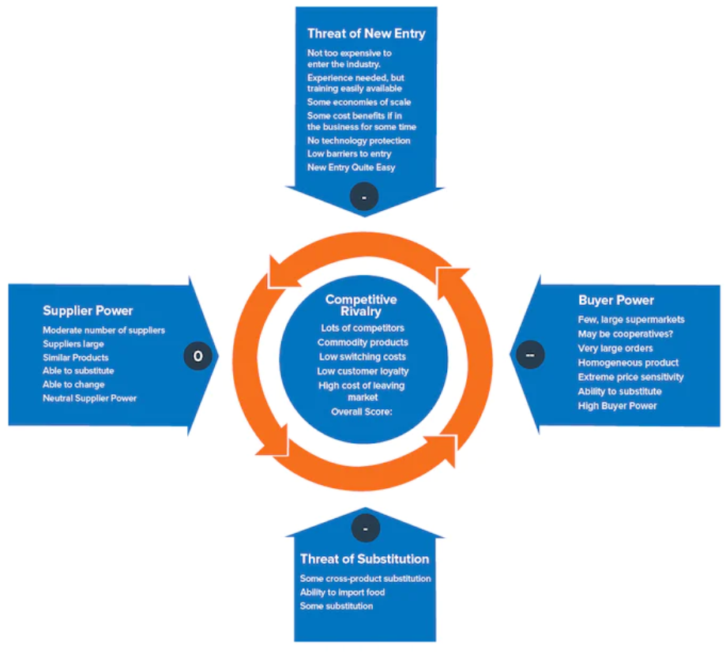

Threat of new entry
This threat will create a low to moderate impact on the mentioned HR company considering its capital investment, advanced infrastructure and higher efficiency. As a new entrant in the UK market, it may face threats due to fewer brand recognition features. Additionally, the threat can be enhanced due to trust issues in the UK market.
Threat of substitutes
There are many substitute services available in the UK market regarding payroll outsourcing of human resources and other related administrative functions. Hence, it may develop a moderate threat for Hire & Talent while entering into the UK market. Additionally, client companies are generally preferred to continuous HRM outsourcing services with familiar organizations that can also create a threat to the new brand after entering the UK market.
Bargaining power of customers
This factor is related to the negotiation strategy and employee strength of a company. In this term, Barringer, and Ireland (2019) have described that customers’ negotiation strategy is high and it has featured an effective influence on companies. Businesses are based on customers' purchasing decision and thus needs to offer services within a budget as per market research. Therefore, it may create a low to moderate threat to the company in aligning with its service features and its price range.
Bargaining power of suppliers
The bargaining power of suppliers can create a high threat to the company as it has a higher power of bargaining across the market. Existing HR consultancy companies have more effective relations with local suppliers in the UK market and initially, Hire & Talent will face challenges while creating a supplier base. Without suppliers, it will not be able to set up its business in the market with proper configuration settings.
Competitive rivalry
Existing competitive companies will provide a high threat to Hire & Talent while introducing their business in the UK market. Integrated service offerings and the consistence of niche payroll services to client companies have developed a trustworthy bond between existing HR consultancy services and leading businesses. Existing companies are always improving their competitive advantage by making faster and easier service implementation features.
Name of competitor companies | Differentiation
Avensure | Significantly gains brand recognition due to effective support of employment laws and regulations.
HR Solutions | Offers sincere and useful employee training services
Wirehouse HR | Providing significant safety and health support services to employees.
Besides this, a VRIO analysis will be done for highlighting the potential competitive advantage of the brand in aligning with differentiations of existing competitive rivalries.
Resources | Valuable | Rare | Inimitable | Organizational Impact | Competitive advantage
Corporate vision | Yes | No | No | Yes | Mid term
Application of HR tools | Yes | Yes | No | Yes | Long term
Compatibility for the post-pandemic situation | Yes | Yes | No | Yes | Mid term
Connectivity with people | Yes | No | No | Yes | Short term
Market research and financial capital | Yes | No | Yes | Yes | Mid term

OPERATIONS AND MANAGEMENT TEAM
OPERATIONS

The new HR company will follow a core business process including marketing, distribution of services, sales and proper customer assistance including the approach of market to customers. It is known as a structured procedure of a company while maintaining all prospects properly (Aydiner et al. 2019). The brand will get its supply items from local vendors to reduce additional transportation costs. It will need a basic office system including wi-fi, computers, laptops, tables, chairs, electricity connection and others. From local suppliers, this equipment will be transported by vans or other modes of transport. Online set-up will be a high priority for this business, and it will connect to clients through emails, messages and over calls. In the case of the non-virtual interview process, and training sessions it connects with talents face-to-face in its office premise.

How would you generate revenue for your business( Upselling,Upgrading, Economies of Scale) ? How would you prevent loss of revenue?

For gaining higher business revenue, the brand will follow a cross-selling strategy for offering job opportunities to talents and for connecting recruiters with preferred talents as per the required job profile. This strategy is played an important role in convincing customers toward a new service by presenting the offer as a suggestion (Van der Borgh, Nijssen, and Schepers 2023). Additionally, it will generate pop-up features on different relevant websites to gain the attraction of potential clients. It will also add some service offers to positively influence people through the suggestion feature. The brand may use customer search behaviour and their data toward similar services and based on that it may present itself as a suggestion option. This can help the brand to enhance its reach to a wide range of potential clients and it may improve brand recognition. Moreover, the enhancement of brand recognition will encourage Hire & Talent to improve its sales revenue.

MANAGEMENT TEAM

Name/Designation | Skills | What do they bring to the firm
Director Mrs. Aysidora Stavreva | Organization skills, people management, | Organizing the new venture with legal assistance and overseeing firm management entirely.
Finance head Mrs. Galya  Vasileva | Economic forecasting, budget making | Calculating a new budget for the business by determining potential risks
Marketing head  Mr. Kiril Ivaylov | Communication, social media handling, SEO, collaboration | Designing promotional advertisements for the brand and making connections with potential clients and presenting reports of market research
Administrative head Miss Niya Nikolova | Critical thinking, analytical skills | Forming policies and work practices for the company

MARKETING: The Four P’s describe my marketing strategy

As a part of a marketing plan, the brand will follow the 4-Ps strategy as mentioned below:
Products: The company will offer placement services to talents, and it will help recruiters by making connectivity with required talents. Along with that, it will help the brand by outsourcing different human resource services to client companies such as payroll, online recruitment and many more. Besides this, it will offer relevant training sessions for employees where required. As a part of the consultancy service, this company may offer different interview placement services.
Price: This company will choose a competitive pricing range after introducing the brand in the UK market. It will focus to offer a broad range of services at a reasonable price for attracting clients. In the UK, the HR service is between £50 and £300 per hour and varied from company to company (Consultancy.uk 2022). Hire & Talent will charge £55 to £60 per hour and it will be finalised later after completing the setup. Based on market research and trends of clients using the service, the price is proposed.
Promotional mix: The new HR company will mainly focus on promoting the brand through different social medial channels (such as Facebook and Instagram) and newspapers. By applying the IDIC model as a CRM tool, it can gain a competitive advantage and connection to potential customers (Sembiring, and Sembiring 2023). First, identify the clients based on the demands and professional behaviour of talents and recruiter companies. Secondly, it needs to differentiate prime or valuable customers by separating desires such as recruiters and potential talents. Thirdly, developing a solid interaction with potential clients through multiple channels to enhance valuable relationships with them. Lastly, tailoring customized service plans for valuable clients including communication and overall working pattern to enhance their expectations and to encourage the touch point.
Place: Networking and SEO will be considered as distribution strategies for expanding the service. Participating in different events will improve the network of the business along with recognition. Application of effective SEO will help to increase the quality and quantity of website traffic for Hire & Talent. It will help the brand to improve its reach to a large volume of customers. Additionally, it may increase the ranking of the website and when people use keywords, automatically it will show on the upper side of the lists on search engines.

FINANCIALS

Sources of funds: where would you be getting funds from?

Two common funding sources are equity funding and debt financing (Eniola 2021). Hire & Talent will follow debt financing by getting a loan. Banks are comparatively less risky than other financial sources. Apart from that, it can take loans from online authentic lenders such as Funding Xchange and many more. It can take loans from £2000 to £ 2 million. However, this source has a higher interest rate than the normal charges of commercial banks. It is advisable for Hire & Talent to take the main loan amount from commercial banks as it has clear term documents.
It may follow the principal and interest loan repayment technique and it will be on monthly mode. Hence, it may reduce additional pressure on the company to repay the entire loan at a time. With a fixed monthly repayment option, the HR company will easily reduce its principal amount in a synchronized manner.

Use of funds

 | Month 1 | Month 2 | Month 3 | Month 4 | Month 5 | Month 6
Revenue (from your operations and marketing section) | £4000 | £5100 | £5800 | £6000 | £6300 | £6600
Fixed Cost
Rent | £1100 | £1100 | £1100 | £1100 | £1100 | £1100
Labour costs | £120 | £120 | £170 | £170 | £180 | £180
Variable Cost
Raw materials | £350 | £300 | £320 | £410 | £380 | £375
Wages | £1200 | £1200 | £1350 | £1350 | £1420 | £1420
Electricity | £450 | £450 | £450 | £450 | £450 | £510
Others | £45 | £120 | £70 | £150 | £100 | £160
Profit | £735 | £1810 | £2340 | £2370 | £2670 | £2855

MARKET RESEARCH

Market research is important to generate offers and services in a new market. The mentioned HR brand will be able to enhance its brand appearance across the market after knowing the requirements of customers. Additionally, it can help the brand to highlight the economic trend of the country for knowing its influence on purchasing behaviour of potential customers (Lukianova, Banit, and Goretko 2019). In the UK market, HR service providers' revenue is grown at an annual compound rate of 2.1% to £2 billion in the last five years (ibisworld.com, 2023). Hence, it may create a positive impression of Talent Management Agency “Talent Hub” due to the demand for this service.
Is important to use all opportunity for online marketing base on social platform. Use this all-marketing tools for successful business, marketing plan and strategy. Is very important to find out best place in the market in UK for this company. Is not simple to penetrated on the market, but with wise strategy is possible to builds successful HR company.

REFERENCES

1.ibisworld.com (2023) Industry market research, reports, and Statistics. Available at: https://www.ibisworld.com/united-kingdom/market-research-reports/human-resources-provision-industry/ (Accessed: 20 July 2023).
2.Reuters.com, (2022) UK job vacancies fall to post-pandemic levels, REC says. Available at: https://www.reuters.com/world/uk/uk-job-vacancies-fall-post-pandemic-levels-rec-says-2022-09-29/ (Accessed: 20 July 2023).
3.Consultancy.uk, (2022) Fees & rates. Available at: https://www.consultancy.uk/consulting-industry/fees-rates (Accessed: 20 July 2023).
4.Azizi, M.R., Atlasi, R., Ziapour, A., Abbas, J. and Naemi, R., 2021. Innovative human resource management strategies during the COVID-19 pandemic: A systematic narrative review approach. Heliyon, 7(6).
5.Barringer, B., and Ireland, D., (2019) Entrepreneurship: Successfully Launching New Ventures. Sixth edition; Global edition. Harlow, England: Pearson
6.Aydiner, A.S., Tatoglu, E., Bayraktar, E., Zaim, S. and Delen, D., 2019. Business analytics and firm performance: The mediating role of business process performance. Journal of business research, 96, pp.228-237.
7.Van der Borgh, M., Nijssen, E.J. and Schepers, J.J., 2023. Unleash the power of the installed base: Identifying cross-selling opportunities from solution offerings. Industrial Marketing Management, 108, pp.122-133.
8.Sembiring, M.S. and Sembiring, S.M.R., 2023. Do customer knowledge and customer trust in IDIC affect bank customer retention? Evidence from Indonesia. Journal of Enterprise and Development (JED), 5(3), pp.535-552.
9.Eniola, A.A., 2021. The entrepreneur motivation and financing sources. Journal of Open Innovation: Technology, Market, and Complexity, 7(1), p.25.
10.Lukianova, L.B., Banit, O.V. and Goretko, T.V., 2019. Effects of global labor market trends on the content of professional training of future IT managers. Information technologies and learning tools, 70(2), pp.16-27.

