
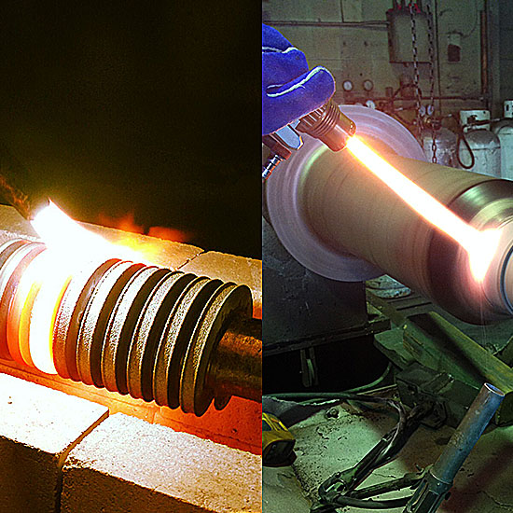

University of Wales Trinity Saint David
SCHOOL OF ENGINEERING
LASER CLADDING AND THERMAL SPRAY
HABTOM GHIRMAY
STUDENT NUMBER- 1810854
L6 MECHANICAL ENGINEERING
09/12/19
ADVANCE PROCESSES AND MATERIALS (M6X00414)
CONTENTS PAGES
- Introduction of non-traditional machining process 1
1.1 Laser cladding 1
1.2 Thermal spray 2
- Advantages and disadvantages 3
2.1 Advantages of laser cladding and thermal spray 3
2.2 Disadvantages of laser cladding and thermal spray 3
- Application and market opportunity
3.1 Applications and market opportunity of laser cladding 4
3.2 Applications and market opportunity of thermal spray 4
- Comparison of between laser cladding and thermal spray 5
- Conclusion 5
- References 6

TABLES AND FIGURES
Table 1. Advantages of laser cladding and thermal spray 3
Table 2. Advantages of laser cladding and thermal spray 3
Table 3. Comparison between laser cladding and thermal spray 5
Figure 1. Laser cladding 1
Figure 2. Thermal spray 2

- INTRODUCTION TO NON-TRADITIONAL MACHINING PROCESS
Non-traditional machining process is a special type of machining process in which there is no direct contact between the tool and the workpiece, and the process remove excess material by various techniques involving mechanical, electrical, chemical and thermal energy. It uses for metals, non-metallic and polymers which is used for process difficult to do by traditional machining such as turning, boring, drilling, sharping and milling. Non-traditional machining is also called advance manufacturing process.
Traditional machining processes are not feasible, suitable and economical due to special reasons:
- Very hard fragile materials are difficult to clamp for traditional machining
- When the workpiece is too flexible or slender
- When the shape of the part is complex
Classification of Non-conventional machining is based on the following factors:
- Energy type: Mechanical, Electro-chemical, Chemical and Thermo-electrical.
- Energy source: Pneumatic or hydraulic, High current or voltage and mechanical pressure.
- Energy transfer Medium: High velocity particles, physical contact, electrolyte and radiation.
- Mechanism of removal: Vaporization, erosion, shear and fusion.
Non-traditional machining processes have been developed to meet extra required machining conditions over traditional machining.
  - LASER CLADDING
Laser cladding or laser deposition is a processing technique used for adding one material to the surface of another in a controlled manner which utilizes a laser heat source to deposit a thin layer of a desired metal on a moving substrate. The deposited material can be transferred to the substrate by several methods: powder injection, pre-placed powder on the substrate, and by wire feeding. Powder injection is most common, processes by melting the powder particles with laser beam and a thin layer of the moving substrate to deposit a layer of the powder particles on the substrate. A great variety of materials can be deposited on a substrate using laser cladding powder injection to form a layer with thicknesses ranging from 0.5 to 3 mm and widths as narrow as 0.4 mm.
Laser cladding is integrated with a three-dimensional CAD solid model, which is sliced into many layers, provides the ability to fabricate complex components without intermediate steps. The interaction between the involved technologies and the process quality is a major step for the development of the laser cladding, but numerous interactions between the technologies involved in laser cladding not only increase the complexity of the process but also increase the number of process parameters.
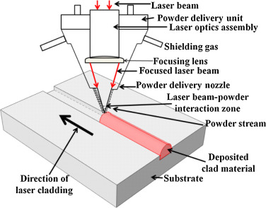 Figure 1. laser cladding
  - THERMAL SPRAY
Thermal spray coating process uses energy sources to heat the coating material ( in powder, wire, or rod form) to a molten or semi molten state, so the material is propelled using a stream of gas, compressed air to deposit and create a surface structure on the substrate. The coating used for metallic and non-metallic coating, but the energy sources of the coating processes can be flame, electric arc, or plasma arc spray. The formed coating material may consist of a single element and an alloy or composite with unique physical properties that are only achievable through the thermal spray process.
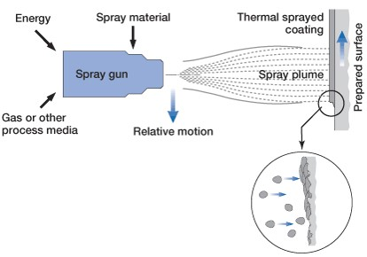
Fig. 2 Thermal spray coating
There are three basic types of deposits can be thermal sprayed:
- Single-phase materials, such as metals, alloys, intermetallic, ceramics, and polymers.
- Composite materials, such as cermet (WC/CO, Cr₃C₂/NiCr, NiCrAlY/Al₂O₃, etc.), reinforced metals, and reinforced polymers.
- Layered or graded materials.
The bonding mechanisms at thermal spray coating or substrate interface and between the particles making up the thermal spray coating is an area which in many cases is still subject to speculation. It generally suffices to state that both mechanical interlocking and diffusion bonding occur.

2. ADVANTAGES AND DISADVANTAGES
2.1 THE ADVANTAGES BETWEEN LASER CLADDING AND THERMAL SPARY
Laser cladding | Thermal spray
This technique can produce a much good coating, with minimal dilution, minimal distortion, and better surface quality | Thick coating up to 10 mm, can be applied at high deposition rate and the thermal spraying capacity form barrier and functional coating on wide range of substrates.
Can be used as rapid prototyping technique (produce component layer by layer) | Thermal spray recognised as a key process to create free standing structures for net-shaped manufacturing of high-performance materials.
Reduce the production time by fabricating tools and main prototypes directly from the CAD solid model | The spray rates range from 0.000378- .00075 kg/s depending on the materials and the spray system.
Enhance thermal control: temperature distribution can be monitored and optimized during the process to improve the laser beam | Accurately controlled temperature of the bulk substrate avoiding any detrimental effects of heat on the material properties.
Used as a safe technology to repair tooling in very critical contacting surfaces, increases tool life and can save high-value tool to be replaced. | Apply coating to substrates without changing the properties and excessive thermal distortion of the part.
Laser cladding produces a functional graded part (produce apart from different materials layers), the method is by injecting different materials during the fabrication of the parts and it also produce desired alloys by injection of different powders through various nozzles around the process zone. | Versatile coating material which can be metal, ceramic and polymer, in the form of powder, rod or wire to meet the wide variety of applications, in particularly protect from wear and corrosion damage.
Create smart structure due to additive nature with the help of embedding objects such as sensors and magnets during fabrication, and these objects reduces the damage or failure from temperature and environmental conditions. | Strong and efficient thermal spray coating would extend the lifespan of that substrate by providing an effective barrier against erosion, decomposition and other surface damage.

Table 1. advantages of thermal spray and laser cladding
  - DISADVANTAGE OF LASER CLADDING AND THERMAL SPRAY

LASER CLADDING | THERMAL SPRAY
Due to disturbances in the process the clad quality vary significantly, variations of the quality may even be observed between processing cycles performed using the same operating conditions. | Thermal spray coating is so efficient in many cases, but it is impossible to tell what material the substrate was made of after the coating process, unless records are kept.
High set up costs for equipment and installation | Some of the methods of thermal spray coatings require expensive apparatus, which can result in a high initial set up cost
Large equipment size limits due to size of the system it is not portable | Cannot precisely evaluate effectiveness-when the thermal spray coating has been applied it is often difficult to tell exactly how well the coating has gone on other than by visual assessment.
Table 2. Disadvantages of laser cladding and thermal spray

3. APPLICATIONS AND MARKET OPPORTUNITY
3.1 APPILICATIONS and MARKET OPPORTUNITY OF LASER CLADDING
- Coating: results in deposition of a thin layer of material (e.g., metals and ceramics) on the surface of a selected material and it changes the surface properties of the substrate. The substrate material alone is not only achievable, so the coating provides a durable, corrosion-resistant layer, and the core material provides the load bearing capability. Some of the coating metals are chromium, titanium, nickel, copper and cadmium.
Coating techniques depends on many parameters such as size, adaptability of the coating material, level of adhesion and cost of the equipment.
Some of the products are shafts used for drilling tools, engine valve seats, tools hard facing, hydraulics pump components and moulds.
- Parts repair and refurbishment: laser cladding used for repair and refurbishment of high-value components such as tools, turbine blades and military components. Laser cladding maintains the error in design and machining process.
Conventional methods can repair and refurbish but it is destruction to the work piece of the material due to uncontrolled temperature distribution over the area of repair and it causes mechanical weak properties, but the success of this technology is due to small heat zone, rapid solidification, increased cleanness, lower dilution, and increased controllability over the depth of heat zone.
Some samples of the products are turbine blades, engines and aircraft engine components.
- Rapid Prototyping and Tooling: a new and major application of laser cladding is in rapid prototyping and rapid tooling markets for rapid fabrication of complex components and tools.
The most common products of laser cladding to construct prototypes and production tooling are different commercial alloys such as 304 stainless steel, nickel-based superalloys, aluminium, composite and titanium-based material.
The global laser cladding equipment market will grow by 5% during the forecast period (2018-2022). The adoption of the material hard facing, and coating technology has been increasing steadily over the past decades. It is driven by increase the service life of equipment and lower operational expenses by reducing the wear and damage to equipment.
3.2 APPLICATIONS AND MARKET OPPORTUNITY OF THERMAL SPRAY
To use thermal spray coating, the coating material must be properly selected, coating process chosen and process parameters.
- Production applications:
- Hard Chromium: thermal spray is used to replace hard chromium plate for aircraft landing gear components by using pure chromium and various carbide coatings.
- Medical Implants: used for strong and durable anchoring of orthopaedic implants, such as artificial hip joints by properly sprayed a very fissured surface that allows the bone to grow into it.
- Gas Turbines: thermal spray used for fixed and flight gas turbines. Protective coating for temperature corrosion resistance, thermal insulating, clearance control and repair of superalloy components with coating similar composition.
- Printing and automotive industry.
- Steel, paper industry and aerospace

- Repair and restoration
Thermal spray also used for repair procedures to restore components to their original size. The coatings can be turned or ground to finished size. Ni-Cr, Ni-Al or Ni-Cr-Al are used as repair material for alloyed steels.
Based on application, the global thermal spray coatings market is segmented into aerospace, industrial gas turbines, automotive, medical and others. Industrial gas turbines segment is expected to expand at a significant over the forecast period (2016-2024), followed by aerospace segment.
- COMPARISION BETWEEN LASER CLADDING AND THERMAL SPRAY

PROCESS | LASER CLADDING | THERMAL SPRAY
Heat source | High intensity laser radiation | Combustion flame, electric, plasma arc
Bond Strength | High metallurgical bonding | Low to moderate, mechanical bonding
Coating structure | Dense, crack and pore-free layers | Lamellar, from porous to nearly dense
Dilution | Low | Nil
Coating thickness | Typically, 0.5-3mm | From 0.05mm
Coating materials | Metals and alloys, alloys with hard particles, hard metals and ceramics | Wide range of metals, alloys, hard metal, ceramics and polymers
Productivity | Low to moderate/high | Low to high
Cost | Moderate to high | Low to high
Heat load to work piece | Low to moderate | Very low to moderate

Table 3. comparison between laser cladding and thermal spray
- CONCLUSION
Thermal spray deposits are often present problems like low strength, dilution, cracking and spalling while exposed to wear conditions. Thermal spray deposits additionally require post processing to enhance their thickness, increment homogeneity and lessen porosity. However, it used for rapid-solidification synthesis of materials. Synthesis of advanced functional surfaces are such as catalytic coatings, dielectrics, ferrites, bioactive materials and solid oxide fuel cells.
Laser cladding is a great coating process, which produces coating with high density, metallurgical bonding and low heat input to the substrate. Main benefits of laser coatings are their significantly improved the corrosion properties and coating adhesion. Laser cladding is even a great technique but comparing with thermal spray the speed of the process was slow. The future improvement for this process is to wards of increasing the speed of process.

REFERENCES
- Laser cladding, by Ehsan Toyserkani, Amir Khajepour and Stephen Corbin, book CRC 2005.
- An introduction to Thermal Spray, Sulzer Metco industry company magazine
- Handbook of Thermal spray Technology edited by Joseph R. Davis
- IRS Surfacing Technologies LTD, Thermal spray system category, magazine May 2018
- Wisdom quality and credit, Research and Innovation, magazine thermal spray technology
- CURTISS-WRIGHT Company web/ cwst.co.uk/
- Degradation and Surface Engineering/ shusuperblog.wordpress.com
- Journal of manufacturing processes 20 (2015) 492-499, by Prakash, Santanu, Ramesh and Wenyi Yan.
- FST, Spray Tech, Thermal spray technology, Journal, June 2016
- Laser coating and thermal spray- process basics and coating properties by P. Vuoristo, J.Tuominen, J.Nurminen Tampere University, Institute of Material Science, research paper.
- Hayden laser service, LLC
- Laser cladding equipment market, BusinessWire , by A Berkshire Hathaway Company, web page
- Thermal spray coatings market, by PERSISTENCE MARKET RESEARCH/persistencemarketresearch.com

