EMPL4011-Smart Technology for Workplace

Submitted
By

Student name: Ashik Ali

Student ID: 1604577

Table of Contents
Introduction 3
Part 1 3
Web based Email 3
Smartphone (iPhone) and Tablet (iPad) 7
Part 2 9
A. Create my own account in Facebook, LinkendIn, and Twitter 9
B. Evaluate the possibilities for communication and collaboration in the workplace 11
Concussion 12
References 13

Introduction
This paper discusses the different utilization of technologies in the place of work. The aim of this paper is to discuss how smart technologies increase the competency and proficiency of the workplace. In the first part of this paper, the activities of two wed depended email and their differences are explained. Then the resemblances and differences of the tablets and smart phones and their utilizations are described. The second part of the paper discussed about my social network accounts like in Facebook, LinkedIn, and Twitter. Finally, benefaction of the social network in the workplace have discusses in the paper.

Part 1

Web based Email
There are many internet depended email services. However, only few of them were able to be the leading email services. Gmail is the one of the most used and renowned email service in today’s world (Patankar, 2016). However, Outlook of Microsoft has also earned their position in the leading email services in the last few years with their competency level. In case of handling the email, both of their operations are similar. Nevertheless, their features have some differences indeed (Prakash, 2018).
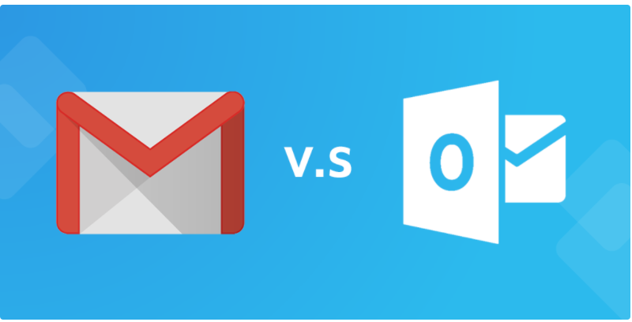
Diagram: Gmail vs. outlook Source: Patankar (2016)

History
Gmail | Outlook
Gmail was launched in 2004. Google launched a free, ads supported internet depended mail service for their clients called Gmail. Paul Buchheit was the first person who developed Gmail. At that time Gmail had only 100 mb storage in it. At present Gmail have over 900M active users all over the world (Buckner, 2018). | Outlook was launched by Microsoft in 2012. Outlook was previously named Hotmail which was the world’s first email service. In July, 31th, 2013 when Outlook’s beta version was made generalized, all the Hotmail users were able to upgrade their email services. Then get the Outlook email service for them. At present Outlook have about 400M active users all over the world (Buckner, 2018).

Features
In Gmail, the emails can be sorted out automatically keywords, senders, attachment names, file size. Gmail automatically sort out the read and unread messages. Gmail use stars and labels to highlight rather than using folders (Buckner, 2018). User can mark their email by different label according to their preferences. However, the extra benefit is Gmail can imply automatic label for finance and travel for their users. In Gmail, users can also create categories like labels (Prakash, 2018).
However, incase of Outlook, their filters or categories are called rules. To filter the messages, users have to create rule first. Some of the features of Outlook is like Gmail, however, they are as like as robust (Pratankar, 2016).
Search within inbox
Gmail provides opportunities for searching old emails as the write of new ones. When a user loses the previous messages and dates, Gmail help them to find out (Buckner, 2018).
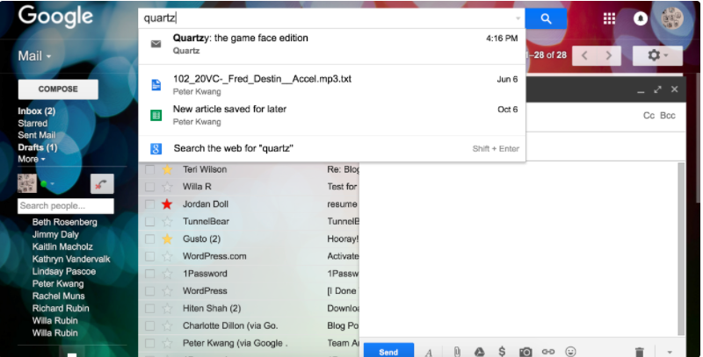

On the other hand, outlook new message process is cleaner. Thus, users face difficulties to find out the old messages within the new messages.
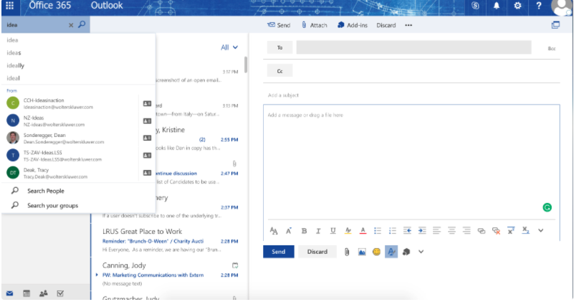

Interface
Outlook has stream like interface. However, in Gmail user can have different layouts. Gmail offers their user a tab viewed inbox which sorts out the messages like email, social messages from social media, messages of advertisement from the promotional site and auto generated email for online bills and transactions. The extra benefit is, if the users want they can turn these tabs off. In the Gmail, the messages are marked as done rather than read. The emails can also be snoozed for later (Buckner, 2018).
Outlook offers their users a basic three panel framework. In the left side of the user’s, the folders and categories are placed (Prakash, 2018). In the middle panel the user can see their email lists on the folders. Users have to click on the email list and select their desired email. Then in the third panel they can see their email opened. In comparison to Gmail, Outlook does not offer their user that many options in case of interface (Prakash, 2018).
User Experience

Text in Gmail is bigger than tax in Outlook. Gmail also offers higher opportunities of customization regarding unread emails.
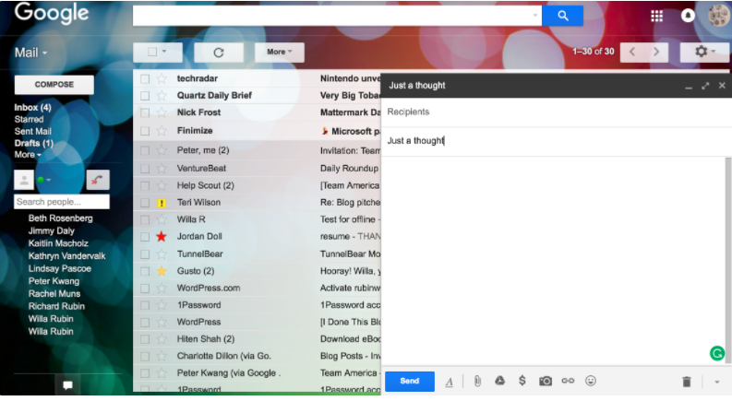
However, Outlook differentiates in color in sender and subject and making them bold, and make the text in smaller sizes (Buckner, 2018).
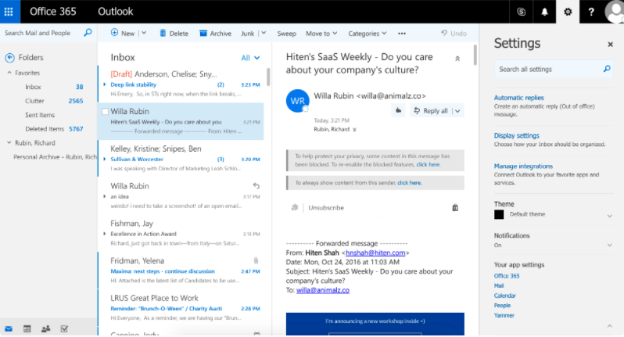

Ads
Advertisements in Gmail and Outlook do appear as same. In Gmail, ads appear as usual email beneath the promotional tab. Users can turn off their promotional app if they do not wish to see those ads (Prakash, 2018).
However, in case of Outlook, ads appear as full banner on the side of the users screen. The disadvantage is user have to pay about $20/year to turn off their ad option. Users cannot do it in free like Gmail (Buckner, 2018).

Calendar integration
In both case of Gmail and outlook, it is difficult for the users to view the calendars and email side-by-side (Patankar, 2016).
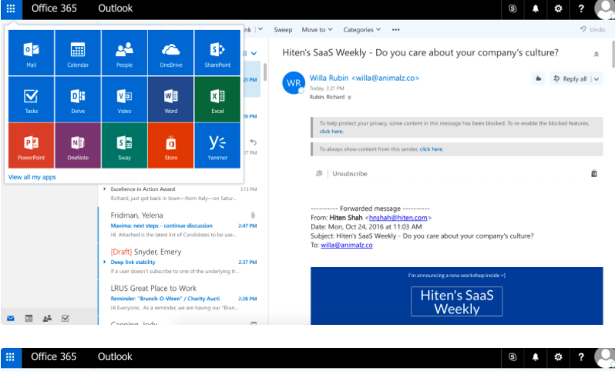

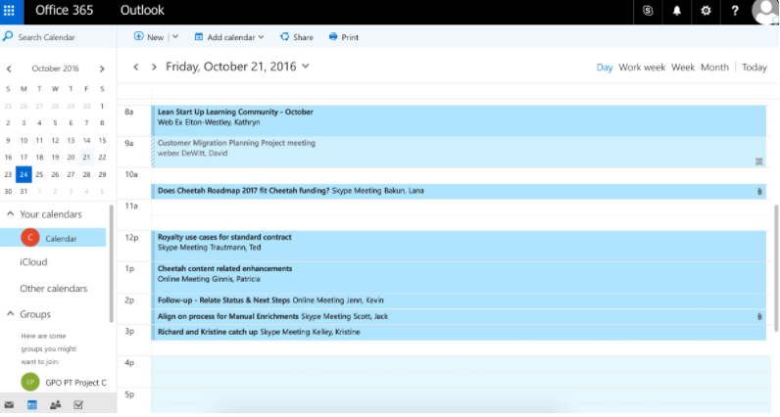

Differences between Outlook and Gmail

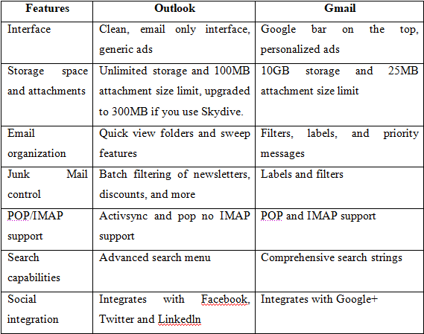
Table: Differences between Outlook and Gmail Source: Patankar (2016)

Smartphone (iPhone) and Tablet (iPad)
iPhone:
iPhone is one kind of Smartphone created by the company of Apple which joins a Tablet PC, iPod, a cellular phone and the digital camera. The device contains capabilities of networking and internet browsing. The iPhone contains 3.5-inch multi-touch screen which can be controls by users with two finger touches (Beal, 2016).
iPad:
iPad is the tablet computer established by Apple Company in 2010 firstly. Though few challenging models were accessible before, the iPad is mainly attributed with making recent market for tablets in 2012, above 100 million iPads were sold internationally. Some 71 million iPads were sold in 2013. Apple has 3 product lines of iPad: iPad Pro, iPad mini and iPad. All iPad models are accessible in gold, gray and silver colors. All the iPads run Apple's iOS operating system (Apple, 2017).
Compare and contrast between the features of iPhone and iPad:
There are a number of differences between an iPhone and iPad. It is easily seen that iPad is larger than the iPhone. However, both devices run the same operating system, IOS, and uses similar, if not identical, CPUs and GPUs.
The most obvious difference between an iPad and an iPhone is the iPad is expanding in small sizes such as the iPad Mini and the iPhone making it slightly larger with each successive generation. The size is very common difference in iPhone and iPad. iPad comparly bigger then iPhone. Two devices use different aspect ratio. The larger screen usually means there is a higher resolution than the iPad, but not always, which makes it difficult to change the size of some applications, the combination of resolution and aspect ratio means that the iPad's iPad app is running on a expanded out display or a black border surrounding the application display.
The main difference between the iPhone and the iPad is that the iPhone can be used to make phone calls over a cellular network, but the iPad cannot. Each iPhone is capable of transmitting information to the cellular network, where the iPad comes in two versions: one that can use cellular data and one that cannot do it. Some devices can make internet calls through the application, but the iPhone is actually a cellular phone that is only two.
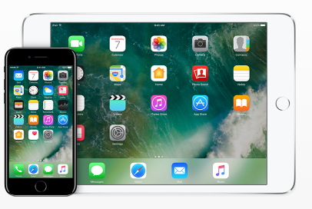
Image: iPhone vs. iPad Source: Apple (2016)
Features | iPhone | iPad
Size | iPhones have become smaller in size with every succeeding generation (Stone, 2016). | iPads are becoming into bigger sizes, such as, iPad mini.
Network | iPhone has 3G, 4G networking system. It also connects to the wifi networking system (Stone, 2016). | The iPad arrives in 2 different flavors in cases of connectivity or network. The iPad which is modern arrives with wifi network connection which permits a person to come into online utilizing hot spot (Stone, 2016). The version of wifi of iPad is not the expensive version and needs no monthly payment or data plan.
App design | The screen sizes are different from the iPad models. iPhone has 3G, 4G networking system. It also connects to the wifi networking system. The iPhone's size which is small creates it simple to function within one hand. | iPad needs higher resolution graphics. The iPad is all the time the two-hand device.
App compatibility | iPhone may only run applications particularly planned for iPhone devices (Stone, 2016). | The iPad may run any kinds of apps planned for iPad devices (Stone, 2016).
Phone calls | Every iPhone is capable to provide data more than cellular networks. | The iPad has in the two types of versions: one that may apply cellular data and one that cannot (Stone, 2016).

Part 2

Create my own account in Facebook, LinkendIn, and Twitter

My Facebook
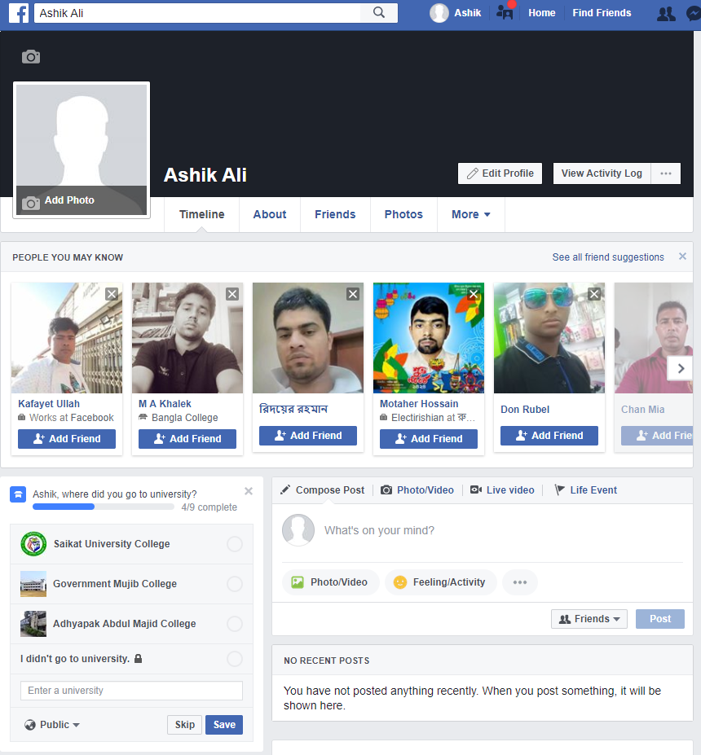
Ashik Ali
Image: My Facebook Page

My LinkedIn

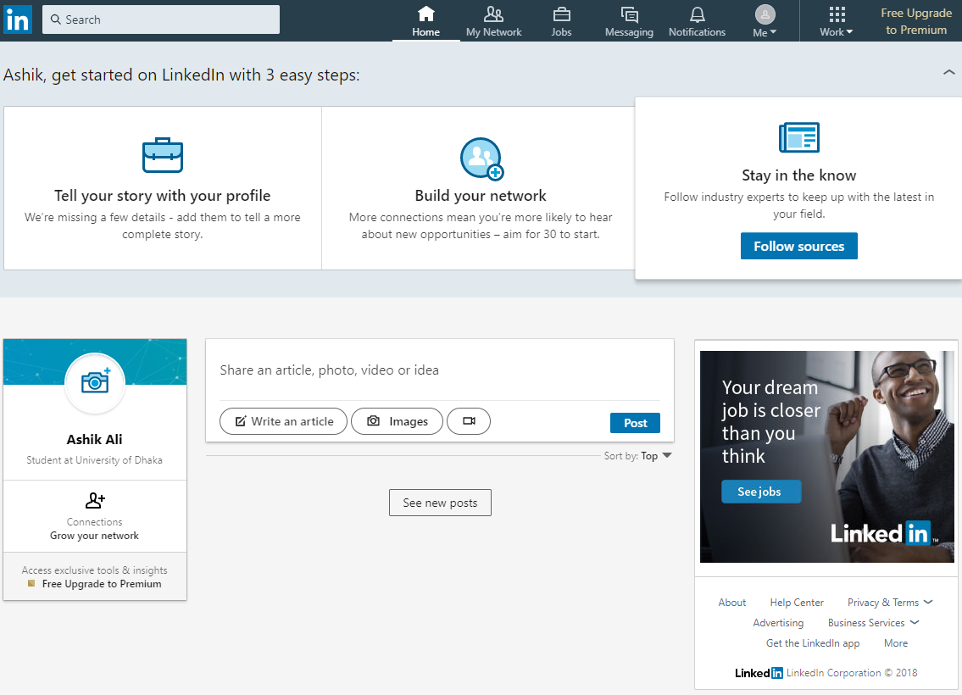
Image: My LinkedIn Page

My Twitter

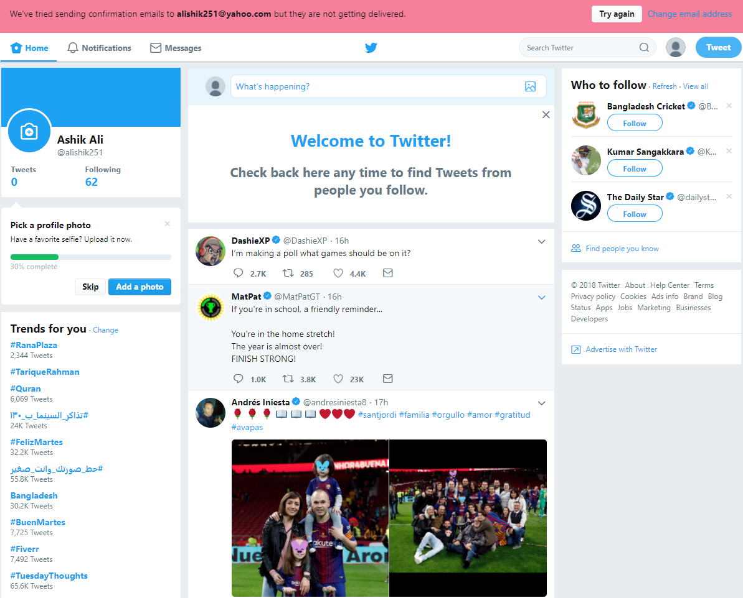
Image: My Twitter Page

B. Evaluate the possibilities for communication and collaboration in the workplace
The social media users increasing in Twitter, LinkedIn and Facebook in working place develop collaboration as well as communication among the staffs. The collaboration and communication possibility that are taken by workplace’s social media are described below:
Communication and collaboration: many staffs consider that they do not have talking chances. In addition, front line managers observe various problems to contact directly with top managers. But social media helping they may simply communicate with one another, they may begin concepts mutual exchange and this supports to raise staff involvement. This may be told that social media uses in business may reduce hierarchy of the business (Hall, 2016).
Productivity: Companies are more aware about their performances as well as productivity of the staffs. Research shows that social media uses in working place make opportunity to connect with staffs and managers that improve the productivity (Hall, 2016). In addition, social media makes opportunity to provide the knowledge and concepts and supports the staffs to operate multi-tasking works, maintaining of deadline and workload helpful balance (Robert, 2017).
Data Analyzing: As Hall (2016) noted that social media performs as the recruiting tool of the experienced and skilled staffs in different companies
Social Selling: The experienced, skilled and knowledgeable managers and staffs can promote their ability to an organization by different social networking. As Hall (2016) noted that any staff may discover his required job by social media. However, there are several demerits social media using in working places. Hacking is the greatest problem in using the social media. Organization can face different hacking activities, for example, spam, viruses, illegal access, fraud etc. The staffs and the organization should be very suspicious to post private information and any other information (Robert, 2017). Organization can observe different hacking activities, for example, spam, viruses, illegal access and fraud.

Concussion
This assignment evaluates various technologies uses and their function in working place which are useful in order to maximize the working activity and competence. The functions description of various web based two emails and the dissimilarity among them are explained in 1st task. Dissimilarity and similarity among tablets and smartphones and in workplace social media uses are explained. In the 2nd task, it describes Twitter, LinkedIn and Facebook social networking sites. Finally, terms of collaboration and communication in working places with managers and staffs the social network sites contributions are explained.

References

My Facebook Page (2018) My Facebook Page. Available at: https://www.facebook.com/profile.php?id=100025654087401. [Accessed on: 12 April 2018]
My LinkedIn Page (2018) My Facebook Page. Available at: https://www.linkedin.com/feed/?trk=onboarding-landing. [Accessed on: 12 April 2018]
My LinkedIn Page (2018) My Facebook Page. Available at: https://twitter.com/?request_context=signup. [Accessed on: 12 April 2018]
Apple (2016) Accessibility support for iPhone and iPad. Available at: https://support.apple.com/ja-jp/accessibility/iphone-ipad. [Accessed on: 18 August 2017]

Hall (2016) what collaboration tools are more effective in the workplace? Available at: https://www.interact-intranet.com/blog/what-collaboration-tools-are-the-most-effective-workplace-intranet/ [Accessed on: 24 April, 2018]
Robert (2017) The Value of Teamwork in the Workplace. Available at: https://www.roberthalf.com/blog/management-tips/the-value-of-teamwork-in-the-workplace [Accessed on: 24 April, 2018]
Beal (2016) iPhone. Available at: https://www.webopedia.com/TERM/I/iPhone.html [Accessed on: 24 April, 2018]
Apple (2017) iPad. Available at: https://searchmobilecomputing.techtarget.com/definition/iPad [Accessed on: 24 April, 2018]
Stone (2016) What Is the Difference Between an iPhone & an iPad? Available at: http://smallbusiness.chron.com/difference-between-iphone-ipad-72690.html [Accessed on: 24 April, 2018]

Prakash (2018) Marketers Terminologies: Gmail vs Outlook Vs Yahoo Mailbox. Available at: https://easysendy.com/blog/marketers-terminologies-gmail-vs-outlook-vs-yahoo-mailbox/ [Accessed on: 24 April, 2018]

Patankar (2016) Gmail vs. Outlook: 5 Game-Changing Differences. Available at: https://www.process.st/gmail-vs-outlook/ [Accessed on: 24 April, 2018]

Buckner (2018) Gmail vs Outlook.com: Which one is better? Available at: http://www.itpro.co.uk/email-providers/24794/gmail-vs-outlookcom-which-one-is-better [Accessed on: 24 April, 2018]

