
Component 2: Written Assessment
Problem Analysis and Solution Development
Level 4 Assessment Specification
Student name | Hamzah Hussain
Student ID number | 1914401
Programme | Applied Computing (Foundation)
Module | Analysing & Solving Problems
Module code | ACCA4019
Lecturer | Dr Abida Perveen
Internal Verifier | Sadhana Jha

Submission deadline: 26 March 2026, 2:00 PM

Table of Contents
1. Introduction 2
2. Problem Deconstruction 3
3. Proposed Solution 7
4. Reflection and Justification 11
5. Conclusion 12
6. References 13

List of Tables
Table 1: MoSCoW prioritisation for the classroom allocation problem 5
Table 2: Key variables used in the solution 6

List of Figures
Figure 1: MoSCoW prioritization (created by using Microsoft Word) 6
Figure 2: Key variables used for solution (created by using Microsoft Word) 7
Figure 3: Logical flow for optimising classroom allocation (created by using visual paradigm tool) 9

Introduction
Efficient classroom allocation is an important operational challenge for educational institutions, particularly when resources such as rooms, time slots, and teaching staff must be coordinated effectively [2]. Ineffective allocation may create the problem of overcrowded classes, idle facilities, and conflict in schedules causing needless transfers among students and employees [4]. The problems have an adverse impact on the quality of learning and the efficiency of an institution. This assessment examines the issue of classroom assignment in one of the local colleges through systematic problem solving strategies. The issue is analyzed by breaking it down into important requirements, constraints and variables. To this, it is then suggested that a logical solution be provided with a flowchart that will optimise the use of the classroom, reduce the time spent, and provide proper timetabling without scheduling conflicts.

Problem Deconstruction
The scenario can be treated as a resource-allocation problem in which classrooms, time slots, students, and staff movements interact as one system rather than as separate tasks. Computational thinking is useful here because it relies on abstraction and decomposition to manage complex tasks [1]. Systems thinking is also relevant because a change in one part of the timetable affects room occupancy, walking time, and lesson start punctuality elsewhere in the college [2].
At a high level, three operational goals must be satisfied. To start with, the classes must be put in a room that safely serves the anticipated number of students. Second, it ought to have consecutive sessions in order to minimize redundant movement within campus. Third, the schedule must not be crowded with any choice of rooms or personnel or showcase late starts. Timetabling the scheduling of education is generally considered to be a complicated optimisation problem that has numerous interconnected constraints, and it is commonly considered an NP-hard problem due to the size of the solution space [4], [5].
A MoSCoW analysis helps separate vital constraints from desirable features. In project terms, the method distinguishes Must Have, Should Have, Could Have, and Won't Have items, allowing the solution to focus on the minimum usable set first [3]. In this case room capacity, conflict-free schedule and valid lesson placement are Must Have requirements. Reduced walking distance is a Should Have requirement since the schedule would still be able to run without it, but the experience would be a low one. Using the latest rooms or the biggest ones exclusively, when it is not essential can be considered a Could Have rule, whereas such features as automated notifications to students or sophisticated analytics could be postponed as Won’t Have in the first version [3].
Table 1: MoSCoW prioritisation for the classroom allocation problem
Priority | Requirement | Reason
Must Have | Allocate each class to a room with sufficient capacity | Prevents overcrowding and safety issues.
Must Have | Ensure one room and one lesson do not clash | A timetable with conflicts is not usable.
Must Have | Ensure staff are not assigned to two lessons at the same time | Teacher availability is a hard constraint.
Should Have | Reduce walking time between consecutive classes | Improves punctuality and student experience.
Should Have | Prefer rooms that are close to the previous class | Cuts wasted movement and transition delays.
Could Have | Prefer the best-fitting room size | Improves space efficiency when feasible.
Could Have | Keep the same cohort in the same building block | Useful for comfort but not essential.
Won't Have | Advanced forecasting dashboards in the first version | Not necessary to deliver a workable timetable.

Figure 1: MoSCoW prioritization (created by using Microsoft Word)
The main variables can be grouped into inputs, decisions, and outputs. Class size (C), room capacity (R), room type or equipment, lecturer availability, lesson duration, available time slots and walking distance between rooms are the input variables [6], [10]. The decision variable is to be allocated to class i to room j at time t. Final timetable, utilisation rate of each room, the amount of conflicts identified and the total movement cost throughout the day are the output variables.
Table 2: Key variables used in the solution
Variable | Meaning | Use in the model
Class size | Number of enrolled students for a lesson | Used to test room capacity fit.
Room capacity | Maximum safe occupancy of a room | Used to exclude rooms that are too small.
Room features | Lab, projector, accessibility, or subject-specific needs | Used to ensure the room is suitable.
Time slot | A discrete period in the timetable | Used to check clashes and start times.
Teacher availability | Periods when the lecturer can teach | Used as a hard scheduling constraint.
Walking distance | Estimated distance between two rooms | Used to reduce movement time.
Allocation score | Composite score for a room-time option | Used to rank feasible assignments.
Conflict flag | Indicator of overlap or impossibility | Used to trigger backtracking.

Figure 2: Key variables used for solution (created by using Microsoft Word)

Proposed Solution
The proposed solution is a generic room-allocation procedure that can be applied manually or implemented in software. Greedy optimisation and validation and backtracking This logic is optimal due to the fact that the literature demonstrates that perfect methods may become computationally challenging with an increased timetable size [6], [7], [9]. The greedy approach is a workable approach in a college context, since it would be able to prioritize viable solutions in a short time and after that only refine them when there is a conflict [6].
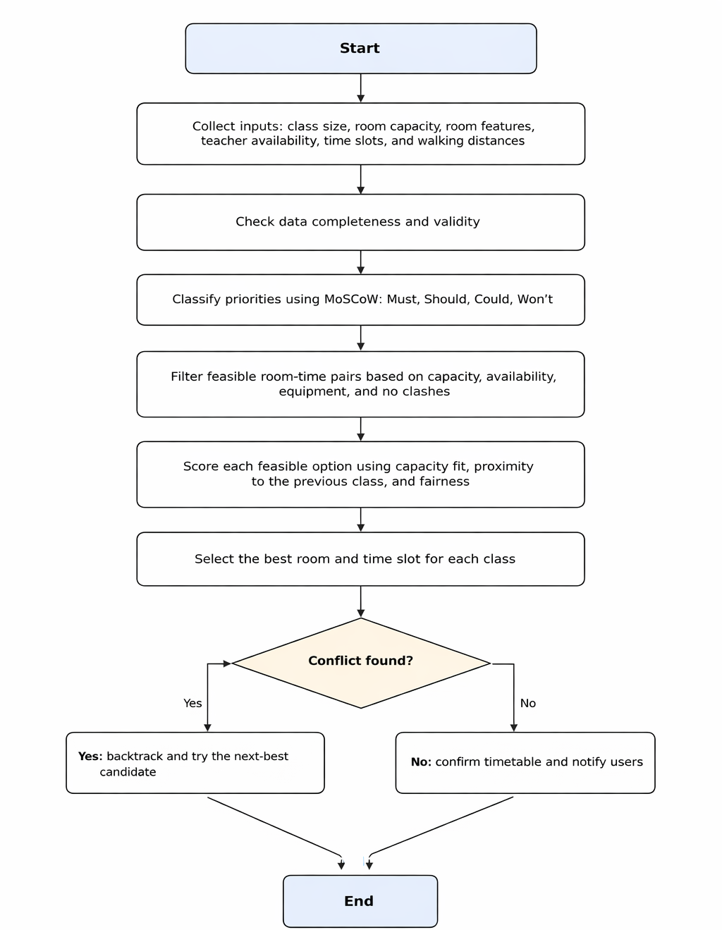
Figure 3: Logical flow for optimising classroom allocation (created by using visual paradigm tool)
The process begins with data collection. All classes, room capacities, equipment details, staff availability, and room-to-room walking distances are gathered into one shared dataset. The importance of having a centralised information base lies in the fact that quality timetabling is based on the fact that there is always an available data to all the stakeholders [8]. It is followed by checking of the data. Missing classes, wrong records of rooms, or unavailable time slot is corrected prior to allocation commences.
All classes are processed one after being validated. The class is then aligned with the MoSCoW priorities in order to safeguard the necessity of conditions before the soft preference is taken into account [3]. After that a viable set of candidates is obtained by eliminating all room-time pairs that violate a hard constraint: the room should be large enough, the room should be available, the lecturer should be available, and the time should not conflict with another lesson. This screening phase shows the conventional design of teaching schedules, in which the hard constraints are distinguished by the soft criteria of optimization [4], [5].
Once the feasible set has been created, each candidate room-time pair is given an allocation score. A simple scoring formula can be used:
$$Score = capacity fit + proximity score - conflict penalty$$
Capacity fit is a reward that gives a reward to a room with the size that is near the size of the class, as it enhances utilisation and results in underutilisation. The proximity score gives a reward to rooms that are close to the previous lesson, which will save on time of movement, and the staff and students can attend the next lesson on time. Conflict penalty ensures that the algorithm does not pick up any pair that will result in a clash or a breakage of an equipment requirement. The concept is backed with room-usage optimisation studies that indicate that the greedy selection and room-occupancy can be more effective than hand-made schedules but at the same time computationally-efficient [6].
The best-scoring feasible option is chosen for each class. Should the decision subsequently lead to a collision in the broader schedule, the algorithm reinvents and an attempt is made to use the next-best candidate. Such retrogressive action is necessary since what might seem a reasonable decision in a vacuum turns out to be a headache once the complete schedule is compiled. This is the reason why timetable construction is commonly handled more or less as a series of mini-manageable sub-purchases as opposed to a single big, unorganized job [7]. The strategy is also in line with automated scheduling systems which adopt a common database and pre-organized checking to assist the timetablers and end users [8].
The solution reduces movement time in two ways. First, it promotes back to back sessions of the same group or a lecturer to stay in adjoining rooms where feasible. Second, it has the ability to impose a cost on traveling between distant buildings and this compels the algorithm to a narrow timetable layout. It has been demonstrated in the literature that spatial arrangement is important in actual timetabling systems and optimisation may be employed to enhance room utilisation and other operational achievements like energy efficiency [10]. In a more general sense this indicates systems thinking: in this case a schedule is not merely a list of classes, but a set of decisions that relate to movement, utilisation and punctuality as a whole [2].
Accurate timetabling is ensured through hard checks at every stage. A lesson is not confirmed when the room is not available, the teacher is not available, the capacity is not enough and the allocated time slot is not shared. This resembles the very essence of timetabling literature where the aim is to optimize the soft constraints secondarily and prior to that, all hard constraints must be met [4], [5], [9]. A timetable officer can then revise the output and then is published, providing an additional human quality-check stage and minimizing the possibility of the introduction of latent errors.
Several assumptions are made. The first one is that the sizes of classes and the availability of teachers are known prior to the commencement of scheduling. The second assumption is that the walking distance and room capacities are documented correctly. The third assumption is that all lessons have a fixed amount of time and are allotted to a specific time slot. These are good assumptions when one speaks of a base-level solution, and they also outline the drawbacks of the approach. When the time periods of the teaching periods are scattered across, or rooms contain extremely specialised equipment, then a more sophisticated mixed-integer or meta-heuristic model must be considered [5], [9].

Reflection and Justification
The problem-solving approach was appropriate because it combined abstract thinking, decomposition, and prioritisation. The process of abstract thinking implied disregarding non-essential information and concentrating on the variables that are in control of the timetable outcome. The task was divided into smaller parts through decomposition: data validation, filtering in terms of feasibility, scoring, checking conflicts, and confirming the output [1]. This minimized the cognitive load and simplified the answer to explain, test and practice.
The MoSCoW technique strengthened the design by making it clear which requirements could not be compromised and which requirements could be improved later [3]. It comes in handy especially in real planning problems, in that at least a timetable will be usable even when not all the soft preferences have been met. The analysis of educational timetabling literature establishes that the practical systems are often based on several competing factors and not a single ideal objective [4], [6], [9].
The main justification for the selected algorithm is practicality. Precise optimisation schemes have the capability of generating very good schedules, though when the quantity of rooms, classes and constraints increase they become sluggish [5], [6]. A backtracking greedy first strategy provides a good tradeoff between quality and speed. It is thus appropriate to a local college which requires a stable solution as opposed to a very specific research model. Its limitations include the fact that it might not necessarily discover the optimal worldwide schedule and its excellence relies on the scoring equation and precision of the input data.
Overall, the solution is appropriate because it mirrors the structure of the real problem. It is not merely a problem of allotment of rooms but also a problem of the coordination of people,space and time within a single system. This is why systems thinking is useful in this case: it allows the designer to see the interdependence between room utilisation, time of movement and punctuality instead of taking them as independent factors [2]. The resultant approach is general, explainable, and can be customized in case the college ever adds new buildings, new types of rooms, or other schedule constraints.

Conclusion
In conclusion, the classroom allocation problem was deconstructed into manageable components, prioritised using MoSCoW, and addressed with a logical allocation flowchart. The proposed solution enhances better room utilization, speed of movement, and avoids scheduling conflicts by filtering only viable choice and ranking them against soft preferences and retracting the choice in case of a conflict. This renders the approach appropriate to be a foundation-level solution, but still to be based on established literature in the field of timetabling and systems-thinking.

References
[1] J. M. Wing, "Computational thinking and thinking about computing," Philos. Trans. R. Soc. A, vol. 366, no. 1881, pp. 3717-3725, Jul. 2008.
[2] D. H. Meadows, Thinking in Systems: A Primer. White River Junction, VT, USA: Chelsea Green Publishing, 2008.
[3] Agile Business Consortium, "MoSCoW prioritisation," DSDM Project Framework Handbook. [Online]. Available: https://www.agilebusiness.org/dsdm-project-framework/moscow-prioritisation.html. Accessed: Mar. 19, 2026.
[4] S. Ceschia, L. Di Gaspero, and A. Schaerf, "Educational timetabling: Problems, benchmarks, and state-of-the-art results," Eur. J. Oper. Res., vol. 308, no. 1, pp. 1-18, Jul. 2023.
[5] S. Abdipoor, R. Yaakob, S. L. Goh, and S. Abdullah, "Meta-heuristic approaches for the University Course Timetabling Problem," Intell. Syst. Appl., vol. 19, Sep. 2023, Art. no. 200253.
[6] A. Lemos, F. S. Melo, P. T. Monteiro, and I. Lynce, "Room usage optimization in timetabling: A case study at Universidade de Lisboa," Oper. Res. Perspect., vol. 6, 2019, Art. no. 100092.
[7] M. W. Carter, "A comprehensive course timetabling and student scheduling system at the University of Waterloo," in Practice and Theory of Automated Timetabling III (PATAT 2000), LNCS 2079, pp. 64-82, 2001.
[8] M. Dimopoulou and P. Miliotis, "An automated university course timetabling system developed in a distributed environment: A case study," Eur. J. Oper. Res., vol. 153, no. 1, pp. 136-147, Feb. 2004.
[9] C. B. Mallari, J. L. San Juan, and R. Li, "The university coursework timetabling problem: An optimization approach to synchronizing course calendars," Comput. Ind. Eng., vol. 184, Oct. 2023, Art. no. 109561.
[10] Y. Liu, H. Ming, X. Luo, L. Hu, and Y. Sun, "Timetabling optimization of classrooms and self-study rooms in university teaching buildings based on the building controls virtual test bed platform considering energy efficiency," Build. Simul., vol. 16, pp. 263-277, Feb. 2023.

