Costel Iosip (2022687)

BA Business Management
LCBB4004
Assessment 2
Marketing Fundamentals
Analysis and Evaluation

Covid 19 Pandemic and its Impacts on British Airways

10.01.2022

Introduction

A novel coronavirus (COVID-19) outbreak spread across multiple countries at the start of the new decade, prompting some countries to seal their borders. An extensive set of limitations and regulations was implemented in an effort to slow the spread of the virus, which was followed by the introduction of more restrictions and rules restricting people's freedom of movement.Because of travel restrictions and a drop in demand, the COVID-19 pandemic has had a substantial impact on the aviation business.
Significant decreases in passenger numbers have resulted in flight cancellations or planes flying empty between airports, resulting in dramatically reduced income for airlines and forcing several to lay off personnel or declare bankruptcy. To mitigate their losses, some have sought to avoid refunding cancelled visits. Employees from airline manufacturers and airport operators have also been laid off.
Due to the severe decline in demand for passenger air transportation (and freight air transportation, to a lesser extent) caused by the COVID-19 epidemic and containment efforts, many businesses in both the air transportation sector and the rest of the aviation industry are experiencing financial difficulties, putting many jobs at risk.
While the aviation sector has frequently been the focus of government measures, the COVID-19 crisis has resulted in a new set of loans, loan guarantees, wage subsidies, and equity injections, raising worries about competition and the effective use of public resources. It is just a small fraction of the total value-added of the OECD countries' air transport business (passenger and freight). The significant inter-industry ties it has with both upstream and downstream sectors, however, make it a necessary component of the economy.
In the wake of the COVID-19 crisis, travel limitations, and the resulting economic crisis, passenger behaviour has changed significantly.... Based on data from the International Air Travel Association (IATA), passenger air transport was down 90 percent year on year in April 2020 and remained down 75 percent until August of the same year. The slowdown in economic activity and trade had an impact on freight, which was roughly 30 percent lower year over year in April and remained around 12 percent lower in August as a result of the slowdown.
Although a significant portion of airline costs is variable (approximately 50 percent, according to the International Air Transport Association, with fuel accounting for 25 percent of total costs), the magnitude of the shock has put a strain on the liquidity buffers of airline companies, despite the fact that airlines' operating costs have decreased recently as a result of the drop in oil prices.
Airlines confront two problems in the medium term: the first is the need to reduce costs. Cost of medical treatments is one of the most significant expenses. Additional health and safety rules (e.g., disinfection, personal protective equipment (PPE), temperature checks, or virus testing) are expected to raise operating costs for airlines and airports in the short term, before being passed on to customers in the longer term. Also of note, when social distancing tactics are used to air travel, they may result in a 50% decrease in the passenger load factor (the number of seats that can be occupied during a trip).
-An investigation of how commercial aviation can be revitalised in the next years Even if many governments ease lockdowns and internal travel restrictions, international travel restrictions, economic contraction, and changes in transportation behaviour on the part of cautious customers may prevent a restoration to pre-crisis levels of demand for transportation. There has been a sluggish recovery in commercial aviation traffic; as of September 2020, there were more than 40% fewer flights worldwide than there were before the crisis started. This masks discrepancies in trip duration: the decline is much greater for long-distance flights than for short-haul flights. Changes in consumer behaviour may, in the long run, result in structural changes in demand for air transportation.

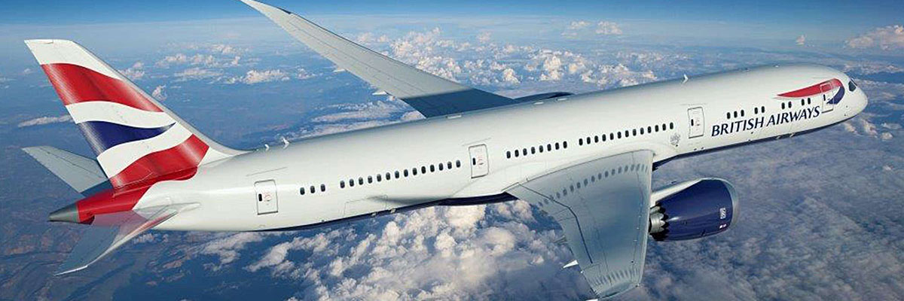

Fig 1 : British Airways
Source : https://www.britishairways.com/

British Airways

Four companies came together to become British Airways in 1974. It is now controlled by the International Airlines Group (IAG). Heathrow Airport serves as the airline's primary hub, and its headquarters are in London. 254 aircraft make to the airline's total fleet of 254. BA is the second-largest airline in the United Kingdom based on the size of its fleet and the number of passengers it carries. BAA flies to more than 160 domestic and international locations (which lie across 70 countries).
British Airways was a state-owned corporation until 1987, when it was privatised by the then Conservative government. There is a vast list of achievements for the airline, which includes being a founding member of the Oneworld airline alliance, which operates around the globe. In addition, it created history in 2018 by being the first passenger airline to generate $1 billion in revenue on a single air route in a single year, a feat that was previously accomplished only by United Airlines.
In its advertising, the airline refers to itself as "The World's Favorite Airline," implying that it is highly regarded. This tagline was retired by American Airlines in 2001, although the company has continued to use a variety of variations on it since then. A few examples are "We'll Take Better Care of You," "The World's Best Airline," and "Fly The Flag," among others.
Among the first to be grounded once the coronavirus made its appearance were planes, particularly international ones. The upshot of this has been a huge decrease in revenue for all airlines, including British Airways. Apart from limiting travel, airlines are now need to follow a range of COVID-19-related Standard Operating Procedures (SOP) in order to keep their operations running smoothly. People will only travel with airlines that they feel are safe, according to their own personal safety standards. It is possible that regulatory authorities may shut down your company if it does not adhere to SOPs.
Many individuals have shied away from international and even local travel because of the uncertainty associated with it. Events that traditionally demanded your physical presence are now handled via internet channels, and the widespread usage of these channels is further reducing distances between participants. The real issue is whether people will continue to travel for all of the same reasons they did prior to the termination of COVID. Will they take into consideration the fact that employing an internet-based platform such as Zoom, a great deal may be accomplished? Furthermore, when the coronavirus will be eradicated remains a major unanswered issue.

Impact of the coronavirus pandemic on the British Airways

Staff Cut
Because of the coronavirus epidemic, there has been a significant drop in international travel. As a result, British Airways expects to lay off up to 12,000 people, or more than a quarter of its staff. James Sillars (James Sillars, 2020)
As the airline looked to the future beyond the COVID-19 epidemic and the grounding of the vast majority of its aircraft, the airline's parent company, IAG, announced a restructuring and redundancy scheme that would primarily affect BA and was being pushed through trade unions at the same time as the announcement.
According to the company, it suffered operating losses of €535 million in the first quarter of the year, with the vast bulk of these losses due to BA.
IAG expects the situation to deteriorate further in the current second quarter.
The following was said in the statement: "British Airways is officially notifying its trade unions about a planned restructuring and redundancy programme in light of the effect of COVID-19 on current operations and the anticipation that passenger demand would not recover to 2019 levels for many years."
However, although the ideas are still subject to public comment, it is likely that they will impact the vast majority of British Airways employees, with up to 12,000 of them potentially facing redundancy.
When it came to fighting for jobs, the Balpa pilots' union stated it would do all in its power, while Unite claimed it was a "heartless option" at a time when the nation was in danger.
Rivals are requesting support from the government in order to remain in the air when the flight freeze is ended.

Cancel flights
Because of lower demand as a consequence of the pandemic, British Airways has reduced the number of flights it operates during the winter season by nearly 2,000.
Flights to both local and long-distance destinations have been cancelled by the airline as fast changing laws continue to generate concern among travellers throughout the globe.
This suggests that the cuts were made prior to the introduction of an Omicron variation and the restoration of DNA testing for this variant.
According to the website Simple Flying, a total of 2,144 flights have been axed from British Airways' winter schedule, with more than half of those flights booked for the month of January.

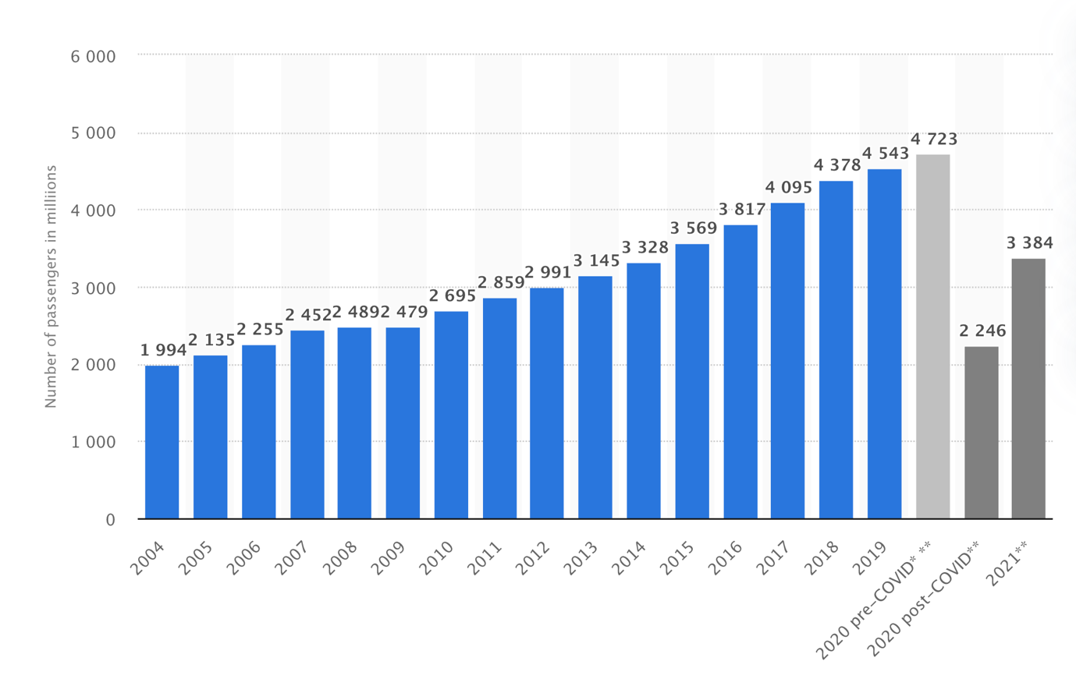
Fig 2: Number of passagers in millions

Loss money
The airline division, which also comprises Iberia, Vueling, and Aer Lingus, recorded a pre-tax loss of £6 billion in 2020, the company's worst performance in 10 years. This is an increase from the £1.48 billion profit recorded a year earlier.
The outbreak destroyed the airline's economic model, which is based on long-haul flights and corporate customers paying business class rates, resulting in a 69 percent decline in revenue last year, from £22.2 billion to £6.8 billion.
According to British Airways CEO Sean Doyle, the airline industry may never be able to go beyond the Coronavirus crisis until the problem of passengers being able to travel again is resolved.
According to SchengenVisaInfo.com, British Airways' CEO outlined the current threat to the aviation sector and the steps that should be taken to assist the company in recovering from the Coronavirus outbreak.
"We must work on a testing pilot in order to launch flights between London and New York, which is typically one of the busiest airline routes in the world.
"We used to fly up to 12 times a day to New York, but now we barely go twice a day, with less than 200 passengers on most days," he stated.
The Coronavirus pandemic's propagation has had a severe effect on the aviation industry. The business is always on the lookout for novel strategies to address the damage caused by the COVID-19 outbreak.
"We must work on a testing pilot in order to launch flights between London and New York, which is typically one of the busiest airline routes in the world.
"We used to fly up to 12 times a day to New York, but now we barely go twice a day, with less than 200 passengers on most days," he stated.
It's tough to overstate the COVID-19 outbreak's effect on airlines. The industry's revenue is predicted to reach $328 billion in 2020, a 40% increase over the previous year. That is the same as it was in nominal terms in 2000. For the foreseeable future, the sector is expected to remain smaller; we do not anticipate traffic to reach 2019 levels until 2024.

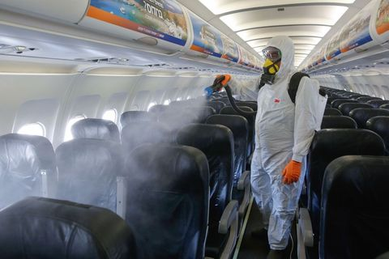

Fig3: Inside BA plane
Source; https://www.aircraft.cleaning/aircraft-disinfection/

Out of worry for short-term financial implications, the pandemic's long-term consequences for aviation are starting to surface. Some of the difficulties are self-evident: the criteria for cleanliness and safety will be strengthened, and the travel experience will continue to be modified as a result of technological advancements. In mobile apps, travellers' immunisation certificates and COVID-19 test results will be kept for future reference.
Others, on the other hand, are more substantial in their consequences. COVID-19 has irreparably altered consumer behavior—as well as the airline industry—in contrast to the global financial crisis of 2008, which was primarily economic in nature and resulted in lower purchasing power for consumers.
The pandemic has resulted in five significant changes in the aviation industry, which will be examined in further detail later in this article. With respect to each of these modifications, we present a call to action. Carriers will be better equipped to look past the pandemic and adapt to the long-term reality of COVID-19 if they react forcefully to the changes that are being implemented now.

Vacations for recreation will assist in the recovery process.
After a protracted recovery period, business travel will only be back to around 80% of its pre-pandemic levels by 2024, according to our predictions, even after that period. As a consequence of the pandemic, people will be less inclined to travel for business, and remote work and other flexible working opportunities will likely continue to exist to some level.

Businesses, both in business class and those that purchase economy tickets the day before they need to travel, are a major source of revenue for certain airlines. In spite of the fact that leisure travellers account for the vast majority of airline seats and contribute to a fraction of fixed expenditures, their overall financial contributions are negligible, if not negative, when measured in net marginal terms. An extremely small percentage of high-yielding customers who travel regularly for business are responsible for the vast bulk of the revenue generated by a long-distance flight journey. The pandemic, on the other hand, has decreased the number of travellers who travel for profit.

The economics of flying should be reviewed, according to the proposal.

Six problem-solving mindsets for a world that is always changing
It is necessary for airlines to reassess their business strategies, especially in the case of long-haul flights. As a starting point, a decreased contribution from business traffic may need a more aggressive pricing plan. For example, most airlines now charge a surcharge for nonstop flights from point A to point B. These nonstop flights are particularly popular with business travellers who place a high value on time above money. Leisure travellers, particularly those travelling in first class, are more cost aware and may choose for a more roundabout route in order to save money. It is possible that a price bridge will be required to bridge the significant price gap between nonstop and connect prices.

Second, lower business traffic may need the reconfiguration of network infrastructure. Using small-size widebodies like as the Boeing 787, airlines have boosted the number of flights between their hubs and smaller destinations in recent years. These flights are lucrative as a result of the high-yielding business demand that exists. Smaller aircraft flying more often are preferred to bigger aircraft flying less frequently when business demand is low, since they are more cost-effective in the long run. It is possible that the backbone of the long-haul network will be made up of larger aircraft such as Airbus A350s or Boeing 777s, which have lower unit costs than smaller aircraft.
For the third time, in order to accommodate an increasing proportion of leisure travel, airlines may explore reorganising the layout of their aircraft cabins. At the most fundamental level, a decline in demand for business-class rooms may compel the use of smaller facilities. Additional changes may be made to products to make them more appealing to premium-leisure travellers, such as the expansion of premium-economy cabins or the introduction of business-class seats that are more suitable for couples or groups travelling together.
As debt levels climb, ticket prices will rise in tandem, and the government will play a more important role in the business.
As a result, numerous airlines have had to borrow vast amounts of money in order to remain viable and cope with huge daily cash burn rates. By leveraging government assistance, credit lines, and bond issuances, the business amassed more than $180 billion in debt in 20201, accounting for more than half of the industry's annual sales income. The national debt, however, continues to climb. Poor credit ratings, as well as higher financing costs, make it even more difficult to pay back these loans on time.
The following is the recommendation: In terms of information technology and digital investment, set greater goals.
It is possible that getting healthy will need a financial investment. However, despite the fact that many airlines are having financial problems, we recommend that airlines invest more in information technology and digitalization. Preceding the pandemic, airlines spent around 5% of their total revenue on information technology services. When compared to other industries, this is a low amount to mention. For example, the retail industry spends around 6 percent on average, but the financial services industry spends 10 percent.
It is possible that the aircraft market will be oversupplied for a period of time.
During the years preceding up to COVID-19, aircraft manufacturers boosted production as a result of the anticipation that demand would continue. As a consequence, there is an excess of aircraft available for purchase. A further point to mention is that a number of airlines, like Norwegian Air Shuttle, have returned relatively new aircraft to lessors after abandoning the long-distance market. Prices for used aircraft leasing have fallen and are projected to continue to reduce in the near future. For a Boeing 777-300ER aircraft that was first delivered in 2016, the monthly lease fee was around $1.2 million in 2019. By 2020, the rate is predicted to have decreased to less than $800,000 per year. New aircraft are said to come on the market, at costs much lower than before.
He advised returning freighters to do so with prudence.
Carriers should consider short- to medium-term opportunities to grow their cargo services in response to the present high demand for air freight and limited supply of available capacity. In order to increase their flexibility, airlines might increase the number of so-called preighters (passenger aircraft that also carry freight). Airlines may pursue freighter conversions in the future, especially if the number of people on board their aircraft fleets reduces significantly.
Airlines must be able to adjust to changing conditions. It is risky to hurry into the establishment and maintenance of a large freighter fleet, as has been shown before. It is necessary for airlines to design cargo in a flexible way that allows for quick alterations; adopting such a strategy may be seen as part of a bigger theme of developing a more flexible manufacturing setup. High fixed expenses, combined with unpredictable high demand levels that are outside the control of an airline, make it even more critical for airlines to be able to cut supply as rapidly as possible.

Conclusion

The COVID-19 epidemic has had a significant impact, but it is far from over. Now that vaccinations have started to be administered, there is some relief in certain parts of the globe, but the road to recovery for air travel will take years. The airline sector is beginning to take shape in the wake of COVID-19, and there are lessons to be learned for airlines operating today. There has been an acceleration of certain long-term trends, such as digitization and the phasing out of less efficient aircraft. Many airlines have depleted their financial reserves as a result of their debt obligations. However, there are some rays of hope in the weather forecast. People are wanting to travel for holidays once again as travel becomes more environmentally friendly and effective. Airlines will be able to thrive in this new environment provided they respond swiftly and effectively today.

Reference List

AGCS Global. (n.d.). Aviation trends post Covid-19 | AGCS. [online] Available at: https://www.agcs.allianz.com/news-and-insights/reports/aviation-trends-post-covid-19.html.
Bouwer, J., Saxon, S. and Wittkamp, N. (2021). Five profound shifts in the post-pandemic aviation sector | McKinsey. [online] www.mckinsey.com. Available at: https://www.mckinsey.com/industries/travel-logistics-and-infrastructure/our-insights/back-to-the-future-airline-sector-poised-for-change-post-covid-19
cycles, T. text provides general information S. assumes no liability for the information given being complete or correct D. to varying update and Text, S.C.D.M. up-to-Date D.T.R. in the (n.d.). Topic: Coronavirus: impact on the aviation industry worldwide. [online] www.statista.com. Available at: https://www.statista.com/topics/6178/coronavirus-impact-on-the-aviation-industry-worldwide/.
IATA (2020). The impact of COVID-19 on aviation | Airlines. [online] airlines.iata.org. Available at: https://airlines.iata.org/news/the-impact-of-covid-19-on-aviation.
ICAO (2020). Effects of Novel Coronavirus (COVID-19) on Civil Aviation: Economic Impact Analysis. [online] Available at: https://www.icao.int/sustainability/Documents/COVID-19/ICAO_Coronavirus_Econ_Impact.pdf
International Airport Review. (2020). COVID-19: Aviation industry latest news and analysis. [online] Available at: https://www.internationalairportreview.com/topic_hub/covid-19/.
ICAO (2021). Economic Impacts of COVID-19 on Civil Aviation. [online] www.icao.int. Available at: https://www.icao.int/sustainability/Pages/Economic-Impacts-of-COVID-19.aspx.
Wikipedia. (2020). Impact of the COVID-19 pandemic on aviation. [online] Available at: https://en.wikipedia.org/wiki/Impact_of_the_COVID-19_pandemic_on_aviation.
www.eurocontrol.int. (n.d.). COVID-19 impact on the European air traffic network. [online] Available at: https://www.eurocontrol.int/covid19.

