Table of Contents
Chapter Two – Literature Review 3
2.1 Introduction 3
2.2 History of Drink Spiking 4
2.3 The Night-Time Economy and Binge Drinking in the UK 5
2.4 Spiking Crimes in the Media 8
2.5 Risk and Safety in the Night-time economy 12
2.6 Moral Panics and Urban Legends 15
2.7 Conclusion 18
Chapter 3 Methodology 18
3.1 Introduction 18
3.2 Aims and Objectives 18
3.3 Research Philosophy 19
3.4 Research Design 21
Secondary Data 21
Primary data 22
3.4 Sample 23
3.5 Data Analysis Method 24
3.6 Validity and Reliability 24
3.7 Conclusion 25
Chapter Four – Results and Data Analysis 26
4.1 Introduction 26
4.2 Participant Demographic 26
4.3 Understanding Spiking 30
4.4 Media Influence 35
4.5 Safety and Risk 40
4.6 Conclusion 43
Chapter 5 – Conclusions and Recommendations 43
5.1 Introduction 43
5.2 Summary of Primary and Secondary Data Findings 44
5.3 Investigate How Online Newspapers as a Media Source Perceive Risk and Drink Spiking 44
5.4 Explore Women’s Views on the Night-Time Economy in Comparison to Media Perceptions 45
5.5 Investigate Whether Online Media has Made Women More Aware of the Dangers of the Night-Time Economy 46
5.6 To Explore if there is a Direct Comparison Between Online Newspaper Articles and Crime Rate Statistics or if Media Perceptions Online are Creating Moral Panics 46
5.7 Recommendations 46
5.8 Final Thoughts 47
Reference list 49
Appendix 56
Appendix 1 – Online survey 56
Appendix 2 – Graphs from data analysis 61
Appendix 3 – Data analysis word clouds 66
Appendix 4 – Question five survey answers 70
Appendix 5 – Question nine survey answers 73
Appendix 6 – Question ten survey answers 75
Appendix 7 – Question twelve survey answers 76
Appendix 8 – Question thirteen survey answers 79
Appendix 9- Question fifteen survey answers 81
Appendix 10 – Question seventeen survey answers 83
Appendix 11 – News articles produced between May 2021 and August 2021 85
Appendix 12 – News articles produced between September 2021 and December 2021 86

Chapter Two – Literature Review

2.1 Introduction

The main purpose of this chapter is to critically analyse available literature relating to the main issues surrounding spiking crimes and how they are portrayed within the media. The literature review both evaluates and reviews relevant, textbooks, academic journals, government publications, articles and research papers. This review will critically analyse and evaluate available evidence as well as criminological theories that underpin the primary research of this study.

The literature review will give specific consideration to spiking crimes in current UK law, the night-time economy and binge drinking, how spiking crimes are portrayed within the media, and moral panics and urban legends as criminology theories. This is done as the research aims to understand if there is a correlation between media portrayal of drink spiking and how society views this type of crime.

Objectives

The subheadings of this chapter are based off the objectives of the dissertation, this is to provide clarity and direction to the literature review. It also serves as a reminder as to what the research objectives are, so that is where the focus of the literature review should be.

- Investigate how newspapers as a media source perceive drink spiking.
- Explore women’s views on the night-time economy and drink spiking in comparison to media perceptions.
- Investigate whether the media has made women more aware of the dangers of the night-time economy for example drink spiking, spiking, sexual assault, violent assault, and drug facilitated sexual assault.
- To explore if there is a direct comparison between media articles and drink spiking crime rate statistics, or if the media perceptions are creating a “moral panic”.

2.2 History of Drink Spiking

To understand spiking as crime it is first important to understand it from a historical context, as overtime spiking has evolved and changed meaning within society. Spiking refers to the covert administration of a drug to alter another person’s consciousness, this is not a new phenomenon. The first historical case recorded was in 1903 in the form of knock out drops or as it was referred to the “Mickey Finn”, spiking was first originally a crime against men for the purpose of robbery (Wells and Phillips, 2009).

In more modern times drink spiking or spiking crimes have taken a dark turn, as drugs such as GBH and Ketamine are being used to spike individuals for different means other than to steal personal belongings. Both GBH and Ketamine as well as Roofies or flunitrazepam are now labelled as “date rape drugs”, used to overpower women in order to gain some form of sexual pleasure from using drugs to overpower an individual (Donovan, 2016). This is where the pervious history has been lost, spiking crimes have now become associated with date rape and no other form of crime. The crime of using a date rape drug is labelled as a crime against women, and to label the whole of spiking crime as a crime specifically as women and as a crime that facilitates rape and sexual assault is to ignore other motives for spiking individuals such as pranking individuals or the historical use of robbing individuals (Ramadan et al., 2013).

Spiking crimes under UK law have previously been classified under the Sexual Offences Act 2003 under Section 61, under this act it makes it a criminal offence for anyone to administer a substance to be taken by another individual where that individual does not consent to taking the substance. The individual administering the substance has to intend to stupefy or overpower the individual, in order to engage in sexual activity. This act was to cover date rape drugs and the substance could be administered in any way such as in an individual’s drink or by an injection (UK Government Legislation, 2022b). This clearly only covered offences of a sexual nature if the individual had been spiked any other crimes that had happened as a result were not covered under this legislation. Recent changes have been made as the UK has seen an increase in spiking crimes, this happened as the UK came out of a national lockdown due to the global coronavirus pandemic. Priti Patel Home Sectary of the UK announced that changes would be coming to include other forms of spiking crimes under the Police, Crime, Sentencing and Courts Act 2022 (Shipman, 2022).

Spiking crimes can include needle injection, slipping something into an individual’s drink or giving a person a drink that contained more alcohol in their drink than they asked for. This is what the new act hopes to address as well as the other crimes that can occur after an individual has been spiked (UK Parliament, 2022). The new Police, Crime, Sentencing and Courts Act 2022 outline spiking under Administering a Substance with Intent to Cause Harm. Under this new act it makes it a criminal offence for an individual to intentionally administer a substance or cause a substance to be taken by an individual, without the consent of that individual and with the intent to cause harm regardless of if it is a criminal offence to that individual (UK Government Legislation, 2022a).

The new legislation lays out the criminal law in simple terms, but it was only put in place in April 2022 meaning that it is still new and it is yet to see if the new legislation covers all forms of spiking and the harms caused by it effectively and if individuals understand that there is a new criminal offence that can be put in place if and individual is a victim of spiking.

2.3 The Night-Time Economy and Binge Drinking in the UK

The night-time economy in the UK breeds a space for crime and disorder to take place, this is where spiking crimes and crimes of date rape are taking place (Burrell and Erol, 2009). The night-time economy is described by the Welsh Government (2020) as economic activity that occurs between the hours of 6pm to 6am. The night-time economy is seen as a valuable asset to Wales as it produces a high amount of revenue, creates jobs and provides an environment for individuals to socialise, all of which is seen as a positive. The growth of the night-time economy however is becoming more associated with anti-social behaviour, criminal activity, substance misuse as well as an increase in individuals drinking to excess which has become classified as binge drinking (Hadfield, Lister and Traynor, 2009).

Binge drinking is seen as drinking heavily over a short period of time or drinking alcohol for the purpose of getting drunk. The more academic definitions are drinking more than eight units of alcohol in a single session for a man, that would be four pints of normal beer. For a woman drinking more than six units of alcohol in a single session, this equates to three pints of normal beer (Courtney and Polich, 2009). It is believed that drinking more than this amount of alcohol makes individuals more vulnerable and more at risk of harm. Binge drinking habits in the UK have transformed how individuals view crime when drunk and how spiking is viewed. In wider public debate drink spiking and spiking crimes have been classified by some as an urban myth and labelled as more of a story to tell individuals to be careful when drinking to excess rather than seen as an actual crime issue (Measham and Brain, 2005). Both police and forensic scientists have also dismissed the idea of drink spiking as an excuse to hide the undesirable behaviour that comes when individuals binge drink, they see spiking as an excuse for individuals who have had too much to drink and have carried out behaviour that is undesirable (Taylor, Prichard and Charltorn, 2004).

Scheufele and Tewksbury (2007) outline that these popular perceptions of drink spiking and binge drinking are more often than not shaped by the mass media, and how they portray the drinking culture of the UK. This is why it is of importance to anchorage acknowledge that the media portrays women’s and men’s binge drinking behaviours as two completely different things and this is also very stereotyped. The media portray men’s binge drinking as normal behaviour but women’s is problematised, women’s drinking is also seen to be the cause of crime within the night-time economy (Patterson et al., 2016).

This view of women being the cause of crime within the night-time economy does not discount that men do commit criminal acts when in drunken states. It acknowledges that men are violent, and this is how they are framed by the media. The view sees the cause of men’s violent behaviour as simply drunken women in the night-time economy, this means responsibility lies with the drunken women for men’s violent behaviour. As they are seen to be in male dominated areas and acting as sexual predators, and as a result making the men act in a violent manner (Day, Gough and McFadden, 2004). There are policies that have been put in place to try and stop the culture of binge drinking. These policies have come at a cost to women as they have been aimed mainly at women, and they represent women as being at risk from male aggression. These polices have produced a stigma that women’s binge drinking issues are the cause for male violence within the night-time economy. The media want women the be the cause of the violent behaviour but also the victims of aggression from men (Wood et al., 2014). This viewpoint fails to see that men can be victims of violence in the night-time economy and also the cause of the violence themselves.

Binge drinking can be perceived to be an issue for young people, this is a common stereotype in the media, but is a common misconception as binge drinking can and is a problem that can span many age groups and all genders (Stanesby et al., 2019). As a Drinkaware (2021) spotlight indicated that those who are high risk drinkers are most commonly aged between thirty five to fifty four as 41% percent were identified and only 27% of individuals aged between eighteen to thirty four were identified as being high risk showing binge drinking being an issue for all ages who can access alcohol.

The way in which the media portrays and focuses on drink spiking may have unintended consequences, as playing into harmful stereotypes and portraying women who choose to drink as overly sexual, overly emotional and both the victim and the reason for violence in the night-time economy is harming victims’ experiences (Staddon, 2015). It actively encourages victims to be blamed for their actions and for perpetrators to take no accountability. Women are portrayed as the vulnerable victims but also the reason for male violence, women are making themselves vulnerable when they binge drink, but that vulnerability should not then be taken advantage of by any individual. To exclude that drink spiking or spiking crimes exist as a whole due to individuals drinking patters in naïve, but it is possible that people are also using it as an excuse to hide undesirable behaviour and that it exists as a crime (Tyler and Bennett, 2010). The media portrays women as vulnerable after they have had too much to drink, and this is easier than identifying the bigger issue of the night-time economy, and the fact that it breeds crime and disorder due to its nature (Schwanen et al., 2012).

2.4 Spiking Crimes in the Media

The media refers to the means in which content is communicated between the origin and the destination, there are artificial forms of media that can be used to enhance the communication capacity. This is where things like social media, the news and TV come into play as they allow us to communicate without needing other individuals or the need to be in the same room as other individuals. Media is anything in which a message can be communicated through (Hodkinson, 2016). It is important to understand what the media is before going any further, as it explains how individuals are getting information on the topic of spiking.

The Home Affairs Committee (2022) indicate that there has been an increase in spiking crimes across the country that started in October 2021, they also indicate that this is also when spiking gained widespread press coverage. Their report directly indicated that the increase that they have seen in reporting is most likely linked to the increased media coverage. The National Police Chiefs Council indicates from September 2021 to December 2021 there were 1,032 cases of needle injection spiking. This data backs up that of the Home Affairs Committee by indicating that they themselves have seen an increase in police reports due to the increase in media coverage. They also share that university students have been reporting spiking crimes on social media long before it gained widespread press coverage (National Police Chiefs Council, 2022).

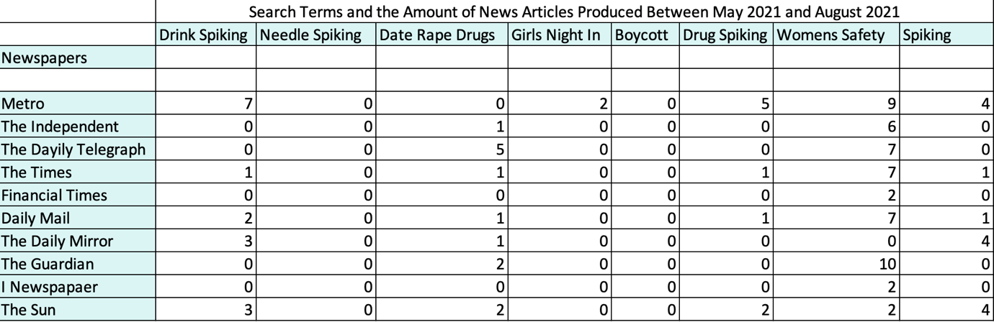
Table 1- News Articles Produced Between May2021 and August 2021

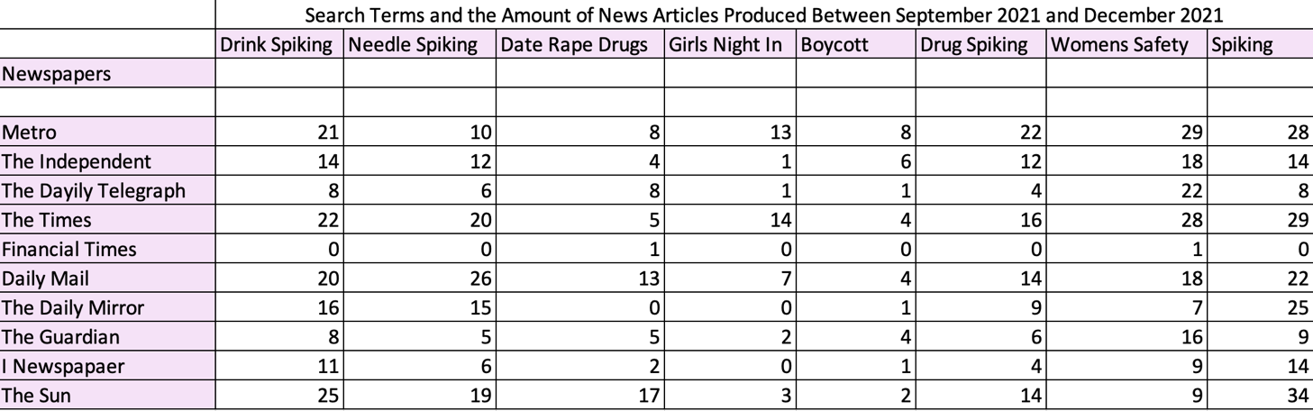
Table 2- News Articles Produced Between September 2021 and December 2021
Comparing data from the four months prior to the indicated period of September 2021 to December 2021, that was identified by both the National Police Chiefs Council (2022) and The Home Affairs Committee (2022) as being the start of the increase in media reporting. As can be seen the four months prior there are little to no reports on the key words such as “drink spiking”, “needle spiking”, “spiking” and “drug spiking “. Whereas in the months between September and December 2021 in The Sun newspaper there were thirty-four mentions of “spiking” and twenty-eight in the metro, showing an increase in media coverage within the news. This indicates that the more the newspapers use the terms linked to spiking crimes the more traction and notoriety they are getting online.

The topic of “drink spiking” was mentioned twenty-two times in The Times newspaper over a four-month period when in the four months earlier it was mentioned once indicating an increase in the amount that the newspaper decided to report on it. As well as an overall increase in these areas surrounding spiking, the topic of “women’s safety” also had an increase in media coverage with regard to newspapers. It was mentioned twenty-nine times in the Metro newspaper between September 2021 and December 2021. However, between May 2021 and August 2021 the Metro only reported on women’s safety nine times. These comparison tables show a clear increase in media reporting from the months of May to August 2021 and indicate that the National Police Chiefs Council and The Home Office Affairs Committee are correct in stating that there was an increase in media coverage of spiking between September and December 2021 as can be seen by the table above.

There are two academic schools of thought that surround drink spiking, the first school is that spiking is a serious issue and that risk factors need to be identified so that spiking crimes can be further prevented in the future. The second school of thought is that spiking crimes provide no real issue and that it is a predatory crime narrative, they acknowledge that drugs play a role in sexual assault but state that this could be overestimated (Colyer and Weiss, 2018). Berrington and Jones (2002) indicate that the media attention that drink spiking has received is disproportionate to the extent of the problem, and when sexual assault is a factor in spiking crimes the view by the media is often voyeuristic and misogynistic. This indicates that a large amount of fear has been produced and created around the issue of drink spiking.

What is not made clear by media reports is that the voluntary consumption of alcohol is the most common form of spiking crimes and incapacitation of women, and this is how women are more than likely being spiked by men known to them (Horvath and Brown, 2007). Hughes et al (2007) study in Wales looked at individuals in accidents and emergency departments who believed that there drinks had been spiked. They found that individuals had overwhelmingly consumed too much alcohol, and also that no spiking drugs had been found in urine tests. Indicating that people are either overconsuming alcohol and using it as an excuse or individuals are being spiked using alcohol.

There appears to be a widespread disbelief or denial that alcohol could be used as a form of spiking, as alcohol can cause the same incoherence, physical distress and incapacity as spiking drugs. This is why drugs have become the focus of spiking crimes and the crime of date rape and sexual assault is the main focus of the media, rather than the fact that alcohol can be used to cause the same distress. The media are making drink spiking and spiking crimes about date rape and sexual assault, rather than the causes and why these crimes happen (Burgess, Donovan and Moore, 2009). The fear of drink spiking and spiking has been misconstrued by the media and also misplaced, the blame is being placed on the object such as a drink or a needle rather than the man or individual carrying out the offence and this is transferring the fear. Some individuals also feel that the media overhypes drink spiking, and that the greater danger is intentional or unintentional spiking with alcohol. This could be things like being bought a double when asking for a single or purchasing alcohol when a person is incapacitated all of this could be seen as a form of drink spiking (Sheard, 2011).

As previously mentioned, drink spiking has been dismissed by some as either an urban myth or a moral panic, to an excuse to hide the binge drinking culture of the United Kingdom. This viewpoint does not account for the fact that drink spiking or spiking crimes may be caused by individuals consuming too much alcohol without their knowledge (Taylor, Prichard and Charltorn, 2004). The attempts to understand spiking crimes fall into three approaches and these overlap, one is to analyse the public and media construction of the spiking phenomenon. There are approaches to seek and understand the use and effects of the intoxicants used, and the feminist perspectives that use a privileged and gendered analysis of women’s experiences (Brooks, 2014). The media story and portrayal of drink spiking could be seen as a cautionary tale, this is due to the associated warning that victims could be victimised in the future. There are questions surrounding the true extent of spiking crimes and drug facilitated sexual assault, it is a socially functional way for interpreting the issue but for the media it offers an easy explanation as to both how and why the crimes happen (Moore, 2010).

To dismiss drink spiking as either an urban myth or a moral panic, is seen by some to produce a nuanced understanding of young woman’s accounts of what is happening within the night-time economy. This is why it is important to view young woman’s perspectives and narratives through both a gendered and feminist theoretical perspective, this is central to understanding both media coverage and young woman’s accounts with a larger social context (Brooks, 2014). Media reports and women’s views have resulted in a disproportionately high level of fear among women, this is in relation to criminal victimisation. This suggests that the fear women experience may be irrational and does not in fact correctly represent the number of spiking crimes that take place. Spiking crimes may also be an extension of conventional gendered fear of sexual violence and this is where many women’s fear comes from, but there are more conventional ways of looking at this such as getting home safely and safety concerns within the night-time economy itself (Mitchell, Bunton and Green, 2004).

The issue with spiking crimes and the media is that it is heavily linked historically with sexual violence, and the media often pick up on individuals who make false allegations, or they face high levels of scrutiny when they report a crime such as spiking crimes when alcohol is involved. This is cause for concern when looking at an increased level of reporting as it is unclear how many convictions have happened, and also when more women are consuming alcohol they may fear reporting spiking crimes, as they may not be believed after what they have seen in the media (Brown and Walklate, 2011).

2.5 Risk and Safety in the Night-time economy

What is clear is that women take a risk by engaging in behaviour such as binge drinking and going on nights out in the night-time economy, it is also clear that women also understand the risk that they themselves are taking. This effects how women use the night-time economy and spaces associated with that environment, making safety campaigns and women more aware of the risks is seen by some feminist theorists to be a form of social control (Wesely and Gaarder, 2004). Hanmer and Maynard (1987) outline that social control is a way of maintaining long standing social standards in society, it is essentially what is appropriate behaviour for women in society and what is not.

What has been seen however is a shift from traditional forms of feminist social control theory, as there have been moves forward away from what is seen as traditional standards of femineity and what it means to be a woman. Forms of social control may still exist there is a move to be more inclusive and include all genders when talking about crime and risk (Mitchell, Bunton and Green, 2004). Green and Singleton (2006) outline that more women are now utilising choice to override social control theory and risk, as self-monitoring and fashion choices are allowing women to step away from this historical male hegemony and control. There is also no longer a need to conform to fit in within society as society has become more tolerable and accepting of individuals who do not conform to historic gender stereotypes.

The social standard and social control may be moving but many women still feel the need to be vigilant on a night out and when interacting within the night-time economy. Many women feel the need to be self-policing when in the night-time economy. This however limits women’s experiences within the night-time economy which is supposed to be a place to socialise and relax and enjoy, many feel they are unable to do this because of the risks involved (Mitchell et al., 2001). This is why many women have taken to implementing safety strategies when they enter the night-time economy, they do so to keep themselves safe from spiking crimes and other forms of crime (Nicholls, 2017).

Where the safety strategies have come from is hard for many women to identify as they are learnt from the media, friends and family over years and are passed down through and are now part of a women’s night-out. Responsibility for one’s own actions is embedded within a woman’s consciousness things like taking drinks to toilets, only taking bottled drinks and not taking drinks from some that you don’t know are all common practice. This passing down of knowledge and understanding that’s how women should behave shows that some form of social conformity still exists, as women are responsible for their own actions and what happens to them. Women are both aware of the potential risk of a night out in the night-time economy but also aware of how to best keep themselves safe (Brooks, 2008). The National Police Chiefs Council (2022) indicate that when the occupation of the victim of spiking crime can be identified 81% is recorded as being a student. This is important as students receive information of their Students Union with regards to spiking crimes, UWTSD Students Union (2021) outlines that they can give out bottle toppers and to be vigilant when in the night-time economy to keep students and yourself safe. Cardiff Students Union (2021) indicate a wide range of safety strategies that students can use to keep themselves safe from not leaving a drink unattended, keeping your drink in hand at all times and covering your drink when you can. Indicating that students’ safety strategies may not only be learnt from family and friends but also students unions.

Brooks (2011) states that when looking at safety campaigns regarding spiking crimes young women are identified as the main target. This advice is supplied by a range of agencies such as police, drug and alcohol agencies and the government and it has the intention of equipping young women with the knowledge to avoid or prevent spiking or sexual assault. There is concern that this safety advice targeted at women specifically could be as a result of a wider concern within society, as crime prevention strategies are now becoming part of everyday life and may indicate that we now live in a culture of fear. The culture of fear relates to the idea that crime is a constant part of modern consciousness, individuals are more aware of crimes and are unable to stop thinking about it unless they have a safety strategy in place to stop it from happening to them (Furedi, 2006).

There are new forms of policing such as targeted police enforcement that was introduced to tackle violence against women and girls, this is where police target specific licensed premises for increased police presence, and this is done with the support of local agencies. This has been shown to be effective in reducing alcohol related violence, as it engages directly with stakeholders (College of Policing, 2022). Recent campaigns are mixed in who they target as an audience as one recent one called Stand With Us (2022) is aimed at all members of the UK with the aim of standing with women to create a safe space against microaggressions and violence. It lays out five ways in which people can help women who are victims, distract, delegate, document, direct and delay. This campaign is aimed at helping women put not targeted at women specifically. Another example of a recent campaign run is that of That Guy (2022) that is aimed specifically at men by Police Scotland , to reduce rape, serious sexual assault and harassment. It is aimed at making men have conversations with other men about male sexual entitlement and how they can change their behaviours to make women feel safer. This indicates that more modern safety campaigns are not just targeted at women so there may now be a wider acceptance that men and other members of society can do something to help women in need.

The feminist perspective on this theory is that women specifically have always been held individually responsible for preventing sexual violence and spiking crimes. There are also four key areas of concern when it comes to crime prevention strategies, these are the individualisation of responsibility, the gendering of responsibility and risk, the adoption of a limited conceptualisation of sexual violence and finally the absence of any focus on the men who choose to perpetrate sexual assault and spiking crimes (Walklate, 1997). There are also individuals who critique crime prevention that is specifically aimed at women, as they feel it furthers the possibility of sexual assault and spiking crimes taking place rather than helping the individual and being a preventive measure. This is because crime prevention casts male sexual behaviour and female vulnerability as being inevitable, falling back to gendered conformity. This crime prevention indicates that cases of sexual violence and spiking are being seen as a fixed reality rather than something that can be prevented (Campbell, 2005).

There is a new morality of caution being seen and this refers to the fact that women being safe and practicing safety is now common sense. Individuals who do not anticipate the potential of their drink being spiked and then being sexually assaulted by either a stranger or acquaintance are now being seen as naïve, as they are not keeping themselves safe (Burgess, Donovan and Moore, 2009). Indicating that women’s safety behaviour is learnt and is normalised and watching drinks in bars, and preventative measures is seen as normalised within society. There is no indication that men may need to change behaviours for women to be better protected, but rather that women need to keep themselves safe from criminal behaviour. They know how to do this from family and friends but it is unclear if this is working as a preventive measure or not (Brooks, 2011).

2.6 Moral Panics and Urban Legends

The idea of moral panics was introduced by Cohen (2011) he states that a moral panic is when something such as a group of persons or a specific crime emerges and that is then deemed as a threat to society. It is then presented by the media in an easily recognisable form that is normally stereotypical in fashion. As a result of this there is then a rapid build-up of concern by the public, that is responded to by the authority and opinion makers. The panic that has then been building up deteriorates and the panic resides, this can either result in a form of social change or other forms of coping are brought back into the view of the public. The individuals or crime that is identified as being the source of the moral panic then often becomes classified a “folk devil” (Newburn, 2017).

The most significant characteristic of moral panics is that it has to distort and exaggerate the seriousness of the crime event taking place. This is most commonly done through the mass media stage, through the use of melodramatic vocabulary and the construction of the folk devils (Skovmand and Schrøder, 2016). Digital communications play a significant role in distorting the undersigning an individual has, digital communications also encourage overreaction. The anonymity that the internet offers allows moral panics to happen on a mass scale for a short duration of time, without knowledge or understanding of how or why the panic happened in the first place (Walsh, 2020).

Walsh (2020) outlines that for Cohen and his peers the idea of moral panics represented media events such as journalists and broadcasters playing a role in spreading the panic, and them also identifying the deviant behaviour then mobilising the consensus and concern of the people. With the rise of social media and digital platforms, it has allowed individuals to broaden their access to information and has also transformed the production of public knowledge. The existing work on moral panics has neglected the introduction of social media and digital platforms as a legitimate way of being able to spread panic. There is now a need for scholars to integrate and interrogate how social media underpins traditional flows of information and power (Falkof, 2020). Social media allows for the diversification of information about public issues and for individuals to broaden the claims that they do make online. This as a result empowers alternative voices and renders Cohens framework inaccurate (Krinsky, 2016).

The idea of moral panics is held together by rectangular relationships, this is the idea of positions and processes that include the media, agencies of social control and moral gradians. This has been replaced by a more diverse and fluid set of institutions, agencies and practices that interlock (Garland, 2008). McRobbie and Thornton (1995) identify the idea that the folk devils are not as marginalised as they would have once been within society, as they have learnt how to defend their own interests and to use the media to their advantage. The distinction between the media and social control has dissolved, most if not all political strategies now use the diversification of media forms to their advantage to push moral panics if they can. With the rise of social media individuals are able to produce their own media sources, indicating that folk devis are no longer powerless victims. Those seen as deviant outsiders and folk devils are able to fight back in the online world, the support that these groups are able show contest against moral panics when they do happen (Krinsky, 2016).

Skovmand and SchrØder (2016) prefer to use the term media panics to describe modern day panics. These are panics that are created by the media and that last a short period of time, they also have a week impact on society as they do not last long. This is why if the coverage of the media was a pure mirror of the reality of day-to-day life, the amount of time and attention an issue would receive would naturally follow the events of the real world as well as the developments that surround the issue. Johnen, Jungblut and Ziegele (2018) use the term online firestorms as a way to describe the spontaneous and electric outbursts that are seen on the internet that could be classified as moral panics. Rather than full blown moral panics their little firestorms that pop up on the internet every minute of every day and are rapidly dismissed. This is due to the online crusaders putting them out.

The media however focus their attention on the need to tell a good story, attention cycles and topics that last seconds and then another issue popping up. It is natural to think that any moral panic that the media pick up on would only have a short time span in the spotlight before focus is shifted onto another issue (Wolfsfeld, 2011). Social media platforms use promotional algorithms to deliver tailored content to an individual, the number of ‘clicks’ a post gets determines what is worthy of users attention (Mcintyre, 2018). Social media favours the content that is more likely to generate significant emotion and outrage, and as a result more ‘clicks’. Historically moral panics require the mass media to generate significant concern and indignation, but social media and the digital world has expanded the pathways in which panic can be produced. This allows ordinary citizens to both identify and sanction transgressions, as well as create crowd sourced panics. Allowing moral panics to be more frequent on the internet (Murthy, 2011; Dijck, 2013).

Moral panics may also not be analytical, as current day issues exist in a complex web of discourse. This means that there is a variety of contradictory impulses, attitudes, behaviours and policies that emerge as a result of society grappling with thorny questions that surround issues like drink spiking and drug facilitated sexual assault (Rek-Woźniak and Woźniak, 2020).

Despite all of these critiques of moral panics there are some that apply it to crimes, Berrington and Jones (2002) indicate that spiking crimes and also crimes liked to sexual assault could be seen as a contemporary form of moral panic. This also links into the fact that there are law enforcement professionals such as police and forensic scientists that dismiss the idea of drink spiking all together as an excuse to hide undesirable behaviour (Taylor, Prichard and Charltorn, 2004).

2.7 Conclusion

This chapter clearly lays out the forms of spiking crime under the England and Wales Criminal Justice System, identified what moral panics and folk devils are, identified what the night-time economy is as well as the ideas of binge drinking. The literature review has also shown that spiking crimes within newspaper reports did increase between the period of September to December 2021, that is clearly stated in this literature review.

What is still unclear is if media reporting through newspaper articles have increased women’s awareness on the issue of spiking crimes, the idea of safety advice and where safety tips were learnt from was explored through other journal articles, but it is still unclear as to if the media has an influence on this.

The next chapter will contain the methodology of the research, this will clearly lay out how the research will be conducted as well as the manner in which the data analysis will be done.

Chapter 3 Methodology

3.1 Introduction

The pervious chapter reviewed and identified the relevant literature, with regards to what are spiking crimes, how the media portrays spiking crimes as well as what are moral panics. This chapter goes onto outline the way in which the data will be collected, this includes both secondary and primary data this will be shown through the research methodology. The research philosophy will also be identified as this will justify why the research methods have been chosen.

3.2 Aims and Objectives

The researcher has chosen to outline the aims and objectives at the start of this chapter as it will give guidance and clarity on why the research methods and philosophies have been chosen. As well as give guidance to the researcher throughout the course of the study.
- Investigate how newspapers as a media source perceive drink spiking.
- Explore women’s views on the night-time economy and drink spiking in comparison to media perceptions.
- Investigate whether the media has made women more aware of the dangers of the night-time economy for example, drink spiking, spiking, sexual assault, violent assault, and drug facilitated sexual assault.
- To explore if there is a direct comparison between media articles and drink spiking crime rate statistics, or if the media perceptions are creating a “moral panic”.

3.3 Research Philosophy

Collis and Hussey (2021) outline that research is a systematic and methodical way of investigation, with the overall aim to increase knowledge. Depending on the type of research being undertaken depends on the type of research method that will be used, and different forms of research require different research methods. This is why it is important that a different research design be created for each individual research idea (Cohen, Manion and Morrison, 2017). The researcher has decided to use Saunders, Lewis and Thornhills Research Onion to provide the philosophy for the research (2019).


Figure 1- Sunders, Lewis, and Thornhill 2019 Research Onion

The research will be cross sectional when it comes to the time-horizon. This is because the research will only represent one time period, as it is being conducted at one specific period of time. When it comes to looking at the secondary data that data will also only be looking at one specific time period of between May to August 2021 then September to December 2021 still making the time period cross sectional (Saunders, Lewis and Thornhill, 2015). A pragmatism philosophy will be used for this research, this philosophy indicates that individuals within social settings can experience action and change in different ways. This as a result encourages flexibility and change in the investigative techniques. As a result encourages the researcher to base choices on the relevant methods and methodologies, this is in terms of carrying the research from the world of practice to the world of theory and vice versa (Kelly and Cordeiro, 2020). This approach to problem solving and research in the social world offers alternative, flexible and a more reflective research design (Yvonne Feilzer, 2010). A pragmatism philosophy will allow the researcher to acknowledge that there are various ways of interpreting and understanding information, and that there are strengths to both qualitative and quantitative research (Johnson and Onwuegbuzie, 2004).

This is why a mixed method approach to the research will be used, as both qualitative and quantitative data will be collected during the research. This will allow for the integration of both data sets at an appropriate stage of the research (Shorten and Smith, 2017). Mixed method research allows for a more panoramic view of the research landscape, as the research is viewed through a more diverse angle when it comes to the data analysis (Kelemen and Rumens, 2008).

3.4 Research Design

Secondary Data

The term secondary data refers to data that already exists, the researcher in this case will use two data bases to compile newspaper articles relating to spiking crimes. Document secondary data will be used as it allows for the data to be transported across space and time, this also allows for the data to be used for different research purposes. This can be seen in this research as online newspapers are being used purely to see if there was an increase in reporting but this is different from their original use (Symon and Cassell, 2012). Online newspapers are being used for the secondary data, as this is where the majority of women get their news from. YouGov (2022a) survey on where women got their news from indicated that 37% got it from online newspaper sources, this is why the researcher will use online newspaper sources that are most popular among women as it is the target demographic for the study. Multiple source secondary data will also be used as the researcher will be combining different data sets in order to form another set of data (Saunders, Lewis and Thornhill, 2015).

The two data bases that will be used are ProQuest Central which the researcher has access to through the University of Wales Trinity Saint David Library, as well as the Metro Newspaper website. The search terms used on the databases were topics of conversation within the literature read through within the literature review and that is how the search terms were decided on. The top ten newspapers Q2 2022 filtered by most popular with women, the Sunday editions of newspapers were discounted as they either did not appear on ProQuest Central or they are in limited quantity as they are only printed every Sunday so they were discounted (YouGov, 2022b). There was a specific time period searched between this was a four-month period from September 2021 to December 2021 as this was the time period that both the National Police Chiefs Council and the Home Affairs Committee identified as an increase in media reporting. The four month prior so from May 2021 to August 2021 were also looked at for comparison purposes.

The search filters on ProQuest Central were also used to allow for the inclusion and exclusion of specific criteria. This was used to exclude things linked to the Covid-19 related spiking incidents such as an increase in cases or spiking related to vaccinations. This secondary data will represent the media response to drink spiking and will be relevant to the research objectives, the secondary data will also form the basis for the interview questions.

Primary data

The researcher will use questionaries as a way to collect primary data, these were designed in a way in which they were easily understood by participants. They were designed in a clear, crisp and concise manner so that only the critical questions were asked that mattered to the research aims and objectives (Denscombe, 2017). The questions were based off the research found within the secondary data as well as the research read in the literature review.

Care was taken to ensure that there were no leading questions asked to the participants, as leading questions can be seen to be creating bias within the answers that the participants provide. The researcher also avoided the use of emotive language within the questions, as the way in which the question is put forward can lead the respondents to answer in a specific way (Robson and McCartan, 2016). Attention was paid to avoid this type of questioning for the reliability of the study. There was also an attempt to avoid complex, irritating or offensive questions. If sensitive questions are asked during the course of the questionnaire care was taken to ensure that the wording of the questions does not make the participants uncomfortable (Babbie, 2016).

The appearance and the layout of the questionnaire was of importance, as a clear and concise instructions have been included throughout to assist participants. This was of importance as the respondents should feel encouraged to answer the questions provided, and they may be put off if the document has been hastily prepared and has unclear instructions (Bell, 2014). Both closed and open questions will be used within the questionnaire. The researcher has included closed questions within the questionnaire. This is down to the limited choices of a questionnaire will be easy to process in the data analysis section (Denscombe, 2017). However, Laws et al (2013) outlines that open ended questions will allow the researcher to use their own category to respond. This then means that even though they may be less easily comparable when it comes to data analysis it may provide more meaningful results overall.

3.4 Sample

Sample is known as the method of selecting a representative sample from the population for the study. The researcher should identify the individuals who they think can provide the information they need to meet the aims and objectives of the research as the sample for the research (Baker, Reynolds and Woods, 2006). This is known as purposeful sampling, or sampling one section of the population to fit the aims and objectives of the research and discarding anyone that does not fit the sample size (Fink, 2016).

The main aim of this research is to look at women’s views on spiking crimes within the night-time economy, so participants will have to identify as women and study or have previously studied at a higher education level to take part. The research will discard anyone that does not identify as a woman or a transgender woman and anyone that has not studied at a higher education level. This is the sample that has been identified at high risk by the National Police Chiefs Council and the Home Affairs Committee.

It is important to exclude and have this exclusion criteria to support the aims of the study, as the study is specifically looking focused on women’s experiences of spiking crimes within the night-time economy. The sample size of this survey aims to be between 100-150 participant’s as this is more than likely to provide the researcher with statistically significant data (Cameron and Price, 2009).

As the sample will look at only women who have had experience within higher education, the questionnaire will be online, and this will be sent on Facebook and other popular online platforms to participants. It will be sent to specific groups that only contain women in hopes to maintain a sample that is specific to the needs of the study.

3.5 Data Analysis Method

The secondary data will be analysed through a Microsoft Excel spreadsheets, this was done so that the data could be understood easily. It also allowed the data collected to be put in multiple different forms if needed such as tables and graphs for the data to be presented in a different format.

The primary data collected will be analysed through both Microsoft Excel and the use of word clouds. The open-ended questions that have allowed the respondent to expand on the answer they have given will be analysed on Microsoft Excel and then put into a word cloud. Word clouds allow data to be seen in a different and easy to read format, as more important topics are displayed in bold in the cloud and smaller supporting topics surrounding and supporting the bigger idea. The open-ended questions will be read multiple times this is so the most important themes and trends can be identified and highlighted, those in which link to the relevant theories. This is where the researcher will remain vigilant as any fresh perspectives will have to be identified and talked about (Cottrell, 2017).

This is why for the open-ended questions a catalogue technique will be used, this is where the researcher will identify a theme or trend then a colour code will be applied and recorded with that index. Then any new information that is gathered from the research will have a new colour code and new index, creating a clear and readable catalogue of findings that will help deliver recordable and readable results. A clear and concise catalogue process will also aid if a repeat of the study is needed (Saunders, Lewis and Thornhill, 2019).

3.6 Validity and Reliability

Evaluating the quality of the research done is essential, this is why reliability is an important factor in all research conducted. Reliability refers to the degree in which the same result is obtained when the same research is measured repeatedly and it uses the same measurement tool (Bryman and Bell, 2015). Online questionaries have advantages such as being cost effective and being good for time constraints as the researcher does not have to talk to every single participant. The researcher will be unable to understand the situation of the respondents when they are completing the questionnaire and if they are being truthful in what they are responding. In order to eliminate this the researcher has made clear the sample of the survey as to who is the demographic to try and make the research as reliable as possible.

Validity relates to how the test is being conducted to ensure that it is being conducted in a logical manner as well as in a way in which accurately measures what the researcher is testing (Drost, 2011). The validity will measure if the comprehensive evaluation system can and is accurately reflecting the requirements of the evaluation. If the validity is poor then there will be no way to measure the relevant content that relates to the research process (Bryman and Bell, 2015).

To eliminate the inaccuracy caused by any bias the study will take its own measures, each question of the questionnaire will relate to the aims and objectives of the study and all questions are based of the literature review and secondary data.

3.7 Conclusion

This chapter has identified the research philosophy and methodology for both the primary and secondary data. This is to aid in the completion of the research aims and objectives set out at the start of every chapter. The methodology chapter has also identified the way in which the research will be analysed, the next chapter will contain the data analysis. The data will be analysed using the methods discussed in this chapter and will use both the primary and secondary research, this will then be analysed and conclusions will be drawn in the final chapter.

Chapter Four – Results and Data Analysis

4.1 Introduction

This chapter will provide both a discussion and analysis of the results and data collected from the online survey, whilst providing a systematic presentation of the findings. A total of 53 participants completed the online questionnaire. The purpose of the research is to explore if there is a link between media reporting on spiking crimes and women’s perceptions of spiking crimes within the night-time economy. Then to consider if the media has created a moral panic surrounding the issue of spiking crimes. In order to achieve this the objectives were considered throughout the research.

- Investigate how newspapers as a media source perceive drink spiking.
- Explore women’s views on the night-time economy and drink spiking in comparison to media perceptions.
- Investigate whether the media has made women more aware of the dangers of the night-time economy for example drink spiking, spiking, sexual assault, violent assault, and drug facilitated sexual assault.
- To explore if there is a direct comparison between media articles and drink spiking crime rate statistics, or if the media perceptions are creating a “moral panic”.

4.2 Participant Demographic

Q2) What was your age range? Q4) Are you studying at a higher education level?
When asked what age range the participants were the majority were aged between 21-25 years at 39.60%. The second highest was other at 35.80% indicating that the participant was over the age of forty. When asked if the participants were studying at a higher education level 45% indicated that they were a pervious university student and 32% indicated that they were in the third year of their study. The National Police Chiefs Council (2022) indicate that when the victims age can be recorded for spiking crimes 73% of victims are aged between 18 – 21, the victim profile suggests that the age would be that of students and that they would be particularly vulnerable.

When in fact in 2019 to 2020 mature students, so students aged 21 and over accounted for 57.5% of the student population, and students studying undergraduate degrees at the ages between 21-24 years old had the highest population of students at 360,885 (Universities UK, 2022). The National Police Chiefs Council (2022) also indicates that when the occupation of the victim can be identified, 81% are recorded to be students. Even though the survey respondents did not match the demographic of spiking victims they matched the age of university students. The respondents also are currently in the final year of studying or have previous knowledge of studding at university.

Figure 2 - Q2) What is your age range?

Figure 3 - Q4) Are you currently studying at a higher education level?

Q3) What gender do you identify as?

All of the individuals that responded to the online survey identified as female giving the statistic of 100% of participants identifying as female. The National Police Chiefs Council (2022) identified that the largest proportion of victims for spiking crimes is female victims and they make up 88% of all victims. Showing that the sample of the survey represented the victims of spiking crimes. This also aligns with the aims and objectives of the study to look at specifically women’s views of spiking crime.

Figure 4- Q3) What gender do you identify as?
Q6) Do you use spaces within the night-time economy? Tick all that apply. Q7) If you use spaces within the night-time economy how often do you use these spaces?

When asked what spaces individuals used in the night-time economy, the two top answers were pubs at 86.80% and night clubs at 58.50%. When looking at where spiking incidents take place 3,212 spiking incidents happen in night clubs and only 695 happen within pubs (Home Affairs Committee, 2022b). Indicating that the women who replied to this survey may not be putting themselves at risk of being spiked or witnessing spiking because they do not interact with the highest risk areas or if they do choose to go to night clubs it is infrequent.

Figure 5- Q6) Do you use spaces within the night-time economy?

When asked how often individuals used these spaces within the night-time economy 62% replied with once a month and 17% with 3-4 times a week. This is quite a large difference in frequency in which people use the night-time economy. A Drinkaware (2021) study looked at how often adults in Wales consumed a drink containing alcohol 22% replied with less than monthly and 13% with once a week. This shows that there may be less individuals using the night-time economy as less are drinking alcohol in general.

When women consume alcohol, they are less aware of their own safety this is due to lowered inhibitions and increased confidence, this is due to the risky consumption of alcohol. The use of these alcohol centred spaces may depend on the age of the individual as older individuals tend to use more social clubs and bars. Whereas younger women are overall more frequent users of city centre night-time economy such as night clubs and bars. This can be seen in the survey results as the participant age is younger and they use more pubs, night clubs and music venues (Sheard, 2011).

Figure 6 - Q7) If you use spaces within the night-time economy how often do you use these spaces?

4.3 Understanding Spiking

Q5) Could you provide a definition of what you think spiking crimes are?

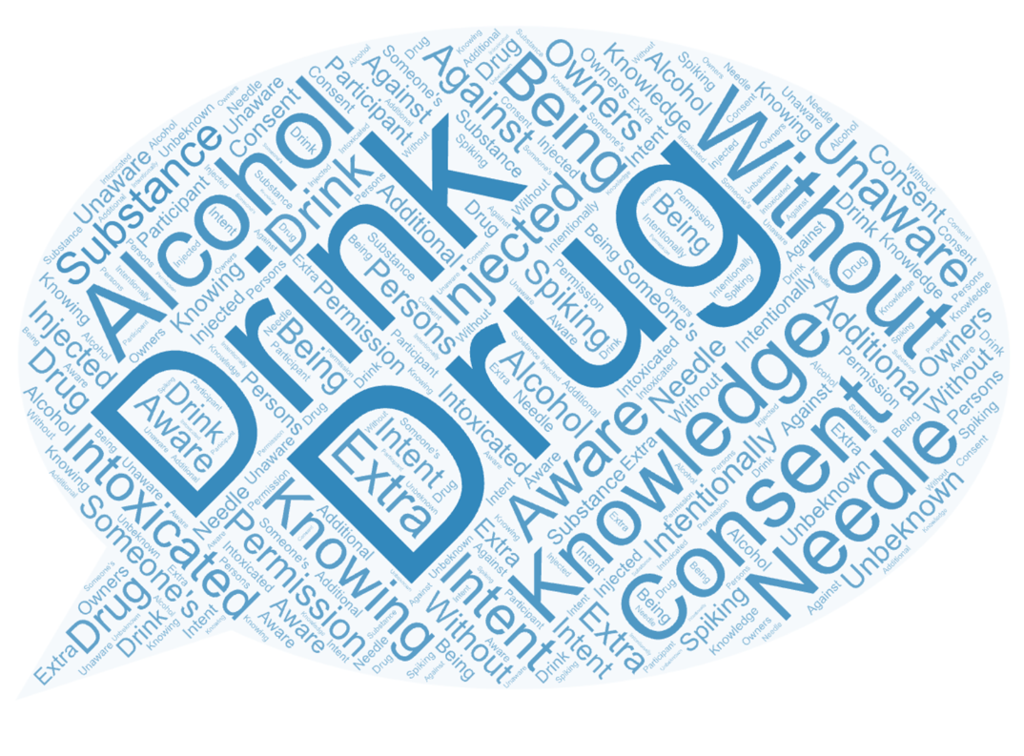
Figure 7 - Q5) Could you provide a definition of what you think spiking crimes are?
The most common themes that could be seen in participants answers, as to what they think drink spiking crimes were, putting a form of drug in an individual’s drink and without knowledge. The full answers can be seen in appendix four. Under new UK legislation, the Police, Crime, Sentencing and Courts Act 2022 outlines that spiking is administering a substance with an intent to cause harm, intentionally administer a substance without the consent of an individual and with the intent to cause harm (UK Government Legislation, 2022a). Some of this legislation can be seen in the participant answers such as the without consent, but the participant answers are very specific when the UK legislation has a very large scope in how the actual spiking crime can take place.

The Home Affairs Committee (2022b) outline that spiking crimes can include needle injection, slipping something into an individual’s drink or giving a person more alcohol than they asked for. There were only a handful of responses that identified needle spiking and alcohol was rarely mentioned in participant responses. This links to the widespread denial that alcohol can be used as a form of spiking, when in fact alcohol can cause the same physical distress and incapacity as spiking drugs (Burgess, Donovan and Moore, 2009). Secondary data provided in the literature review and that can be seen in appendix 12 shows that between September 2021 and December 2021 The Sun newspaper online mentioned drink spiking twenty-five times and needle spiking nineteen. The Metro mentions drink spiking twenty-one times throughout that period and needle spiking only ten. The National Police Chiefs Council (2022) indicates at the beginning of September 2021 there were 1,032 cases of needle injection.

Individuals’ perceptions of drink spiking are being shaped by the media and media reports as there were an increase in reports of needle spiking by the Police, the media and online newspaper articles reported an increase in drink spiking. Participants of the online survey identified drink spiking or slipping something in someone’s drink as the main form of spiking, indicating the media has some form of influence.

Q8) Have you ever been a victim or witness to any form of spiking crime?

Figure 8 - Q8) Have you ever been a victim or witness to any form of spiking crime?
When asked if the participants had been a victim of spiking crimes 49.10% of participants stated no and only 34% responded yes that they had been a victim. The Home Affairs Committee (2022a) indicates that out of the individuals they interviewed a total of 63% individuals had not been personally spiked in their report and only 8% have personally been a victim of spiking. This shows that the number of individuals that have had their drinks spiked personally is low, and individual’s personal experiences with spiking crimes within the night-time economy may not be as much of a widespread problem.

Q9) If the answer was yes to previous question could you explain what happened?
Figure 9 - Q9) If the answer was yes to previous question could you explain what happened?
When asked what happened when individuals had experienced spiking, the main themes were physical changes such as falling over or being unable to stand which this noted sixteen times. The theme of friends such as being looked after by friends or friend’s experiences was also a key theme.

Intoxication was also a key theme identified. As the participants felt that they had not consumed enough alcohol, or they were not drunk enough to exhibit the type of behaviour that they did at the time of the incident. From the results suspected was also a key theme linked to intoxication and this was mentioned in relation to having no confirmation of spiking, full participant answers can be found in appendix five.

The themes of suspected and intoxication are linked together so heavily as individuals do not know if they have over consumed alcohol or if they have been spiked. A Welsh study looked at Accident and Emergency departments where individuals believed their drinks had been spiked, this found that individuals had overwhelmingly consumed too much alcohol and there were no spiking drugs found in urine tests (Hughes et al., 2007). Showing that individuals may be drinking too much alcohol, so they may not be able to tell if there drunk or that alcohol is being used as a form of spiking.
Suspected also comes up when looking at answers that contain friends. Brooks (2014) identified in her study that twenty two out of the thirty five participants talked about a friend or family member thinking their drink had been spiked. She talks about the fact that there is difficulty in proving if a drink has been spiked and that this was beyond the scope of the study.

Physical changes played a big part in participants answers such as not being able to stand, to falling over. There are a total of 1,148 physical injury’s recorded as a result of spiking crimes in the UK showing that this is a factor when someone has been spiked (Home Affairs Committee, 2022a). This relates back to friends as a theme. Sheard (2011) indicates that there is a reliance on friends by individuals to get them home safe after a night out after being overly intoxicated, and the participants in this study changed behaviour as they felt embarrassed.

Q11) Have you been made more aware of spiking crimes since you became a student?

Figure 10 - Q11) Have you been made more aware of spiking crimes since you became a student?
The majority of participants responded yes at 65.30% that they had been made more aware of spiking crimes since they became students. This links back to the fact that the majority of victims are in fact students, when occupation could be recorded 81% of victims were in fact students (National Police Chiefs Council, 2022). Cardiff Students Union (2021) on there website provides clear information for students on the risks of spiking and also how to prevent spiking crimes, also where to get help from if needed. UWTSD Students Union (2021) also has a webpage that explains what the students union is doing to help students be safe, such as introducing bottle stoppers and improving CCTV. This shows that students can gain more information about drink spiking if they so wish, neither websites mention directly talking to first year students about drink spiking to make them more informed. If students are not witnessing, being victims or being told about spiking crimes then how do they know spiking crimes exist, the only answer has to be through some form of media.

4.4 Media Influence

Q14) Have you noticed an increase in media reporting surrounding spiking crime?

Figure 11- Q14) Have you noticed an increase in media reporting surrounding spiking crime?

Q16) Have you been made more aware of the dangers of spiking crimes due to media coverage of spiking crimes?

Figure 12 - Q16) Have you been made more aware of the dangers of spiking crimes due to media coverage of spiking crimes?

When participants were asked if they had seen an increase in media reporting surrounding spiking crime, the majority of participants 81.10% indicated that yes in fact they had seen an increase. Then when asked if they had been made more aware of the dangers of spiking crimes due to the media the majority 64.20% indicated that yes, they had been made more aware.
The Home Affairs Committee (2022a) indicate that there was an increase in spiking crimes across the country in October 2021, and as a result this gained widespread press coverage. This is further stated by The National Police Chiefs Council (2022) which indicate that they have also seen an increase in police reports and an increase in media coverage for the same time period. This shows that individuals of the survey may have been made more aware from an increased media coverage on spiking crimes.

The secondary data explored in the literature review identified an increase in the reporting of spiking crimes in online newspapers. The tables can be seen in appendix 11 for May 2021 to August 2021 where reports on drink spiking were relatively low The Metro reported on drink spiking seven times, The Sun only three and The Daily Mail only two. The increase in the four months after between September 2021 and December 2021 table can be seen in appendix 12 is noticeable. The Metro reported on drink spiking a total of twenty-one times, The Sun increased reporting to twenty-five newspaper articles, the most noticeable is The Daily Mail producing twenty articles on drink spiking. This shows a clear increase in media reporting regarding spiking crimes in online newspapers, and an increase in knowledge given to the respondents by the survey.

Q15) What media platforms have you seen an increase of reporting on?
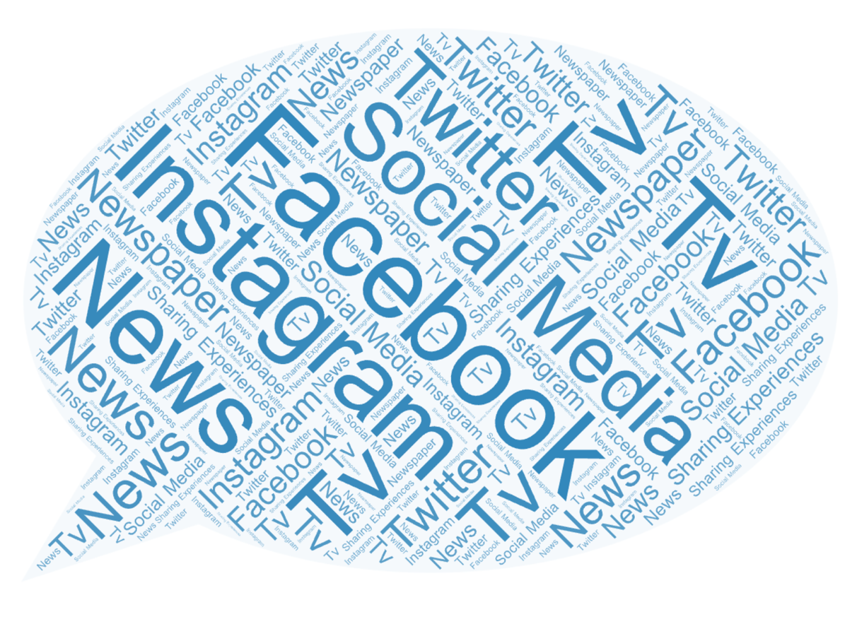
Figure 13 - Q15) What media platforms have you seen an increase of reporting on?
There were two key themes that came up when asked where the participants had seen spiking crimes reported on, that was news and social media there were specific social media platforms mentioned like Facebook and Instagram but there were only two common answers. The majority of women in the UK get their news from news websites as a YouGov (2022a) poll form December 2021 found that 37% of women get there news form news websites. The second most popular category for women to get their news from was then social media at 26%. This shows that the participants of the survey are getting their news from where most other women in the UK are online newspapers and that this is where there has been an increase in reporting of spiking crime. What is of interest is that the majority or all participants mentioned some form of social media by name or in general, and this is not where most women in the UK get most of their news form and how this has impacted views of spiking.

Q17) Are there any other crimes that you’ve seen in the media other than spiking crimes that cause you concern when going out in the night-time economy?
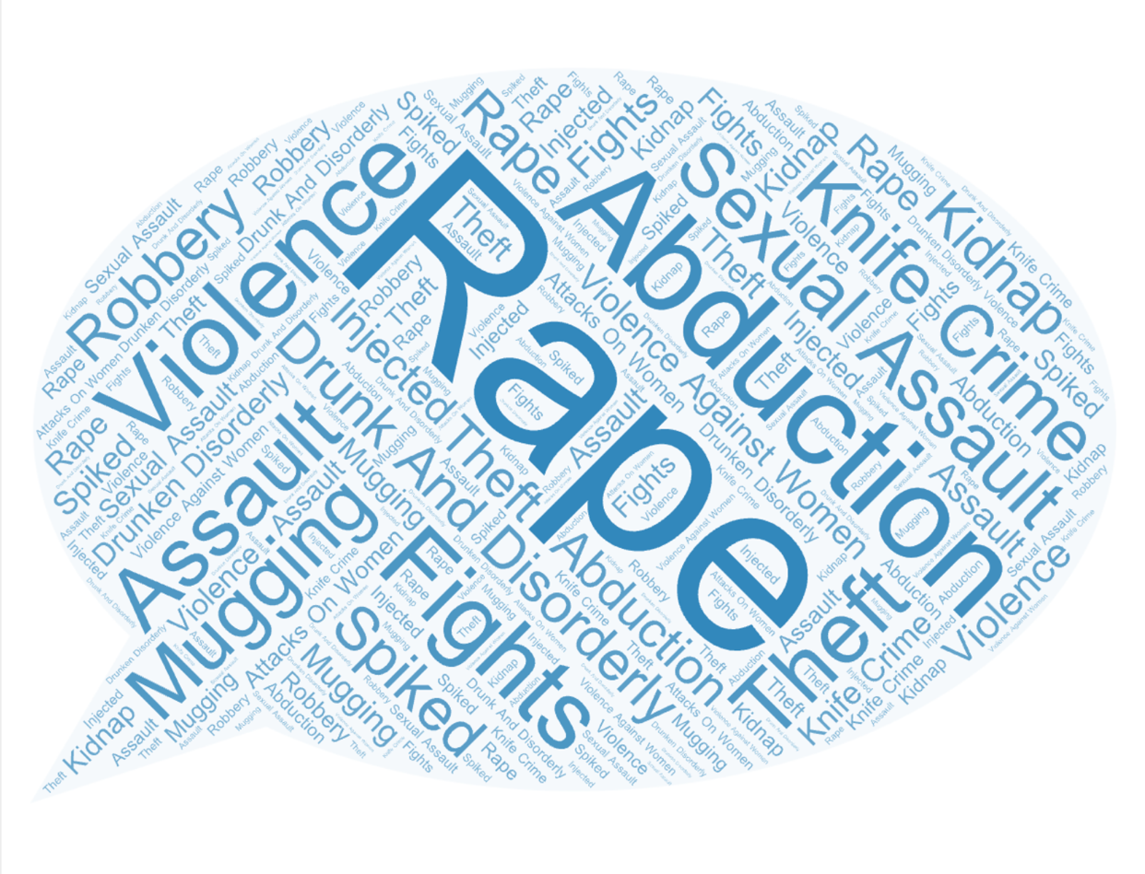
Figure 14- Q17) Are there any other crimes that you’ve seen in the media other than spiking crimes that cause you concern when going out in the night-time economy?
There are three key themes that participants identified when asked what crimes they are more concerned about when they are using the night-time economy these are rape, abduction and drunk and disorderly. The full list of key themes brought up by participants can be seen in appendix 10, these are the themes that women identified the most in their answers.

The three key themes identified by the women who carried out the survey are shared concerns and fears throughout other academic works as Sheard (2011) identified in her study that women often avoided venues and streets were trouble might occur. As the women in her study witnessed violence within the night-time economy and as a result were more fearful of crimes of a violent nature and drunk and disorderly behaviour as it was unpredictable in nature.

Many women in the survey identified rape as a source of concern, this is furthered by the work of Brooks (2014) as the women in her study felt that their safety was compromised in a bar environment through sexual assault and sexual harassment. She also found that young women’s concerns around drink spiking were in relation to the broader spectrum of sexual violence. The Office for National Statistics (2021) data on the nature of sexual assault by rape or penetration in England and Wales for the year ending March 2020, shows that there were 1.6 million adults aged sixteen to seventy four years old that had experienced sexual assault by rape or penetration.

Looking at abduction or kidnappings the Office for National Statistics (2022) the year from April 2021 to March 2022 there were a total of 6,906 kidnappings. These two statistics are of importance as in comparison to the number of spiking crimes that take place they can be seen as legitimate fears as at the beginning of September 2021 there were only 1,032 cases of needle spiking incidents (National Police Chiefs Council, 2022). Showing that in comparison women’s fears would be better placed on kidnappings or rape as they happen far more frequently than spiking crimes.

The media increased reporting on drink spiking crimes between September 2021 and December 2021 this can be seen in appendix twelve, Bows (2021) identified that violence against women and girls regularly makes the headlines in the UK. The reason that violence against women like spiking crimes gained notoriety due to the murder of Sarah Everard in March of 2021, who was abducted by a police officer whilst walking home. News of this spread quickly online and many women took to social media to share their experiences.

Women in this study have gotten their news primarily form social media, and have stated that their main fears are that of rape and being abducted this shows a clear link between what happens on social media and what women are concerned about in the night-time economy.

4.5 Safety and Risk

Q10) Did you receive any help after the spiking incident occurred?

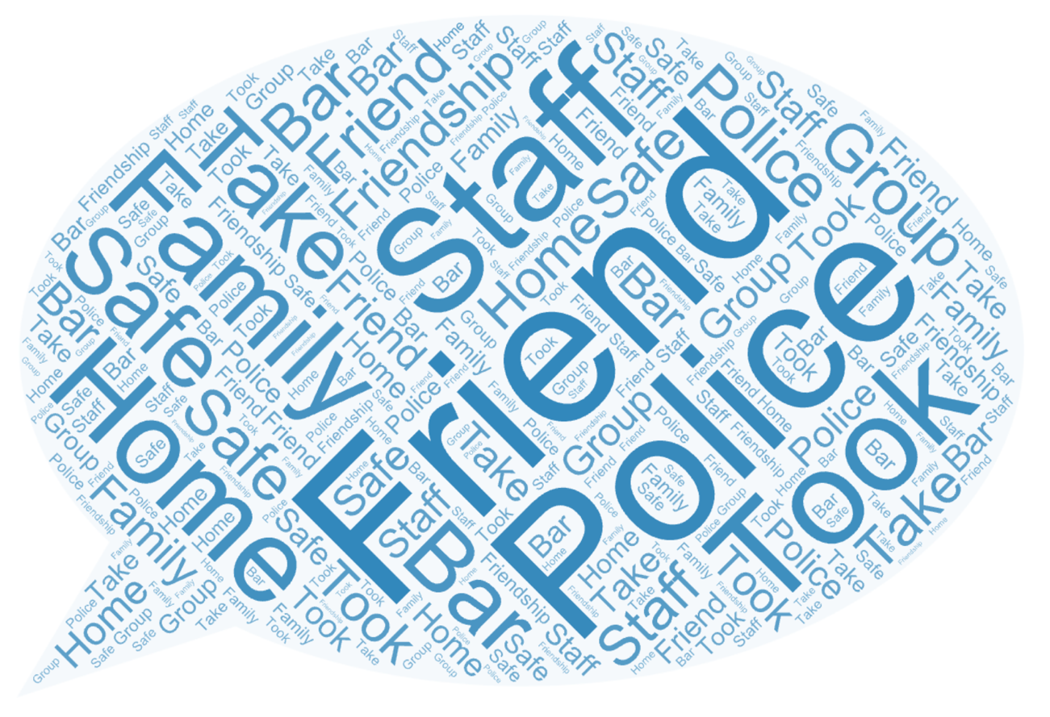
Figure 15- Q10) Did you receive any help after the spiking incident occurred?
The most common form of help that women received was from friends and family, and the key theme of friend and family help was that of helping the individual home safe. Only a handful of individuals mentioned police, when the police were mentioned, women indicated that they were no help. Women’s full answers can be seen in appendix three. The reason individuals may seek out help from friends and family rather than police, is due to the lack of evidence that individuals have and that they are often seen as over intoxicated by the police rather than to have had their drinks spiked (Taylor, Prichard and Charltorn, 2004).

Groves (2015) identified in his study that friends play a vital role in why people use the night-time economy, they identified that 87.4% of individuals use night clubs with the same group of friends and 83.4% of participants indicated that it was important to be with a group of friends. This shows that friends play a large role in how people feel safe and have safety within the night-time economy.

Q12) Are you aware of any safety measures that you or others use on a night out to prevent spiking?
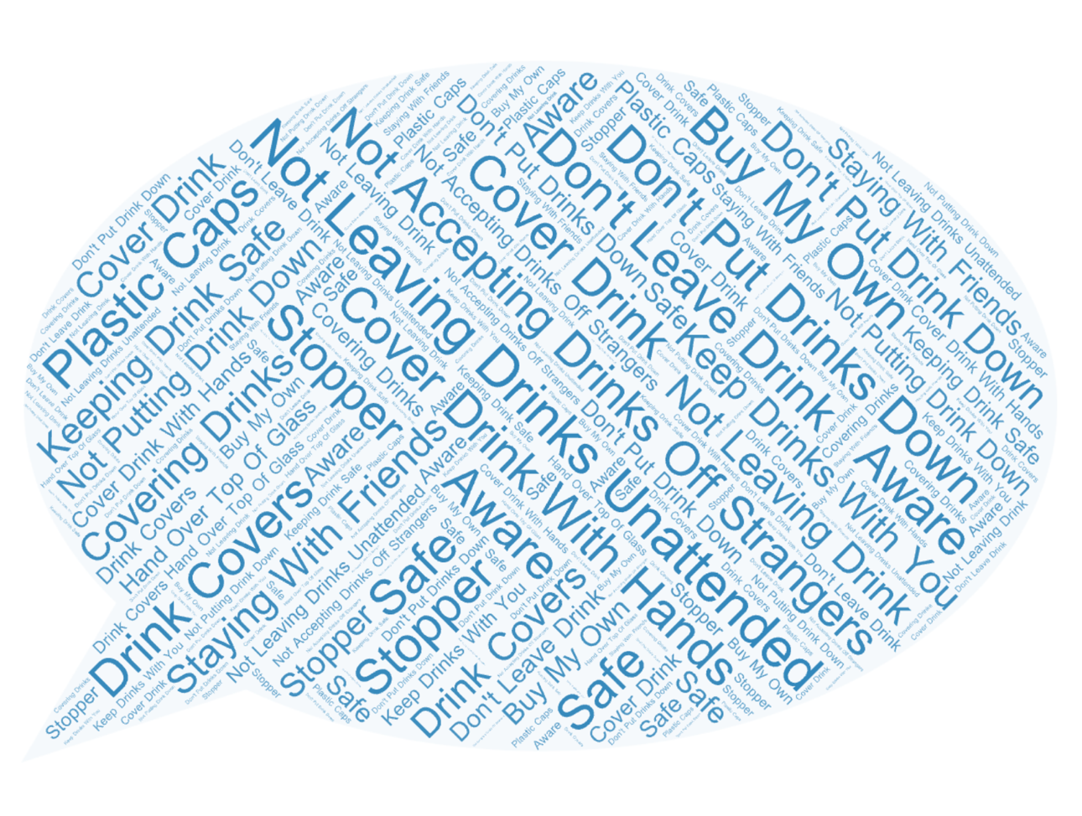
Figure 16 - Q12) Are you aware of any safety measures that you or others use on a night out to prevent spiking?

When women were asked what safety measures, they used to prevent spiking or keep themselves safe on a night out, full participant answers can be seen in appendix seven. There were two key themes that were identified in participant answers this was not leaving drinks unattended and covering drinks to keep them safe. Sheard (2011) identified that the women in her study practiced significant caution around the consumption of alcoholic drinks. The women in her study indicated that they practiced the protecting and safeguarding of drinks when on a night out, and that they always kept drinks in their hands and never drank them if they had been put down.

Cardiff Students Union (2021) identify a wide range of safety measures that women can use to keep themselves safe including not leaving drinks unattended, keeping drinks in hand at all times as well as offering things to cover the tops of drinks or to cover the top of drinks when you can. The majority of correspondents to this survey are either students or previous university students, so this is why the safety strategies mentioned by the participants link up to the ones on Students Unions websites. These safety strategies are also universal this can be seen by the age of the survey respondents.

Q13) Where do you think you have taken or learnt these behaviours from?
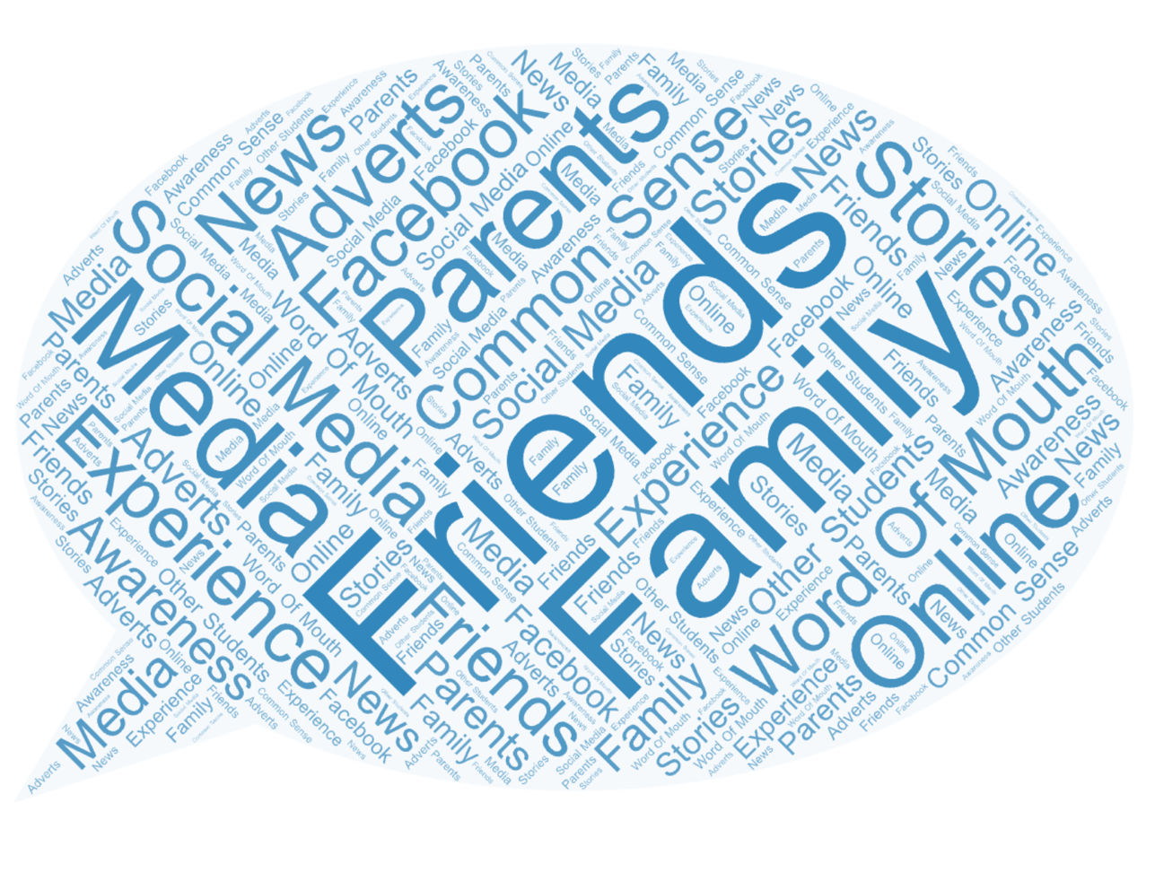
Figure 17- Q13) Where do you think you have taken or learnt these behaviours from?
Family and friends were identified as the key themes, when individuals tried to identify where they had learnt safety measures from. Brooks (2008) talks about the fact that where women have learnt these safety strategies from is unknown and hard to tell, some of the participants in there study identified learnt from the media. Other women indicated that the information may have been passed down from family and friends. There is no clear understanding of where or how these behaviours are learnt but family and friends play a large role in what safety strategies women use to keep themselves safe.

4.6 Conclusion

This chapter looked at analysing the data collected from the survey, this was in hopes to draw conclusions and answer the objectives of the research study. What has been made clear is that social media has played a role in how women understand spiking crimes. Students are more aware of spiking because they have been to university, but they may not have been a victim or witness to spiking crimes, indicating that there may not be evidence to support that there was a moral panic surrounding the issue of drink spiking. Students or previous university students also know how to keep themselves safe and their friends safe when they are in the night-time economy this is also clear within the research, what was not understood was where this behaviour is learnt from other than family and friends.

The next chapter will conclude the research, it will aim to bring a close the discussion on if the media has created a moral panic around drink spiking. It will also outline areas for improvement for the research and where the researcher feels the research question could be expanded on in the future.

Chapter 5 – Conclusions and Recommendations

5.1 Introduction

This chapter aims to provide conclusions and a summary on both the primary and secondary research findings, and then present recommendations for further or future research. This chapter will then revisit the objectives of the research for two reasons:
- To discover if the objectives of the dissertation have been met.
- In order to evaluate if the findings of the research either corroborate or contradict the findings of the research discussed in the literature review.
The chapter will then conclude with the recommendations as well as the final thoughts. The objectives of the research are.
- To investigate how online newspapers as a media source perceive risk and drink spiking.
- Explore women’s views on the night-time economy in comparison to media perceptions.
- Investigate whether online media has made women more aware of the dangers of the night-time economy for example drink spiking, spiking, drug facilitated sexual assault and abduction.
- To explore if there is a direct comparison between online newspaper articles and crime statistics or if media perceptions online are creating moral panics.

5.2 Summary of Primary and Secondary Data Findings

The aim of this dissertation was to explore women’s views of spiking crimes within the night-time economy, and then to look at if online newspapers are creating a moral panic surrounding the issue of drink spiking. This information was collected by the online questionaries which were completed by thirty-five participants, and also secondary data that looked at ten online newspapers perceptions and reports on spiking crimes. The online survey indicated that women are infrequent users of the night-time economy, and when they do use the night-time economy, they put themselves at some form of risk by doing so. The secondary data found that online newspapers were in fact producing more reports surrounding drink spiking during the period of September 2021 and December 2021. It was and is unclear if this produced a moral panic, as the women in the study indicated an increase in awareness but also indicated that they feared other crimes like sexual assault and abduction more than drink spiking.

5.3 Investigate How Online Newspapers as a Media Source Perceive Risk and Drink Spiking

This objective was achieved through the secondary data and also the literature review, the online newspaper sources perceive drink spiking as a drug problem rather than a drug and alcohol related issue. Within the secondary data the ten newspapers only reported forms of drink spiking and needle spiking, rather than identifying alcohol as either a way of being spiked or alcohol as a way in which people are falling victim to these crimes by being overly intoxicated then spiked. When under the Police, Crime, Sentencing and Courts Act 2022, it is illegal to cause spiking by giving an individual to much alcohol (UK Parliament, 2022).

Media sources in the secondary data also increased reporting surrounding the issue of women’s safety in the same period of increasing reporting surrounding spiking crimes. This is perceiving risk as a cautionary tale, indicating to women how to be safe on a night out. This is using the story to make women more aware, but also in a way it makes them more scared of using the night-time economy as a result (Moore, 2010). The media perceive drink spiking as a story to be written about and the risks that women face also as a way to get more clicks and views on their websites.

5.4 Explore Women’s Views on the Night-Time Economy in Comparison to Media Perceptions

Spiking crimes in the media are heavily linked to cases of sexual assault and are often made sexual in nature, they also pick up on individuals who make false reports (Brown and Walklate, 2011). Women are scared of violence that is sexual in nature as when asked if they feared any other crimes, more crimes like rape and sexual assault were identified, indicating that this lines up with how the media portrays crime and spiking crimes within the night-time economy.

Both secondary data and data within the literature review indicated that there is a widespread denial or disbelief that alcohol can be used as a form of spiking (Burgess, Donovan and Moore, 2009). The secondary data online newspapers identified spiking by needle injection as well as drink spiking but no mention of alcohol being the cause of spiking. This can be seen in the participants answers also as the main theme identified was drugging an individual’s drink, there was no mention of alcohol being used as a form of spiking. Both of these examples show that the media plays a role in how women perceive spiking crimes within the night-time economy as well as how they perceive what crimes they are at risk of.

5.5 Investigate Whether Online Media has Made Women More Aware of the Dangers of the Night-Time Economy

In order to achieve this objective question sixteen was asked, as to if individuals have been made more aware of the dangers of spiking crimes due to the media coverage of spiking crimes? in response to this question 81.10% of participants indicated that yes, they had been made more aware of spiking rimes due to media coverage. This objective is also linked to the Home Affairs Committee (2022a) as well as The National Police Chiefs Council (2022) who indicated that an increase in reporting was and could be leading to an increase in awareness of spiking crimes. This objective has been answered as individuals clearly showed that an increase in media reporting does lead to an increase in awareness.

5.6 To Explore if there is a Direct Comparison Between Online Newspaper Articles and Crime Rate Statistics or if Media Perceptions Online are Creating Moral Panics

This question was answered by the secondary data, literature review as well as question seventeen where participants were asked if the media had made them more aware of any other crimes other than spiking crimes. The women in the study indicated that the media had made them more aware of crimes of rape, abduction and drunk and disorderly. When comparing the statistics from the Office for National Statistics for kidnappings (2022) there were 6,906 kidnappings between April 2021 and March 2022, also then looking at sexual assault by rape or penetration there were 1.6 million report of this in the year ending March 2020 (Office for National Statistics, 2021). There were only 1,032 cases of spiking by needle injection (National Police Chiefs Council, 2022), the secondary data shows an increase in reporting that does not match up with the amount of crimes that are being recorded by the police. It is not clear if a moral panic happened surrounding the issue of drink spiking, rather what happened is more of an online firestorm (Johnen, Jungblut and Ziegele, 2018) a form of small moral panic happening online in a short period that has now been overtaken by more pressing issues.

5.7 Recommendations

Upon completing this dissertation, the following recommendations have been made
- In order for the findings to be generalised and then also be representative of society it is recommended that the future research should include a larger sample size which consists of equal genders and also age brackets
- Also recommended that future research look at understanding the male perspective of drink spiking as an individual sample as little is known about men as victims of spiking crimes
- Further recommendation would be to take a longitudinal approach to this study, as it may assert variables that could provide a more accurate vison of societies views on drink spiking crimes in the media
- The final recommendation focuses on risk and safety, safety strategies and safety campaigns were identified but it is unclear what role they play if any within how women feel safe in the night-time economy. Also, if men are more aware of their behaviours as a result and this is an area for further discussion.

5.8 Final Thoughts

Spiking crimes are still a massive unknown within the night-time economy as they happen without the individual’s knowledge, the media attention that was brought to spiking crimes in 2021 resulted in a change. The Police, Crime Sentencing and Courts Act 2022 includes a new offence aimed at tackling spiking crimes, it does however sound like old legislation and how this will stop or prevent people from being spiked is yet to be seen as the act has only been brought in this year. If the new act works in the correct way, then the outrage caused by the media has done its job. What is important and has been made clear by this dissertation is that there is an increased awareness surrounding spiking crimes and how individuals keep themselves and their friends safe and this is always the main point of bringing an issue to public attention. The topic of moral panics needs to be updated and refreshed as there is no mention of social media in Cohens original or updated theory, so to apply modern day social media to an outdated theory is complicated. What is clear is that the media outrage has resulted in a change of legislation with a new act and talking points for women and men about how to be safe when in the night-time economy.

Reference list

Babbie, E.R. (2016) The Basics of Social Research. 7th edn. Boston: Cengage Learning.
Baker, J., Reynolds, R. and Woods, R. (2006) Handbook of Research on Electronic Surveys and Measurements. London: Idea Group Inc (IGI).
Bell, J. (2014) Doing Your Research Project: A Guide for First-Time Researchers. 6th edn. New York: McGraw-Hill Education (UK).
Berrington, E. and Jones, H. (2002) ‘Reality vs. Myth: Constructions of Women’s Insecurity’, Feminist Media Studies, 2(3), pp. 307–323. Available at: https://doi.org/10.1080/1468077022000034817.
Bows, H. (2021) Sarah Everard: why women shouldn’t have to risk trading their freedom for safety, The Conversation. Available at: http://theconversation.com/sarah-everard-why-women-shouldnt-have-to-risk-trading-their-freedom-for-safety-157029 (Accessed: 20 September 2022).
Brooks, O. (2008) ‘Consuming Alcohol in Bars, Pubs and Clubs: A risky freedom for young women?’, Annals of Leisure Research, 11(3–4), pp. 331–350. Available at: https://doi.org/10.1080/11745398.2008.9686801.
Brooks, O. (2011) ‘“GUYS! STOP DOING IT!”: Young Women’s Adoption and Rejection of Safety Advice when Socializing in Bars, Pubs and Clubs’, The British Journal of Criminology, 51(4), pp. 635–651.
Brooks, O. (2014) ‘Interpreting Young Women’s Accounts of Drink Spiking: The Need for a Gendered Understanding of the Fear and Reality of Sexual Violence’, Sociology, 48(2), pp. 300–316. Available at: https://doi.org/10.1177/0038038512475108.
Brown, J.M. and Walklate, S.L. (2011) Handbook on Sexual Violence. Routledge.
Bryman, A. and Bell, E. (2015) Business Research Methods. 4th edn. Oxford: Oxford University Press.
Burgess, A., Donovan, P. and Moore, S.E.H. (2009) ‘Embodying Uncertainty?: Understanding Heightened Risk Perception of Drink “Spiking”’, British Journal of Criminology, 49(6), pp. 848–862. Available at: https://doi.org/10.1093/bjc/azp049.
Burrell, A. and Erol, R. (2009) ‘Tackling violence in the night-time economy on the ground: Putting policy into practice in England and Wales’, Crime Prevention and Community Safety, 11(3), pp. 189–203. Available at: https://doi.org/10.1057/cpcs.2009.13.
Cameron, S. and Price, D. (2009) Business Research Methods: A Practical Approach. London: Chartered Institute of Personnel and Development.
Campbell, A. (2005) ‘Keeping the “Lady” Safe: The Regulation of Femininity through Crime Prevention Literature’, Critical Criminology, 13(2), pp. 119–140. Available at: https://doi.org/10.1007/s10612-005-2390-z.
Cardiff Students Union (2021) Drink Spiking, Cardiff Students Union - Drink Spiking. Available at: https://www.cardiffstudents.com/advice/health-and-wellbeing/drinkspiking/ (Accessed: 19 September 2022).
Cohen, L., Manion, L. and Morrison, K. (2017) Research Methods in Education. 8th edn. Oxford: Routledge.
Cohen, S. (2011) Folk Devils and Moral Panics. London: Routledge.
College of Policing (2022) Reducing violence in the night-time economy, College of Policing. Available at: https://www.college.police.uk/guidance/interventions-reduce-violence-against-women-and-girls-vawg-public-spaces/reducing-violence-night-time-economy (Accessed: 5 October 2022).
Collis, J. and Hussey, R. (2021) Business Research: A Practical Guide for Students. 5th edn. London: Bloomsbury Academic.
Colyer, C.J. and Weiss, K.G. (2018) ‘Contextualizing the Drink-Spiking Narrative That “Everyone Knows”’, Criminal Justice Review, 43(1), pp. 10–22. Available at: https://doi.org/10.1177/0734016817747011.
Cottrell, S. (2017) Critical Thinking Skills: Effective Analysis, Argument and Reflection. 3rd edn. London: Bloomsbury Publishing.
Courtney, K.E. and Polich, J. (2009) ‘Binge drinking in young adults: Data, definitions, and determinants.’, Psychological Bulletin, 135(1), pp. 142–156. Available at: https://doi.org/10.1037/a0014414.
Day, K., Gough, B. and McFadden, M. (2004) ‘“Warning! alcohol can seriously damage your feminine health”: A discourse analysis of recent British newspaper coverage of women and drinking’, Feminist Media Studies, 4(2), pp. 165–183. Available at: https://doi.org/10.1080/1468077042000251238.
Denscombe, M. (2017) The Good Research Guide: For Small-Scale Social Research Projects. 6th edn. London: Open University Press.
Dijck, J. van (2013) The Culture of Connectivity: A Critical History of Social Media. Oxford: Oxford University Press.
Donovan, P. (2016) Drink Spiking and Predatory Drugging A Modern History. New York: Palgrave Macmillan.
Drinkaware (2021) Drinkaware Monitor 2021, Spotlight on: Wales, November 2021, Drinkaware Monitor 2021, Spotlight on: Wales, November 2021. Available at: https://www.drinkaware.co.uk/media/cedpgt0q/drinkaware-wales-nations-report.pdf?mode=pad&rnd=132862835670730000 (Accessed: 18 September 2022).
Drost, E.A. (2011) ‘Validity and Reliability in Social Science Research’, Education Research and Perspectives, 38(1), pp. 105–124.
Falkof, N. (2020) ‘On Moral Panic: Some Directions for Further Development’, Critical Sociology, 46(2), pp. 225–239. Available at: https://doi.org/10.1177/0896920518803698.
Fink, A. (2016) How to Conduct Surveys: A Step-by-Step Guide. 6th edn. New York: SAGE Publications.
Furedi, F. (2006) Culture of Fear Revisited. 4th edn. London: Continuum.
Garland, D. (2008) ‘On the concept of moral panic’, Crime, Media, Culture, 4(1), pp. 9–30. Available at: https://doi.org/10.1177/1741659007087270.
Green, E. and Singleton, C. (2006) ‘Risky Bodies at Leisure: Young Women Negotiating Space and Place’, Sociology, 40(5), pp. 853–871. Available at: https://doi.org/10.1177/0038038506067510.
Groves, A. (2015) ‘Young people’s perceptions of the risks of methamphetamine use in Adelaide nightclubs: a quantitative study’, Flinders law journal, 17(1), pp. 95–126.
Hadfield, P., Lister, S. and Traynor, P. (2009) ‘“This town’s a different town today”: Policing and regulating the night-time economy’, Criminology & Criminal Justice, 9(4), pp. 465–485. Available at: https://doi.org/10.1177/1748895809343409.
Hanmer, J. and Maynard, M. (1987) Women, Violence and Social Control. London: Macmillan Press.
Hodkinson, P. (2016) Media, Culture and Society: An Introduction. SAGE.
Home Affairs Committee (2022a) House of commons home Affairs Committee Spiking Report 2021-2022, House of commons home Affairs Committee Spiking Report 2021-2022. Available at: https://committees.parliament.uk/publications/21969/documents/165662/default/ (Accessed: 22 July 2022).
Home Affairs Committee (2022b) UK Parliament- Spiking, UK Parliament- Spiking. Available at: https://publications.parliament.uk/pa/cm5802/cmselect/cmhaff/967/report.html (Accessed: 24 July 2022).
Horvath, M. and Brown, J. (2007) ‘Alcohol as drug of choice; Is drug-assisted rape a misnomer?’, Psychology, Crime & Law, 13(5), pp. 417–429. Available at: https://doi.org/10.1080/10683160601061117.
Hughes, H. et al. (2007) ‘A study of patients presenting to an emergency department having had a “spiked drink”’, Emergency Medicine Journal, 24(2), pp. 89–91. Available at: https://doi.org/10.1136/emj.2006.040360.
Johnen, M., Jungblut, M. and Ziegele, M. (2018) ‘The digital outcry: What incites participation behavior in an online firestorm?’, New Media & Society, 20(9), pp. 3140–3160. Available at: https://doi.org/10.1177/1461444817741883.
Johnson, R.B. and Onwuegbuzie, A.J. (2004) ‘Mixed Methods Research: A Research Paradigm Whose Time Has Come’, Educational Researcher, 33(7), pp. 14–26. Available at: https://doi.org/10.3102/0013189X033007014.
Kelemen, M.L. and Rumens, N. (2008) An Introduction to Critical Management Research. London: SAGE.
Kelly, L.M. and Cordeiro, M. (2020) ‘Three principles of pragmatism for research on organizational processes’, Methodological Innovations, 13(2), p. 2059799120937242. Available at: https://doi.org/10.1177/2059799120937242.
Krinsky, C. (2016) The Ashgate Research Companion to Moral Panics. London: Routledge.
Laws, S. et al. (2013) Research for Development: A Practical Guide. 2nd edn. London: SAGE.
Mcintyre, L. (2018) ‘Fighting Post-Truth’, Humanist, 78(2), pp. 20–22.
McRobbie, A. and Thornton, S.L. (1995) ‘Rethinking “Moral Panic” for Multi-Mediated Social Worlds’, The British Journal of Sociology, 46(4), p. 559. Available at: https://doi.org/10.2307/591571.
Measham, F. and Brain, K. (2005) ‘“Binge” drinking, British alcohol policy and the new culture of intoxication’, Crime, Media, Culture, 1(3), pp. 262–283. Available at: https://doi.org/10.1177/1741659005057641.
Mitchell, W., Bunton, R. and Green, E. (2004) Young people, risk and leisure : constructing identities in everyday life. Basingstoke: Palgrave Macmillan.
Mitchell, W.A. et al. (2001) ‘Situating young people’s experiences of risk and identity’, Health, Risk & Society, 3(2), pp. 217–233. Available at: https://doi.org/10.1080/13698570124548.
Moore, S.E.H. (2010) ‘Cautionary tales: Drug-facilitated sexual assault in the British media’, Crime, Media, Culture: An International Journal, 5(3), pp. 305–320. Available at: https://doi.org/10.1177/1741659009349242.
Murthy, D. (2011) ‘Twitter: Microphone for the masses?’, Media, Culture & Society, 33(5), pp. 779–789. Available at: https://doi.org/10.1177/0163443711404744.
National Police Chiefs Council (2022) Written evidence submitted by NPCC (SPI0036). Available at: https://committees.parliament.uk/writtenevidence/42866/pdf/ (Accessed: 22 July 2022).
Newburn, T. (2017) Criminology. 3rd edn. London: Routledge.
Nicholls, E. (2017) ‘“Dulling it down a bit”: managing visibility, sexualities and risk in the Night Time Economy in Newcastle, UK’, Gender, Place & Culture, 24(2), pp. 260–273. Available at: https://doi.org/10.1080/0966369X.2017.1298575.
Office for National Statistics (2021) Nature of sexual assault by rape or penetration, England and Wales - Office for National Statistics, Nature of sexual assault by rape or penetration, England and Wales - Office for National Statistics. Available at: https://www.ons.gov.uk/peoplepopulationandcommunity/crimeandjustice/articles/natureofsexualassaultbyrapeorpenetrationenglandandwales/yearendingmarch2020 (Accessed: 20 September 2022).
Office for National Statistics (2022) Crime in England and Wales: Appendix tables - Office for National Statistics, Crime in England and Wales: Appendix tables - Office for National Statistics. Available at: https://www.ons.gov.uk/peoplepopulationandcommunity/crimeandjustice/datasets/crimeinenglandandwalesappendixtables (Accessed: 20 September 2022).
Patterson, C. et al. (2016) ‘Content analysis of UK newspaper and online news representations of women’s and men’s “binge” drinking: a challenge for communicating evidence-based messages about single-episodic drinking?’, BMJ Open, 6(12), p. e013124. Available at: https://doi.org/10.1136/bmjopen-2016-013124.
Ramadan, A.S.E. et al. (2013) ‘Chemical submission to commit robbery: A series of involuntary intoxications with flunitrazepam in Asian travellers in Brussels’, Journal of Forensic and Legal Medicine, 20(7), pp. 918–921. Available at: https://doi.org/10.1016/j.jflm.2013.06.017.
Rek-Woźniak, M. and Woźniak, W. (2020) ‘BBC’s Documentary “Stadiums of Hate” and Manufacturing of the News: Case Study in Moral Panics and Media Manipulation’, Journal of Sport and Social Issues, 44(6), pp. 515–533. Available at: https://doi.org/10.1177/0193723519899244.
Robson, C. and McCartan, K. (2016) Real World Research. 4th edn. London: Wiley Global Education.
Saunders, M., Lewis, P. and Thornhill, A. (2015) Research Methods for Business Students. 7th edn. London: Pearson Education.
Saunders, M., Lewis, P. and Thornhill, A. (2019) Research Methods for Business Students. 8th edn. London: Pearson.
Scheufele, D.A. and Tewksbury, D. (2007) ‘Framing, Agenda Setting, and Priming: The Evolution of Three Media Effects Models’, Journal of Communication, 57(1), pp. 9–20. Available at: https://doi.org/10.1111/j.0021-9916.2007.00326.x.
Schwanen, T. et al. (2012) ‘Rhythms of the Night: Spatiotemporal Inequalities in the Nighttime Economy’, Environment and Planning A: Economy and Space, 44(9), pp. 2064–2085. Available at: https://doi.org/10.1068/a44494.
Sheard, L. (2011) ‘“Anything Could Have Happened”: Women, the Night-time Economy, Alcohol and Drink Spiking’, Sociology, 45(4), pp. 619–633. Available at: https://doi.org/10.1177/0038038511406596.
Shipman, T. (2022) ‘Patel planning law against drink-spiking’, 20 February. Available at: https://www.thetimes.co.uk/article/patel-planning-law-against-drink-spiking-6nfkcx9kn (Accessed: 22 July 2022).
Shorten, A. and Smith, J. (2017) ‘Mixed methods research: expanding the evidence base’, Evidence Based Nursing, 20(3), pp. 74–75. Available at: https://doi.org/10.1136/eb-2017-102699.
Skovmand, M. and Schrøder, K.C. (eds) (2016) Media Cultures: Reappraising Transnational Media. London: Routledge. Available at: https://doi.org/10.4324/9781315511931.
Staddon, P. (2015) Women and Alcohol: Social perspectives, Women and Alcohol. Policy Press. Available at: https://bristoluniversitypressdigital.com/view/book/9781447318910/9781447318910.xml (Accessed: 9 August 2022).
Stand With Us (2022) No More-Stand With Us, No More-Stand With Us. Available at: https://nomore-standwithus.com (Accessed: 5 October 2022).
Stanesby, O. et al. (2019) ‘The contexts of heavy drinking: A systematic review of the combinations of context-related factors associated with heavy drinking occasions’, PLoS ONE, 14(7), pp. 1–29. Available at: https://doi.org/10.1371/journal.pone.0218465.
Symon, G. and Cassell, C. (2012) Qualitative Organizational Research: Core Methods and Current Challenges. London: SAGE.
Taylor, N., Prichard, J. and Charltorn, K. (2004) ‘National Project on Drink Spiking: Investigating the nature and extent of drink spiking in Australia’. American Psychological Association. Available at: https://doi.org/10.1037/e672432010-001.
That Guy (2022) About the That Guy campaign, That Guy. Available at: https://that-guy.co.uk/about/ (Accessed: 5 October 2022).
Tyler, I. and Bennett, B. (2010) ‘“Celebrity chav”: Fame, femininity and social class’, European Journal of Cultural Studies, 13(3), pp. 375–393. Available at: https://doi.org/10.1177/1367549410363203.
UK Government Legislation (2022a) Police, Crime, Sentencing and Courts Act 2022. Queen’s Printer of Acts of Parliament. Available at: https://www.legislation.gov.uk/ukpga/2022/32/part/2/chapter/4/crossheading/administering-a-substance-with-intent-to-cause-harm/enacted (Accessed: 21 July 2022).
UK Government Legislation (2022b) Sexual Offences Act 2003, Sexual Offences Act 2003. Queen’s Printer of Acts of Parliament. Available at: https://www.legislation.gov.uk/ukpga/2003/42/notes/division/5/1/48 (Accessed: 11 July 2022).
UK Parliament (2022) Police, Crime, Sentencing and Courts Act 2022 - Parliamentary Bills - UK Parliament. Available at: https://bills.parliament.uk/bills/2839 (Accessed: 21 July 2022).
Universities UK (2022) Higher education in facts and figures: 2021, Universities UK. Available at: https://www.universitiesuk.ac.uk/what-we-do/policy-and-research/publications/higher-education-facts-and-figures-2021 (Accessed: 20 September 2022).
UWTSD Students Union (2021) Spiking: Harmful, Illegal, Not Tolerated. @ UWTSD Students’ Union. Available at: https://www.uwtsdunion.co.uk/articles/spiking-harmful-illegal-not-tolerated (Accessed: 19 September 2022).
Walklate, S. (1997) ‘RISK AND CRIMINAL VICTIMIZATION: A Modernist Dilemma?’, The British Journal of Criminology, 37(1), pp. 35–45.
Walsh, J.P. (2020) ‘Social media and moral panics: Assessing the effects of technological change on societal reaction’, International Journal of Cultural Studies, 23(6), pp. 840–859. Available at: https://doi.org/10.1177/1367877920912257.
Wells, D. and Phillips, M. (2009) ‘Importance of excessive ethanol ingestion in the patient with suspected drink spiking’, Emergency Medicine Australasia, 21(3), pp. 167–169. Available at: https://doi.org/10.1111/j.1742-6723.2009.01177.x.
Welsh Government (2020) A Framework for Managing the Night Time Economy in Wales. Available at: https://phwwhocc.co.uk/wp-content/uploads/2020/08/A-Framework-for-Managing-the-Night-Time-Economy-in-Wales-Full-report.pdf (Accessed: 22 July 2022).
Wesely, J.K. and Gaarder, E. (2004) ‘The Gendered “Nature” of the Urban Outdoors: Women Negotiating Fear of Violence’, Gender & Society, 18(5), pp. 645–663. Available at: https://doi.org/10.1177/0891243204268127.
Wolfsfeld, G. (2011) Making Sense of Media and Politics: Five Principles in Political Communication. Routledge.
Wood, K. et al. (2014) ‘Harms to “others” from alcohol consumption in the minimum unit pricing policy debate: a qualitative content analysis of UK newspapers (2005–12)’, Addiction (Abingdon, England), 109(4), pp. 578–584. Available at: https://doi.org/10.1111/add.12427.
YouGov (2022a) How Brits get their news, How Brits get their news? Available at: https://yougov.co.uk/topics/politics/trackers/how-brits-get-their-news (Accessed: 19 September 2022).
YouGov (2022b) The most popular newspapers among women | Media | YouGov Ratings, YouGov. Available at: https://yougov.co.uk/ratings/media/popularity/newspaper/women (Accessed: 23 August 2022).
Yvonne Feilzer, M. (2010) ‘Doing Mixed Methods Research Pragmatically: Implications for the Rediscovery of Pragmatism as a Research Paradigm’, Journal of Mixed Methods Research, 4(1), pp. 6–16. Available at: https://doi.org/10.1177/1558689809349691.

Appendix

Appendix 1 – Online survey

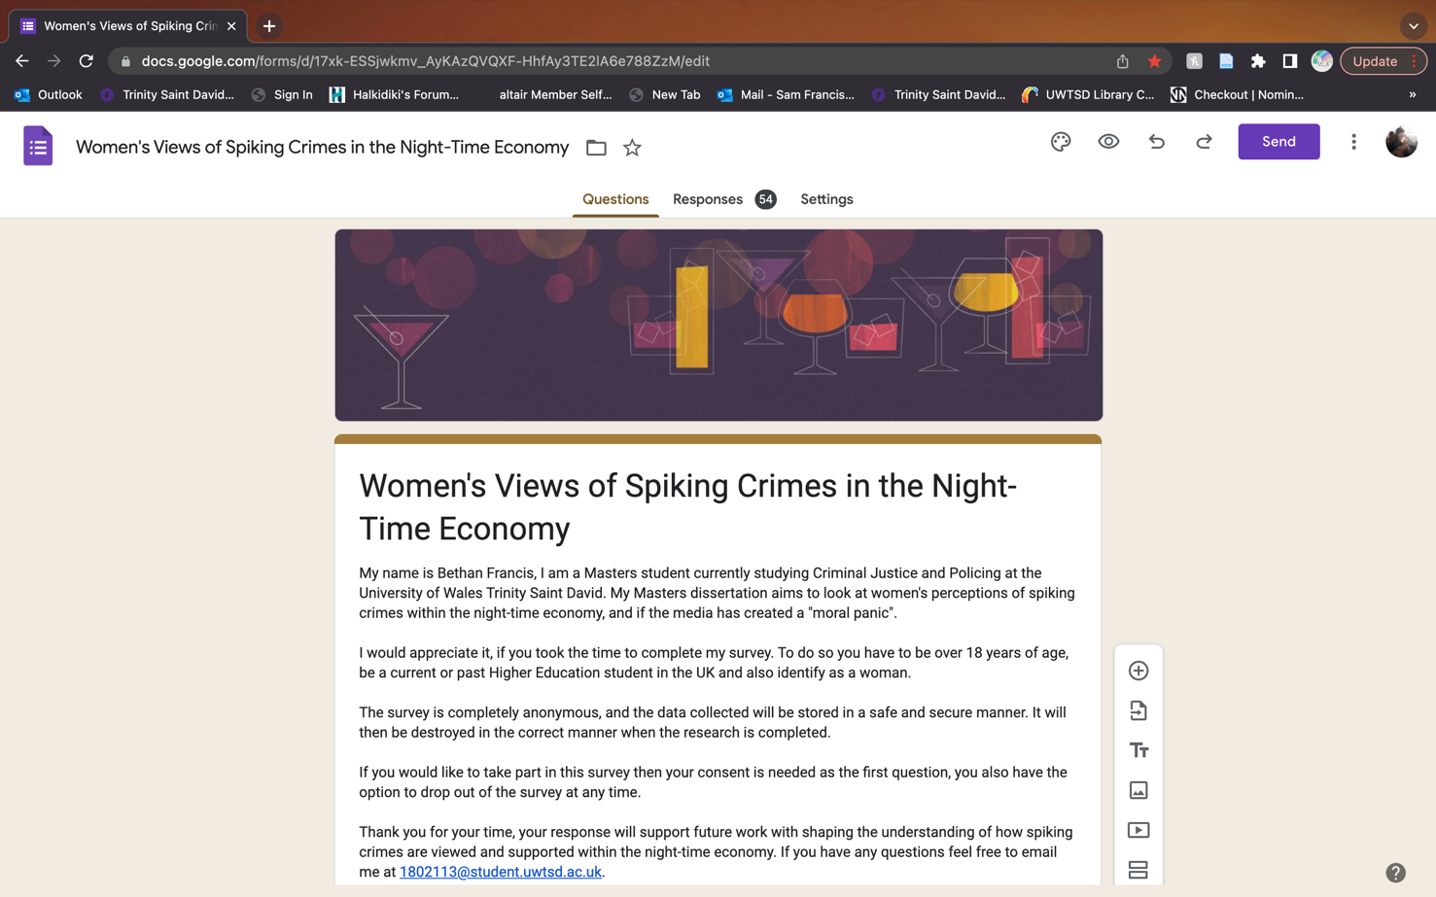

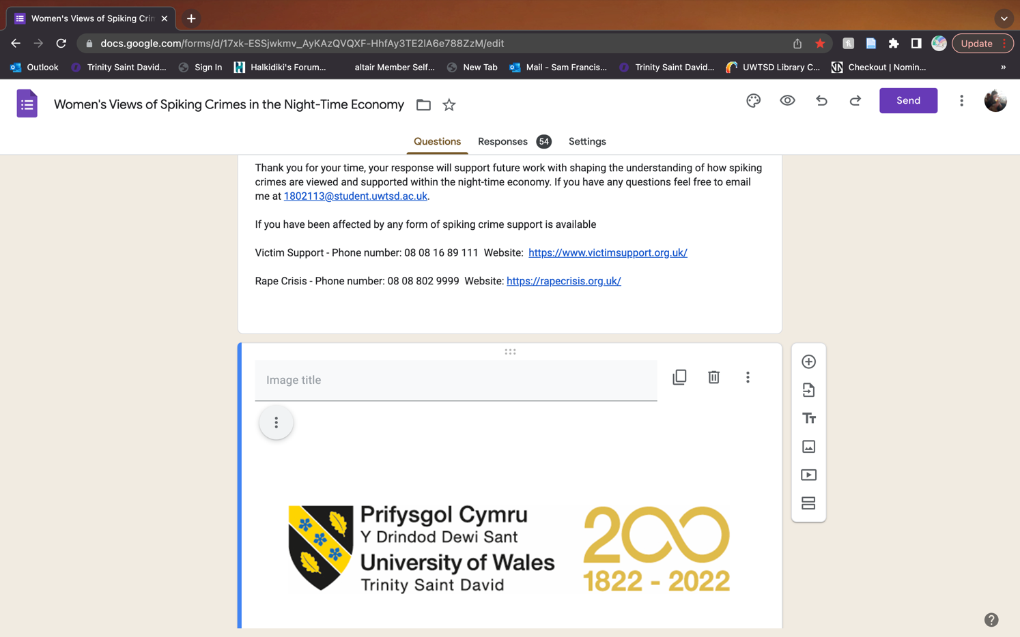

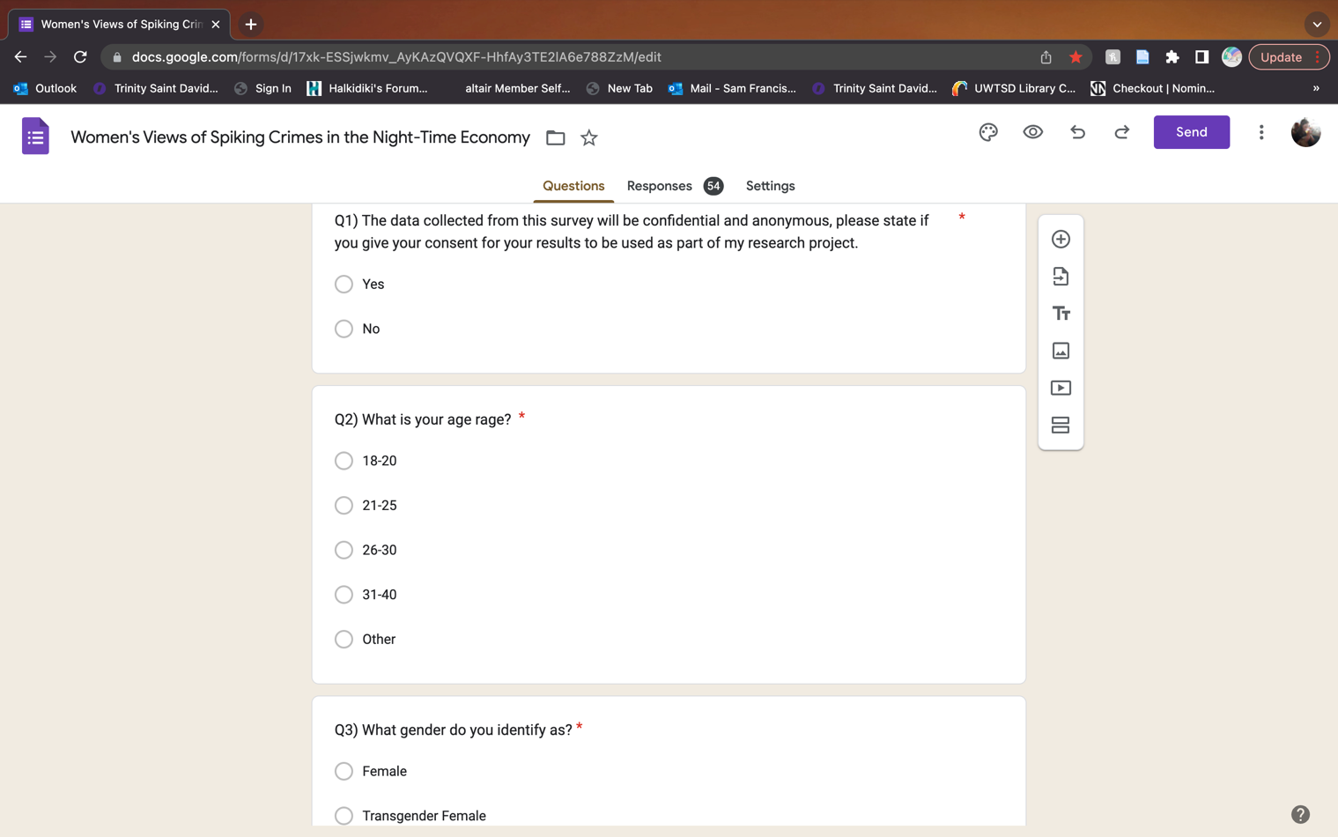

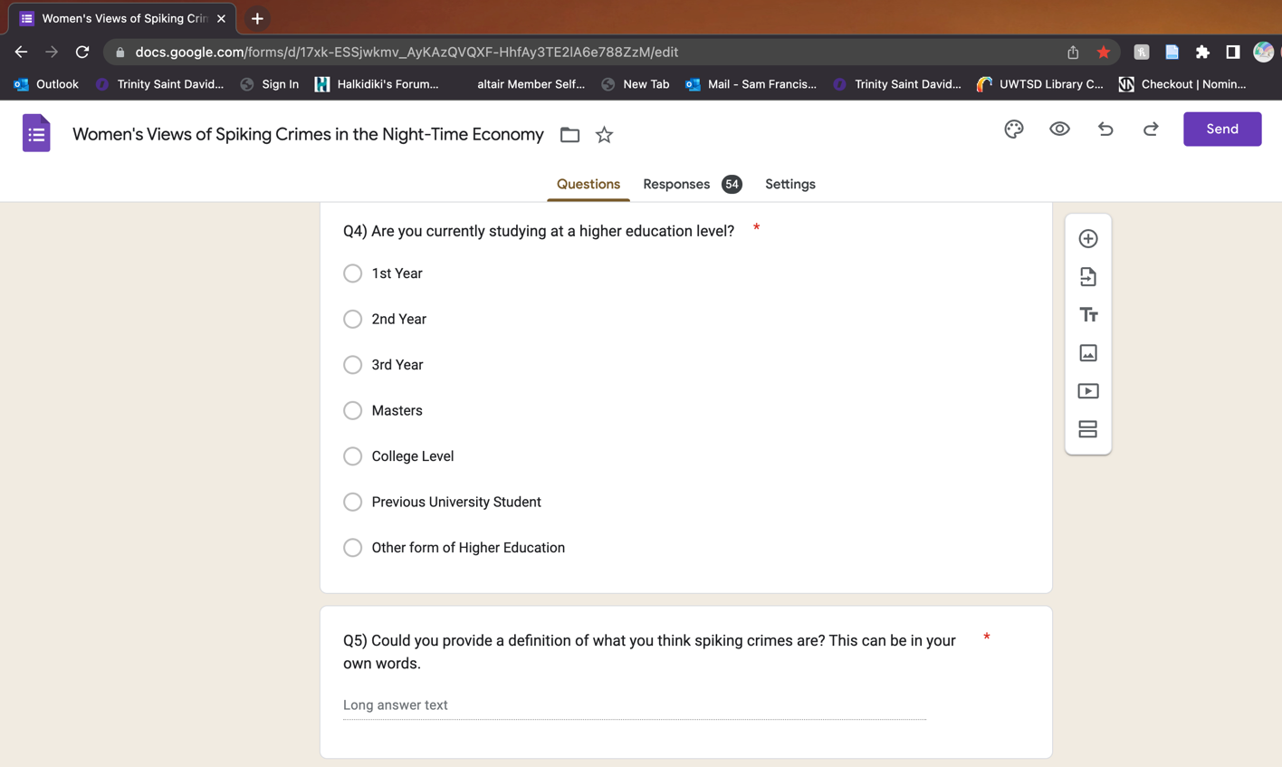

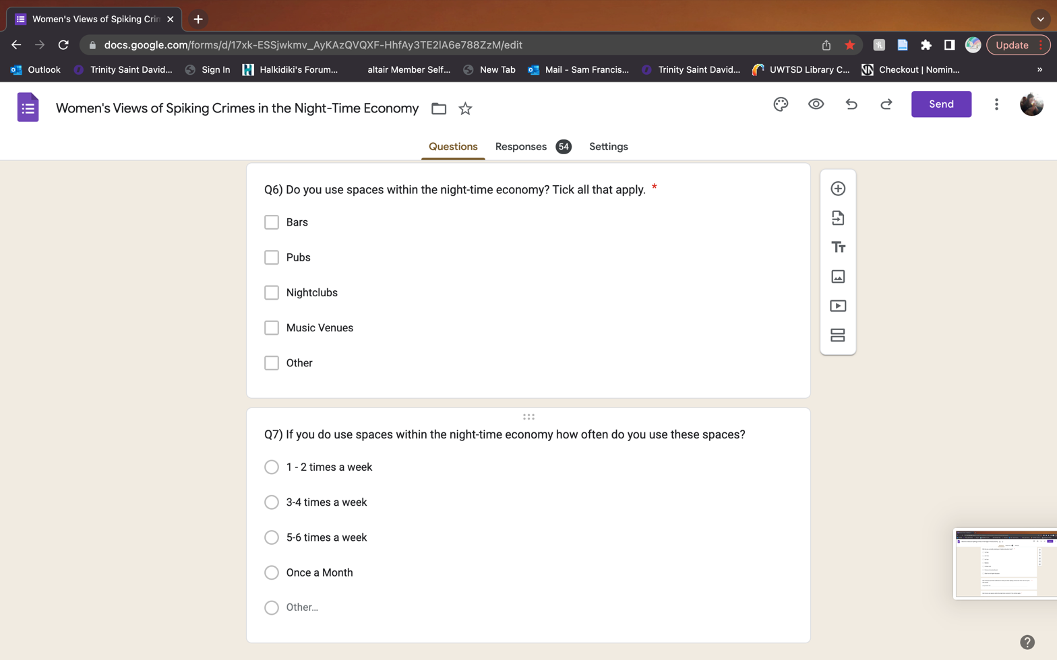

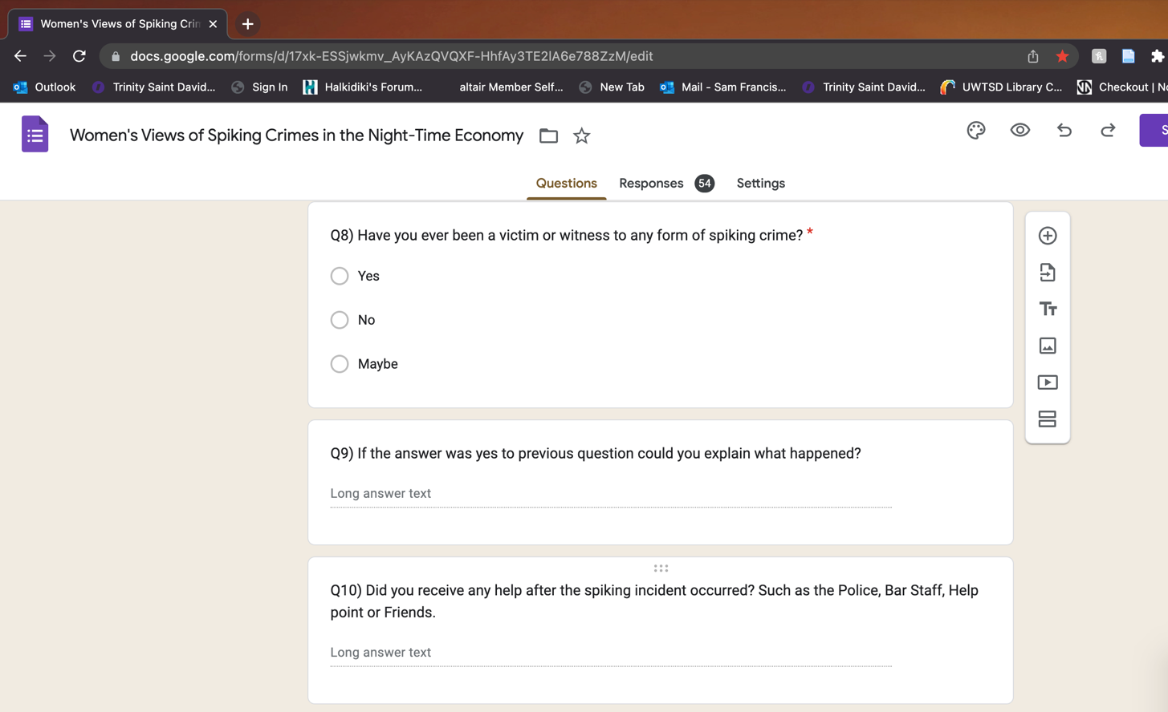
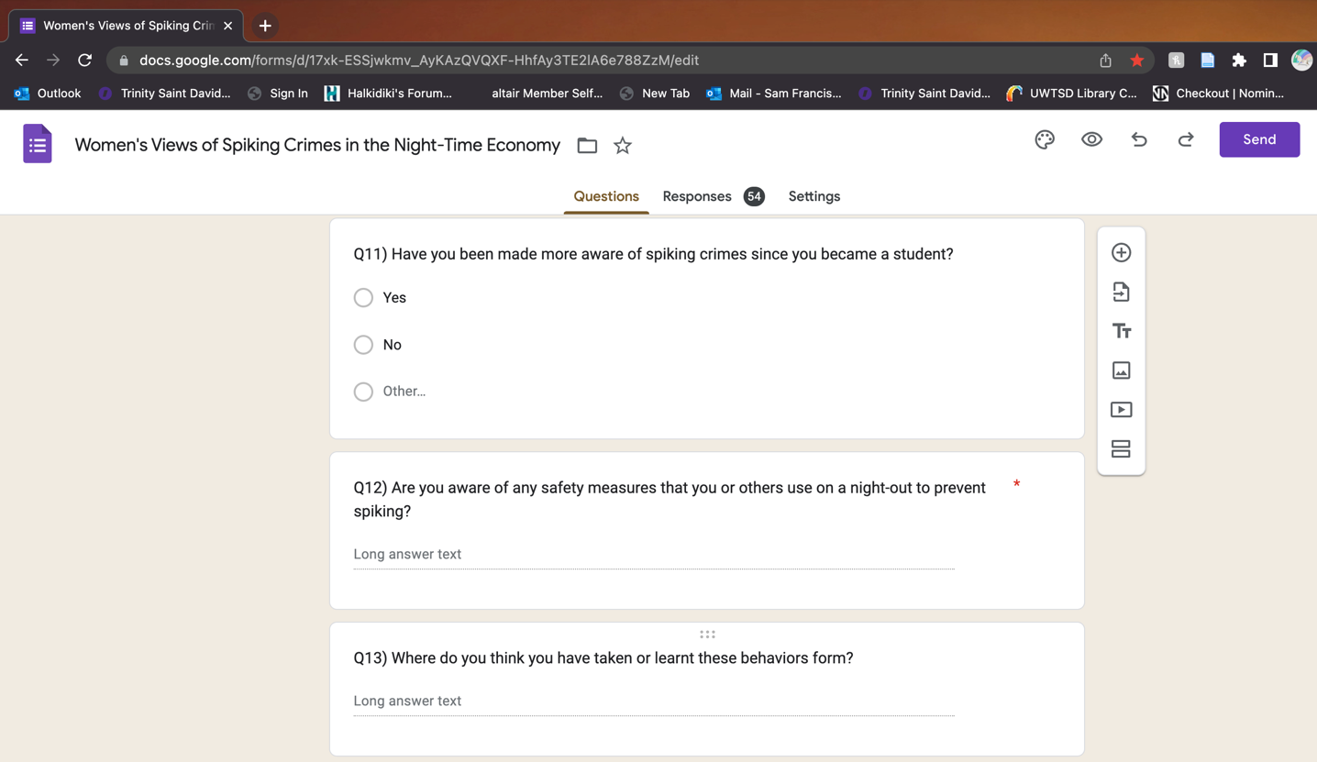
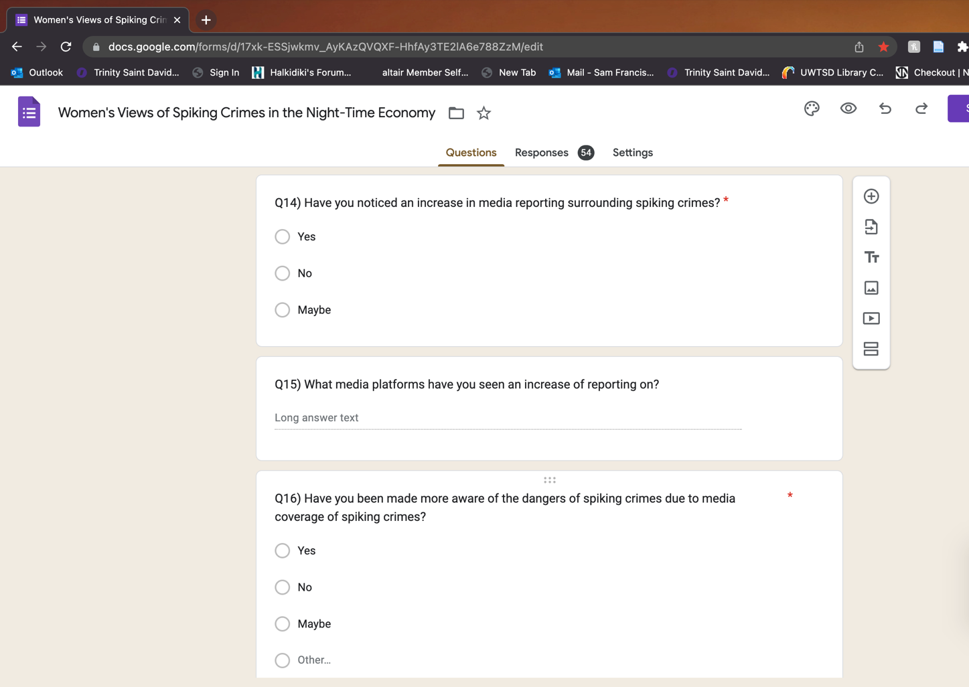

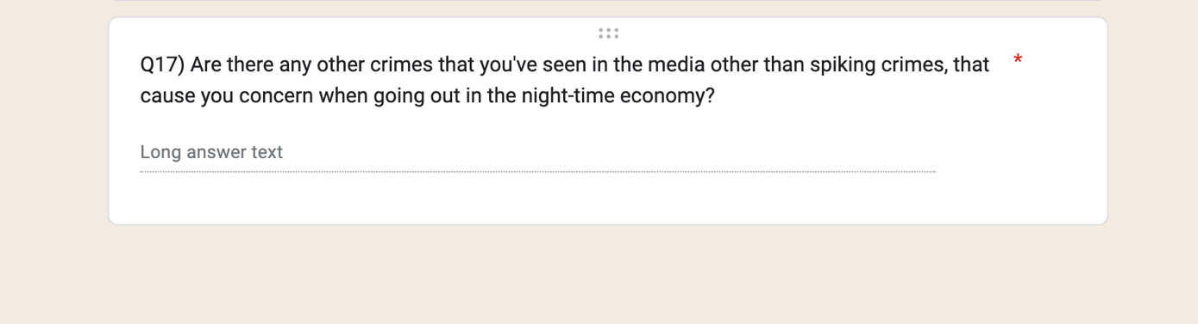

Appendix 2 – Graphs from data analysis

Appendix 3 – Data analysis word clouds

Q5) Could you provide a definition of what you think spiking crimes are? This can be in your own words.

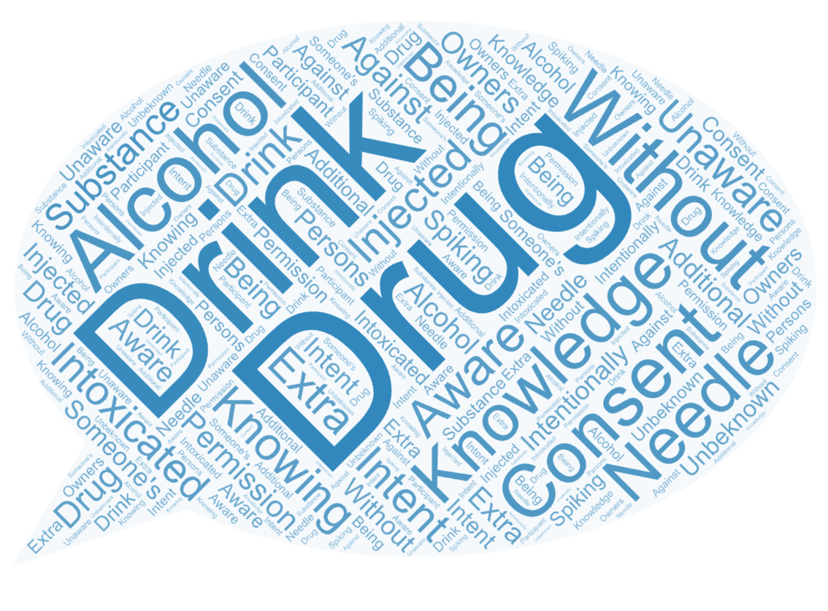
Q10) Did you receive any help after the spiking incident occurred? Such as the Police, Bar Staff, Help point or Friends.

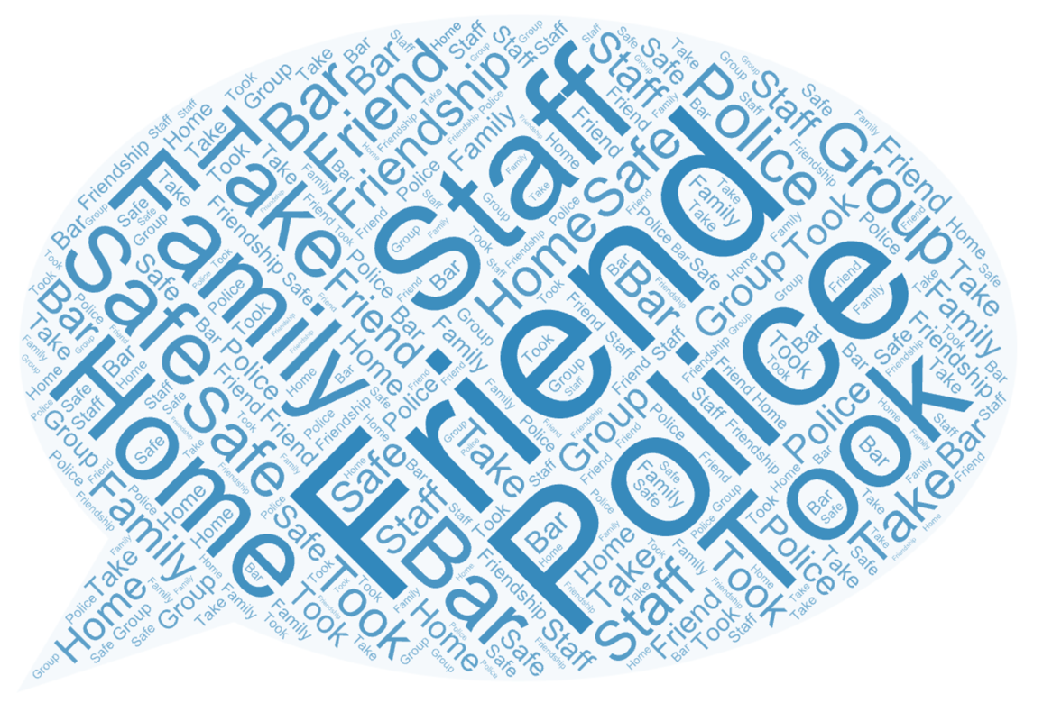

Q12) Are you aware of any safety measures that you or others use on a night-out to prevent spiking?

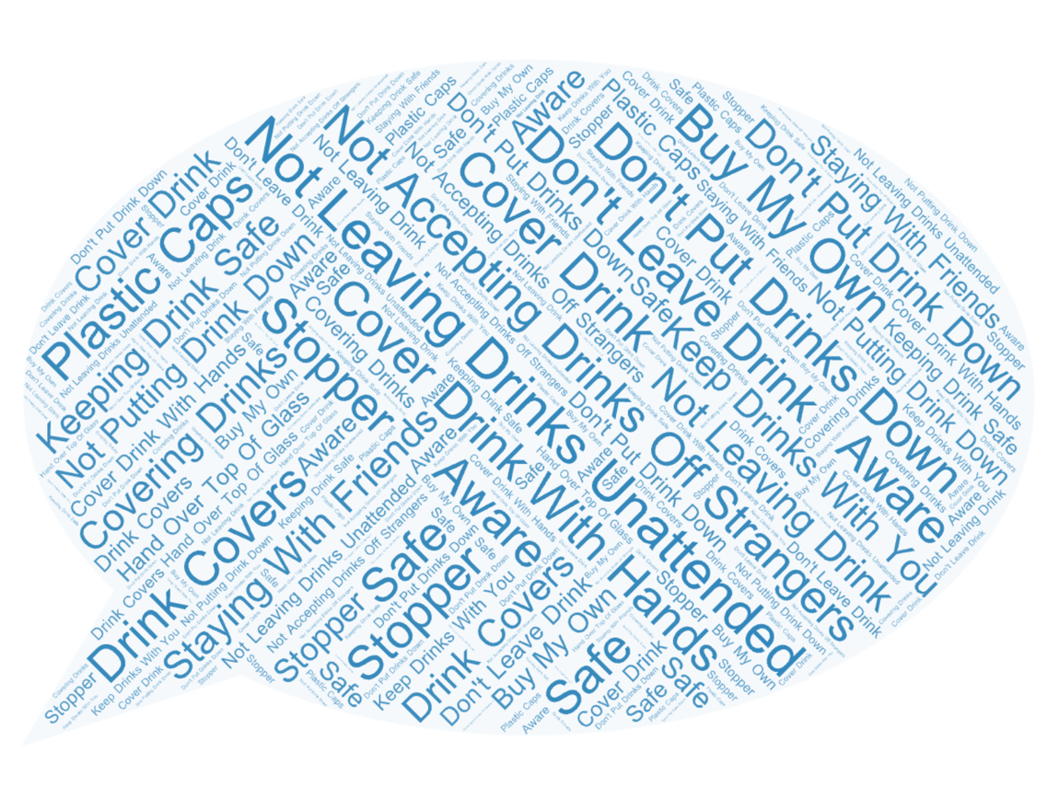
Q13) Where do you think you have taken or learnt these behaviours from?
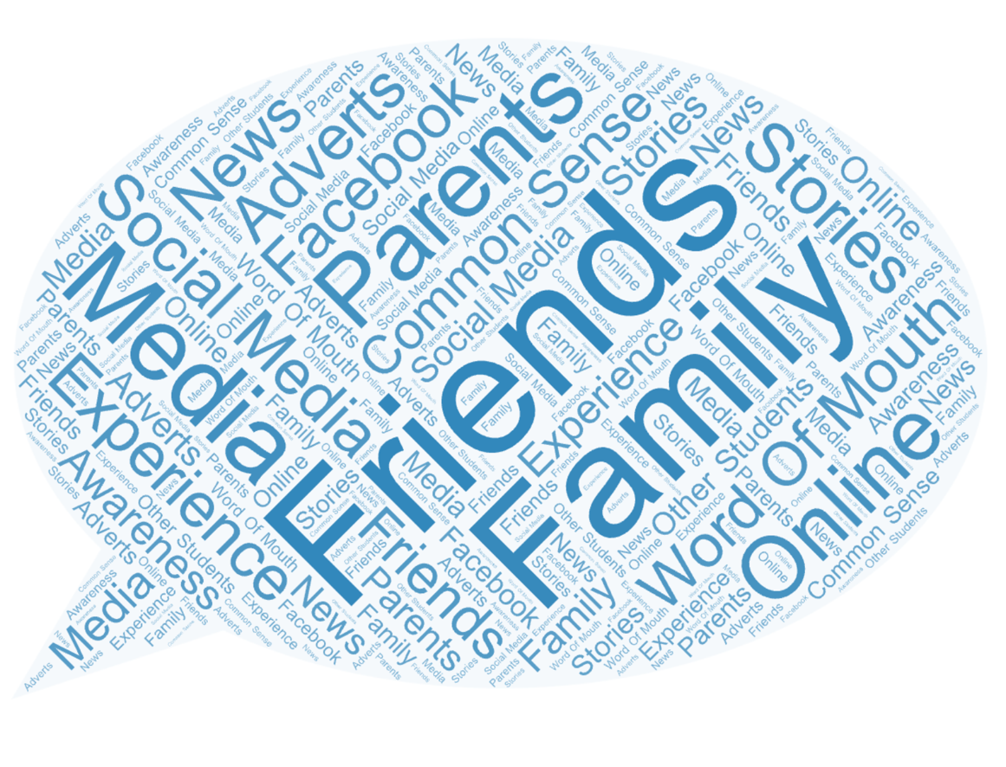

Q15) What media platforms have you seen an increase of reporting on?

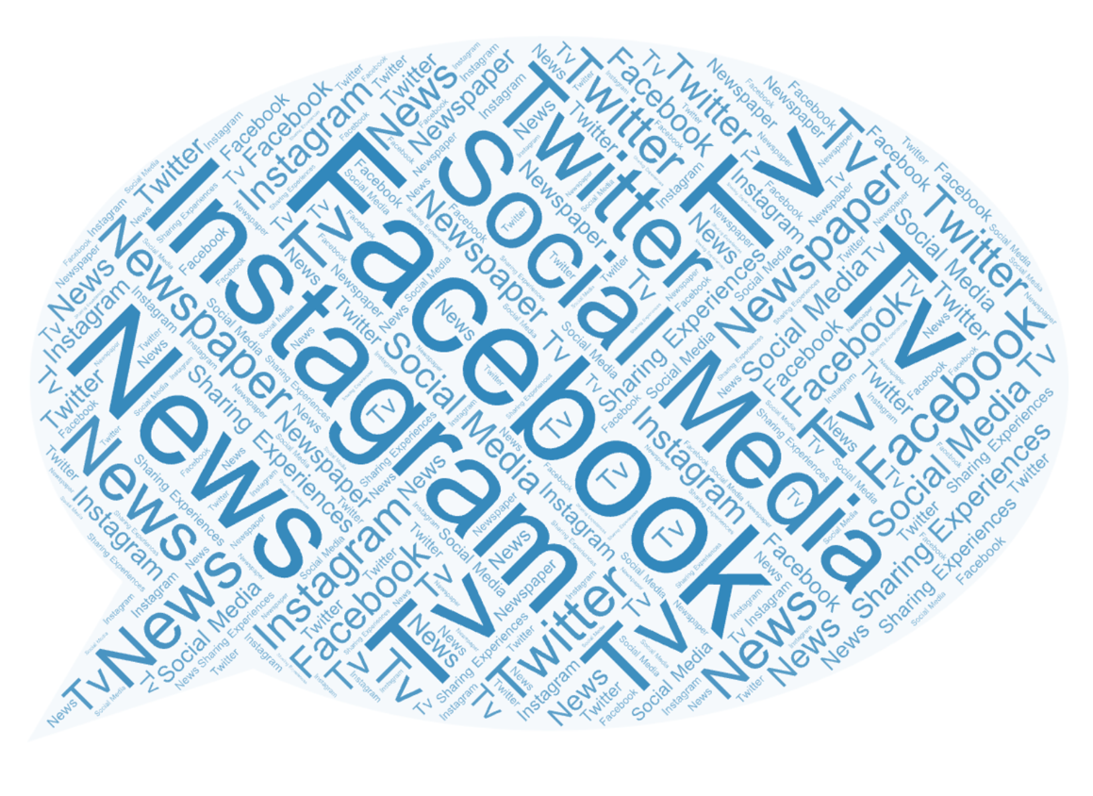

Q17) Are there any other crimes that you’ve seen in the media other than spiking crimes, that cause you concern when going out in the night-time economy?
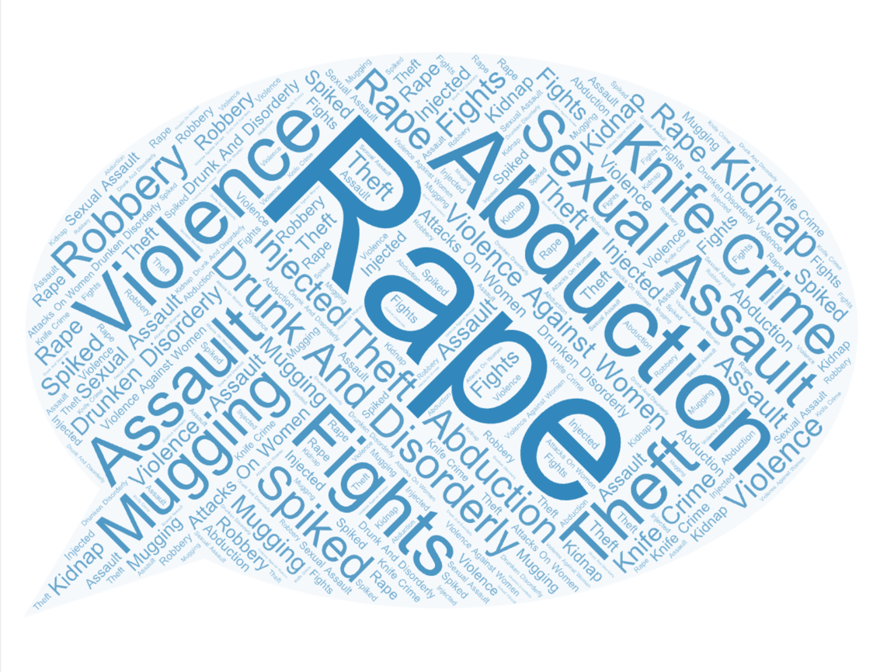

Appendix 4 – Question five survey answers

Q5) Could you provide a definition of what you think spiking crimes are? This can be in your own words.

Being drugged by someone without you knowing.

Given drugs without my knowledge

Placing something in someone else’s drink, that the person is unaware of. Leading to increased intoxication.

physical and mental harm to people

drugs or alcohol given without permission with the intend take an individual vulnerable, less inhibited

Putting a substance (legal or illegal) into someone's food or drink without them knowing about it

Illegally putting a substance in another person’s drink

When a girl goes out and she gets spiked without knowing.

When people are drugged unawarenessly by dropping into drinks or even injected.

Drugs

Putting alcohol or other drugs in someone's drink without their consent or knowledge.

Spiking drinks with drugs without the owner's knowledge or consent

When people add drugs or additional alcohol to a persons drink without them being aware of them

Spiking crimes, - against own will or knowledge, various settings where victims are made vulnerable by a substance, not allowing them to have control of their own body and mind.

High settings I feel are premises selling alcohol such as bars, nightclubs, education settings such as university and college

When a drug is given in either a drink or other forms against someone's will.

When someone puts a drug in your drink without your consent.

When someone interferes with a drink, by adding something to it or an individual by injecting you with a substance

Drugs put into drinks

A spiking crime is when drugs or extra alcohol is added to a drink without the person’s knowledge. This can result in other crimes - e.g. sexual assault, robbery and can have a detrimental effect on the person spiked - e.g. confusion, nausea, memory loss, loss of consciousness etc

Someone putting drugs into a someone else’s drink

Putting drugs into another persons drink without them being aware of it

When someone is given more drugs or alcohol than they consented to without their knowledge or permission

Not enough learnt at home

Giving another person drugs without their knowledge or consent

Whereby a drink is contaminated with a medication that prohibits normal behaviours

leaving you vulnerable with potential memory loss

Spiking drinks which could leave you unaware unconscious or no memory

Adding alcohol or drugs to someone’s drink without them knowing.

Spiking crimes are invasive drugging to an unbeknown participant (drugs or alcohol added to drinks or injecting someone).

Absolutely insane

Adding something to drinks/ injecting / giving someone something without their consent

Giving a person something without their knowledge

Big given something witbout consent

Given a drug without your consent

Been given drugs without my knowledge

When someone puts something in your drink or drugs you another way ,and you are not aware of it.

When someone drugs you without you knowing.

I would say it's when you get drugged without you knowing that you have been.

Being drugged by someone.

Spiking is intentionally giving someone drugs or alcohol for purpose of intoxication this can be through needle spiking, putting something in someone's drink or giving someone too much alcohol when they only asked for a single

giving someone drugs without their knowledge normally in drinks or needle

putting something in someone's drink without them knowing like GBH or another drug

slipping a drug into an individual's drink without their knowledge

I guess putting a drug in a persons drink or spiking them with a needle

Taking something that you don’t know about that could cause intoxication

i guess putting something in a persons drink on a night out

Someone else putting something into my drink with the intent to get me intoxicated

giving someone a drug without their knowledge like slipping it in their drink or something

giving someone drugs on a night out without them knowing

Having something put in my drink or could be stabbed in the back with a needle, heard that’s going around

slipping a drug into someones drink without them knowing

Someone who intentionally puts more alcohol or another substance into someone else’s drink when they are not aware of it with the intention for that person to become overly intoxicated

slipping a drug into a persons drink or spiking them with a needle on a night out

Appendix 5 – Question nine survey answers

Q9) If the answer was yes to previous question could you explain what happened?

Not sure but felt strange no myself

I have had friends come back from nights out who believe that they were spiked due to how intoxicated they were and how they feel afterwards. But that could have been down to how much they just drank on their own accord.

Suspected spiking after behaviour significantly changed after leaving a drink unattended and drinking it. Resulted in being kicked out of a nightclub and being supported by police

Can’t remember getting home- lost hours of the night

My legs stopped working properly and struggled to walk myself home, luckily I was with a large group of friends who go me home safe - we were only 2 minutes away from my house when this happened. I have no memory of what happened after but my friends told me I was pretty much unconscious/asleep for a little while. Next morning had a strange allergic reaction (no idea if they are related but have not had reaction before or since). I thought I was very safe with my drinks when I was out too - please note I did not have official confirmation that this was due to spiking but my friends agreed that I had not drank enough on that night for this to happen due to what I was drinking.

I've had this happen twice, first time aged 16 at a party, I remember having a coke drink, and next thing I knew was waking up in my bed, friends had seen me lose control of body and mind, and thankfully got me home to my parents. 2nd time aged 24, first night out with then partner after birth of our child, I had 2 drinks (bottled beer) good tolerance with alcohol and know my limits, same thing happened again, My partner and family members got me home, I remained in bed for 2 weeks feeling so unwell, this was at a bar/nightclub
Whilst out with friends in pub about 15 years ago I went from being absolutely fine to not knowing where I was and collapsing on the floor. Was taken home. When I woke in morning I had no memory of most of night before. When talking to a friend from previous evening I was told that same thing happened to her. We had been standing together with our drinks on bar behind us.

Fighting in streets

1996 hen party 1 drink was spiked in Mumbles

My daughter got injected in festival

Think my son was once spiked on a night out

I was in a nightclub in Swansea, I had left my drink on a table but had only had 1 drink previously. I went to the toilet and needed to be sick shortly after I went back to my drink then passed out and friends couldn’t wake me for about 2/3 hours when I woke up o was repeatedly sick and my legs were very weak and was unwell for a few days after

I just felt really strange after just one drink

I think I was spiked around 10years ago .Think someone put something in my drink.

My friend in university was drugged on a night out. She was OK one minute and totally out of it the next. It was like she was really drunk unable to stand up straight falling over and we wete unable to communicate with her properly as she was out of it.

I think I may have been spiked a few years ago.

My friend potentially got there drink spiked when they were out for the rugby, or they had too much to drink it was hard to tell. They were acting more than drunk and almost got taken home by the police. I also worked behind a bar and there were definitely some overly intoxicated people where there friends were providing them with drinks that they shouldn't have been.

my drink got spiked on a student night out

some man put something in my friends drink it was horrible she was ill for days

friend got spiked at a concert

got spiked at a club was not a pleasant experience, a man bought me a drink
in a nightclub don't remember what happened exactly just remember feeling funny and more drink than the amount of drinks i actually drunk

Someone I don’t know who spiked my drink, I could taste that my drink had changed and when you looked at it it was cloudy.

Friend got spiked in a club once, started to feel weird and act different like falling and stumbling and acting overly drunk when in fact she really had not had that much to drink to was frightening

a friend just thought she had been spiked when she had too much to drink we still can't tell of that was what happened or not because it was the same symptoms but she did take a drink off a boy so we assumed that he had spiked her when she started being sick and could stand.

Appendix 6 – Question ten survey answers

Q10) Did you receive any help after the spiking incident occurred? Such as the Police, Bar Staff, Help point or Friends.

Friends

No

I imagine will

Supported by police and family to get home

Friends

Friends and family

Eventually

Friends help take her home

Yes staff from festival morning after

No

Friends helped and stayed with me for the time then the bouncers took me into a room but was just under the impression I had drank too much a thought it was very early and had only had 2 drinks at the time and was clearly not just drunk

Friends took me home

No ,I just felt awful for a few days and very down.

The police helped us to get her transport to hospital. She went to hospital and underwent tests where they told her she'd been a victim of spiking.

I didn't realise I may have been spiked until following day.So No.

The police tried to help but didnt know how as they thought my friend was just overly intoxicated and acting out other than that no no one offered other than the rest of us in the friendship group.

no not really other than my own friends looking after me

no we so her friends just looked after her

no not really i just looked after her went to look for her other friends

no

my friends said they looked after me and just got me home safe and put me to bed

I made sure to stop drinking and went home with a friend, I was lucky all that happened was that I was severely hungover the following morning.

we asked the bar staff for help but they did nothing so it was left to use as her friends to get her home safe

Nope

Appendix 7 – Question twelve survey answers

Q12) Are you aware of any safety measures that you or others use on a night-out to prevent spiking?

No

Yes

No leaving drinks on there own and going back to them.

We don’t put out drinks down, over it with our hands at all times, or you can get drink covers behind some bars and stoppers in long neck bottles to prevent spiking.

suspicious people, 911 emergency calls and wear more safety clothes

There are plastic caps that fit on drinks to reduce the risk. Don't leave your drink in attended (although it is not always put in your drink)

Not leaving your drink unattended, putting your hand over the top of the glass, staying with a group of people

Covering drinks with hands or drink covers

Some Of Them yes.

Don’t drink in crowds and sit somewhere to drink, don’t accept drinks off other people

Not putting drink down or not buying a drink at all.

"spikeys" to put in bottles that only allow room for straws, thumb over the top of bottles when walking around/dancing, not accepting drinks from strangers

Yes, mindful, observant, safety precautions, I don't accept drinks from anyone, I buy my own, have used spike preventive methods such as the stop cap to put inside bottles.

No, other than alerting door staff and not leaving drinks unattended

Don’t leave your drinks unattended

The bottle stoppers, which allow straws to be inserted and glass covers

Straws

Yes - buy own drinks, don’t leave drinks unattended, don’t take drinks from strangers etc

2 of us go together to order the drinks?

Cover drinks Never put drink down

Spikies, night caps, not leaving drinks unattended

Cover ur drink at all times

Nail varnish that changes colour

Yes keeping drinks with you and covered at all times

Never leave drink unattended

Drink covers, group of friends who look out for each other.

Yes

Drinks covers, never leave your drink!

Just been aware

Don't leave your drinks unattended.

Been safe

Keep hold of your own and your friends drinks and don't leave them unattended.

Only drink from bottles so you can cover top of bottle. Keep your drink with you at all times.

Don't leave your drink. Don't get to drunk so you are not in control.

Look after yourself and friends. Never leave drinks unattended. Stay away from bars ,clubs etc ,which have bad reputations when it comes to drugs and spiking.

Not going to places where you know people use drugs.

Bottle tops and drink covers are the main ones that social media shows but the ones I actually use are never leaving my drink and not taking a drink of anyone I don't know I only get myself drinks or my partner other than that no thanks. Definitely my parents and friends telling us to be safe and look out for each other

covering drink tops, and also bottle top stoppers and not taking drinks of strangers

yes, things like keeping your drink safe and not taking a drink of anyone you don't know

just covering my drinks and making sure im aware of my own safety

not taking drinks from strangers and keeping my own drink safe

Cover drinks, don’t put them down. If it’s cloudy or discoloured in anyway, tastes different give it back to the bar staff to get rid and order a new drink

what i normally do now so no drinks from strangers and just keeping my drink close to me

Covers can be put over drinks

just keeping my drink with me and if i don't i get rid of it and get another one

keeping my drink to myself and just being aware of my surroundings

Covers for drinks

just staying with friends

We make sure to never put our drinks down we keep them in our hands at all times and cover them as best as we can

staying close to friends

Appendix 8 – Question thirteen survey answers

Q13) Where do you think you have taken or learnt these behaviours form?

friends and social media

From friends. Stories of instances either by word of mouth or reading on Facebook mainly sometimes the news such as wales online will publish articles about spiking in local nightclubs.

friends, online

Word of mouth, adverts

Other students, social media

Other girls who have been spiked/ social media informing me about ways to stay safe

Word of mouth

Hearsay. Media.

Experience over the years

Hearing other peoples experiences in media

experiences and online

From experience

Media

Just word and mouth

Word of mouth

Peers

Unsure

It’s just something I’ve always done

Bar staff training and online

Not worth going out

Marketing advise

News

Some are common sense, others throgh media

Word of mouth, Social media

Social media

Previous experience, adverts

Friends

My parents.

Friends

Just common sense

Think it's just common sense not to leave your drink unattended making it easier for someone to put something into it.

Parents.

I think everyone knows not to leave their drinks unsupervised. Also from experience of going out in night time economy you hope you've learned to notice suspicious behaviour.

I think it's common sense to avoid places which have a bad reputation for drug spiking and drug use.

parents and friends

friends and mum

friends and family

definitely family and friends

friends and possibly family

Just having an awareness of it from uni days, all girls looking out for each other, hearing horror stories from others.

family or friends don't really know

From friends experiences and my own

Uni friends and family like telling me to be safe and look out for weird behaviour
Family

From friends and family stories

From others, friends stories, social media. The police came in in first year and gave a talk about the importance of keeping aware of your surrounding and to make sure you know if you’ve been spiked or not, like the cloudy colour or taste change in drinks

Appendix 9- Question fifteen survey answers

Q15) What media platforms have you seen an increase of reporting on?

Social media

Facebook

Facebook

All

Facebook, Instagram, university pages such as the SU in Cardiff.

Instagram

Newspaper, facebook

Instagram, Facebook

Social media- Instagram for example, many female sharing their experiences of being spiked

Social media

Facebook. Instagram

News, social media

News apps, Facebook

Facebook

Social media such as Facebook, tik tok Also newspapers such as the sun

Facebook, Instagram, news channels etc

In the news

Instagram, newspapers

Everything u read this days

TV

Radio

News channels on tv

Tv, social media

TV, newspapers, Facebook

Facebook, tv

Snapchat

Newspaper articles.

Tv news,social media.

Twitter

Online, tv

Social media, TV news channels.

Newspapers,social media and TV news channels.

Tv , Social media.

News and social media

the news on TV and social media

social media, like facebook and twitter also newspapers on facebook like online

Facebook, twitter online news sources

facebook and twitter sometimes instagram posts

facebook and others like instagram like newspapers online being posted and individuals sharing their own stories

Facebook, Twitter, in the papers

twitter and instagram like people posing their stories of what happened

Instagram

Facebook definitely and also people sharing stories on instagram of what happened to them
Facebook, instagram anything twitter

Facebook, and Twitter

TV and social media like Facebook

Instagram posts from friends about experiences

Facebook and other social media sources as well as TV

Appendix 10 – Question seventeen survey answers

Q17) Are there any other crimes that you've seen in the media other than spiking crimes, that cause you concern when going out in the night-time economy?

Knife crime

No

Fighting

Instances of kidnap, and rape that have come from spiking.

Stolen

General violence and rape

Rape, murder, assault

Sexual assault

Violence against women.

Sexual assault, mugging, rape

People being injected whilst in clubs.

Theft, drunken disorderly behaviour that leads to violence

Weapons are becoming a thing where I live now, carrying of knives, gangs fighting

Yes, sexual assault. We are seeing a lot more of this being reported (of course a good thing!)

But it's disturbing to understand how often this is happening to women in our city.

Attacks on women in the evenings

Abduction of women/ youngsters, there's was a report on TV and FB about a place in Swansea where young girls were locked in

None

Antisocial behaviour leading to fights & someone getting hurt

Rape, SA, murder

Yes safer to stay at home

Acid attacks

Mugging, stabbing, assault, rape

Theft, videoing crimes, gbh, gang bulling

Always concerned about my Sons when going on a night out with regards to their safety

Still the same problem but people using needles to spike people in clubs

Been assaulted.

Maybe violence.

Unruly behaviour drunk and disorderly..

Drinking behaviour, violence.

No really.

Drunken disorderly behaviour.

Robbery, drunken behaviour violence.

Assault

Probably being taken like by a man as that seems to always feature on the news someone going missing and then being sexually assaulted or killed

violence or being taken like abduction

being taken and murdered seen lots of that recently

violence and being taken by a stranger

men and their violence and other behaviour towards women

Rape, sexual assault, robbery

no not really other than being spiked and then taken by a stranger

Rape, drug abuse

i don't really think about it maybe like being taken by someone i don't know

no not to my knowledge

Muggings, rapes

nope maybe violence like rape and what not but not really

Rape, sexual abuse, fighting

no not really

Appendix 11 – News articles produced between May 2021 and August 2021

Appendix 12 – News articles produced between September 2021 and December 2021

