May Davies

Advanced Software Development
OO Programming

Contents
1.Declaration 2
2.Abstract 2
3.Introduction 2
4.The Car Park Task 1 2
4.1.What is Object Oriented Programming 2
4.2.Classes and Class Diagram for Car Park Task 1 3
4.3.Task 1 Testing 4
5.The Car Park Task 2 7
5.1.Inheritance 7
5.2.Revised class diagram for Car Park Task 2 8
5.3.Task 2 Testing 9
6.User Guide 10
7. References 12
8.Appendix A – Code 13
8.1CarPark.cpp 13
8.2.EntryBarrier.cpp 18
8.3.ExitBarrier.cpp 20
8.4.FullSign.cpp 22
8.5.IDReader.cpp 24
8.6.Sensor.cpp 26
8.7.Source.cpp 27
8.8. CarPark.h 28
8.9.EntryBarrier.h 29
8.10.ExitBarrier.h 29
8.11.FullSign.h 30
8.12.IDReader.h 31
8.13.Sensor.h 32

1.Declaration
The work of this report has been completed under the supervision of Gordon Dickers. I declare that this report is the product of my own work and is not being submitted for any other degree etc.

May Davies.

2.Abstract
This report goes over the successful implementation of an object oriented car park written in C++, and includes class diagrams along with explanations of said classes. There is also a testing log for this program, and a user guide as well. Code is available in Appendix A.

3.Introduction
This is a report that has been written for the purpose of creating a Car Park using C++ in Visual Studio with the use of Object Oriented Programming, there are a few different techniques available in Object Oriented Programming that have been demonstrated within this report.

4.The Car Park Task 1
To begin with, the first task is to make a car park. This car park is made up of an entrance barrier, an exit barrier, a sensor for both of these barriers, a full sign, and an ID Reader. The ID Reader is implemented in Task 2 in this report, so task 1 in this report will not go over the ID reader.
A car should be able to approach the entrance barrier, the barrier should detect it, the barrier will lift, the car will drive through, the sensor will no longer detect the car, the barrier will lower, and then the available space in the car park shall go down. If a car leaves the car park, a similar thing will happen with the exit barrier, except as the car is leaving, the available parking space will increase.
If there are no spaces, the full sign should light up, and the entrance barrier should refuse entry.

4.1.What is Object Oriented Programming
Object oriented programming is essentially a method of programming that can allow the programmer to create objects. Objects are made up of the attributes and methods that have been defined by that objects class [1].
Essentially, a class acts as a template for an object.

4.2.Classes and Class Diagram for Car Park Task 1
The following is a class diagram that has been created to represent the Car Park as it should be for Task 1.
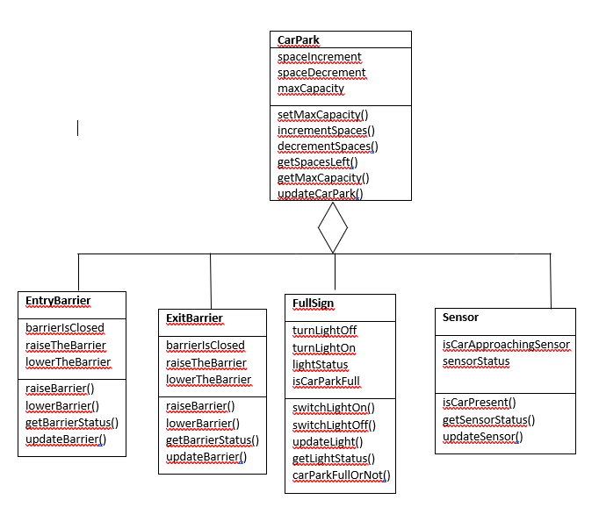
Here it can be observed that the car park object itself contains within it 4 other objects, being the barriers, the full sign, and the sensors. The top halves of the tables represent the variables/arrays, while the bottom half represents the different methods that the object class contains.
So, the car park itself has multiple different methods for managing the remaining space in the car park. A majority of this program should happen within the car park’s update method.
Meanwhile, the entry and exit barrier has methods for lowering and raising barriers. The update method for these object classes should toggle the raising/lowering of the barrier each time the car park update poll happens, as this will be where the barrier will be called.
The full sign object calss has methods for toggling on and off the full sign’s light, so that people driving by will know that the car park is full, thus cannot be entered. The update method for this will toggle the light on and off when it is polled by the car park’s own update method.
Lastly, the sensor object class has methods for checking if a car is near the barrier or not. The update method for the sensor will toggle the censor detecting a car on and off, which will be polled each time the car park’s own update method is executed.
To see the code for this, please see Appendix A, however, do note that task 2 has some changes to the system, thus Appendix A is representative of this program after task 2, not necessarily as it is in task 1.

4.3.Task 1 Testing
The following table is a test harness for task 1 of the Car Park scenario.
Test no. | Description | Expected Result | Actual Result | Success Y/N? Other Notes
1 | Check that the car park size can be set to 4 | Car park size becomes 4 | 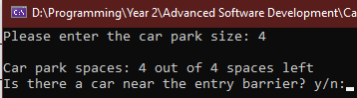 | Y
2 | Check that the car park size defaults to 5 if a value that is 0 or less is entered | Car park size should become 5. | 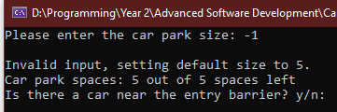 | Y
3 | Check that if no car is detected, the available size of the car park does not change | Available size does not change. | 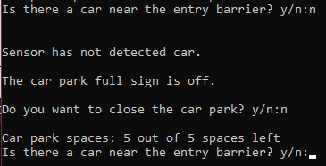 | Y
4 | Check that if a car is detected by the sensor, the barrier raises, and the parking space goes down by 1. | Available space should go down by 1. | 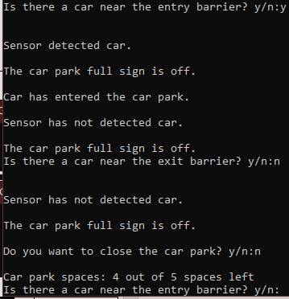 | Y (Note: There is no Cout for barriers, though they did go up/down as intended.
5 | Check that a car cannot enter if the car park is full. | Car park is full light should turn on, and the car should not be able to enter. | 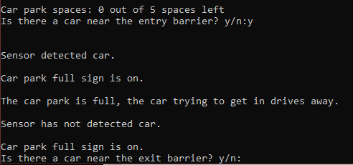 | Y
6 | Check that a car cannot exit from the car park when its empty | User shouldn’t even have the option to exit a car if the car park is empty. | 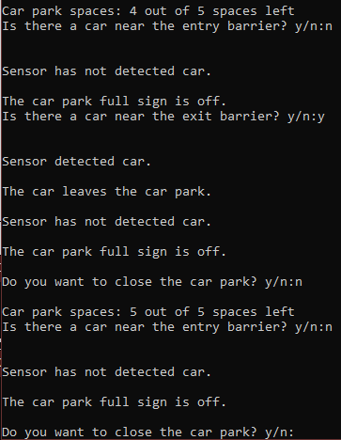 | Y
7 | Check that the user can exit the program | Upon typing yes, or y on the prompt for closing the car park, the user should be given a good bye message as the main loop ends. | 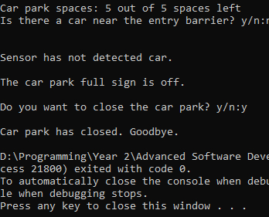 | Y

5.The Car Park Task 2
The second task of this car park scenario is to do with inheritance. The ID Reader will now be included in this section, as this task is to make two different types of ID Reader. One of these is a bar code reader, while the other is a number plate reader. These are both readers, and as such inherit from the ID Reader base class.

5.1.Inheritance
Inheritence essentially allows for a class to be created from another class that uses that class as a base [1]. The class that has been made that inherits a previous class will have certain functionality that the original did not, though due to it being a similar object, it can be made with inheritance also have the same properties as the base class. For example, a base class of animal can be derived to inherited classes of dog, or cat, or bat.
Another example could be a car base class, which has a horn method and a brand, and then a class derived from that to be a car with a specific model. It will still have the capabilities to have its own horn method and brand, as it inherited these from the base class[2].
This is relevant to this task, as the task desires 2 different ID readers to be made by being derived from an ID Reader base class.

5.2.Revised class diagram for Car Park Task 2
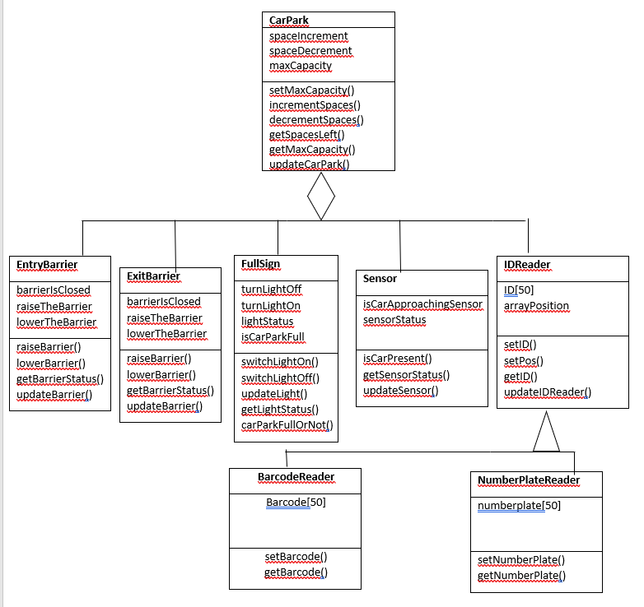
As can be seen, now there is an ID reader that has been added, which is the base class for a number plate reader and a barcode reader. Whenever the program will run through the car park’s update method, these readers will be used when a car has reached the appropriate barrier to add or remove a logged ID alongside its barcode and its number plate.
The barcode and numberplate have both inherited IDReader, meaning that they can both make use of the attributes in IDReader as they are both a type of IDReader.

5.3.Task 2 Testing
The following table is a test harness for task 2 of the Car Park Scenario.
Test no. | Description | Expected Result | Actual Result | Success Y/N? Other Notes
1 | Add an ID with the barcode “BZBB” and the number plate “B0BWSH3R3” | Should give an ID number. | 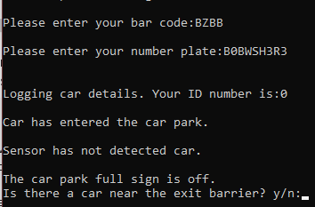 | Y
2 | Exit car ID 0. | The car that leaves should have the bar code BZBB and the number plate B0BWSH3R3 | 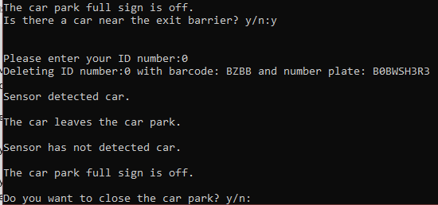 | Y
3 | Check that if the user does not enter a number plate and bar code that they cannot enter | User should not be able to actually enter an empty input, pressing enter should do nothing until they enter an input. | 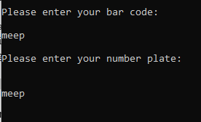 | Y Note: Here if the user presses enter, the user will only go down a line if the input is empty, forcing the user to enter something as seen here, “meep”.
4 | User should not be able to exit an invalid id | Trying to exit the id “74” when it does not exist should put the user in a loop until a valid ID is entered. | 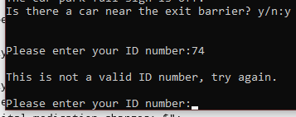 | Y

6.User Guide
When the user runs the program, the user is greeted with a screen which will allow the user to set a car park size. This number could be anything, however as the arrays for reading ID’s are not dynamic, the functional maximum is 50.
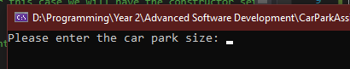
Once the user has entered a car park size, the main loop will begin. The user will be prompted for if a car is approaching. If the user types a variation of yes (be it yes, y, y, so on), the car park is polled to see if the car park is full or not. If it is empty, the user will then be able to enter a barcode and a number plate.
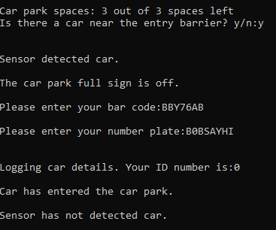
Now that there is a car in the car park, the user will be asked if a car is leaving. If the user confirms this, the program will ask for the ID assigned above to the relevant car that is leaving, to remove the car’s details.
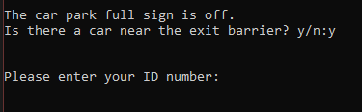
Upon entering the ID, the car will be removed, and will drive out of the car park.
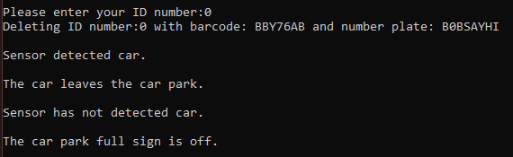
The user will then be asked if they would like to close the car park. If the user confirms this, the car park loop will stop, and the program will end.
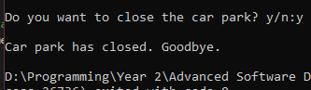

Additionally, if the user enters an invalid input for car park size, the size will be assumed to be 5.
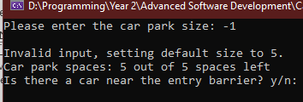
If the user enters an invalid ID to remove when attempting to exit, the user will be put through a loop until a valid ID is entered.
If the car park fills up and the user attempts to enter another car, the car will not be able to get in, the full sign will be turned on, and the car will be forced to drive away.
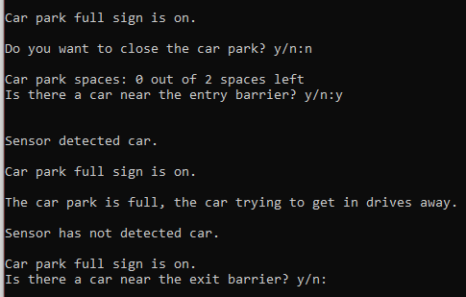
Additionally, if the car park is empty, the user will not even be prompted for a car to exit, as a car that does not exist should not be able to exit the car park.
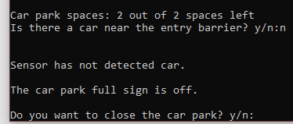

7. References

[1] | J. M. Chambers, “Object-Oriented Programming, Functional Programming and R,” Statistical Science, vol. 29, no. 2, p. 169, 2014.
[2] | W3Schools, “C++ Inheritance,” Refsnes Data, [Online]. Available: https://www.w3schools.com/cpp/cpp_inheritance.asp. [Accessed 10 2 2021].

8.Appendix A – Code

8.1CarPark.cpp
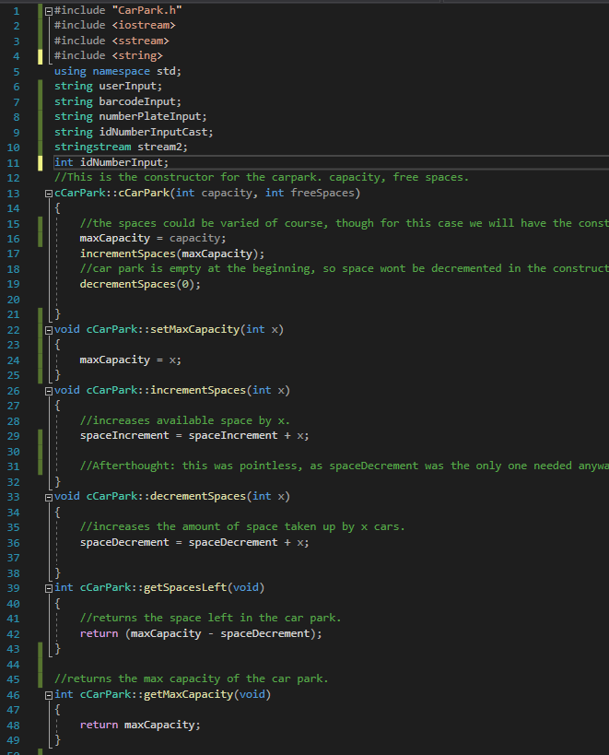
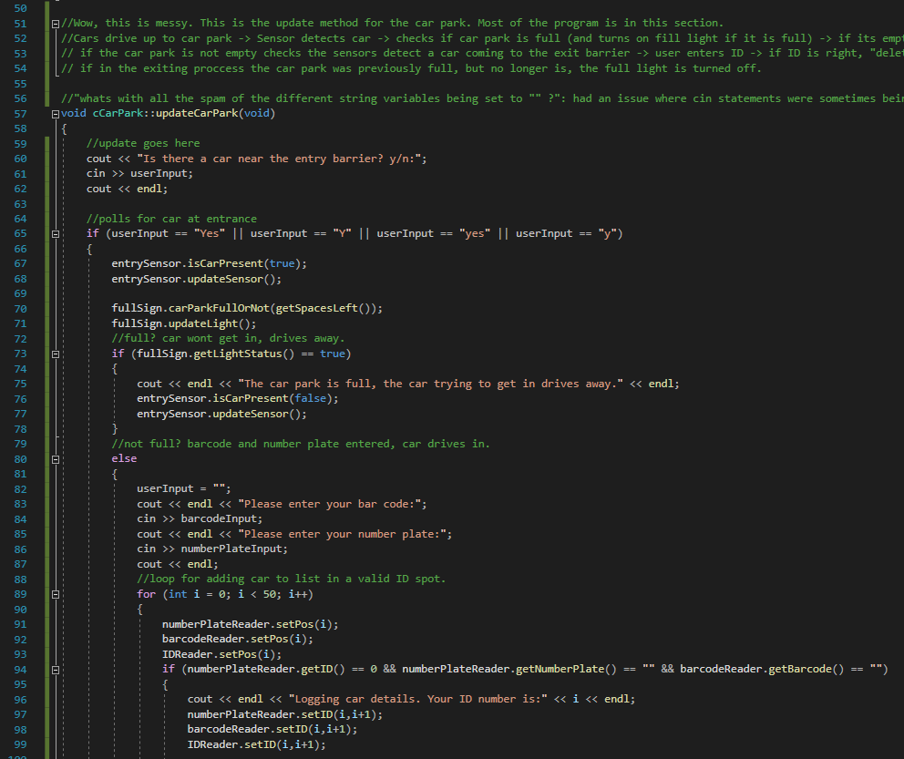
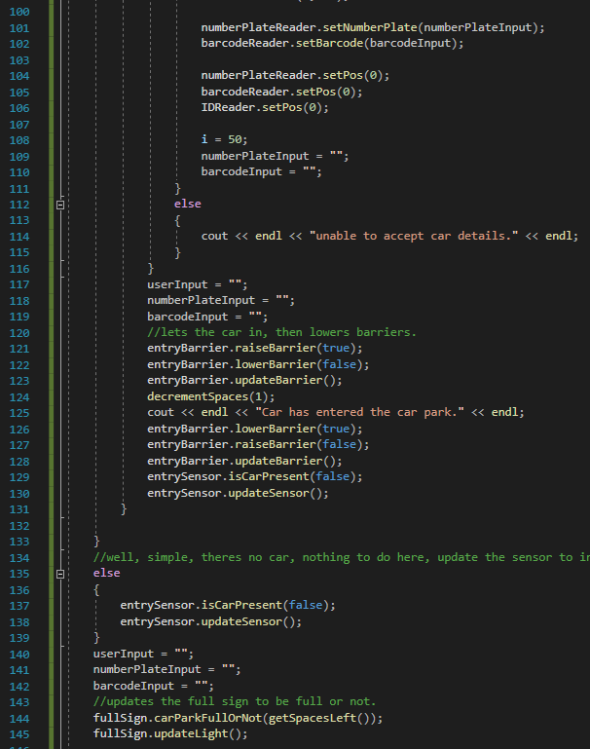
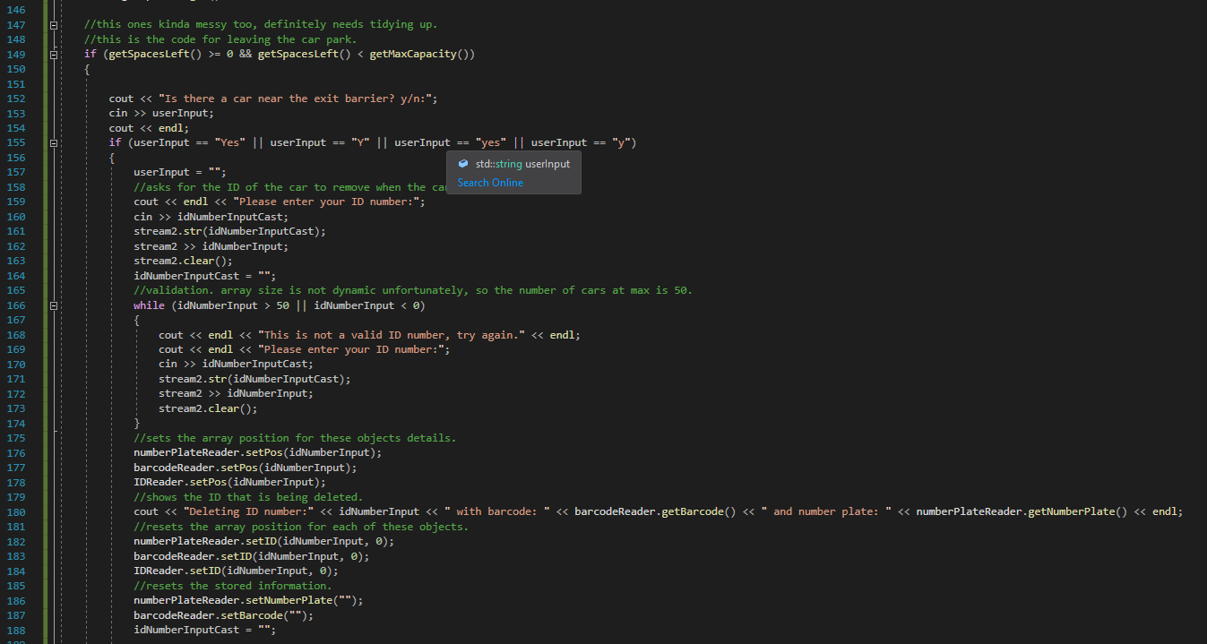
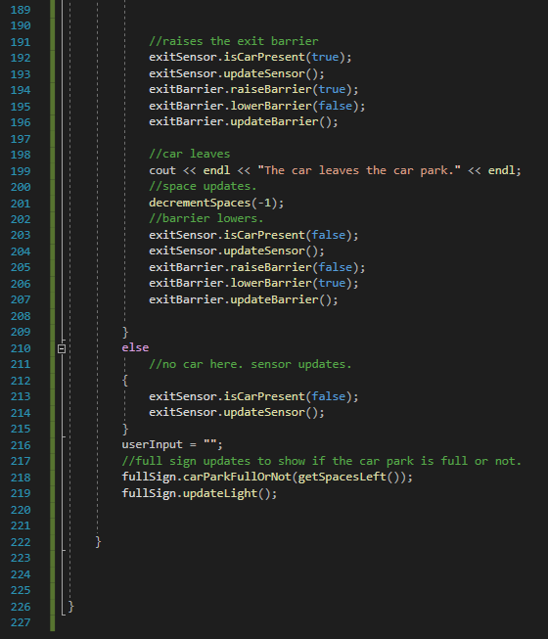

8.2.EntryBarrier.cpp
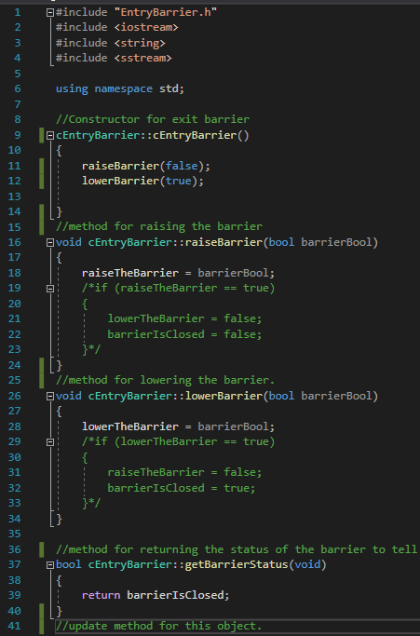
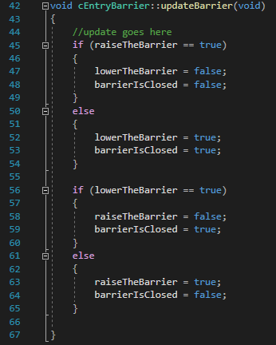

8.3.ExitBarrier.cpp
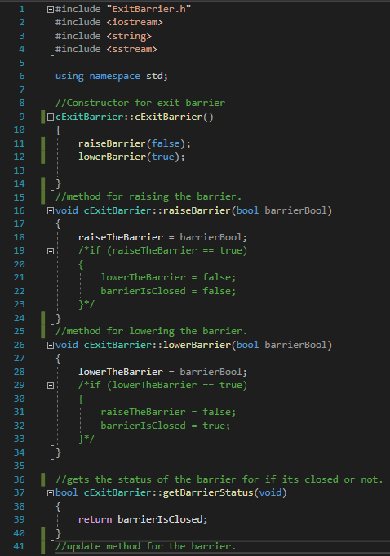
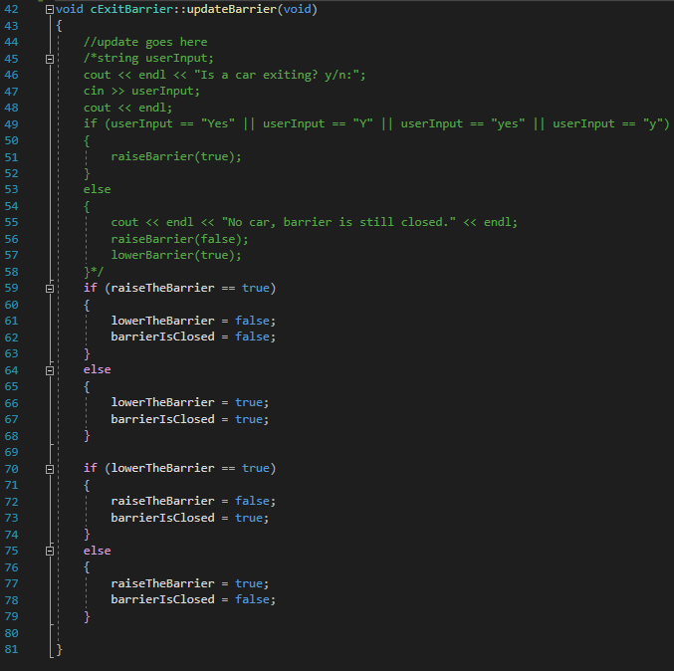

8.4.FullSign.cpp
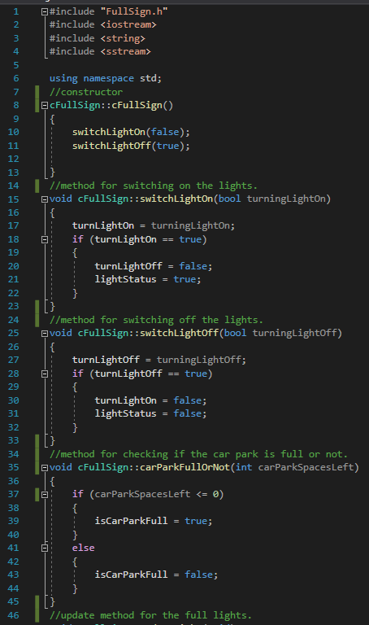
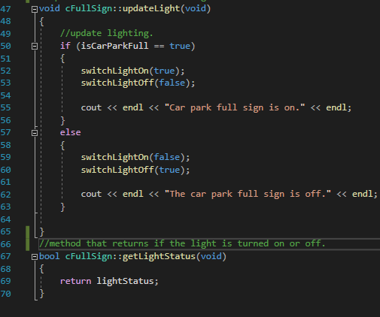

8.5.IDReader.cpp
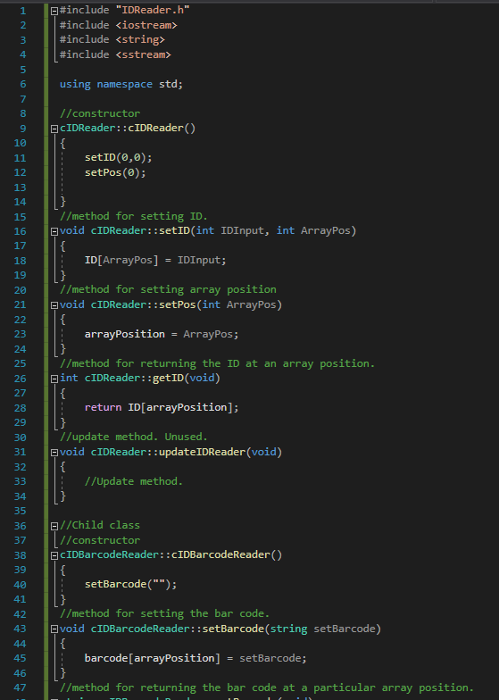
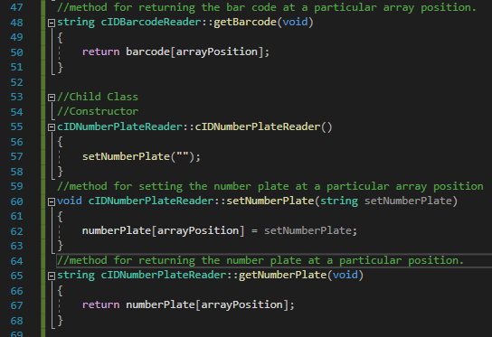

8.6.Sensor.cpp
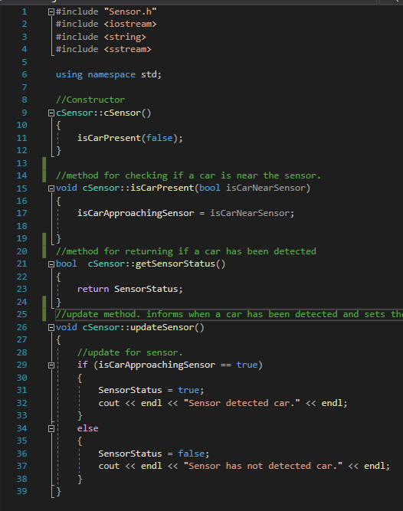

8.7.Source.cpp
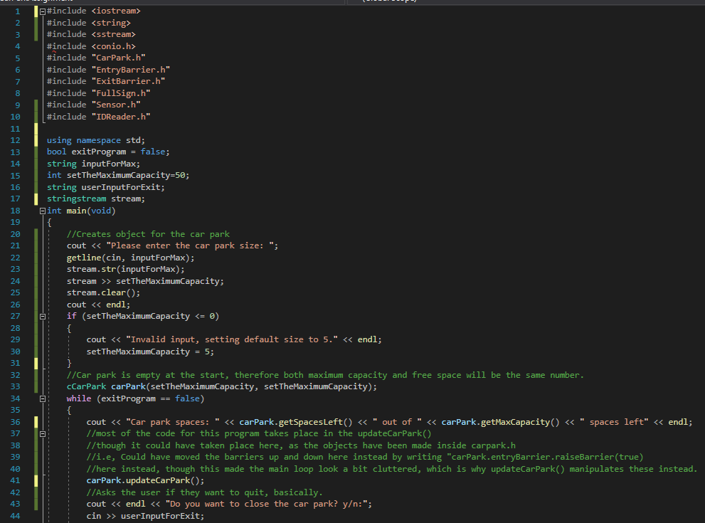
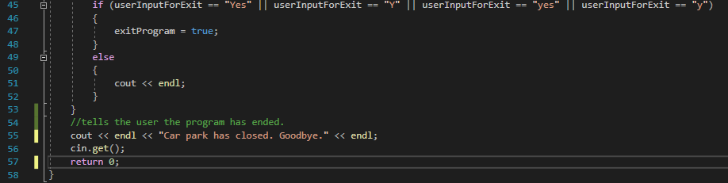

8.8. CarPark.h
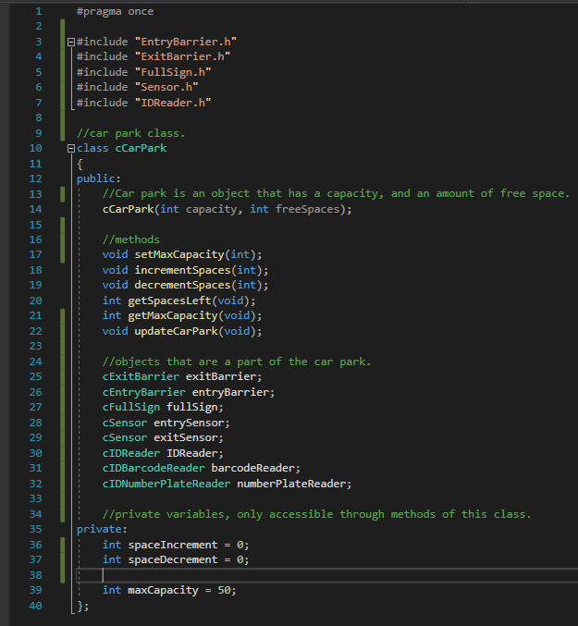

8.9.EntryBarrier.h
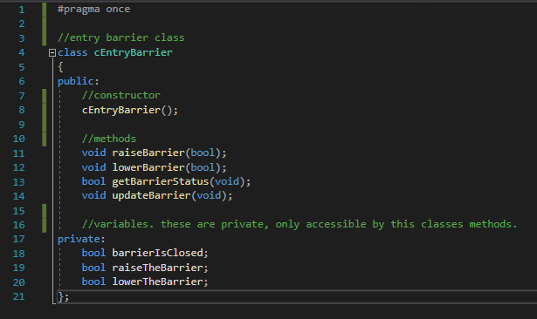

8.10.ExitBarrier.h
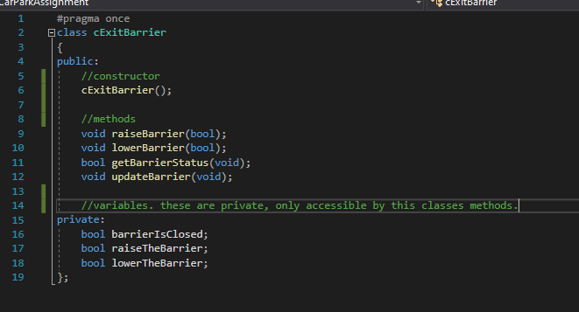

8.11.FullSign.h
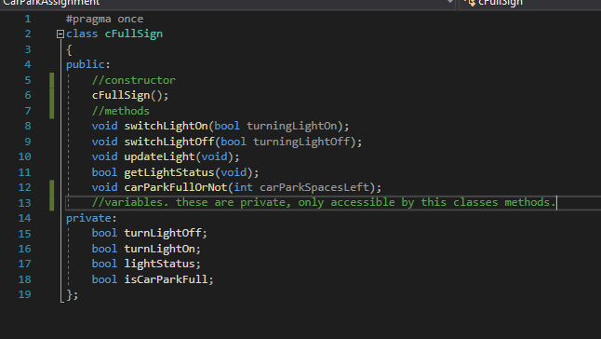

8.12.IDReader.h
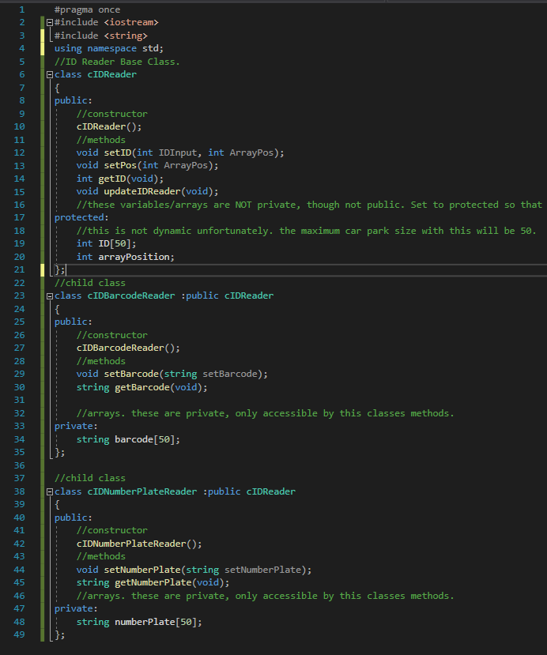

8.13.Sensor.h


