
gigs and shows
A C# and asp.net project
Dr Kemi Ademoye
Daniel Algie 1706977
Dr Kemi Ademoye
Daniel Algie 1706977



Contents
Abstract 2
Introduction 2
Requirements 2
The application 2
Development 2
Database 2
Models 3
Controllers and views 4
Security 5
Testing 7
Incomplete and changes 9
Conclusion 10
Bibliography 11

Figure 1-shows NuGet packet manager scaffolding 3
Figure 2-completed models 3
Figure 3-shows backend development for new concert location 4
Figure 4-concert location page 4
Figure 5-admin editing a concert location 5
Figure 6-code to work out if user is admin 5
Figure 7-shows admin booking 6
Figure 8-shows customers booking 6
Figure 9-shows access denied for user 6
Figure 10-home page 13
Figure 11-artist page 13
Figure 12-manage bookings page 14
Figure 13-concert location page 14
Figure 14-creating a booking 15
Figure 15-policy page 16
Figure 16-reviews page 16

Abstract
Using C# and asp.net [1] to create the gigs and shows website this report will discuss how the application works and how it was created.

Introduction
It will be shown how the website gigs and shows website was created, it will be showing how the frontend and backend development was created to provide the user with a reliable website to book their concert tickets from it will also be discussed creation of the database and security measures to keep users sensitive data secure.

Requirements
The requirements needed to create the gigs and shows application are:
- Firstly deciding what topic to create it was decided on concert tickets due to the nature of the user booking tickets it was looked at to create an online retail shop selling a range of items but changed to concert tickets as this was more relevant for the creator and have more excitement and enjoyment when creating the project
- Creating a database to store all data which will be used for displaying artist information, concert locations and storing users’ details and booking information.
- Connecting the database with the application to display data to the user
- Creating a front-end interface to display the data to the user and make it possible for user to book tickets
- Testing application to work out bugs and any other problems which might arise when running application to public

The application
The application created was for the purpose of users being able to book tickets to see their favourite artist in concert the target market is anyone interested in live music.
The application was created with making it as user friendly as possible to make it easy to book tickets and see what artists are preforming at what location.

Development

Database
First steps of developing the application was creating the database [2] it was decided to do the database first approach instead of the code first approach to help have a understanding of what would be needed to store and display the data received and displayed through the application first step was creating the data base tables the tables created was
- Booking tickets storing all details of the customer purchases
- Reserved tickets to display if the ticket purchased has been accepted to the user
- Concert location storing all details for concert location and artist playing there
- Artist showing information of all artist which have tickets available
- Ticket storing which seat and row the user has chosen to sit at the concert

Models
With the database finished and all tables created it was needed to connect the database to the application this was achieved by adding the path of the database and adding it to the appsetting.json file to make a connection [3].
With the database connected it was the created using the NuGet packet manager to configure the models this will generate the classes which be used for defining the variables created in the database to be able to use display or receive from the application [4]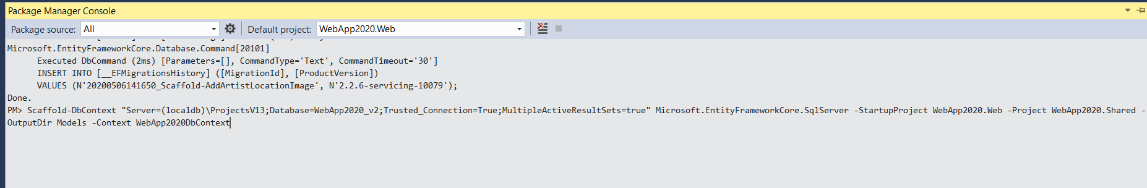
Figure 1-shows NuGet packet manager scaffolding
Once the packet manager console has created the models it will look like this
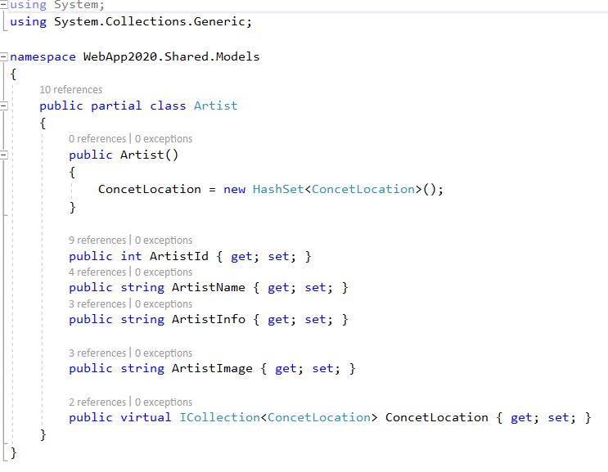
Figure 2-completed models

Controllers and views
Controllers are the link between the database and the website and handles any request from the URL [5] and views are the interface how the website displays the data [6].
Controllers and views pages were created the controller is for the backend development and the view is frontend displaying to the user. The controller creates adding new data for the admin without having to add directly to the database and deal with any of the software it will create a edit delete or add a new field to the database and this will all be done through the views interface making it easier for the admin to complete day to day tasks.
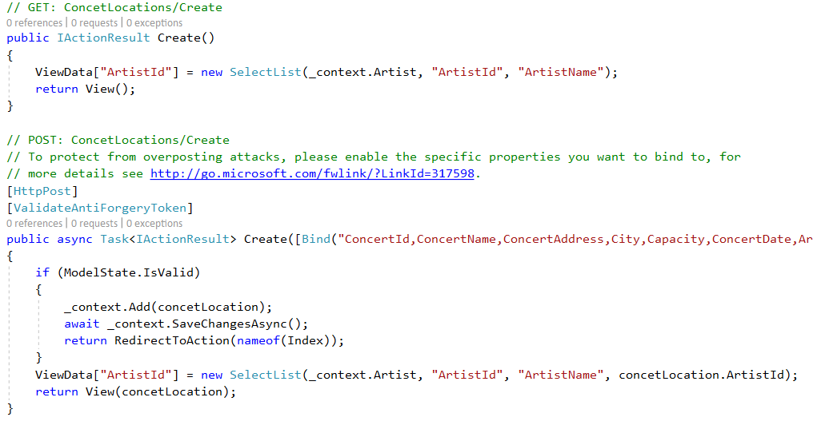
Figure 3-shows backend development for new concert location
The code above will generate a new concert location when the admin clicks on create button on the views page.
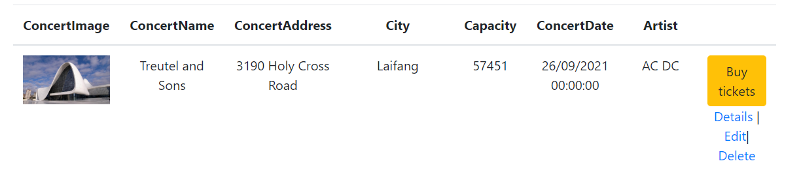
Figure 4-concert location page
This is the concert location where customers can choose which concert they wish to book tickets for if a user is logged in it will not show the edit delete fields this was designed so only the admin could change details and making it easier for the admin to do.
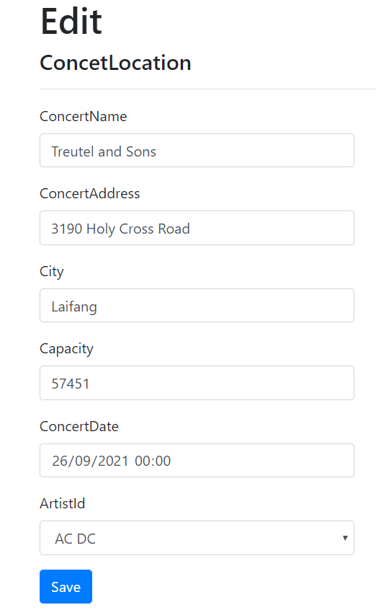
Figure 5-admin editing a concert location

Security
Due to the nature of the website having the user enter sensitive data security was a big priority when creating the gigs and shows website it was implemented that only the admin could access all bookings and for the user they could only see their own previous bookings [7] [8].
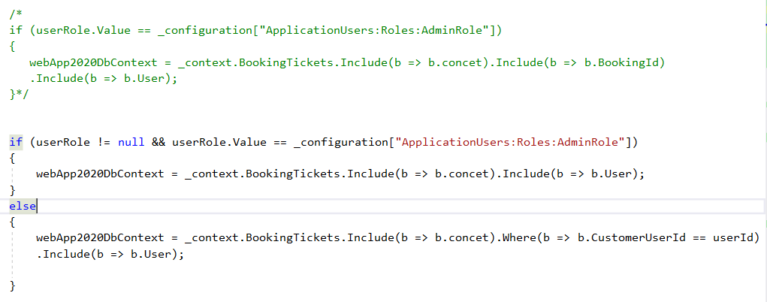
Figure 6-code to work out if user is admin
The code above works out if the user is an admin it will display all contents of the booking table or if it is a user it will display only the booking for that user first code above (green code) commented out was the original code but the code kept displaying error message when trying to use the user role it would result in null and not reading the user with a few tweaks it was possible to set that if the user was a admin display all else just set it to display by using the customer used id.
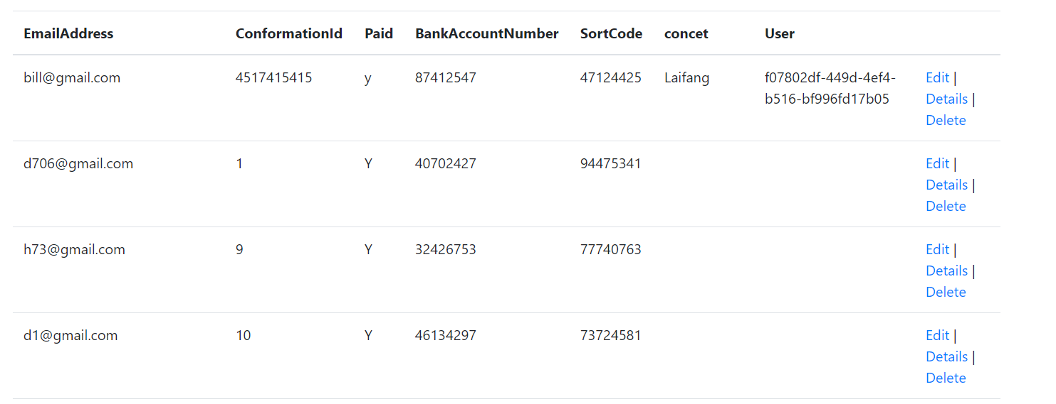
Figure 7-shows admin booking
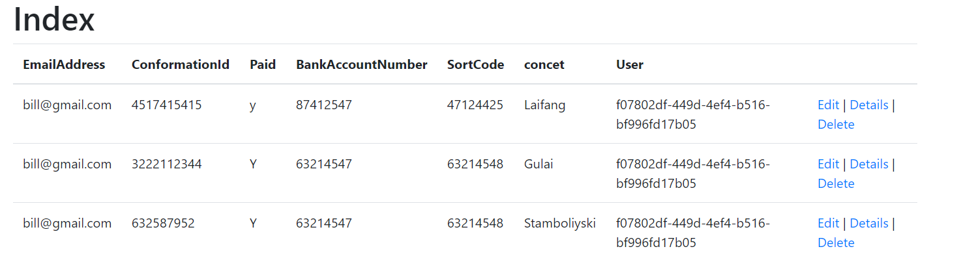
Figure 8-shows customers booking

It was also implemented that if the user did not have admin rights that it would hide the edit and delete fields from concert locations and artist. This was shown earlier but it was also implemented that if for some reason there was a error and the website displayed the option to the user that it would display that you do not have access to change the website.

Figure 9-shows access denied for user

Testing
Test case | Preconditions | Test steps | Test data | Expected result | Actual result | Pass/fail
Displaying data from database for concert locations | Set out for the website to display all data from the table concert locations | Running application to see what displays | Concert locations database, connection to database and website | Displays the correct data | Displays the correct data from the database to website | Pass
Only displays the correct data to the user for bookings | Set that if the user is not an admin it will only display the data connected with the correct email | Running application and logging in with different user to view which data is received | Bookings created by different users | It will display bookings only from that user or if no bookings have been made the website will not display any data | Displayed correct data and did not display any data if the user has not made any bookings | pass
Not letting the user go to the create a booking page with out choosing a concert location first | Setting security features to restrict and display page by searching | Running application and searching for the create page in the URL to see if it displays | Creating booking page | Should display error saying page cannot be found | Displayed page cannot be found | Pass
Creating a new booking | It was set that when booking tickets, it would take user to a booking page and complete a booking with the form and display in the users purchases | Choosing a concert location and making a purchase to check that it completes purchase and registers booking in database and displays to the user | Concert locations booking tickets, create a booking, displaying booing | Should display a book tickets button and direct the user to boking page complete booking and display in the user bookings | Displayed book tickets button, completed form, displayed in booking tickets | pass

Incomplete and changes
There are a few aspects of gigs and shows which due to time scale and deadlines for submission have not been able to rectify or change this includes:
- Changing the booking tickets form there aspects of the form which should be taken out this includes the conformation number this should be a number that generates automatically that the user can see once a booking has been completed instead of having the user manually enter it in to complete booking this would be rectified by changing the booking table database to auto increment the number and then can move the field from the form.
- The paid feature also from the booking table form this is also a feature which should be shown after the booking has been complete.
- It also should have been set to auto increment [9] the booking id instead of having the customer enter their own booking id.
- it would also been better to set when looking at artist page when clicking the button to navigate to concert location if it was set that the only concert location which would be visible are the ones which the artist is paying at this would have to be changed in the controller to set to take into account the artist id and the concert location due to time scale this was tried but will have to try fix again at a later date.
- The reviews page if it was set up so users could leave photos of them enjoying their concert experiences and leave reviews about the website due to time constraints and problems arising with the booking tickets to complete and show correct data this was not completed but the table was created and to rectify this would need to create the models and controllers to store and display the data.

Conclusion
In conclusion the gigs and shows website/ application is believed to be a success there are a few problems which arise that need to be rectified but in all the frontend interface and backend have completed what was set out to do, it corresponds with the database to receive and display the correct data and lets users book tickets to concerts. For the future of gigs and shows once submitted is to keep working with the application to complete the changes and look at new and different ways to change the way the application is used and progressing and improving gigs and shows.

Bibliography

[1] | T. GLee, ghogen, g. warren, v-shils and nschonni, “microsoft,” 29 april 2019. [Online]. Available: https://docs.microsoft.com/en-us/visualstudio/get-started/csharp/tutorial-aspnet-core?view=vs-2019. [Accessed 10 April 2020].
[2] | guru99, “guru99,” [Online]. Available: https://www.guru99.com/insert-update-delete-asp-net.html. [Accessed 10 April 2020].
[3] | c. s. team, “connection strings,” [Online]. Available: https://www.connectionstrings.com/store-and-read-connection-string-in-appsettings-json/. [Accessed 10 April 2020].
[4] | R. Anderson and T. Dykstra, “docs microsoft,” 13 january 2020. [Online]. Available: https://docs.microsoft.com/en-us/aspnet/core/tutorials/first-mvc-app/adding-model?view=aspnetcore-3.1&tabs=visual-studio. [Accessed 10 April 2020].
[5] | “tutorials teacher,” [Online]. Available: https://www.tutorialsteacher.com/mvc/mvc-controller. [Accessed 10 may 2020].
[6] | t. point, “tutorials point,” [Online]. Available: https://www.tutorialspoint.com/asp.net_core/asp.net_core_views.htm. [Accessed 10 may 2020].
[7] | Anupama, “code 4 copy,” 14 december 2013. [Online]. Available: https://www.code4copy.com/csharp/how-to-check-current-user-role-is-admin/. [Accessed 10 April 2020].
[8] | microsft, “microsoft,” [Online]. Available: https://docs.microsoft.com/en-us/dotnet/api/microsoft.azure.batch.computenode?view=azure-dotnet. [Accessed 10 April 2020].
[9] | w3schools, “w3schools,” [Online]. Available: https://www.w3schools.com/sql/sql_autoincrement.asp. [Accessed 10 April 2020].
[10] | facebook, “facebook,” [Online]. Available: https://www.facebook.com/lewiscapaldi/. [Accessed 06 April 2020].
[11] | a. greene, “rolling stone,” [Online]. Available: https://www.rollingstone.com/music/music-lists/readers-poll-the-10-best-ac-dc-songs-153246/ andy grenne . [Accessed 10 April 2020].
[12] | “biography,” [Online]. Available: https://www.biography.com/musician/drake. [Accessed 10 April 2020].
[13] | m. beech. [Online]. Available: https://www.forbes.com/sites/markbeech/2018/01/27/led-zeppelin-adds-to-300-million-sales-with-live-album-50th-anniversary-surprises/#2bddb304ca59. [Accessed 11 April 2020].
[14] | f. book, “facebook,” [Online]. Available: https://www.facebook.com/ClassicWestCoastHipHop/ . [Accessed 10 April 2020].
[15] | “issuu,” [Online]. Available: https://issuu.com/floodmagazine/docs/side_a_-_wu_tang. [Accessed 10 April 2020].
[16] | “booking agent info,” [Online]. Available: https://bookingagentinfo.com/celebrity/billy-ocean/. [Accessed 10 April 2020].
[17] | “wikipedia,” [Online]. Available: https://en.wikipedia.org/wiki/List_of_songs_recorded_by_Olly_Murs. [Accessed 11 April 2020].
[18] | “taylor swift,” [Online]. Available: https://taylorswift.fandom.com/wiki/The_Weeknd. [Accessed 10 April 2020].
[19] | “wikipedia,” [Online]. Available: https://en.wikipedia.org/wiki/Madison_Square_Garden. [Accessed 10 April 20202].
[20] | p. janiak, “unsplash,” [Online]. Available: unsplash.com.
[21] | K. Ademoye, “assignment support (power point ),” UWTSD, Swansea , 2020.

Abstract
Please find here a screen shot of all pages of the gigs and shows website

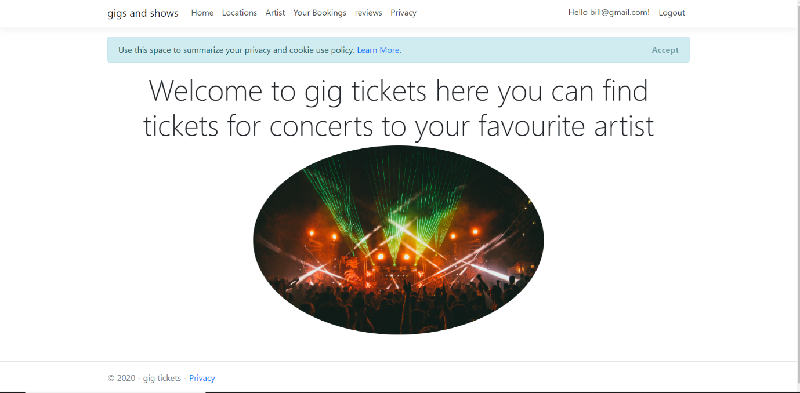
Figure 10-home page

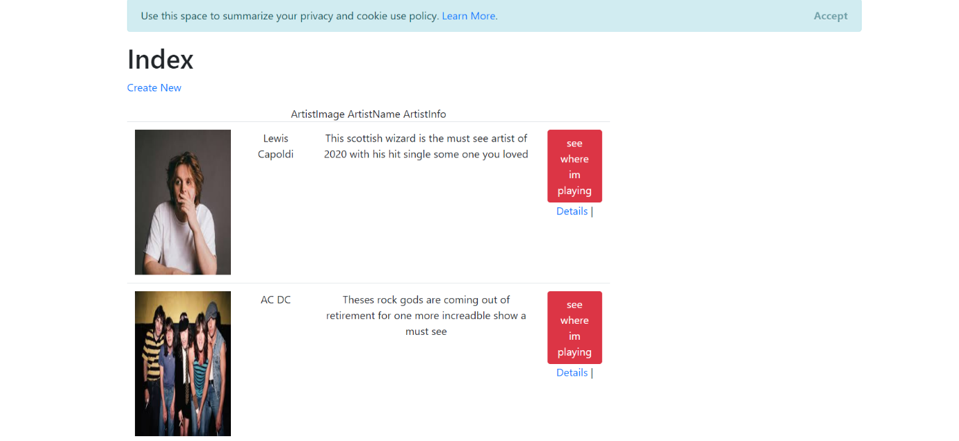
Figure 11-artist page

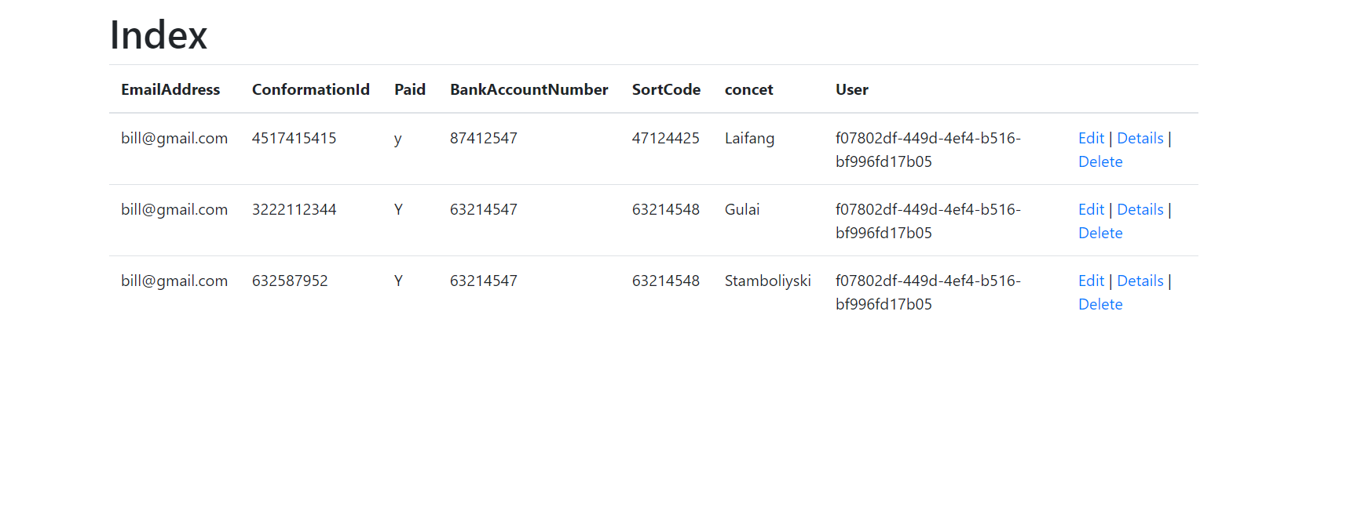
Figure 12-manage bookings page
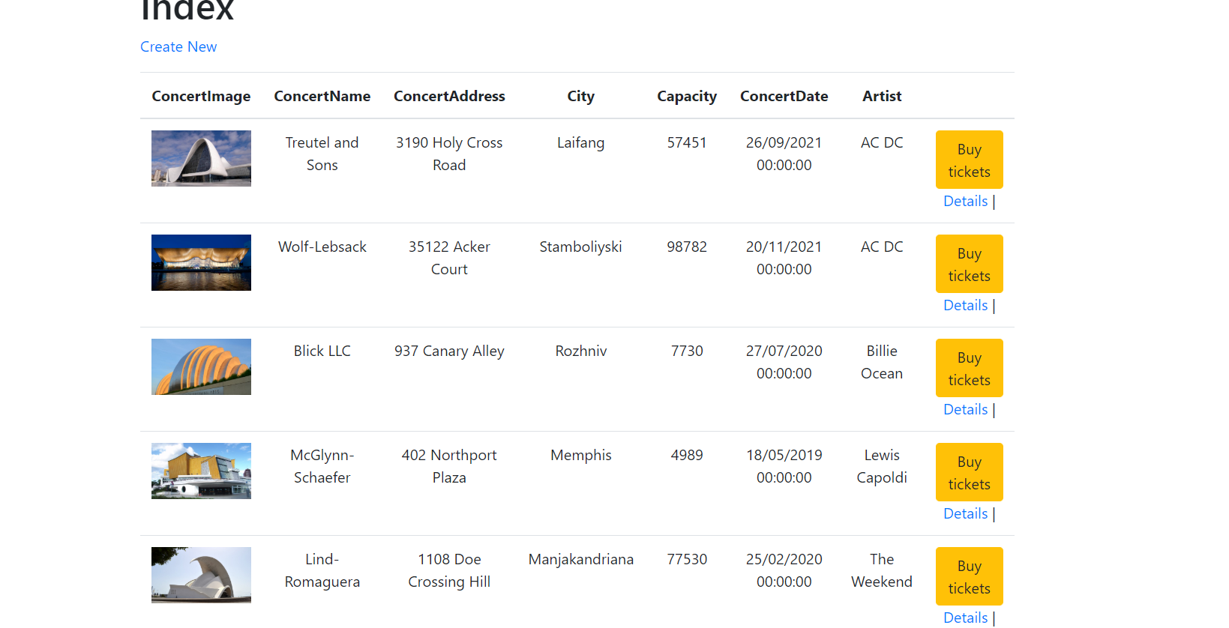
Figure 13-concert location page
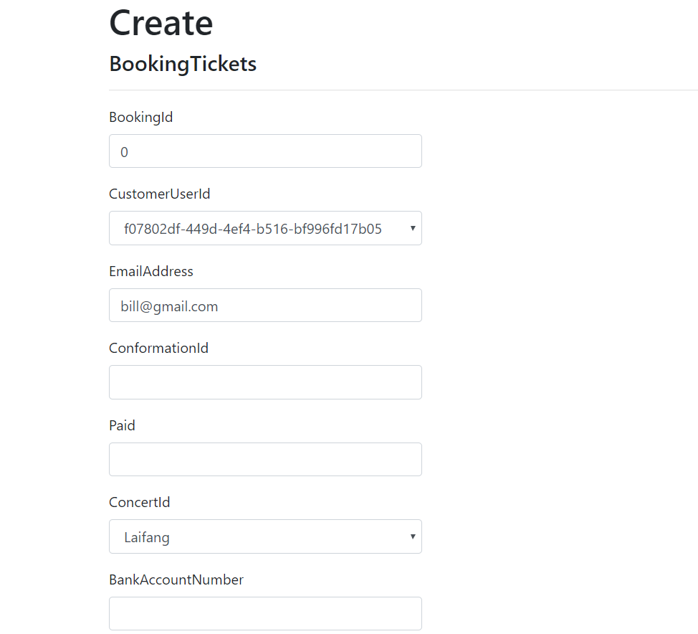
Figure 14-creating a booking

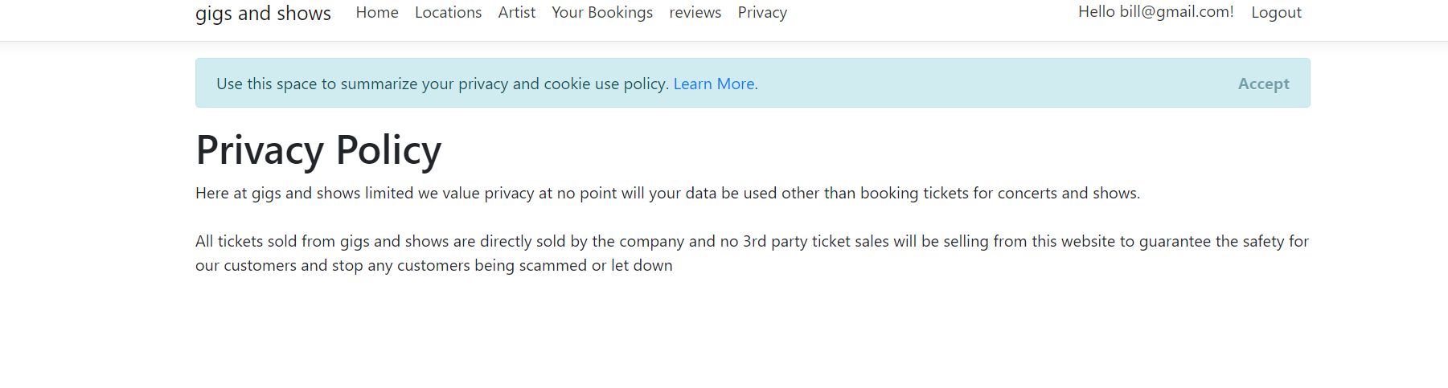
Figure 15-policy page
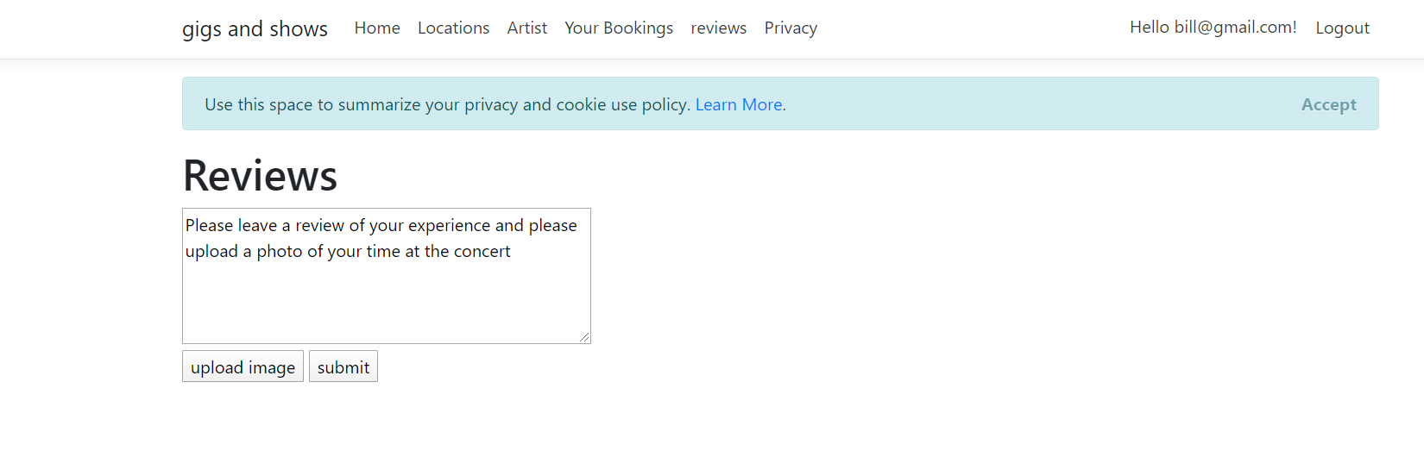
Figure 16-reviews page

marking criteria and Student FEEDBACK

This section details the extent to which the assessment criteria are demonstrated by you, which in turn determines your mark. The marks available for each category of skill are shown. Lecturers will use the space provided to comment on the achievement of the task(s), including those areas in which you have performed well and areas that would benefit from development/improvement.

Common Assessment Criteria Applied (Assignment 2) | Marks available | Marks  awarded
1. Engagement with Literature Skills

2. Knowledge and Understanding Skills

3. Cognitive and Intellectual Skills

Overall, a good set of test cases have been developed, but the scope of the test cases needs to be expanded upon as the demonstrated test cases are for the "scaffold" functionality provided by VS, which will work as expected. Give your test cases some more thought. For example, I would have expected robust, test cases that are more robust to demonstrate the functionality for buying tickets. It is okay if the test(s) fail, as it is your approach to testing that is being evaluated. A good evaluation has been provided highlighting limitations of the application with practical recommendations for improvement. (Grade mark: 56.67%) | 30 | 17
4. Practical Application Skills

A very good attempt featuring a simple application based on the class tutorial exercise. There is, however, room for improvement. The functionality of the application and its user interface generally requires some more thought, some of which you have identified in your evaluation. Some good use of authentication and authorisation, but you have not been consistent in your application of these. Remember, you do not want users create, editing, or deleting certain records from the database.Simply hiding the links is not enough; you have to add the necessary code to the controllers and views. The database design is okay but also requires some improvements. Generally, I would have liked to see you complete some of the intended functionality. (Grade mark: 65.00%) | 60 | 39
5. Transferable Skills for Life and Professional Practice

The report is of a good standard, but use the spelling and grammar check tool in your word processor application to improve the quality of your reports. (Grade mark: 60.00%) | 10 | 6

Assignment Mark (Assessment marks are subject to ratification at the Exam Board. These comments and marks are to give feedback on module work and are for guidance only until they are confirmed. ) | Late Submission Penalties (tick if appropriate) |  | 62%
 | Up to 1 week late (40% Max) |  | 62%
 | Over 1 week late (0%) |  | 62%

