MANAGEMENT ECONOMICS
LCBB 5008
Lecturer:Taye Osadiya
Student:Elitsa Ivanova
Student ID:2123375

Table of Contents
Introduction 3
Task 1 3
A) Discuss the fundamental economic problems identified in the case study. 3
B) Suggest various ways in which these economic problems can be resolved. 5
Task 2 7
A) Why is demand and supply relevant in this case study? 7
B) What is the difference between elasticity and inelasticity of demand with reference to price changes in the cost of fuel? 9
C) List and explain the laws of supply and demand. 10
Conclusion 11

Introduction
The report considers important economic implications stemming from changes in demand and supply. The information is relevant for better understanding the recent economic trends amid the pandemic, as well as many scenarios affecting businesses and consumers.

Task 1

A) Discuss the fundamental economic problems identified in the case study.
The case study highlights some significant economic issues that also impact the UK. It is important to acknowledge that the pandemic is an unparalleled occurrence that necessitates firms to adapt promptly and efficiently to accommodate fluctuating supply and demand situations. Businesses must exercise greater caution in managing their supply and demand chains to maintain uninterrupted and seamless operations (Institute for Government, 2021). The experienced supply chain stress, as indicated by the FED Global Supply Chain Barometer, has posed significant challenges (Institute for Government, 2021). Furthermore, several firms had to contend with more stringent social distancing measures and mandatory closures, further impeding regular operations.
It is also crucial to acknowledge that supply constraints play a significant and ongoing role in the aftermath of the pandemic and Brexit. A shortage of drivers has caused a labour supply problem affecting economic activity (Institute for Government, 2021). The new migration rules in the post-Brexit period have led to an outflow of EU drivers (Statista, 2023). Consequently, the scarcity of skilled drivers resulted in delays in logistics and transportation, further worsening the pre-existing problems in the supply chain (Institute for Government, 2021).

Figure 1 – Key reasons behind the shortage of drivers (% of respondents)
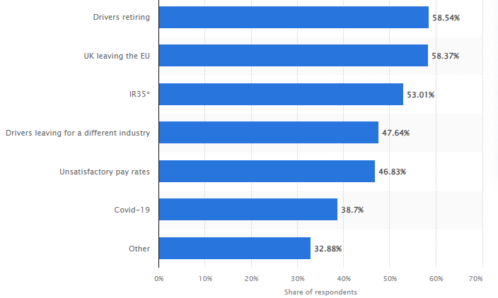
Source: Statista (2023)
According to the information from the case study, the UK also had limitations in fuel supply, which therefore contributed to the broader supply issues (Institute for Government, 2021). The shortage of fuel is a key factor for the experienced high inflation in the UK recently (ONS, 2023). This example clearly indicates the negative role of supply shortages on price stability.
Furthermore, the example clearly highlights significant demand-related concerns. Amidst the epidemic, there were substantial variations in demand. For instance, the occurrence of panic buying was common during the initial months of the pandemic and the high level of uncertainty about the future affecting consumers (BBC, 2021). Panic purchasing occurred concurrently with the announced gasoline shortages in the present situation (Institute for Government, 2021). Consumers augmented their gasoline use in response to the anticipation of forthcoming fuel scarcities, as deliberated in the case. Consumer behaviour, resulting in increased demand, further exacerbated the fuel shortages due to the already constrained supply (Institute for Government, 2021). Given the influence of demand, there have been changes in consumer preferences. The pandemic led to an increased demand for tangible products, but the years after the epidemic has once again redirected consumer focus towards services (Institute for Government, 2021). The examined variations in demand have exerted strain on supply networks due to enterprises' need to rapidly adjust to significant adjustments in demand.
Furthermore, the experienced considerable fluctuations in supply and demand have resulted in both shortages and surpluses in the marketplace. For example, the scarcity of fuel and the widespread rush to purchase it resulted in substantial price hikes (Institute for Government, 2021). The annual inflation rate in the UK reached a peak of 9.6% in 2022, as measured by the consumer price index (CPI) (ONS, 2023). The fluctuation in demand between services and products has also had an impact on pricing and output. The observed price rises in recent years have been significantly influenced by the shortages of manpower and physical products caused by the Brexit and especially the pandemic shock (Institute for Government, 2021).
To fight inflation, the Bank of England has engaged in a campaign for interest rate increases by reaching a level of 5.25% - the highest lending costs in 15 years (Partington, 2023). The increased interest rates have placed significant strain on both individuals and businesses due to the higher borrowing rates and costs of debt service (Partington, 2023). Consequently, the anticipation is that there would be an increase in bankruptcies, as well as increasing unemployment as a condition to restore low inflation rates (Partington, 2023).

B) Suggest various ways in which these economic problems can be resolved.
The identified supply and demand issues can be addressed with some potential solutions. The role of the government is important, as this is a major economic player defining the fiscal policy (Osadiya, 2023). Through fiscal stimulus, the government can stimulate the aggregate demand in the economy (Osadiya, 2023). For example, tax reductions can be supportive for businesses and households. In addition, targeted financial support can be delivered to the affected sectors from the pandemic or vulnerable households. These are examples of fiscal expansion supporting demand and the policies quite conventional. In the UK, the fiscal support in 2020-2021 was significant, as the extra government spending reached between £310 and £410 billion, or the equivalent of about £4,600 to £6,100 per person (Brien and Keep, 2023). Thus, public spending supported the aggregate demand in the economy.
Other solutions to cope with the observed problems are related to the supply side. Labour shortage is seen as one of the problems, especially in the transportation sector (Institute for Government, 2021). The government can relax some of the immigration rules or provide stimuli to attract qualified foreign labour. The increased supply of labour is expected to solve the experienced shortages of drivers. Supply can also be increased by reducing some of the earlier imposed stringent social distancing rules. The chart below shows the number of employees on furlough. As seen, almost nine million people were prevented from working during the peak of the pandemic in early 2020 (Francis-Devine et al., 2021). The total cost of the applied furlough schemes is estimated to be at least £70 billion (Francis-Devine et al., 2021). Therefore, the elimination of the furlough can lead to a return of millions of employees back to work; thereby, ensuring higher labour supply and the achievement of significant supply increase in the economy (Francis-Devine et al., 2021).
Figure 2 – Number of furloughed people in the UK (million)
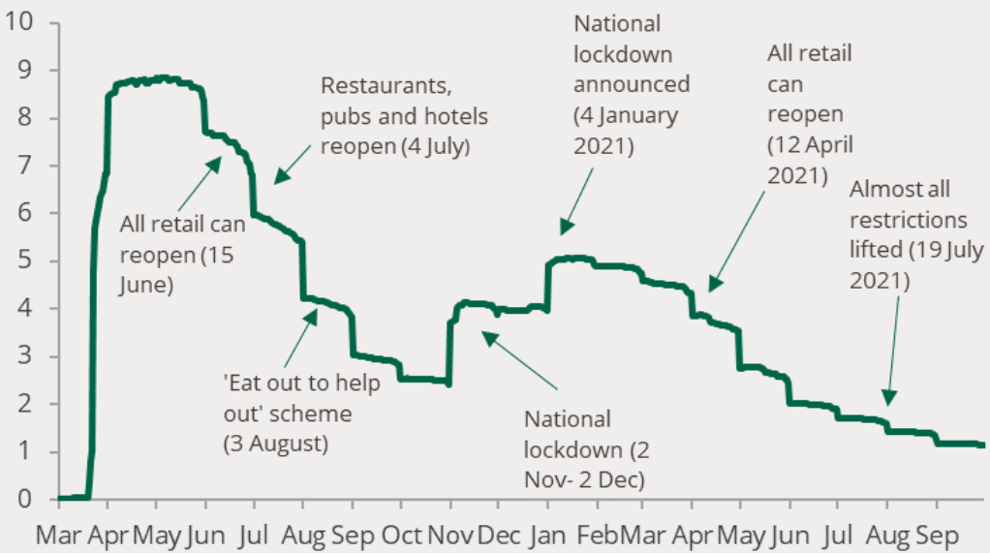
Source: Francis-Devine et al. (2021)
Supply can also be improved by modifying the supply chain. Shortening of the supply chain, especially international one, is essential in minimising the risk of bottlenecks and delays (Hwang and Rau, 2006). Therefore, the shift to domestic suppliers can be a solution to preventing future supply chain issues. If this is not possible, international companies must consider suppliers who are located closer to the UK.
In general, it is also important to improve the collaboration of suppliers across the entire supply chain. Better information sharing, developing of contingency plans and buffers, as well as engaging in active collaboration can be key solutions to an improved resilience and response to supply issues (Stowe, 2023). Therefore, it is necessary to better manage all stakeholders along the supply chain by keeping them informed accordingly. In some cases, suppliers may also be included in the process of decision-making, especially if they supply differentiated and rare products which make them important (Stowe, 2023). Overall, better stakeholder management can be a key to faster and more effective problem-solving if supply issues emerge in the future (Stowe, 2023). This also stays in the core of developing a shortage management team strategy.
Waste reduction is another area for improvement, especially in the long-term. By reducing waste, business organisations can better utilise the available resources; thereby, improving efficiency (Sumich, 2022). In the context of the restricted supply during the pandemic, restricted waste and re-use of resources can make businesses less exposed to shortages due to the lower demand for new resources, including fuel and other restricted inputs (Sumich, 2022). Eventually, better waste management and re-use can make the demand curve more elastic which benefits the consumers of the restricted supplies.
The evidence suggests the existence of different supply- and demand-related solutions to better manage and respond to unfavourable changes in the external economic environment.

Task 2

A) Why is demand and supply relevant in this case study?
Demand and supply are relevant in many business contexts. Knowledge about the changes in demand and supply can lead to better pricing decisions which optimise business performance and efficiency (Osadiya, 2023). Panic buying is an example of a sudden and significant increase in demand. Knowledge about the consequences of demand spike is important for businesses which must increase prices in such situations. And the vice versa, episodes of weak demand must motivate price decreases to boost demand and avoid the accumulation of excessive inventory. When supply is considered, businesses must be aware of the consequences of supply increases and declines. These situations motivate price declines and increases, respectively (Osadiya, 2023). This is necessary to maximise sales and avoid product shortages stemming from a mismatch between the existing demand and the changes in supply (Osadiya, 2023).
The proper management of demand and supply is essential for maximising productivity level. This is achieved by avoiding inefficiencies stemming from shortages when demand exceeds supply, or excesses when demand is weaker than supply (Osadiya, 2023). In this context, demand and supply knowledge is essential for manufacturing organisations, and retailers which must balance their inventories (Banton, 2023). In the case of just-in-time inventory system, matching demand changes is essential for achieving optimal performance, as the just-in-time system is entirely demand-driven (Banton, 2023).
In terms of pricing, other factors may also affect final decisions. Competition is seen as a major force which influences profit margins. Intensive competition is associated with price reductions, as there are many suppliers being in a rivalry for the existing consumers (demand) (Isabelle et al., 2020). Therefore, demand and supply specifics must be well understood in developing an effective marketing strategy, as well. Pricing is a key part of the marketing mix and overall strategy of organisations (Kotler and Armstrong, 2013). Thus, effective pricing decisions, which maximise the effectiveness of the marketing strategy, must be based on solid understanding of the main demand and supply trends.
Knowledge regarding demand and supply is also important from a risk management perspective. As mentioned, a mismatch between demand and supply can erode business efficiency, marketing strategy effectiveness and overall performance (Osadiya, 2023). Therefore, an effective risk management system must maintain the equilibrium between demand and supply. In this context, knowledgeable businesses must be able to react accordingly and deliver flexible pricing changes to match demand and supply given the relevant market changes.
Demand and supply are also relevant for making long-term investment decisions. For example, expectations for strong demand in the future may motivate investment decisions to increase productive capacity and efficiency (University of Minnesota, 2023). As a result, businesses may be more willing to engage in solid financing commitments in acquiring new equipment, machines, buildings and other factors of production. Given the long-term nature of many types of investments, it is necessary to accurately forecast future changes in demand and supply and demand. If future demand is weak, a company may develop extra capacity with little value and the vice versa – delayed investments may cause limited capacity to meet high demand in the future; thereby, missing profit opportunities.
It is also important to mention that there are some spillover effects. If a company properly forecasts and reacts to changed in demand and supply, better financial performance can be achieved over time. Given the role of financial stimuli in human resource management, improved motivation can be achieved by delivering secure employment, increased salaries, financial bonuses and others (Herzberg, 1987). Considering this, demand and supply knowledge can indirectly affect the management of human resources, as well. This is also a major aspect of management which determines business performance and competitiveness.

B) What is the difference between elasticity and inelasticity of demand with reference to price changes in the cost of fuel?
The concept of elasticity measures the changes in the demanded quantity which occur because of price changes (Osadiya, 2023). When exploring demand, quantity changes may also originate from alternations in income, income inequality level and other factors (Osadiya, 2023). Demand is elastic when a percentage point increase in price leads to more than a percentage point decline in demand (Osadiya, 2023). Demand is inelastic when demanded quantities decline at a slower rate than the drop in prices (Osadiya, 2023). Inelastic demand is commonly observed in relation to essential products and services, such as utilities, fuel, key food products and others (Hall, 2023). Demand appears to be elastic when considering non-essential and luxury products (Hall, 2023).
Demand elasticity is a key determinant of price formation. Products with elastic demand are likely to experience significant price spikes if supply is restricted. This is explained by the essential nature of these products and the insignificant decline in quantity demanded when prices increase. This is also the case with fuel. As reported by Reuters (2022), energy companies in the UK achieved excessive profit of £170 billion during the energy crisis and price spikes. This development is explained by the inelastic demand which makes consumers still willing to purchase the essential product regardless of the significant price increases.
There are certain advantages and drawbacks related to demand elasticity. The above-mentioned example of the demand inelastic fuel prices describes consumer vulnerability. This also explains the relatively high importance of fuel prices. In other cases, inelastic demand can deliver benefits. For example, government can generate additional money through increased taxation of inelastic products. The tax-based price increase leads to an insignificant decline in the demanded quantity, which in turn generate additional income from the increased tax. Thus, taxation of inelastic products can be quite effective in increasing government revenue.
When high demand elasticity is present, businesses can boost sales by adopting price-based stimuli. This is explained by the fact that the demanded quantity disproportionally increases when the price is lowered (Osadiya, 2023). For companies selling demand elastic products, however, it is quite challenging to maintain optimal revenue and profitability. This is explained by the need to continuously monitor competitors and their actions and adjust accordingly due to the demand elastic nature of the sold products. Hence, lagging competitors can be quite disadvantageous for performance.

C) List and explain the laws of supply and demand.
There are four basic laws of supply and demand worth discussing given their impact on businesses. Respectively, knowledge regarding the laws of supply and demand can be of value for achieving business efficiency and improved performance in the marketplace.
The first law identifies a situation of increasing demand and constant supply. Such a situation produces a change in the equilibrium point associated with an increased output and price (Taylor, 2023). In most cases, this increase in demand is driven by favourable preferences and wants of customers who are willing to pay higher prices to get access to valuable products and services (Taylor, 2023). Therefore, the situation leads to many business opportunities for expansion by increasing supply. Alternatively, businesses may maintain unchanged supply and enjoy higher profit margins.
The second law also assumes unchanged supply but there is a decline in demand. This leads to a new equilibrium point of lower output and prices (Taylor, 2023). The decline in demand can be explained by low interest by customers. Businesses may consider lower prices to stimulate consumer demand or reduced supplies to stabilise prices amid the low demand (Taylor, 2023). Irrespectively of the management strategy, the decline in demand is an unfavourable development for businesses.
The third law assumes unchanged demand and increasing supply. This scenario is associated with an increased output and lower prices (Taylor, 2023). Price reduction may be necessary to account for the changed market equilibrium conditions (Taylor, 2023).
The final scenario assumes unchanged demand and restricted supply. This leads to a shift in the equilibrium point associated with lower output and higher prices (Taylor, 2023). Suppliers are in advantageous position due to the scarcity of available products and consumers’ willingness to pay extra to get access to the limited supply (Taylor, 2023). Thus, suppliers can achieve extra profits given the changed market conditions.

Conclusion
The discussion identified important aspects of demand and supply. As evident, changes in these basic economic laws can deliver profound implications for businesses, the government and society in general. Therefore, knowledge regarding demand and supply is of value for achieving an improved business efficiency, macroeconomic policy and maximised value for producers and consumers.

References
Banton, C. (2023) Just-in-Time (JIT): Definition, Example, and Pros & Cons, [online] Available: https://www.investopedia.com/terms/j/jit.asp [Accessed: 10 December 2023]
BBC (2021) Food firms warn of panic-buying this Christmas, [online] Available: https://www.bbc.com/news/business-58654725 [Accessed: 8 December 2023]
Brien, P. and Keep, M. (2023) Public spending during the Covid-19 pandemic, [online] Available: https://commonslibrary.parliament.uk/research-briefings/cbp-9309/ [Accessed: 5 December 2023]
Francis-Devine, B., Powell, A. and Clark, H. (2021) Coronavirus Job Retention Scheme: statistics, [online] Available: https://commonslibrary.parliament.uk/research-briefings/cbp-9152/ [Accessed: 8 December 2023]
Hall, M. (2023) Elasticity vs. Inelasticity of Demand: What's the Difference? [online] Available: https://www.investopedia.com/ask/answers/012915/what-difference-between-inelasticity-and-elasticity-demand.asp#:~:text=Elastic%20goods%20include%20luxury%20items,remains%20constant%20despite%20price%20changes [Accessed: 14 December 2023]
Herzberg, F. (1987) One More Time: How Do You Motivate Employees? Harvard Business Review, Vol. 65, pp. 109-120.
Hwang, M-H. and Rau, H. (2006) Development of strategies for shortening supply chain and demand chain, Human Systems Management, Vol. 25. DOI: 10.3233/HSM-2006-25404.
Institute for Government (2021) Supply chain problems, [online] Available: https://www.instituteforgovernment.org.uk/explainer/supply-chain-problems [Accessed: 5 December 2023]
Isabelle, D., Horak, K., McKinnon, S. and Palumbo, C. (2020) Is Porter’s Five Forces Framework Still Relevant? Technology Innovation Management Review, Vol. 10(6), pp. 28-41.
Kotler, P. and Armstrong, G. (2013) Principle of Marketing. 15th edition, Prentice Hall
Office for National Statistics (ONS) (2023) CPIH annual rate 00: All items 2015 = 100, [online] Available: https://www.ons.gov.uk/economy/inflationandpriceindices/timeseries/l55o/mm23 [Accessed: 6 December 2023]
Osadiya T. (2023) Introduction to Economics. Amazon
Partington, R. (2023) Bank of England holds rates at 5.25% as it gives inflation warning, [online] Available: https://www.theguardian.com/business/2023/dec/14/bank-of-england-keeps-interest-rates-on-hold-concern-economy-shrank [Accessed: 15 December 2023]
Reuters (2022) UK gas, electricity industry may make 170 bln pounds excess profits -Bloomberg, [online] Available: https://www.reuters.com/business/energy/uk-gas-electricity-industry-may-make-170-bln-pounds-excess-profits-bbg-2022-08-30/#:~:text=LONDON%2C%20Aug%2030%20(Reuters),that%20the%20finance%20ministry%20disputed [Accessed: 14 December 2023]
Statista (2023) Reasons behind the driver shortage in the UK 2021, [online] Available: https://www.statista.com/statistics/1288322/reasons-driver-shortage-united-kingdom/ [Accessed: 8 December 2023]
Stowe, L. (2023) 11 Key Benefits of Stakeholder Management for Government Affairs, [online] Available: https://fiscalnote.com/blog/benefits-stakeholder-management-government-affairs [Accessed: 15 December 2023]
Sumich, K. (2022) Benefits of Waste Management, [online] Available: https://ecoresources.net.au/benefits-of-waste-management/ [Accessed: 14 December 2023]
Taylor, R. (2023) An SME's Guide to Supply and Demand, [online] Available: https://fleximize.com/articles/002211/what-is-supply-and-demand [Accessed: 15 December 2023]
University of Minnesota (2023) Determinants of Investment, [online] Available: https://open.lib.umn.edu/principleseconomics/chapter/29-2-determinants-of-investment/ [Accessed: 12 December 2023]

