Generating Business Data and Analysis: Assessment 2
Thomas Ollason Ryan
University of Wales Trinity St David

Abstract

In this report the author shall be demonstrating an understanding of the key principles of data analysis and modelling. This will be done through presenting relevant theoretical materials in support of practical concepts carried out to properly pre-process, analyze and visualize an assignment data set comprising of 4 spreadsheets. The author will demonstrate key principles of data modelling and analysis theory, referring to the techniques used in the author’s own modelling and analysis of the 4 spreadsheets with the purpose of validating the importance of data management and analysis.

Abstract 2
Generating Business Data and Analysis: Assessment 2 4
Scenario Part 1: Collated Prosumer Survey 4
COLLATED APPLIANCE CARBON DATA FILE 8
Scenario Part 2: Weather List file 11
Electrical Data file 15
Summary 21
REFERENCES 22
Appendix 24

Generating Business Data and Analysis: Assessment 2

Scenario Part 1: Collated Prosumer Survey
A survey concerning the use of prosumer methods by companies was created by each student contributing to a collated spreadsheet. This spreadsheet already contained several data categories, including: Labels, in the form of descriptive pieces of information such as the company names and identifying statistics in the form of the “yes” or “no” answers presented in the prosumer questions. Another data category would be the values attributed to the companies such as the number of employees (Reding & Wermers, 2011).
In order to properly analyze the data presented in this collated file, firstly the problems had to be identified and a series of steps had to be taken to implement a solution (Evans, 2014).
One of the problems that was immediately apparent in the collated prosumer survey file was that there was a large amount of duplicated data, rendering a large proportion of the presented data redundant, which in turn results in the effectiveness of the database to be limited (Cornell & Morris, 2018). The solution the author decided to implement was to change the format of the label data “company name” into a name rather than an URL for the company’s website, this allowed the author to organize the data using the filter function. Once the data was organized into ascending alphabetical order, the author could transfer the duplicated entries into a separate sheet that did not contribute to the logical and visual data.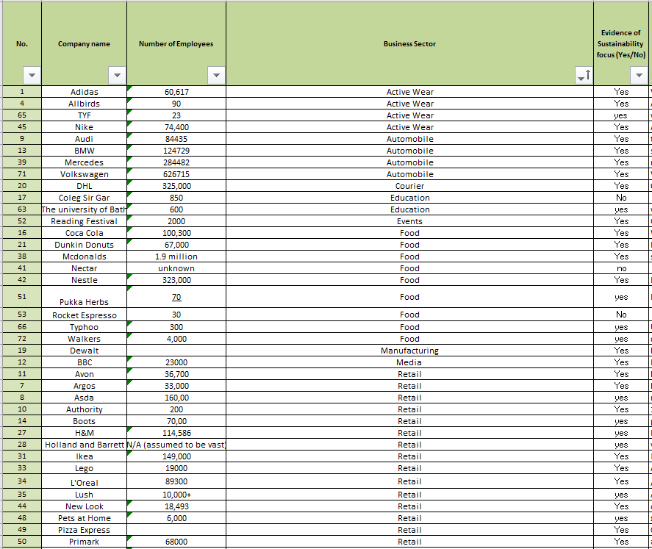
Figure 1.1
Another problem seemed to be that the “Yes” and “No” entries were not represented properly in the “Sum” column. To correct this the author deleted all “No” entries, rendering the empty cell as a negative answer. The “COUNTA” function was then used in all the cells in the field containing answers to the prosumer questions. The use of the COUNTA function was appropriate as where the COUNT function is used to reference cells that contain values such as numbers and dates, the COUNTA function references all cells that contain any type of data such as text, meaning the empty cells are not counted and the “Sum” field tallies the “Yes” entries (Oja, Ageloff, Carey & DesJardins, 2013). 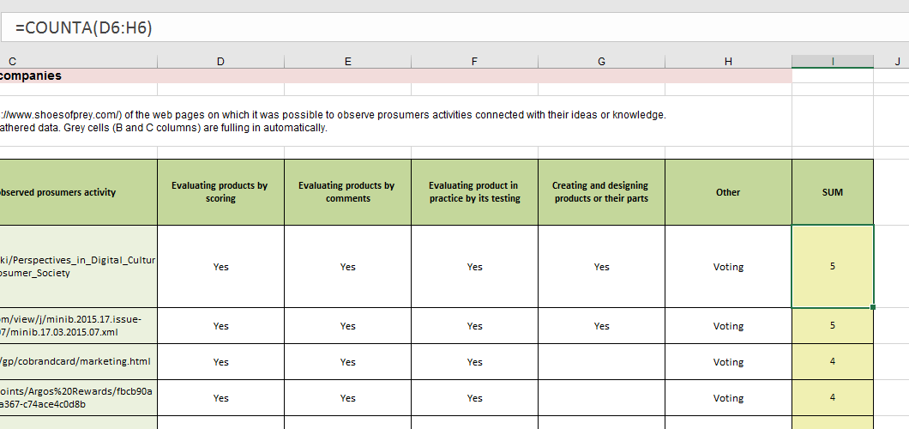
Figure 1.2
Data was then modeled visually in the form of bar graphs to display the companies with the higher prosumer scores. When visualizing data, it is important to be selective with which pieces of information you wish to display, as the digitalization of data management has not necessarily made it easier to display information. The huge amounts of data now at our disposal makes it more difficult to filter the most relevant information (Knaflic, 2015). 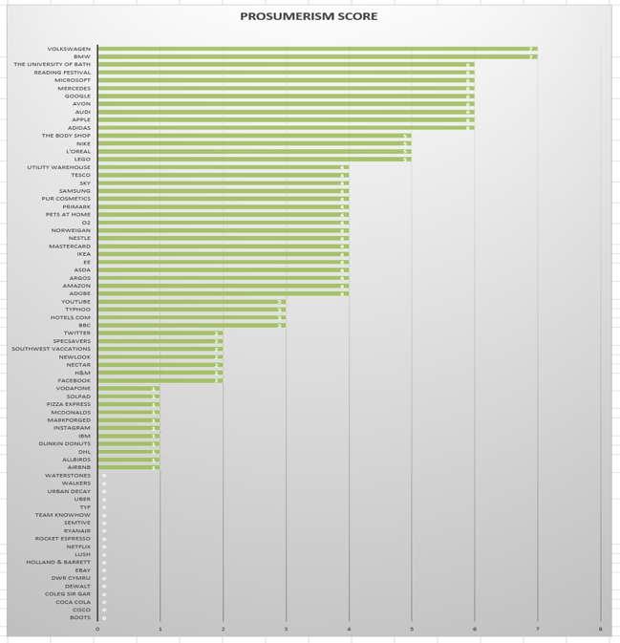
Figure 1.3
To analyze the finalized sets of data, the author arranged the companies into their business sectors using the “Filter” function. The AVERAGE function was then used calculate the average number of prosumer tactics used by companies in these sectors. A bar graph was then created to show which business sectors had the highest average prosumer score.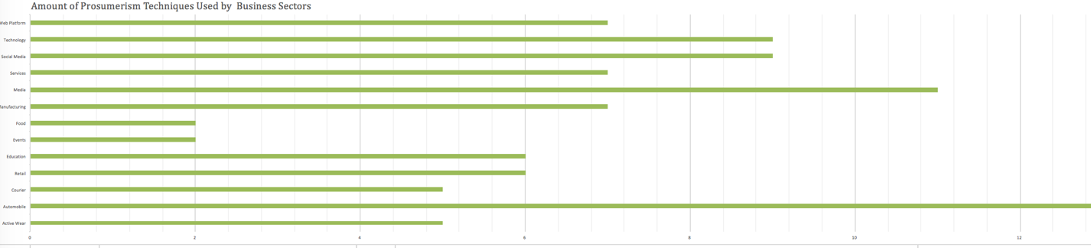
Figure 1.4
A weakness of this database would be that some business sectors were represented in greater number than others. As well as this, duplicate sets of data showed different scores as a result of the numerous contributors to the collated data. This emphasizes the importance of time constraints in data analysis and implementing solutions to problems, as well as the importance of not immediately discarding redundant data. A way to more fairly present the data would to be calculate the average prosumer score for all the duplicated companies and input the average score into visual data (Evans, 2014).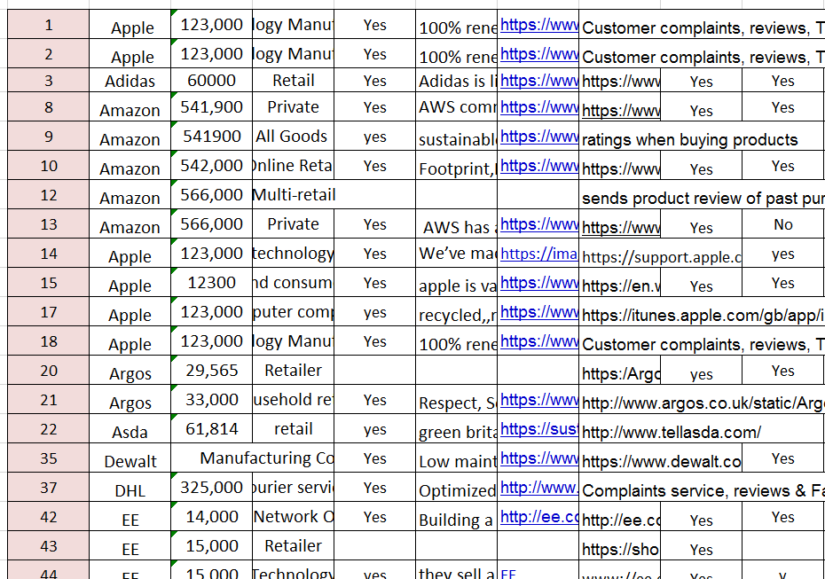
Figure 1.5

Collated Appliance Carbon Data
Similarly, to the prosumer survey file, the carbon data file was constructed by surveys undertaken by 19 students collated into a database. The first problem perceived by the author was that there were clearly students who had entered the number of appliances they owned as opposed to a binary based system representing “yes” as 1 and “no” as 0. There were also cells without any entries which would render the Sums calculated by the COUNT function inaccurate. Any entries greater than 1 were changed to 1, and 0’s were entered into empty cells so that the functions for logical modeling would work efficiently (Chmura & Heumann, 2011). 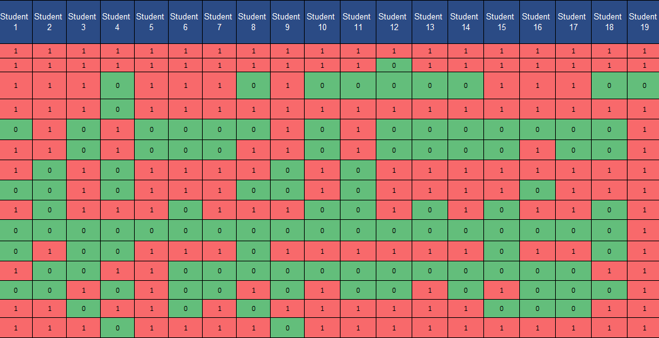
Figure 2.1
A field for Total Cost and Total CO2 were added and the answers we calculated using the SUM function. For the sum to work, the author ensured that the formula referred to the correct cell, to do this, absolute cell referencing was used (Reding, 2014). The same techniques were used to make a combined total of both tables.
Figure 2.2
These totals were used to produce graphs showing the usage and costs of all 19 students. 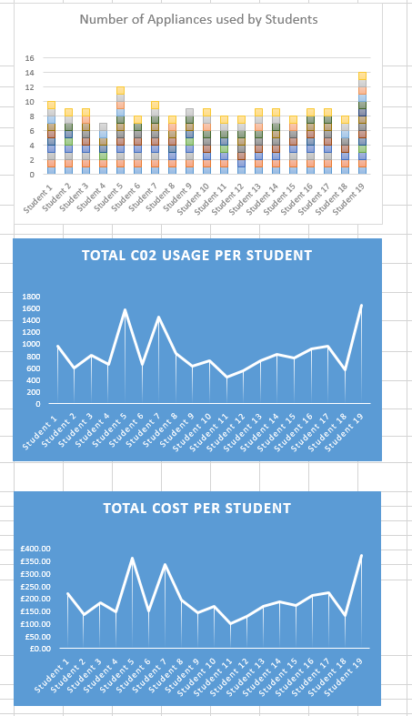
Figure 2.3
Further solutions were implemented by the author to make the data more visual.
Cells were merged to create a less confusing layout. The conditional formatting function was used to highlight all 0 values as green and 1 values as red so that the usage could be instantly recognized. The importance of visual stimuli in presenting data is noted by McCormick, Salcedo & Peck (2017) they explain that adding aesthetics to data allows the data to take on a visual form, giving a more instant understanding of the information showed. 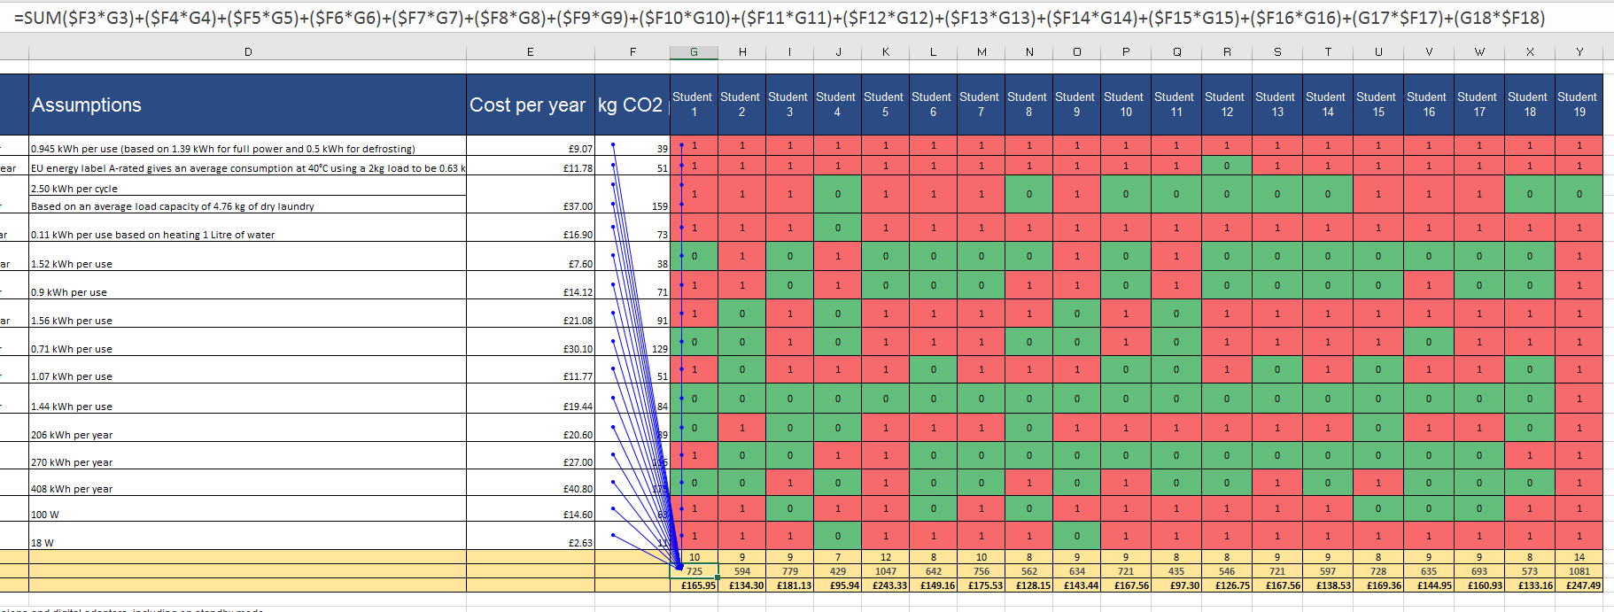
Figure 2.4
The author ensured the cells were correctly formatted, the benefits of which being that once correct format is applied, additional options will become available to the cells with a specific format other than those available to the default “General” format, this will only affect the appearance and will not alter the calculations (Burton, 2011).
The benefits of using data management software such as Excel for business data analysis are that it can allow a business to engage in proactivity and anticipate the needs of the customer, can help reduce fraudulent activity, allows the delivery of relevant products, offers a personalized service that is more appealing to a customer and generally optimizes and improves the experience for the customer as it supports inventory management, sales and customer service and facilitates a relevant and smooth experience with increased engagement. As well as this it allows businesses to identify problems and implement solutions (Albright & Winston, 2016).

Scenario Part 2: Weather List file
The author was also tasked with the scenario of analyzing the data set of weather files provided to us. The data was checked to be correct and that no anomalies or extreme values were present. Countable data was organized into correct fields and the data was standardized to the relevant formats and checked for any redundant data. These steps are what is known as pre-processing the data. However, with all data modelling steps, it is important to note the limitations, being the likelihood of human error and introducing more mistakes, as well as the highly time consuming nature of manual data pre-processing (Akerkar & Sajja, 2016).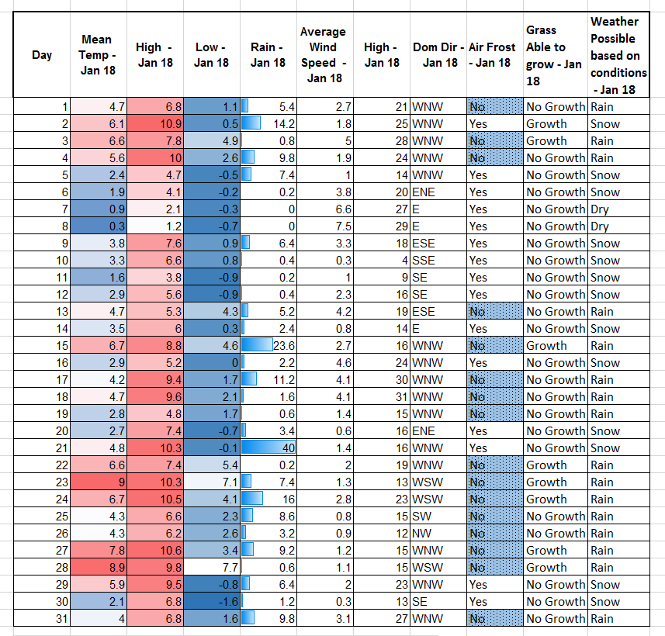
Figure 3.1
After the data was pre-processed, it was used to determine relevant objectives associated with weather data. Totals were firstly calculated using the SUM and AVERAGE functions, this monthly information is then displayed in line graphs, comparing different factors.
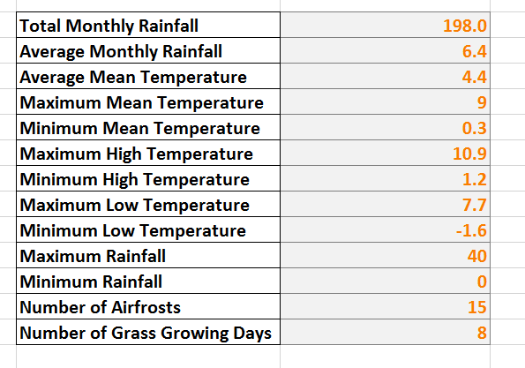
Figure 3.2
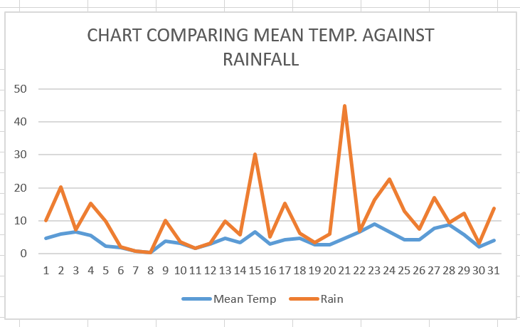
Figure 3.3
The IF function was used to determine the likelihood of air frost. This was done by referencing the cells where low temperatures were recorded and using the IF function to determine whether the temperature was less than 1°C, if yes, then the result of air frost would be extremely likely.
Likewise, an IF function was also used to reference the mean temperature to indicate if mean temperature was above 6°C, then grass growth was likely. Double IF functions can also be used, as displayed in the weather data file the referenced the temperature and rainfall fields to indicate the likelihood of rain, snow or dry weather. The IF function is extremely useful for preforming logical tests to return a value for a true and false result and can be combined with other functions such as AND and OR (Besedin, 2017). 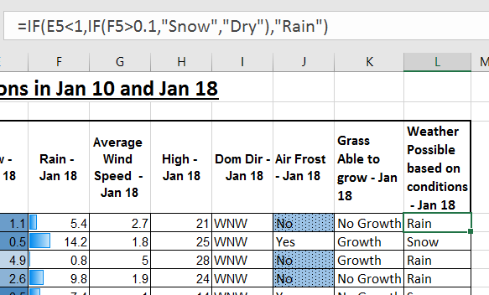
Figure 3.4
This set of data was also made more visual using conditional formatting to easily display the lowest and highest temperatures using colour scales and the rainfall amounts using data bars.
The data was also compared to a series of recordings taken in 2010 and compared in graph format, which clearly shows striking similarities in the trends of temperature and wind speed. These types of trends are much easily recognized in a visual format as looking up values and comparing them individually is a very difficult task as short-term memory is not designed to store many pieces of information (Wexler, Shaffer & Cotgreave, 2017). 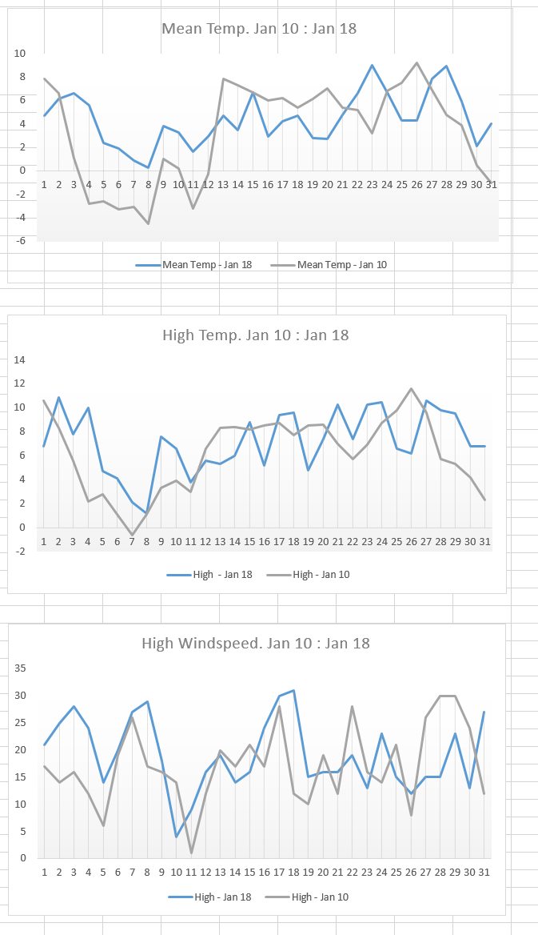
Figure 3.5
This type of data collection demonstrates the importance of data management, as weather stations such as this set up by millions of amateur and professional weather observers across the globe are vital for weather services such as the Met Office, who provide weather and climate related services to forecast the climatic conditions for the military, government, businesses and the public. All these groups and services rely heavily on these forecasts to carry out their operations efficiently and safely (Brugge, 2016).
The use of good quality data is highlighted as no extreme readings are present and all information is correctly formatted. O’Beirne (2008) explains how a mistake made by NASA resulted in the loss of a Mars Climate Orbiter. This was due to two teams using different units of measurement (Imperial and Metric) and cost NASA the loss of a technology valued at $125,000,000, showing just how detrimental not paying proper attention to the format of data and coherently labelling any units of measurements relating to values entered into a spreadsheet can be.

Electrical Data file
The last file that was processed and analyzed by the author were a series of half-hourly readings concerning the amount of energy used by Swansea business school. These half hourly readings dated from February 2015 to August 2018 so a large amount of data could be analyzed for this scenario.
The first step taken in pre-processing the data was to remove a large section of cells which had no data in the energy usage table, this made the process of viewing and analyzing the data easier for the author. Next, the SUM function was used to calculate the half-hourly entries into a daily total, this formula was applied to all cells in the Daily Total column. These totals were then added together using the SUM function to calculate monthly totals, and these monthly totals were used for annual totals.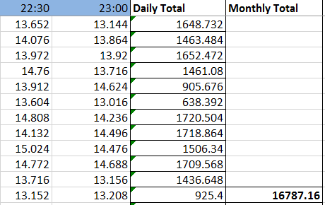
Figure 4.1
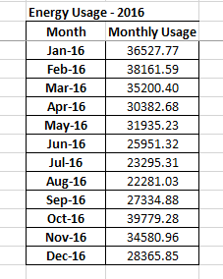
Figure 4.2
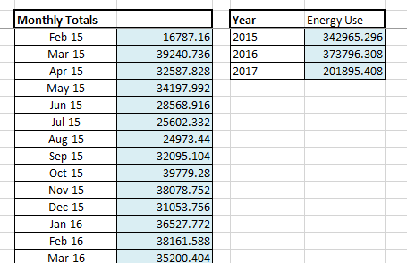
Figure 4.3
Annual totals were imputed into graphs and a trend that appears is that the summer months seem to be less intensive in terms of energy usage. This could possibly be explained by the buildings being less occupied in the summer due to students being away for term breaks or the higher mean temperature resulting in less electricity required for heating purposes.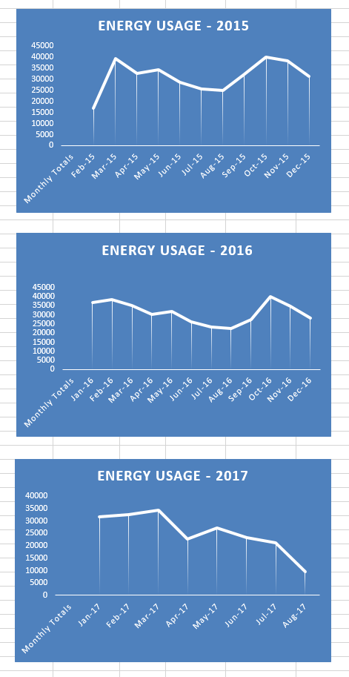
Figure 4.4
The pre-processing revealed a row of cells that contained no data on the 09/08/2016, a few other anomalies are apparent in terms of empty cells, this could either be attributed to human error, or it is possible that these building consumed no electricity during these periods. It has been suggested that human error accounts for a large proportion of all data loss, more so than malicious attacks and hacking (Saran, 2016).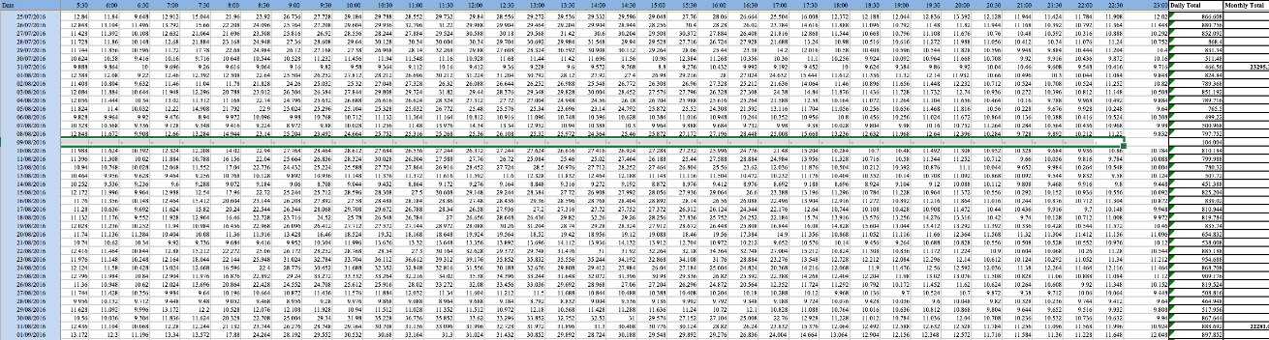
Figure 4.5
A way of making the data more visual was to use a Pivot Table. The author selected the cells containing the data for energy usage in 2015, displayed in months and half hourly intervals I then formatted the cells to show red as high usage and green as low. This revealed an expected trend, the times expected to be busy in the university are very visually high in electricity usage. These results can then be filtered into the users desired order to display the objectives information. 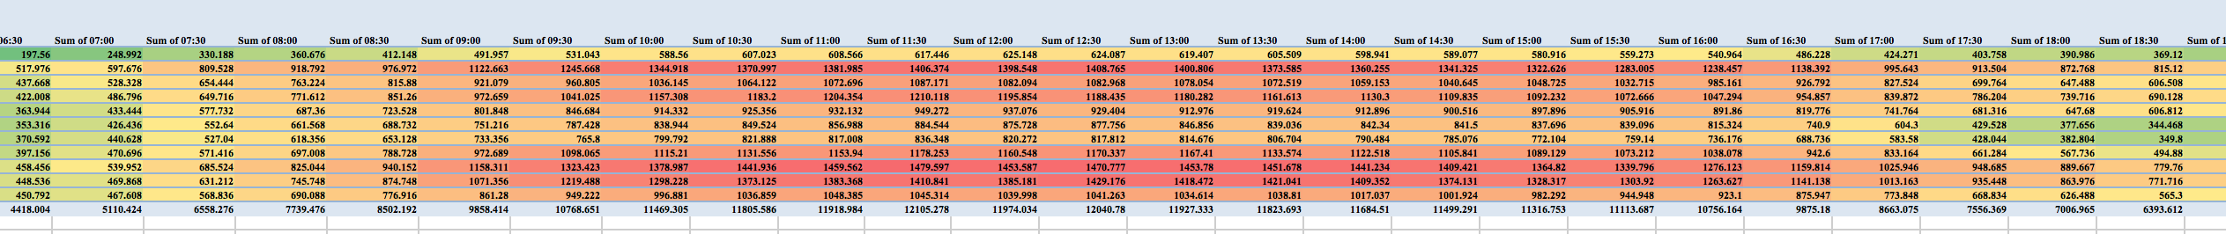
Figure 4.6
Another function that was utilized in this spreadsheet was the VLOOKUP function. The VLOOKUP function is used to return a value from a table by looking up another related value (Walkenbach, 2013). The author applied this formula to return a daily total of electricity used by referencing the total column when a date is entered. These formulas are an example of logical modelling; it can save time and effort for the spreadsheet user looking to find a specific set of data in a large field. 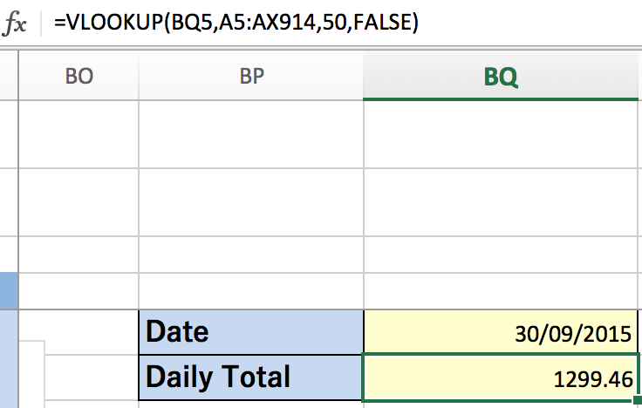
Figure 4.7
Scatter graphs were plotted of the complete data set of electricity used for the whole of 2016 and Linear, Polynominal and Exponential trendlines were added. When inputting the trendline, the author displayed the equation on chart and the R-squared values. These can be used in a table to make a prediction based on the trendline. 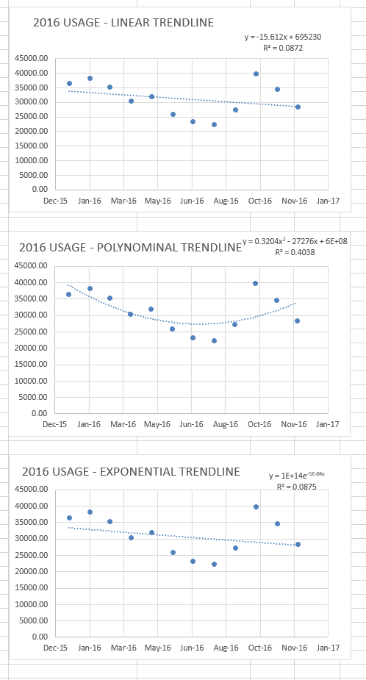
Figure 4.8

Summary
For successful data management and analysis, the data must be modelled efficiently. Success and efficiency are subjective terms so it is important when identifying problems and implementing solutions that the data analyst knows the objectives of the spreadsheet user (Davies, 2014). Pre-processing data and applying logical modelling will aid the user of the spread sheet by providing good quality data that uses formulas such as IF and LOOKUP to make the use of the spreadsheet easier to use. Visual modelling can vastly improve the speed in which people can process the data presented, key in identifying trends and using this to make predictions, a vital process that businesses are using today to stay ahead of competition.

References

Akerkar, R., & Sajja, P. S. (2016). Intelligent techniques for data science. Switzerland: Springer.

Albright, C. S., & Winston, W. L. (2016) Business Analytics: Data Analysis & Decision Making. Boston, MA: Cengage Learning

Brugge, R. (2016). Setting up a weather station and understanding the weather: A guide for the amateur meteorologist. Ramsbury, Marlborough, Wiltshire: The Crowood Press.

Burton, S. (2011). Business math using Excel. Mason, OH: South-Western Cengage Learning.
Chmura, A., & Heumann, J. M. (2011). Logical data modeling: What it is and how to do it. New York: Springer.

Cornell, C., & Morris, S. (2018). Database Systems: Design, Implementation, & Management. Boston, MA: Cengage Learning.

Evans, J. R. (2017). Business analytics: Methods, models, and decisions. Boston, MA: Pearson.

Knaflic, C. N. (2015). Storytelling with data: A data visualization guide for business professionals. Hoboken: Wiley.

McCormick, K., Salcedo, J., Peck, J., & Wheeler, A. (2017). Data analysis and visualization. Indianapolis, IN: John Wiley & Sons.

O’Berne, P., (2008). Information Quality in Spreadsheets. Wexford, Ireland: EuSpRIG

Oka, D., Ageloff, R., Carey, P., & Desjardins, C. (2013). New Perspectives on Microsoft Excel 2013. Boston, MA: Cengage Learning.

Reding, E. E. (2014). Microsoft Excel 2013: Illustrated brief. Boston, MA: Course Technology, Cengage Learning.
Reding, E. E., & Wermers, L. (2011). Microsoft Excel 2010: Illustrated complete. Boston, MA: Course Technology, Cengage Learning.

Saran, C., (2016, June 02). Human error causes more data loss than malicious attacks. Retrieved from https://www.computerweekly.com/news/450297535/Human-error-causes-more-data-loss-than-malicious-attacks (03/05/2018)

Walkenbach, J. (2013). Excel 2013 Formulas. John Wiley & Sons.

