University of Wales Trinity Saint David London
Programme: BSc Cloud Computing
Module: Academic & Employability Skills
Name: Celdwan Bandeira
ID:1812407

Table of Contents

Section I: Personal overview 2
Section II: Skills evaluation 8
Section III: Actions plan 12
Section IV: Application 13
Section V: Conclusion and evaluation 15
Reference List 16
Appendices 17

Introduction
Employment is one of difficult phase of the individual life. With the fast growth of community, the competitions between the organizations are also maximizing, what the employers desire from the graduates are not only aim on the degree but pay more attention to the candidates skills. This study has determined the weaknesses as well as the proper way to overcome those. In fact, several skills have been reviewed as well as techniques have been shown to enhance those.

Section I: Personal overview
My name is Celdwan Bandeira and I am studying in the University of Wales with focus in Cloud Computing. I am looking for a proper academic and employment skill which will help me to make a strong and successful career in future. I love to enjoy meeting new people as well as finding ways to assist them, which uplift my experiences. In fact, I am a dedicated person with 4 members in my family and spend times reading books or novels help to strengthen knowledge and presentation capabilities. At present I am focusing to be a successful employability and high education learning.
One of the prime professional skills which have been learnt at the time of course is the capability to showcase to a feasible team or employer they are performing with the way they utilize the present technologies in order to interact, find and describe solutions to feasible thematic they can encounter at the time of course of meeting and interview.
In order to prepare student to penetrate the workforce the education, the university programs need to contribute experiences which go beyond the knowledge alone to establish other critical skills essential for productive and effective professionals. Strategies for assisting students gain skill set required for successful careers involve delivering courses dedicated to the skills of a student, amalgamating student skill aimed activities into regular curricular delivering as well as involving students in internship and research experiences. This study is aimed on my personal overview on what my future needs to look like as well as personal development plan in order to assist to accomplish the aim.
- While creating the presentation, it has been seen that an effective presenter requires being enthusiastic, energetic and flexible.
- Creating a presentation keeps one on public display.
- The audience not only listens to their concepts, this also answers to the way one utilizes their body and their voice.
- One requires more than a well written presentation in order to create an influence. One needs to serve this in a lively, interesting and flexible way.
- At the time of presentation, needs to catch the interest of the audience, aiming directly on the goals of the presentation, creating and utilize proper pictures so that the prime audience does not distract from the subject matter.
- In the finish slide, one needs to summarize the context of their presentation they provide aiming on the key sections they have described at the time of this. In fact, it is essential to ask questions to their audience in order to check in case there are beginning feasible discussion and misunderstandings on the delivered subject.

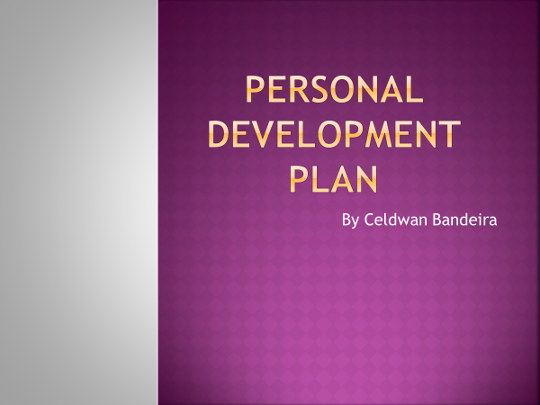
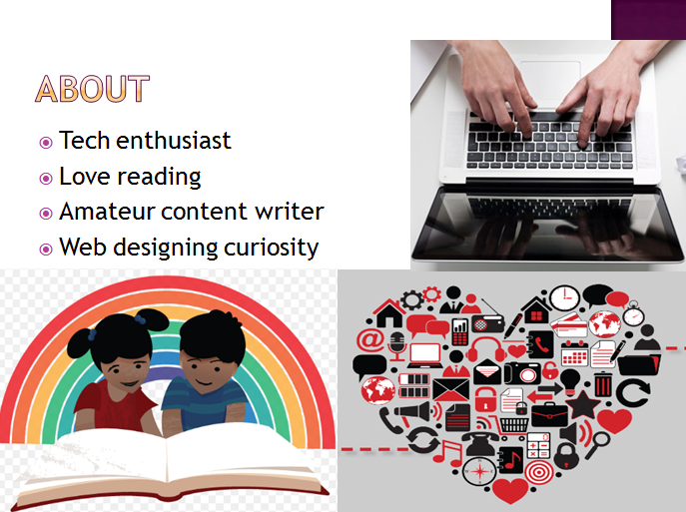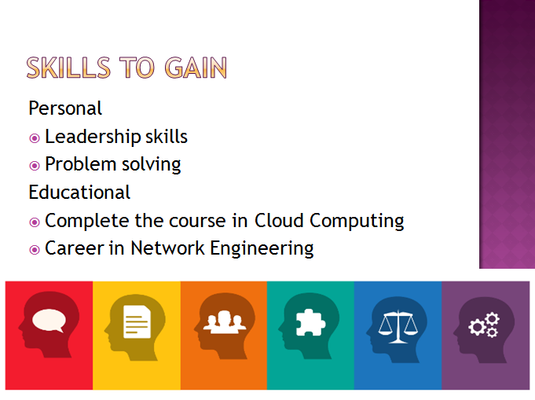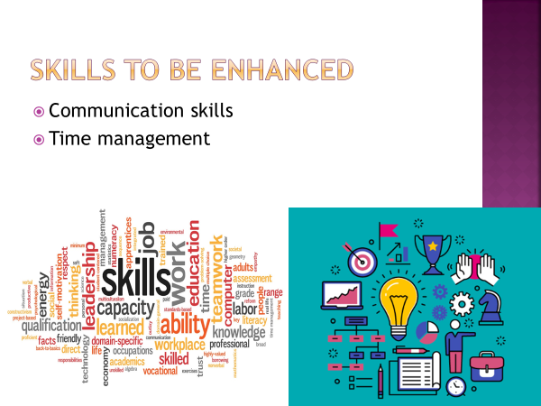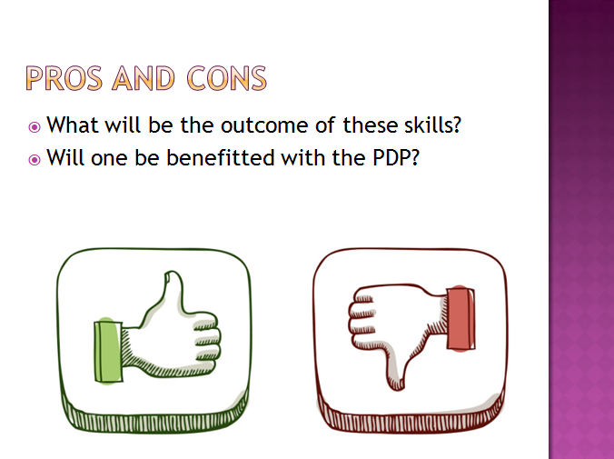

Section II: Skills evaluation
In this section, the explanation and introduction of the prime phase attempted at the time of the growth of the Personal Development Plan and its evaluation required being Employability and High Education learning. In order to enhance the skill of one in Employability, this is essential to able to finish the course in the best way. In fact, in order to achieve the HE learning, the similar approach can be utilized. The skills which have been identified at the time of the course are as follows:
- Collaboration skills: This is an essential skill as students of the digital era are social by nature. While they are not able to engage with technological environment, they become unattached and disengaged to their learning. Thus, collaboration and connection with other are crucial not only to their learning but their emotional and mental health. Student needs to have the capability in order to collaborate seamlessly in both virtual and physical spaces with virtual and real partners globally. As per Oviawe et al. (2017), collaboration is a skill which educators need to exercise with them at a regular basis and understanding Collaboration Fluency may help with such.
- Communication skills: According to Foronda et al. (2017), students need to be able to interact not just with speech or text, but also in multiple multimedia ways. They need to be capable to interact visually with the aid of imagery and video as effectually as they do with speech and text. As per Hasan et al. (2017), communication is a wide term which amalgamates multi-faced scales of sharing data and interaction. Thus, it is a crucial section of Media Fluency.
- Problem solving skills: Students require the capability to resolve complicated issues in real time. Complicated issues which they cannot even discern at present may be everywhere. As opined by Argaw et al. (2017), the more the society aims on the ability of a student to devise effective solutions to real world issues, the more accomplished such students may become. Therefore, this is an important skill of Solution Fluency.
- Analytical skills: Student needs the capability in order to think analytically which involves proficiency with applying, synthesizing, evaluating, contrasting and comparing without supervision or instruction. Bravo et al. (2016) have mentioned that analytic thinking means being capable to utilize the higher order thinking skills. Thus, this is important to manage student towards being capable to work analytic thinking. This is all about Information Fluency.
- Time management skills: At the time of the studies, it has been learnt how to maintain the present time a student has at the time of the everyday life. Time management is the prime to plan and organize the time they have in between the tasks they have to gain at day (He et al. 2016).
Self-evaluation
As per the opinion of own, the best overview to be productive is to get the direction to divide the day in a phase of moments in which they have the feasibility to devote them to various activities. They do not have to devote them to only 2 or 1 tasks in a day, but they can map to provide to each task a variable time length in between 2 to 3 hours minimum.
In respect to analyse the strengths and weakness as well as personality kinds, a self-evaluation exercise from Alberta (https://alis.alberta.ca/careerinsite/know-yourself/skills-quiz/) and Mindtools (https://www.mindtools.com/pages/article/get-started.htm) have been attempted. The following scores have been gathered from the online test:
Skills | Score
Leadership skills | 6/10
Problem solving | 8/15
Communication skills | 10/15
Time management | 15/20
Table 1: Outcomes of the online test
Goals | Term
Enhance personal skills | Short
Complete the course in Cloud Computing | Short
Career in Network Engineering | Long
Table 2: Goals
In respect to accomplish the goals determined, it is mandatory to enhance both personal and technical skills related to the self-evaluation online web test. The final goal is clear but completing the course itself is not going to be sufficient. An easy learning plan has been made and the learning material from Academic and Employability skills Model has been mastered to self-reflect the process.
Leadership skills: Developing and learning good leadership skills as a University student may deliver the student well while they leave any learning environment as well as step into the world of business. In order to enhance the leadership skills, it is needed to work hard on own. It is not possible to lead anyone else in case one does not lead own in the proper way. As opined by Kamba et al. (2018), it is essential to perform on own by becoming the best example to the other. This engages establishing character and self-discipline. In addition, it engages learning in order to establish own organization skills so one becomes an effectual leader. When it is critical to perform on enhancing own, learning to be hard on own as well as to perform on own is a crucial skill which one leader needs to have.
It has been seen that 6/10 has been scored thus, it is essential to enhance the critical skills to effectually manage and lead a group.
Problem solving skills: Explaining the issue is one of the best ways to solve any issue. Problem solving skill is termed to understand and identify the root effect of the issue, thus, to implement great techniques and tools to solve this. Thus, this is like the analytical skill which is the capability to collect by one student.
It has been seen that 8/15 has been scored and it is the lowest score which has been highlighted. Before solving any sort of problem, it is necessary to understand and explain that issue. Therefore, it is needed to motivate one to approach the solution in various ways as well as to converse with the aid of their opinion method out loud.
Communication skills: Conversation is one of the prime basic and important communication skills. This secures one to share ideas, opinions and thoughts as well as receive them in return. As opined by Huda et al. (2017), one student can learn the fundamental factors of conversation by watching videos or films of such interaction occurring. The best way to achieve the skill is by pause the video and raise queries.
10/15 has been scored in the online web test, in order to score much more in future, it is mandatory to use technology like audio books (Paper Telephone and Voice Thread). Student can read or listen to along with audio books to listen the way speaker enunciates and pronounces various phrases or words.
Time management: According to Noe et al. (2017), this covers the schedule and priority among the activities and tasks one has to finish. In case a student does not feel like doing work, they need to set time for few minutes.
15/20 has been scored in time management skills. This area is fair enough among all the skills, but still it needs to maintain always so that one can easily maintain time better by scheduling and prioritizing time effectually. In fact, it is needed to keep establishing the strengths as well as enhancing the weaknesses by organizing personal aims.

Section III: Actions plan
Date | 1 May 2019
Aim of the plan | To enhance the academic and personal skills for work and university
Action process
Leadership skills | - Establishing discipline in personal and professional life  - Establish situational consciousness  - Keep learning new things to sharp mind
Problem solving | - Collecting and analysing the data  - Breaking down the issue into sub elements
Communication skills | - Listening actively before responding to anyone  - Take feedback from the other while communicating
Time management | - Writing a to do list to save time  - Breaking big activities into smaller chunks
Table 1: Action plan

Section IV: Application
- Taking care of data
Robust level of data protection: Digital technology makes this vulnerable to outer threats as well as securing own information is essential for one.
- Departed of hardware which carries data or physical damaging is one side. For example, vandalism and natural disasters are some of the threats. Security actions for such threats are much varies.
- It is essential to secure the software assets from the outer threats. It mainly includes malware, computer viruses and accidents or hacking affected by improper utilization of information software (Zhang, 2017).
Effectiveness of strategy: In order to keep hacking or accidents to reduce, it is needed to determine proper instructions on the way the software on their system needs to be utilized. This is simply to copy the information back from the cloud website or medium of storage to the clean or fresh system. It is one of the appropriate ways to keep secured even against malicious software like Ransomwares. This is the prime motive to encrypt the information on the contaminated hosts as well as raise query for a pay-off in transformation of the decryption key. Security from hackers, malware and viruses is best completed by installing intrusion detection programs, firewall and virus detection systems. Moreover, in order to secure data, making passwords for sensitive data and encrypting is other strategy.
- Time management and organization
In order to improve the productivity as well as minimize the stress scales at scales at work as at the time of the life of university, some of the key areas which are needed to be aimed at are as follows:
- Using a time planner
- Increasing productivity by performing from a list
- Organizing the list by priority
- Enhancing the organizational skills
- Receiving regulators breaks in between each activity
- Making a to-do list as well as organizing deadlines for each task
- Scheduling and prioritizing the several activities which are needed to achieve
Delegation and automatization are an investment in the time. The very act of utilizing the organizational skills to map their month, week and day, provides one a higher feeling of control as well as may assist increase productivity within the day. One may feel in charge in their life. Monitoring their time organization mainly maximizes their self-esteem and enhances their sense of personal strength.

Section V: Conclusion and evaluation
Most of the career chances for student at present may need some form of education, there are lot of times while students may not be capable to gain the essential academic, employability and technical skills in University which may permit them to be career ready without further training and education. Specialization and additional knowledge in one or more of such areas is mainly needed either instantly after University or during the courses, relying on the career opportunities of a student. In fact, regardless of the path of student, this takes all the two wide skill sets for the student to be prepared for their career. 21st universities need to aim on contributing all their students a hard foundation across all the areas so they are ready for whatever their lives may face. Collaboration skills, Communication skills, Problem solving skills and Analytical skills as well as Time management skills have provided a great understanding of all the subjects one student learns. In order to improve the detected skills, the student needs to encourage themselves as well as align each of the weaknesses and work on those. This may assist the student in order to make their weaknesses as their strengths. After attempting the online web skill tests of Leadership skills, Problem solving skills, Communication skills and Time management skills, a better concept regarding the weakness and strength of student have been gained to project in future.

Reference List
1- Argaw, A.S., Haile, B.B., Ayalew, B.T. and Kuma, S.G., (2017). The effect of problem based learning (PBL) instruction on students’ motivation and problem solving skills of physics. EURASIA Journal of Mathematics Science and Technology Education, 13(3), pp.857-871.
2- Bravo, A., Porzecanski, A., Sterling, E., Bynum, N., Cawthorn, M., Fernandez, D.S., Freeman, L., Ketcham, S., Leslie, T., Mull, J. and Vogler, D., (2016). Teaching for higher levels of thinking: developing quantitative and analytical skills in environmental science courses. Ecosphere, 7(4), p.e01290.
3- Foronda, C., MacWilliams, B. and McArthur, E., (2016). Interprofessional communication in healthcare: an integrative review. Nurse education in practice, 19, pp.36-40.
4- Hasan, S., Tarazi, H. and Halim Hilal, D.A., 2017. Enhancing Student Communication Skills Through Arabic Language Competency and Simulated Patient Assessments. American journal of pharmaceutical education, 81(4), p.76.
5- He, W., Holton, A., Farkas, G. and Warschauer, M., (2016). The effects of flipped instruction on out-of-class study time, exam performance, and student perceptions. Learning and Instruction, 45, pp.61-71.
6- Huda, M., Sabani, N., Shahrill, M., Jasmi, K.A., Basiron, B. and Mustari, M.I., (2017). Empowering learning culture as student identity construction in higher education. In Student Culture and Identity in Higher Education (pp. 160-179). IGI Global.
7- Kamba, A.H., Giwa, A.A., Libata, I.A. and Wakkala, G.T., (2018). The relationship between science process skills and student attitude toward physics in senior secondary school in Aliero metropolis. African Educational Research Journal, 6(3), pp.107-113.
8- Noe, R.A., Hollenbeck, J.R., Gerhart, B. and Wright, P.M., (2017). Human resource management: Gaining a competitive advantage. New York, NY: McGraw-Hill Education.
9- Oviawe, J.I., Uwameiye, R. and Uddin, P.S., (2017). Bridging skill gap to meet technical, vocational education and training school-workplace collaboration in the 21st century. International Journal of vocational education and training research, 3(1), pp.7-14.
11- Zhang, E., (2017). HOW GDPR WILL RESHAPE YOUR DATA PROTECTION STRATEGY. Available at: https://digitalguardian.com/blog/how-gdpr-will-reshape-your-data-protection-strategy [Accessed on 30/4/2019]

Appendices
Appendix 1: e-Portfolio in processing
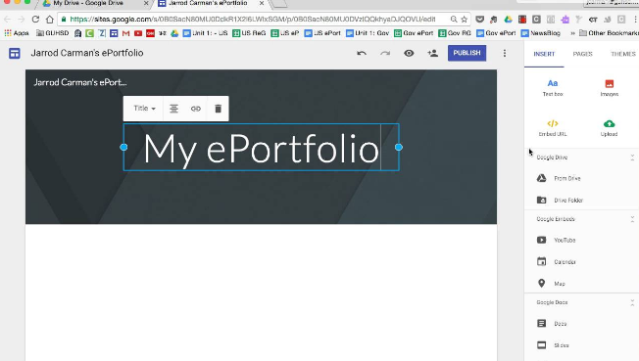 Linkedin Id: <>

Appendix 2: Personal Development Plan
 | Short-Term Time Frame  What do I want to accomplish in the next three to six months? | Mid-Term Time Frame  What do I want to accomplish in the next six months to two years? | Long-Term Time Frame  What do I want to accomplish in the next two to three years?
Section 1 - My Goals  What are my overall goals that I want to accomplish in this time period?  Example: become a Student Affairs Officer; learn computer graphics | Learning basic cloud computing | Complete the course in Cloud Computing | Learning to build server-less web application
Section 2 - Skills and Knowledge to be Learned  What specifically do I need to learn? What project do I need to work on?  Example: Student advising; Banner; Dreamweaver; develop a procedures manual | Programming language | Computer HW knowledge
Section 3 - Next Steps  How am I going to acquire the skills and knowledge? How am I going to do this project?  Example: take Dreamweaver class; do an informational interview; set up a project outline | Starting some project on subject based and complete that

 | Short-Term Time Frame  What do I want to accomplish in the next three to six months? | Mid-Term Time Frame  What do I want to accomplish in the next six months to two years? | Long-Term Time Frame  What do I want to accomplish in the next two to three years?
Section 4 - Resources What resources do I need? Example: free time; funding | Material to study  Good attitude  Free time
Section 5 - Time Schedule

What is my time schedule?
When will I start?
When do I expect to finish?
Section 6 - Completion  When have I completed each step? | □  Date  □  Date  □  Date | □  Date  □  Date  □  Date | □  Date  □  Date  □  Date

Appendix 3: Skills Evaluation questionnaires


