Effective Team Work and Communication

BMSW4002
Stefanel Lazar : 2132344
Table of Contents

1. Introduction 3
2. Models of Communication 3
2.1 Shannon and Weaver (1948/49) 3
2.2 Schramm (1954) 5
2.3 Berlo (1964) 6
3.0 COMMUNICATION SKILLS 9
3.1 Verbal – spoken and written, choice of words, tone and pitch. 9
3.2 Non-Verbal 9
3.3 Listening 10
4.0 The Advantages And Disadvantages Of Technology In Communication 11
5.0 CONCLUSION 11
6.0 REFERENCES 12

1. Introduction
Communication is the exchange of ideas, thoughts, information, and messages between two or more people. It is an essential part of life and is used to facilitate everyday activities. There are various models of communication which aim to explain how people communicate with each other. These models also provide insight into the different aspects of communication and how they affect the effectiveness of communication. Additionally, communication skills are essential to facilitate successful communication. Finally, technology has significantly impacted how people communicate, with both positive and negative effects being felt. The purpose of this report is to display knowledge of communication theory, communication abilities, and the benefits and drawbacks of technological advancements in the field of communication. The report will start with a discussion of several communication models, and then move on to a summary of the various communication skills that can help make that model a reality. The pros and cons of using technology for communication will next be discussed.

2. Models of Communication

2.1 Shannon and Weaver (1948/49)
Description
The linear, unidirectional model of communication proposed by Shannon and Weaver (1948/49) consists of a sender, a message, and a receiver. A message is sent to the receiver after being encoded and sent by the sender. Once the communication has been received, the recipient can decipher it. The model also recognises interference or noise that can distort the message and advises using feedback to verify correct transmission and reception (CT, 2022).
The information theory of Claude Shannon and Warren Weaver, created in 1948, serves as the theoretical foundation for this paradigm. Sender, Message, Channel, Receiver, and Noise are the five parts of the model. In this context, "sender" refers to the person or group actually transmitting the communication. What's being communicated is the message (Muyanga and Phiri, 2020). The channel is the means by which the message is conveyed, be it a wired or wireless connection, a radio wave, or a digital network. The recipient is the person or group that actually reads the communication. Finally, we have noise, which is any form of interference that changes the sent message.
For decades, professionals in fields as diverse as marketing and telecommunications have relied on this paradigm (PM, 2019). Its useful foundation for comprehending communication's multifaceted processes ensures its continued applicability.
Diagram

Figure: Shannon and Weaver Model of Communication
(Source: CT, 2022)
Case study
The foundation of the said misunderstanding was probably the issue with concentration and miscommunication. Probably there was some deficit of utilisation of basic common sense as well. It should have occurred to Pedro that Maria would not just call him to tell him that he would meet him in the Kitchen. This seems absurd. Therefore, Pedro should have double-checked the matter by asking Maria about what exactly she called for.
A similar example from the workplace
Yes, in my workplace, once I called my senior to request leave as I had some personal issues to deal with. The senior accepted my leave. Therefore I did not show up at the office. But then a few hours later the senior called me to ask why did not I present at the meeting. I reminded him that I called him and asked for a leave and he approved. Then the senior said he thought I was asking if I could leave the office early and that was why he approved my leave. Otherwise, I was required in the meeting. I felt sorry for the matter and requested my senior if I could help with anything. He then rescheduled another meeting for an upcoming day.

2.2 Schramm (1954)
Description
The Schramm (1954) model is a communication model which proposes that communication involves a sender, a message, a channel, and a receiver. The sender encodes the message, which is then sent through the channel, and decoded by the receiver. It is an expansion of the Shannon and Weaver (1949) communication model, which suggested that communication involves a sender, a message and a receiver.
The Schramm model builds on this by adding a feedback loop in which the receiver can send a response to the sender. This feedback loop is integral to the Schramm model, as it allows for two-way communication and the opportunity for the receiver to provide feedback and modify the message. The model also takes into account the environment and the noise which can affect the communication process.
This model differs from the Shannon and Weaver model in that it includes the feedback loop, and takes into account the environment and noise. The presence of the feedback loop allows for a two-way communication process, as opposed to the one-way process in the Shannon and Weaver model. Additionally, the Schramm model is more comprehensive and takes into account the environment and noise, which can affect the communication process.
Overall, the Schramm model is an extension of the Shannon and Weaver model and provides a more comprehensive view of communication by including a feedback loop and considering the environment and noise. It has become the basis for modern communication models and is widely used in communication research.

Diagram
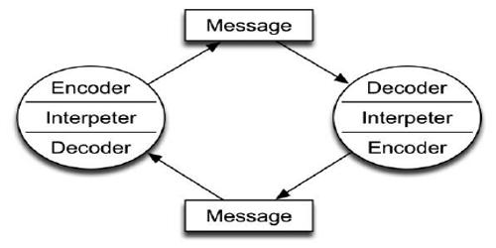
Figure: Schramm's (1954) model of communication
(Source: CMT, 2021)
Case Study
In order to avoid the situation, Maria could have texted Pedro about her requirement for chicken for that night. Further, she could have called Pedro to check on his status and reminded him to check the messages. In this way, she could easily be communicating with Pedroi as well as there would not be any misunderstanding precisely.
A similar example from the workplace
During my work days, I faced a similar situation as I have already stated. Further, I made sure to put on emails every time I was required to leave or for any emergencies. I make sure that there does no0t occur any sort of miscommunication from my end.

2.3 Berlo (1964)
Description
Berlo's communication model, also known as the SMCR (Source, Message, Channel, Receiver) model, is a linear model of communication which was developed by David Berlo in 1960. It is designed to help people understand the complexity of the communication process, and it helps to identify the key components of successful communication (Abbass et al., 2021).
The model consists of four main parts: sender, message, channel, and receiver. The sender is the originator of the message, the message is the verbal or non-verbal information that is being conveyed, the channel is the means by which the message is sent (i.e. face-to-face, email, phone, etc.), and the receiver is the individual or group of people who receive the message (Medendorp et al., 2021).
Berlo's model is different from S/W's and Schramm's models in that it is much more detailed and complex. It includes a number of variables such as the sender's credibility, the receiver's understanding of the message, the clarity of the message, the environment in which the message is communicated, the language used, and the feedback received. All of these variables are important to successful communication and must be taken into account in order to ensure that the message is accurately and effectively conveyed (LMS, 2022).
Berlo's model is also different in that it emphasizes the role of the sender in the communication process. The sender must be aware of the receiver's needs in order to effectively convey the message. They must also take into account the language used, the environment in which the message is communicated, and the feedback received in order to ensure that the message is accurately and effectively conveyed.
In conclusion, the Berlo model is an important model of communication which outlines the key components of successful communication. It is more detailed and complex than S/W's and Schramm's models, and it emphasizes the role of the sender in the communication process.
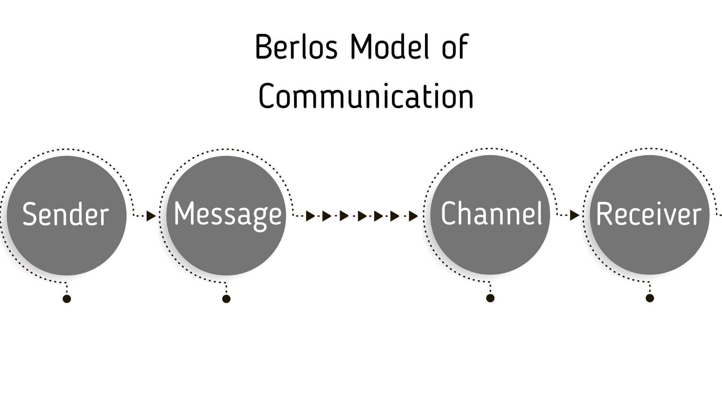
Figure: Berlo's communication model
(Source: CMT, 2021)
Case Study
In the case study of the English Professor, it was observed that the professor had the potential to use up his knowledge of the English language and literature to communicate well with the villagers. When he had to explain the severity of the fire at the house, he implemented strong and, meaningful wordings that can penetrate deep into the hearts of the listeners and make the listeners aware of the situation so that the circumstance can be avoided by all means. Here the villagers actively listened are it was their respected professor who was talking. His knowledge of the subject was appropriate to handle the situation. He was panicked but he could calmly deliver the requirements to the villagers. Ultimately, it can be said that it was his knowledge and effective communication skill that saved the day.
A similar example from the workplace
Yes, I have had a similar experience at my workplace. Once there was a severe earthquake when we were at work. Everyone was scared and started to panic. But our senior was cal;m and composed. He then used positive and powerful words redirecting us towards the nearest potential exit from the workplace building. Therefore we were capable of getting out of the building on time. The earthquake did not cause any harm but still was able to leave the building without harm.

3.0 COMMUNICATION SKILLS

3.1 Verbal
Verbal communication is the use of words and language to express oneself and understand others. Verbal communication is the primary way of exchanging information, ideas, and emotions between people (Koegel et al., 2020). Verbal language is made up of a combination of words, sounds, and gestures. It can include both spoken and written communication, as well as nonverbal cues, such as facial expressions and body language (Kubota, 2019). Examples of verbal communication include conversations, lectures, interviews, presentations, speeches, and other forms of verbal exchange.

3.2 Non-Verbal
Nonverbal communication, also known as body language, is the use of physical cues to communicate with others. Nonverbal communication includes gestures, facial expressions, eye contact, body posture, and tone of voice. Nonverbal communication can often reveal more than verbal communication, as it conveys emotion and attitude (Kuznar and Yager, 2020). Examples of nonverbal communication include a smile, a nod, a hug, an eye roll, a shrug, and a head shake.
CASE STUDIES
In the case study situation, it was observed that the chiefs were natural. She could comfortably handle a meeting where the other person remains uncomfortable. Mark was amused by Mrs Brown’s charm. This worked as a charm for Mrs Brown as she was required to gain the trust of Mark and gather important internal organisational information about the company Mrs Brown is about to be a part of. Further, Mark had to finish the meeting nicely. He could do it with the help of Mrs Brown. So it was evident that proper verbal and non-verbal communication modes implied by Mrs Btrown had favoured both parties to achieve what they wanted.

3.3 Listening
Active listening is a communication technique that requires the listener to provide feedback to the speaker in order to demonstrate understanding and retain information. Active listening involves listening carefully to the speaker, paraphrasing what the speaker has said, and asking questions to clarify information (Pang et al., 2019). Active listening also involves being attentive and using nonverbal cues to show that the listener is engaged. Examples of active listening include nodding, making eye contact, and responding with phrases such as “I see” and “Yes, go on.”
Empathetic listening is a communication technique that involves listening to another person with understanding and compassion. Empathetic listening is focused on understanding the other person’s feelings and points of view. The listener strives to understand the speaker’s feelings and thoughts, rather than focusing on their own opinion (RS, 2022). Empathetic listening involves active listening and nonverbal communication, as well as maintaining an open, non-judgmental attitude. Examples of empathetic listening include mirroring the speaker’s body language, reflecting on the speaker’s words, and providing support and understanding.
CASE STUDY
In the case of Max the Multitasker, their overtasking and multitasking tendency of Max had caused him big trouble with one of his loyal and oldest customers precisely. Such kind of situation is required to be avoided. In the case situation, it was observed that Tamara was furious and upset with Max but she should have been an empathetic listener and put herself in their shoes of Max. then probably should be able to understand the struggles Max is doing to sustain himself and his family. Therefore she could have definitely used him another chance to arrange the same party for her. After all, it was not exactly the day of her parent’s wedding anniversary, they could have easily taken any other date for the same event. Tamara required to be a bit more empathetic towards Max at the end.

4.0 The Advantages And Disadvantages Of Technology In Communication
The advantages of technology in communication are numerous. Technology has enabled communication to be more convenient, efficient, and faster. With the help of technology, people can communicate with each other in real-time, no matter their location. Technology also allows for a much larger audience to be reached with less effort. From emails to video conferencing and social media, technology has made it easier to communicate with others. Additionally, technology has given us access to a wealth of information and resources, allowing us to stay better informed (Liu et al., 2020).
However, technology has some disadvantages when it comes to communication. One of the most obvious disadvantages is that it can lead to isolation as people become more reliant on technology and less likely to interact in person. Additionally, technology can lead to misunderstandings and misinterpretations due to the lack of facial expressions and body language that can be expressed during face-to-face conversations (Medendorp et al., 2021). Technology can also lead to distraction, as people become more likely to multitask and neglect to pay full attention to the conversation. Overall, technology has made communication more convenient, efficient and faster, but it is important to be aware of its potential drawbacks.

5.0 CONCLUSION
In conclusion, there are many moving parts to good communication, but the three most crucial ones are communication models, communication skills, and the pros and cons of using technology in communication. Models of communication help us make sense of the process of communication, while communication skills enable us to improve our own interpersonal interactions. Finally, technology can facilitate or obstruct communication, so it's crucial to consider all sides before implementing changes to the approach.

6.0 REFERENCES
Abbass, H., Petraki, E., Hussein, A., McCall, F. and Elsawah, S., 2021. A model of symbiomemesis: machine education and communication as pillars for human-autonomy symbiosis. Philosophical Transactions of the Royal Society A, 379(2207), p.20200364.
CMT, 2021, “BERLO’S SMCR MODEL OF COMMUNICATION” Available at https://www.communicationtheory.org/berlos-smcr-model-of-communication/ [Accessed on 31st December 2022]
CMT, 2021, “OSGOOD- SCHRAMM MODEL OF COMMUNICATION” Available at https://www.communicationtheory.org/osgood-schramm-model-of-communication/ [Accessed on 31st December 2022]
CT, 2022, “Shannon and Weaver Model of Communication”, Available at https://www.communicationtheory.org/shannon-and-weaver-model-of-communication/ [Accessed on 31st December 2022]
Koegel, L.K., Bryan, K.M., Su, P.L., Vaidya, M. and Camarata, S., 2020. Definitions of nonverbal and minimally verbal in research for autism: A systematic review of the literature. Journal of autism and developmental disorders, 50(8), pp.2957-2972.
Kubota, M., 2019. What is “Communication”?―Beyond the Shannon & Weaver’s Model―. International Journal, 13(1), pp.54-65.
Kuznar, L.A. and Yager, M., 2020. The Development of Communication Models, Quick Look. Joint Staff J39, Strategic Multi-layer Assessment Washington, DC United States.
Liu, Y., Yu, F.R., Li, X., Ji, H. and Leung, V.C., 2020. Blockchain and machine learning for communications and networking systems. ieee communications surveys & tutorials, 22(2), pp.1392-1431.
LMS, 2022, “David Berlo's Model of Communication (Strength and Weeknesses)”, Available at https://lms.su.edu.pk/lesson/2492/david-berlos-model-of-communication-strength-and-weeknesses [Accessed on 31st December 2022]
Medendorp, N.M., van den Heuvel, L.M., Han, P.K., Hillen, M.A. and Smets, E.M., 2021. Communication skills training for healthcare professionals in providing genetic counseling: A scoping literature review. Patient education and counseling, 104(1), pp.20-32.
Muyanga, C.C. and Phiri, J., 2020. Assessment of Effective Communication in International Schools in Developing Countries Based on the Berlo’s SMCR Model. Open Journal of Business and Management, 9(1), pp.448-459.
Pang, B., Jouybari, L., Vakili, M.A., Santiago, A. and Torik, A., 2019. The effect of reflection on nurse-patient communication skills in emergency medical centres. Journal of caring sciences, 8(2), p.75.
PM, 2019, “A Mathematical Theory of Communication” Available at https://people.math.harvard.edu/~ctm/home/text/others/shannon/entropy/entropy.pdf [Accessed on 30th December 2022]
RS, 2022, “The Models of Communication” Available at https://www.researchgate.net/publication/344295651_The_Models_of_Communication [Accessed on 31st December 2022]

