By Daniel Rowley

1703117

Web-development

Introduction to web-development

Contents
Introduction: 2
Requirements: 2
Evaluation: 9
References: 9

Introduction:
This report will contain information on the website which I also created for this assignment, it will look further into what tools were used, why they were used and what they were used for.

Requirements:
Intro to the website:
The website that I have created is called Swansea tours and will give users advice of what location to visit when in the city of Swansea.
It contains a home-page (the purpose of which is to entice people into utilising the services of my website), sites-page (the purpose of this page is to inform users on what sites to visit in Swansea), restaurants-page (the purpose of this page is to inform users on what restaurants to visit in Swansea), about-page (which is tasked with the purpose of informing users on what services Swansea tours provides) and the contact-page (the contact-page is used with the purpose of allowing users to get in contact with Swansea tours in order to gain answers to their queries).
The target audience of this website would likely be anyone over the age of 18 who is interested in visiting the best sites and restaurants that Swansea has to offer, perhaps for a day-out with their family or for a calm withdrawn walk on their own.
The information that can be found on my website is very relevant to its purpose of educating users on the topic of landmarks in Swansea.
Site-map:
Home-page
The below diagram shows the whereabouts of each of the attributes of the homepage to my website. Each of the attributes on the page are contained within their own box and they are all contained within one large box known as the wrapper. The page layout is as follows:

Site-map:
Each page contains a navigation bar which yields links to all of the pages on the website e.g. Home, About, Site, Restaurant and Contact. As you can see all page are able to reach each other with easy using their navigation bars. The About page also has hyperlinks which will lead the user to the sites page and restaurants.

Homepage

Contact
Restaurants
Sites
About

Sites
Restaurants

Home-page grid layout:
The banner holds the logo image of my website.
The navigation bar holds links to all of the pages on my website such as: Home, About, Site, Restaurant and Contact.
The image box holds an image of a site that can be visited by the users of my website.
Brief introduction to my website
Home
About
Site
Restaurant
Contact
Logo
Logo
Image

The text box holds a brief introduction to the website site and the services it provides such as: tours of the nicest site and restaurants that can be visited in Swansea.

Implementation:
HTML:
When validating the HTML of my website’s homepage I found that I only had one error, as shown below. The error in question stated that the image file name which was used in order to call my logo image was unable to contain spaces. After being made aware of this error, I have since replaced the spaces with underscores which are valid as shown below.
Before I had replaced of the spaces within my file name:
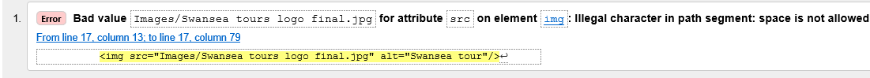
After I had replaced of the spaces within my file name:
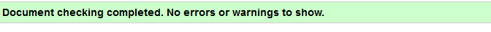
CSS:
When validating the CSS of my website’s homepage I found that I didn’t have any errors, as see below.
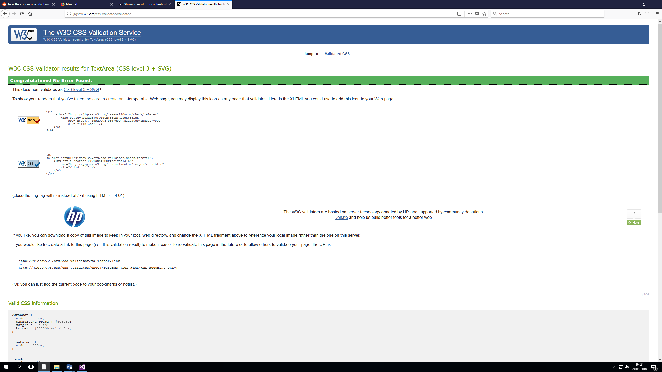

Evaluation:
Accessibility:
Headings:
My website utilizes headings at the top of each page to signify the contents of their current page. This increases the accessibility of my website as the users can identify what page they are current looking at.
Images:
My website contains images of locations in Swansea which can be visit on the tours provided by my website. This makes my website more attractive and allows users to view the destinations in question although these images also mean that the website will load up slower than if I did not use them. All images used were edited slightly in order to fit the purpose of my website, e.eg the LOGO was heavily edit as I had to overlay images and text on top each other, as for the other images I simply had to shrink and crop them.
Colours scheme:
My website uses numerous dark colours in different areas so that it loads up slightly faster in browsers. The background of my website is plain white whereas the foreground is a light grey with a dark grey boarder.
Navigation:
All pages of my website are equipped with a menu bar that allows the user to navigate between all five pages of my website. This makes my website increasingly accessible to new user.
Look and feel:
The aesthetic of my website is simplistic in design and easy to navigate. The text found on the website is easy to read because of the text font and size and because of the colour scheme of the website. The site also contains images which make it a lot more attractive than if it was simple text.

References:
Code:
Certain parts of the html code on my website, such as:
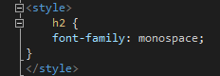
Were inspired by code from:
https://www.freecodecamp.org/

Certain pieces of CSS code utilized for website, such as:
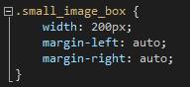
Were inspired by code from:
https://www.w3schools.com/
Images:
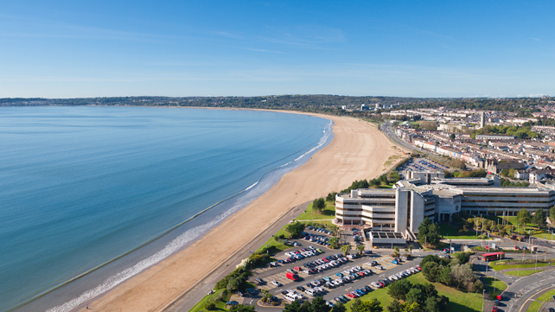
File name: Mumbles_16x9.jpg
The following Image was found on:
https://www.visitswanseabay.com/wp-content/uploads/2014/05/swansea-bay_SVW-C39-0910-0038-1024PX.jpg

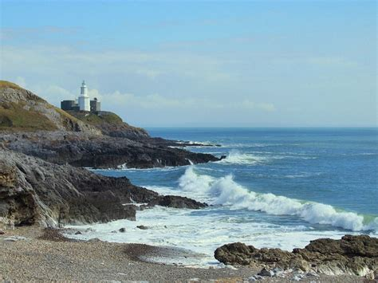
File name: th7IJTIZ5C.jpg
The following Image was found on:
http://www.explore-gower.co.uk/images/phocagallery/mumblesbraceletlimeslade/18-81.jpg

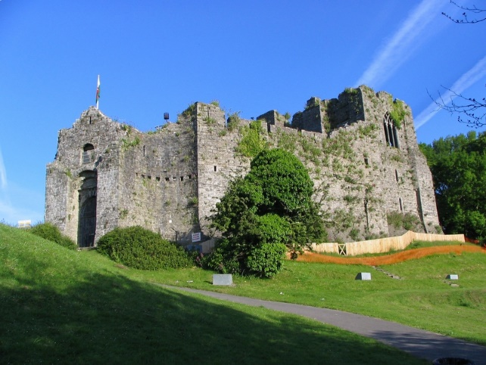
File name: oystermouth01.jpg
The following Image was found on:
http://www.castlewales.com/oystermouth01.jpg

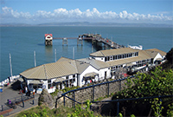
File name: MumblesPier.jpg
The following Image was found on:
https://upload.wikimedia.org/wikipedia/commons/thumb/7/78/MumblesPier.jpg/1200px-MumblesPier.jpg

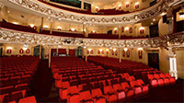

File name: Grand.jpg
The following Image was found on:
https://images.trvl-media.com/media/content/shared/images/travelguides/destination/9958/Grand-Theatre-148643.jpg

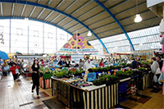
File name:
Market.jpg
The following Image was found on:
http://i1.walesonline.co.uk/incoming/article8572809.ece/ALTERNATES/s615/JS54525339JPG.jpg

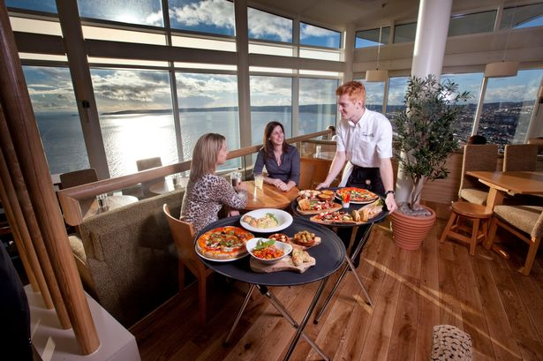
File name:
rdhr_mai_270115services_1.jpg
The following Image was found on:
http://i2.walesonline.co.uk/incoming/article8522934.ece/ALTERNATES/s615/rdhr_mai_270115services_1.jpg

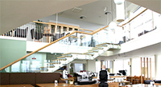
File name:
Grape and olive.jpg
The following Image was found on:
http://www.goakley.com/images/port-grape2.jpg

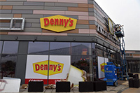
File name:
Dennie's.jpg
The following Image was found on:
https://i2-prod.walesonline.co.uk/incoming/article14058319.ece/ALTERNATES/s615b/JS139278634.jpg

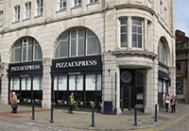
File name:
10180813.jpg
The following Image was found on:
http://lds.localdataimages.com/large/1018/10180813.jpg

marking criteria and Student FEEDBACK

This section details the assessment criteria. The extent to which these are demonstrated by you determines your mark. The marks available for each criterion are shown. Lecturers will use the space provided to comment on the achievement of the task(s), including those areas in which you have performed well and areas that would benefit from development/improvement.

Common Assessment Criteria Applied (Assignment 1) | Marks available | Marks  awarded
1. Research-informed Literature
Extent of research and/or own reading, selection of credible sources, application of appropriate referencing conventions.
Demonstrates a satisfactory level of research, but please use an appropriate referencing format for your list of references. See your report for comments. (Grade mark: 40.00%) | 5 | 2
2. Knowledge and Understanding of Subject
Extent of knowledge and understanding of concepts and underlying principles associated with the discipline.
Demonstrates a good understanding of the standards used to design and implement a website. The main area for improvement is your use of the grid system to layout and structure your content. Also take care to properly close and nest all tags. (Grade mark: 55.00%) | 20 | 11
3. Analysis
Analysis, evaluation and synthesis; logic, argument and judgement; analytical reflection; organisation of ideas and evidence
A satisfactory accessibility evaluation of the website has been provided, but some of the required elements for this section have not been provided. (Grade mark: 40.00%) | 20 | 8
4. Practical Application and Deployment
Deployment of methods, materials, tools and techniques; application of concepts; formulation of innovative and creative solutions to solve problems.
A good attempt featuring a simple website. Well done. Generally, learn how to use a grid system and note that it is good practice to name the home page of a website as either index.html or default.html. See your report for additional comments. (Grade mark: 49.00%) | 50 | 24.5
5. Skills for Professional Practice
Attributes in professional practice: individual and collaborative working; deployment of appropriate media; presentation and organisation.
The report is of average standard, but work at improving your writing style. Please note that you were required to submit your report write-up to Turnitin. (Grade mark: 50.00%) | 5 | 2.5

Assignment Mark (Assessment marks are subject to ratification at the Exam Board. These comments and marks are to give feedback on module work and are for guidance only until they are confirmed. ) | Late Submission Penalties (tick if appropriate) |  | 48%
 | Up to one week late |  | 48%
 | 1st/2nd/3rd attempt? |  | 48%

Note that as this is a RESIT attempt, the mark is capped at 40%.

