M5X02111
Research Methods

Word Count: 2057
P149368
Jerus Dovaston

This report is designed to ensure competency in certain aspects of research skills and project construction. In preparation for future tasks studied at level 6, this task is to produce a research proposal in which is an interest area of study. The research proposal is to develop knowledge and understanding of planning and implementing a research project and will explore procedures in research methods and data collection.

Contents
- Background and Literature …………………………………………………………………………………………4
- Aim and Objectives…………………………………………………………………………...5
- Research Methodology………………………………………………………………………..6
- Data Collection……………………………………………………………………………7
- Research Design ………………………………………………………………………………………..8
- Reliability and Validity………………………………………………………………………………9
- Ethics and Risks………………………………………………………………………………...9
- Research Plan……………………………………………………………………..9
- Appendices………………………………………………………………………..11
- Reference List……………………………………………………………………..12

An investigation into the nature of creativity in events and its social and economic impacts: a study of Swansea

  - Background and Literature
This research plan is intended to use the knowledge of previously studied elements of the events industry, particularly in the areas of creativity and development, to answer the aims and objectives of this research project. Having already studied the relationship between creativity and events this study will further investigate this relationship in addition to the social and economic impacts of events within a specific destination profile. One of the reasons for this study is to investigate the claims of creativity aiding in development of events, using a range of reliable academic sources such as the International Journal of Event and Festival Management. The basic rationale of the study is based upon two elements: one relating to the researcher and the other to the value of work (Saunders et al., 2012, p. 53). Therefore, the researcher is conducting this research project to identify answers for the claims and for intellectual curiosity having partially studied this subject, also with having a range of sources of information into this subject to enable a critical study. Furthermore, with a range of research into creativity, social and economic developments into events, none interrelate the three aspects to identify their relationship in event impacts. This research project is therefore intended to establish the role they play in shaping the events impact.
Events are often described as ‘central to our culture’ (Allen et al., 2005), not only has the increase in leisure time led to the engagement of events, governments also embrace events as stated by Walo et al., (1996) and Allen et al., (2005), due to their ‘reliability’ in promoting tourism and developing strategies for economically improving the host destination. In agreement to this, events are perceived as a strength in shaping the destinations national and local development (Nyjkana et al., 2014), such as its infrastructure and tourism products. Numerous research conducted by event management authors state that the events industry continues to grow an impact on societies and economies, such as Berridge (2007) and Allen et al., (2005) understand this growth to be encouraged by ‘social, political, development and culture’ (p.43). Therefore, to understand these statements and relationships in event impacts, further research must be conducted to identify the reality of these claims. Investigating these impacts will establish whether the type and size of events influences the severity of impacts. Booker (2016) states that the events industry in the United Kingdom is worth £43.4bn, to which attracts over 85 million attendees and greatly impacts the UK’s economy. Besides the economic impacts, it is believed by Berridge (2007) and Bladen (2012) that the event design and production surround the level of impact. Berridge defines this as ‘essential’ to an events success as it leads to ‘improvement on every level of the event’ and is therefore fundamental to the overall experience (2007. p.82). Berridge (2007) and Bladen (2012) continue to explain that applying creativity in the activity of designing an event is essential for success. The application of creativity is acknowledging the needs of consumers and designing ‘new and distinctive’ products and services (Dr. Okpara, 2007, p.2). Moreover, whilst there is a wide range of literature available which identifies the impacts of events, whether it be socially, economically, and politically, there is minimal research on whether the level of creativity applied in events influences these said impacts. Reasons for these limitations may be due to creative events being highly recognised within the ‘niche’ tourism market, rather than the wider scope. Therefore, this project will establish the relationship between creativity and impacts to identify whether events in Swansea increase the development of infrastructure and the economy.
  - Aim and Objectives
Saunders et al., explains that whilst collecting data is key to the ‘research process’, without having a clear purpose, it will it not be considered ‘research’ (2012, p.4). Therefore, the purpose or aim of this research project is establishing the application of creativity within events and the relationship it has between positive or negative social and economic impacts on a host destination
To achieve this aim, the research will achieve three precise objectives which are as follows:
- To understand the social impacts by investigating attendee motivations to events in the host destination
- To measure the economic impacts of events within recent years through statistical data
- To identify the market for creative events and how it interrelates with the event outcomes of the studied destination

These objectives will be accomplished through collecting information using the research methodology explained below.

  - Research Methodology
Rajasekar et al., defines research as a ‘logical and systematic search’ approach to identify information on a topic (2013, p.2). Particularly in research methodology, it is described as a ‘science of studying how research is to be carried out’, in other words, the procedures which will be taken to gather data and information.
When conducting research, there a various strategies and approaches. The ‘Research Onion’ below by Saunders, et al., (2012) illustrates these variations
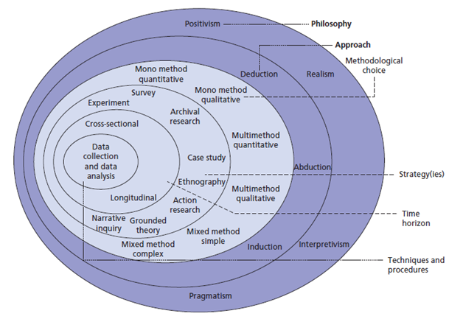
Bajpai (2011) defines research philosophy to be the way in which data that has been collect and analysed should be used. Bajpai believes philosophy is the nature and development of knowledge. There are four main philosophies in research: Pragmatism, Positivism, Realism and Interpretivism (Dudovskiy, n.d).
The approach that this project will use is ‘Pragmatism’. Saunders et al., defines it as ‘’to recognise many ways of interpreting the world and undertaking research, that no single point of view can ever give the entire picture and that there are multiple realities’’ (2012, p.130). This simply means that this approach can incorporate other philosophical strategies and use multiple methods. Kelemen & Rumens (2008) cited by Saunders et al., justifies that Pragmatists use methods that facilitate ‘credible, reliable and relevant’ data to be collected to forward the research (2012, p.130). Pragmatism combines a deductive and inductive approach whilst incorporating both qualitative and quantitative strategies. The ways in which these methods will be applied are explained in the next sections.
  - Data Collection
Data collection is the process of collecting information through multiple strategic methods to gain knowledge on a subject. In a research project, data collection is a ‘systematic’ approach to ‘measure’ this information from numerous sources to answer the research question (Rouse, 2016).
To achieve each objective, the two methods of collecting data for this report will be through primary and secondary research.
Secondary research or data, otherwise known as ‘desk research’, is raw data where there has been minimal processing. Secondary data includes both quantitative and qualitative data (Saunders et al., 2012, p.256). Secondary data which is collected by others includes sources such as academic literature, journals, newspapers, case studies and articles. These sources shall be used as the basis of formulating the research topic to ‘fill in the gaps’ missing from the published data. In other words, this data will generate a discussion or argument within the project to back up the researcher’s findings. In addition, government departments contain a wealth of statistical data covering social and economic topics, which is required throughout this project. As suggested by Saunders et al., ‘’once this data has been obtained, it can then be analysed to provide different knowledge and interpretations’’ (2012, p.304).
Thus, turning into the collection of primary data, which is obtaining new data that is original. The most common data collection techniques are interviews, surveys, observations and focus groups.
The two primary methods to obtain data for this project will be semi-structured interviews and self-completed questionnaires. Saunders et al., defines the research interview as ‘’a purposeful conversation between two or more people, requiring the interviewer to establish a rapport, to ask concise questions, to which the interviewee is willing to respond’’ (2012, p.372). Therefore, the interviews will be semi-structured with open and closed questions to establish personal thoughts, feelings, and experiences, known as qualitative, which tells you ‘how, why, and when’ (Saunders et al., 2012).
Furthermore, the questionnaires are proposed to receive approximately 100 respondents including those of visitors and residents of the study destination but also from governing bodies. The purpose for this approach is to gather quantitative data whilst ensuring the collected data is fresh and original. Opposed to the qualitative approach, this method will obtain non-numeric data. This is essentially important as this enables a wider insight into the research topic and complete collection and knowledge of the study.
  - Research Design
As stated, this project will carry out mixed methods research using qualitative and quantitative approaches to ensure as much data collection as possible and to avoid bias.
The type of sampling that will be used for the qualitative data is Purposive sampling, also known as selective or subjective sampling (Laerddissertion, n.d). The goal for this research is to collect characteristics of a focused population, which will be used to answer the research question and therefore holds as a reliable quality. This project will use two methods, Maximum variation: which is used to establish attributes, behaviours, experience, and perspectives on the topic that is being studied and Expert sampling: which is gaining an insight from those who have particular expertise in the topic area (Laerddissertation, n.d). The analyses of this research are described as ‘transformation and interpretation’ (Richards and Morse, 2007). Therefore, the interview transcripts will be organised and coded as suggested by Seers (2012) to identify themes in the data and be presented in graphs and tables.
The sampling to be used for the quantitative data is ‘Convenience sampling’. This sample is the selection and inclusion of the easiest accessed population (Laerddissertation, n.d) and is interested in only achieving the sample size. This sample is a quick and cost-effective method of targeting a sample size, however, there is a risk of inadequacy and bias (McLeod, 2014). Therefore, the questionnaires will be conducted through SurveyMonkey where all the data is collated and produces information from respondents in the form of graphs and tables which will be effective and provide high quality analysis, thus it is a reliable method. Although, there are limitations such as respondents requiring access to a computer and internet, it is however, a valid method due to its efficiency.
  - Reliability and Validity
The methods of this research are for the researcher to embark upon greater data collection. The advantages of these methods are the reliability within them, such as the semi-structured interviews enable the researcher to create a rapport with the respondent to which will gain a wider insight into thoughts, feelings, and general perceptions for the wider phenomena. Additionally, creating opportunity to collect unforeseen information. However, it is said that both research methods warrant the risk of bias. Thus, the appropriate selection of questions should be chosen and where information does not hold quality to include in the research, it will however be used as basis and direction for the research project.
  - Ethics and Risks
Saunders et al., states that ‘’access and ethics are critical aspects for the success of any research project’’ (2012, p.208). These ethical concerns remain important whether the research methods involve secondary data or collecting data through human participation. Therefore, prior to conducting the research, an ethics approval form which demonstrates considerations and measurements taken to limit the risks associated with the research must be authorised. Additionally, participants will receive a consent form and sample of questions to ensure there is knowledge and authorisation of what is being researched and how they are contributing. To avoid bias and limit the risks, questionnaires and interviews will be anonymous to which will encourage honest responses. The participants will remain unidentifiable from their responses and the data collected will protect anonymity of respondents in the final report.
8. Research Plan
To complete this study, many resources will be required to provide an effective dissertation. Such as, a suitable PC with access to the internet to gather online resources from the university library, Google Scholar, articles, reports, and journals.
In addition, a SurveyMonkey account will be created to distribute the questionnaires and collect the data, and a Dictaphone will be required to record the interviews, to transcript them in the stage of analysis.
All the above proposed research will be conducted effectively in strategic timeframe through October 2018 to May 2019. A Gantt chart found in Appendix 1, has been constructed to ensure all tasks are completed efficiently.

9. Appendices
Appendix 1 – Gantt Chart
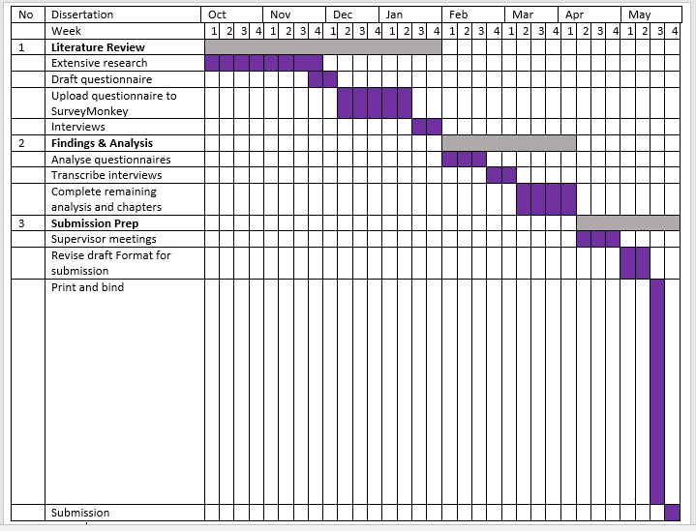

10. Reference List
Allen, J., O’Toole, B., McDonnell, I., Harris, R. (2005). Festival and Special Event Management. 3rd edition. Wiley: Milton.
Bajpai, N. (2011) Business Research Methods. Pearson Education: India
Berridge, G. (2007). Event Design and Experience. Event Management Series. London: Butterworth-Heinemann
Bladen, C. (2012). Events Management: An Introduction. London: Routledge.
Booker, B. (2016) An Introduction to The UK Event Industry in Numbers. Eventbrite. (online) Available from: https://www.eventbrite.co.uk/blog/uk-event-industry-in-numbers-ds00/ [Accessed 22/02/2018]
Dr. Halej, J. (2017) Ethics in Primary Research (Focus groups, Interviews and Surveys). (Online) Available at: https://warwick.ac.uk/fac/cross_fac/ias/activities/accolade/resources/ecu_research_ethics.pdf [Accessed 01/03/2018]
Dr. Okpara, F.O (2007) The Value of Creativity and Innovation in Entrepreneurship. Journal of Asia Entrepreneurship and Sustainability. 111(2), p. 1-14. Ethiopia: University of Gondar. (Online) Available at:
http://www.asiaentrepreneurshipjournal.com/AJESIII2Okpara.pdf [Accessed 22/02/18]
Dudovskiy, J. (n.d). Pragmatism Research Philosophy. (Online) Available at: https://research-methodology.net/research-philosophy/pragmatism-research-philosophy/ [Accessed: 23/02/2018]
Laerd Dissertation, (n.d) Purposive Sampling. (Online) Available at: http://dissertation.laerd.com/purposive-sampling.php#types [23/02/2018]
McLeod, S. A. (2014). Sampling methods. (Online) Available at: www.simplypsychology.org/sampling.html [Accessed: 23/02/2018]
Nyikana, S., Tichaawa, T.M., & Swart, K. (2014). Sport, tourism and mega-event impacts on host cities: A case study of the 2010 FIFA World Cup in Port Elizabeth. African Journal for Physical, Health Education, Recreation and Dance, 20(2:1), 548-556.
Rajasekar, S., Philominathan, P., & Chinnathambi, V. (2013). Research Methodology. School of Physics: India (Online) Available from: https://arxiv.org/pdf/physics/0601009.pdf [Accessed 22/02/2018]
Richards L and Morse J. (2007) Users Guide to Qualitative Methods. 2nd edition. Thousand Oaks, CA: Sage 2007
Rouse, M. (2016) Data Collection. (Online) Available at: http://searchcio.techtarget.com/definition/data-collection [Accessed: 22/02/2018]
Saunders, M., Lewis, P., & Thornhill, A. (2012). Research Methods for Business Students. 6th Edition. Financial Times/Prentice Hall.
Seers, K (2012). Qualitative Data Analysis. Evidence – Based Nursing; London. 15 (1) p. Warwick: Research Institute, School of Health & Social Studies. (Online) Available at: https://search-proquest-com.ezproxy.uwtsd.ac.uk/docview/1784027237/fulltextPDF/3B0939718B4E4279PQ/1?accountid=130472 [Accessed: 21/02/2018]
Walo, M., Bull, A., and Breen, H. (1996). Achieving Economic Benefits at Local Events: A Case Study of a Local Sports Event. Festival Management & Event Tourism. Vol. 4 pp. 95-106. Southern Cross University: The School of Tourism and Hospitality Management. (Online) Available at: http://docserver.ingentaconnect.com/deliver/connect/cog/10652701/v4n3/s3.pdf?expires=1515859926&id=0000&titleid=41000034&checksum=E4E79E532B5BB03F81D365D0303B7002 [Accessed 22/02/2018]

