CONSTRUCTION & RESEARCH OF NETWORK & DATA CENTER MANAGEMENT SYSTEMS

BIG DATA STORAGE AND PROCESSING
Ross Thomas P146741
School of Applied Computing
University of Wales Trinity Saint David’s
Swansea, United Kingdom
Dr. Carlene Campbell

Abstract – Most networks deal with big data in some form. Discussing the main characteristics that all networks should follow for the ultimate design, from the 4 V’s of big data to the CIA Triad. Otherwise without data center where will the big data be stored, managed and analysed? Later, implementing such structure into a network design for UWTSD, discussing strengths and possible improvements to the network design.0

Keywords – Big Data, Analytics, The 4 V’s, Data Centers, CIA Triad, Networking

Introduction
In this report, the author discusses the term “big data”, explaining the term and why it matters that this term is known in the world of computers. Every company has masses of data following through it every second, and this data needs to be stored and managed. Later in the report, expanding onto the 4 main characteristics of big data & processing called the 4 v’s, further discussing data centers and how this apply to big data and processing. With data being collected at an extraordinary scale [1], every business needs some sort of backup, be it a recovery plan, backup through cloud services, while still following the CIA Triad system. Because if a disaster were to strike it could put all the information at a big risk, and this is something that needs to be avoided. Finally, by following the CIA Triad, it will later be discussed how this data has to be available at all times, to its employees, students etc, through remote access, such as VPN’s (Virtual Private Networks). This method of storing data is usually referred to as the big data movement. [2] As part of this report, a design was made to simulate UWTSD’s complete network, including data center features.

Big Data & Processing
Big Data is usually seen as a very hyped term in the world today, it is most often enough related to Data Mining for BI (Business Intelligence). It can also be related to the method of storage data through different methods. Such as cloud services, network attached storage, etc. Business Intelligence and data mining both work by analyzing data, for example data mining is used by businesses to calculate trends. For example, it will analyze patterns by its users, like a favorite designer, meaning businesses will use this as a sales method.

The term data mining “is the procedure of mining knowledge from data”. [3] Due to data mining many can benefits from it, as it helps with previously mentioned, market analysis, even fraud detection. Usually data mining consists of criteria, being support and confidence. As data mining needs a database, support is how often it is added to said database, “while confidence is the number of times if/then statements are accurate.” [4] BI, can simply be defined as an analysis methodology which is used to exploit user data, as a method of automatic decision making, that aids in better results for businesses.

Data is everywhere, collected in data warehouses and put to good use, there are many types of data that organizations will collect. This could be from generic web data and social network data, to text data to time and location data for example GPS. “Text data (email, news, Facebook feeds, documents, etc) is one of the biggest and most widely applicable types of big data.” [5]
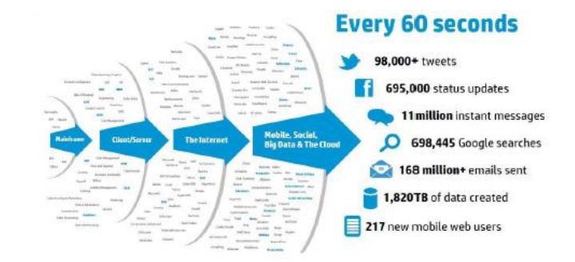
Figure 1: [6] Showing the amount of data that is needed to be stored every 60 seconds in 2013. It is predicted that by 2020, it is expected that the number of data stored in the world will reach 35 zettabytes. [7] For clarification, there is 10²¹ bytes in a zettabyte, where there is 10¹² bytes in a terabyte.

One of the biggest names with big data is Hadoop, this is a system created by Apache (as a MapReduce model), that also aims to collected data, but does it a different way compared to more traditional methods of collecting interesting data.

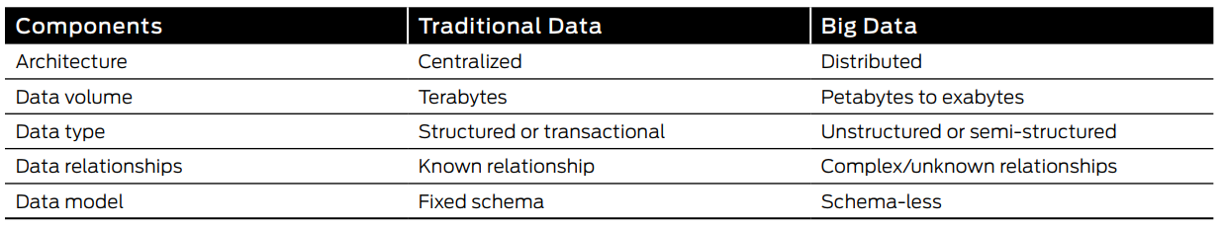
Figure 2: [8] Traditional Data vs Big Data.

The biggest advantage of Hadoop is scalability. “It is easy to add new hardware to extend an existing cluster in means of storage and computation power.” [9] This is because Hadoop is a software library and uses cloud storage rather than relying on a cluster of devices, meaning this system offers high availability. These systems came about purely because, traditional systems like relational database manage systems (RDBMS) are just to complication for any big data system. [10] Hadoop is also referred to as a data lake, which is a method of storing data within a system, in its raw format, making all the data it holds either un-structured or semi-structured.
Examples of big data pioneers are amazon and google, amazon do it very well as they take all your buying history from the database and then recommend possibly interested via the support and confidence methodology as previously discussed. For companies process any of the data, they must use analytics, and there are 4 types of big data analysis.

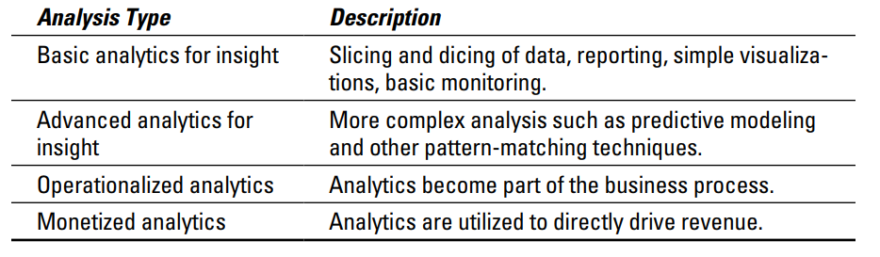
Figure 3: [11] Showing the 4 different types of analysis that can be done.

Characteristics of Big Data
Big data can be seen to have many characteristics, usually called the “4 V’s” of big data. These 4 can be see as Volume, Velocity, Veracity and Variety, there can also be a 5th, being Value. Without these steps or characteristics, big data businesses run the risk of becoming unmanageable.

“High volume, and high velocity and high variety of such data make it an unfit candidate to our currently employed and tested database architectures.” [12] This means, businesses need to make sure they understand these 4 main characteristics of big data, so they can run a successful enterprise with minimum risks. The 4 V’s are very similar to steps of success when dealing with big data, as it allows a business to prepare for such scenarios, for example where the velocity and volume of data is overwhelming, that the business is just not prepared for it. Resulting in issues throughout the business.

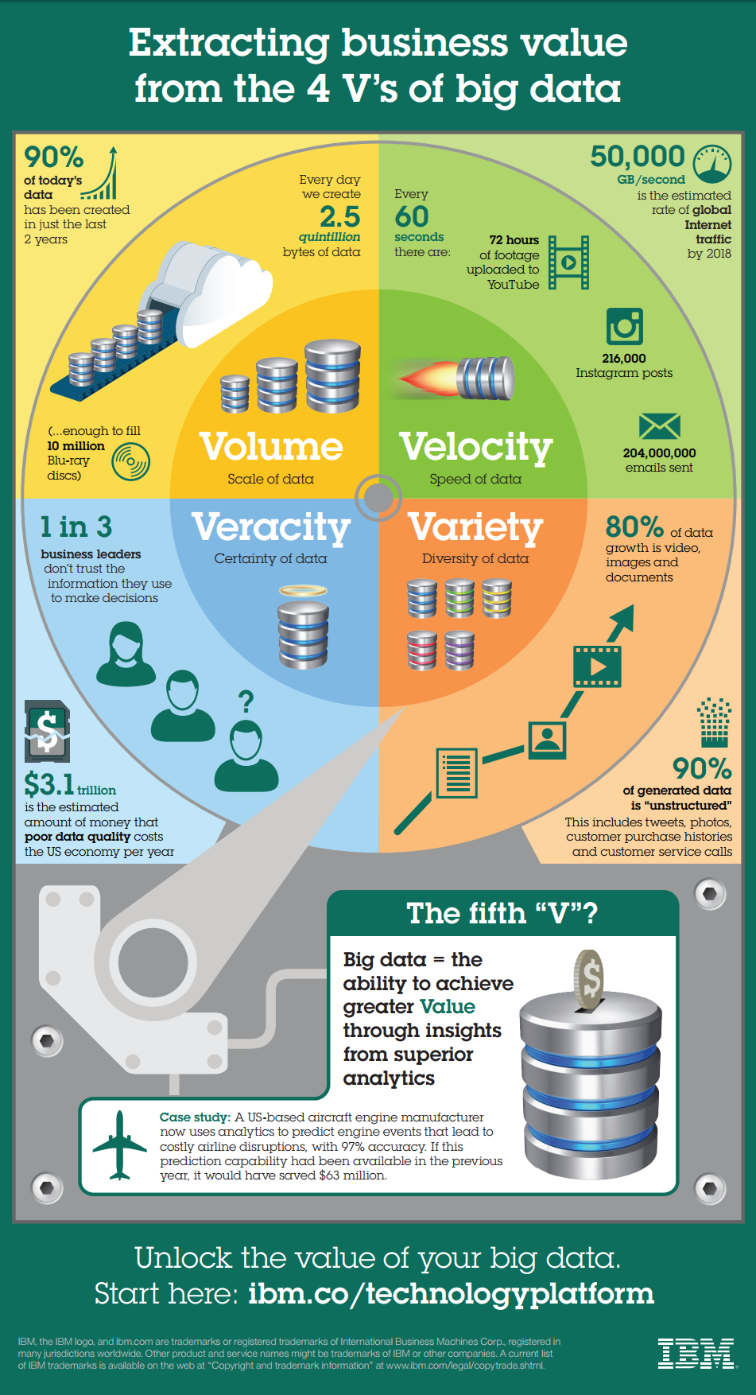
Figure 4: [13] Showing the 4 main V’s of Big Data, and how they work within a business. Also showing the 5th V, which is Value.

Volume – Defined as being the scale of data, it is a dataset that is too big for typical database software tools, without such tools businesses will be unable to store, capture, manage or even analyze its data. “According to IBM (2012) 90% of the data in the world today has been created in the last two years alone.” [14] Once a business can understand the steps and characteristics of big data it can be made easy for data to be captured and stored. This step helps the business prepare for such large datasets, that if not prepared for could cause downtime while they are updating their systems. Which goes against availability of data, later discussed CIA Triad, see Part V of report.

Velocity – Defined as the speed of data, if this set is not well prepared for, it could potentially cause a lot of harm to the business, for example every 60 seconds 240 million emails are sent and stored. If a business can not keep up with the velocity of its data is could cause problems, for example businesses need to be able to deal with real time data, “reacting quickly enough to deal with data velocity is a challenge for most organizations.” [15]

Veracity – Defined as the certainty of data, the trustworthiness of said data. Without this, businesses could be led down a path where there is no return. For example, business that make decisions without recognizing the trustworthiness of the data. By following this step, businesses are made aware that all data can be split into quality or misleading data.

Variety – Defined the diversity of data. Data comes in all shapes and sizes, structured, unstructured & semi-structured. Dealing with these 3 different types of data in a work place could be confusing. For example, businesses can end up working with many different kinds of data, to make sure every employee can understand these different types of data is the big challenge. By creating a standard in the business, it could be made possible for the employees to understand with ease.

Data Center
Big data is everywhere, the biggest in fact being businesses like Google, Amazon and Facebook. But where do they store all this data?

Amazon use their data for product recommendations, Google for personalized searches and Facebook have a lot of messages, pictures and videos to store, with reaching a total of 2 billion users in 2017. With all this big data, it has to be stored somewhere.

A data center is what is used by companies that require mass storage, usually placed in the businesses main headquarters or offsite for physical protection. “The data center environment is a compilation of servers, storage, network systems, mechanical/electrical systems, applications and tools, governance procedures and staff.” [16] Data centers hold hundred and of thousands of servers which are there to do one thing, to store data. Google have specific data centers for personal use, like Google docs, even others like one drive and drop box. These are cloud based applications that allow users to store data, even rent out server space for personal storage. “Today’s Data Centres face many challenges.” [17] Often enough these challenges derive from security concerns. To avoid these issues, most companies follow the CIA Triad as a guide for a successful data center.

Challenges & Security Services (CIA Triad)
Just like the 4 V’s, which was put in place to ensure all challenges can be met. The CIA Triad does a similar thing, it stands for Confidentiality, Integrity and Availability. It is a standard for most data centers and anything involved with big data. The CIA Triad, ensures that two goals are achieved in a business, protecting the data while making sure it is available to those who need it, when they need it. [18]
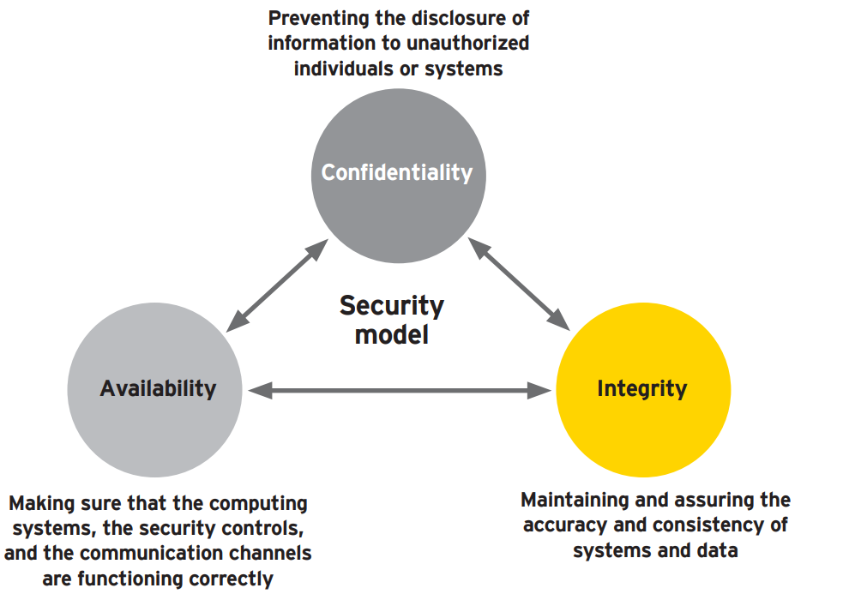
Figure 5: [19] The CIA Triad Diagram.

Confidentiality – The most important features of the Triad, confidentiality. This insures data held, can not be shared and is kept private and away from prying eyes. There are many methods that data centers can adopt, serving the purpose, encryption methods with the use of access control could be adopted to ensure all data is help secure and confidential.

Integrity – When it comes to personal data, or even business data. Any data stored can not be returned to the owner modified. This step in the triad ensures that all data stored still holds the value it held when stored. It is very important not only to a business, but this could be student records, hospital records, even person records that are stored. In this case it is imperative that all data stored is accurate.

Availability – Data centers must ensure that all information stored, can be accessible and availability to those who stored it in the first place. Most data centers do experience minor downtime throughout the year, but it is not noticeable. Resulting in all data being available 24/7 with ease.

Network Design of UWTSD
After discussing big data, data centers and the challenges related to each. It is clear that a network must be designed carefully and effectively, and based around with the appropriate qualities to make it a successful network. For example, as mentioned in part of the CIA triad, with the correct security throughout the network, confidentiality is covered.

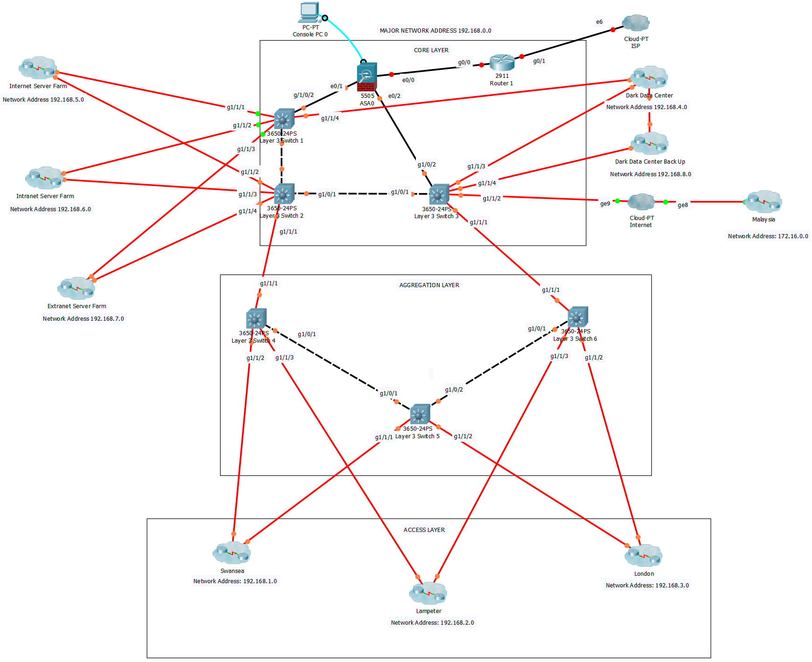

Figure 6: A Network design for University of Wales, Trinity Saint David. The data center model can be seen being split up by boxes around the appropriate devices and clusters.

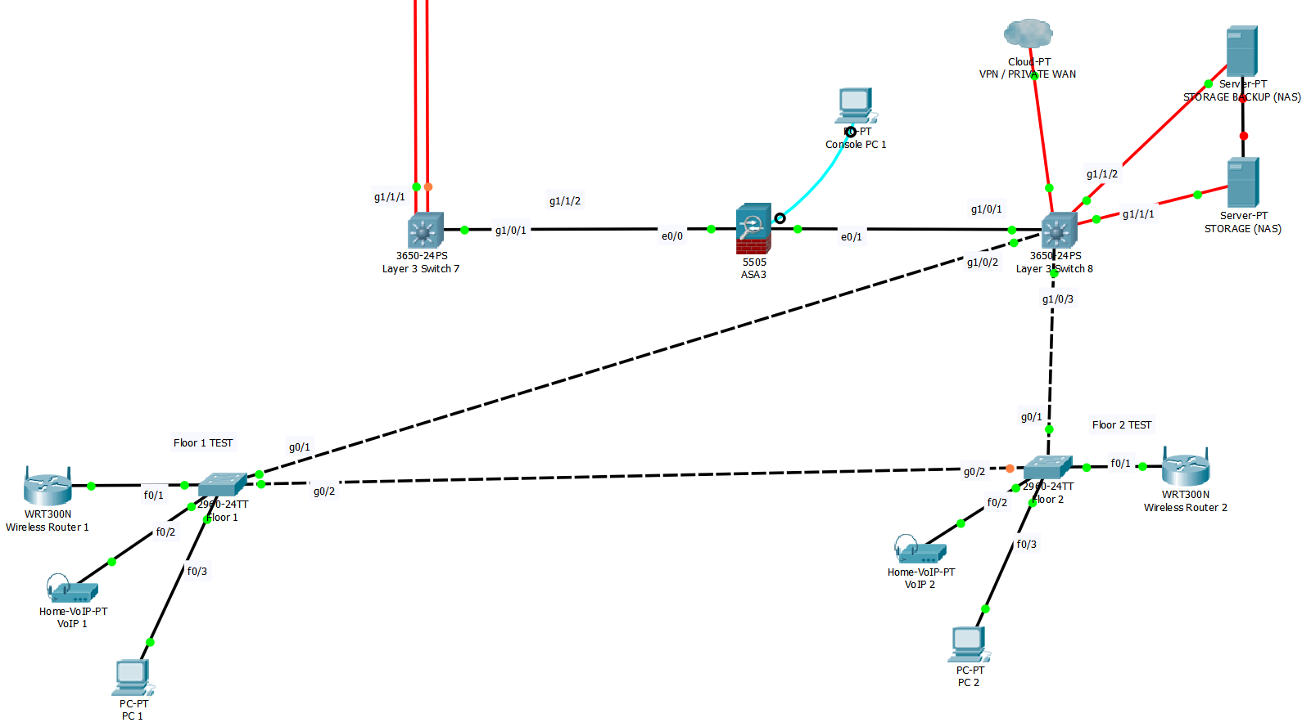
Figure 7: A test network for the Swansea campus and its two floors, which represent the type of devices that would complete the network. All information stored in this campus is stored locally to the NAS server, backed up on side. A private WAN/VPN, was added in each campus to allow staff to access any university information from anywhere at any time.

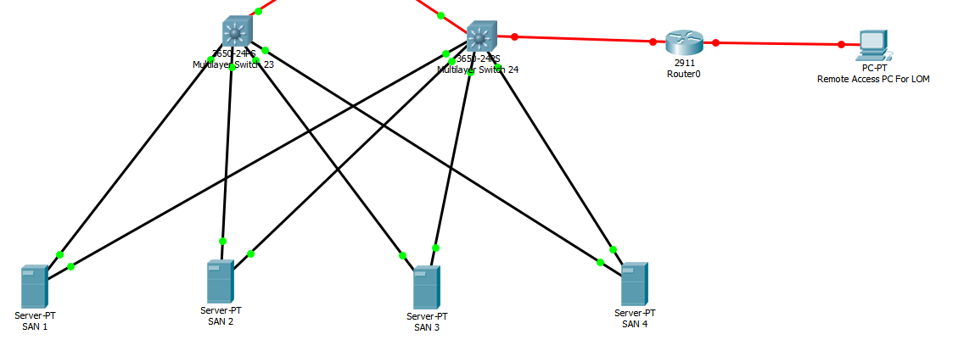
Figure 8: Inside of the data center for UWTSD backbone. All information that needs to be shared throughout UWTSD, is stored here. While also storing as a backup for the LAN based storage, while operating a LOM (Lights out management) System.

Data Center Architecture Model
For this network design, the model chose was the multi-tier data center architecture method. This is a method that splits the design into layers. These layers are core, aggregation and access layers. See fig 7.
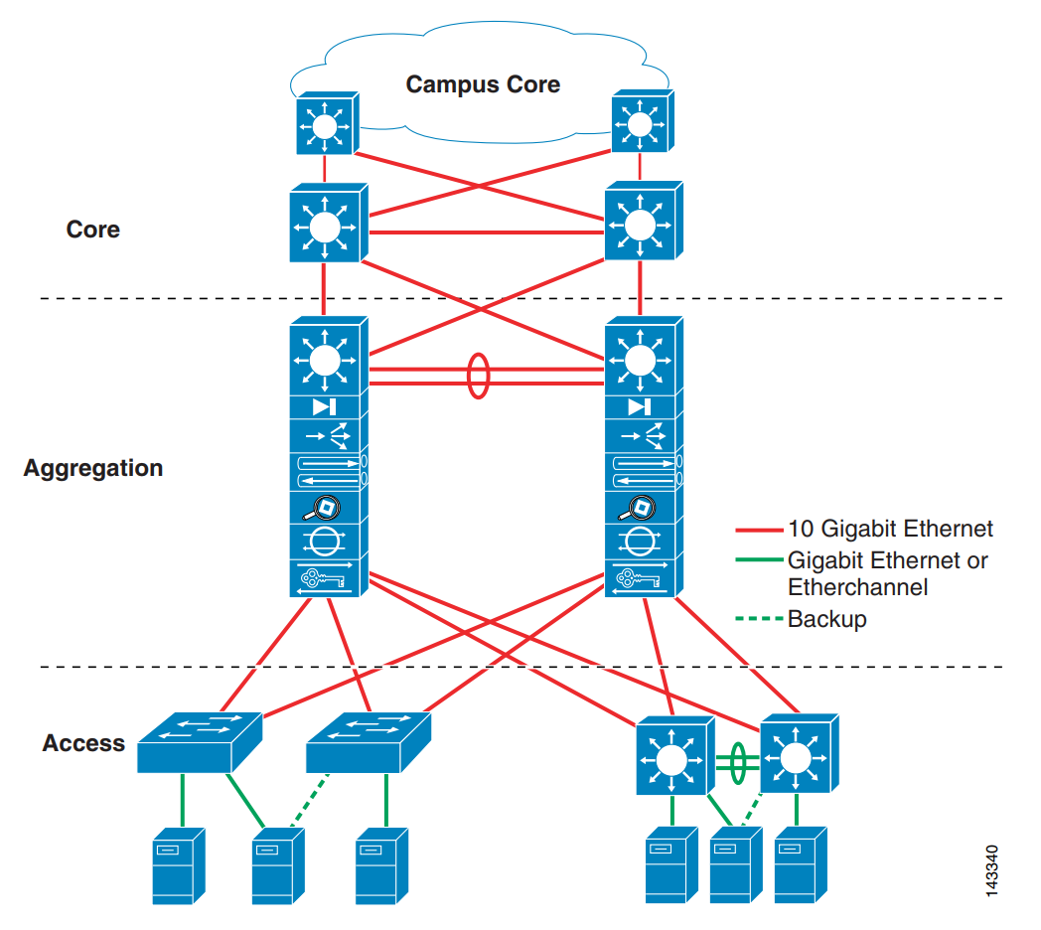
Figure 9: [20] The basic data center layered design.

Core layer – This layer is the backbone of the Campus, it should provide high speed packet switching, with the bonus of redundancy, making sure there is no point of failure. As if a link went down without redundancy, it could cause severe downtime for the university.

Aggregation Layer – As well, providing necessary redundancy. This layer offers functions, for example service module integration and spanning tree processing. This layer can also use different services like server load balancing and firewalls for added security.

Access Layer – The lowest level of the network model, it is the layer where all devices attach to the network, this could be switches, servers etc. It is basically crucial as it ensures all packets sent, are delivered to all end users, by connecting client nodes to the network. In the UWTSD design, each device in the campus is linked to a layer 3 switch.

Server Farm Types (Intranet vs Extranet)
The 3 server farms that were included in this design were Internet, Intranet and Extranet. The reason they were places attached to the core layer, is because it was preferred that they have a direct connection to the back bone of the network, while providing high speed connectivity via fiber cabling.

Intranet Server Farm – The intranet can be thought of as a private internetwork, that is used within the campus that implements internet technology, like web servers and browsers.

Extranet Server Farm – “Extranets refer to applications and services that are Intranet based, and use extended, secure access to external users or enterprises.” [21] For example, in this design, it could allow other campuses to share work between one another.

Storage Services (NAS/SAN)
In the network design, see fig 6 & 7. It can be seen that NAS (Network Attached Storage) is used as a method of storing data within the individual campuses. The reason for this is so staff can store all the necessary information on side rather than having to collect and store data in the core data center, this is because NAS is considered “LAN-attached file server that serves files by using a network protocol, such as Network File System (NFS).” [22]

In fig 8, SAN (Storage Area Networks) is shown, a high-speed method of storage, creating an any to any connection across a network. SAN was used because of its high-speed connectivity, also because comparing it to NAS, SAN is ultimately cheaper to setup and manage. “SAN products can result in lower installation and storage management costs in the long term” [23]

Taking into consideration is also a business continuance infrastructure, where these units act as a necessary backup for any disaster incident. In case of a disaster, “this Disaster Recovery Plan is designed to ensure the continuation of vital business processes in the event that a disaster occurs.” [24] Aa part of this network, a term called a “Dark Data Centre” with LOM (lights out management) being used. This is a method where all management of the data center is controlled remotely [25], allowing for this data center to be placed anywhere away from any of the main campuses. So, if a disaster does strike, all LAN information is backed up to the data center and can be easily recovered for each campus. Included, is also a backup for the data center, just in case problems are caused that side, data can always be accessed.

Results of Implementation
Due to complications, IP addressing and the firewall were not configured in the university network design, only simple security configurations were successful on this design, for instance passwords. With more attention to security on the switches, EIGRP would have been configured while implementing MD5 authentication for extra security.

Throughout the design, it was chosen to use Layer 3 switches over Layer 2, due to the added security by using layer 3 switching through the network. Making sure the network was high speed, fiber was also used throughout the university network, another reason for using Layer 3 switches. As the Layer 2 options in packet tracer would not allow fiber connectivity.

Before anything, the main issue was redundancy, making sure the network design was redundant. If links were to go down, it could cause connectivity problems as well as severe downtime for the university systems. By taking action, the network seems redundant and if a link was to fail another link would take its place.

Conclusion
To conclude, after discussing big data, it can be said that the university will deal with big data in some form, for example use of the 4 V’s, but not to the extent that other businesses use big data via data mining. By having another chance to pursue this idea, implementing data mining into the university structure would be a future project.

After discussing the university network design in detail, showing the network via images. There are clear weaknesses as well as strengths, for example two strengths in the design in opinion, redundancy and security are the important strengths to any network. Though, a clear improvement to this design in the future would be successfully implementing IP addressing & subnetting for this design to work as a simulation.

REFERENCES

[1] M. H. Padgavankar and R. Gupta, “Big Data Storage and Challenges.”
[2] W. Eckerson, “Big Data and its Impact on Data Warehousing Despite Problems, big Data Makes it Huge Two Markets for big Data: comparing Value Propositions categorizing big Data Processing systems The new analytical ecosystem: Making way for big Data 1 2 3 4 BIG DATA AND ITS IMPACT ON DATA WAREHOUSING Despite Problems, Big Data Makes it Huge.”
[3] “About the Tutorial.”
[4] “What is data mining? - Definition from WhatIs.com.” [Online]. Available: http://searchsqlserver.techtarget.com/definition/data-mining. [Accessed: 09-Jan-2018].
[5] “Introduction to Big Data.”
[6] K. Adam, I. Hammad, M. Adam, I. Fakharaldien, J. M. Zain, and M. A. Majid, “Big Data Analysis and Storage.”
[7] P. C. Zikopoulos, “Understanding Big Data About the Authors.”
[8] J. Networks, “INtroduCtIoN to BIg data: INfrastruCture aNd NetworkINg CoNsIderatIoNs.”
[9] A. Hadoop Tutorial, “Apache Hadoop Tutorial.”
[10] N. Marz and J. Warren, “Big Data MEAP v17 - Chapter 1.”
[11] J. Hurwitz, “Big Data for Dummies.”
[12] M. A. Khan, M. F. Uddin, and N. Gupta, “Seven V’s of Big Data understanding Big Data to extract value,” in Proceedings of the 2014 Zone 1 Conference of the American Society for Engineering Education, 2014, pp. 1–5.
[13] IBM, “Extracting Business Value from the 4 V’s of Big Data.”
[14] S. Sonka, “Big Data Characteristics,” 2016.
[15] R. Toshniwal, K. Ghosh, and D. A. Nath, “Big Data Security Issues and Challenges,” Int. J. Innov. Res. Adv. Eng., vol. 2, no. 2, pp. 2349–2163, 2015.
[16] “Findings from the IBM Global Data Center Study.”
[17] P. Timmer, “New dimensions in Data Centre design Professionalising the Data Centre by striving for Operational Excellence.”
[18] S. D. Lowe, J. Green, and D. Davis, “BUILDING A MODERN DATA CENTER.”
[19] “Cyber insurance, security and data integrity.”
[20] “Cisco Data Center Infrastructure 2.5 Design Guide.”
[21] “INTERNET, INTRANET AND EXTRANET Intranet.”
[22] “Introduction to Storage Area Networks.”
[23] “What is NAS?”
[24] B. C. Martin, “Disaster Recovery Plan Strategies and Processes Disaster Recovery Plan Strategies and Processes Written,” 2002.
[25] “What is lights-out management (LOM)? - Definition from WhatIs.com.” [Online]. Available: http://searchdatacenter.techtarget.com/definition/lights-out-management. [Accessed: 09-Jan-2018].

