7/24/2026
LDE ASSIGNMENT 1
E-Portfolio

Module Name: Learning in the Digital Era
Module Code: ACCA4025
Student Name: Mumtaz Ali
Student ID:2541394
Group: 1

Lecturer's Name: Koushik Modak
E-PortfolioLink: https://2541394.wixsite.com/my-site-2
University of Wales Trinity Saint David
London Campus

LONDON

Table of Contents
Introduction 3
E-Portfolio 3
Task 1: Essential Academic and Employment Skills for Computing/IT 3
Summary 3
Turnitin Reflection 4
Task 1 Page Screenshot 4
Task 2: Collaborative Mind Map and Individual Poster 5
Mind Map 5
Poster 6
Task 2 Page Screenshot 7
Task 3: Virtual Collaboration and RefWorks 7
Unit 3 Topic: Microsoft Teams — Summary 7
RefWorks Evidence 8
Task 3 Page Screenshot 12
Task 4: E-Portfolio Creation and Review 12
Illustrative Review of E-Portfolio Tool Selection 12
Task 4 Page Screenshot 13
Conclusion 13
AI Acknowledgement 13
References 13
Task 1 References 13
Task 3 References 14
Task 4 References 14

Introduction
The following is evidence to support my E-Portfolio, which has been submitted for Assignment 1 of Learning in the Digital Era (ACCA4025). The e-portfolio has been created through Wix and includes my answers to the four tasks within the assignment, which include a summary of key academic and employability skills, a collaborative mind map and academic poster on teamwork, a summary of virtual collaboration using RefWorks referencing evidence, and the creation and evaluation of the e-portfolio. The current document is a backup in case my live e-portfolio cannot be accessed by the tutor of the module.

E-Portfolio
E-Portfolio Homepage Link: https://2541394.wixsite.com/my-site-2
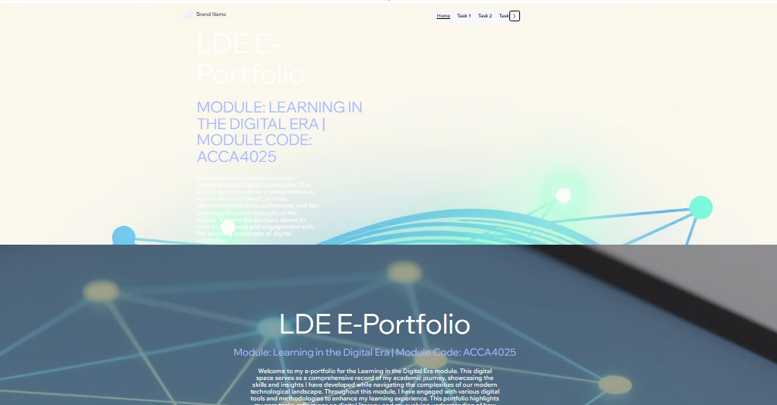

Task 1: Essential Academic and Employment Skills for Computing/IT

Summary
It is very important for the students who wish to pursue their careers in computing and IT to develop academic and employability skills. The former consists of skills like critical analysis, research, and effective writing while the latter comprises skills which will help the graduates to perform effectively after graduating. In other words, academic skills prepare an individual to go for interviews while employability skills are needed for getting and succeeding in the job [4].
In the specific field of computing, apart from technical skills, there are several transferable skills that the individual should possess. Today, colleges design courses in consultation with industry to prepare the graduates in those skills that are appreciated by the industry. They even offer a structured program like yearlong work placement for students in industry before graduating [2]. Academically, a computing and IT student is required to synthesize, analyze and evaluate information, adapt to change in technology and understand the principles of computing [1].
Digital literacy is very relevant to this area due to the rapid changes in technology and platforms taking place in industry. Next, teamwork and professionalism are very much appreciated; when studying the employability attributes of computing students, it was found that the attribute of professionalism received the highest score of all core employability factors (mean of 3.72), while computer cognition and operation skills received a slightly lower mean of 3.49, implying that ethical and non-technical skills matter just as much [3].
The acquisition of these skills, which include communication, critical thinking, digital literacy, and teamwork, will assist me in my entry into the field of computing after completing university [5].
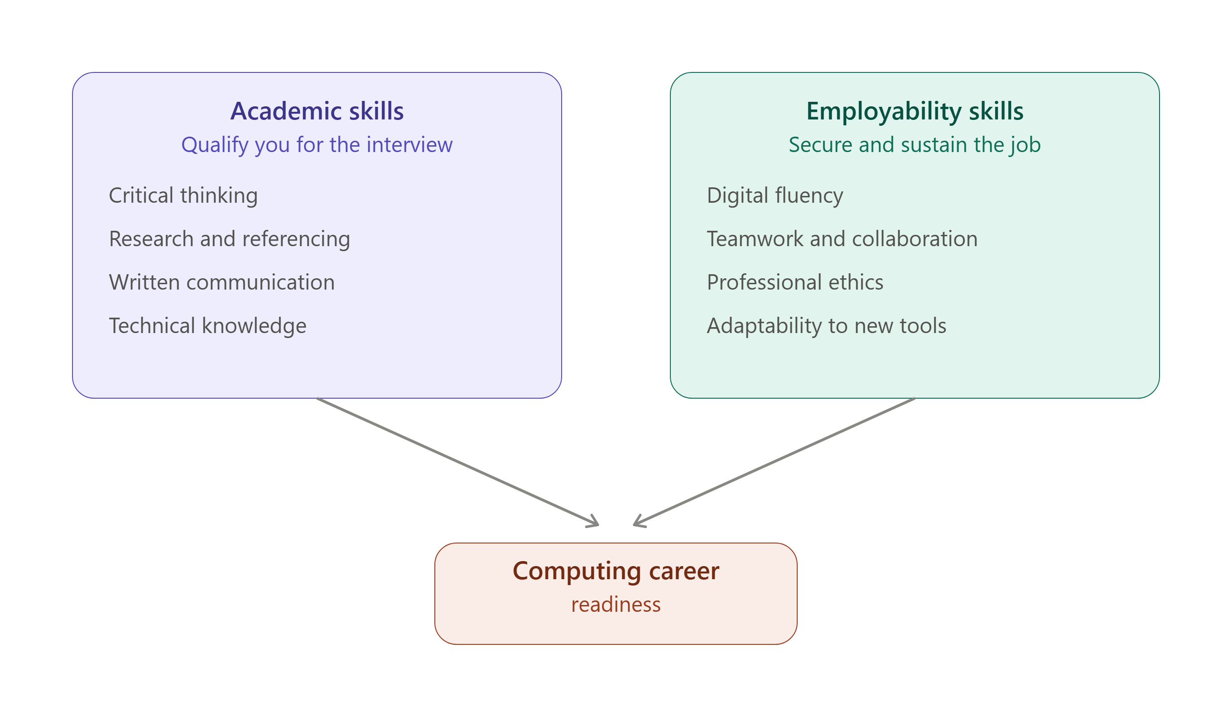
Figure 1: Academic skills vs employability skills diagram

Turnitin Reflection
After submitting my summary for Task 1 to the practice Turnitin link, I obtained a similarity of 12%, indicating good paraphrasing and correct in-text citation but not replication of sources. This similarity indicates that my use of references and phrasing was quite good; to ensure further success, I will try checking my sentences' structures against the sources during my editing to keep my similarity score low. With regard to the Generic Assessment Criteria, I will give myself a mark within the Excellent (70-84%) bracket since my work shows knowledge of a wide range of sources and proper employability theories alongside good IEEE referencing.

Task 1 Page Screenshot
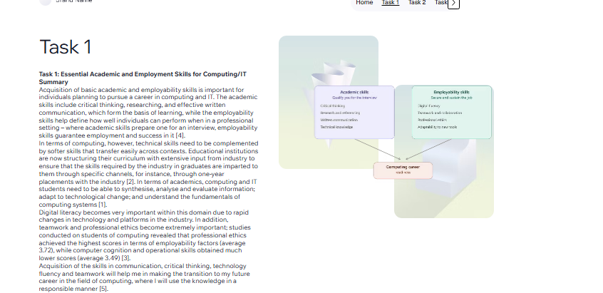
Figure 2: Screenshot of Task 1 e-portfolio page

Task 2: Collaborative Mind Map and Individual Poster

Mind Map
This mind map was done individually through MindMeister with the theme, "Life is a Sport Team." This mind map comprises of eight major branches, which include: Team Work (trust, support, motivation, communication), Leadership (responsibility, decision making, motivation), Communication Skills (listening, feedback, conflict resolution, reflection), Fair Play (integrity, respect, sportsmanship), Individual Roles (individual strengths and accountability), Challenges (perseverance, learning from setbacks, learning), Success (success, hard work and planning), and Personal Growth (adaptability, confidence and learning all your life). Creating the mind map in this way gave me the opportunity to see how individual behavior such as fair play and personal growth relate to team results.
Mind Map Link: https://mm.tt/map/4055368221?t=I1wVyMLP8s
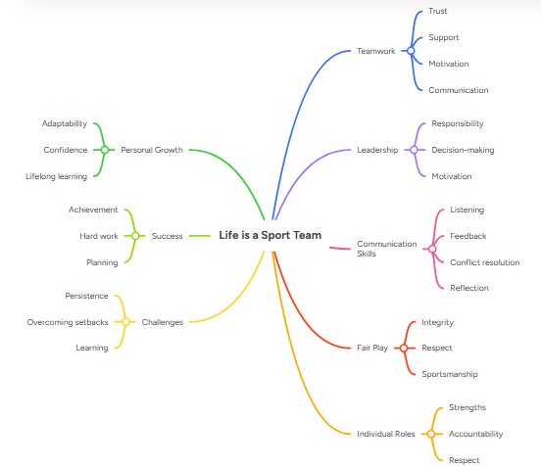
Figure 3: Screenshot of completed MindMeister mind map

Poster
This individual A3 academic poster has been created to demonstrate the importance of teamwork principles presented in the book "Life is a Sport Team" and how they can be applied to both academic and career success in computing. These principles relate to the importance of teamwork, academic and career success in computing, as well as three pillars that support them: communication, leadership and collaboration, each of which can be illustrated by computing-related examples like cooperation in software development and versioning tools. Mindmeister mind map has been used as an additional visual aid to this poster, along with a simple flow chart that illustrates how individual skills turn into teamwork skills and career readiness.
Poster Link (Google Drive): https://drive.google.com/file/d/1EYMjjlUvp4wbQNOtPGzVKwCIGFtSUtIH/view?usp=sharing

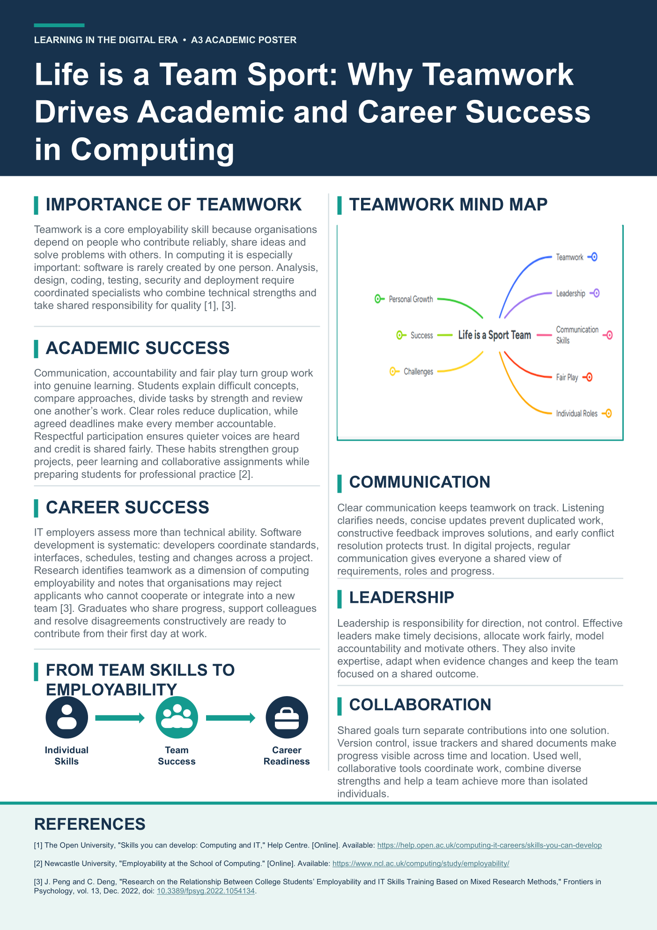
Figure 4: A3 academic poster — 'Life is a Team Sport'

Task 2 Page Screenshot
[INSERT: Screenshot of Task 2 e-portfolio page here — capture once the mind map image resizing fix is confirmed]

Task 3: Virtual Collaboration and RefWorks

Unit 3 Topic: Microsoft Teams — Summary
Virtual collaboration tools have become indispensable in today's working environments, and Microsoft Teams is among the most popular such platforms that have been able to bridge the divide between physical distance and collaboration. With the emergence of remote work trends, virtual collaboration tools, including Teams, are vital for connecting and fostering collaboration among distributed teams through centralizing workplace functionalities in a single platform, hence fostering an efficient and collaborative workplace.
One of the main benefits of Teams is the ability to unify different workplace applications. With Teams, it is possible to integrate various activities, such as chat, video conferences, and file sharing in a single application without using other applications for communication purposes. This makes operations within the application more efficient. It is also possible to collaborate on documents at real time.
Communication quality in virtual settings has been enhanced as well by the features of Teams. The features have been introduced with a view to enhancing connections between people and their teams, reducing meeting fatigue and increasing inclusivity and engagement in meetings. The ability to hold large-scale meetings is another feature that enables organisational use cases; up to 10,000 participants can join virtual meetings held by Teams users, making it appropriate for webinars, company meetings, and client presentations, complete with live captioning and transcription.
The research on virtual collaboration platforms confirms these practical uses. Studies comparing virtual platforms to one another indicate that virtual platforms such as Microsoft Teams can provide an interactive experience similar to physical presence and allow for efficient collaboration despite the spatial distance, strengthening the argument about virtual platforms as true replacements for in-person collaboration and not mere alternatives to it.
Knowledge about Microsoft Teams and similar tools is now becoming an essential skill for computer science students and professionals, since virtual collaboration became an indispensable element of software development.

RefWorks Evidence
I have utilized RefWorks for managing the references in my Task 3 summary on Microsoft Teams and virtual collaboration. After signing in, I made a new folder entitled “Task 3 - Virtual Collaboration” and added four resources that focus on practical and research views on virtual collaboration software. I chose the IEEE citation style from the available list of citation styles provided by RefWorks and generated in-text citation numbers and the entire bibliography list based on the new folder. RefWorks helped me create accurate IEEE references and avoid possible referencing errors, while my bibliography can be easily matched with the in-text citations in my summary.
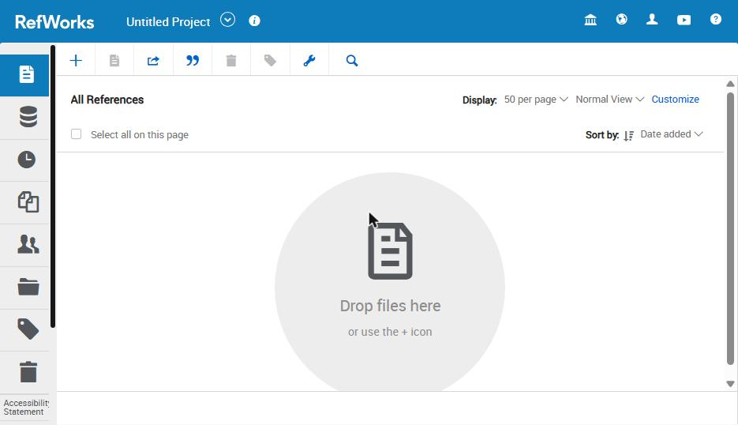
Figure 5: RefWorks — logged in, viewing All References
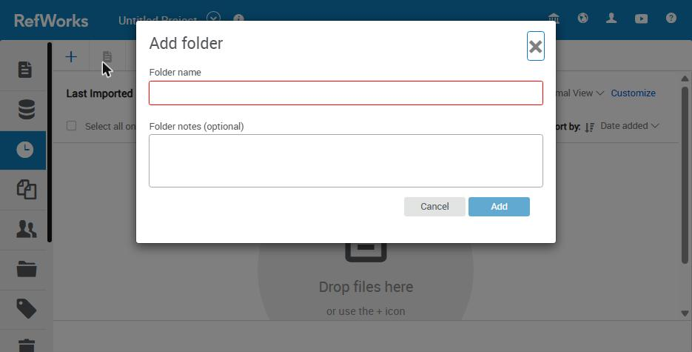
Figure 6: RefWorks — creating a new folder
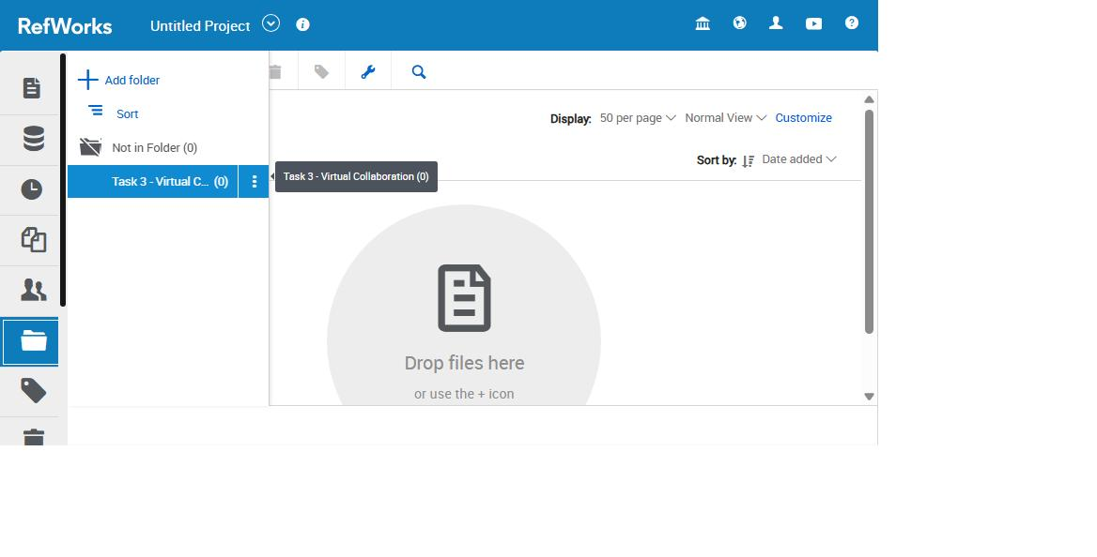
Figure 7: RefWorks ‘Task 3 - Virtual Collaboration' folder created
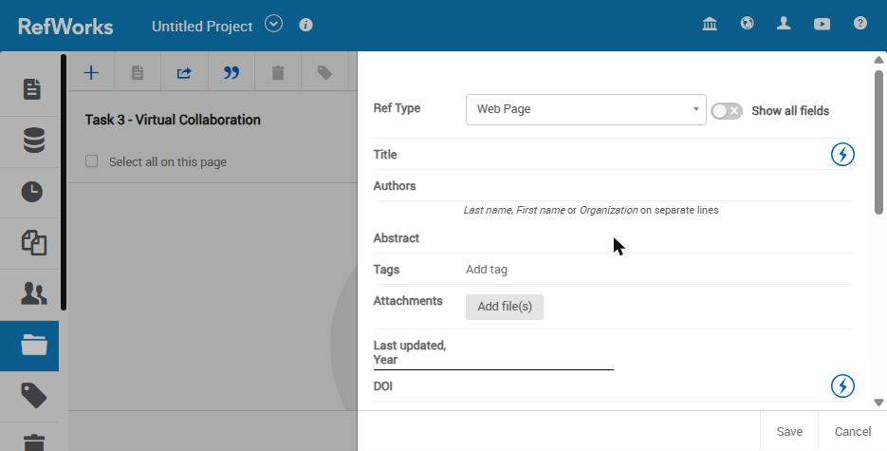
Figure 8: RefWorks — adding/importing a reference
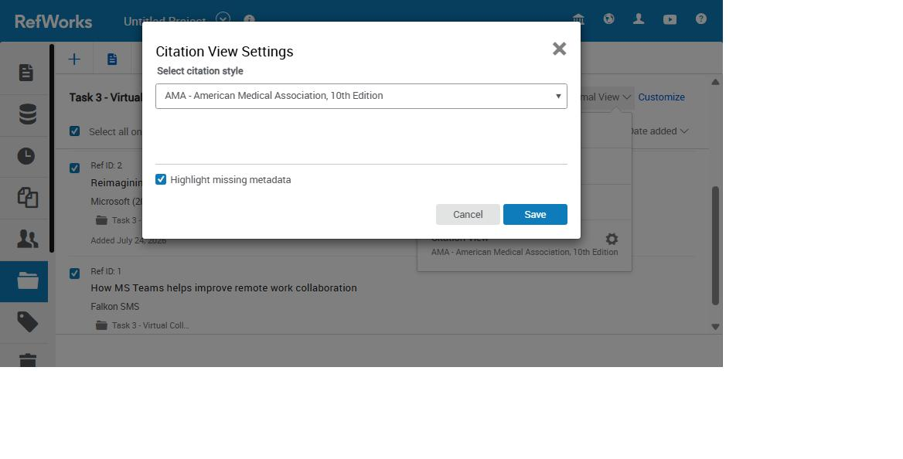
Figure 9: RefWorks — Citation View Settings (selecting citation style)
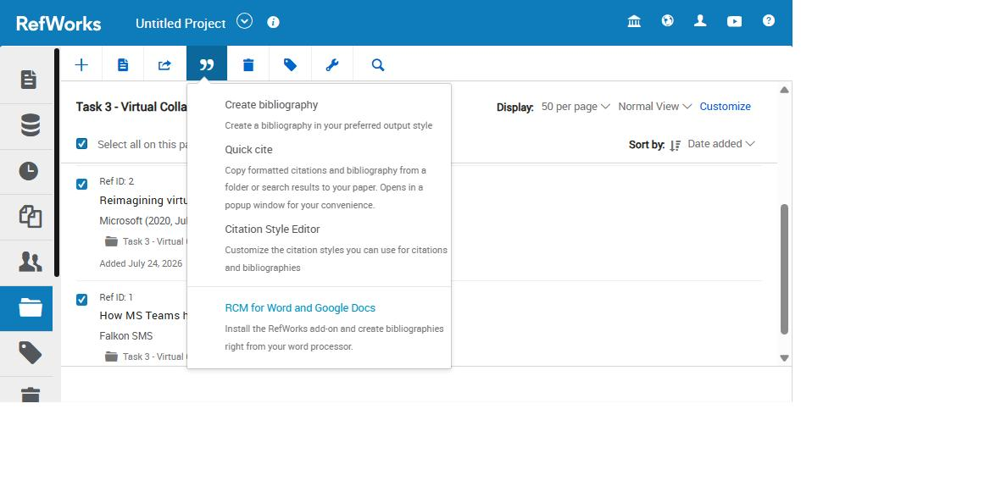
Figure 10: RefWorks — Quick Cite tool for inserting in-text citations
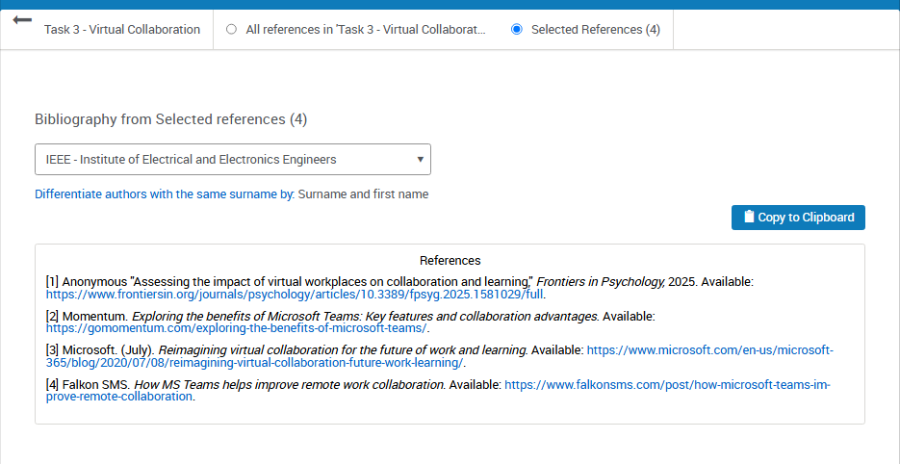
Figure 11: RefWorks — generated bibliography in IEEE style

Task 3 Page Screenshot
[INSERT: Screenshot of Task 3 e-portfolio page here (showing the summary text)]

Task 4: E-Portfolio Creation and Review

Illustrative Review of E-Portfolio Tool Selection
For the creation of an e-portfolio within the current module, I selected the Wix service. The drag-and-drop editor of Wix enables its users to create a website without any knowledge of coding, providing at the same time many more design options and template variations compared to Google Sites, which only provides few templates for its users to select from [1].
Moreover, accessibility of the website was another important criterion. The websites created using Wix are published with a public URL which makes them viewable by anyone who does not necessarily need to have an account or to log in in order to see the website. This feature was very necessary due to the fact that tutors of the module had to have access to the portfolio without any problem. In order to test that, I opened the website in a private/incognito window and checked that there is no need for the login process. Even though Google Sites are normally recommended for creating simple single purpose sites, Wix is known as a better choice when it comes to building more complex websites.
In conclusion, the easy-to-use nature coupled with the design flexibility of Wix made it a useful tool in ensuring that my coursework was presented effectively

Task 4 Page Screenshot
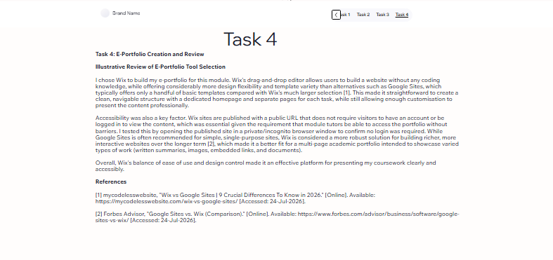

Conclusion
This assignment has helped me to learn about my digital literacy, referencing and collaboration skills with tools such as MindMeister, Wix and RefWorks for the very first time within the academic world. Creating the portfolio showed how important it is to organise your assignments for future employment as these are the digital skills that are required by the profession of Computing. This AI acknowledgment shows the level of Generative AI involvement in completing this assignment.

AI Acknowledgement
Generative AI has been utilized in the current assignment for research purposes and proofreading, consistent with the permissible use of AI in the module. The generative AI has not been used to generate the final submission text.

References

Task 1 References
[1] The Open University, "Skills you can develop: Computing and IT," Help Centre. [Online]. Available: https://help.open.ac.uk/computing-it-careers/skills-you-can-develop [Accessed: 23-Jul-2026].
[2] Newcastle University, "Employability at the School of Computing." [Online]. Available: https://www.ncl.ac.uk/computing/study/employability/ [Accessed: 23-Jul-2026].
[3] J. Peng and C. Deng, "Research on the Relationship Between College Students' Employability and IT Skills Training Based on Mixed Research Methods," Frontiers in Psychology, vol. 13, Dec. 2022, doi: 10.3389/fpsyg.2022.1054134.
[4] S. Cottrell, Skills for Success: Personal Development and Employability. London: Bloomsbury/Red Globe Press. (Edition confirmed by student against library copy.)

Task 3 References
[1] Falkon SMS, "How MS Teams helps improve remote work collaboration." [Online]. Available: https://www.falkonsms.com/post/how-microsoft-teams-improve-remote-collaboration [Accessed: 23-Jul-2026].
[2] Microsoft, "Reimagining virtual collaboration for the future of work and learning," Microsoft 365 Blog, Jul. 2020. [Online]. Available: https://www.microsoft.com/en-us/microsoft-365/blog/2020/07/08/reimagining-virtual-collaboration-future-work-learning/ [Accessed: 23-Jul-2026].
[3] Momentum, "Exploring the benefits of Microsoft Teams: Key features and collaboration advantages." [Online]. Available: https://gomomentum.com/exploring-the-benefits-of-microsoft-teams/ [Accessed: 23-Jul-2026].
[4] Frontiers in Psychology, "Assessing the impact of virtual workplaces on collaboration and learning," 2025. [Online]. Available: https://www.frontiersin.org/journals/psychology/articles/10.3389/fpsyg.2025.1581029/full [Accessed: 23-Jul-2026].

Task 4 References
[1] mycodelesswebsite, "Wix vs Google Sites | 9 Crucial Differences To Know in 2026." [Online]. Available: https://mycodelesswebsite.com/wix-vs-google-sites/ [Accessed: 24-Jul-2026].
[2] Forbes Advisor, "Google Sites vs. Wix (Comparison)." [Online]. Available: https://www.forbes.com/advisor/business/software/google-sites-vs-wix/ [Accessed: 24-Jul-2026].

