A STRATEGIC CHANGE PLAN

TITLE: LEADING AND IMPLEMENTING CHANGE (LIC)
STUDENT NAME: Farhat Rubbani
STUDENT ID NUMBER: 2314659

Programme: BA (Hons) Leadership and Management Skills for the Workplace
Module Code: LCLM6003
Lecturer(s):
Nadeem Mirza
Ivan Rodriguez Hernandez
Assignment Title:
A Strategic Change Plan

Contents
1. Introduction to the Organisation (LO1) 3
2. Analysis of Environmental Changes (LO1 & LO2) 4
2.1 External Environment – PESTLE Analysis 4
2.2 Industry Analysis – Porter’s Five Forces 5
2.3 Internal Environment Analysis (SWOT) 7
3. Evaluation of Change Management Models (LO3 & LO4) 8
3.1 Lewin’s Three-Step Model 8
3.2 Kotter’s Eight-Step Model 10
3.3 Model Comparison 11
4. Leadership and Organisational Culture (LO3). 12
4.1 Leadership Approach 12
4.2 Organisational Culture Analysis 13
5. Strategic Change Management Plan (LO4) 14
5.1 Proposed Change 14
5.2 SMART Objectives 15
5.3 Financial Plan 16
5.4 Communication Plan 17
5.5 Implementation Timeline 18
5.6 Evaluation Plan (KPIs) 19
6. Reflection (LO5) 21
References: 22

1. Introduction to the Organisation (LO1)

Marks and Spencer (M&S) could be viewed as one of the oldest and advanced organisations to be found within the retail markets of the United Kingdom and to sell its products in the arenas of clothing, food, and homeware. Since the company was founded in 1884, it has traditionally framed itself as a quality-based retailer, serving the middle-income consumer market with a massive physical store base that is supplemented by a slowly growing online presence. M&S has been enjoying a long history thereby developing a good brand image and customer loyalty which is one of its strategic assets in a more competitive retail market (Hong, 2024).



Fig 01: Marks and Spencer (M&S) (Source: Logo.wine.logo)

Nevertheless, digital commerce, supply chain innovation and changing consumer interests in convenience, speed, and personalization have revolutionized the UK retail industry considerably. Retailers such as M&S are finding it difficult to adjust to changing market dynamics with fast-fashion and online-only retailers to rewrite the rules of the game. The old model of operation used by the company and the use of physical stores to continue its business, restrict the organizations capacity of responding to these changes promptly, compared to digitally integrated competitors who are able to adapt faster, provide a more efficient service and still maintain a low cost of operation (Chen, 2025).

Also, the shift in consumer behavior, e.g. the rise in online shopping and desire to receive personalised experiences, points to the increasing disconnect between the current potential and the current needs on the M&S side. Lack of strategic organisational change may lead to the loss of profitability, loss of customer relevancy, and market share. Thus, M&S urgently needs to ensure that its resources, technological strengths, and business operations strategies are adjusted to the modern retail reality and remain competitive, deliver sustainable growth, and be able to hold up of potential changes in the highly digitalized and customer-focused market (Omee, 2023).

2. Analysis of Environmental Changes (LO1 & LO2)

2.1 External Environment – PESTLE Analysis
Factor | Environmental Change | Impact on M&S
Political | Trade regulations and supply chain uncertainties | Increased sourcing complexity and costs
Economic | Inflation and reduced consumer spending | Pressure on pricing and margins
Social | Shift toward convenience and online shopping | Declining store footfall
Technological | AI, e-commerce platforms, automation | Need for digital investment
Legal | Sustainability and labour regulations | Compliance costs increase
Environmental | Demand for ethical fashion | Need for sustainable sourcing

The biggest disruption is technological change. Customers are becoming more demanding to smooth-sailing digital interactions, fast delivery, and customisation. Retailers that fail to provide omnichannel risks are losing their business.
The PESTLE analysis shows that Marks and Spencer are faced with a very complicated macro-environment that involves several external forces that affect the performance of organisational performance at the same time. Political and legal forces add uncertainty to operations by making compliance with regulations and international sourcing more difficult, necessitating the use of flexible supply chain management. The economic pressures like inflation lower the consumer purchasing power and the organisation is forced to strike a balance between quality positioning and price competitiveness (Mihailova, 2020).
The most transformational influences include social and technological factors. Lifestyles of the consumers compromise more on convenience, speed as well as digital availability, a factor that diminishes reliance on physical stores. Retail operations are changing due to technological progress like artificial intelligence and data analytics that allow personalised marketing and inventory optimization. The expectations of the environment also force the organisation to work towards sustainable sourcing and ethical production practices which adds the responsibility of operations and strategy opportunities to the organisation (Dalirazar, 2023).
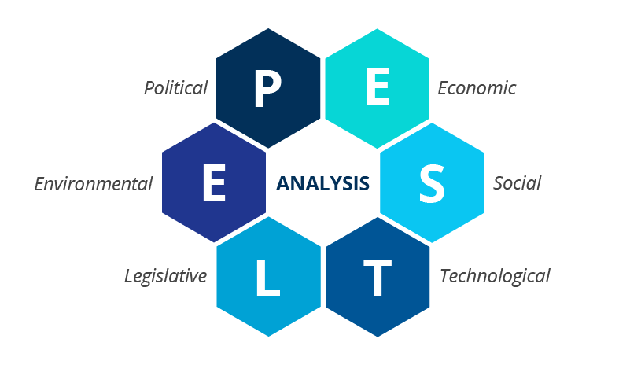
Fig 02: PESTLE analysis (Source: Short brains)

In general, the discussion has shown that organisational adaptation and innovation put an organisation under a permanent pressure of change by the external environmental change that is not individual but rather global

2.2 Industry Analysis – Porter’s Five Forces
Force | Analysis
Competitive Rivalry | Extremely high due to Zara, H&M, and online retailers
Threat of New Entrants | Moderate due to digital platforms lowering entry barriers
Buyer Power | High because customers easily compare prices online
Supplier Power | Moderate depending on global sourcing networks
Threat of Substitutes | High due to resale platforms and fast fashion

The Five Forces analysis will identify the level of competition in the UK retail business and justifies the need for strategic change to enable organisations to survive. Fast-competitive rivalry is brought about by fast-fashion retailers whose supply chains are digitally integrated with high production rates and thus can react swiftly to trends. This puts the traditional retailers like M&S in a disadvantage where organisational processes are either slower or less technologically advanced (Ndzabukelwako, 2024).
The pressure is also intensified by the buyer's power since the customers can find it easy to compare prices, quality, and delivery services through online platforms. Since the switch cost is low, experience has become more important in customer loyalty, but not the brand heritage itself. The medium risk of entry is due to the fact that digital commerce platforms decrease the entry barrier and, thus, small brands can compete without investing in big physical infrastructure (Isabelle, 2020).
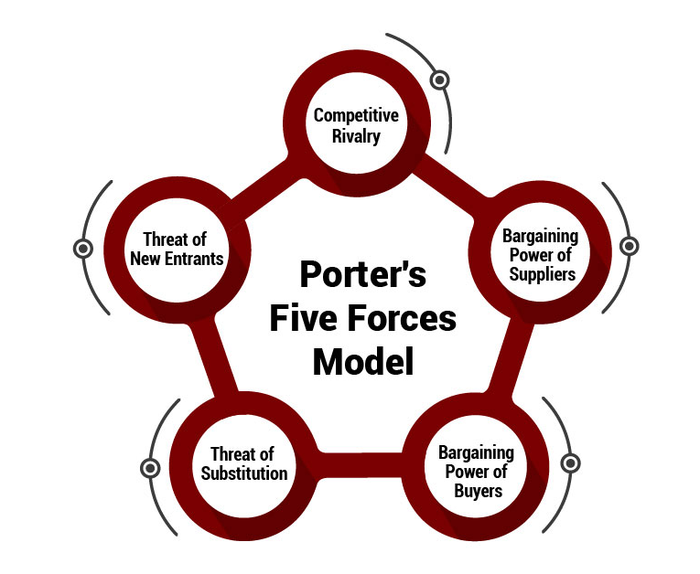
Fig 03: Porter’s Five Forces (Source: The strategy institute)
All of these forces are indicative that profitability is now being defined by innovation, efficiency, and digital capability as opposed to historic market recognition. Competitors in the digital native sector have supply chains that are flexible and have a shorter product cycle which puts traditional retailers at a disadvantage.

2.3 Internal Environment Analysis (SWOT)
Strengths | Weaknesses
Strong brand reputation | Legacy IT systems
Loyal customer base | Slow innovation speed
Quality perception | High operational costs
Opportunities | Threats
Digital expansion | Fast-fashion competitors
Data-driven retail | Changing consumer expectations

The SWOT analysis indicates that Marks and Spencer have an imbalance in the strategic strength of the company compared to external threats. Although brand reputation and customer trust would be an effective competitive base, organisational weaknesses, including old systems and slower innovation cycles, restrict the ability to respond to environmental change (Benzaghta, 2021).
The opportunities related to digital retail and data-driven decision-making present growth prospects; nevertheless, the opportunities demand the development of high capabilities. The urgency to change is provided by the existence of intense fast-fashioned rivals and the ever-changing customer demands. This analysis thus demonstrates the existence of a gap in capabilities, in that the current organisational capabilities are not sufficiently matched with the future market needs (Pereira, 2021).
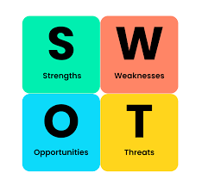
Fig 04: SWOT Analysis (Source: Businessballs)
The solution to this misfit becomes the primary reason why a structured strategic change programme has to be executed. The analysis indicates that the necessary environmental change and organisational responsiveness have a gap in their capabilities, which is a direct response to the needs of LO2.

3. Evaluation of Change Management Models (LO3 & LO4)

3.1 Lewin’s Three-Step Model
Stages:
- Unfreeze
- Change
- Refreeze
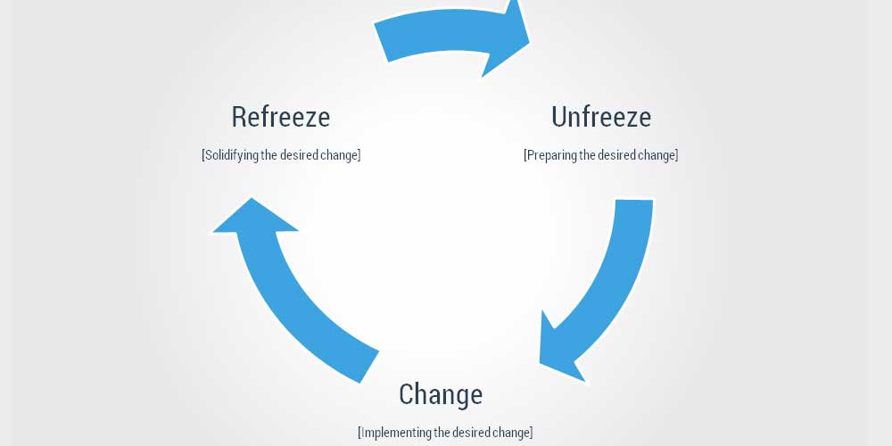
Fig 05: Lewin’s Three-Step Model (Source: Collierbroadlink)
Strengths
- Simple and structured
- Helps reduce resistance
- Clear transition stages
Limitations
- Too linear for fast-changing environments
- Assumes stability after change
Application to M&S

The Three-Step Model of Lewin offers an organized system of change management in organisations as it helps a company pass three consecutive stages, i.e. unfreeze, change, and refreeze. The unfreeze phase is one of the most crucial in the case of M&S since it entails getting the employees and other stakeholders ready to receive the impending digital transformation. Through communicating change requirements and targeting the current habits and mindsets, the management will be able to minimize the resistance and create awareness as to why the old operating models are no longer adequate (Burnes, 2020). The change phase works on the introduction of new processes, technologies, and behaviours, including the introduction of online platforms, AI analytics, and online customer engagement systems. This phase promotes trial, error, and embrace of new customs in the labor market. Lastly, the refreeze phase ensures the stabilisation and entrenching of new behaviours and processes into the organisational culture, which is a good move towards consistency and continued improvement in the long term. Generally, the Lewin model is clear and psychologically prepared, which is why it is especially applicable in the beginning of the transformation in the companies that are already established, such as M&S (Adelman-Mullally, 2023).

3.2 Kotter’s Eight-Step Model
Step | Application at M&S
Create urgency | Communicate declining store performance
Build coalition | Senior leadership alignment
Develop vision | Digital-first retail strategy
Communicate vision | Organisation-wide messaging
Empower action | Employee reskilling
Generate wins | Online sales milestones
Sustain momentum | Continuous innovation
Anchor change | Culture transformation
Strengths
- Leadership-focused
- Encourages employee engagement
- Suitable for large organisations
Weaknesses
- Time-consuming
- Requires strong leadership commitment

The Eight-Step Model developed by Kotter offers a thorough method of organisational change management, especially in large and complicated organisations such as M&S. The creation of urgency is a way of making the employees realise that change is necessary because their stores are not performing so well, whereas building a coalition is a method of ensuring that the senior leadership is on board with the change and commitments are made (Shah, 2023). Creating and sharing a digital-first vision helps employees and other stakeholders to work towards shared goals. Action empowering with training and reskilling enables staff to learn new digital systems and victories of online sales, among other things, strengthen motivation. Continuing momentum and entrenching change in the organisational culture is a guarantee of long-term adoption. Hence, the model is very effective although it is time consuming and needs autocratic commitment of the leaders (Alhaderi, 2021).

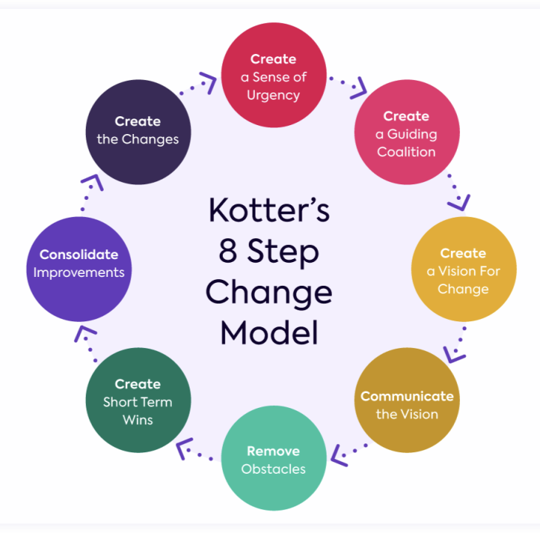

Fig 06: Kotter’s Eight-Step Model (Source: Bitesize learning)

3.3 Model Comparison
Model | Strength | Weakness | Suitability
Lewin | Clarity | Oversimplified | Preparation phase
Kotter | Strategic mobilisation | Complex | Full transformation

The analysis of change management models shows that various models are used to deal with various aspects of organisational change. The Lewin model offers a conceptual clarity in its focus on psychological preparation and stabilisation and, due to its linear nature, might be too simplistic in relation to the present organisational reality in which change is not a sequence but a continuum.
In comparison, the model by Kotter focuses more on leadership participation, communication, and the creation of momentum and therefore is more applicable to a massive transformation initiative. The systematic procedures motivate the employees and minimize resisting change by jointly developing a vision. In the case of Marks and Spencer, where cultural and behavioural change is essential as the operational change, the model provided by Kotter is more practical.
The comparison hence warrants a mixed methodology approach in which the Lewin framework will facilitate the preparation phase whereas the Kotter model will facilitate the implementation process and institutionalization of the change.

4. Leadership and Organisational Culture (LO3).

4.1 Leadership Approach

Transformational leadership is the best type of leadership that suits organisational change since staff members are inspired, empowered, and motivated by vision (Kotamena, 2020).

The major leadership positions are:
- Creating strategic vision
- Reducing resistance
- Encouraging innovation
- Encouraging organizational learning.

During the digital transformation, trust and psychological commitment are developed by transformational leaders (O’Reilly, 2020).

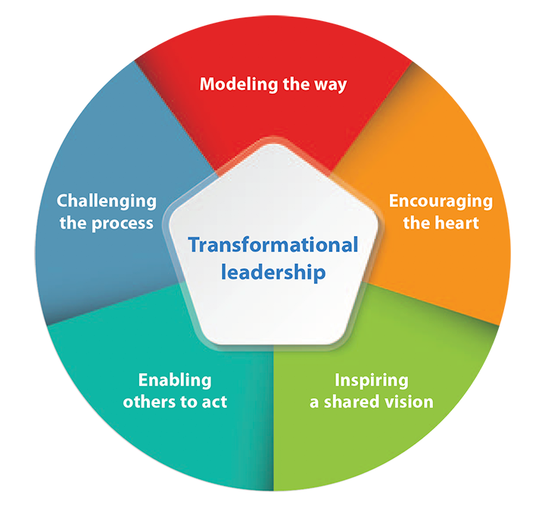

Fig 07: Transformational leadership (Source: American nursing journal)

4.2 Organisational Culture Analysis
Using Schein’s Cultural Model:
Level | M&S Culture Observation
Artefacts | Traditional store-focused operations
Values | Quality and reliability
Assumptions | Risk avoidance and stability
Cultural analysis demonstrates the strength of deep-rooted assumptions in organisational behaviour especially at the time of change. Artefacts that are observable include store-centered operations that were successful in the past but have to reinforce opposition to digital transformation without intent. Qualitative and reliable organisational values are beneficial to brand identity and can promote slothfulness and risk aversion (Alankarage, 2024).
There can be psychological barriers to experimentation and innovation as a result of underlying assumptions regarding stability and traditional retail success. Cultural change is then necessary to bring the mindset of the employees in line with strategic goals. Leaders should actively redefine norms through facilitation of teamwork, education, and flexibility which will see organisational culture become a change facilitator and not a barrier to change (Makumbe, 2022).
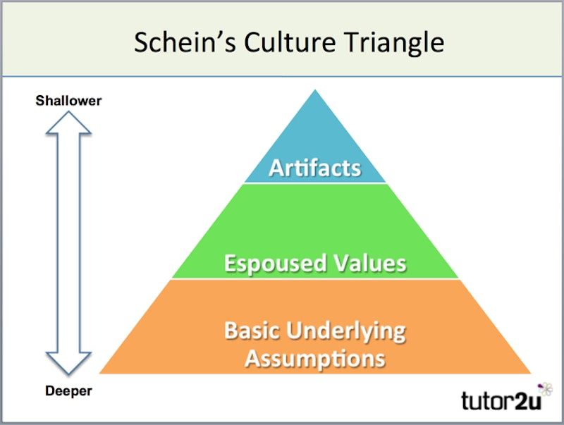
Fig 08: Schein’s Cultural Model (Source: Tutor2u)

5. Strategic Change Management Plan (LO4)

5.1 Proposed Change

The change idea is a Digital Omnichannel Transformation Strategy that involves the use of online channels, analytics supported by artificial intelligence, and customer interaction based on data to transform the organisational processes. The purpose of this transformation is to design a smooth customer experience in physical stores, mobile applications, and e-commerce platforms, giving the customers the opportunity to contact the brand using various interconnected channels. AI-based analytics will provide the possibility of real-time customer intelligence, customised marketing suggestions, and better demand projections and assist in more precise inventory control and less operational waste (Proskurnina, 2021).

The strategy will also improve the process of decision making by integrating data between departments and thus assist managers to react promptly to evolving consumer trends and market environment. Enhancing the digital infrastructure, increasing the level of coordination in logistics, and implementing automated customer service solutions (chatbots and intelligent support systems) are also part of the transformation. With harmonisation of technology, processes and employee capabilities the organisation will be able to enhance customer satisfaction, agility in operations and enhance the long-term competitive positioning in the changing retail environment (Spanaki, 2024).

5.2 SMART Objectives
Objective | Target
Increase online sales | +30% within 2 years
Reduce operational costs | 15% reduction
Improve customer satisfaction | 20% increase
Employee digital training | 80% workforce trained

The SMART objectives use strategic intentions and transform them into quantifiable organisational results, making them accountable during the change process and facilitating performance management. The process of transforming macro-level strategic goals into operational objectives helps the organisation to minimize confusion and provide a sense of direction to both employees and the management. The rising online sales is equivalent to meeting the trend of digital consumer behaviour when it is understood that the future of retail practice is becoming more reliant on the capability of e-commerce and the incorporation of the omnichannel as opposed to further expansion of the store. This goal is also in line with the long-term goal of diversifying the revenue because it lowers dependence on the performance of stores (Duca, 2021).
The cost minimization goals help deal with the challenge in operational efficiency due to the legacy systems and the high store operating costs. The goal is not about cost reduction but rather the improvement of efficiency by optimisation of the processes, automation, and better management of inventories. The training of employees has targets that technological change will not work without the development of workforce capability. Digital systems force employees to reform, acquire analytically, and adopt new working practices, which further make investment in human capital a pivotal aspect of success (Syed, 2022).
In addition, SMART provides the alignment of the organisations by connecting the work of departments with strategic aims. Marketing, operations, and human resources functions can align themselves to the same targets and enhance coordination between the functions across the organisation. The organisation can track the progress of the implementation process on a constant basis by setting certain deadlines and measurable goals to be achieved by the end of the process. This elasticity assists with dynamic control so that the leaders can react to the new obstacles that arise in the transformation (Mansouri, 2021).
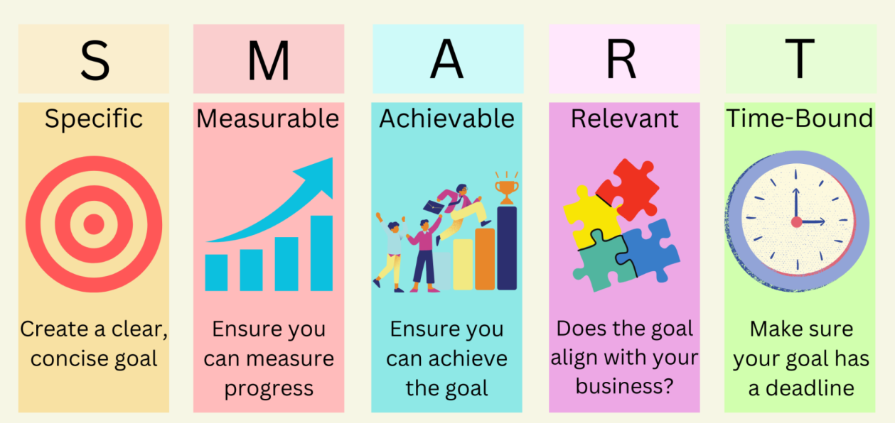
Fig 10: SMART Objectives (Source: Forbes Advisors)
The objectives are also known to give psychological clarity to the employees and other stakeholders, thus eradicating uncertainty that is usually synonymous with organisational change. Clear expectations would enhance the confidence of employees and make them accountable which would enhance their commitment to the collective organisational objectives and also guarantee that the progress is visible and measurable in the change process (Zhang, 2021).

5.3 Financial Plan
Investment Area | Estimated Purpose
Technology systems | E-commerce infrastructure
Employee training | Digital skill development
Marketing | Online customer acquisition
Expected benefits:
- Higher sales efficiency
- Reduced inventory waste
- Improved profitability
The financial plan shows that strategic change cannot be achieved by reducing costs only. Organisational transformation entails redirection of resources to future growth areas which are competitive in the long term. The investment in technology infrastructure promotes operational efficiency by automating, using integrated data systems, and enhancing better customer analytics. Such systems allow making quicker decisions, precise forecasting of demand, and individual interaction with customers, which all contribute to market responsiveness (Setyorini, 2021).
The investment in human capital development through training expenditure is the guarantee that the employees have the skills necessary to work in the digital space and remain innovative in the environment. The capability of the workforce has a direct linkage to the success of the adoption of technology; hence training costs are to be perceived as strategic facilitators instead of operational costs. The competent employees lead to the enhancement of productivity, minimised operational mistakes, and greater organisational flexibility (Mahapatra, 2022).
Investment on marketing enhances customer awareness and contributes to behaviour shift to online activity. With customers moving in digital platforms, the targeted marketing campaigns are also useful in facilitating consumers through new purchase experiences, as well as reinforcing the brand's relevance. Digital marketing analytics are also making organisations more precise about the customer response, which enhances the marketing money spent.
Even though the company may incur higher financial expenses in the initial phases of the change, the long-term gains will incorporate increased productivity, decrease inventory losses, and improvement in income generation. Automation eliminates manual operations, whereas inventory management based on data reduces wastage and overstocking. The financial strategy is thus an indication of a progressive investment strategy that does not focus on instant profitability but sustainable growth to guarantee competitive edge in a fast-changing retailing landscape (Lyons, 2021).

5.4 Communication Plan
Stakeholder | Method | Purpose
Employees | Workshops & intranet | Reduce resistance
Managers | Leadership briefings | Alignment
Customers | Digital campaigns | Awareness
Investors | Reports | Confidence building

Communication is key in lessening uncertainty and resistance in organisational change since the stakeholders are convinced of the reason and the benefits of change. The failure issue of change initiatives is not always based on ineffective strategy but rather lack of proper communication that will lead to misunderstanding or lack of trust with the employees. Communication, therefore, needs to be ongoing, open and planned in a strategic manner.
The various stakeholder groups also need different communication strategies that are aligned to their interests, responsibilities and levels of influence. Workers need to feel open and assured in order to keep morale high and reduce anxiety about employment or job reassignments. The ability to receive feedback helps to motivate people to participate and make psychological ownership of change efforts. In contrast, managers need strategic clarity and detailed instructions that would facilitate the implementation of activities and contribute to team adaptation.
Customer communication is a continuity of brand trust as it keeps customers abreast of any advancement in service delivery and digital experience. Effective communication will avoid customer dissatisfaction when the company is in the process of transition and will support the perception of innovation and responsiveness. Communication with investors ensures a sense of confidence within the organisational direction through evidence of structured planning and value creation over the long-term.
To achieve similarity in the message distribution among different organisational levels, structured means of communication like workshops, leadership briefings, digital means, and internal newsletters can be used. Coherence minimizes rumours and misinformation, which can be a regular feature of the change efforts. Finally, the process of communication contributes to increased engagement, trust, and alignment of the stakeholders with organisational goals during the transition process.

5.5 Implementation Timeline
Phase | Activities
Preparation | Strategy communication
Implementation | Technology rollout
Stabilisation | Training & adjustments
Evaluation | KPI monitoring

The phasing implementation method is such that change is introduced in a manageable and gradual way and does not cause much disruption in operations of the organisation but rather enables progressive adaptation to the change. When a change is undertaken on large scale, it brings about uncertainty hence breaking down the implementation into systematic steps helps in risk management and stability within an organisation.
The preparation phase concentrates on the preparation, such as preparation of leadership, employee preparation, and resource preparation. Early involvement will limit resistance as employees will know the reason why there is a change before the changes start to affect operations. The implementation phase presents new working practices, processes that have been redesigned, and introduction of technological systems. At this step, constant monitoring is needed to detect the operational difficulties and offer on-the-spot assistance where necessary.
The stabilisation stage enables the employees to completely acclimatise to new systems as performance gaps or technical problems are solved. Managerial coaching and training reinforcement are especially relevant at this stage so that behavioural change can be entrenched. The absence of stabilisation means that the organisations are likely to go back to old practises, which derail transformation initiatives.
The evaluation phase is the assurance of organisational learning as it would measure the outcomes against the planned objectives and determine the scope of the subsequent improvement. This is a systematic schedule that minimizes risk through the fact that it does not change the system abruptly but rather encourages a slow adoption of new practices into regular activities. A staged model also helps the leadership team to recognize short-term achievements, which keeps the change going and strengthens the morale of the employees in the process.

5.6 Evaluation Plan (KPIs)
KPI | Measurement
Online revenue growth | Sales data
Employee adoption rate | Training completion
Customer satisfaction | Surveys
Profit margin | Financial reports

Key Performance Indicators (KPIs) present objective indications of the success of the change initiative and allow analysing the organisational progress in data numbers. The setting of clear metrics would make sure that the success of transformation would be evaluated based on the objective measurements but not on the subjective impressions (Guo, 2020).
Financial measures like the profit margin and revenue growth are used in gauging economic success and in checking whether the investments are yielding the results. Nevertheless, financial performance cannot be the ultimate measure of effectiveness of transformation. The employee adoption rates determine behaviour change within the organisation and it implies whether or not the staff has successfully implemented the new systems and practices in day-to-day work practices or not. A high level of adoption indicates a good leadership strategy, training, and communication strategy (Sari, 2023).
Customer satisfaction indicators are used to measure market response improvements and quality of services provided by an organisation following organisational change. Good comments by customers show consistency in how the transformation initiatives are matched to the expectations of the consumers. Following up, productivity indicators also assist in determining operational efficiency realized with the help of automation and process redesign (Ngure, 2021).
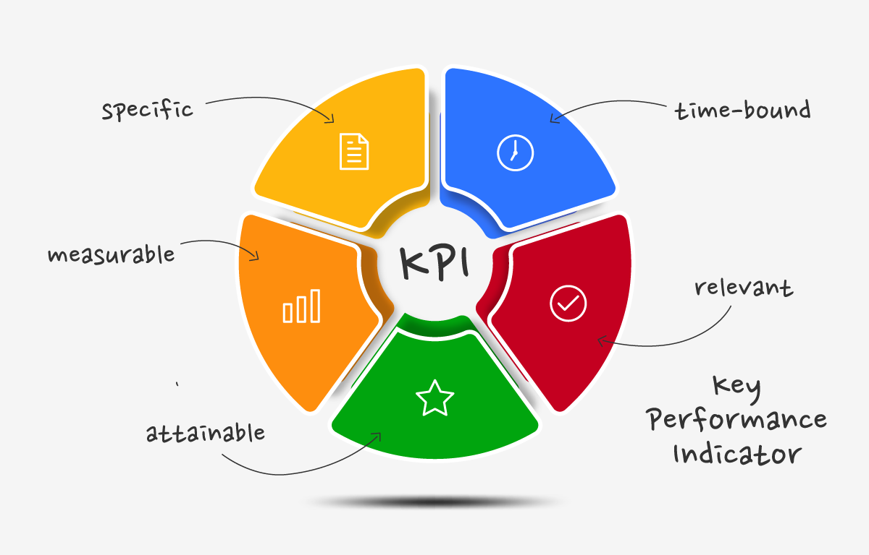
Fig 11: Key Performance Indicators (KPIs) (Source: SalesBook)
Application of various performance dimensions will ensure that assessment is balanced as opposed to basing it on financial results. Constant checks allow management to know the areas of weaknesses at an early stage and put corrective measures before issues become more complicated. KPI analysis helps in organisational learning over time as it shows the strategies that have the most impact. Such an evidence-based practice enhances the decision-making process and guarantees a lasting organisational improvement even after the first change of implementation period.

6. Reflection (LO5)
The process of creating this strategic change plan helped me to gain more knowledge of how organisations must constantly change to stay alive and competitive in changing and unpredictable business environments. It was demonstrated in the process that change management is not a mere theoretical model but necessitates the proper combination of leadership behaviour, organisational culture, and long-term strategic planning. The analysis of organisational issues has shown that the key to successful transformation is not only a strategy design, but also dealing with people and their perceptions, expectations, and responses to change.
The analysis of change models indicated that no universal model of change can be regarded as a guarantee of success, managers should be selective and adaptive to that workforce should be prepared, approaches should be adapted based on the organisational settings, industry environment, and the condition of the workforce. The significance of communication, motivation, trust-building, and emotional intelligence in influencing employee attitudes in uncertain times highlighted the use of leadership in such situations. I understood that fear of the unknown is the root cause of most resistance to change and not necessarily disagreement with organisational objectives and thus clear communication with the leaders is very crucial.
This assignment reinforced my analytical skills, strategic planning ability, and my professional decision-making skills because it demanded the use of theory to a realistic organisation situation. It further enhanced my skills of assessing intricate business situations and coming up with organized solutions with quantifiable goals. Moreover, the practice developed my understanding of stakeholder management and the need to align organisational vision and engagement of employees. Using structured change frameworks as a future manager will help in facilitating effective organisational change and reduce resistance with greater success as well as enhance collaboration and sustainability in organisational performance in quickly changing industries.

References:
Adelman-Mullally, T., Nielsen, S. and Chung, S.Y., 2023. Planned change in modern hierarchical organizations: A three-step model. Journal of Professional Nursing, 46, pp.1-6.
Alankarage, S., Chileshe, N., Samaraweera, A., Rameezdeen, R. and Edwards, D.J., 2024. Diagnosing organizational BIM culture: A qualitative case study using Schein’s model. Journal of Management in Engineering, 40(3), p.05024005.
Alhaderi, S.M., 2021. Kotter's eight step change model for employees' intentional, cognitive and emotional readiness for change and developing regional economy in saudi banking sector's, role of homologous communication, learning demand and job involvement. J. Legal Ethical & Regul. Isses, 24, p.1.
Benzaghta, M.A., Elwalda, A., Mousa, M.M., Erkan, I. and Rahman, M., 2021. SWOT analysis applications: An integrative literature review. Journal of Global Business Insights, 6(1), pp.55-73.
Burnes, B., 2020. The origins of Lewin’s three-step model of change. The Journal of Applied Behavioral Science, 56(1), pp.32-59.
Chen, K., 2025. Marks and Spencer’s Global Sustainability Strategy: A Case Study. Journal of Education, Humanities and Social Sciences, 61, pp.124-128.
Dalirazar, S. and Sabzi, Z., 2023. Strategic analysis of barriers and solutions to development of sustainable buildings using PESTLE technique. International Journal of Construction Management, 23(1), pp.167-181.
Duca, G., 2021, July. Design of the smart objectives system in the management of a research project. In International Conference on Management Science and Engineering Management (pp. 452-462). Cham: Springer International Publishing.
Guo, X., Chen, T., Chen, K. and Tang, Y., 2020, February. Design and implementation of KPI evaluation system. In The International Conference on Cyber Security Intelligence and Analytics (pp. 218-223). Cham: Springer International Publishing.
Hong, T.K., 2024. Strategic Analysis and Enhancement of Corporate Social Responsibility Practices at Marks & Spencer (M&S).
Isabelle, D., Horak, K., McKinnon, S. and Palumbo, C., 2020. Is Porter's Five Forces Framework Still Relevant? A study of the capital/labour intensity continuum via mining and IT industries. Technology innovation management review, 10(6).
Kotamena, F., Senjaya, P. and Prasetya, A.B., 2020. A literature review: is transformational leadership elitist and antidemocratic?. International Journal of Social, Policy and Law, 1(1), pp.36-43.
Lyons, A.C. and Kass‐Hanna, J., 2021. A methodological overview to defining and measuring “digital” financial literacy. Financial planning review, 4(2), p.e1113.
Mahapatra, M.S., Raveendran, J. and Mishra, R.K., 2022. Role of mental accounting in personal financial planning: A study among Indian households. Psychological Studies, 67(4), pp.568-582.
Makumbe, W. and Washaya, Y.Y., 2022. Organisational culture and innovation: testing the Schein Model at a private university in Zimbabwe. Cogent Business & Management, 9(1), p.2150120.
Mansouri, S.A., Ahmarinejad, A., Nematbakhsh, E., Javadi, M.S., Jordehi, A.R. and Catalao, J.P., 2021. Energy management in microgrids including smart homes: A multi-objective approach. Sustainable Cities and Society, 69, p.102852.
Mihailova, M., 2020. The state of agriculture in Bulgaria-PESTLE analysis. Bulgarian Journal of Agricultural Science, 26(5).
Ndzabukelwako, Z., Mereko, O., Sambo, T. and Thango, B., 2024. The impact of porter's five forces model on smes performance: A systematic review. Available at SSRN 4999059.
Ngure, S.W., 2021. The balance score card as a strategic plan monitoring and evaluation tool: A practical approach.
O’Reilly, C.A. and Chatman, J.A., 2020. Transformational leader or narcissist? How grandiose narcissists can create and destroy organizations and institutions. California Management Review, 62(3), pp.5-27.
Omee, F.A., 2023. Apparel supply chain management and challenges: An analysis on Marks and Spencer (Bangladesh sourcing office).
Pereira, L., Pinto, M., da Costa, R.L., Dias, Á. and Gonçalves, R., 2021. The new SWOT for a sustainable world. Journal of Open Innovation: Technology, Market, and Complexity, 7(1), p.18.
Proskurnina, N.V., Shtal, T.V., Slavuta, O.I., Serogina, D.O. and Bohuslavskyi, V.V., 2021. Omnichannel Strategy of digital transformation of retail trade enterprise: From concept to implementation. Studies of Applied Economics, 39(6).
Sari, T.D., Susilawati, N., Wahyudi, T. and Hayati, M.N., 2023, March. Mapping the Budget Plan Towards the Key Performance Indicators. In International Joint Conference on Arts and Humanities 2022 (IJCAH 2022) (pp. 1237-1244). Atlantis Press.
Setyorini, N., Indiworo, R.H.E. and Sutrisno, S., 2021. The role financial literacy and financial planning to increase financial resilience: household behaviour as mediating variable. Media Ekonomi dan manajemen, 36(2), pp.243-255.
Shah, G.M., Memon, N.A., Tunio, G. and Joyo, A.S., 2023. Revamping higher education: Unleashing the power of John Kotter's eight-step change model for enhanced performance. Russian Law Journal, 11(5), pp.613-623.
Spanaki, K., Zissis, D., Papadopoulos, T. and Li, F., 2024. The transformation of digital strategy and value creation in omnichannel organisations: the case of the gambling industry. European Journal of Information Systems, 33(6), pp.975-992.
Syed, A.S., Sierra-Sosa, D., Kumar, A. and Elmaghraby, A., 2022. Making cities smarter—optimization problems for the IoT Enabled smart city development: a mapping of applications, objectives, constraints. Sensors, 22(12), p.4380.
Zhang, D., Zhu, H., Zhang, H., Goh, H.H., Liu, H. and Wu, T., 2021. Multi-objective optimization for smart integrated energy system considering demand responses and dynamic prices. IEEE Transactions on Smart Grid, 13(2), pp.1100-1112.

