

STATISTICAL ANALYSIS OF URBAN AIR POLLUTION USING THE AIRQUALITYUCI DATASET IN R

Name: Patel Manankumar Kamleshbhai.
Student no: 2515077
Course name: MSc Date and Artificial Intelligence
Module: Advanced Statistical Programming

Table of Contents
Task 1 – Data Analysis 4
1. Introduction 4
2. Dataset Description and Preparation 4
3. Exploratory Data Visualisation 5
4. Correlation Analysis 9
5. Hypothesis Testing 12
6. Seasonal Group Comparison (ANOVA) 13
7. Summary of Findings 15
Task 2 – Reflective Summary 16
References 18

Task 1 – Data Analysis

1. Introduction
The level of air quality is also crucial in terms of environmental protection and human health safety. Several health complications like heart diseases, respiratory illnesses and reduced lifespan have been attributed to low quality of air. Therefore, the meaning of air pollution data is paramount in the learning of the tendencies of pollution, the most important sources of emissions, and contributing to environmental policies to curb air pollution. With the emerging data analytics and statistical programming software, one can analyse massive environment datasets and determine trends, relationships and contributing factors on air pollution.
This report discusses the AirQualityUCI dataset that was retrieved in UCI machine learning repository. The data set is the hourly measurements of several air pollutants of a city surveillance station. Nitrogen monoxide (CO), nitrogen dioxide (NO₂), nitrogen oxide (NOx), and benzene (C6H6) are the key pollutant variables. Sensor measurements, as well as meteorological variables, are also included in the dataset such as temperature, relative humidity, and absolute humidity. The analysis will attempt to follow the patterns of the pollutants with the help of the data exploration, visualisation, correlation analysis, hypothesis testing, and seasonal comparison.

2. Dataset Description and Preparation
The data that will be used in the research will be AirQualityUCI dataset which is a collection of hourly air pollution data that was recorded at an urban monitoring post. There are 9,357 measurements and 15 variables in the dataset that are pollutant concentrations, sensor measurements, and weather measurements. These variables provide a clearer insight into time variation of quality of air and allow the researcher to analyse the behaviour of pollutants and ascertain the environmental factors that might influence the degree of pollution.
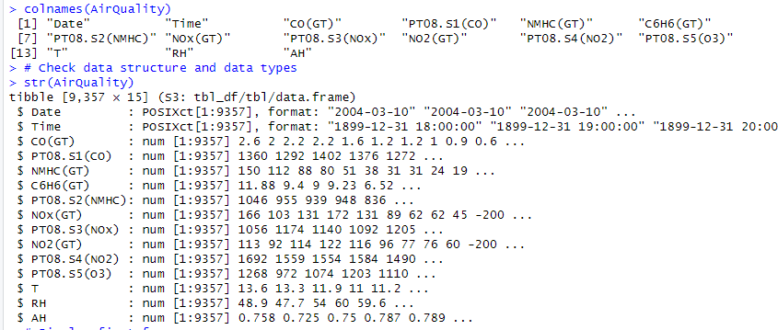
Figure 1: Initial Data overview
(Source: RStudio)
Cargo has a few important pollutant variables, such as carbon monoxide (CO), nitrogen dioxide (NO₂), nitrogen oxides (NOx), and benzene (C6H6). Carbon monoxide is mostly formed during incomplete combustion processes, in particular, automobile emissions. Traffic and industrial activities have the tendency of generating nitrogen dioxide and nitrogen oxides, and benzene is the volatile organic compound that is formed because of burning fuel and industries. These pollutants can be analyzed and understood to identify the trends of air pollution in cities and the potential source of the emission.
The sensors are also present in the dataset, which is PT08.S1(CO), PT08.S2(NMHC), PT08.S3(NOx), PT08.S4(NO2), PT08.S5(O3), and meteorological parameters, such as temperature and relative/absolut humidity. In data preparation the NA was taken to fill the -200 values that were missing measurements. Additionally, the distinct date and time variables were merged into a DateTime variable to permit a time-based analysis. The dataset was properly data-cleaned so that it was fit to statistical analysis.

3. Exploratory Data Visualisation
Time Series Analysis of Pollutants
Time series plots were used to analyse the behaviour of two primary polluters, one of them being carbon monoxide (CO) and the other nitrogen dioxide (NO₂). The visualisation of time series also complies very well with environmental data because the levels of pollutants in the air often vary within the hours, days, and seasons. Plotting the levels of pollutants versus time, it becomes possible to observe the fluctuations and get the understanding of what trends can be observed or the patterns can be defined as irregular.
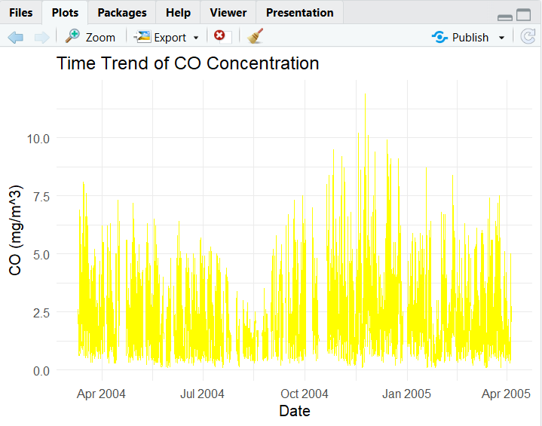
Figure 2: Time trend of CO
(Source: RStudio)
The formation of time series plot of the analysis suggests that the concentration of pollutants varies significantly within the monitoring period. As an example, the CO quantities change in different periods of time and it implies the change in the emission levels or the environmental conditions. Traffic jams, industrial activities, or atmospheric conditions where the dispersal of pollutants takes place can influence these changes. Similarly, the time series plot of NO 2 is also able to demonstrate the fluctuating pattern over time, which means that urban air pollution is a dynamic constituency.
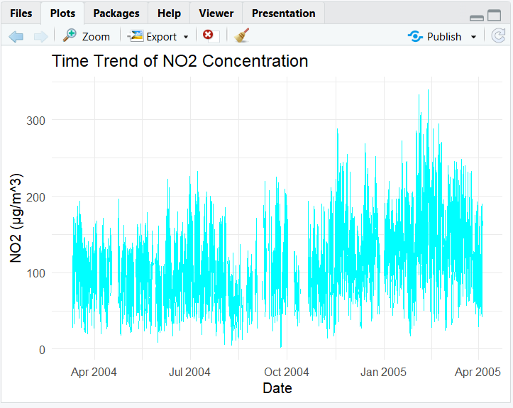
Figure 3: Time trend of NO2
(Source: RStudio)
Visualisations such as these are handy since they provide a big picture of how the levels of pollutants change with time and allow a researcher to indicate the periods in which the level of pollution was extraordinary. Such temporal patterns play an important role regarding the behaviour of air pollution and the identification of the potential environmental or human factors that can influence the concentration of pollutants.
Scatterplots of Pollutants and Meteorological Variables
The Pearson correlations between the meteorological conditions, as well as the pollutant concentrations, were examined with the help of scatter plots. There were two relationships that were examined: the CO concentration and temperature and the NO₂ concentration and relative humidity. Scatterplots find their application in the analysis of a relationship between two continuous variables because the researcher can easily determine the presence or absence of a relationship between the two variables through the visual process.
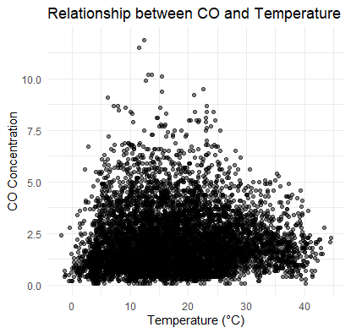
Figure 4: Relationship between CO and Temperature
(Source: RStudio)
To establish the correlation that exists between the temperature and the CO levels, the correlation between the temperature and the CO was analyzed using the scatterplot of CO Vs temperature. Atmospheric chemical reactions and the dispersion of the pollutants may depend on the temperature and may alter the levels of pollutants. Similarly, the relative humidity against NO₂ scatterplot was plotted to examine the hypothesis of whether the level of humidity influences the concentration of nitrogen dioxide.
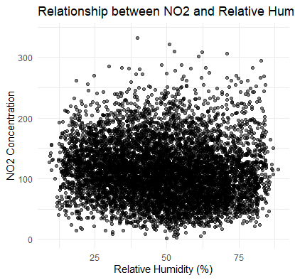
Figure 5: Scatterplot of NO₂ vs relative humidity
(Source: RStudio)
The scatter plots that were drawn during this analysis prove that there appears to be quite a weak correlation between these variables and no linear tendency is found in the data. It means that temperature and humidity may be indirectly influenced on these pollutants’ concentrations in the data.

4. Correlation Analysis
The strengths of relationships between some of the major air pollutants in the dataset and their direction were established using correlation analysis. Correlation analysis can also be applied in the analysis of the environmental data as it assists in determining whether various forms of pollution are likely to go up or down. The information on these correlations would give hints on probable common causes of the emissions, or common environmental causes of the magnitude of the pollutants.
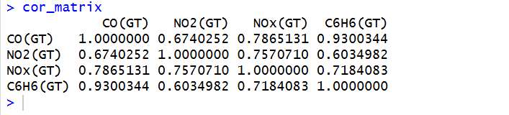
Figure 6: Correlation matrix
(Source: RStudio)
The correlation analysis used in the study focused on four variables of pollutants, namely carbon monoxide (CO(GT)), nitrogen dioxide (NO 2 (GT)), nitrogen oxides (NOx(GT)) and benzene (C6H6(GT)). The reason these pollutants were selected is because they are generally associated with the air pollution in cities and are typically produced by similar sources that include the traffic emissions and combustion. Pearson correlation coefficient was used to determine the relationship between two continuous variables that established the correlation matrix, which measures the linear relationship between the two 2023 variables. The coefficient is between -1 and +1 with the value close to +1 representing very strong positive relationship, value close to -1 representing very strong negative relationship, and value close to 0 representing little or no linear relationship.
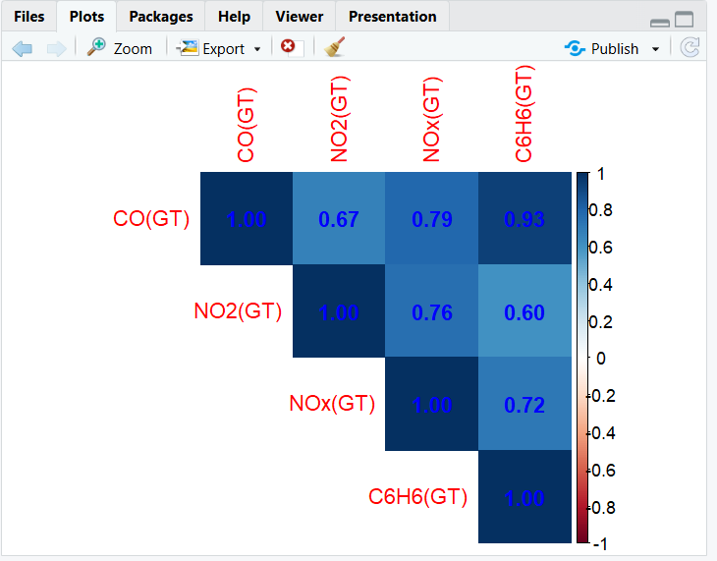
Figure 7: Correlation Heatmap
(Source: RStudio)
The outcome of the correlation analysis shows that the pollutants have several strong positive relationships. CO(GT) and C6H6(GT) had the greatest correlation with a correlation coefficient of 0.93. It is a very strong positive correlation, which implies that these pollutants are bound to increase. This association is likely to occur since the two pollutants are widely generated by the burning process most notably the automobile emissions.
Another notable correlation was between CO(GT) and NOx(GT), the coefficient was 0.79 and between NOx(GT) and NO 2(GT) that was 0.76. Such results suggest that carbon monoxide and pollutants containing nitrogen may have the same sources of emission, such as traffic, and industrial combustion. Furthermore, CO(GT) had a moderate positive relationship with NO₂(GT) of 0.67 that also leads to the fact that these two pollutants belong to the same processes of emissions.
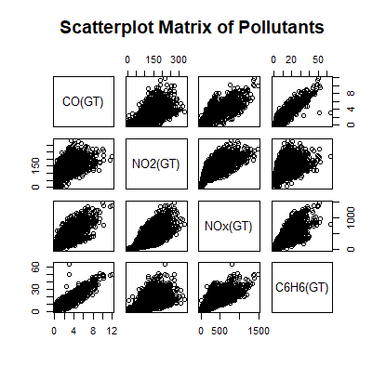
Figure 8: Scatterplot matrix of Pollution
(Source: RStudio)
The visualisation of correlation results was done using correlation heatmap that provides a graphical representation of the relationship between the variables. The darker the colours in the heatmap, the stronger the correlations and therefore, the patterns can be identified within a very short time. Pair-wise relationship visual analysis between the pollutant variables was also carried out by coming up with a scatterplot matrix.

5. Hypothesis Testing
To verify the hypothesis, the authors tested the hypothesis that temperature conditions can significantly affect the amount of carbon monoxide (CO) in the data. Statistical hypothesis testing is one of the relevant procedures to discover whether the obvious variance between groups is statistically significant or could have occurred because of chance. The significance of the CO level in different temperature conditions was compared using a Welch two sample t-test in the analysis.
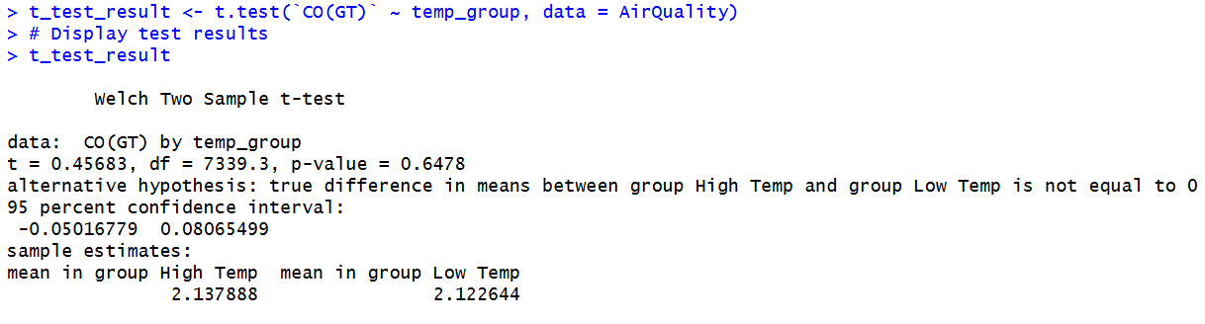
Figure 9: T-Test Results
(Source: RStudio)
To perform the analysis, the dataset was divided into two based on the value of temperature. To classify the temperature into two sequences, high temperature and low temperature, median split technique was used. The values that exceeded the median were considered as High Temp, and those that were below the median value were regarded as Low Temp. This grouping allowed the comparison of the averages of the CO concentration in the two temperature conditions.
The following were the test hypotheses:
- Null hypothesis (H₀): The mean CO levels are equal under high and low temperature conditions.
- Alternative hypothesis (H₁): The means of the CO levels in the high and the low temperature conditions differ.
A Welch two-sample t-test was selected because it is appropriate to use in the event of comparing the means of two independent samples, particularly when it is not known that the two variables have the same variance. The test is frequently used in statistical analysis when two numbers are compared.
The results of t-test provided a t-value of 0.4619 and a p-value of 0.6442. The null hypothesis cannot be rejected since the p-value is far greater than the standard level of significance, 0.05. This means that CO level is not statistically different in the high temperature group and low temperature group.
The concentration of CO of the high temperature group had an average of 2.1379 and that of the low temperature group was 2.1225. This difference between these values is very small, which also proves the assumption that the temperature is not a strong variable in the concentration of CO in this sample.

6. Seasonal Group Comparison (ANOVA)
Other than testing the impacts of temperature, the study also included examination of the occurrence of different levels of carbon monoxide (CO) on different seasons. The fact that weather conditions, the atmosphere circulation, and human activity may fluctuate throughout the year makes air pollution seasonal. To test this, a one-way analysis of variance (ANOVA) of seasonal group was conducted.
The dataset was separated into four seasons based on the value of date variable in terms of the month. The categories used in the analysis were seasonal which included Winter, Spring, Summer and Autumn. The distribution of the observations was relatively balanced as there were 2160 observations in Winter, 2805 in Spring, 2208 in Summer and 2184 in Autumn. The data contained by this distribution is sufficient to perform reliable statistical comparison of the seasonal groups.
The hypotheses of ANOVA tests were as follows:
- Null hypothesis (H₀): The mean CO levels are equal across all seasons.
- Alternative hypothesis (H₁): A season is present with which the seasonal mean of CO is different.
The justification behind the use of the one-way ANOVA is that it was meant to compare the means of more than two groups. ANOVA can compare different categories simultaneously, as compared to the t-test that compares 2 groups.
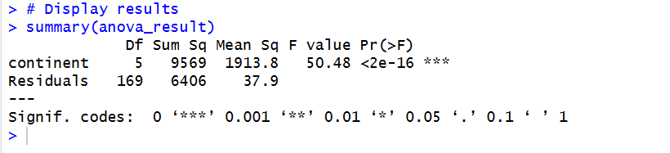
Figure 10: Anova Results
(Source: RStudio)
The obtained results of the ANOVA test show that F-value is 106.3 and p-value is less than 2 × 10⁻¹⁶, which is much less than the typical significant 0.05. This indicates that the difference of the CO levels between the seasons is highly statistically significant and this makes the null hypothesis rejected.
The above findings suggest that seasonal factors influence CO concentrations within the dataset to a large extent. Seasonal changes in air pollution can be caused by several factors. Using the example, in colder seasons, the amount of pollution may be more due to the more intensive heating and the absence of the dispersion of the atmosphere.
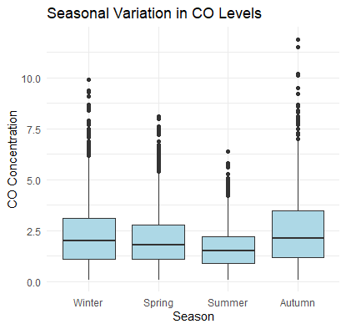
Figure 11: The Distribution of CO Levels
(Source: RStudio)
The results were also visualised using a boxplot to indicate how the four seasons were distributed with regards to CO levels. The boxplot can help to explain the difference in median, variability, and potentially outliers of each of the seasonal groups. These differences provide to the results of statistical tests and are more helpful to understand the patterns of seasonal pollution.

7. Summary of Findings
In the current analysis air pollution trend was examined using the AirQualityUCI data set containing 9, 357 hourly data. Exploratory visualisations revealed that the concentration of the pollutants was varying over time, and that the pollutants and meteorological variables such as temperature and humidity had low correlations. The results of correlation analysis showed a strong positive correlation between most of the pollutants, in particular, the correlation between CO and benzene implying the potential origin of common sources of emissions to encompass, traffic and combustion processes. The hypothesis was tested and it has been demonstrated that the temperature difference does not significantly affect the concentrations of the CO. However, seasonal analysis through ANOVA was able to show that the difference in CO level across the seasons was statistically significant to show that the seasonal environmental factors have a strong influence on air pollution pattern.

Task 2 – Reflective Summary
In this project, I developed a R script that analyzed the AirQualityUCI dataset and determined the patterns in the air pollutant measurements. The main aim of the analysis was to get to know about the relations between different pollutants, study how environmental factors may justify the level of pollutants, and test the subsequent hypotheses with the use of statistical tools. It is through this process that I was able to get practical experience on R data exploration, visualisation and statistical analysis.
Another important element of the analysis was visualisations to get to know better the data. I prepared a time series plot to examine how carbon monoxide (CO) and nitrogen dioxide (NO₂) concentrations varied with time. I have chosen time series plots because the data set has a time dimension, which is measured every hour and, therefore, it becomes feasible to trace the variations and changes in time with regards to pollutant levels. The visualisations allowed me to conclude that the levels of the pollutants are dynamic and can be influenced by the external variables, such as human activity or environmental factors. I have also been able to use the scatterplots to investigate the relationship between the pollutants and the meteorological variables i.e. CO and temperature and (NO₂) and relative humidity. Scatterplots were also appropriate because they allow visualising correlation between two continuous variables. These visualisations also enabled me to conclude that certain pollutants, in this case, the CO and benzene are highly correlated.
There were several issues that I encountered when working with the dataset in the analysis. One of the big issues was that value -200 was shared across several variables to show that the dataset is gap analysis or invalid measurements. To start with, these values distorted the summary statistics and could have affected the results of the analysis. To address this issue, all the values that were -200 were transformed into NA to be regarded as values that are not found in statistical analysis. The date and time variables were the other issue. The data set was made to store date and time in the various columns and I had to combine them together in one DateTime variable to make time series analysis easier. The evolution of this variable added to the fact that the visualisation and the time analysis could be performed in appropriate way. These issues also helped me to understand that data should be cleaned and preprocessed before statistical analysis.
The second significant detail of the project was a series of statistical tests that should be held to explore the specific research questions. The welch two sample t-test was used to find out whether there was any difference in the concentration of carbon monoxide under high and low temperature. The results indicated that there was no significant difference in the level of CO between these two groups. On the other hand, I used one-way ANOVA test to investigate the seasonal differences in CO concentrations. The results showed that there was a statistically significant shift in seasons that meant that the level of pollutants could be predetermined by environmental conditions in season.
I would also consider using more advanced means of analysis in the future in my work in case I expand this analysis. Regression models can be used as one example to determine the impact of a combination of environmental factors on the concentration of pollutants simultaneously. Second, time series modelling can be used to identify the long-term trends and seasonal changes in air pollution data. One can also study machine learning strategies that can make an estimate of the level of pollutants based on weather condition.

