Build, deploy, configure and manage a Type 2 Hypervisor platform based Virtualised network

Worksheet 4 – Routing and Packet Filtering Within Core TCP/IP Services and Critical Failover/Redundancy Practices

Donna Wright
Network Operating Systems and Services
1808260@student.uwtsd.ac.uk

Contents
Introduction 3
Task 1 4
Task 2 5
Task 3 7
Task 4 9
Annex A 10
Annex B 13
Annex C 23
Annex D 32

Introduction
The purpose of this assignment is to incorporate routing and remote services.

Task 1
For task 1 the author was required to utilise ARP and Routing Tables. Screenshots can be found in annex A.

Task 2
For this task the author was tasked with deploying core services. Screenshots evidencing the work undertaken can be found in annex B.

Task 3
For task 3 the author was required to install and configure the routing and remote access service. Screenshots can be found in annex C.

Task 4
For task 4 the author was required to complete IP packet filtering. Screenshots can be found in annex D.

Annex A
Utilising ARP and Routing Tables
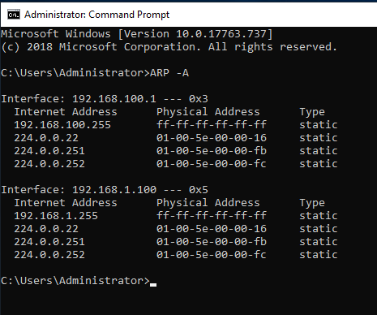
Attempted pings to 192.168.1.100 were successful
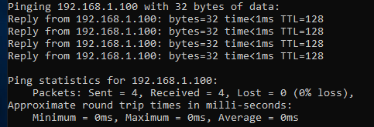
Attempted pings to 192.168.100.2 were timed out
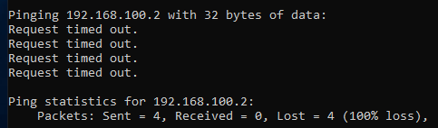
Attempted pings to 192.168.1.101 received destination unreachable
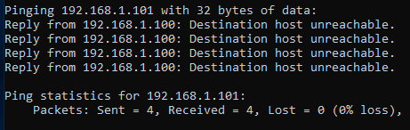
Attempted pings to 192.168.101.1 received general failure
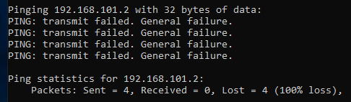
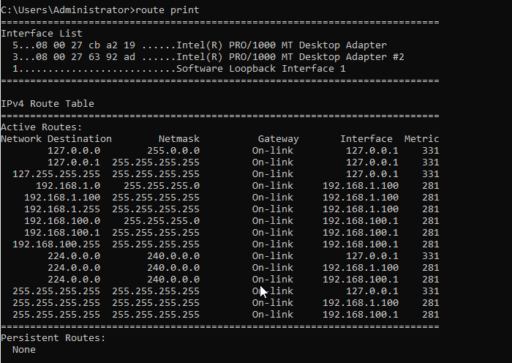
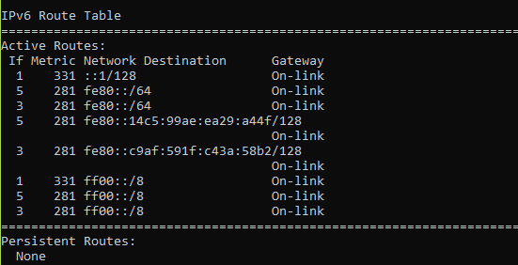

Annex B
Task 2: Deploy core services (FTP server)
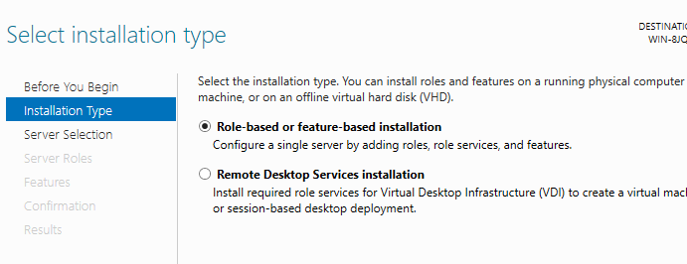
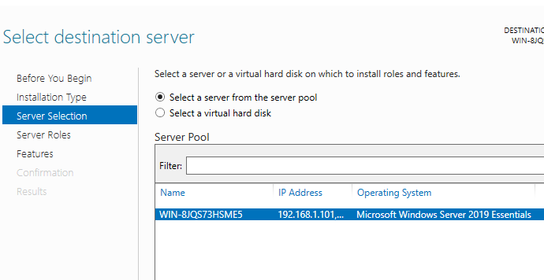
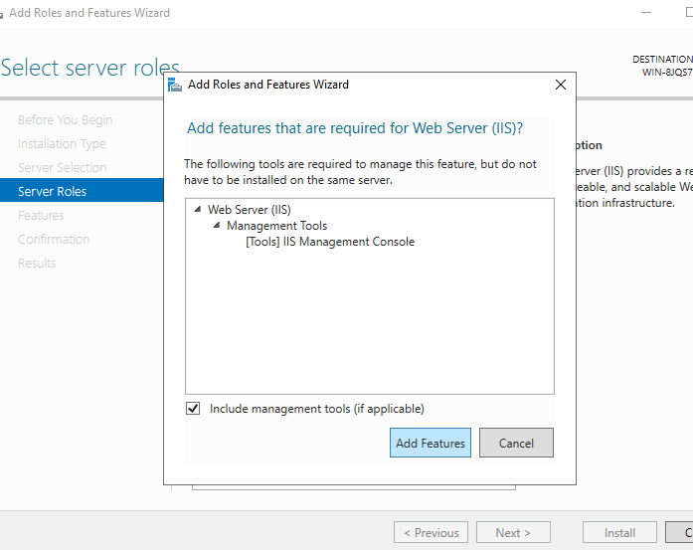
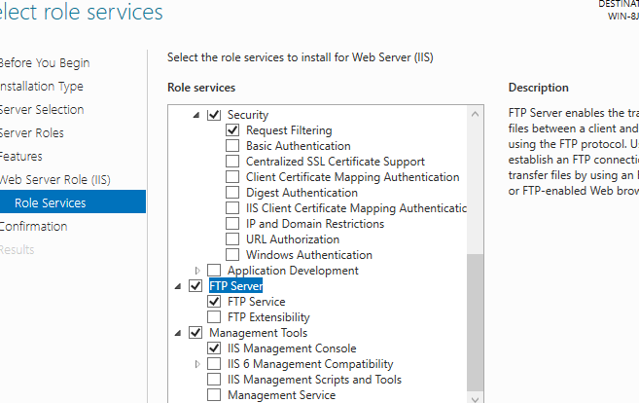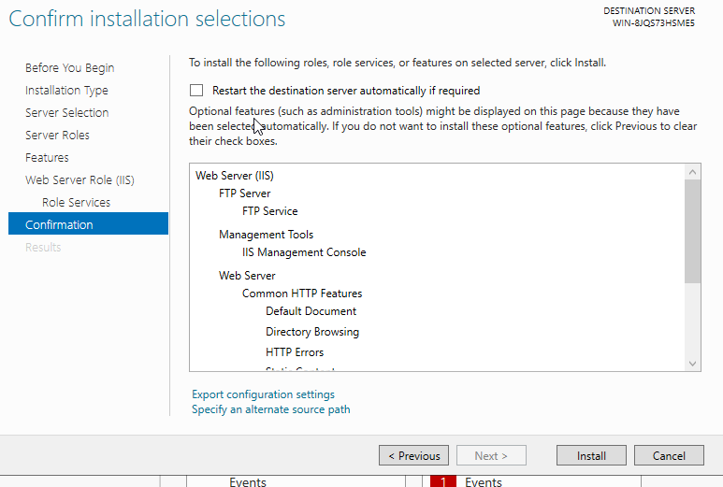
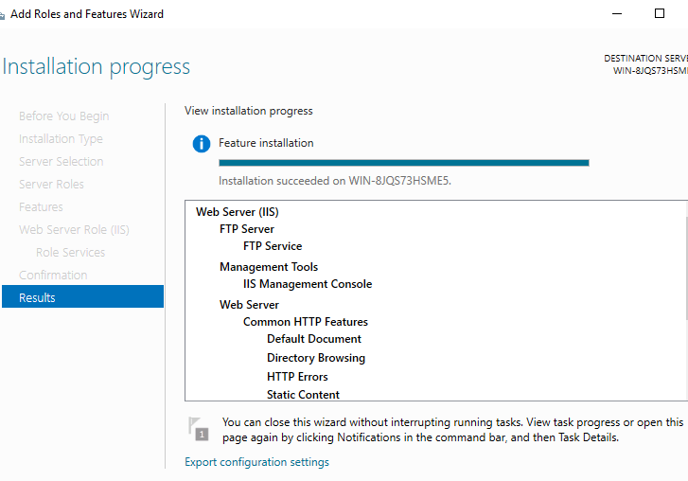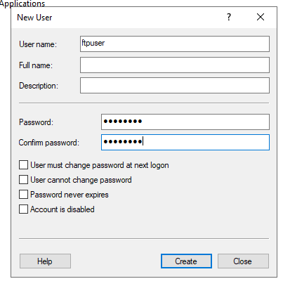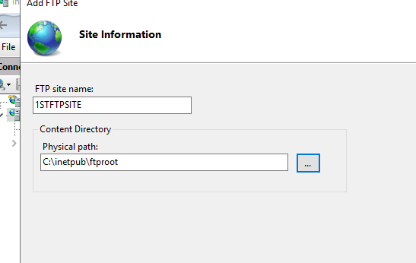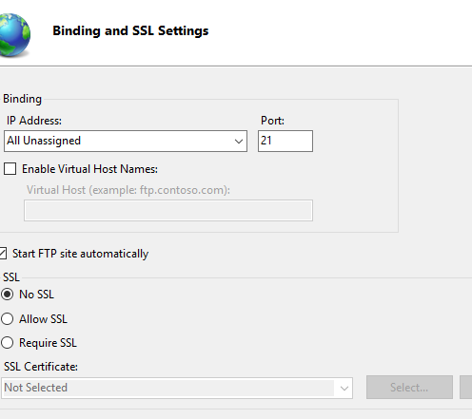
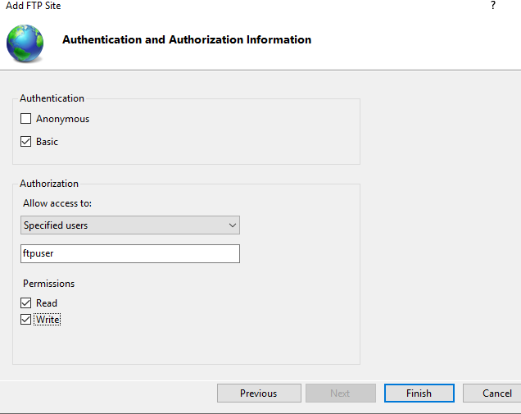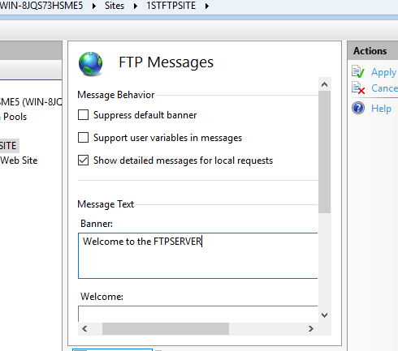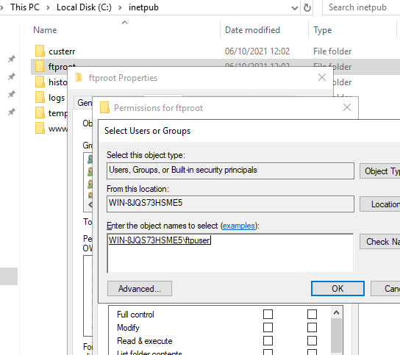
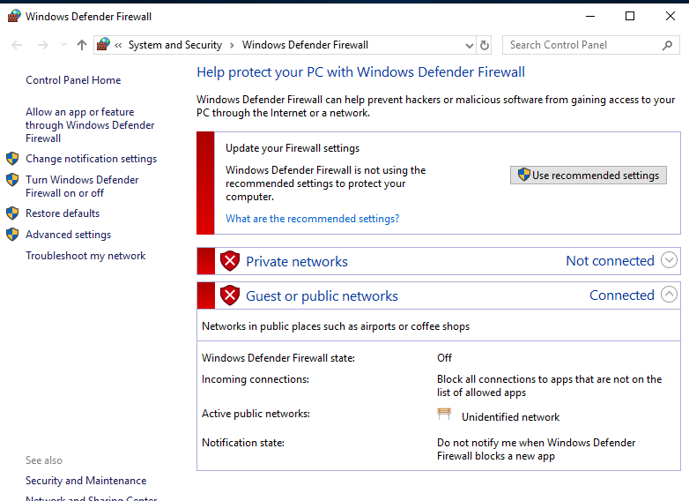
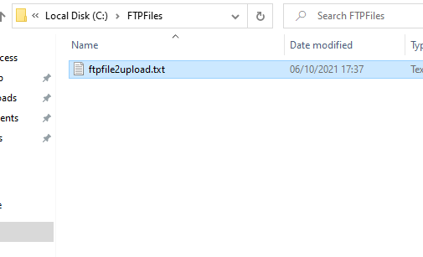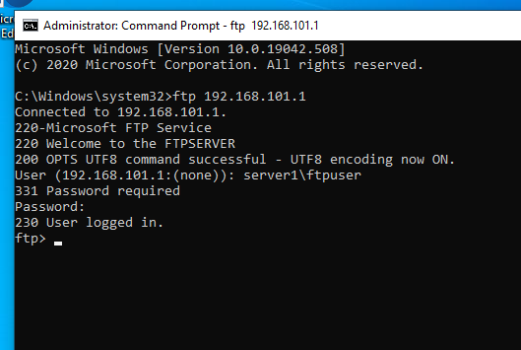
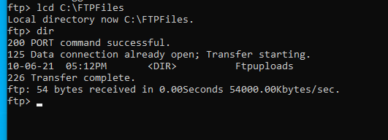
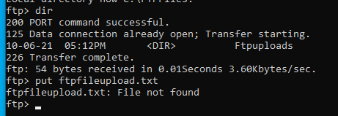
Attempts to upload the file as directed failed as the file could not be found.

Annex C
Task 3: Installing and configuring the routing and remote service
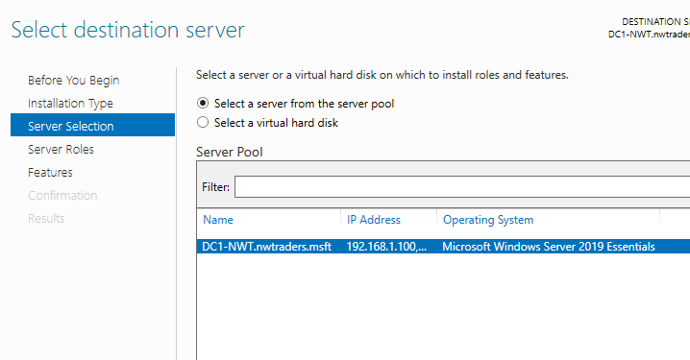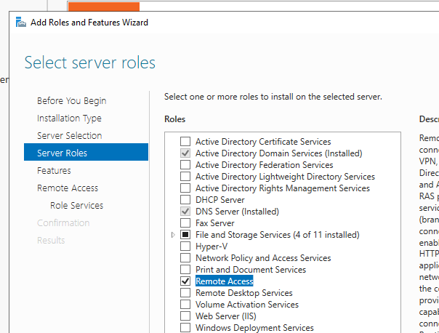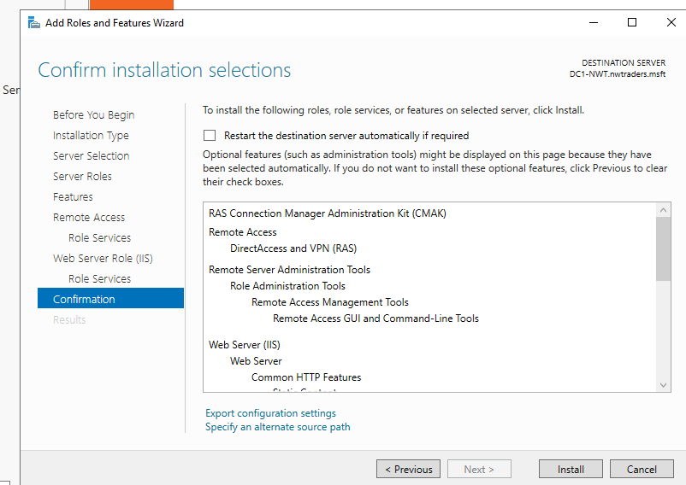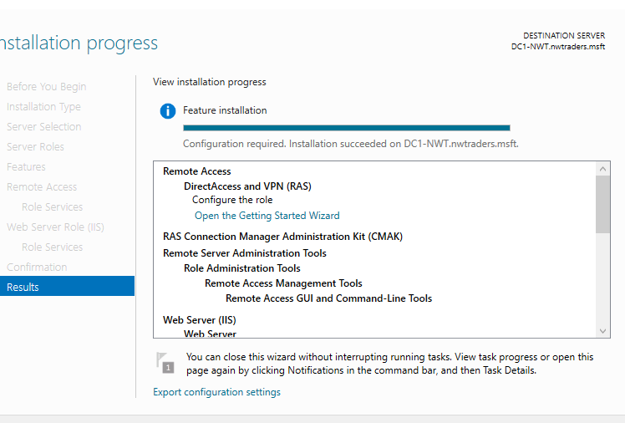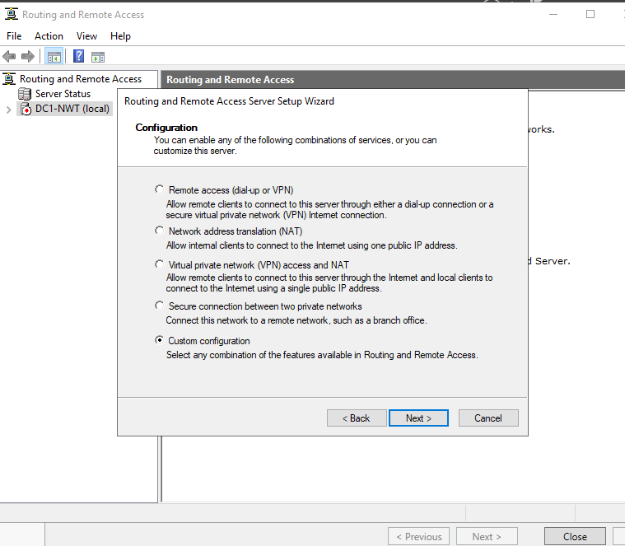
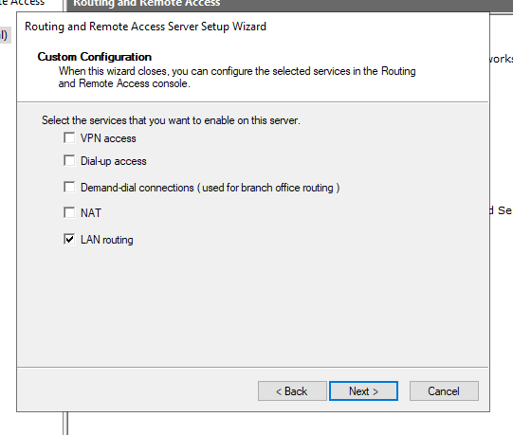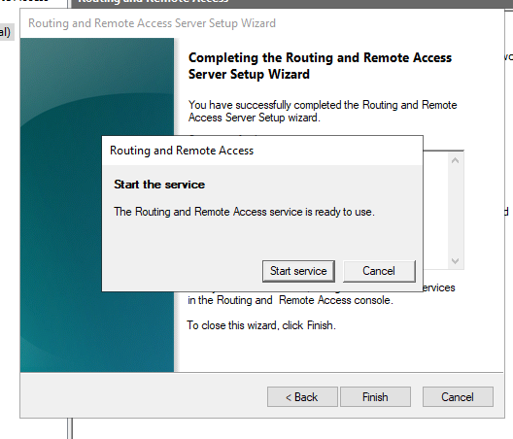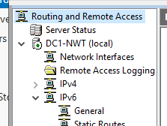
RIP V2 was not an available protocol only DCHP Relay Agent
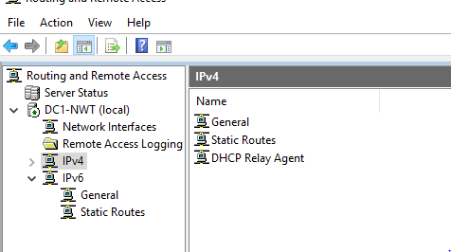
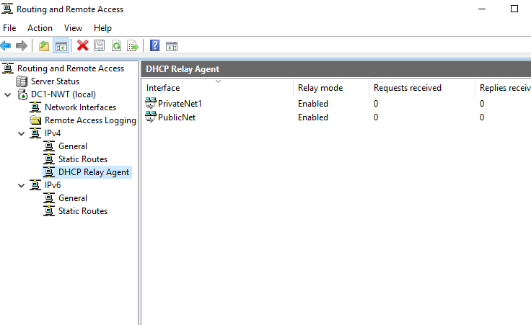
On server 2
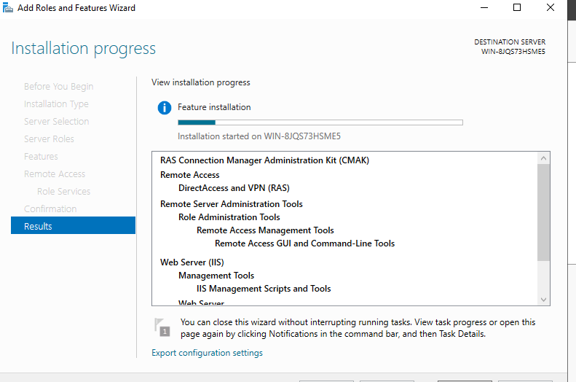
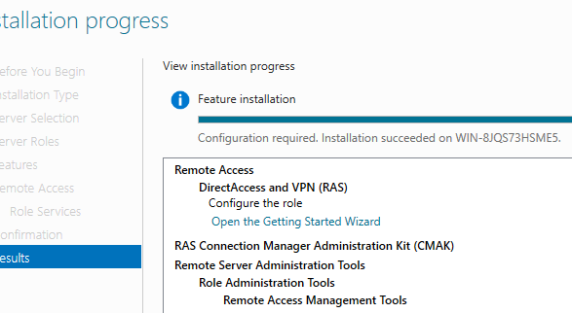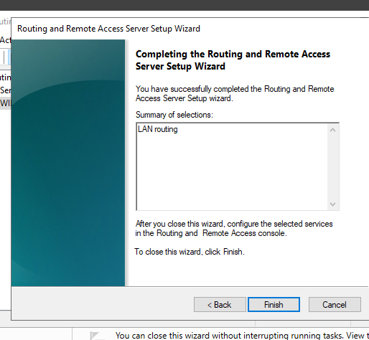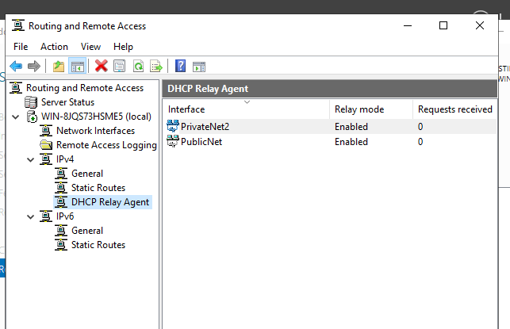
Server 1 can now ping server 2’s PublicNet IP
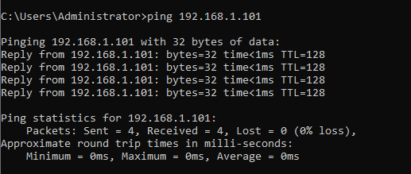

Annex D
Task 4: IP Packet Filtering


