ACDA6020 LAB #1

FTIR Analysis and Identification of Organic Materials
Max Fisher
2113637

Contents
ACDA6020 LAB #1 1
FTIR Analysis and Identification of Organic Materials 1
Introduction 2
Background 2
Method 2
Results 4
Sample A 4
Sample B 6
Sample C 9
Sample D 11
Conclusions 14
References 14

Figure 1 Sample A 4
Figure 2 Ascorbic Acid Structure 5
Figure 3 Ascorbic Acid Reference Spectra [2] 6
Figure 4 Sample B spectra 6
Figure 5 Guanidine Nitrate structure 7
Figure 6 Guanidine Nitrate Reference Spectra [4] 8
Figure 7 Sample C Spectra 9
Figure 8 Methyl 3-nitrobenzoate structure 10
Figure 9 Methyl 3 nitrobenzoate reference spectra [5] 11
Figure 10 Sample D spectra 11
Figure 11 Acetaminophen structure 13
Figure 12 Acetaminophen reference spectra [6] 13

Table 1 Sample A Identified peaks 4
Table 2 Ascorbic acid functional groups 5
Table 3 Sample B Peaks 7
Table 4 Guanidine Nitrate functional groups 7
Table 5 Methyl 3 Nitrobenzoate functional groups 10
Table 6 Acetaminophen functional groups 13

Introduction
This report will highlight compounds detected from 4 samples recovered from an facility researching new energetic formulation. The samples were believed to be common laboratory or industrial chemicals which require specific identification before processing and disposal. The following report will explain the methods used to identify these samples providing the likely matches.

Background
The samples provided were recovered in plastic containers and transported to the ordnance munitions an explosives lab at the University of Wales Trinity Saint David SA1 Campus.

Method
Equipment and software used:
FT-IR spectrometer (Perkin Elmer Spectrum 2)
FT-IR surface plate: (Perkin Elmer UATR 2)
Desktop computer with ‘Spectrum IR’ Software.
Small Plastic Weighing boat (x4)
Metal Spatula (x1)
Safety Googles (x1)
Nitrile Gloves (x4)
Isopropyl alcohol (for cleaning)
Paper Towel (for cleaning)

Before undertaking any tasking, first gloves and safety goggles were donned.
A small sample was first decanted from its recovery container into a small plastic weighing boat; this was done using a metal spatula.
Next the FTIR instrument was prepared for use by cleaning the sample area (the spectrometer used had a diamond crystal). This was done by flushing the crystal with Isopropyl alcohol (IPA) and wiping with Paper towel, ensuring that the surface was free from contamination.
Using the computer control software, a background check was conducted to ensure than any residues remaining from the IPA would not significantly influence the results. To that extent the software was set to conduct 15 scans. It is important to conduct the same number or greater of background scans before conducting sample scans. The Spectral range set for these scans was 4000-4450cm⁻¹
A small quantity of each sample was then placed onto the sensor, covering it completely to ensure that the material would be fully exposed to the laser.
Now that the sample was in place, the FTIR head was lowered using the ratcheting knob. It was tightened until the ratchet head clicked. This indicates the appropriate force is applied to the sample, without overstressing any components.
Using the computer 15 sample scans were then conducted again using the 4000-450cm⁻¹ spectral range. The software averaged the results of the 15 scans to create a single graph, but no other smoothing methods were used. The use of multiple scans reduces the effect of the samples physical properties such as reflectivity on the FTIR results, enabling more accurate identification.
The file generate was compared with an inbuilt spectral database which the author of the report does not currently have access to. This provisionally identified each material. However, the following section will detail the full identification process used. The file was then saved with the following convention: SampleX_Tester_Tester.csv
Finally, the sensor was again cleaned using the IPA and the small sample disposed of in the appropriate bin.
This was repeated for each of the four recovered samples.

Results

Sample A
Figure 1 shows the spectra generated for sample A. The peaks identified can be found in Table 1
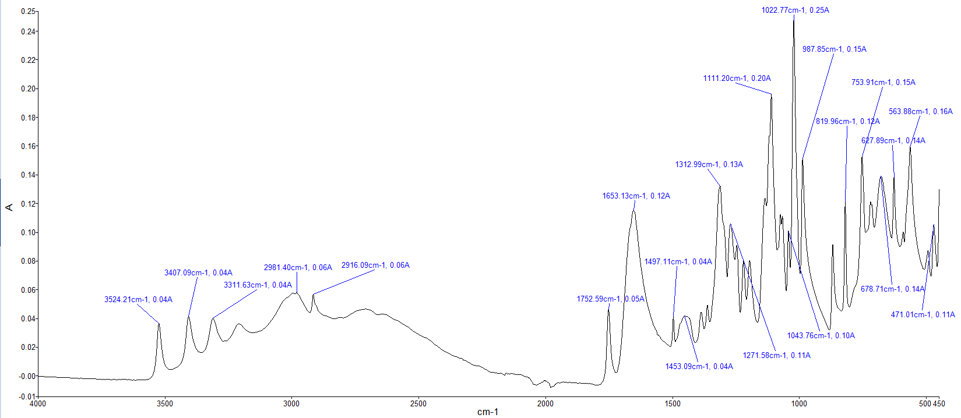
Figure 1 Sample A
Table 1 Sample A Identified peaks
Peak Wavenumber | Amplitude | Possible bonds | note
3524 | 0.04 | O-H / N-H | Broad peak between 3550-2000cm⁻¹
3407 | 0.04 | O-H / N-H | Broad peak between 3550-2000cm⁻¹
3312 | 0.04 | O-H / N-H / O-H / C-H / =C-H | Broad peak between 3550-2000cm⁻¹
2981 | 0.06 | O-H / N-H / C-H | Broad peak between 3550-2000cm⁻¹
1753 | 0.05 | C-H / C=O | sharp separate peak
1653 | 0.12 | C-H / C=O / C=N / C=C / N-H | Mostly sharp peak
1497 | 0.04 | N-O / C=H | Smaller peaks with bases merging
1453 | 0.04 | C-H / O-H | Smaller peaks with bases merging
1313 | 0.13 | O-H / C-F / S=O / C-N / C-O | Larger peak with bases merging further
1272 | 0.11 | C-F/ C-N / C-O | Larger peak with bases merging further
1111 | 0.20 | C-F / C-N / C-O | Sharp peak
1023 | 0.25 | C-F / C-N / S=O / CO-O-CO | Largest peak detected on spectra very narrow
1044 | 0.10 | C-F / C-N / C-O/ S=O/ CO-O-CO | Small peak between lulls of surrounding large peak
988 | 0.15 | C-F / C=C/ =C-H | Sharp narrow peak
820 | 0.12 | C=C / C-H / C-Cl | large sharp peak
753 | 0.15 | C-H/ C-Cl | Several peaks with bases merged.
679 | 0.14 | C=C / C-H / C-Br / C-Cl | Several peaks with bases merged.
628 | 0.14 | C-Br/ C-Cl | Several peaks with bases merged.
564 | 0.16 | C-Br / C-I / C-Cl/ M-O | Several peaks with bases merged.
471 | 0.11 | M-O | Smaller peak
In ascorbic acid there is several types of functional groups as can be seen in Figure 2. There is Hydroxyl groups (-OH), Carbonyl group (-C=O) and an cyclic ether group (lactone) (-O-), these have the following IR response:
Table 2 Ascorbic acid functional groups
Functional Group | IR Band | Notes | Presence
Hydroxyl (carboxylic acid) | 3000-2500 [1] | Broad stretch | Yes
Carbonyl | 1780-1710 |  | Yes
Lactone | 3600-3000;1750-1730; 1200-1000 |  | Yes
From the functional groups above as well as the similarity of the reference spectra (Figure 3) it is likely that the sample A is ascorbic acid.

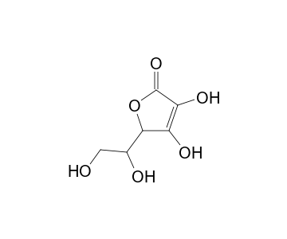
Figure 2 Ascorbic Acid Structure
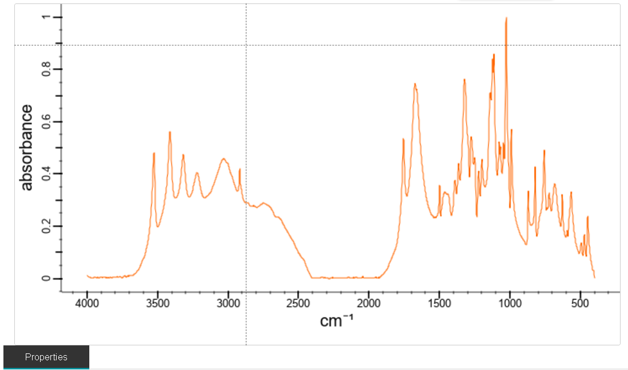
Figure 3 Ascorbic Acid Reference Spectra [2]

Sample B
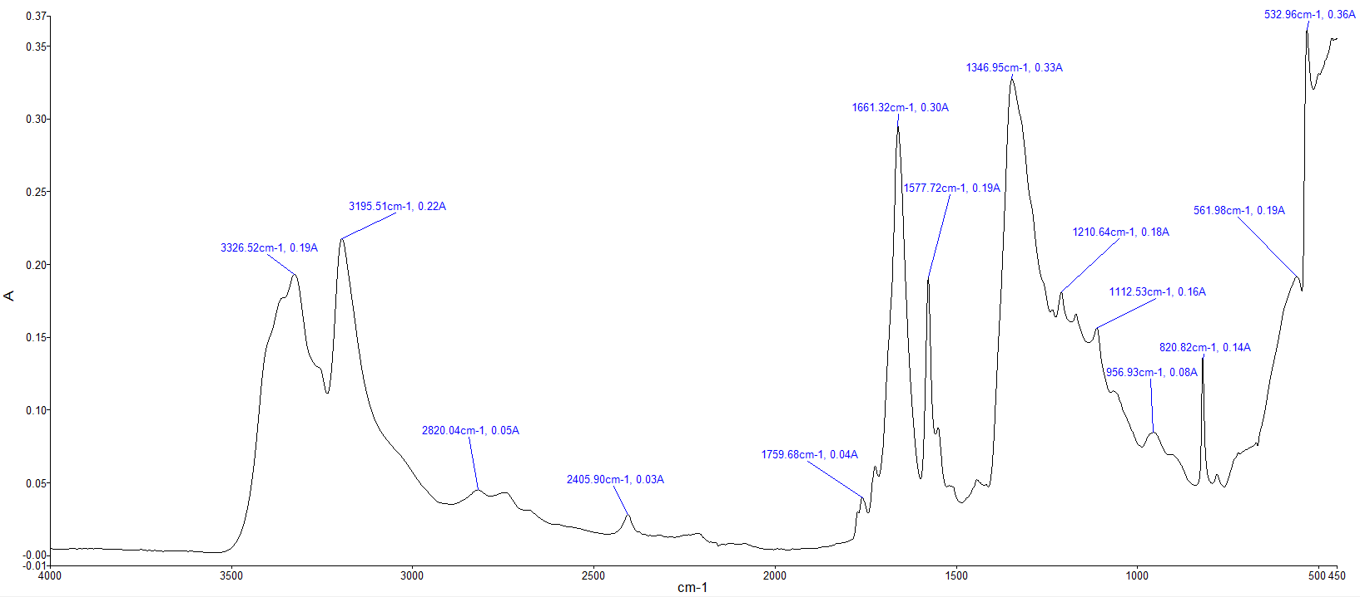
Figure 2 shows the spectrum of sample B. The peaks identified can be seen in Table 2.
Figure 4 Sample B spectra

Table 3 Sample B Peaks
Peak Wavenumber | Amplitude | Possible Bonds | Notes
3327 | 0.19 | O-H / N-H / C-H / =C-H | Large peaks with merged base
3196 | 0.22 | O-H | Large peaks with merged base
2820 | 0.05 | O-H / N-H / C-H | Very small peaks over wide area, almost negligible
2406 | 0.03 | - | Very small peaks over wide area, almost negligible
1760 | 0.04 | C-H / C=O | Very small peaks over wide area, almost negligible
1661 | 0.30 | C-H / C=O / C=N / C=C / N-H | Sharp peak
1578 | 0.19 | N-H / C=C | Sharp peak
1347 | 0.33 | O-H / C-F / S=O / C-N | Large peak with merged base
1211 | 0.18 | C-F / C-O / C-N | Smaller peak with merged base
1112 | 0.16 | C-F / C-N / C-O | Smaller peak with merged base
957 | 0.08 | =C-H / C=C | Small peak wide base
821 | 0.14 | C=C / C-H / C-Cl | Sharp peak
562 | 0.19 | C-Br / C-I / C-Cl M-O | Large peaks with wide base
533 | 0.36 | C-Br/ C-I / C-Cl / M-O | Large peaks with wide base

The functional groups of guanidine nitrate are as follows: amino group (NH₂) primary amine / (NH) secondary amine with two NH₂ groups and a single NH group.
Table 4 Guanidine Nitrate functional groups
Functional group | IR response | notes | Presence
Primary Amine | 3400-3500 [3] | Two distinct peaks | Yes
Secondary Amine | 3420 | Single peak | Possible
Table 4 shows that the NH₂ group can be seen, but that the secondary amine is mostly hidden by the primary amine, as there is significant overlap in the IR response. When comparing the spectra recorded with the reference spectra (Figure 6) it can be seen that these is a good match. Therefore sample B is likely Guanidine nitrate.
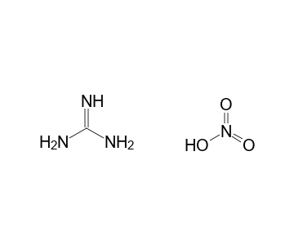
Figure 5 Guanidine Nitrate structure

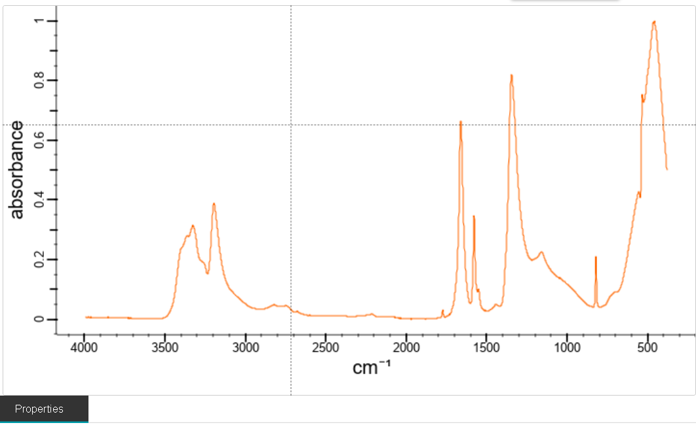
Figure 6 Guanidine Nitrate Reference Spectra [4]

Sample C

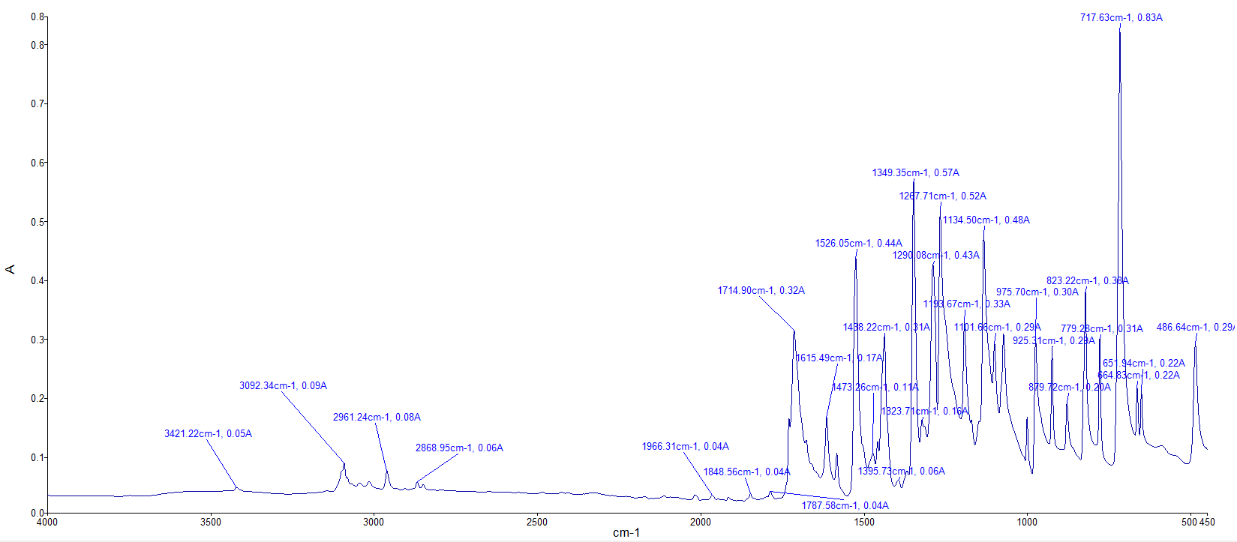
Figure 7 Sample C Spectra

Peak Wavenumber | Amplitude | Potential Bonds | Notes
3421 | 0.05 | O-H | Small narrow peaks
3092 | 0.09 | C-H / O-H | Small narrow peaks
2961 | 0.08 | O-H/ N-H / C-H | Small narrow peaks
2869 | 0.06 | O-H / N-H / C-H | Small narrow peaks
1966 | 0.04 | C=C=C / C=C=N / C-H | Small narrow peaks
1848 | 0.04 | C-H / C=O | Small narrow peaks
1788 | 0.04 | C-H / C=O | Small narrow peaks
1715 | 0.32 | C-H / C=O | large sharp peaks
1615 | 0.17 | C=O / C=C / N-H / C=C | large sharp peaks
1526 | 0.44 | N-O | large sharp peaks
1473 | 0.11 | C-H | large sharp peaks
1438 | 0.31 | C-H / O-H | large sharp peaks
1396 | 0.05 | C-H / O-H / S=O / C-F | large sharp peaks
1324 | 0.16 | O-H / C-F/ S=O / C-N / C-O | large sharp peaks
1349 | 0.57 | O-H/ C-F/ S=O/ C-N | large sharp peaks
1290 | 0.43 | C-F / O-H /S=O / C-N/ C-O | large sharp peaks
1268 | 0.52 | C-F/C-N/C-O | large sharp peaks
1193 | 0.33 | C-F/C-O/C-N | large sharp peaks
1134 | 0.48 | C-F/C-N/C-O | large sharp peaks
1102 | 0,29 | C-F/C-N/C-O | large sharp peaks
976 | 0.30 | C=C / =C-H | large sharp peaks
925 | 0.29 | =C-H | large sharp peaks
880 | 0.20 | C=C/ C-H | large sharp peaks
823 | 0.38 | C=C/C-H C-Cl | large sharp peaks
778 | 0.31 | C=C / C-H/ C-Cl | large sharp peaks
718 | 0.83 | C=C / C-H/ C-Cl | large sharp peaks
665 | 0.22 | C=C/C-H/C-Br/C-Cl | large sharp peaks
652 | 0.22 | C=C/ C-H/ C-BR/ C-Cl | large sharp peaks
487 | 0.29 | C-I / M-O | large sharp peaks
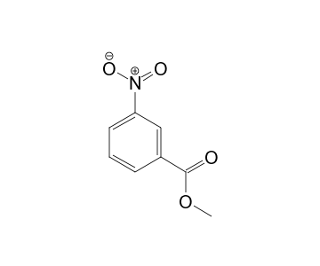
Figure 8 Methyl 3-nitrobenzoate structure
Table 5 Methyl 3 Nitrobenzoate functional groups
Functional group | IR response | notes | Presence
Ester Group | 2950 1735-1750, 1200-1300 | Sharp prominent peak | Yes
Nitro Group | 1500-1570, 1300-1370 | Two distinct strong peaks | Yes
Aromatic Ring | ~3030, 1450-1600, 690-900 | Multiple smaller peaks | Yes

From the available information of both the functional groups, and the reference spectra it is highly likely that sample 3 is Methyl 3 Nitrobenzoate. Literature describes a large number of peaks present at the lower end of the spectra, with only weak peaks present in the ~3000cm⁻¹ range. These are all present, showing a good match.
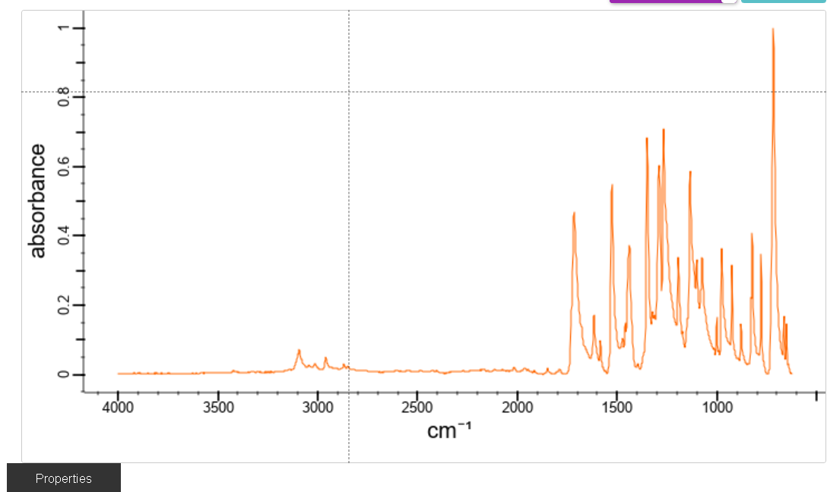
Figure 9 Methyl 3 nitrobenzoate reference spectra [5]

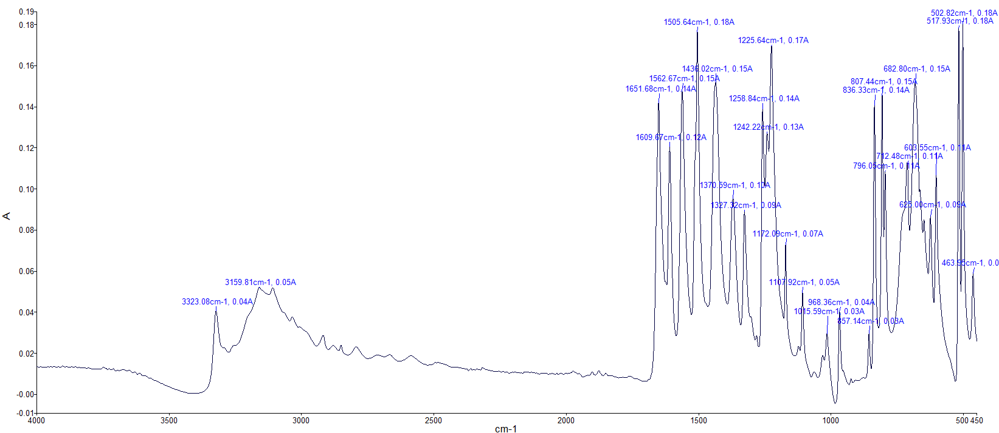
Sample D

Figure 10 Sample D spectra

Peak Wavenumber | Amplitude | Possible bonds | Notes
3323 | 0.04 | O-H / N-H/ C-H/=C-H | Broad shallow peaks
3160 | 0.05 | O-H | Broad shallow peaks
1652 | 0.14 | C-H/ C=O / C=N/ C=C / N-H | Sharp tall peaks
1610 | 0.12 | C=O /C=C/N_H | Sharp tall peaks
1563 | 0.15 | N-H/ C=C/ N-O | Sharp tall peaks
1506 | 0.18 | N-O/ C-H | Sharp tall peaks
1436 | 0.15 | C-H/O-H | Sharp tall peaks
1371 | 0.10 | C-H/O-H/S=O/C-F/ | Sharp tall peaks
1327 | 0.09 | O-H/C-F/S=O/ C-N/C-O | Sharp tall peaks
1259 | 0.14 | C-F/C-N/C-O | Sharp tall peaks
1242 | 0.13 | C-F/ C-O /C-N | Sharp tall peaks
1225 | 0.17 | C-F/C-O/ C-N | Sharp tall peaks
1172 | 0,07 | C-F/C-N/C-O | Sharp tall peaks
1107 | 0.05 | C-F/C-N/C-O | Sharp tall peaks
1016 | 0.03 | C-F/C-N/S=O | Sharp tall peaks
968 | 0.04 | C=C/=C-H | Sharp tall peaks
857 | 0.03 | C=C/C-H/C-Cl | Sharp tall peaks
836 | 0.14 | C=C/C-H/C-Cl | Sharp tall peaks
807 | 0.15 | C=C/C-Cl/C-H | Sharp tall peaks
796 | 0.11 | C=C/C-H/ C-Cl | Sharp tall peaks
712 | 0.11 | C=C/C-H/C-Cl | Sharp tall peaks
683 | 0.15 | C=C/ C-H/ C-Br/C-Cl | Sharp tall peaks
625 | 0.09 | C-Br/ C-Cl | Sharp tall peaks
604 | 0.11 | C-Br/C-I/C-Cl / M-O | Sharp tall peaks
518 | 0.18 | C-Br/C-I/ M-O | Sharp tall peaks
502 | 0.18 | C-Br / C-I / M-O | Sharp tall peaks
464 | ? | M-O | Sharp tall peaks
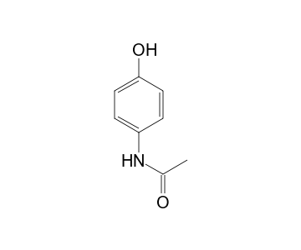
Figure 11 Acetaminophen structure
Table 6 Acetaminophen functional groups
Functional group | IR response | notes | Presence
Hydroxyl Group (phenol) | 3200-3550 | Large broad stretch | Yes
Amide Group | 3300-3400, 1640-1680,  1500-1600 | Medium peak, strong peak, multiple strong peaks | Yes
Aromatic Ring | ~3030, 1500-1600, 700-900 | Weak peaks, smaller peaks, present in fingerprint zone. | Yes

All evidence present is highly indicative of the presence of acetaminophen; the functional groups show a good match as well as the reference spectra. Therefore, the author has high confidence that sample D is likely acetaminophen (paracetamol).
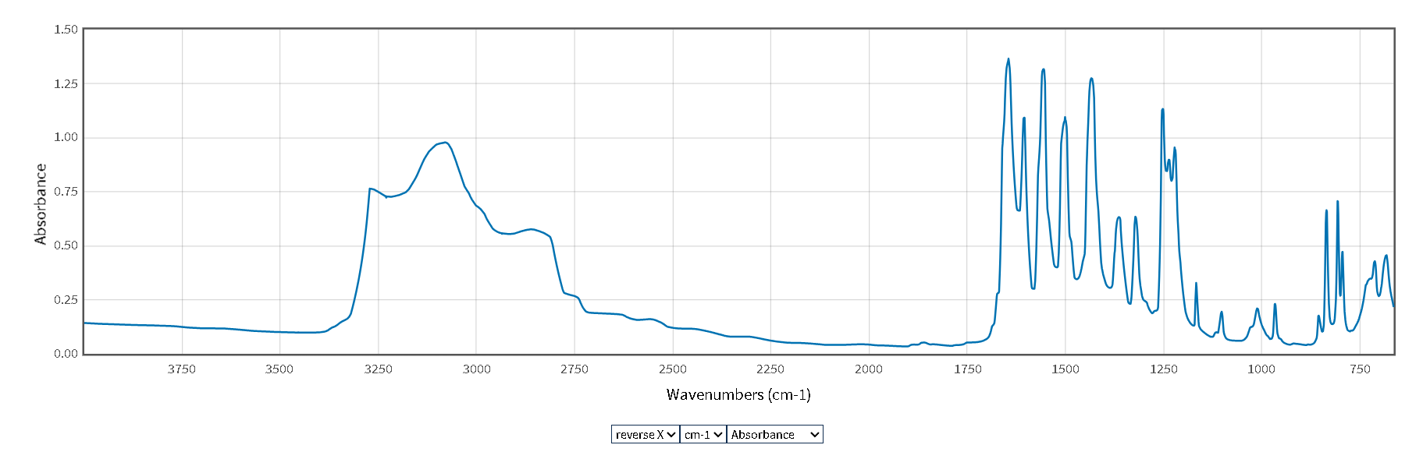
Figure 12 Acetaminophen reference spectra [6]

Conclusions
In Conclusion, FTIR has been used to identify all 4 compounds. Three of the four present near perfect matches with the available literature, with only sample 2, presenting a challenge when identifying the functional groups; but still showing a good match with the reference spectra.
FTIR is an excellent confirmatory method, that allows rapid identification of existing compounds when using libraries whilst also providing opportunities to identify new compounds from the basic principles of the bonds which make up all matter.

References

[1] | Webspectra, “Table of IR absorptions,” [Online]. Available: https://webspectra.chem.ucla.edu/irtable.html. [Accessed 16 10 2025].
[2] | E. Merck AG, Darmstadt, 1989. [Online]. Available: https://spectrabase.com/spectrum/FpAlU5XGetD.
[3] | D. K. W. R. &. L. B. Steven Farmer, “Spectroscopy of Amines,” [Online]. Available: https://chem.libretexts.org/Bookshelves/Organic_Chemistry/Organic_Chemistry_%28Morsch_et_al.%29/24%3A_Amines_and_Heterocycles/24.10%3A_Spectroscopy_of_Amines. [Accessed 16 10 2025].
[4] | Spectrochem Pvt. Ltd., “Guanidine nitrate,” 2014. [Online]. Available: https://spectrabase.com/spectrum/7haMJ08Izke. [Accessed 16 10 2025].
[5] | Ega-Chemie GmbH & Co KG, Steinheim, 1989. [Online]. Available: https://spectrabase.com/spectrum/PumGN62O9p. [Accessed 16 10 2025].
[6] | Coblentz Society, “Acetaminophen - NIST chemistry WebBook,” 1987. [Online]. Available: https://webbook.nist.gov/cgi/cbook.cgi?ID=C103902&Units=SI&Type=IR-SPEC&Index=1#IR-SPEC. [Accessed 15 10 2025].

