Penko Nedelchev (2112415)

Lecturer: Dr. Hossein Shokri
Strategic Management and Sustainability
Tesco PLC

Table of Contents
Introduction 2
Company Overview 2
Business and Corporate Strategies 3
Porter’s Generic Strategies 3
Ansoff Matrix Analysis 6
Resources and Capabilities of Tesco Company 7
Value Chain analysis 7
VRIO analysis 9
Evaluating Strategy in Action 10
SAF Framework 10
Evaluating Sustainability Efforts 10
Recommendations 11
Conclusion 11
References 12
Appendix – Swot Analysis 12

Introduction
Strategic management and sustainability are two different connected concepts that are effectively increasing in the current business environment. Strategic management includes the formulation or the implementation of long-term goals and initiatives that develop the organization's management significantly. Suitability refers to the meeting requirements of the existing markets or consumers without compromising the ability of future generations to meet their own needs. Tesco Plc is a multinational British company that has been serving in the global market as a profound player (Tesco PLC, 2024a). The company also has adopted various strategies and sustainable management, and this report will explore Tesco’s business strategies while assessing their proactive approaches for gaining competitive advantages in the markets and the suitability goals. It will include the analysis of the company’s capabilities and how the company has aligned its resources and capabilities of current business. This report will explore how Tesco manages its strategies and approaches to become competitive in the market. It will include an analysis of the company’s consideration of suitability and the environment for adapting the competitive growth in the sector.

Company Overview
Tesco is a British multinational consumer goods company that has been serving the retail sector since 1919 and was founded by Jack Cohen. The company has been offering various products such as beauty products, baby food, breakfast cereals, cleaning agents, energy drinks, etc (Tesco PLC, 2024a). The company has its head office in Tesco House, Shire Park, Welwyn Garden City, England, UK. Its stores and supermarkets are in 4,419 locations as of 2023 (Tesco PLC, 2023). The brands included in the company are Premier, Makro, Booker, Paperchase, F&F, and One Stop. It has 222 306 workers as counted in 2024. The total revenue of the organisation was £65.762 billion in 2023 and the net income generated was £0.744 billion (Statista, 2024).
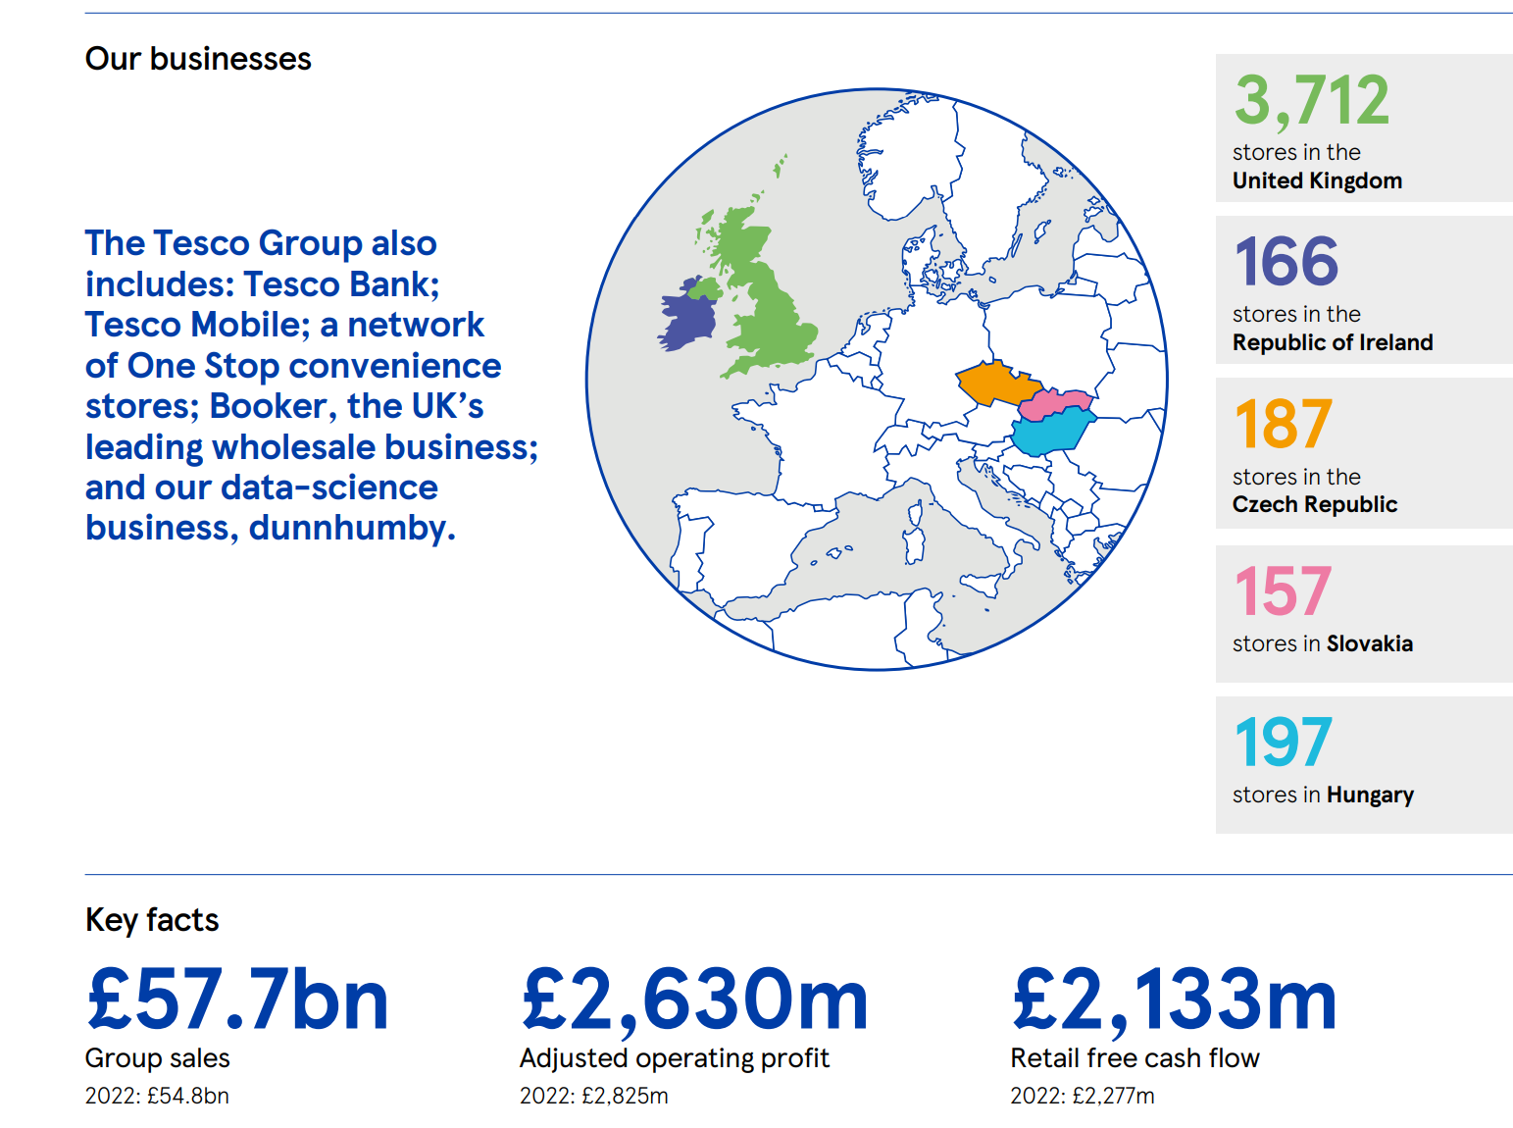
Source: (Tesco PLC, 2023)

Business and Corporate Strategies

Porter’s Generic Strategies
Tesco plc has been operating significantly and with the help of one of the significant strategies which is known as Product Diversification, which includes offering a wide range of products across various categories (Tesco PLC, 2023). By offering various products such as beauty products, baby food, breakfast cereals, cleaning agents, energy drinks, fashion, and clothing among others, the diversification strategy allows Tesco to spread its reach across various markets and product segments that reduce the dependence on any specific product or the market. Additionally, this strategy enables the company to include and offer the diverse needs of consumers worldwide. In all the product categories, the company managed a portfolio of well-recognized brands that target specific consumer segments. Tesco’s brands such as Premier, Makro, Booker, Paperchase, F&F, and One Stop include its different products and effectively attract the different needs of consumers. This brand diversification strategy has been helping Tesco attract a large area in the market and has been offering effective capabilities to capture a larger share of the market which also helps in managing the competitive development (MarketLine, 2024).
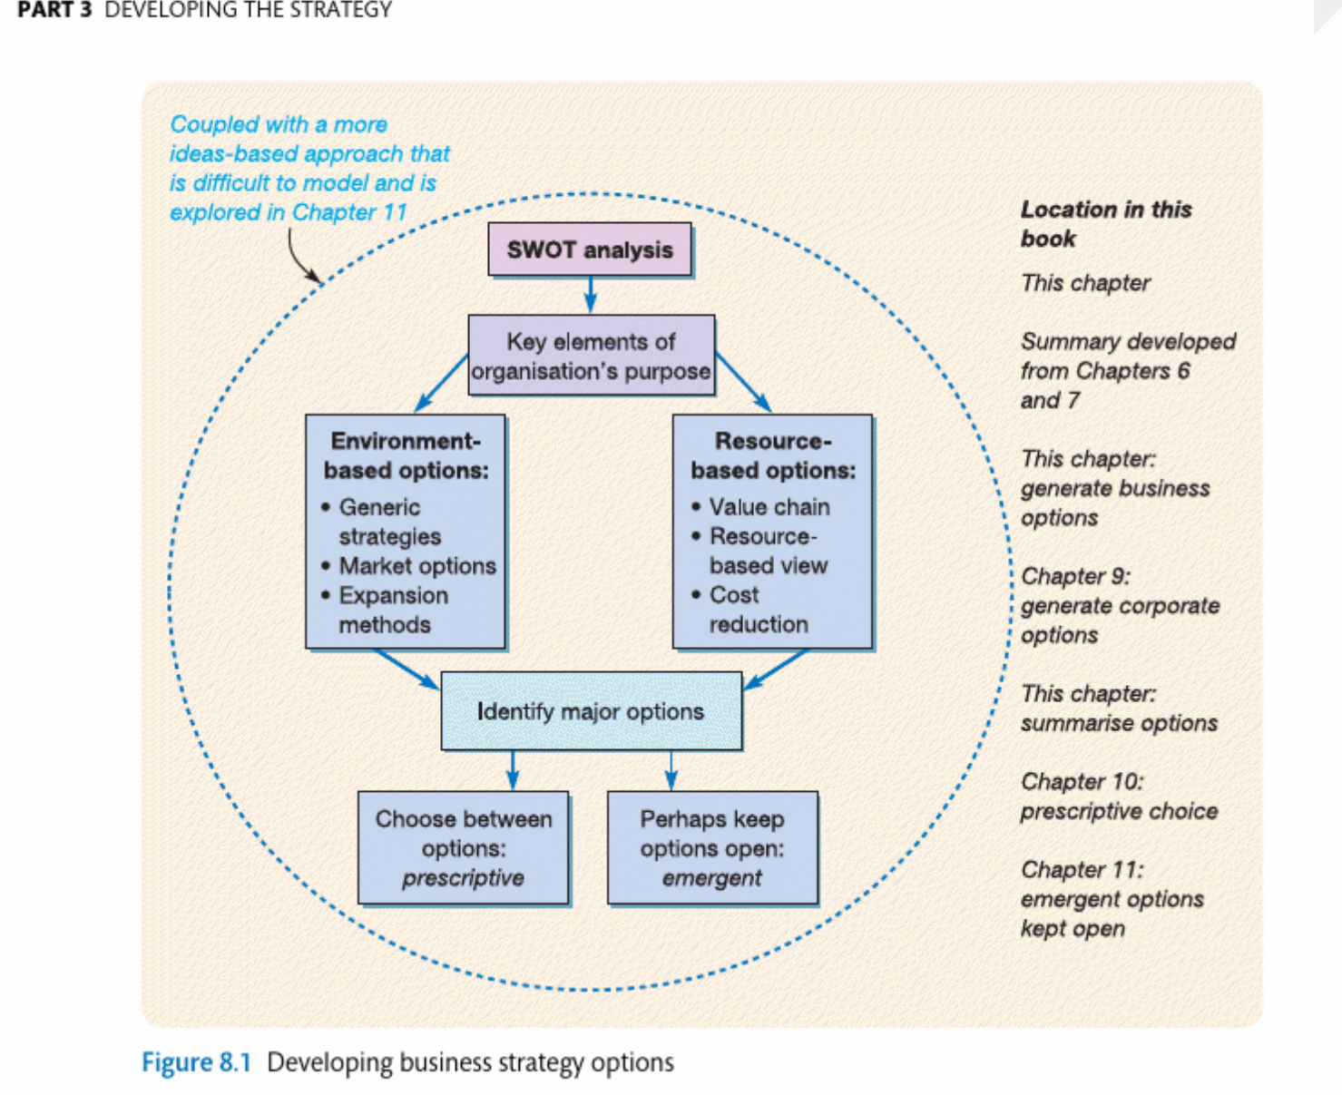
Source: (Lynch, 2018)
Sustainability Initiatives
Tesco has illustrated a solid commitment to sustainability by aiming to reduce its environmental footprint and promote social responsibility across its business operations. Within initiatives various aspects of Tesco’s business have been covered including community involvement, energy efficiency, reduction in waste, and supply chain management. Tesco is strongly committed to sourcing products in an ethical and responsible manner by focusing on sustainable agriculture. The company ensures that its products meet social and environmental standards by working with the suppliers. Moreover, throughout its operations, Tesco has implemented measures to minimise waste accumulation. Efforts such as managing inventories and donations to food banks. The company also aims to decrease its packaging waste by promoting the usage of recyclable materials in packaging processes. The sustainability efforts of Tesco also include energy efficiency (Tesco PLC, 2024b). The company has made investments in technologies related to energy efficiency such as refrigeration systems and LED lighting. This is helpful in reducing energy consumption in distribution centres, warehouses, and stores. Renewable sources of energy are also utilised by the company including wind power and solar power so that it can reduce its carbon footprint. In addition, Tesco supports local communities actively to promote social responsibility. The sustainability initiatives of Tesco are indicative of a detailed approach for addressing social and environmental challenges in its operations and functions.
Global Expansion
Tesco’s global expansion strategy includes establishing strong preferences not only in developed markets but also in emerging markets worldwide. This business strategy allows the company to tap into the different consumer segments and capitalize on the economic growth opportunities in different regions. In the developed markets around the world, Tesco leverages its well-managed and improved brands as well as distribution networks to manage the marketing lead and drive sales growth (MarketLine, 2024). Tesco’s brands such as Premier, Makro, Booker, Paperchase, F&F, and One Stop include its different products and effectively attract the different needs of consumers. Tesco has been serving these brands across various countries including Malaysia, France, China, Ireland, etc. Tesco has been focusing on capturing market share by adapting its products and marketing strategies to local preferences and cultural nuances. For example, Tesco’s products have been significantly delivering the consumer's needs in China and have been offered by its local preferences (Woohyoung, et al., 2020).
Through this strategic partnership and the achievement, the company has been serving almost 12 countries across the globe and has a diverse range of products. These initiatives allow the company to access the new distribution channels, manage the process and recognise the local consumer’s needs as well. This strategy helped the company to become stronger globally and strengthen its competitive position across the markets (Whittington, et al., 2020).

Ansoff Matrix Analysis
The Ansoff Matrix is a tool that helps the companies or business to manage their product and marketing strategies (Whittington, et al., 2020). To analyse Tesco's strategy directions and resource allocation, this tool could be a significant choice.
Market Penetration: Tesco could manage its focus on the current market like its market shares and brand extension allows the company to make its brand more strong and more innovative. By implementing the competitive strategies, the company could effectively enhance its consumers base and aligning pricing with consumer preferences and market dynamics as well. By the product innovation, the company could attract the new consumers, and managing the marketing trend is also effective strategy.
Market Development: Tesco could investigate unused geological markets or statistic sections to support development and grow its shopper base. One road for showcase advancement is entering developing markets with its existing item lines. These districts frequently have developing populaces and rising expendable salaries, showing a critical opportunity for buyer products companies like Tesco. By leveraging its set up brands and dissemination systems, Tesco can enter these markets viably, capturing advertise share and setting up brand nearness (Lynch, 2018).
Product Development: Advancement and item improvement are fundamental for Tesco to remain ahead of changing customer inclinations and showcase patterns. By persistently improving and progress in its items, Tesco can cater to the advancing needs of shoppers whereas keeping up its competitive edge. One angle of item improvement is cantering on maintainability activities, such as creating more maintainable bundling arrangements.
Diversification: Differentiating its item portfolio can give Tesco with modern development openings and decrease dependence on markets or businesses. Wandering into the renewable vitality division is one alternative for broadening. As the world shifts towards renewable vitality sources, there's a developing request for maintainable vitality arrangements (Lynch, 2018). By leveraging its ability and assets, Tesco can contribute in renewable vitality ventures or create feasible vitality items, extending its trade into a unused industry.

Resources and Capabilities of Tesco Company

Value Chain analysis
Value chain analysis is a strategic management tool that helps identify the activities a company performs to deliver a valuable product or service to the market. For Tesco, the value chain can be broken down into primary and support activities (Lynch, 2018).
Tesco’s capability has been significant since the start, the well-managed brands that serve as a core stone of the competitive advantage. Tesco’s brands such as Premier, Makro, Booker, Paperchase, F&F, and One Stop. Tesco has managed its business into five groups including beauty & wellbeing, personal care, home care, nutrition, and ice cream. The company has reached effectively in China, Ireland and the Netherlands, the company has been serving through its online website as well (MarketLine, 2024). The brand portfolio offers the wide needs of the consumers and every brand within the portfolio is effectively cultivated to resonate with the selected target demographic allowing Tesco to get diverse market shares and different consumer segments. There are many brands of Tesco that ash gained effective consumer loyalty over the years and product quality, innovation attracted the consumers. The brand extension allows the company to make its brand more strong and more innovative.
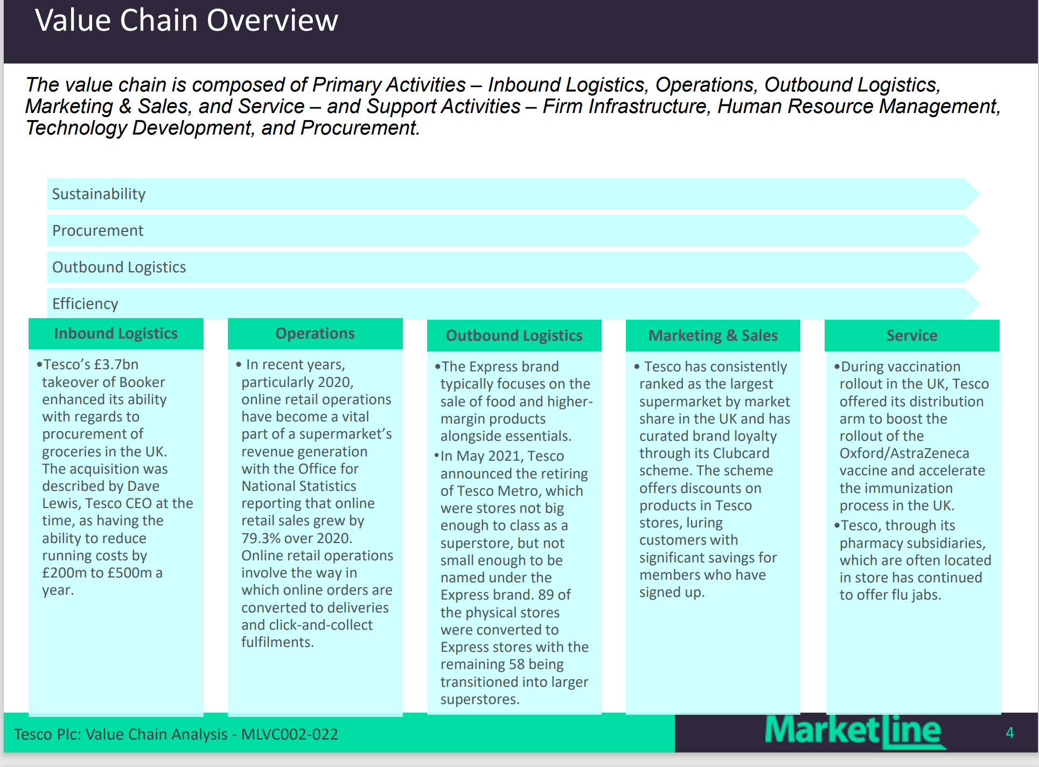
Source: (MarketLine, 2024)
R&D Capabilities
Tesco’s dedication towards research & development (R&D) is evident through the company’s strategic investment aimed at driving innovation and introducing new products that relate to evolving consumer preferences and marketing demands while following the trends. While operating with a global network of research and development facilities and innovation hubs, Tesco fosters its collaborating process among scientists and researchers to improve cutting-edge formulations and technological adaptations in its operations (Whittington, et al., 2020).
Global Supply Chain
Tesco’s global supply chain is a major part of its operational efficiency and has been delivering a competitive advantage for the company. The global supply chain of the company is characterised by effective infrastructure and strategic capabilities. This business strategy allows the company to tap into the different consumer segments and capitalize on the economic growth opportunities in different regions (Lynch, 2018). Spanning multiple continents, Tesco’s wide network includes manufacturing facilities. The company has adapted forecasting models and supply chain analytics to recognize demand fluctuation and optimize inventory management. By managing all these the company ensures product availability with effective quality along with maximizing sales opportunities. Tesco supports good relations with suppliers that support transparent operations and connectivity across the supply chain.

VRIO analysis
VRIO analysis is used to assess a company's resources and capabilities to determine whether they can provide a sustained competitive advantage. VRIO stands for Value, Rarity, Imitability, and Organization (Lynch, 2018).
Resource/Capability | Value | Rarity | Imitability | Organization
Extensive Retail Network | Yes | Yes | Partially | Yes
Tesco Clubcard Program | Yes | Yes | Partially | Yes
Online Platform | Yes | Partially | Partially | Yes
Organizational Structure | Yes | Yes | Yes | Yes

Tesco's VRIO analysis highlights the company's strengths in terms of valuable, rare, and organizationally supported resources and capabilities, which collectively contribute to its competitive advantage in the retail industry. However, Tesco must remain vigilant in protecting and enhancing these advantages while continuously innovating to stay ahead in the dynamic market landscape.

Evaluating Strategy in Action

SAF Framework
Suitability: Tesco’s relentless focus on product diversification and innovation has been playing a significant role in enhancing its competitive position in the market. This includes offering a wide range of products across various categories. By offering various products such as beauty products, baby food, breakfast cereals, cleaning agents energy drinks etc, the diversification strategy allows Tesco to spread its reach across various markets and product segments that reduce the dependence on any specific product or the market (Lynch, 2018).
Acceptability: Acceptability analysis focuses on whether stakeholders, including shareholders, customers, employees, and society, find the proposed strategy satisfactory. Financial performance is a key consideration, as the strategy should generate returns that meet stakeholders' expectations while managing risks effectively. Additionally, ethical considerations and social responsibility play a crucial role in determining the acceptability of the strategy.
Feasibility: Tesco’s focus on global expansion has significantly contributed to its competitive advantage and market leadership. The effective global expansion allows the company to tap into the different consumer segments and capitalize on the economic growth opportunities in different regions.

Evaluating Sustainability Efforts
Tesco has been operating effectively to improve its competitiveness while prioritizing sustainability and environmental responsibility. Suitability refers to the meeting requirements of the existing markets or consumers without compromising the ability of future generations to meet their own needs. One of the notable approaches that has been adopted by the company is product innovation and reformulation to reduce the environmental impact. Through economic sourcing hones, Tesco points to playing down the natural effect of its operations while supporting nearby communities and smallholder agriculturists. For illustration, Tesco has vowed to economically source 100% of its agrarian crude materials, counting palm oil, soy, and tea (Tesco PLC, 2024b).
Strategic Direction
Tesco has various strategic directions which could be considered for the future development of the organization and with its implications for suitability as well as competitive advantage.
Innovation and Product Development: Tesco could continue its investment in the innovation of the products and services among the markets to attract consumers effectively.
Supply Chain Optimization: Optimizing the supply chain for effective sustainability could yield significant benefits for the company in managing its operations.
Circular Economy Initiatives: Adapting the circular economy model could be a significant strategic direction for Tesco in future management. This includes designing the products effectively and consumer’s satisfaction, recycling, and compositing.

Recommendations
Tesco could become competitive in the market by collaborating with partners, industry peers, NGOs and the government to address systemic sustainability issues collaboratively.
Building the connection with the consumers is an effective approach for the company and the company could offer programs that support and educate the consumers regarding the environmental and social benefits of sustainable products and practices (Whittington, et al., 2020). While understanding the consumers is important, the company could target any specific consumer’s needs that are valuable and trending as well. Adapting the circular economy model could be a significant strategic direction for Tesco in future management. This includes designing the products effectively and consumer’s satisfaction, recycling, and compositing.

Conclusion
In conclusion, Tesco’s strategic adaptation in its management has been significantly managing the effective competitive level and sustainable growth. By adapting the resources and capabilities, the company has been growing effectively as well as achieving significant success in the market. Tesco has been operating effectively to improve its competitiveness while prioritizing sustainability and environmental responsibility. Suitability refers to the meeting requirements of the existing markets or consumers without compromising the ability of future generations to meet their own needs. The company also has adopted various strategies and sustainable management and this report explored Tesco’s business strategies while assessing their proactive approaches for gaining competitive advantages in the markets and the suitability goals. It will include the analysis of the company’s capabilities and how the company has aligned its resources and capabilities of current business.

References
Lynch, R., 2018. Strategic management. 8th ed. Harlow: Pearson .
MarketLine, 2024. Tesco Plc. [Online]
Available at: https://advantage-marketline-com.ezproxy.uwtsd.ac.uk/Company/Profile/tesco_plc?companyprofile
[Accessed 10 4 2024].
Statista, 2024. Tesco PLC - statistics & facts. [Online]
Available at: https://www.statista.com/topics/3807/tesco-plc/#dossier-chapter4
[Accessed 30 3 2024].
Tesco PLC, 2023. Annual Report and Financial Statements , Welwyn Garden City: Tesco PLC.
Tesco PLC, 2024a. Our history - From market stall to the UK's biggest supermarket. [Online]
Available at: https://www.tescoplc.com/about/our-history
[Accessed 2 4 2024].
Tesco PLC, 2024b. Sustainability-Serving customers, communities and planet a little better every day.. [Online]
Available at: https://www.tescoplc.com/sustainability
[Accessed 11 4 2024].
Whittington, R. et al., 2020. Exploring Strategy. 12th ed. Harlow, UK: Pearson.
Woohyoung, K., Kim, H. & Hwang, J., 2020. Transnational Corporation’s Failure in China:Focus on Tesco. Sustainability, 12(17), p. 7170.

Appendix – Swot Analysis

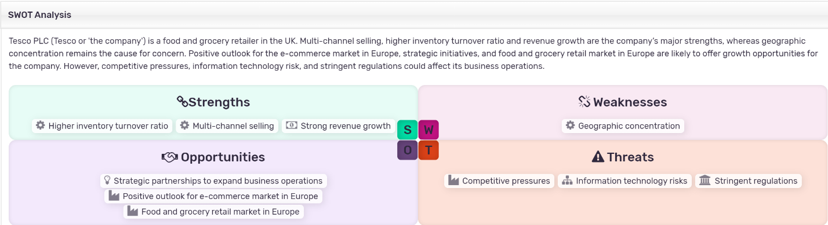

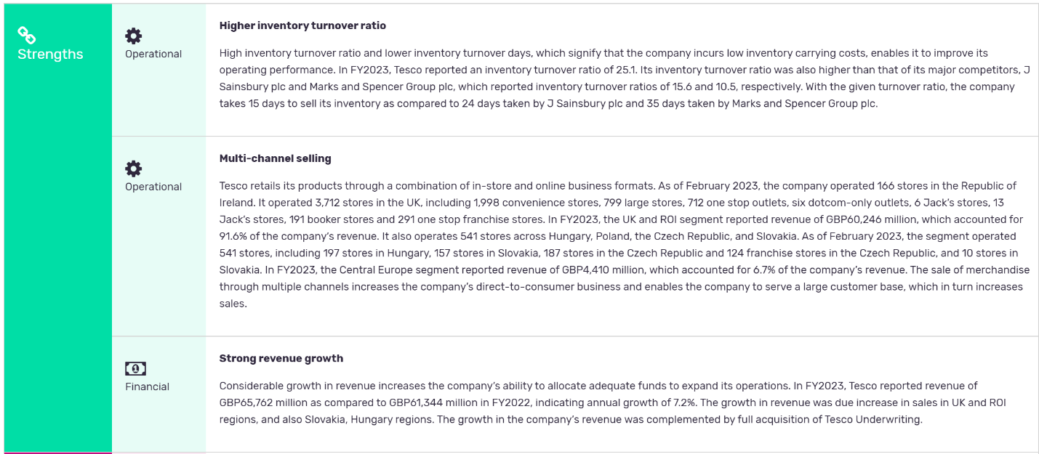

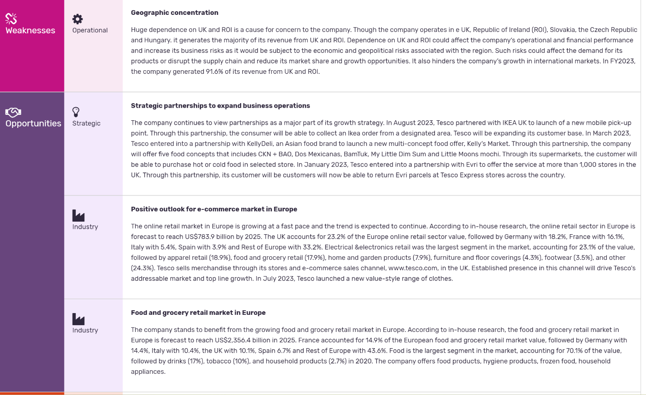
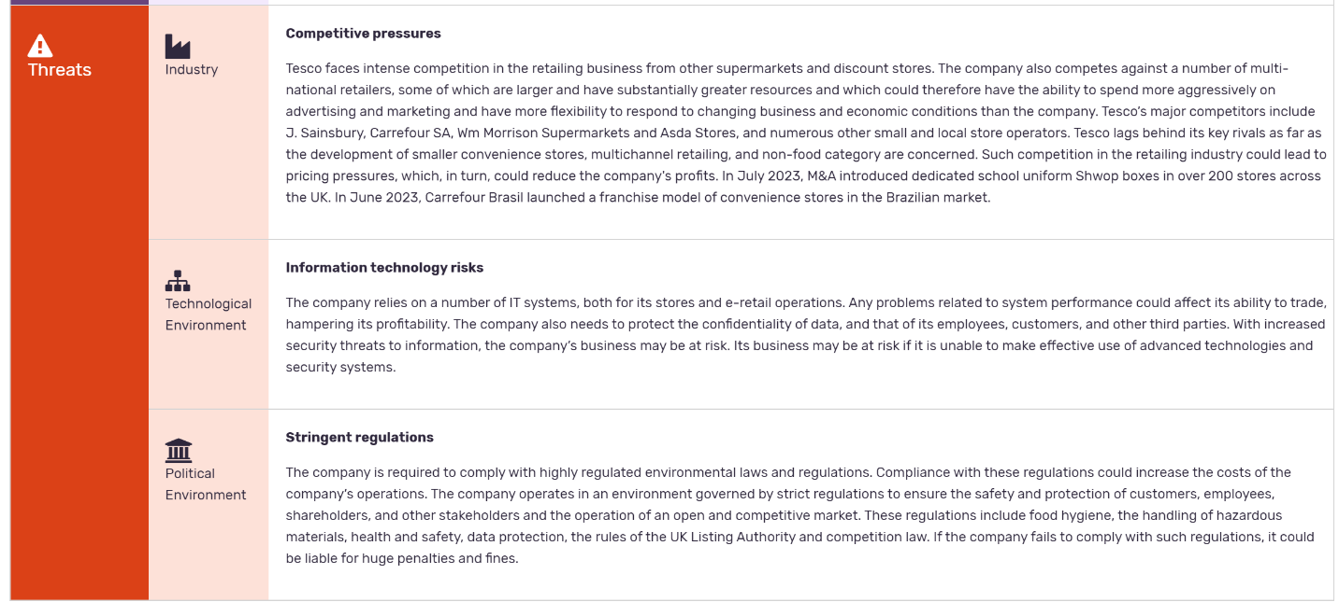
Source: (MarketLine, 2024)

