

LOCATION: Coleg sir gâr | LLEOLIAD: coleg sir gâr
LEVEL 5 | LEFEL 5
EXAMINATION PERIOD | CYFNOD ARHOLIADAU
JANUARY 2018 | IONAWR 2018

MODULE CODE: CSAC5001
Application Design and Development

TIME: 2 HOURS

answer ALL QUESTIONS

Equipment or materials required – Open Book
Adnoddau neu ddefnyddiau sydd eu hangen – Open Book

ANSWER ALL QUESTIONS in SECTION A and B

SECTION A

QUESTION 1

Define the following terms:
- Class
- Object
- Abstract data type
- Method overloading
- Constructor
(Marks 10)

QUESTION 2

Describe why it is sometimes useful to overload a constructor.
(Marks 5)

QUESTION 3

Consider the following class definition that represents a radio:

public class radio
{
public bool isSwitchedOn; // either true or false
public int volume; // from 0 to 10
public double frequency; // from 535 to 1605 Mhz
}

  - Provide a redesigned radio class that uses more appropriate member access operators.
(5 marks)

- Provide signatures for two mutator (setter) methods that will enable the two instance variables to be changed through an object of the class.
(5 marks)
QUESTION 4

Define the terms coupling and cohesion in the context of object oriented programming. Within your discussion, explain how coupling and cohesion can lead to either good or bad software design.
(10 marks)

QUESTION 5

Define compile time polymorphism, and provide a code fragment that implements this concept in c#.
(10 marks)

QUESTION 6

Define run-time polymorphism, and provide a code fragment that implements this concept in c#.
(15 marks)

SECTION B

QUESTION 7

The Stradey Park Hotel has developed a new website that allows visitors to make room reservations, providing they specify the dates of the visit required and the type of room they are requesting. If they have registered with the hotel previously their guest details are used to speed up the process, otherwise they are required to register as a new customer. Each reservation is given a unique reservation number.

Before the date of their stay the customer may enter this reservation number into the website to change details or cancel the reservation. Alterations can include changes to the dates, changes to the room type or changes to the number of guests in each room. When the guests arrive at the hotel, the reservation number is used by the receptionist to quickly find the customer details to allow for check-in.

At the end of the customer stay, the receptionist checks the visitors out. At this point the hotel system will validate payment through the card payment system, and a printed invoice
may be requested by the guest. The hotel has many room types available, each with a room-type name, number of guests and additional facility information. Each room in the hotel has a room number and is of one specific type. Monthly reports are prepared by the system which may be viewed on request by the Stradey Park Hotel Manager.

Produce a System Use Case diagram for the above scenario.
(20 marks)

QUESTION 8

Carmarthen County Council are developing a software application called the Llanelli Parking Enforcement System (LLPES). The software will manage their parking enforcement processes. The program will receive information about new fines uploaded from the parking attendant mobile devices. Most fines are currently paid within the allowed period and the payment recorded against the fine is then closed. However, sometimes only part of the fine is received in which case the outstanding balance should be updated and the fine should remain active.

Produce a class diagram for the system described above.
(10 marks)

QUESTION 9

Explain the meaning of the following UML multiplicity indicators:
(i) 1..*
(ii) 0..*
(iii) 0..1
(iv) 2
(v) *
(5 marks)

QUESTION 10

a) Explain the meaning of the following UML visibility operators:
(i) +
(ii) –
(iii) _
(iv) /
(v) #
(5 marks)

Diwedd/End
SOLUTIONS

QUESTION 1

Define the following terms:
- Class
- Object
- Abstract data type
- Method overloading
- Constructor
(Marks 10)

A class is an extensible program-code-template for creating objects, providing initial values for state (member variables) and implementations of behaviour (member functions, methods).

An object is a particular instance of a class where the object can be a combination of variables, functions, and data structures.

Abstract data types are data types described in terms of the operations they support: their interface, rather than how they are implemented.

Overloaded methods are those that have the same name, but that have different formal parameter types (or result value type, if the language supports overloading on result type).

A constructor in a class is a special type of method called to initialise an object. It prepares the new object for use, often accepting arguments that the constructor uses to set the value of member variables.

QUESTION 2

Describe why it is sometimes useful to overload a constructor.
(Marks 5)

The creation of an object may involve the setting of a number of instance and class variables. These may have a number of sensible defaults. A default constructor can be used to set all the defaults. Where the defaults are not suitable an overloaded constructor can set the appropriate values according to the arguments passed to it. There can be a series of constructors each setting a subset of the instance and class variables each of which will allow some defaults to stand.
QUESTION 3

Consider the following class definition that represents an AM radio:

public class radio
{
public bool isSwitchedOn; // either true or false
public int volume; // from 0 to 10
public double frequency; // from 535 to 1605 Mhz
}

  - Provide a redesigned radio class that uses more appropriate member access operators.
(5 marks)

public class radio
{
private int volume;
private double frequency;
}

- Provide signatures for two mutator (setter) methods that will enable the two instance variables to be changed through an object of the class.
(5 marks)

Similar to any of the following:

private int Volume();

public int newVolume()
{
get
{
return Volume;
}
set
{
Volume = value;
}
}

or

bool setVolume(int newVolume);
bool setFrequency(double newFrequency);
bool setOnOff(bool newState);

QUESTION 4

Define the terms coupling and cohesion in the context of object oriented programming. Within your discussion, explain how coupling and cohesion can lead to either good or bad software design.
(10 marks)

Cohesion refers to what a class will do. Low cohesion means the class does a lot of actions, whereas high cohesion will mean the class focuses on what it should be doing. For example, given a Student class with two attributes: name and DOB, high cohesion would only include methods appropriate to the intention of that class, such as getName, setName(), getDOB(), setDOB(), whilst one with low cohesion could include other methods appropriate to other classes, such as printResults(), setExamMark().

Coupling refers to how dependent classes are on each other. Low coupling would mean changing something in one class should not affect the other, such as changing the definition of a method. High coupling could mean code is difficult to change, so changes, or maintenance in one area could mean revamping the whole system.

Good design should go for high cohesion and low coupling.

QUESTION 5

Define compile time polymorphism, and provide a code fragment that implements this concept in c#.
(10 marks)

Compile-time polymorphism, also known as static binding, is polymorphism in which the exact code that will be run is determined at the time that the source code is compiled. This is the case where overloading is used.

One example of compile-time polymorphism is method overloading, demonstrated below:

class Program
{
public class TestOverloading
{

public void Add(string a1, string a2)
{
Console.WriteLine("Adding Two Strings :" + a1 + a2);
}

public void Add(int a1, int a2)
{
Console.WriteLine("Adding Two Integers :" + a1 + a2);
}

}

static void Main(string[] args)
{
TestOverloading obj = new TestOverloading();

obj.Add("Dan " , "Davies");

obj.Add(2, 3);

Console.ReadLine();
}
}

QUESTION 6

Define run-time polymorphism, and provide a code fragment that implements this concept in c#.
(15 marks)

Run-time polymorphism, also known as dynamic binding, is polymorphism in which the exact code that will be run cannot typically be determined at the time that the source code is compiled, but is decided while the program is executing.

class Program
{
public class Base
{

public virtual void Show()
{
Console.WriteLine("Show From Base Class:");
}
}

public class Derived : Base
{
public override void Show()
{
Console.WriteLine("Show From Derived Class:");
}
}
static void Main(string[] args)
{
Base objBase;
objBase = new Base();
objBase.Show();// Output ----> Show From Base Class.

objBase = new Derived();
objBase.Show();//Output--> Show From Derived Class.

Console.ReadLine();
}
}

SECTION B

QUESTION 7

The Stradey Park Hotel has developed a new website that allows visitors to make room reservations, providing they specify the dates of the visit required and the type of room they are requesting. If they have registered with the hotel previously their guest details are used to speed up the process, otherwise they are required to register as a new customer. Each reservation is given a unique reservation number.

Before the date of their stay the customer may enter this reservation number into the website to change details or cancel the reservation. Alterations can include changes to the dates, changes to the room type or changes to the number of guests in each room. When the guests arrive at the hotel, the reservation number is used by the receptionist to quickly find the customer details to allow for check-in.

At the end of the customer stay, the receptionist checks the visitors out. At this point the hotel system will validate payment through the card payment system, and a printed invoice
may be requested by the guest. The hotel has many room types available, each with a room-type name, number of guests and additional facility information. Each room in the hotel has a room number and is of one specific type. Monthly reports are prepared by the system which may be viewed on request by the Stradey Park Hotel Manager.

Produce a System Use Case diagram for the above scenario.
(20 marks)

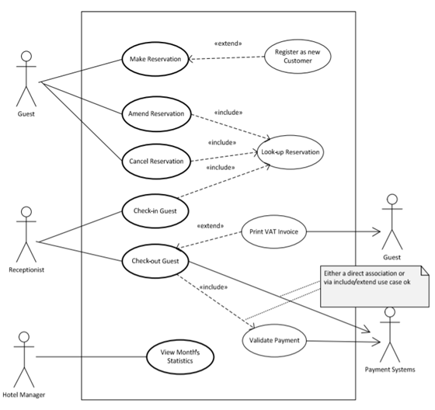

Element | Details | Mark
System Boundary | 1 Mark for displaying and naming the system boundary | 1
Actors | 1 Mark for each actor [up to 4] – including Guest/Customer, Receptionist, Hotel Manager, Payment System | 4
Use Cases | 1 Mark for correctly named (verb-object/noun) use cases [up to 6] - Including sub-use cases that are included or extended providing they are reasonable | 6
Use Case Actor Associations | Marks allocated for each correct actor to use case association crossing system boundary. A use case’s interactions with secondary actors are counted in addition to the primary actor to use case association | 5
Include/extend associations | 2 marks for each correct include and extend use case example [up to 2 examples] - multiple use cases including same use case counts as single example; depending on both assumptions made and definition of include/extend allow for various interpretations | 4
TOTAL |  | 20

QUESTION 8

Carmarthen County Council are developing a software application called the Llanelli Parking Enforcement System (LLPES). The software will manage their parking enforcement processes. The program will receive information about new fines uploaded from the parking attendant mobile devices. Most fines are currently paid within the allowed period and the payment recorded against the fine is then closed. However, sometimes only part of the fine is received in which case the outstanding balance should be updated and the fine should remain active.

Produce a class diagram for the system described above.
(10 marks)

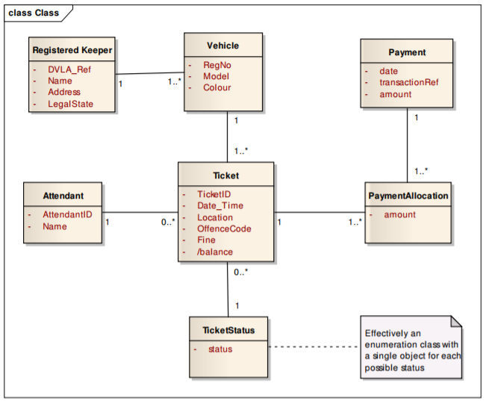

QUESTION 9

Explain the meaning of the following UML multiplicity indicators:
(i) 1..*
(ii) 0..*
(iii) 0..1
(iv) 2
(v) *
(5 marks)

QUESTION 10

a) Explain the meaning of the following UML visibility operators:
(i) +
(ii) –
(iii) _
(iv) /
(v) #
(5 marks)

Diwedd/End

