‘Describe a learning event which has happened during your recent school experience. Reflect upon what took place, connecting events to theories of learning and teaching. Make recommendations about how you could improve your own practice in light of this. Produce a poster to illustrate how you would develop the elements of an effective learning environment.’

In accordance with the ethical guidelines set out in BERA (2018), the school and pupils observed will be anonymised for the purposes of this assignment. Written consent was obtained for any photographs taken and I familiarised myself with the school’s safeguarding policy whilst in attendance.

The observation was carried out in a Key Stage 2 class within a large pioneer school (Reference removed for anonymity). Pioneer schools are working together with the Welsh Government to help shape the future of education in Wales (Donaldson, 2015). Donaldson (2015) Successful Futures report sets out the four purposes of the proposed new curriculum which can be seen in Figure 1.
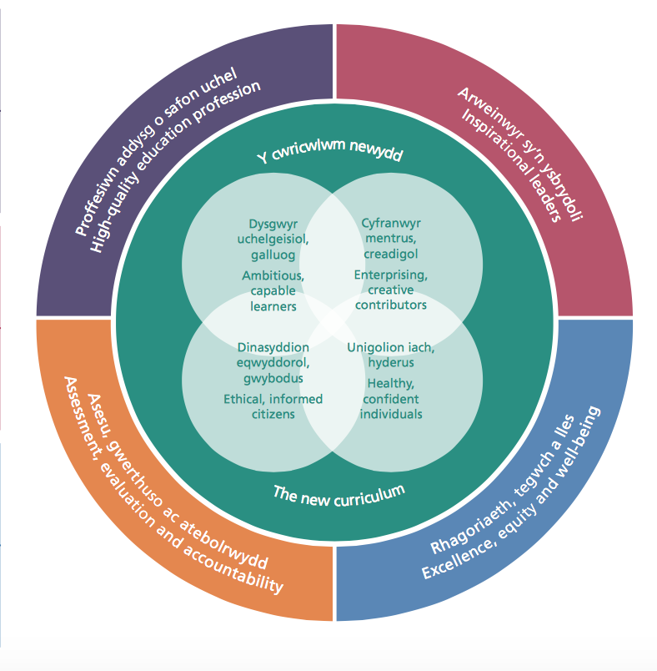
Figure 1: Welsh Government (2018)
The observation
At the beginning of a Year 5 science lesson, the teacher asked the children to turn back to work they had completed last week. As Year 5 are studying the human body, the children had investigated the basic functions of various organs of the body and written their findings into their exercise books. The teacher asked them to ‘traffic light’ how they felt about their own work, after reading the marked feedback. An example of this can be seen in Figure 2 below. During the observation, I noted that not all pupils had done as the teacher asked, as they had not completed the traffic lights.
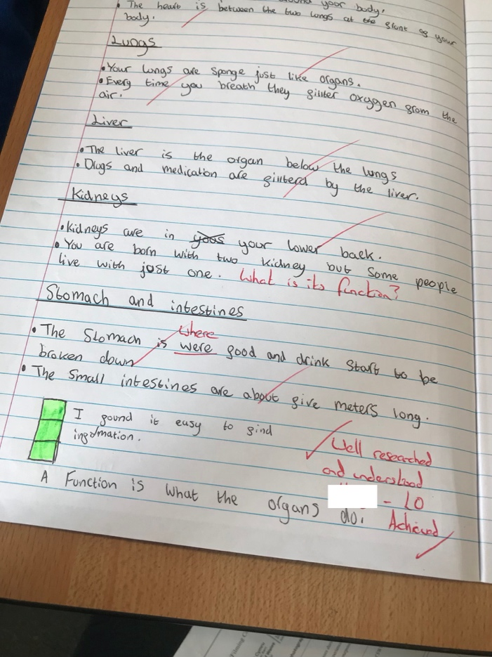
Figure 2: An example of the ‘traffic light’ system used by a child to suggest how they felt about their own work.

Green traffic light with pupil’s own comment
Teacher’s comments

Pupil’s response to teacher’s question “What is its function?”.

The observation was carried out as a written event, as I believed it was a reliable method to capture the learning event as it occurred. Schön (1983) emphasised the importance of the written method in terms of “reflection in action” and “reflection on action” (Schön in Papatheodorou and Luff, 2011:102). Carrying out the written observation is an example of reflection in action, as I was making notes at the time of the event. An example of reflection on action would be looking back at the observation notes and beginning to make links to knowledge I already possess. I requested permission to take photographic evidence of the pupil’s book in order to back up my written notes. According to Moore (2001), Observations can deliver accurate information provided that they are carried out objectively (cited in Thomas and Lewis, 2016). Henceforth, I made sure that my notes were objective and only accounted for what was seen during the session.
I chose this as a significant learning event as it is an excellent example of assessment for learning (AFL hereafter) by virtue of reflection (Thomas and Lewis, 2016).
AFL is a concept that was introduced by Black and Wiliam (1998). Their research looked at raising standards in education by improving formative assessment. They later made additional recommendations in 2002 after learning more about how AFL can improve classroom practice. These recommendations took the form of: making learning objectives and success criteria explicit to the pupil, encouraging self-assessment and peer-assessment and encouraging pupils to refer back to the learning objectives and success criteria when assessing their own work (Black et al. 2002:12)
The traffic light system was introduced by Black and Wiliam (2002) as a “simple and effective” way for children to assess their work: Green for a good level of understanding, amber for partial understanding and red for very little or no understanding (2002:11).
AFL is referred to as a formative assessment when teachers act upon the feedback in order to alter their practice (Black et al. 2003). By using the traffic light system, pupils can communicate their self-assessment in an explicit way, so the teacher can see straight away who does or does not understand. Consequently, this permits teachers to alter their practice to assist the children’s learning (Black and Wiliam 2002).
Wiliam (2009) goes further to clearly outline what formative assessment is, which he summarised in the table found in Figure 3.

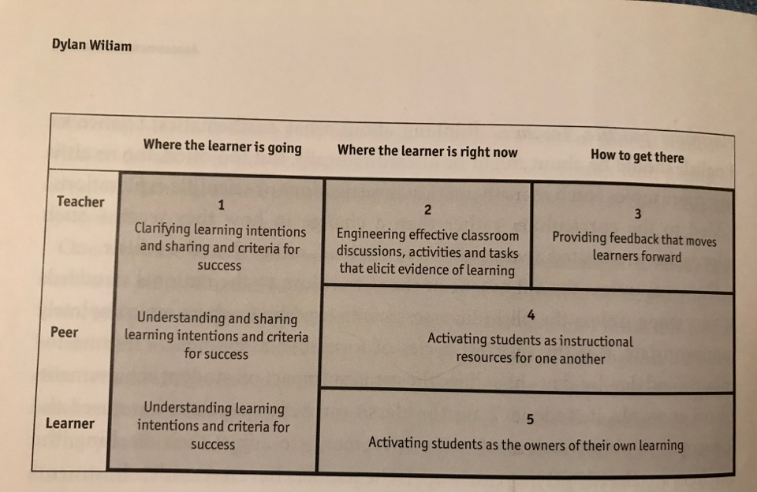
Figure 3:
Wiliam (2009:12)

It was highlighted by Black et al. (2002) that a researcher observed many instances where children paid very little attention to reading the teacher’s comments. Providing children with purposeful feedback is pointless unless the child actually takes note of the comments. By asking the children to use the traffic light system for last week’s work, it gave them an opportunity to look back and read the teacher’s comments.
This particular observed child coloured the traffic lights green and added the comment “I found it easy to find information”. It is clear that the child read the teacher’s comments as they responded to the teacher’s question: “What is its function?” by answering “a function is what the organs do”.
The observed use of AFL showed many of the features set out in Figure 3. The learning objectives could be seen at the beginning of the written work. Additionally, the teacher’s written comments refer back to the learning objectives to show whether they have been successfully met. Lastly, the teacher is encouraging the children to take ownership of their learning by asking them to reflect on what they know.
John Hattie (2012) focused on how to make learning visible by giving teaching skills “effect sizes” determined by how effective they were on a child’s achievement. He stated that, as children would naturally develop and achieve without intervention, anything that has an effect size lower than 0.4 is to be considered inadequate. This is because children would be expected to achieve more as they get older, so teachers should only use techniques that have a larger effect size in order to raise the achievement above the child’s expected natural course (Hattie 2012:3; Cremin and Burnett 2018:83). Effective feedback was given an effect size of 0.75 and most prominently, encouraging children to self-assess by reflecting on their performance thoughtfully was given 1.44 (Frey et al. 2018). In support of this, Black et al. (2003) found that by using AFL as a “rapid formative assessment” children’s achievement was increased by approximately 70% (Hattie 2012:128).
The proposed new curriculum for Wales wants all children to become independent life-long learners. As suggested by Professor Donaldson, in order to do this, children need to be able to reflect on their learning so far and recognise what needs to be done in order to progress further (Donaldson, 2015:80). With respect to independent learning, The Education Endowment Foundation (EEF) (2018) refers to the necessity of metacognitive strategies being utilised by children when reflecting on their learning (2018a:22). Metacognition can be defined as a person thinking about and understanding their own process of learning (Pritchard, 2014). Drawing back to the observation, whilst reflecting on last week’s work, the child is required to think about how they did or did not achieve the lesson outcomes.
The Welsh Assembly Government (WAG) (2007 cited in WAG 2008) clearly displayed the link between AFL and developing thinking skills which can be seen in Figure 4 below. 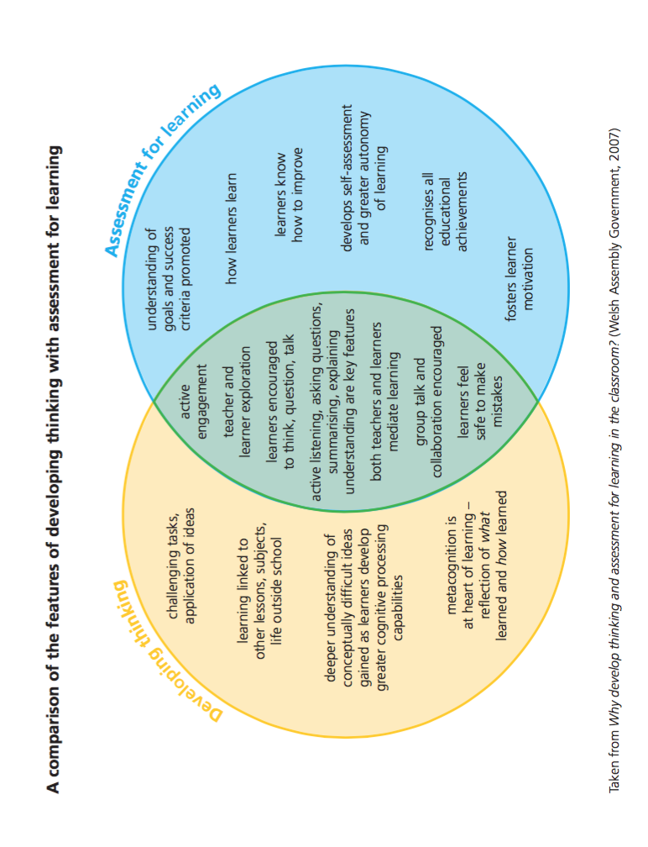
Figure 4: WAG (2007) in WAG (2008) Skills Framework
Furthermore, the WAG has issued guidance on how to develop thinking and AFL (WAG, 2010). As thinking skills are included within the current curriculum, the document refers to metacognition being central to the learning process:
“learners need to ‘unpack their thinking’ in order to appreciate the strategies they have used to learn, to assimilate the learning that has taken place, and to link the learning to a new context”
(WAG, 2010:23)
This can be compared to the High/Scope approach that was developed in America, which modelled the “plan-do-review” process. The process encouraged children to make sense of their learning through reflection and active learning (Pound, 2006:57).
In similarity to Hattie’s (2012) “effect size”, the EEF show the effect size in relation to cost effectiveness in schools (Figure 5). As it has been established that AFL can be used as a means of feedback and getting children to think deeper about their learning, it is possible to interpret these effect sizes as showing the impact of using AFL techniques within the classroom.

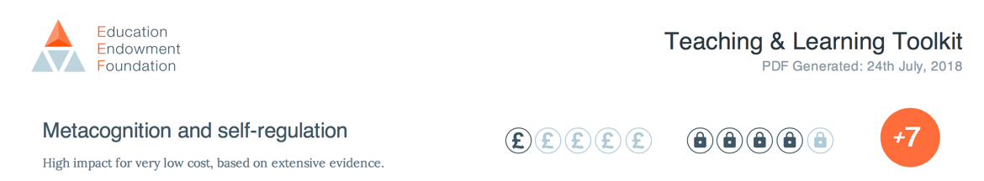
Figure 5: EEF (2018b) showing the effect size of metacognition and feedback

Limitations of formative assessment were touched upon by Hall and Burke (2003), stating that teachers find it too complex to implement. However, together with the strategies of metacognition and clear guidance from the Skills Framework (WAG 2008) there is extensive support for teachers to draw upon. Key strategies for effective learning identified by Hendrick, were to “revisit previous learning”, “check for understanding”, “give feedback”, “create a positive classroom environment” and “offer plenty of guidance” (The Guardian, 2017). In light of the above information, all of these can be linked to AFL techniques.

As AFL requires children to think about what they have learnt in order to build upon prior knowledge and experiences, it is seen to be best explained by constructivist theories of cognitive reasoning. Furthermore, it is essential to focus on social constructivism to explain why the teacher needs to support the children’s process of metacognition, by asking them to self-assess work the teacher has already marked (Smidt, 2009:69).

Learning Theories
As stated by Donaldson (2015) the curriculum constantly has to contend with keeping up with proposed theories of learning, psychology and neuroscience (Donaldson, 2015: 6). Understanding how children learn is a complex notion and there is no agreed definition on what constitutes learning (Wray, 2018; in Cremin and Burnett, 2018). The definition of learning varies amongst the different theories.
From a behaviourist perspective the learner is treated as a “blank page”, waiting for the teacher to give them knowledge (Grigg, 2015: 135). Behaviourists believe that learning is taking place when behaviour visibly changes in response to something (Pritchard, 2014). Theorists, such as Pavlov and Skinner, paid very little attention to the importance of logical process and understanding, whilst deriving their thesis from experiments where animals were conditioned to respond to a stimulus (Pritchard, 2014). As AFL is a reflective tool for the child to understand how to progress in their learning, it is more appropriate to consider the influence of the constructivist theory of learning.
In stark contrast to behaviourism, constructivists believe that learners should be considered as playing an active role in their learning and not dependent on the adult feeding them knowledge (Piaget, 1976; in Grigg 2015). This idea compliments the proposed new curriculum for Wales, as the four purposes encompass the need for children to become “ambitious, capable learners” with the ability to become life-long learners.
In order to achieve this, according to Donaldson:
“they need to be able to reflect and diagnose their own progress and further learning needs” (2015:80)
AFL as a tool of reflection, means that children are making sense of their learning for themselves and assessing how they can improve their understanding further. Therefore, they are taking ownership of their learning with the support of the teacher’s feedback (Fig. 3: Wiliam, 2009).
Piaget believed that the child’s ability to fully understand, may be hindered by being shown how to do something before having the opportunity to explore and discover it for themselves (Pritchard, 2014). Piaget developed the idea of the “lone scientist”, where he believed that it was necessary for the child to construct their own understanding through contact with the world around them (Pritchard, 2014: 22). Piaget (2002) outlines how children need to reflect on their learning by making connections with what they already know.
In light of this, the traffic light system could be seen as a means of children reflecting on their prior knowledge (what they did last lesson), in order to bridge the connections with what they are about to do in the following lesson.
Despite agreeing that children are active in the learning process, Vygotsky emphasised the need for social interaction to engage the learner, thus his work is referred to as social-constructivism (Smidt, 2009). Dismissing the idea that children are “blank pages”, Vygotsky placed significance on the adult helping the child bridge gaps in their learning by allowing the learner to “borrow the knowledge” of the adult (Bruner, 1986:76). Vygotsky’s notion of the zone of proximal development (ZPD hereafter) is still highly regarded in practice today (Pritchard, 2014). The ZPD is representative of the gap in the child’s knowledge or capability when carrying out a task independently, in comparison to what they would be capable of doing with help from someone who is more experienced. Therefore, it is evident that Vygotsky focussed on the child building on their existing knowledge with help from others (Pound 2006). It has been established by Black and Wiliam (1998) that AFL needs social interaction to enable the children to learn from the teacher and each other.
Metacognition can be linked to this approach, as teachers are considered to be crucial in developing the child’s ability to think for themselves (Larkin, 2010:43).
Limitations of metacognition can be that it cannot be assumed that children know how to think about their learning, as learning is “hidden” and unique to the individual (Grigg, 2015:114). In relation to AFL being a means of metacognitive reflection, the children would need to be shown how to use the technique and the purpose of doing so in relation to their learning. With knowledge of this, there are a range of possibilities to consider, as to why some children did not make any attempt of the traffic lights. Children need a “clear understanding of what went wrong and achievable targets for putting it right” (Black and Wiliam 1998:9). Therefore, if children do not understand why they made mistakes and the teacher does not give them enough support to rectify the misunderstanding, they are unlikely to gain anything from the AFL technique. In support of this, Williams (2003) maintains that allowing children to work too independently can lead to reinforcement of misunderstandings and in turn discourage the desire to be involved. Hall and Burke (2003) also point out that teachers find it difficult to carry out formative assessment due to it being too complex, meaning that the teacher may not recognise how to support children effectively.
Vygotsky explained how children initially rely on external speech to explain their thoughts and as the thoughts become internalised, it indicates that the learner has reached a “higher mental function” (Vygotsky, 1978 cited in Larkin 2010:42). This approach may be interpreted in relation to the process of using AFL to internalise the learning, by reflecting on what they already know.
Inspired by Vygotsky’s work, Bruner (1986), developed the idea of “scaffolding”. This relates to the process of a child being dependent on help from someone who has more knowledge than themselves, to eventually becoming independent and carrying out the activity unaided (Smidt, 2011:118). It is possible to think of the teacher’s feedback as a means of “scaffolding”, as the teacher models how successful the child has been by referring back to the lesson outcomes (EEF, 2018a:17). Limitations of teachers’ feedback are stressed by Grigg (2015) as teachers often fail to provide children with constructive feedback by not giving clear direction in how to progress in their learning. This is supported by Thomas and Lewis (2016), in stating that general comments such as “good work” purely boosts the child’s self-esteem, rather than giving benefit to the child’s learning (2016:134). Effective feedback which “moves the learner forward” (Wiliam 2009:12), can give a clear indication of what the child has understood in order for them to then build new understandings (Smidt 2009).
Behaviourists would argue that a child’s understanding can be conditioned or learned in response to a reward (Pritchard, 2014). However, Black et al. (2002) argues that giving rewards as feedback does not give the pupil any indication of how to improve their knowledge and learning, instead only enhances their self-worth.

According to Holt (1994)
“one of the most important things teachers can do for any learner is to make the learner less and less dependent on them” (Holt, 1994; in Pollard and Bourne, 1994:8).
As soon as the children are confident in using the AFL technique, it is possible that the “scaffolding”, of being able to base their reflections on the teacher’s feedback, can be removed. For instance, the teacher will be able to ask the children to reflect on their learning at different stages of the lesson or before the work has been marked.
Larkin (2010) goes on to say that teachers need to provide a supportive classroom environment in order to enable children to reflect on their learning. Webb and Jones (2009) discuss the need for children’s self-confidence to be boosted to ensure they are not afraid to make mistakes; therefore, more likely to reflect honestly. This is supported by Frey et al. (2018) pointing out that a positive environment emphasises the importance of learning rather than performance.
Taking a behaviourist view, it would be possible to condition the reflection process in response to rewarding to boost self-esteem (Pritchard, 2014). However, in order for children to reach a level of being able to process their learning, there needs to be an element of higher order thinking to make the implicit learning, become explicit to the learner (Grigg, 2015:114).

In light of analysing the observed learning event, I am able to understand how learning has taken place which can be used to inform my future practice. As it has been established that creating “assessment capable” children increases the speed in which they learn by more than three times the normal rate (Frey et al., 2018:48); I would ensure that children know how to reflect on their learning honestly to get the most out of the technique. Taking a social constructivist approach to teaching, I would “scaffold” the process of reflection and metacognition. This would enable me to show the child the purpose of thinking about how they got to the answer, rather than just making their judgement based on whether they got the answer right or wrong (Frey et al., 2018). In order to do this, I would have to create a ‘can do’ environment where children are not afraid to make mistakes (Black and Wiliam 1998). In attempt to create life-long learners, I would ensure that children are independent enough to challenge themselves to making sense of new concepts; but also engage in dialogic teaching, by encouraging social interaction with others in order to bridge any gaps in their knowledge (Bruner, 1986:76).

My Ideal Learning Environment

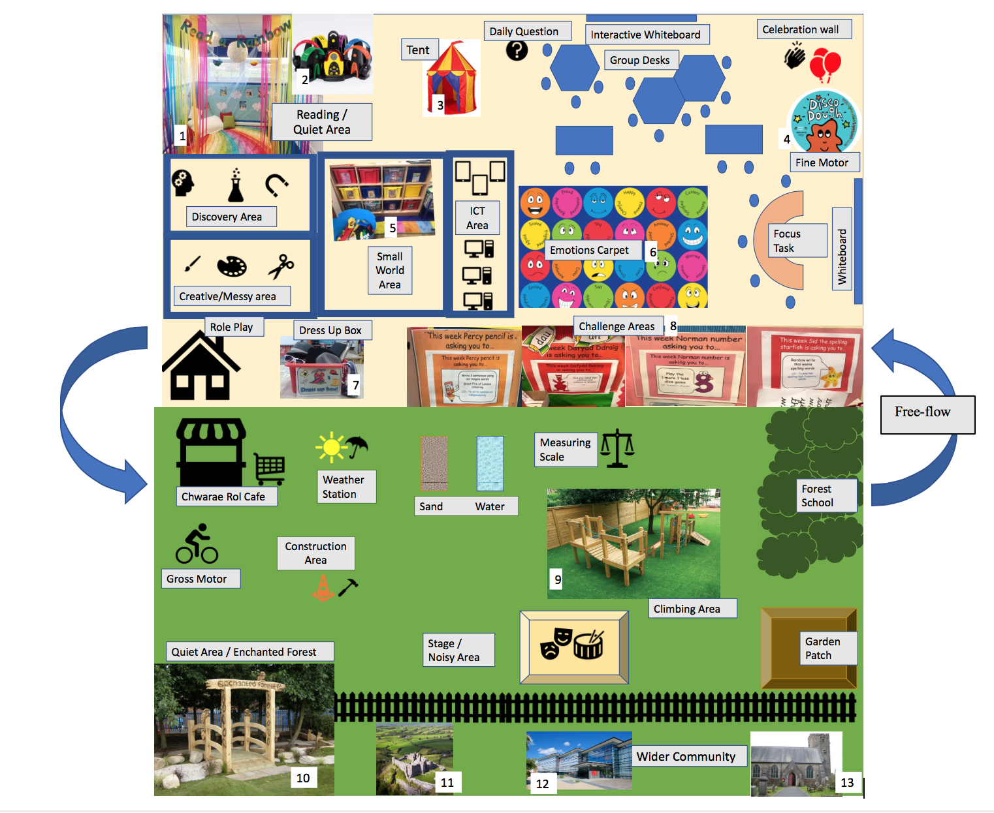

I have designed my ideal learning environment based on the proposed new curriculum for Wales. Instead of the current seven areas of learning, Donaldson (2015) has proposed the curriculum should be made up of six areas of learning and experience (AoLE from here on in).
Some examples of how the learning environment can lend themselves to the delivery of the AoLE can be seen in the following table:

AoLE | Aspect of learning environment
Languages, Literacy and Communication | Challenge area/ Reading corner/ Labels on display/ Literacy focused task.
Mathematics and Numeracy | Weighing scale/ Challenge area/ Numeracy focused task/ Small world area.
Science and Technology | ICT area/ Discovery area/ Creative area/ Noisy area.
Humanities | Wider community/ Weather station/ Small world area.
Health and Wellbeing | Role play/ Daily question/ Emotions carpet/ Construction/ Tent/ Outdoor provision/ Gross and fine motor areas.
Expressive Arts | Role play/ Stage/ Messy area.

Although this is not an exhaustive list, I will be focussing on the learning areas I believe are key to enabling an effective learning environment.

The learning environment can substantially influence how well the children learn (Grigg, 2015). Estyn’s (2018) key findings show that learning experiences need to ignite curiosity and creativity. I have included different areas in the learning environment to provide a varied learning experience, where children can learn independently, but also take risks in a supported environment (Estyn 2018). Activities delivered in the ideal learning environment will be well-planned in order to meet all of the AoLE and four purposes (Figure.1).

Encouraging pupil independence will be a major part of my learning environment. A daily question would require the children to self-registrate by answering the question. This could be used as assessment for learning, to find out what the children already know about a particular subject or can be used to assess whether they have understood a concept taught in focused tasks, thus permitting myself to “scaffold” their learning (Bruner 1986; Wiliam 2009). Huggins and Wickett (2011, cited in Thomas and Lewis 2016) argue that children need to be given enough time to become absorbed in their learning. On the basis of this I would ensure that children have plenty of time to carry out the activities they choose.
The learning environment gives the children opportunities to learn by doing. All of the areas would give children the chance to learn by doing activities or experiments independently. Dewey influenced the child-centred approach, stating that children learn by having hands on experiences (Thomas and Lewis 2016; Grigg 2015). The Foundation Phase places significance on learning through play, so I have provided areas to facilitate all types of play. In doing so, learning experiences would be more likely to inspire children to sustain their desire to learn (Thomas and Lewis 2016). The small world area would encourage children to develop an understanding of real-life situations and thus become “ethically, informed citizens” (Welsh Government 2018). This can be facilitated by acting out scenarios such as defending a castle or running a farm; giving opportunities to explore the world we live in. Physical play would be facilitated in the gross motor, fine motor, climbing and forest school areas. Developing gross motor skills are essential for movement such as pushing and pulling. Froebel was criticised for undermining the importance of gross motor skills (Thomas and Lewis 2016). I have therefore ensured that children have a varied experience with activities such as: riding bicycles, climbing and lifting. Fine motor skills are essential for hand-eye coordination such as holding a pencil and tying shoelaces (Cremin and Burnett 2018). Montessori was criticised for not valuing the importance of imaginative play (Thomas and Lewis 2016). However, Moyles (2005) identifies how role play encourages children to play creatively and cooperatively, which embodies many aspects of the four purposes (Donaldson 2015). The role play areas will not only encourage creativity and communication, but also enable the children to build upon prior knowledge, as they would be familiar areas such as a home or café (Bruner 1986). Furthermore, the café would have key Welsh vocabulary labelled on the menu alongside pictures of the food taught under the topic ‘Bwyd’. It would encourage children to communicate in Welsh and get used to both hearing and seeing the written word. The Welsh Government (2017) has issued a strategy to increase the number of Welsh speakers to one million by 2050. Education is seen as at the heart of this vision, in order to get children comfortably conversing in Welsh and in turn to be proud of the Welsh culture (2017:3). Therefore, Welsh language will also be an important feature in my learning environment.
The learning environment is not limited to the indoor and outdoor provisions, but also encompasses the emotional classroom culture. Holt (in Pollard and Bourne, 1994) highlights how boredom and fear can affect the learning environment. I would ensure that the classroom culture is positive, where children do not fear making mistakes (Black and Wiliam 1998). Health and Wellbeing extends to “healthy minds” (Donaldson 2015:25), so it is important to encourage children to express their emotions in a controlled way. The emotions carpet would permit children to explicitly express how they are feeling to everyone around them. As an inclusive practitioner, I would ensure that the children know how to deal with their emotions and also that it is acceptable to feel different emotions. Allowing children to express how they feel will create better relationships within the classroom, allowing them to feel that they can overcome challenges (Donaldson 2015:30). The tent would provide a safe place for children to go to if they need time to process their emotions. Piaget believed that children thought in an “egocentric” manner between the ages 2 to 7 (Grigg 2015:137), so in light of this, I believe it is important to give children time to process their thoughts before acting out.

As a reflective practitioner, I would ensure that the learning environment is adaptable to the needs of the pupils. I have chosen to have different shape tables which could be moved into large groups, small groups and individual seating arrangements to suit the context of the lesson (Grigg 2015). Donaldson identifies Literacy, Numeracy and Digital Competence as “cross-curriculum responsibilities” (2015:40); requiring teachers to provide frequent opportunities to develop skills in these areas by incorporating them across the rest of the curriculum. I would provide multiple opportunities to develop skills in all three areas by doing sufficient planning, to not only incorporate them throughout curriculum delivered lessons, but also in tailoring the enhanced provisions to give fun opportunities for the skills to be practised. These are visible in the learning environment from a large measuring scale outside for children to weigh objects and compare the weight of different objects. Furthermore, ICT can be used to research during cross-curricular lessons or to take photographic evidence of practical work undertaken in the learning areas. Digital competence extends to knowing how to be safe online, which can be delivered through Personal and Social Education lessons (Cremin and Burnett 2018).

According to Bilton (2010), a learning environment can be anywhere so long as ‘who’, ‘what’ and ‘how’ components are present. That is to say, a learning environment only needs a curriculum, children and teaching strategies. Drawing from this, I will ensure that I use a varied environment that suits the context. The arrows on my learning environment signify free-flow access to indoor and outdoor provisions. I would encourage children to use the outdoor provision on a free-flow basis, where they can move freely between indoors and outdoors (Thomas and Lewis 2016). Encompassing the notion of children having freedom, influenced by Montessori, will further encourage independence (Pound 2006).

The Foundation Phase has been highly influenced by practice over in Scandinavian countries, where they place importance on teachers facilitating rather than dominating learning experiences (Thomas and Lewis 2016). Forest schools originated in Denmark, where children were encouraged to investigate freely, take risks and have hands on experience in a natural forest area (Grigg 2015). Bilton (2010) emphasises the need for adults to stand back, which is reinforced by Mercogliano (2007), who argues that children’s “wildness” is “over-supervised”. The use of outdoors will be a major part of my learning environment as there are many benefits for children. As highlighted by the Welsh Assembly Governement (2009), being able to get vitamin D and run about improves the child’s health, whilst having a first-hand experience of nature. This gives them a better appreciation for their surroundings alongside building up their confidence, with the added benefit of many resources being free (Bilton 2010).
Key aspects of the foundation phase are the use of continuous, enhanced and focused provision. Focused provision will take place on the focus task area and led by an adult. The continuous provisions should be constantly accessible for the children to develop skills and is predominantly child-led (Cremin and Burnett 2018). Examples of continuous provision would be the sand and water trays, discovery area, creative area, ICT area and role play.
Enhanced provision is where the skills learnt in the focus task are extended in the continuous provision (Thomas and Lewis 2016). An example of this would be the challenge areas, where challenges would link to work completed in all of the AoLEs. For instance, if the literacy focus task was on a particular sound, the challenge area could be an ‘I spy’ game for children to identify objects with that sound. The enhanced provision is designed to extend the current knowledge of the child by enabling them to actively make sense of the learning process (Thomas and Lewis 2016).
Estyn identify five inspection areas, of which include: “wellbeing and attitudes to learning; teaching and learning experiences and; care, support and guidance” (Estyn 2017:1). This shows that these are areas of significance, so I have tried to incorporate these into my learning environment. As the learning experiences are varied, with a mixture of adult-led and independent provision, I believe that in turn children would have a positive attitude towards learning.

To conclude by drawing on the learning event, analysis of learning theories and my ideal learning environment; it is clear that in order to enable learning there is no one size fits all. Despite the learning event being analysed in light of the constructivist approach, I believe it is necessary to adopt a variety of learning strategies to create an effective learning environment (Donaldson 2015). Pedagogical knowledge includes: the strategies adopted to teach, behaviour management and classroom organisation (Cremin and Burnett 2018:12), it is therefore the responsibility of the teacher to apply pedagogical knowledge in order to facilitate an effective learning process. In light of behaviourism, I believe that rewarding good behaviour has its place in the learning environment in order to set levels of appropriate behaviour, which covers behaviour management (Pound 2006). However, I also believe that it is necessary to support the child to build upon their prior knowledge (Bruner 1986). As techniques such as AFL have been proven to be effective, it shows that effective teaching strategies can accelerate the learning process. Finally, organisation of the classroom, whether inside or outside, provides endless opportunities for exploration and extension of learning (Cremin and Burnett 2018).

Reference List

Bilton, H (2010) Outdoor Learning in the Early Years: Management and Innovation. Oxon: Routledge

British Educational Research Association [BERA] (2018) Ethical Guidelines for Educational Research. 4th ed. London: https://www.bera.ac.uk/researchers-resources/publications/ethical- guidelines-for-educational-research-2018 (last accessed: 16th October)

Black, P. and Wiliam, D. (1998). Inside the black box. London: NferNelson

Black, P., Harrison, C., Lee, C., Marshall, B. and Wiliam, D. (2002). Working inside the black box. London: School of Education, King's College London.

Black, P., Harrison, C., Lee, C., Marshall, B., Wiliam, D. (2003) Assessment for Learning. London: Open University Press.

Bruner, J (1986) Actual Minds, Possible Worlds. Cambridge: Harvard University Press.

Cremin, T and Burnett, C. (2018) Learning to teach in the primary school. 4th ed. London: Routledge

Donaldson, G (2015) Successful Futures: Independent review of curriculum and assessment arrangements in Wales. Cardiff: Welsh Government.

Education Endowment Foundation (2018a) Metacognition and Self-Regulated Learning, Guidance report. https://educationendowmentfoundation.org.uk/public/files/Publications/Campaigns/Metacognition/EEF_Metacognition_and_self-regulated_learning.pdf (last accessed: 16th October)

Education Endowment Foundation (2018b) Teacher and Learning Toolkit. 24th July. https://educationendowmentfoundation.org.uk/public/files/Toolkit/complete/EEF-Teaching-Learning-Toolkit-July-2018.pdf (last accessed: 16th October)

Estyn (2017) Common Inspection Framework from September 2017: Summary. Available: https://www.estyn.gov.wales/sites/default/files/documents/2018%20-final%20CIF%20%28v2%29_0.pdf (last accessed:16th October)

Estyn (2018) Curriculum innovation in primary schools. May 2018. https://www.estyn.gov.wales/sites/default/files/documents/Curriculum%20innovation%20in%20primary%20schools%20-%20en.pdf (last accessed: 16th October)

Frey, N., Fisher, D., Hattie, J (2018) Developing Assessment Capable Learners: If we want students to take charge of their learning, we can’t keep relegating them to a passive role in the assessment process. Education Leadership, 75(5), pp 46-51. Available at: https://web-a-ebscohost-com.ezproxy.uwtsd.ac.uk/ehost/pdfviewer/pdfviewer?vid=1&sid=a6aa9eb2-a64d-47aa-8e23-79a54d95faf4%40sessionmgr4007 (last accessed: 16th October)

Grigg, R (2015) Becoming and Outstanding Primary School Teacher. 2nd ed. London: Routledge.

Hattie, J (2012) Visible Learning for Teachers. London:Routledge

Larkin, S (2010) Metacognition in Young Children. Oxon:Routledge.

Mercogliano, C (2007) Children: An Endangered Species? ENCOUNTER: Education for Meaning and Social Justice. Volume 20, Number 3. (Autumn 2007) Available: https://web-b-ebscohost-com.ezproxy.uwtsd.ac.uk/ehost/pdfviewer/pdfviewer?vid=1&sid=9d7008fa-a2e9-416a-a4d0-a8bef0b52c77%40sessionmgr120 (last accessed: 15th October)

Moyles, J (2005) The Excellence of Play. 2nd edition. Berkshire: Open University Press

Papatheodorou, T and Luff, P (2011) Child Observation for Learning and Research. London: Routledge.

Piaget (2002) The Language and Thought of the Child. 3rd Edition. London: Routledge

Pollard and Bourne (1994) Teaching and Learning in the Primary School. London: Routledge.

Pound (2006) How Children Learn. London: Practical Preschool Books.

Pritchard, A (2014) Ways of Learning: Learning Theories and Learning Styles in the Classroom. 3rd ed. London: Routledge

Smidt, S (2011) Introducing Bruner. London: Routledge

Smidt, S (2009) Introducing Vygotsky. London: Routledge

The Guardian (2017) Teachers: Your Guide to Learning Strategies That Really Work. 27th October 2017. Available: https://www.theguardian.com/teacher-network/2017/oct/27/teachers-your-guide-to-learning-strategies-that-really-work (last accessed: 16th October)

Thomas, A and Lewis, A (2016) An Introduction to the Foundation Phase. Early Years Curriculum in Wales. London: Bloomsbury Publishing

Webb, M & Jones, J (2009) Exploring tensions in developing assessment for learning,Assessment in Education: Principles, Policy & Practice, 16:2, 165-184, DOI: 10.1080/09695940903075925 (last accessed: 14th October)

Welsh Assembly Government (2008) Skills Framework for 3 to 19-year-olds in Wales. Available: http://learning.gov.wales/docs/learningwales/publications/140626-skills-framework-for-3-19-year-olds-en.pdf (last accessed: 16th October)

Welsh Assembly Government (2009) Foundation Phase: Outdoor Learning Handbook. July. Available: http://learning.gov.wales/docs/learningwales/publications/140828-foundation-phase-outdoor-learning-handbook-en.pdf (last accessed: 16th October)

Welsh Assembly Government (2010) How to develop thinking and assessment for learning in the classroom: Guidance. November 2010. Available: http://learning.gov.wales/docs/learningwales/publications/130429how-to-develop-thinking-en.pdf (last accessed: 16th October)

Welsh Government (2017) Cymraeg 2050: A Million Welsh Speakers. Available: http://www.assembly.wales/Laid%20Documents/GEN-LD11108/GEN-LD11108-e.pdf (last accessed: 16th October)

Welsh Government (2018) Timelines made visible: Curriculum and Education Reform. Available: https://gov.wales/docs/dcells/publications/171218-education-in-wales-key-dates-calendar-cyen.pdf (last accessed: 16th October)

Wiliam, D (2009) Assessment for Learning: why, what and how? London: IOE Press.

Poster Photo References:

- Pintrest: https://www.pinterest.co.uk/pin/17240411055922166 (last accessed: 16th October)
- Audiobook headphones - https://www.cheapdisabilityaids.co.uk/easi-ears-digital-audio-story-headphones-71734-p.asp (last accessed: 16th October)

- Tent - https://www.amazon.com/Circus-Children-Outdoor-POCO-DIVO/dp/B00OMX23BU (last accessed: 16th October)
- Dough Disco - http://www.amybradley.co.uk/blog/2016/05/-international-dough-disco (last accessed: 16th October)
- Construction area – photo taken by myself from St. Michael’s School Llanelli
- Emotions carpet - https://www.equip4work.co.uk/education-furniture/early-years-furniture/play-learn-carpets/emotion-carpets/emotions-rectangular-carpet.html?gclid=EAIaIQobChMIkMq2l9iK3gIVyuF3Ch1yJQEOEAQYAyABEgLghPD_BwE (last accessed: 16th October)
- Dress up box – Google images via: http://www.scoilghrainnecns.ie/dress-up-box-in-seomra-donn/ (last accessed: 16th October)
- Challenge areas – from bridging day observed school (written permission to take photographs of displays)
- Climbing frame - https://www.handmadeplaces.co.uk/product-category/early-years-playground-equipment/ (last accessed: 16th October)
- Enchanted forest – Google images via https://www.flickr.com/photos/creativeoutdoors/5383762557 (last accessed: 16th October)
- Carreg Cennen Castle – Google images via: https://mymaxcard.co.uk/carreg-cennen-castle/ (last accessed: 16th October)
- Swansea Waterfront Museum - https://mymaxcard.co.uk/national-waterfront-museum-swansea/ (last accessed: 16th October)
- Llandeilo Church - http://www.visitllandeilo.co.uk/?Where_to_Visit:Llandeilo_Fawr_Gospels (last accessed: 16th October)

