

Module Code: BMIH5003
Module Name: Cultural Awareness
Assignment Title: Intercultural Competence Report
Assignment No: 2
Student ID:2215573
Student Name:Andreea Catalina Mecic
Lecturer: Giulia Chifari
[Word Count: 1000]

Executive Summary
This essay evaluates the difference in culture between the host and home country and how the behaviours, customs, beliefs and social values differ in the host country as compared to the home country. The main focus of this essay is to evaluate the culture and leadership styles in the host country for the expansion of the Diversity Hotel & Spa and discuss why it is necessary to do the country analysis before the expansion of the business into the host country. As Italy is a country with a rich culture, it is very important for the business to explore the culture and analyze the factors that can have an impact on the overall performance and operations of the business.

Table of Contents
Executive Summary 2
1. Introduction 4
2. Culture Overview 4
2.1. GLOBE Project/Country Analysis 5
2.2. Cultural intelligence and sensitivity 6
3. Conclusion 6
4. Recommendations 7
5. References 8

Introduction
A 5-star hotel company in the UK named Diversity Hotel & Spa in London intends to expand its operation to overseas countries. The selected country for expansion is Italy. This report will analyze the cultural differences between the home and host country and will mainly focus on exploring the culture and behaviours of the host country, i.e. Italy. The significance and importance of cultural intelligence and sensitivity will also be evaluated in context with the hotel personnel. The country analysis for the selected host country, Italy, will also be included by using the GLOBE project's culture and leadership study. Last, the essay will include recommendations for the project general manager.

Culture Overview
The Hospitality industry is among those sectors that are usually the most complex and are highly competitive around the world (Hole 2019). The hospitality sector is usually responsible for providing the best care and services to the guests and is the sector that mostly depends upon its customers, and the approaches and strategies adopted within the sector are also customer-centric (Hay 2020). Before entering any new country, it is very important to explore the culture of that country in order to be successful within a new market. As the selected country, Italy has a rich heritage in art, history, religion, cuisine, architecture and fashion. Usually, people come here from other parts of the world to see its culture and architecture (Carriero et al., 2019). The Italian people are known as a nation of charming people who are flexible and confident. Their style of communication and lively nature usually impress the travellers and foreigners and give the impression of being enthusiastic and appreciative. Italian people are usually known for being hospitable and people who welcome newcomers and visitors within their country. Italian people usually pay more attention towards personal presentation in appearance and action, and they mainly pay attention to ensure that their attire is appropriate for the occasion (Orsolini et al., 2022). Maintaining cleanliness and sophisticated decorum is mainly focused on by the Italian people. Italian culture has a deep focus on being social in the environment and relationships. Socialization is considered important within the culture, and mainly, people go to public squares such as piazzas to mingle without having necessarily planned an occasion.

GLOBE Project/Country Analysis
The cultural framework, GLOBE (Global Leadership and Organizational Behaviour Effectiveness) Project, includes the cross-cultural leadership styles from sixty countries around the globe and further provides additional information on how businesses who are thinking of expansion into the international market can create a better understanding of the social, cultural and Leadership styles within the host country (Lindner and Tovar 2022). Country analysis is usually carried out by the home country while thinking of expanding its business into the international market to analyze the factors, risks and challenges that can have an impact on the performance, such as social, cultural, legal, political, economic and environmental factors (Alfano and Ercolano 2020).
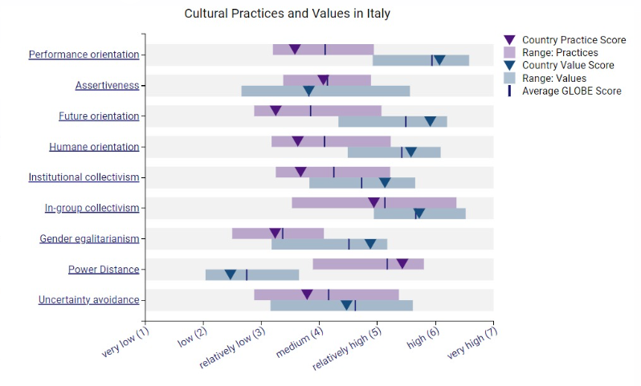
Italy is a country known for its rich culture, architecture and heritage, and it is one of the countries that people usually like to visit. Italy has one of the oldest cultures in the world, so most people like to explore the culture within the country. It is considered one of the best countries for international investment in the hospitality sector. As people from diverse nations come to Italy for tourism, it is important for the hospitality business to evaluate the different cultural and social factors in order to avoid taking any measures that can hurt the sentiments, cultural values and religious beliefs of the guests (Hawthorne 2021).
Diversity Hotel & Spa needs to understand and explore the culture of Italy and needs to analyze the consumer's preferences as well. As the people in Italy are appearance conscious and mostly focus on appearance on every occasion, the Diversity Hotel & Spa needs to include this thing in their business while operating operations and needs to make sure that the staff is well dressed and neat, and cleanness should be maintained (Toti et al., 2020). Further, it is also observed that people in Italy are more social and welcoming, so it is important for the business to provide that kind of working environment for the staff where they can easily socialize with the guests as well as in teams. The individual's thoughts and values should be given consideration when it comes to consumers as well as staff. The general manager needs to hire an HR manager from within the host country, as the other staff will also be hired from the host country. The local HR person will be able to understand the problems in a better way. The leadership style that is followed in the host country should be adopted in order to minimize the impact of leadership style on the performance of staff.

Cultural intelligence and sensitivity
Cultural intelligence is a way of exploring, assessing and improving the effectiveness within culturally diverse situations, while cultural sensitivity is defined as being aware of the host country's culture and beliefs and the cultural differences and similarities with the home country. Both of these are used by the hospitality industry nowadays in order to be successful within the new business market. The staff of the Diversity Hotel & Spa needs to know the cultural values and beliefs of different nations as they have to deal with people from different nations, and in order to make them comfortable with the setting, it is important to understand their cultural values and beliefs beforehand (Göl and Erkin 2019). Having good knowledge and well-trained staff is likely to provide the best care and services to the guests.

Conclusion
The essay concludes the discussion on the difference in culture between the host and home country for the e expansion of the hotel Diversity Hotel & Spa into Italy. The cultural factors such as values, beliefs, customs and leadership evaluation for the host country have also been discussed thoroughly. With the help of the GLOBE project's culture and Leadership, the difference in social as well as leadership styles between the home and host country has also been analyzed and is discussed thoroughly how the values and beliefs differ from culture to culture.

Recommendations
The recommendations for the general manager and strategies are also suggested that will help him in the expansion within the market of Itlay for the hotel Diversity Hotel & Spa, and that will further help in assessing the risks and challenges within the host country.
- It is recommended that the general manager understand the culture of the host country in detail before making the decision to expand.
- It is recommended to explore the factors that lack of staff that is being hired in the host country and make sure to provide the staff with the training regarding their job role if needed.
- It is recommended to make the proper strategies for the expansion into the new market
- It is recommended to analyze and explore the risk factors as well as assess the challenges within the host country.
- It is recommended to assess other micro and macro factors as well that can have an impact on the performance, such as political, economic, political, legal and environmental factors.
- As every country has its own culture and people's beliefs and values differ from nation to nation, it is recommended that the general manager explore the new leadership styles that are mainly used within the sector or the country.

References
Alfano, V. and Ercolano, S., 2020. The efficacy of lockdown against COVID-19: a cross-country panel analysis. Applied health economics and health policy, 18, pp.509-517.
Carriero, V.A., Gangemi, A., Mancinelli, M.L., Marinucci, L., Nuzzolese, A.G., Presutti, V. and Veninata, C., 2019. ArCo: The Italian cultural heritage knowledge graph. In The Semantic Web–ISWC 2019: 18th International Semantic Web Conference, Auckland, New Zealand, October 26–30, 2019, Proceedings, Part II 18 (pp. 36-52). Springer International Publishing.
Globe Project (no date a) GLOBE Project. Available at: https://globeproject.com/ (Accessed: 30 September 2023).
Göl, İ. and Erkin, Ö., 2019. Association between cultural intelligence and cultural sensitivity in nursing students: A cross-sectional descriptive study. Collegian, 26(4), pp.485-491.
Hole, Y., 2019. Challenges and solutions to the development of the tourism and hospitality industry in India. African Journal of Hospitality, Tourism and Leisure, 8(3), pp.1-11.
Hay, B., 2020. Perceptions of commercial hospitality space: The case of a UK university campus hotel. Hospitality & Society, 10(3), pp.243-262.
Hawthorne, C., 2021. Making Italy: Afro-Italian entrepreneurs and the racial boundaries of citizenship. Social & Cultural Geography, 22(5), pp.704-724.
Lindner, M. and Tovar-Gálvez, J.C., 2022. Sustainable Globe Project’s Statement on Challenges for Sustainability. Interdisciplinary Journal of Environmental and Science Education, 18(3), p.e2296.
Orsolini, L., Bellagamba, S., Volpe, U. and Kato, T.A., 2022. Hikikomori and modern-type depression in Italy: A new phenotypical trans-cultural characterization? International Journal of Social Psychiatry, 68(5), pp.1010-1017.
Toti, E., Massaro, L., Kais, A., Aiello, P., Palmery, M. and Peluso, I., 2020. Entomophagy: A narrative review on nutritional value, safety, cultural acceptance and a focus on the role of food neophobia in Italy. European Journal of Investigation in Health, Psychology and Education, 10(2), pp.628-643.

